**Phase 2: Innovation**

**Introduction:**

In this phase, we will further enhance our chatbot project by exploring advanced techniques and technologies. Here is an overview of the key steps and considerations for this phase:

**Project Description:**

In this phase, we aim to enhance our customer service chatbot project by incorporating advanced techniques and technologies. Our project involves creating a chatbot to provide exceptional customer service for a hotel's web application. Initially, we planned to use natural language understanding platforms and custom data for responses. However, in this phase, we will explore the use of pre-trained language models like GPT-3 to improve the quality of responses and user interactions.

**Scope of the Project:**

Our project's scope remains the same: to create a chatbot that delivers high-quality customer service for a hotel's web application. The chatbot will handle user queries, offer assistance and provide information about services.

**Base Paper Research:**

For our Phase 2 submission, we have conducted research on the below research article

L. N. Michaud, "Observations of a New Chatbot: Drawing Conclusions from Early Interactions with Users," in IT Professional, vol. 20, no. 5, pp. 40-47, Sep./Oct. 2018, doi: 10.1109/MITP.2018.053891336.

<https://ieeexplore.ieee.org/document/8509534>

This paper provides valuable insights into the design and implementation of a chatbot-based virtual assistant for a hotel in London. It discusses challenges, outcomes, and recommendations for best practices in designing chatbots for customer service in the hospitality domain.

**Dataset Selection:**

While we initially planned to use custom data and the provided dataset (<https://www.kaggle.com/datasets/grafstor/simple-dialogs-for-chatbot>), we will now explore the possibility of using additional datasets specifically curated for training and fine-tuning pre-trained language models. Our customised dataset is still under development. However, here is a sample for your reference: <https://drive.google.com/file/d/1_ifHxSC35oNJ59T2S2UmM45tgKyPGL-4/view?usp=drive_link>

**Project Design Steps:**

a. Data Collection: Gather relevant datasets for training and fine-tuning the language model.

b. Preprocessing: Prepare the data, clean it, and format it for model training.

c. Model Selection: Choose a pre-trained language model, such as GPT-3 or use machine learning or deep learning for chatbot responses according to requirements.

d. Fine-tuning: Fine-tune the selected model on our hotel-specific dataset to make it domain-specific.

e. Integration: Integrate the fine-tuned model with the hotel's web application using appropriate tools and frameworks.

f. User Interface Enhancement: Optimise the user interface for seamless chatbot interactions.

g. Testing and Evaluation: Conduct rigorous testing to ensure the chatbot's performance meets our objectives.

h. Continuous Improvement: Gather user feedback and refine the chatbot's responses and capabilities over time.

**Architecture/Framework:**

Below is a simplified architecture for our enhanced chatbot project:

User Interface:

* Web application
* Chatbot integrated into web app

Web Application:

* Python for web development and chatbot development
* Flask framework used for python web development
* Web server
* Chatbot which uses a ML model

Python:

* NLP library (e.g., spaCy, NLTK)
* Machine learning library (e.g., TensorFlow, PyTorch)
* Machine Learning Model

**Architecture diagram:**

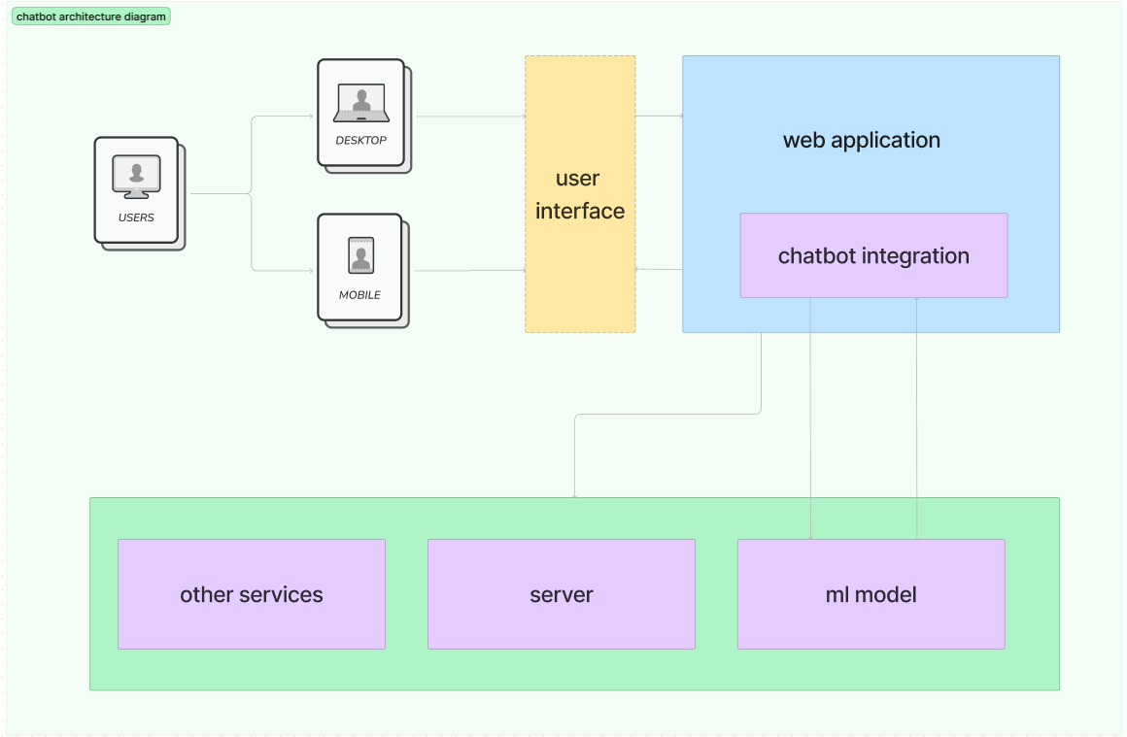

User Interface:

* Web application
* Chatbot integrated into web app

Web Application:

* Python for web development and chatbot development
* Flask framework used for python web development
* Web server
* Chatbot which uses a ML model

Python:

* NLP library (e.g., spaCy, NLTK)
* Machine learning library (e.g., TensorFlow, PyTorch)
* Machine Learning Models/Deep Learning Neural Networks

**Conclusion:**

This phase aims to take our customer service chatbot project to the next level by incorporating advanced NLP techniques and leveraging pre-trained language models. We also use customised dataset for training for improving customer satisfaction and user experience. As we move forward, we will continue to adapt and refine our project to meet evolving customer needs and expectations. We will make our chatbot project more innovative and capable of delivering exceptional customer service in the hotel industry.