2.
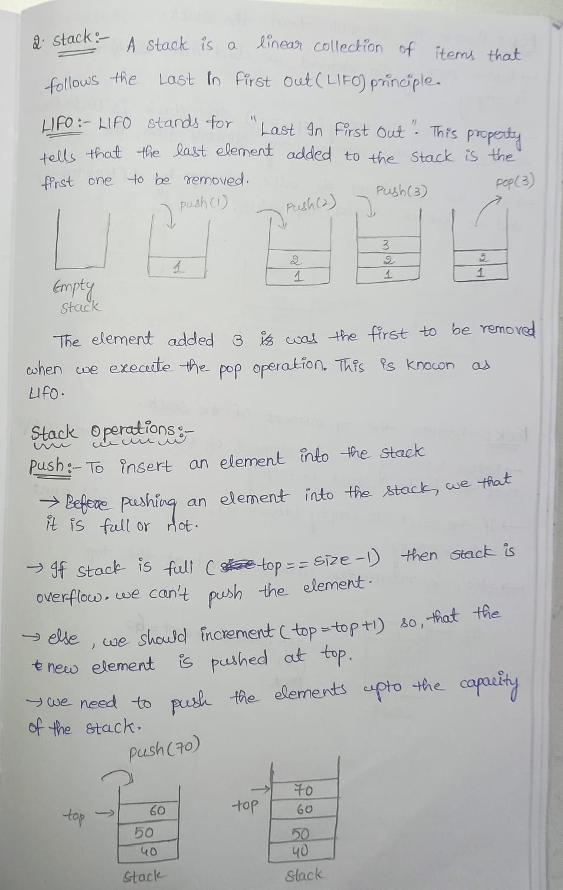
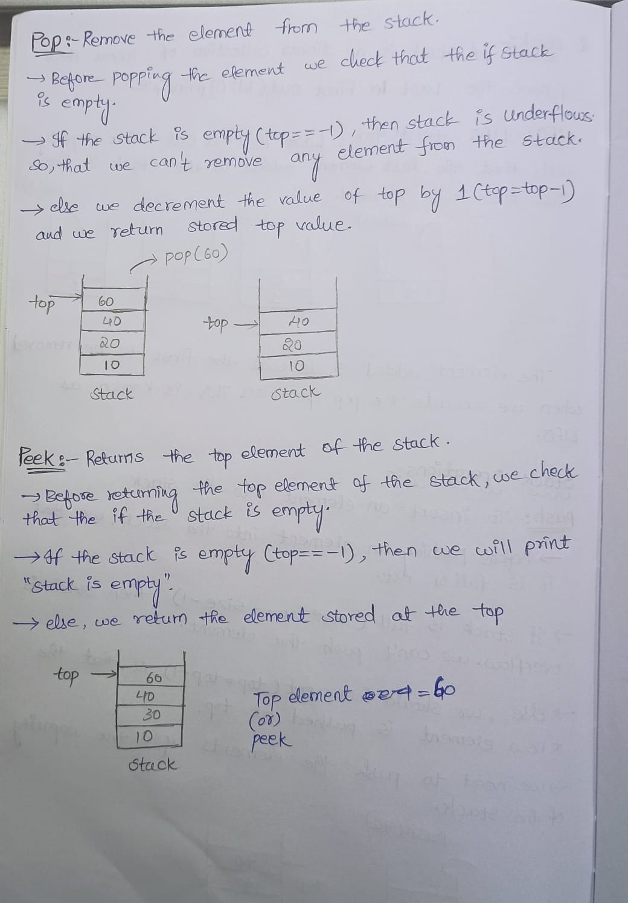

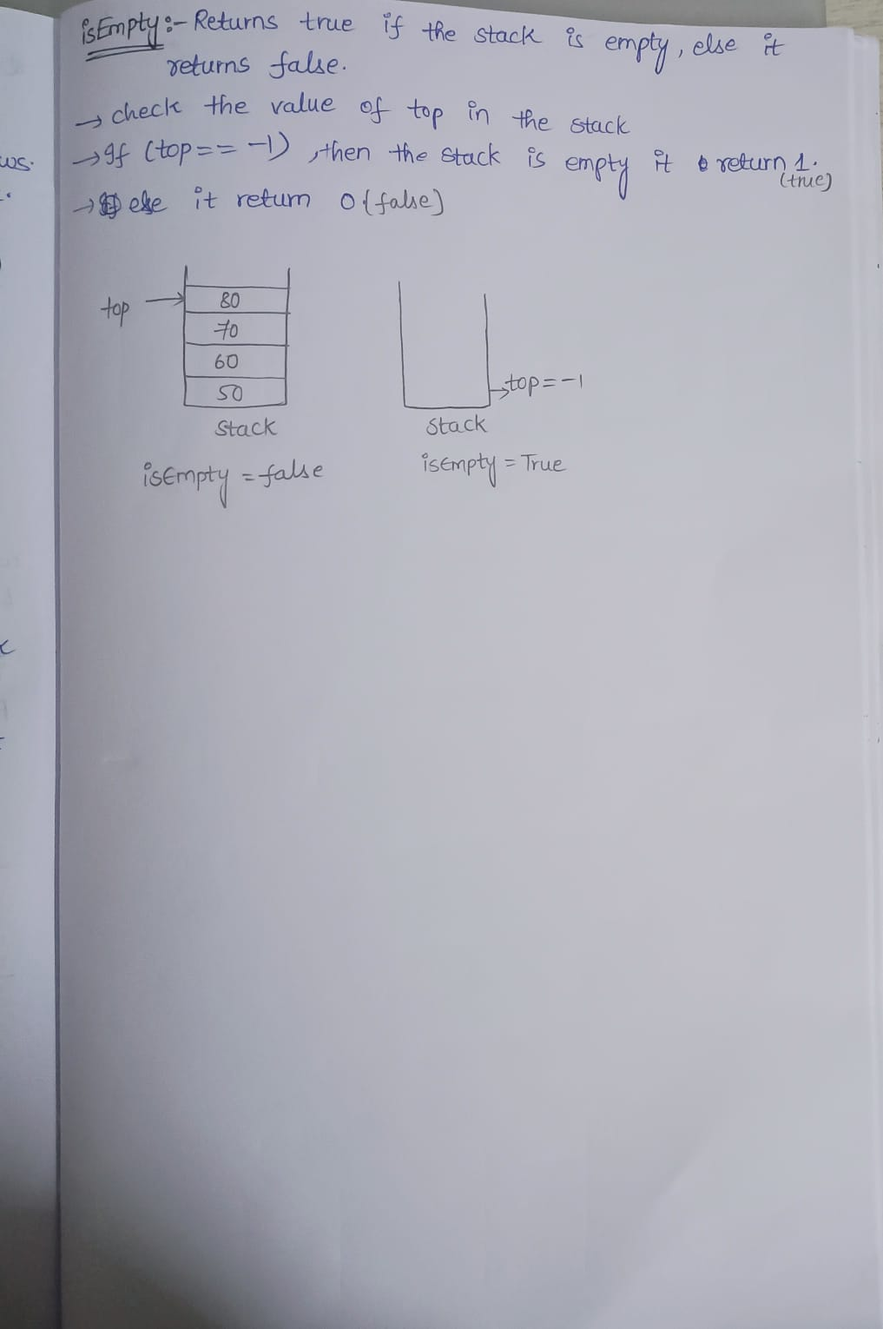
3.
Stack:
Stack is a linear collection of elements that follows the Last In First Out(LIFO) property.
Real-life examples :
- Packing of a biscuit packet, the last biscuit you put in last is the biscuit that you take first to eat , when you open the biscuit packet .
- When you are packing your bag for a trip ,the last thing you put in last is the thing that you take ,when you open the bag.
Queue:
Queue is a linear collection of elements that follows First In First Out(FIFO) property .
Real life examples :
- Standing in supermarket to get bill and pay the money in a queue. The person who is in the first of the queue will be billed first and pay amount .
- Before consulting a doctor the appointment (OP)are taken ,the person ,the person who took the first OP will be called first for the consultation.
4 . Asymptotic notations:
Instead of comparing algorithms explicitly, asymptotic analysis is concerned with knowing the relative growth rates of the complexity of algorithms.
Asymptotic analysis makes it possible to compare algorithms' space and time complexities by considering their performance attributes as the input size increases.
By employing asymptotic notations like Big O, Big Omega, and Big Theta, we are able to classify algorithms in accordance with their worst-case, best-case, or average-case space or time complexity, and derive useful information concerning their efficiency.
Types of notations:
Big-O notation:
- Big-O notation is the bound above for an algorithm's running time. So, it denotes the worst-case complexity of an algorithm.
Functions.
Let f(n), g(n),
f(n) = O(g(n))
0 <= f(n) <= cg(n) for all n >= n0
- It gives the maximum possible output value (big-O) for an input.
The time taken for execution is an upper bound on the time complexity of an algorithm.
Omega notation :
- Omega notation gives the lower bound of the running time of an algorithm. Therefore, it gives the best case complexity of an algorithm.
Let f(n), g(n) be functions,
f(n) = omega(g(n))
c*g(n) <= f(n) for all n>= n0
- Theta notation :
Theta notation brackets the function from above and below. Because it denotes the upper and the lower limit of the running time of an algorithm, it is employed to analyze the average-case complexity of an algorithm.
Let f(n), g(n) be functions,
f(n) = theta(g(n))
c1* g(n) <= f(n) <= c2* g(n) for all n>=n0
It serves as both, most, and least boundary for an input value.

