AP24110010935
E.vindhya sri

CREATE TABLE SCHOOL (
ID INT PRIMARY KEY,
NAME VARCHAR(50)
);

CREATE TABLE EMPLOYEE (
ID INT PRIMARY KEY,
LAST_NAME VARCHAR(50),
FIRST_NAME VARCHAR(50),
MIDDLE_NAME VARCHAR(50),
FATHER_NAME VARCHAR(50),
MOTHER_NAME VARCHAR(50),
SEX CHAR(1),
HIRE_DATE DATE,
ADDRESS VARCHAR(100),
CITY VARCHAR(50),
STATE VARCHAR(50),
ZIP VARCHAR(10),
PHONE VARCHAR(15),
PAGER VARCHAR(15)
);

CREATE TABLE EMP_SCHOOL (
EMP_ID INT,
SCHOOL_ID INT,
FOREIGN KEY (EMP_ID) REFERENCES EMPLOYEE(ID),
FOREIGN KEY (SCHOOL_ID) REFERENCES SCHOOL(ID)
);

INSERT INTO SCHOOL VALUES
(1, 'Computer Science'),
(2, 'Mechanical Engineering'),
(3, 'Civil Engineering'),
(4, 'Electrical Engineering'),
(5, 'Electronics'),
(6, 'Mathematics'),
(7, 'Physics'),
(8, 'Chemistry'),
(9, 'Biology'),
(10, 'Management');

INSERT INTO EMPLOYEE VALUES
(1,'Sharma','Sohan','K','Ramesh','Sita','M','2015-06-10','Addr1','Mumbai','MH','400001','9999991111','101'),
(2,'Verma','Snehith','L','Suresh','Geeta','M','2018-08-20','Addr2','Pune','MH','400002','9999992222','102'),
(3,'Reddy','Ramu','M','Raju','Lakshmi','M','2012-03-15','Addr3','Hyderabad','TS','500001','9999993333','103'),
(4,'Naidu','Harshith','R','Ravi','Padma','M','2016-07-25','Addr4','Chennai','TN','600001','9999994444','104'),
(5,'Kumar','Dhiraj','P','Mohan','Radha','M','2020-01-05','Addr5','Delhi','DL','110001','9999995555','105'),
(6,'Patel','Sami','T','Rakesh','Kiran','M','2013-09-10','Addr6','Ahmedabad','GJ','380001','9999996666','106'),
(7,'Singh','Samantha','S','Mahesh','Ganga','F','2011-11-11','Addr7','Jaipur','RJ','302001','9999997777','107'),
(8,'Das','Vijay','D','Hari','Lata','M','2019-02-14','Addr8','Kolkata','WB','700001','9999998888','108'),
(9,'Nair','Rashmika','N','Krishna','Meera','F','2017-04-18','Addr9','Kochi','KL','682001','9999999999','109'),
(10,'Iyer','Kajal','I','Sundar','Lalitha','F','2014-12-12','Addr10','Bangalore','KA','560001','8888888888','110');

INSERT INTO EMP_SCHOOL VALUES
(1,1),
(2,1),
(2,2),
(3,2),
(4,3),
(5,1),
(5,2),
(6,4),
(7,1),
(8,5);

1. SELECT * FROM EMPLOYEE
WHERE ID NOT IN (SELECT EMP_ID FROM EMP_SCHOOL);
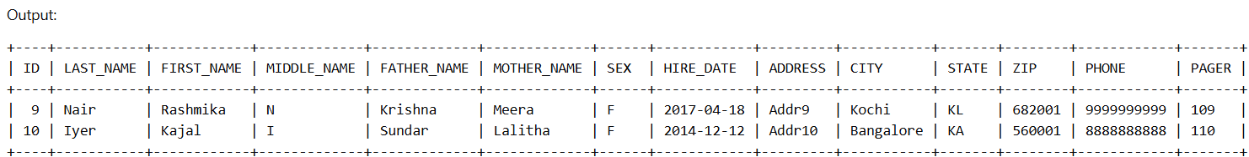

2. SELECT EMP_ID
FROM EMP_SCHOOL
GROUP BY EMP_ID
HAVING COUNT(SCHOOL_ID) > 1;
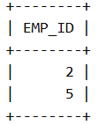

3. SELECT E.*
FROM EMPLOYEE E
JOIN EMP_SCHOOL ES ON E.ID = ES.EMP_ID
JOIN SCHOOL S ON ES.SCHOOL_ID = S.ID
WHERE S.NAME IN ('Computer Science','Mechanical Engineering')
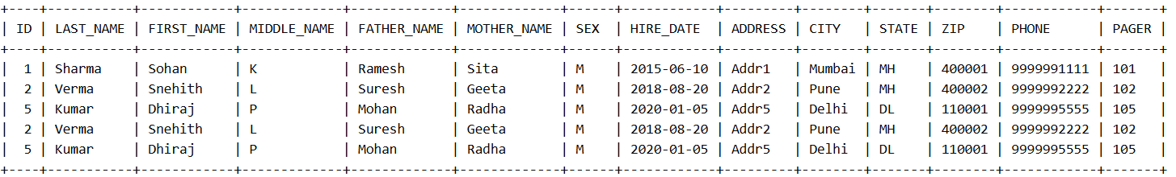
AND TIMESTAMPDIFF(YEAR, HIRE_DATE, CURDATE()) BETWEEN 5 AND 10;

4. CREATE INDEX idx_emp_name
ON EMPLOYEE(FIRST_NAME, MIDDLE_NAME, LAST_NAME);

5. DROP INDEX idx_emp_name ON EMPLOYEE;
CREATE INDEX idx_new_emp_name
ON EMPLOYEE(FIRST_NAME, MIDDLE_NAME, LAST_NAME);

6. DROP INDEX idx_new_emp_name ON EMPLOYEE;

7. COMMIT;

8. CREATE VIEW emp_view AS
SELECT FIRST_NAME, LAST_NAME FROM EMPLOYEE;
DROP VIEW emp_view;

9. ROLLBACK;

