- Implementation Details and Screenshots of the Working App

5.1 Implementation Overview
UniMentor brings tutor discovery, booking, learning and account management into one mobile application. React Native and Expo provide the interface; screens call repository functions through the shared Axios client, while the Express API uses Mongoose to access MongoDB. React Navigation separates student, tutor and administrative workspaces, and Zustand stores hold the current user and feature state.
The four implementation sections follow the member responsibility split documented in Milestone 02. Each section maps the assigned requirements and prototype flow to repository screens, test IDs, and four handset evidence slots. Paste genuine Android phone captures into Figures 5.1–5.16 and enter only outcomes observed on the final build. The current source document contained Expo web-preview images; these have been replaced with clearly marked phone-capture spaces.
Evidence to record | Details for the demonstrated version
Handset and build | Source state: Git HEAD 5934335; local working-tree changes are present, so exact tested build/source state: [enter].  Handset OS: MyOS 16 / Android 16 base (reported by user; on-device verification pending). Phone model and Android build/API level: [enter].  App: UniMentor 1.0.0; repository declares Expo SDK ~57.0.21 and React Native 0.86.3. Launch method (Expo Go or Android build): [enter].  Capture date/time and test role: [enter].
Phone connectivity and test data | Backend API URL reachable from handset: [enter LAN URL; do not use localhost on the phone].  Database/environment: [enter the isolated non-production test database actually used].  Test account role(s) and seeded/test-data note: [enter]. Selected API-only pass labels from the earlier implementation notes are summarized in Section 7; attach the corresponding execution/read-back evidence. They do not establish a handset result.
Prototype traceability | Prototype baseline: Milestone 02, Section 5.2 high-fidelity screens and the relevant member workflow. Numbered frame ID: [enter if present].  Observed match/deviation against the final handset build: [enter after visual comparison].

Mobile evidence capture details
Handset evidence status: MyOS 16 with Android 16 base was reported by the phone owner. The device is not connected in this session, so OS properties, phone model, app launch method, live API connectivity, and mobile test outcomes have not been independently verified. Capture the final build on the handset and complete the [enter] fields below; do not treat the former browser preview as phone evidence.

5.2 Booking Scheduling and Payment
V. D. Wijesiri | IT23730724
The booking component connects a student's tutor selection with session planning. Booking Flow Screen provides steps for individual or group study, topic and time selection, verification and payment, followed by a receipt view. Tutor Slot Management Screen lets tutors enter the module, date, start/end time, duration, fee, mode and capacity. Student bookings and registered attendees are then presented through the student and tutor session screens.
The tutor-slot screens support availability creation, retrieval, editing, and deletion; group-session registration updates attendee membership, and a booking can create a session record. In the final evidence, show the selected date and time, then use the same booking and session IDs in the student and tutor views so the full journey is traceable.
CRUD focus: C/R/U/D tutor slots; C/R/U/D session API; attendee registration/cancellation changes a slot. A cancellation is an update or attendee removal, not automatically deletion of the booking. Show server persistence separately from the local booking list.
Payment workflow: The checkout, wallet, and refund screens are part of the booking journey. State the test mode used in the figure caption and link the visible transaction outcome to its related booking or session evidence.
Four Android phone evidence slots — V. D. Wijesiri (IT23730724) | Booking, scheduling and payment. Four captures are reserved for the student booking list, tutor-managed availability, time selection, and checkout review. Scope and linked cases: FR15–FR22, HMW02, NFR08 and NFR10; record actual handset results for FT14, FT15, FT19 and FT30 in Table 7.2.
Member 1 interface evidence
Figure 5.1 | My Bookings shows active tutor cards, modules, rates, upcoming sessions and student-side session actions. | Figure 5.2 | Slot Allocation shows the tutor schedule, open capacity, prices and registered attendees.
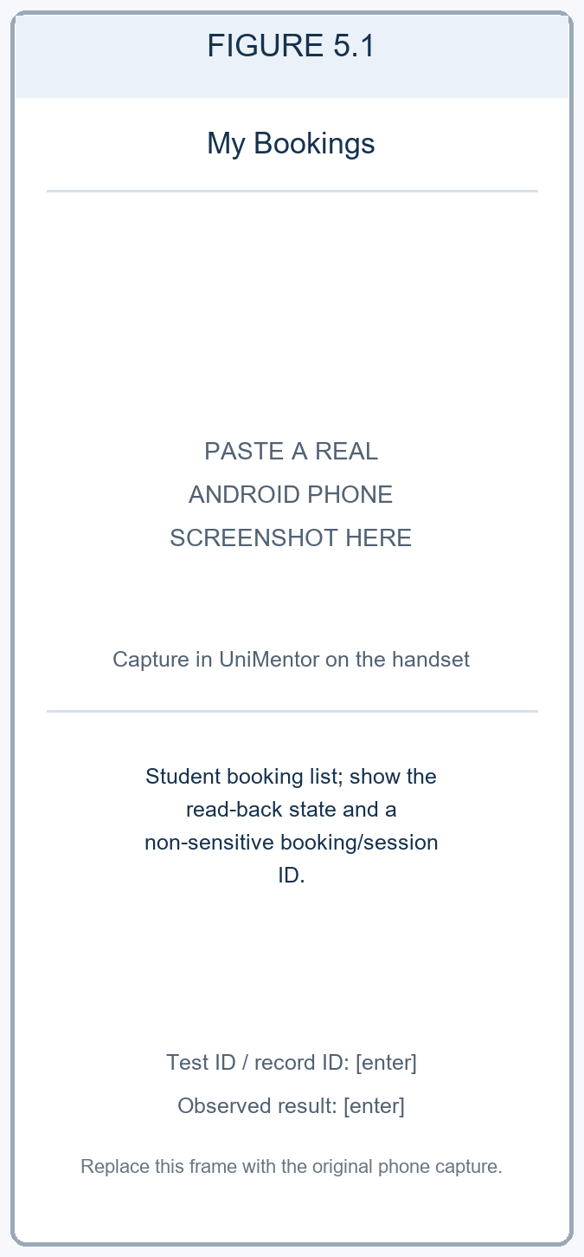  Figure 5.1. My Bookings shows the student booking list and session state. Phone evidence: [enter test ID, record ID, observed result].  Role: Student demo. Read-only seeded demo state. | 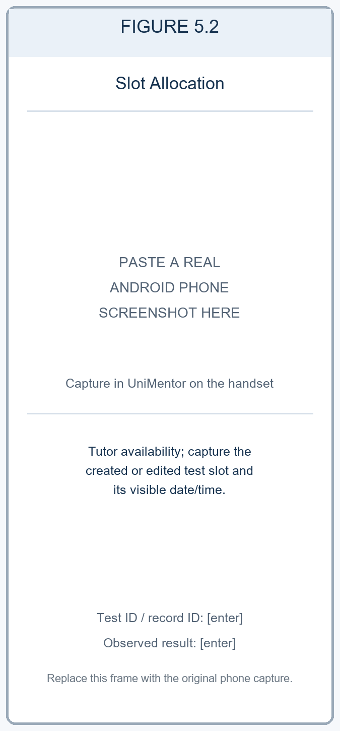  Figure 5.2. Slot Allocation shows tutor availability and the test slot state. Phone evidence: [enter test ID, slot ID, observed result].  Role: Tutor demo. Read-only seeded demo state; no slot was changed.

Figure 5.3 | Choose Time compares the requested session time with an available tutor slot before confirmation. | Figure 5.4 | Verify Booking presents the session summary, fee breakdown and wallet, card and bank payment options.
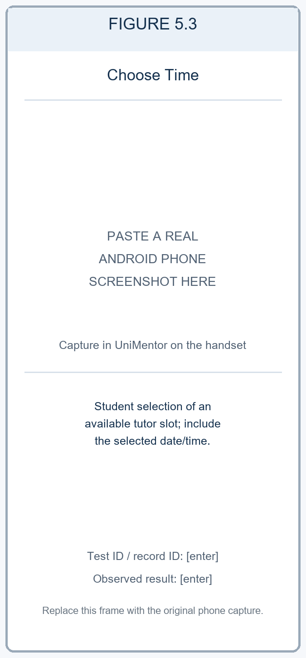  Figure 5.3. Choose Time shows the selected available tutor slot. Phone evidence: [enter test ID, selected date/time, observed result].  Role: Student demo. No booking was submitted. | 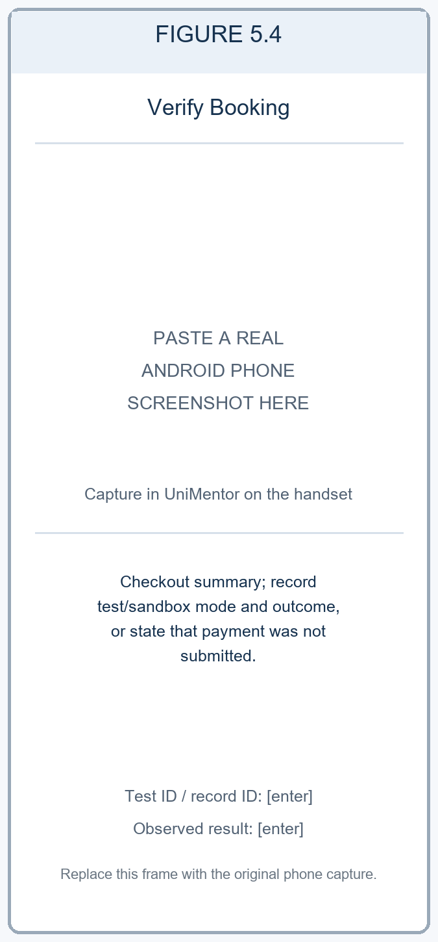  Figure 5.4. Verify Booking shows the checkout summary. Phone evidence: [enter test mode and result; no live payment].  Role: Student demo. Checkout is shown; Confirm & Pay was not pressed.
Phone capture instructions: Figures 5.1–5.4 are reserved for actual handset captures from the final app build. Use a test account and non-production records. For write actions, reopen the item and record its non-sensitive ID and persisted state. For checkout, use a sandbox or test mode and record the mode; do not present a checkout screen alone as a completed payment.
Table 5.1. Booking and scheduling operation coverage
Operation | Feature / interface | Repository route and method | Verification and evidence
Create | Tutor availability slot | POST /api/slots | API execution status: [enter after execution]. Phone result, date/time, slot ID and screenshot: [enter].
Read | Tutor availability slot | GET /api/slots; GET /api/slots/:id | API execution status: [enter after execution]. Phone result, persisted state and screenshot: [enter].
Update | Tutor availability slot | PUT /api/slots/:id | API execution status: [enter after execution]. Phone before/after values, slot ID and screenshot: [enter].
Delete | Tutor availability slot | DELETE /api/slots/:id | API execution status: [enter after execution]. Phone deletion result, slot ID and screenshot: [enter].
Session lifecycle | Booking and tutor response | GET /api/sessions/me; POST /api/sessions; PUT /api/sessions/:id; PATCH /api/sessions/:id/status or /cancel; DELETE /api/sessions/:id | API execution status: [enter after execution]. Phone test FT14, role, date/time, session ID and screenshots: [enter].

5.3 Academic Management and Tutor Discovery
W. K. Nethmi | IT23721128
The discovery component helps students move from a learning need to a tutor shortlist. Search Screen presents tutor cards and applies search and filter criteria. The current filter logic includes price, rating, experience, language and lesson type. Tutor profiles, comparison and recommendation screens bring profile information and review summaries together so that students can inspect alternatives before starting a conversation or booking.
Saved tutors are stored through the user shortlist API. Students can add a tutor, read the list, change priority/notes and remove the entry. Reviews also have save, read, edit and delete operations, while tutors can reply to received feedback. Academic module registration supports mentor assignment, progress updates and removal. These flows give stronger evidence than a screenshot of a populated search list alone.
CRUD focus: C/R/U/D shortlist entries, student reviews and enrolled-module sub records. Profile comparison and changing a filter are read/computation actions; they should not be counted as database updates.
Discovery workflow: Search and comparison screens present tutor profiles, reviews, and available filter criteria. In the evidence, show the search values used and the resulting tutor cards so the selection can be reproduced.
Four Android phone evidence slots — W. K. Nethmi (IT23721128) | Academic management and tutor discovery. Four captures trace module registration, filtered tutor search, profile inspection, and tutor comparison/shortlisting. Scope and linked cases: FR08–FR14 and HMW01; API cases FT04, FT06 and FT09 are referenced in Table 7.1, and record the actual phone workflow result for FT13 in Table 7.2.
Member 2 interface evidence (1 of 2) — academic registration and tutor search
Figure 5.5 | Register New Module presents module name/code fields, curriculum choices and mentor selection. | Figure 5.6 | Find Your Mentor shows module filters and verified results with subjects, ratings, rates and comparison actions.
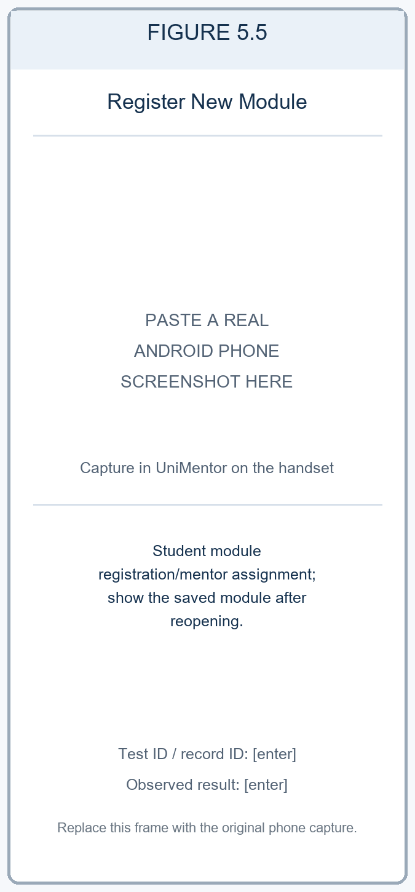  Figure 5.5. Register New Module shows module registration and mentor assignment. Phone evidence: [enter test ID, module code, read-back result].  Role: Student demo. Registration form only; enrollment was not submitted. | 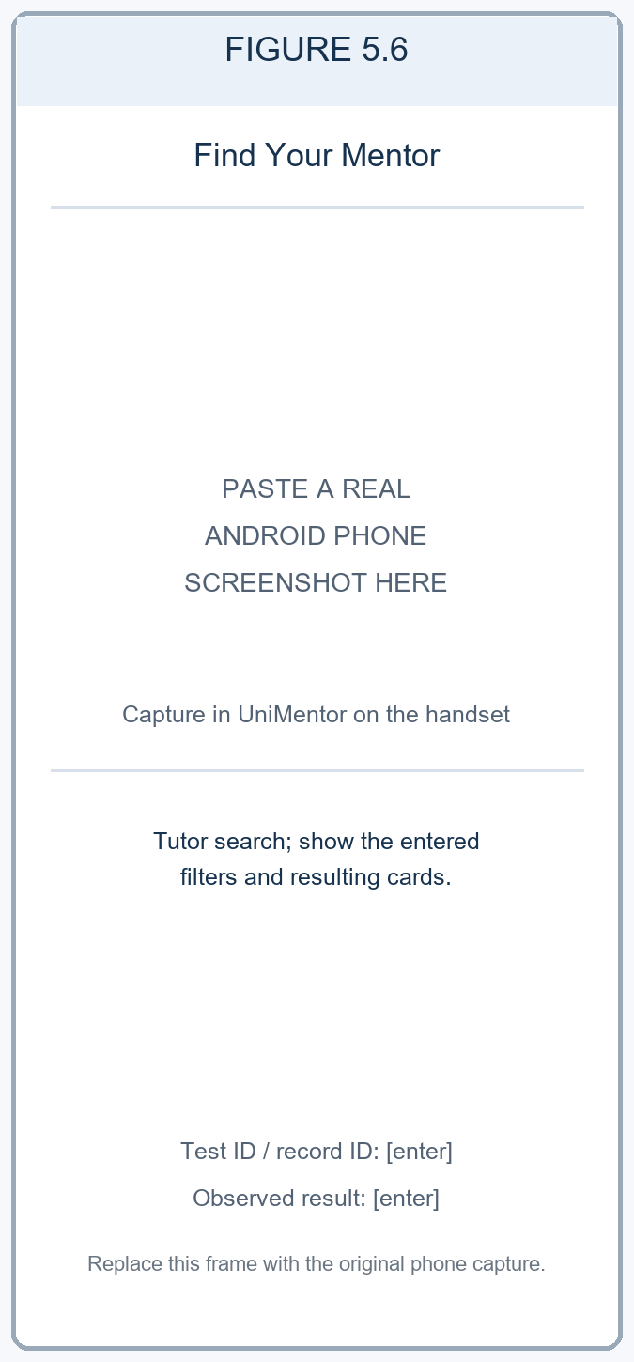  Figure 5.6. Find Your Mentor shows tutor search filters and results. Phone evidence: [enter filter values and test ID].  Role: Student demo. Read-only seeded demo results; no shortlist was changed.
Member 2 interface evidence (2 of 2) — tutor profile and comparison
Figure 5.7 | Tutor Profile presents qualification, availability, taught modules, support areas and review summary. | Figure 5.8 | Compare Tutors presents selected profiles side by side by rating, rate, experience and modules.
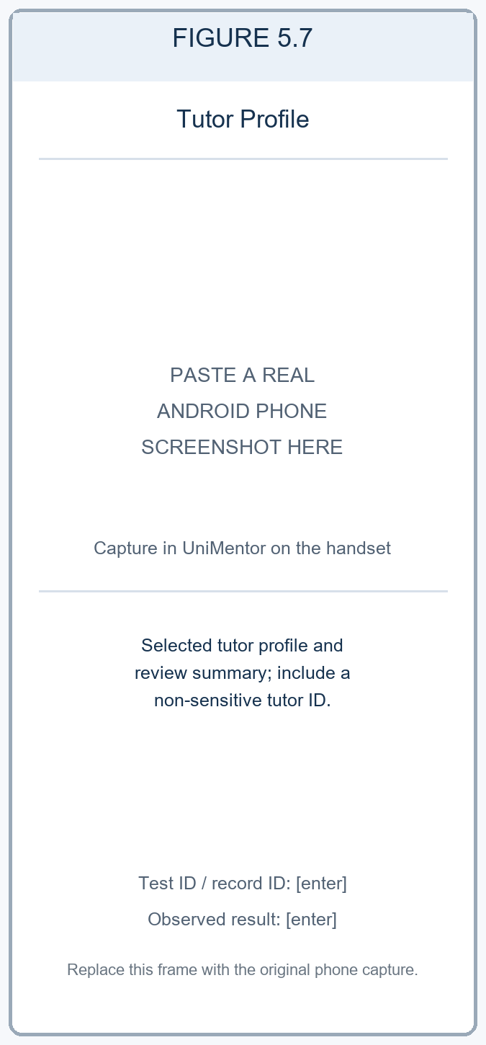  Figure 5.7. Tutor Profile shows the selected tutor profile and reviews. Phone evidence: [enter test ID and tutor ID].  Role: Student demo. Read-only seeded demo state. | 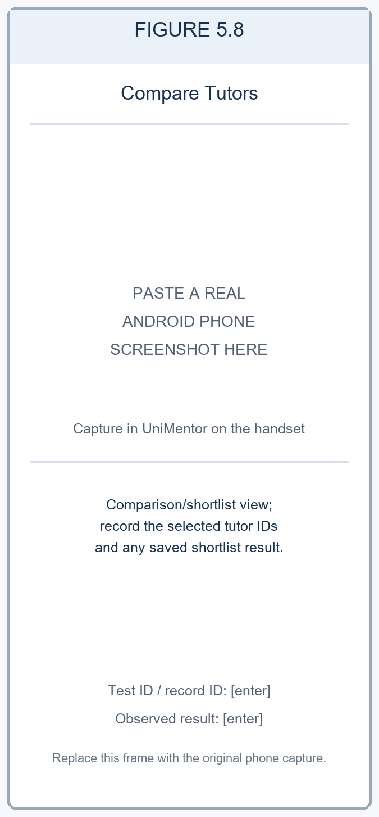  Figure 5.8. Compare Tutors shows selected profiles and shortlist state. Phone evidence: [enter test ID and saved result].  Role: Student demo. Comparison is a view; no shortlist mutation was submitted.
Phone capture instructions: Figures 5.5–5.8 are reserved for actual handset captures. Include the module, filter values, or tutor IDs needed to reproduce the result. For a module or shortlist change, reopen the list and record the persisted outcome. Enter the observed result for FT13 in Table 7.2.
Table 5.2. Tutor discovery and review operation coverage
Operation | Feature / interface | Repository route and method | Verification and evidence
Create | Shortlist and student review | POST /api/users/shortlist; POST /api/reviews/tutors/:tutorId | API execution status: [enter after execution]. Phone result, test ID and record IDs: [enter].
Read | Tutor search, saved tutors and reviews | GET /api/mentors/search; GET /api/users/shortlist; GET /api/reviews/tutors/:tutorId | API execution status: [enter after execution]. Phone search inputs, test ID and screenshot: [enter].
Update | Shortlist note/priority and review | PUT /api/users/shortlist/:mentorId; PUT /api/reviews/:id | API execution status: [enter after execution]. Phone before/after values, test ID and evidence: [enter].
Delete | Shortlist entry and review | DELETE /api/users/shortlist/:mentorId; DELETE /api/reviews/:id | API execution status: [enter after execution]. Phone delete result, test ID and record IDs: [enter].

5.4 Learning Management Assessments and Administration
R. G. C. S. Ranasinghe | IT23725256
The learning component combines resources, goals, study activity and assessments. LearningDashboardScreen shows progress and a weekly target. Students can browse learning materials, open their details, save them and update progress; StoreMaterialScreen creates a resource through the library API. Goal screens connect progress logs, tasks and milestones to an individual learning goal, making the interface useful beyond finding and booking a tutor.
The assessment flow separates tutor preparation, staff review and student work. Tutors create papers and view submissions; students save answers, submit attempts and open results. Staff can review a paper, while tutor grading controls save marks and release grades. Link each action to the relevant assessment and attempt records, and execute the role-specific mobile checks in Section 7.2.
CRUD focus: The repository provides create and read routes for learning materials and tutor papers, and update-style routes for saved material progress, goal progress, assessment attempts and grading. For the assigned CRUD demonstration, record the specific delete action only after confirming the screen, route and result in the final build; use the [enter] field in Table 5.3 if needed.
Learning workflow: Capture tutor preparation, student submission, assessment review, and the resulting feedback or grade using the relevant roles. Reopen the record after each action and link the student attempt to the corresponding assessment.
Four Android phone evidence slots — R. G. C. S. Ranasinghe (IT23725256) | Learning management, assessments and administration. Four captures are reserved for the learner dashboard/resources, material progress, student assessment, and tutor/staff assessment workflow. Scope and linked cases: HMW03, NFR01 and NFR08; record the executed cross-role outcome for FT16 in Table 7.2.
Member 3 interface evidence (1 of 2) — learning dashboard and materials
Figure 5.9 | Learning Dashboard summarizes the weekly study target, module goals, resumed activity and academic sessions. | Figure 5.10 | Learning Materials shows source/type filters, sync status and course resources such as notes, code and recordings.
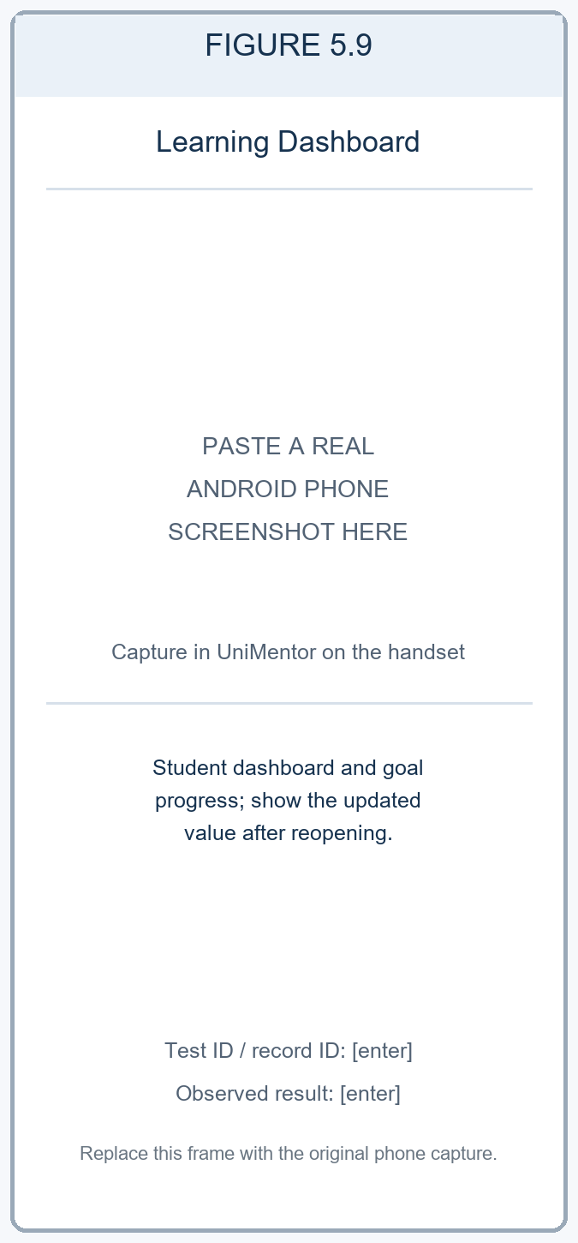  Figure 5.9. Learning Dashboard shows study goals and progress. Phone evidence: [enter test ID and before/after values].  Role: Student demo. Read-only seeded demo state. | 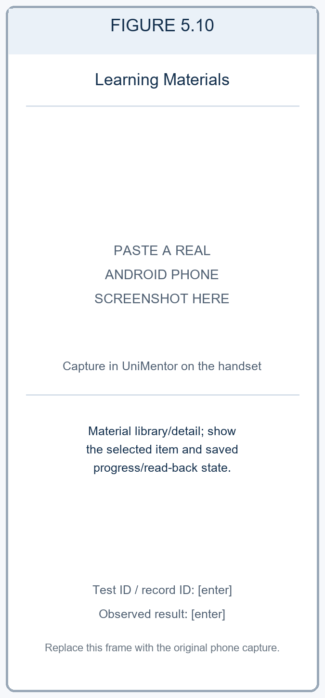  Figure 5.10. Learning Materials shows a resource and saved progress. Phone evidence: [enter test ID, item ID and read-back result].  Role: Student demo. Read-only seeded demo state.
Member 3 interface evidence (2 of 2) — student and tutor assessment views
Figure 5.11 | Assessment Center lists active and due tasks, deadlines, task types and assessment progress. | Figure 5.12 | Tutor Assessment Hub shows the authoring entry point, grading queue, live-test overview and assessment list.
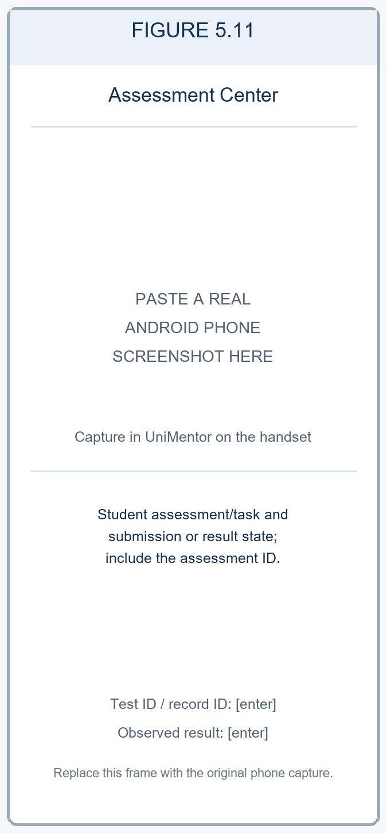  Figure 5.11. Assessment Center shows the student task and submission/result state. Phone evidence: [enter test ID and assessment ID].  Role: Student demo. No assessment attempt was submitted. | 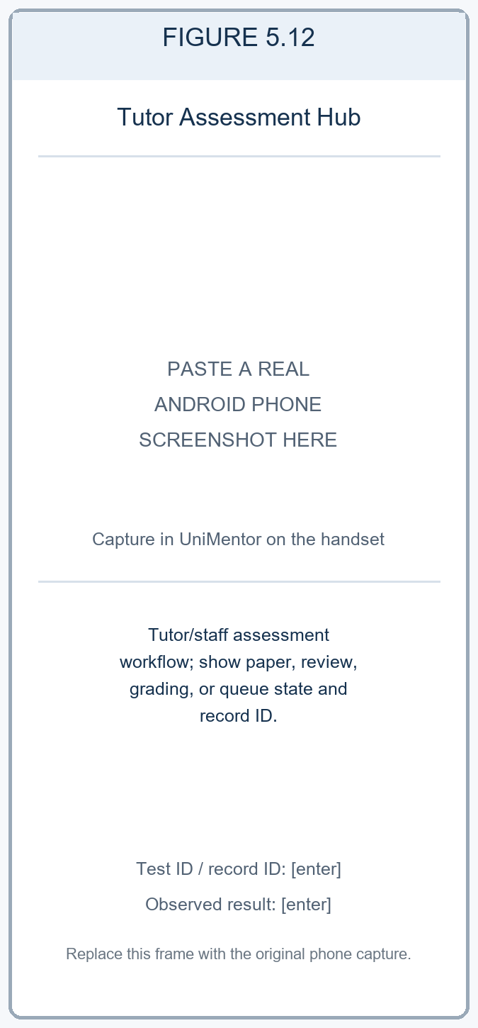  Figure 5.12. Tutor Assessment Hub shows the tutor/staff assessment workflow. Phone evidence: [enter role, test ID, record ID and outcome].  Role: Tutor demo. No assessment was created or graded.
Phone capture instructions: Figures 5.9–5.12 are reserved for actual handset evidence. Use separate student, tutor, and staff test roles as required. For progress, submission, paper creation, review, or grading, reopen the relevant record and include its non-sensitive ID. Enter only actions actually completed and the observed FT16 outcome in Table 7.2.
Table 5.3. Learning and assessment route-to-evidence map
Operation | Feature / interface | Repository route and method | Verification and evidence
Create | Learning material and tutor assessment paper | POST /api/library; POST /api/learning/tutor/papers | Mobile/API result, role, item ID and screenshot: [enter].
Read | Materials, goals and submissions | GET /api/library; GET /api/library/:id; GET /api/learning/goals/board; GET /api/learning/tutor/papers/:id/submissions | Mobile/API result and record ID: [enter].
Update | Saved material progress, goal progress and student attempt | POST /api/library/:id/save; POST /api/library/:id/progress; PATCH /api/learning/goals/:id; PUT /api/learning/papers/:id/progress | Mobile/API result and before/after values: [enter].
Grade / review | Tutor grade and staff review actions | POST /api/learning/tutor/attempts/:attemptId/grade; POST /api/learning/admin/papers/:id/review | Role, assessment/attempt ID, observed result and screenshot: [enter].
Delete demonstration | Assigned learning/assessment entity | [enter implemented screen, route and method] | [enter reproducible test ID, result, record ID and screenshot after final-build verification].

5.5 User Management and Platform Services
N. G. H. Rashini | IT23729384
User management provides registration, sign-in, profile maintenance and tutor evidence review. Authentication routes include password login, campus-login code verification and password recovery. The normal sign-in path returns a JWT, which the API client attaches to requests. Profile screens retrieve and update user information, while subject interests are managed as items within the user profile rather than as separate accounts.
Tutor identity and transcript images are submitted through the document repository. Authorised staff screens can inspect evidence, approve or request re-upload, and change account verification/status. Security settings, notification preferences, password change and session revocation now have API paths. Their saved values should be reopened during evidence capture; saving a setting does not alone prove that every associated policy is enforced.
CRUD focus: Create and read account and evidence records, update profiles, preferences, evidence review and verification status and remove a subject-interest subrecord. Link each operation to its route and the matching test account or record.
User-management workflow: Demonstrate authenticated registration, profile maintenance, document submission/review, and the resulting account status. Record the role used and reopen the status view after the staff action.
Four Android phone evidence slots — N. G. H. Rashini (IT23729384) | User management and platform services. Four captures are reserved for settings, profile maintenance, verification status, and the administrator user directory. Scope and linked cases: FR01–FR07, HMW03, NFR05 and NFR06; record the actual role, staff, and profile workflow results for FT12, FT17, FT18 and FT31 in Table 7.2.
Member 4 interface evidence (1 of 2) — platform services and profile
Figure 5.13 | Settings & Platform Services groups academic account, security, notification, support and reviewer tools. | Figure 5.14 | Student Profile shows the account role, campus wallet, academic summary and profile-management entry point.
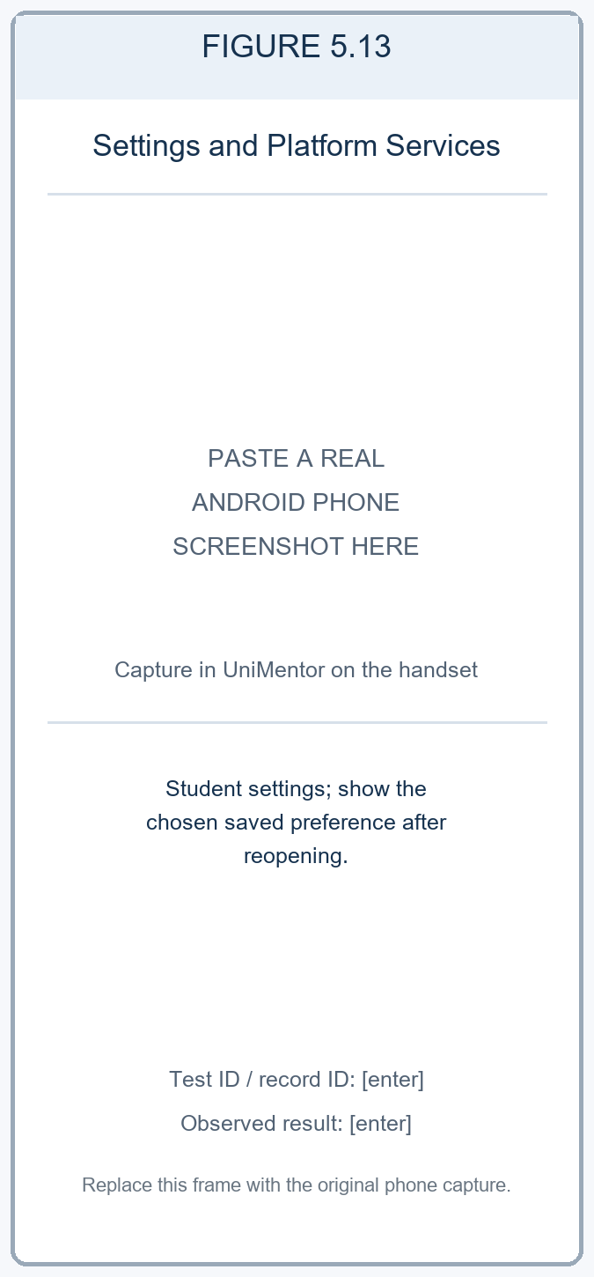  Figure 5.13. Settings & Platform Services shows student preferences. Phone evidence: [enter test ID and saved setting].  Role: Student demo. Read-only seeded demo state. | 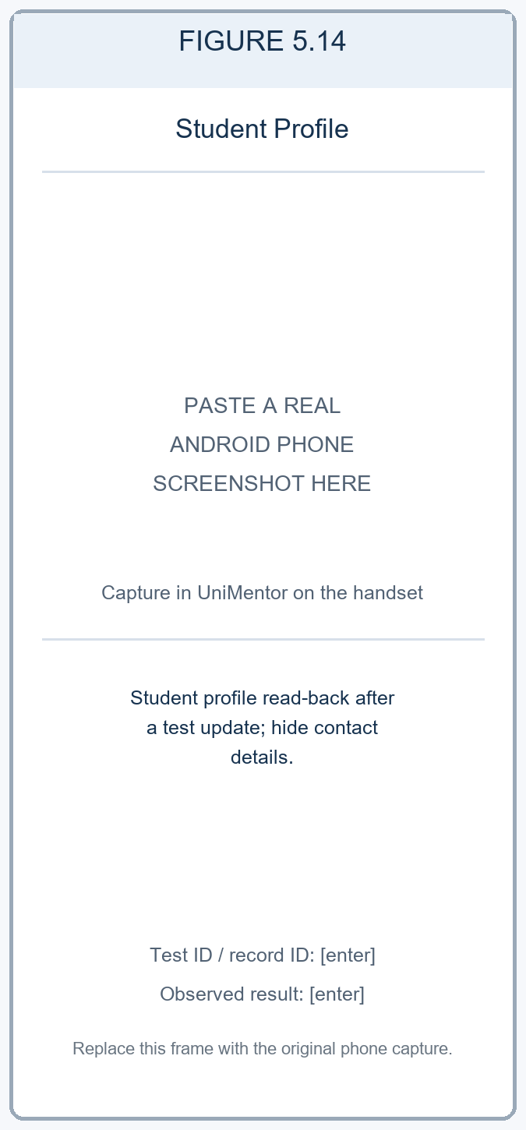  Figure 5.14. Student Profile shows account details after a verified test update. Phone evidence: [enter test ID and read-back result; hide private data].  Role: Student demo. Read-only seeded demo state.
Member 4 interface evidence (2 of 2) — verification status and user directory
Figure 5.15 | Verification Status shows the account review state, module approval breakdown and verification timeline. | Figure 5.16 | User Directory presents role filters, search and registered accounts with role and status labels.
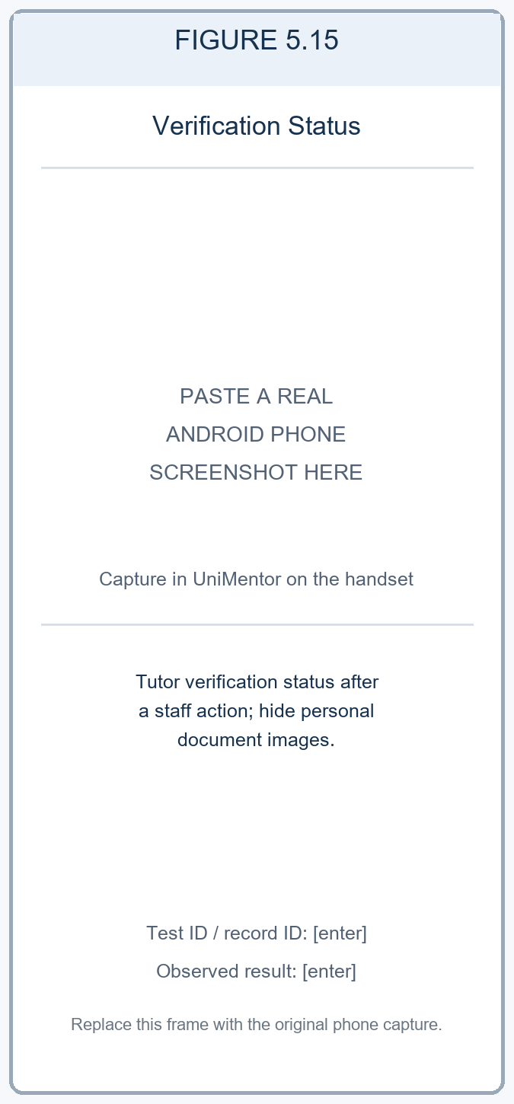  Figure 5.15. Verification Status shows the account review state. Phone evidence: [enter test ID and status; hide personal documents].  Role: Student demo. Status view only; no credential was uploaded. | 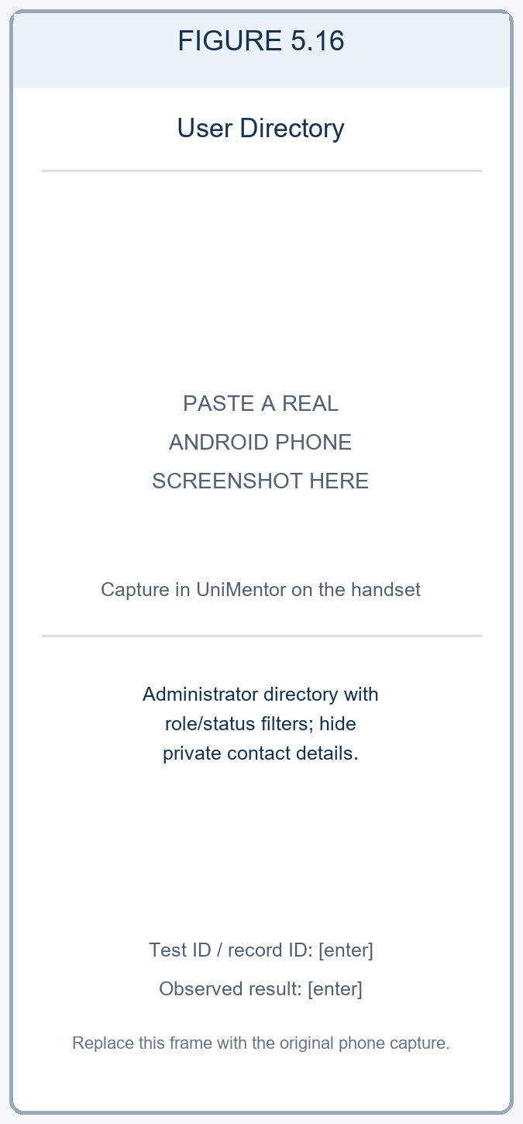  Figure 5.16. User Directory shows administrator role/status filtering. Phone evidence: [enter role, test ID and observed result; hide private data].  Role: Administrator demo. Read-only seeded demo state; no account was changed.
Phone capture instructions: Figures 5.13–5.16 are reserved for actual handset evidence. Use test accounts, avoid displaying passwords, tokens, personal documents, or private contact data, and record the role for each image. For profile or staff changes, reopen the record and enter the observed state and linked test ID.
Table 5.4. User-management and platform-service operation coverage
Operation | Feature / interface | Repository route and method | Verification and evidence
Create | Student/tutor account and submitted evidence | POST /api/auth/register; POST /api/users/documents | API execution status: [enter after execution]. Phone registration/document evidence, role and test ID: [enter].
Read | Current account, profile and submitted evidence | GET /api/auth/me; GET /api/users/profile; GET /api/users/:id/documents | API execution status: [enter after execution]. Phone profile read-back, role and screenshot: [enter].
Update | Profile, settings and verification review | PUT /api/users/profile; PUT /api/users/security; PUT /api/users/notification-settings; PATCH /api/users/:id/documents/:kind; PATCH /api/users/:id/verification | API execution status: [enter after execution]. Phone profile/settings/staff result and evidence: [enter].
Delete | Subject-interest sub record | DELETE /api/users/profile/subjects/:subject | Mobile result, test account, removed value and evidence: [enter].

5.6 Prototype Fidelity and Implementation Deviations
Use the Milestone 02 high-fidelity flow as the prototype baseline. The matrix below traces each member’s requirement set through the prototype flow and implementation screens to the linked test IDs. After capturing the final mobile build, record whether the observed flow matches the prototype or identify a visible deviation and its reason.
Table 5.5. Milestone 02 prototype to working-app comparison
Member and requirements | Milestone 02 prototype flow | Milestone 03 implementation and figures | Linked test cases and evidence result
V. D. Wijesiri (IT23730724)  FR15–FR22; HMW02; NFR08; NFR10 | Booking, scheduling and payment high-fidelity flow (Milestone 02, Section 5.2). Frame ID: [enter if numbered]. | BookingFlowScreen; TutorSlotManagementScreen; SessionsScreen; TutorSessionsScreen. Figures 5.1–5.4. | FT14, FT15, FT19, FT30. Actual phone status, role, record IDs and outcome: [enter]. Prototype match/deviation and reason: [enter after capture].
W. K. Nethmi (IT23721128)  FR08–FR14; HMW01 | Academic management and tutor-discovery high-fidelity flow (Milestone 02, Section 5.2). Frame ID: [enter if numbered]. | Module registration; SearchScreen; TutorProfileScreen; CompareTutorsScreen; recommendation/review flows. Figures 5.5–5.8. | FT13 mobile; FT04, FT06 and FT09 API references. Actual phone status, filter inputs, record IDs and outcome: [enter]. Prototype match/deviation and reason: [enter after capture].
R. G. C. S. Ranasinghe (IT23725256)  HMW03; NFR01; NFR08 | Learning, assessment and administration high-fidelity flow (Milestone 02, Section 5.2). Frame ID: [enter if numbered]. | Learning Dashboard; material detail/library; student Assessment Center; Tutor Assessment Hub and administration screens. Figures 5.9–5.12. | FT16 cross-role workflow. Actual phone status, student/tutor/staff roles, item IDs and outcome: [enter]. Prototype match/deviation and reason: [enter after capture].
N. G. H. Rashini (IT23729384)  FR01–FR07; HMW03; NFR05; NFR06 | User-management and platform-services high-fidelity flow (Milestone 02, Section 5.2). Frame ID: [enter if numbered]. | Login/registration; ProfileScreen; DocumentReviewScreen; SecurityScreen; Notification Settings; User Directory. Figures 5.13–5.16. | FT12, FT17, FT18, FT31. Actual phone status, roles, test IDs and outcome: [enter]. Prototype match/deviation and reason: [enter after capture].

5.7 Evidence of Runtime Behavior and Persistence
Figures 5.1–5.16 reserve four mobile evidence positions for each of the four members. The positions are grouped by Milestone 02 responsibility and cover booking, academic registration and tutor discovery, learning and assessment, and user/platform services. A frame placeholder is not evidence of a running feature; replace every placeholder with a genuine phone capture and link it to the relevant test case and observed result.
Verified repository facts: the mobile manifest declares Expo SDK ~57.0.21, React Native 0.86.3, and app version 1.0.0. Git HEAD at document preparation is 5934335, with local working-tree changes present; record the exact source state used for the phone build as [enter]. Handset model, MyOS/Android build properties, launch method, API host, database, test date, and all phone results: [enter after capture and execution].

7 Functional Testing
Functional testing checks whether UniMentor applies its business rules, validates inputs, enforces user roles, and saves or retrieves records correctly. The team performs these black-box checks through the app workflows and confirms each write by reopening the record; where available, the isolated test database provides a second persistence check. Usability testing measures ease of use and participant feedback and is reported separately in Section 8.

7.1 Test Environment and Method
Use a dedicated non-production database and student, tutor, and authorised staff test accounts. Enter synthetic test data, not real payment details or private identity documents. For each create, update, or delete action, record the item ID, leave the screen, reopen the relevant list or detail view, and confirm the final state. Attach a genuine handset screenshot for mobile cases and redact tokens, email addresses, phone numbers, and document images.
Environment item | Recorded value
Test method | Black-box functional checks of core workflows, validation, permissions, and CRUD/read-back. Usability ratings and participant observations are excluded from these results.
Handset | MyOS 16 with Android 16 base, as reported by the user; on-device OS/build and phone model: [enter]. App launch method (Expo Go or installable Android build): [enter].
Build and backend | Tested source revision/build: [enter]. The supplied implementation notes refer to an earlier source revision and a local API/test database; exact API URL reachable by the phone and database type/version for this run: [enter].
Test data and date | Test accounts/roles, seeded records, unique IDs, and execution date/time: [enter]. Use an isolated test dataset and sandbox mode for payment scenarios.
The test IDs below map the Milestone 01 requirement to the Milestone 02 member flow and the Milestone 03 interface. The API outcomes are supporting checks. A recorded API pass does not establish that the same task passed on an Android handset.

7.2 API and Persistence Test Cases and Results
Table 7.1 records the API-level checks that support the mobile workflows. “Previously recorded pass” carries forward only the pass labels present in the supplied implementation notes; the response, record ID, test log, and exact database read-back were not attached there and remain [enter] fields. These API checks do not count as handset execution.
Table 7.1. API and persistence test cases and results
Test ID / M01 requirement | Member, prototype flow and implementation | Scenario, steps and input | Expected result | Actual result | Status
FT01  FR01 | Member 4 — M02 account-registration flow → registration screen / POST /api/auth/register | Create a student test account with a unique synthetic email and valid required fields. | Account is created once with the selected role; response can be used to sign in. | Previously recorded as Pass in API notes; account/response ID and log: [enter]. | Pass recorded (API only); attach evidence.
FT02  FR01–FR02 | Member 4 — M02 authentication flow → login and verification screens / POST /api/auth/login and verification routes | Register or sign in using an approved test account; verify role and authenticated access. | Valid account is authenticated; invalid or unverified values are rejected without creating a second account. | Previously recorded as Pass in API notes for registration checks; exact operation, response and account ID: [enter]. | Pass recorded (API only); attach evidence.
FT03  FR03–FR06 | Member 4 — M02 tutor verification flow → document upload/review / POST /api/users/documents; PATCH /api/users/:id/documents/:kind | Upload a synthetic test document, then use an authorised staff account to review it. Input: approved dummy file and test account. | Evidence is associated with the correct test tutor; authorised review changes its status and the status can be read back. | [enter response, document ID, before/after status and log reference]. | [enter after execution].
FT04  FR08–FR09 | Member 2 — M02 tutor-discovery flow → SearchScreen / GET /api/mentors/search | Search by a test module/topic and apply one supported filter, such as rate or lesson format. | Results match the query/filter and each result has a stable tutor identifier. | Previously recorded as Pass in API notes; query, result count and test log: [enter]. | Pass recorded (API only); attach evidence.
FT05  FR01; NFR05 | Member 4 — M02 account/profile flow → ProfileScreen / GET and PUT /api/users/profile | Read a test profile, update one non-sensitive field, then read the profile again. | Only the authenticated account changes; the new value persists on read-back. | Previously recorded as Pass in API notes; before/after values, account ID and log: [enter]. | Pass recorded (API only); attach evidence.
FT06  FR12; HMW01 | Member 2 — M02 tutor-discovery flow → shortlist and review screens / /api/users/shortlist | Create a shortlist entry, read it, edit its note/priority, read it again, and remove it. Input: test tutor ID. | Create/read/update/delete are reflected in the saved-tutor list; deleted entry is absent after refresh. | Previously recorded as Pass in API notes; entry ID, before/after values and deletion read-back: [enter]. | Pass recorded (API only); attach evidence.
FT07  FR15–FR16 | Member 1 — M02 availability flow → TutorSlotManagementScreen / /api/slots | Create a future test slot, read it, edit a field, re-read, delete it, and re-read the list. | Slot fields persist after each action; the deleted test slot no longer appears. | Previously recorded as Pass in API notes; slot ID, values and read-back log: [enter]. | Pass recorded (API only); attach evidence.
FT08  FR17–FR21; NFR08 | Member 1 — M02 booking flow → BookingFlowScreen and session screens / /api/sessions | Create a test booking against an available slot, retrieve it, update/cancel its status, and re-read it as the relevant role. | A single session record is linked to the correct student, tutor and slot; status changes persist without duplication. | Previously recorded as Pass in API notes; session/slot IDs and read-back log: [enter]. | Pass recorded (API only); attach evidence.
FT09  FR10; HMW01 | Member 2 — M02 tutor-profile/review flow → TutorProfileScreen and WriteReviewScreen / /api/reviews | Create a review for a test tutor, read it, update it, and delete it using the permitted student account. | Review is associated with the correct tutor/student; edits persist and deletion removes it from the returned list. | Previously recorded as Pass in API notes; review ID, before/after values and log: [enter]. | Pass recorded (API only); attach evidence.
FT10  HMW03; NFR01; NFR08 | Member 3 — M02 learning flow → library, goals and material-detail screens / /api/library and /api/learning | Read a test resource, save it or update progress, then reopen the resource/goal board. | Resource and progress state are associated with the correct test student and persist on read-back. | No result is recorded in the supplied implementation notes; response and item ID: [enter]. | [enter after execution].
FT11  HMW03; NFR09; NFR08 | Member 3 — M02 assessment/administration flow → tutor assessment, submissions and review screens / /api/learning/tutor and /api/learning/admin | Create or assign a test paper, submit a student attempt, grade/review it using the authorised role, then read the result. | Role permissions are enforced; paper, attempt, review and grade are linked and visible in the correct role views. | No result is recorded in the supplied implementation notes; paper/attempt IDs and read-back: [enter]. | [enter after execution].

7.3 Mobile Functional Test Cases and Results
Run Table 7.2 in the final app on the physical handset. The actual-result fields are intentionally left open because no phone was connected for this preparation. Enter the observed screen state, test/record ID, screenshot filename, and pass/fail/blocked result after execution; do not copy the expected result into the actual-result column.
Table 7.2. Physical-handset functional test cases and results
Test ID / M01 requirement | Member, prototype flow and implementation | Scenario, steps and input | Expected result | Actual result | Status
FT12  FR01; NFR05 | Member 4 — M02 role/account flow → login, role workspace and directory (Figures 5.13–5.16) | Sign in with one test account for each role used; open only the role-appropriate workspace. | Each valid role sees its permitted functions; restricted actions are not exposed or are denied. | [enter role, screen, observed access result, screenshot and test account ID]. | Not run on handset here; [enter].
FT13  FR08–FR14 | Member 2 — M02 module/tutor-discovery flow → registration, search, profile, comparison (Figures 5.5–5.8) | Register a test module if required; search by module/topic, filter results, inspect a tutor, compare tutors and save one. | Search, filters, profile details and comparison correspond to the selected values; saved tutor remains after refresh. | [enter search/filter values, tutor IDs, shortlist read-back and screenshot]. | Not run on handset here; [enter].
FT14  FR17–FR20; NFR08 | Member 1 — M02 booking flow → BookingFlowScreen, My Bookings and Tutor Sessions (Figures 5.1, 5.3–5.4) | Create one individual test booking using an available slot; confirm it in the student list and tutor view. | The same booking/session ID, tutor, student, date/time and status appear in both permitted views. | [enter role, booking/session ID, persisted status and screenshot]. | Not run on handset here; [enter].
FT15  FR15–FR16 | Member 1 — M02 availability flow → Slot Allocation (Figure 5.2) | As tutor, create a future test slot, edit its time or capacity, refresh, then delete the test slot and refresh. | Create/read/update/delete changes persist; the removed slot is absent and no unrelated slot changes. | [enter slot ID, before/after values, deletion read-back and screenshot]. | Not run on handset here; [enter].
FT16  HMW03; NFR01; NFR08 | Member 3 — M02 learning/assessment flow → Learning Dashboard, Materials, Assessment Center, Tutor Assessment Hub (Figures 5.9–5.12) | Use student and tutor/staff test roles to read a resource, update progress, submit a test assessment and read the resulting tutor/staff action. | Each action is visible in the correct role view; linked resource/assessment/attempt IDs and updated values persist. | [enter roles, item IDs, actual results, evidence images and any permitted data read-back]. | Not run on handset here; [enter].
FT17  FR01; NFR05 | Member 4 — M02 account/profile flow → Student Profile (Figure 5.14) | Change one non-sensitive test-profile field, save, leave the screen, and reopen the profile. | The new value appears after reopening and belongs only to the signed-in test account. | [enter field tested, account ID, before/after result and screenshot]. | Not run on handset here; [enter].
FT18  FR03–FR07; NFR05 | Member 4 — M02 tutor verification flow → Verification Status and User Directory (Figures 5.15–5.16) | Submit approved dummy evidence as a tutor; review it as authorised staff; reopen the tutor status view. | Only authorised staff can change review status; the tutor sees the final status; audit/status record is linked. | [enter roles, document/status IDs, observed states and redacted screenshots]. | Not run on handset here; [enter].
FT19  HMW04; NFR10; NFR08 | Member 1 — M02 payment flow → Verify Booking (Figure 5.4) | Review the amount breakdown and perform a payment only if a sandbox/test mode is configured. | Fees and final amount are clear; test transaction is linked to the booking and does not charge a live payment method. | [enter payment mode, booking/transaction ID and observed result; state if not submitted]. | Not run on handset here; [enter].
FT30  FR21–FR22; NFR08 | Member 1 — M02 scheduling/conflict flow → Choose Time and booking screen (Figure 5.3) | Attempt to choose a slot that overlaps a known test booking or blocked period. | Conflicting slot is rejected; the user receives a clear explanation and can select an available alternative. | [enter conflict values, message, alternative selected and screenshot]. | Not run on handset here; [enter].
FT31  NFR05–NFR06 | Member 4 — M02 platform-services flow → security/notification settings (Figure 5.13) | Change a non-sensitive notification preference; save, leave the screen and reopen it. | Preference persists for the test account; no private data or credentials are exposed in the screenshot. | [enter setting changed, read-back value and screenshot]. | Not run on handset here; [enter].
FT32  FR02; FR19 | Member 1/4 — M02 booking/registration forms → required-field validation | Leave one required field blank or enter a malformed value; submit, then inspect form feedback and saved test records. | Submission is blocked or rejected with a clear field-level message; no incomplete record is saved. | [enter field/value, actual validation response, database/read-back check and screenshot]. | Not run on handset here; [enter].
FT33  FR06; NFR05 | Member 4 — M02 document-review flow → staff-only review action | Sign in as a student/tutor and attempt a staff-only review action using the app. | The app/API denies the action and leaves the document/account status unchanged. | [enter account role, actual denial message/status and unchanged record ID]. | Not run on handset here; [enter].
FT34  NFR08 | Member 3 — M02 learning flow → resource progress/read-back | Disconnect the test device from the API during a non-payment read or progress update; reconnect and retry once. | The app gives clear connection feedback; retry does not create duplicate or partial records; final state is consistent. | [enter network condition, actual feedback, retry result and record ID]. | Not run on handset here; [enter].

7.4 Execution Summary and Defect Tracking
The execution plan contains 24 cases: 11 API/persistence checks in Table 7.1 and 13 physical-phone workflows in Table 7.2. The supplied implementation notes record API-only pass labels for FT01, FT02 and FT04–FT09. Those labels do not include the detailed response, record, or database evidence needed to calculate an independently verified pass rate. FT03, FT10 and FT11 have no recorded outcome in the supplied notes. Physical-phone execution results have not been recorded in this session.
Execution measure | Result
Planned cases | 24 (11 API/persistence; 13 handset workflows)
Executed cases | [enter after completing the run log]
Pass / fail / blocked | [enter counts from the executed cases]
Pass rate | [enter: passed ÷ executed × 100]
Build and evidence reference | [enter tested revision, date, API/database setup, log file, screenshot filenames and record IDs]
If a case fails or is blocked, assign an issue ID and record the requirement, build, steps, expected and observed behavior, severity, fix or recommendation, and retest ID in the “Issues identified and fixes/recommendations” section. Report “no functional defects observed” only when the relevant cases have been executed and their evidence reviewed. These engineering results are separate from Section 8 usability testing, which requires at least five participants.
SIMULATED WORKED EXAMPLE — NOT REAL TEST EVIDENCE

8 Usability Testing Plan, Execution, and Results
This copy demonstrates how the section could look if a five-person phone study were conducted. Every EX-P participant profile, simulated session entry, M03 outcome, score, and SIM-U observation in the filled tables is hypothetical. The paragraph labelled “Earlier prototype evidence (M02)” is based on the submitted prototype report and is not a working-app result. No working-app usability session was conducted on 9 October 2026; do not submit the simulated tables as collected evidence. The factual report remains in the separate non-simulated document.
Earlier prototype evidence (M02): The submitted report records five mobile-based Figma sessions (P01–P05), with one video per participant. The sample comprised three university students, one tutor/proxy, and one student/tutor proxy. Its issue log contains nine observations: eight rated medium and one low, covering availability labels, booking navigation, group-payment clarity, conflict messages, fee display, OTP guidance, confirmations, attendance instructions, and booking-history statuses. This study focused on the booking, scheduling, and payment component. It does not report working-app outcomes or numerical task-time, error, or SUS results. Use these prototype findings as re-test prompts only.
For this example only, the scenario assumes an in-person session on a physical Android phone running the reported MyOS 16 / Android 16 base. The device model and OS were not verified during a real session. Figure 8.1 shows the planned process, not evidence of a completed test.
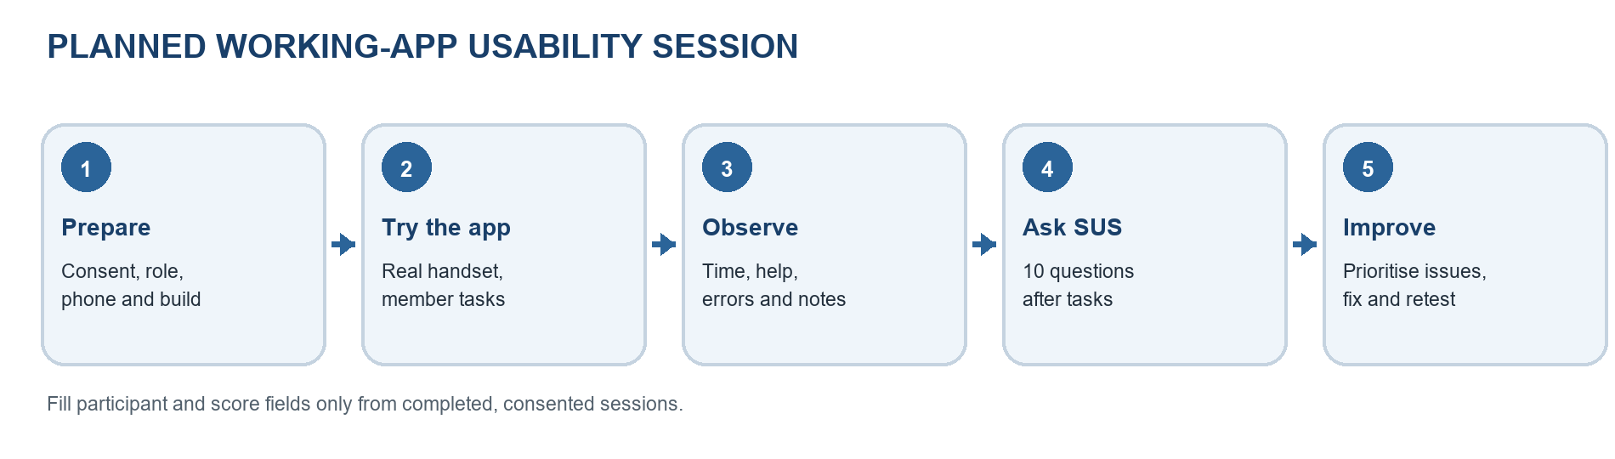
Figure 8.1. Planned working-app usability session flow.

8.1 Usability Testing Plan
Goal. See whether students, tutors, and authorised reviewers can find the right feature, understand the app’s feedback, and finish the task without help. Recruit at least five real target or proxy users. Use anonymous IDs, synthetic accounts, and test records.
Participant and session record. Complete one row per person. A proxy participant should be labelled as a proxy. Record consent, device details, and evidence reference without including names or private account information.
ID | Role / tech comfort | Phone and OS | Date / mode / duration | Consent and notes ref
EX-P01 | Target university student; moderate | Shared example Android test phone; MyOS 16 / Android 16 base (assumed, unverified) | 9 Oct 2026; in-person; 39 min | SIM ONLY; no real consent or log
EX-P02 | Target university student; high | Shared example Android test phone; MyOS 16 / Android 16 base (assumed, unverified) | 9 Oct 2026; in-person; 44 min | SIM ONLY; no real consent or log
EX-P03 | Target university student; low | Shared example Android test phone; MyOS 16 / Android 16 base (assumed, unverified) | 9 Oct 2026; in-person; 47 min | SIM ONLY; no real consent or log
EX-P04 | Target tutor; high | Shared example Android test phone; MyOS 16 / Android 16 base (assumed, unverified) | 9 Oct 2026; in-person; 42 min | SIM ONLY; no real consent or log
EX-P05 | Proxy reviewer/admin; moderate | Shared example Android test phone; MyOS 16 / Android 16 base (assumed, unverified) | 9 Oct 2026; in-person; 46 min | SIM ONLY; no real consent or log

Task scenarios. Read each goal and allow the participant to choose their own path. Use disposable test data. If a feature is missing in the tested build, record it as unavailable instead of counting the task as successful.
Task and member scope | Goal and success check
T1 — M4 account services (FR01–FR02, FR07) | Review a test account and its verification status, change a permitted profile field, then check whether it remains saved after reopening.
T2 — M2 tutor discovery (FR08–FR14) | Find tutors for a test module, compare two profiles, save one, and remove it from the saved list. Confirm the list updates.
T3 — M1 availability (FR15–FR16) | Create a disposable availability slot, edit one value, and delete it. Confirm the schedule shows the saved changes.
T4 — M1 booking (FR17–FR22, NFR10) | Request a session in the test environment, review the time and fee, then locate the resulting booking status. Do not make a live payment.
T5 — M3 learning and assessment (HMW03, NFR01, NFR08–NFR09) | Open a test learning resource, complete a supported sample activity or assessment, and find its saved progress or result.
T6 — M4 tutor review (FR03–FR07, NFR05–NFR06) | Using an authorised test account and synthetic record, review a tutor application and check the resulting status.

8.2 Usability Testing Execution
Example setup (hypothetical): five moderated, in-person sessions on 9 October 2026, using a shared physical test phone and synthetic accounts. The scenario assumes app version 1.0.0, a development environment, and a five-minute limit per task. The phone model, OS, build, backend, and date must be verified from real session records before reporting actual results.
Ask participants to think aloud: what they expect, what they notice, and where they feel unsure. The moderator reads tasks and gives neutral prompts without showing the next step. A second team member records task outcome, start/end time, help, wrong taps, backtracks, and short anonymised comments. Stop before a live charge or any real personal-data change. Suggested session length: 35–50 minutes; record the actual time.
Scoring for this worked example: independent = finished without help; assisted = finished after a prompt or help; incomplete = not finished. Overall completion = (independent + assisted) ÷ attempts × 100. The example mean time uses completed attempts only; mean errors uses all attempts. A distinct wrong tap, invalid submission, or misdirected navigation counts as one error.

8.3 Usability Testing Results
Illustrative values are filled below to demonstrate the calculations. They are not results of phone sessions and must be replaced with observed data.
Task | Attempts | Independent / assisted / incomplete | Completion % | Mean time (s) | Mean errors
T1 [M4] | 5 | 4 / 1 / 0 | 100% | 42 | 0.4
T2 [M2] | 5 | 4 / 1 / 0 | 100% | 64 | 0.8
T3 [M1] | 5 | 2 / 1 / 2 | 60% | 97 | 1.8
T4 [M1] | 5 | 3 / 2 / 0 | 100% | 122 | 1.4
T5 [M3] | 5 | 3 / 1 / 1 | 80% | 93 | 1.0
T6 [M4] | 5 | 4 / 1 / 0 | 100% | 72 | 0.4

After the tasks, give participants the standard 10-question System Usability Scale (SUS). Score odd questions as answer minus 1 and even questions as 5 minus answer; add the adjusted values and multiply by 2.5. Average only complete questionnaires. Use the course-approved source to interpret the score; do not insert an example score as a result.
Participant | Complete SUS form? | SUS score / 100
EX-P01 | Yes — simulated | 75.0
EX-P02 | Yes — simulated | 82.5
EX-P03 | Yes — simulated | 67.5
EX-P04 | Yes — simulated | 77.5
EX-P05 | Yes — simulated | 70.0
Mean of simulated forms | n = 5 | 74.5

Findings and follow-up. Enter only behaviours and comments recorded in the sessions. Use anonymised participant IDs; quote exact words only when they were written down. Link each issue to its task and retest after a fix.
Finding and evidence (task, n, quote or behaviour) | User impact | Recommended fix and retest
SIM-U01 — T3; 2/5 paused to distinguish open and blocked slots (hypothetical; no quote) | Delay and extra rereading | Medium example priority: add a clear legend and consistent slot labels; retest T3.
SIM-U02 — T4; 2/5 reread fee details before finding the total (hypothetical; no quote) | Hesitation before submitting a booking | Medium example priority: emphasise the final amount and retain a clear fee breakdown; retest T4.
SIM-U03 — T6; 1/5 hesitated before confirming the review status (hypothetical; no quote) | Uncertainty about whether the review was saved | Low example priority: show a confirmation and updated status; retest T6.
SIM-U04 — T2; 4/5 completed compare-and-save independently (hypothetical positive pattern) | Discovery flow appears understandable in this example | Keep the flow; verify with actual participants.

Worked-example summary (simulated): “In this hypothetical scenario dated 9 October 2026, five participants attempted six tasks each. Of 30 task attempts, 20 were independent completions, 7 were assisted completions, and 3 were incomplete, giving a 90% overall completion rate. Mean time across completed task attempts was approximately 80 seconds; mean errors were approximately 1.0 per attempt. The five hypothetical SUS scores averaged 74.5/100. The example notes suggest rechecking availability-state labels and the booking-fee summary. These figures describe only this synthetic example and are not findings from the UniMentor working app.”
For an actual submission, attach the real SUS sheets, anonymised observation notes, and consented phone evidence in the appendix. Remove this simulated copy from the submission and use real session records in the factual document. If fewer than five app sessions are completed, report the actual number and the limitation.

9 Issues Identified and Recommended Follow-up
A source review of the mobile screens found four small interface issues across the four member scopes. The evidence below is from the repository code; these issues have not been confirmed through participant sessions or physical-phone testing. Confirm each item on the handset before describing it as a user-observed problem.
Priority is an initial estimate from likely user impact. Medium items can mislead users or make an important state harder to understand; Low indicates a visible control mismatch with another way to continue.
Table 9.1. Repository-reviewed UI issues and follow-up actions
Issue and source evidence | Possible user impact | Recommended change and retest | Priority
CODE-UI-01 — M1 availability  TutorAvailabilityScreen.tsx:68–70 | Day/time choices show the selected state through colour only. The touchable does not expose a checkbox/toggle role or checked state, so TalkBack may not announce which hours are selected. | Add a spoken label with the day and time range, plus checkbox/toggle semantics and the current selected state. Verify both states with TalkBack; retest T3. | Medium
CODE-UI-02 — M2 tutor discovery  SearchScreen.tsx:880–882 | When availability is null or missing, the tutor card displays “Schedule available.” A student could read unknown availability as confirmed. | Show a neutral “Availability not provided” state or omit the badge until confirmed. Check the actual slot before booking; retest T2 and T4. | Medium
CODE-UI-03 — M3 learning materials  StudyMaterialsScreen.tsx:178, 305–306 | “Sync All” is styled like a button but is a plain View with no press handler. It looks actionable but cannot be tapped. | If sync is supported, make it pressable and show progress and result feedback. Otherwise restyle it as status text. Retest T5 online and offline. | Low
CODE-UI-04 — M4 user management  UserManagementScreen.tsx:261–271; User.ts:3 | The status label is red only for “suspended”; every other status uses the success colour. Pending, under-review, rejected, or expired accounts can look approved. | Map every status to its own clear colour and icon while keeping the text label. Check active, pending, under-review, suspended, rejected, and expired; retest T1 and T6. | Medium
Follow-up: first correct the availability and account-status messages because they can show users the wrong state. Then make the material-sync control either work or look non-interactive, and expose availability selection to screen readers. Retest the related tasks on the physical MyOS 16 / Android 16 phone, record the app build and screenshot reference, and close an item only after a successful retest.

Appendix A Local Development Setup Instructions
The repository is split into two folders: backend (Express API) and mobile (Expo app). Open two terminal windows so the API can stay running while the app is started.

A.1 Requirements
Install Git, Node.js and npm. The repository README specifies Node.js 18 or later. You also need access to the project’s MongoDB database and an Android phone with Expo Go, or an Android Studio emulator. Do not commit or share .env files, database credentials, or JWT secrets.

A.2 Clone the repository
git clone https://github.com/sliit-hci-2026/unimentor-mobile-app.git
cd unimentor-mobile-app
Repository URL note: the URL above is the one supplied for this report. The inspected local checkout has a different Git origin (https://github.com/VindiWijesiri/UniMentor.git). Confirm the intended, accessible group repository URL before distributing this appendix.

A.3 Configure and start the backend
cd .\backend
Copy-Item .env.example .env
notepad .env
In backend/.env, set MONGO_URI to the authorised MongoDB Atlas connection string (or the project’s approved local MongoDB URI) and replace JWT_SECRET with a private development secret. Keep PORT=5000 unless the team has configured another port. For Atlas, add the developer’s IP address to the project network access list and use a database user with the required permissions.
npm install
npm run dev
Leave this terminal running. The API listens on port 5000 after the database connection succeeds.

A.4 Configure and start the mobile app
cd .\mobile
Copy-Item .env.example .env
notepad .env
Set EXPO_PUBLIC_API_URL in mobile/.env to the backend address reachable from the chosen device. The repository’s example currently uses localhost; change it for a physical phone because localhost on the phone refers to the phone itself.
Physical Android phone: EXPO_PUBLIC_API_URL=http://<COMPUTER_LAN_IP>:5000/api
Android Studio emulator: EXPO_PUBLIC_API_URL=http://10.0.2.2:5000/api
For a physical phone, find the computer’s Wi-Fi IPv4 address with ipconfig and use that address in the URL. Connect the phone and computer to the same Wi-Fi network, and allow Node.js/backend traffic through Windows Firewall on port 5000 if prompted.
npm install
npx expo start -c
Keep the Expo terminal running. The -c option clears the Metro bundler cache before startup.

A.5 Open the app on Android
Physical phone: open Expo Go and scan the QR code shown in the Expo terminal or browser. The phone must be able to reach the computer over the selected network.
Android emulator: start an Android Studio emulator, set EXPO_PUBLIC_API_URL to http://10.0.2.2:5000/api, then press a in the Expo terminal to open the app.

A.6 Quick connection checks
Confirm the backend terminal reports that the API is listening on port 5000 and that MongoDB connected successfully. If the app cannot reach the API, check the IP address in mobile/.env, confirm both devices are on the same network, review firewall access, and restart Expo after changing the environment file.

