- Implementation Details and Screenshots of the Working App

5.1 Implementation Overview
UniMentor brings tutor discovery, booking, learning and account management into one mobile application. React Native and Expo provide the interface; screens call repository functions through the shared Axios client, while the Express API uses Mongoose to access MongoDB. React Navigation separates student, tutor and administrative workspaces, and Zustand stores hold the current user and feature state.
The four implementation sections follow the member responsibility split documented in Milestone 02. Each section maps the assigned requirements and prototype flow to repository screens, test IDs, and four handset evidence slots. Paste genuine Android phone captures into Figures 5.1–5.16 and enter only outcomes observed on the final build. The current source document contained Expo web-preview images; these have been replaced with clearly marked phone-capture spaces.
Evidence to record | Details for the demonstrated version
Handset and build | Source state: Git HEAD 5934335; local working-tree changes are present, so exact tested build/source state: [enter].  Handset OS: MyOS 16 / Android 16 base (reported by user; on-device verification pending). Phone model and Android build/API level: [enter].  App: UniMentor 1.0.0; repository declares Expo SDK ~57.0.21 and React Native 0.86.3. Launch method (Expo Go or Android build): [enter].  Capture date/time and test role: [enter].
Phone connectivity and test data | Backend API URL reachable from the handset: [enter LAN URL; do not use localhost on the phone].  Database/environment: [enter the isolated non-production test database actually used].  Test account role(s) and seeded/test-data note: [enter]. No API or mobile result is reported as passed until it has been run and recorded.
Prototype traceability | Prototype baseline: Milestone 02, Section 5.2 high-fidelity screens and the relevant member workflow. Numbered frame ID: [enter if present].  Observed match/deviation against the final handset build: [enter after visual comparison].

Mobile evidence capture details
Handset evidence status: MyOS 16 with Android 16 base was reported by the phone owner. The device is not connected in this session, so OS properties, phone model, app launch method, live API connectivity, and mobile test outcomes have not been independently verified. Capture the final build on the handset and complete the [enter] fields below; do not treat the former browser preview as phone evidence.

5.2 Booking Scheduling and Payment
V. D. Wijesiri | IT23730724
The booking component connects a student's tutor selection with session planning. Booking Flow Screen provides steps for individual or group study, topic and time selection, verification and payment, followed by a receipt view. Tutor Slot Management Screen lets tutors enter the module, date, start/end time, duration, fee, mode and capacity. Student bookings and registered attendees are then presented through the student and tutor session screens.
The tutor-slot screens support availability creation, retrieval, editing, and deletion; group-session registration updates attendee membership, and a booking can create a session record. In the final evidence, show the selected date and time, then use the same booking and session IDs in the student and tutor views so the full journey is traceable.
CRUD focus: C/R/U/D tutor slots; C/R/U/D session API; attendee registration/cancellation changes a slot. A cancellation is an update or attendee removal, not automatically deletion of the booking. Show server persistence separately from the local booking list.
Payment workflow: The checkout, wallet, and refund screens are part of the booking journey. State the test mode used in the figure caption and link the visible transaction outcome to its related booking or session evidence.
Four Android phone evidence slots — V. D. Wijesiri (IT23730724) | Booking, scheduling and payment. Four captures are reserved for the student booking list, tutor-managed availability, time selection, and checkout review. Scope and linked cases: FR15–FR22, HMW02, NFR08 and NFR10; record actual handset results for FT14, FT15, FT19 and FT30 in Table 7.2.
Member 1 interface evidence
Figure 5.1 | My Bookings shows active tutor cards, modules, rates, upcoming sessions and student-side session actions. | Figure 5.2 | Slot Allocation shows the tutor schedule, open capacity, prices and registered attendees.
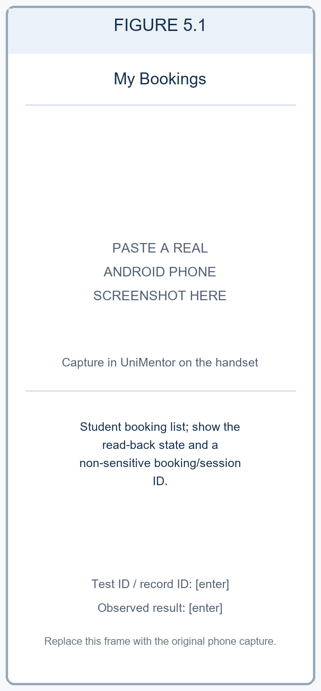  Figure 5.1. My Bookings shows the student booking list and session state. Phone evidence: [enter test ID, record ID, observed result].  Role: Student demo. Read-only seeded demo state. | 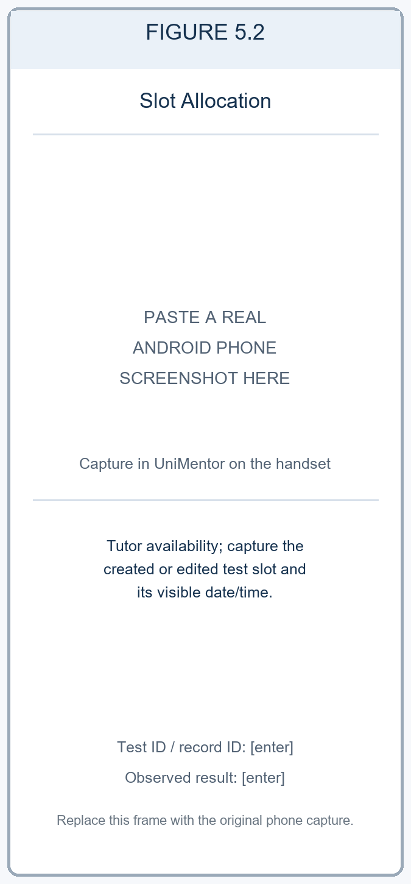  Figure 5.2. Slot Allocation shows tutor availability and the test slot state. Phone evidence: [enter test ID, slot ID, observed result].  Role: Tutor demo. Read-only seeded demo state; no slot was changed.

Figure 5.3 | Choose Time compares the requested session time with an available tutor slot before confirmation. | Figure 5.4 | Verify Booking presents the session summary, fee breakdown and wallet, card and bank payment options.
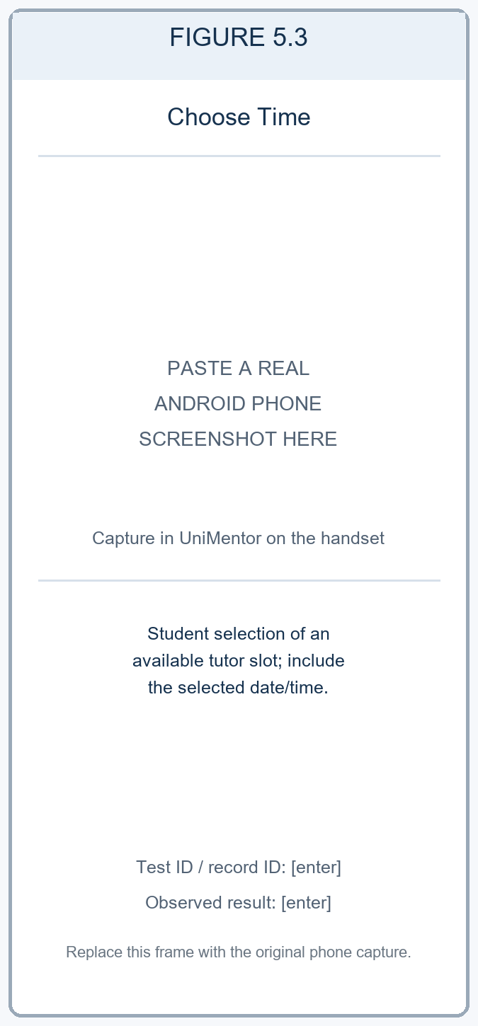  Figure 5.3. Choose Time shows the selected available tutor slot. Phone evidence: [enter test ID, selected date/time, observed result].  Role: Student demo. No booking was submitted. | 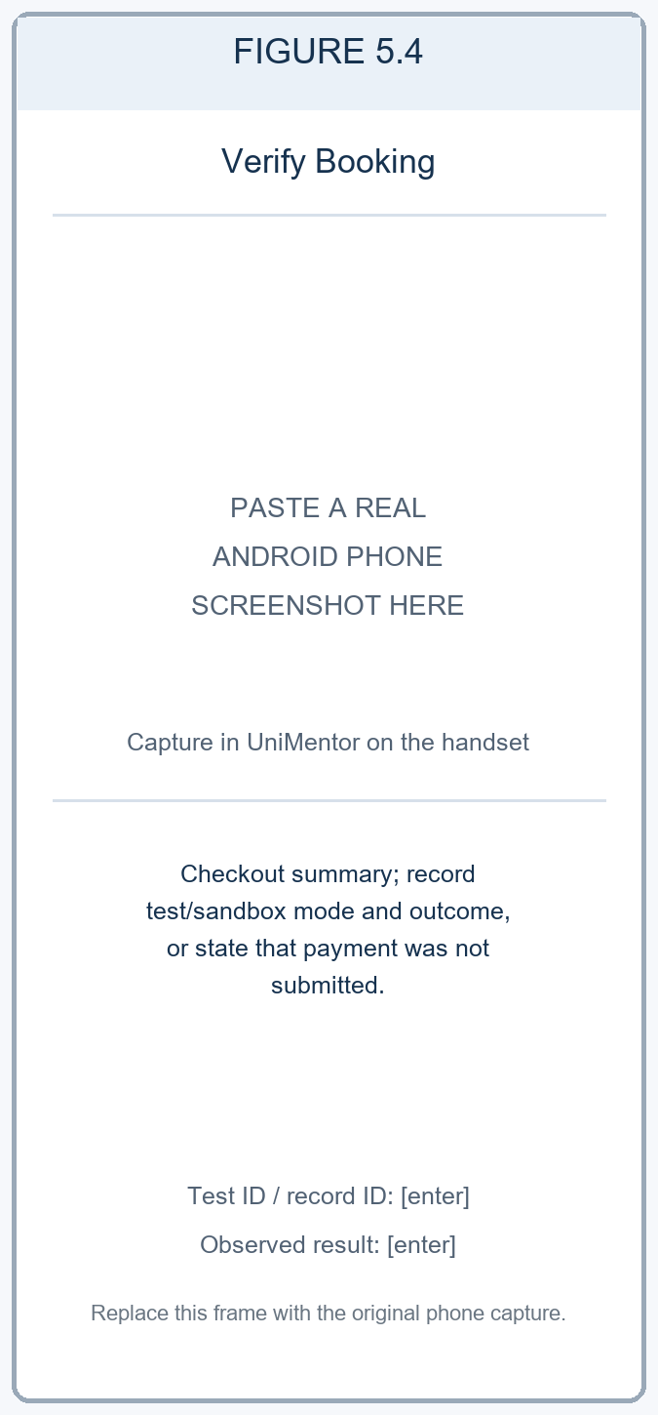  Figure 5.4. Verify Booking shows the checkout summary. Phone evidence: [enter test mode and result; no live payment].  Role: Student demo. Checkout is shown; Confirm & Pay was not pressed.
Phone capture instructions: Figures 5.1–5.4 are reserved for actual handset captures from the final app build. Use a test account and non-production records. For write actions, reopen the item and record its non-sensitive ID and persisted state. For checkout, use a sandbox or test mode and record the mode; do not present a checkout screen alone as a completed payment.
Table 5.1. Booking and scheduling operation coverage
Operation | Feature / interface | Repository route and method | Verification and evidence
Create | Tutor availability slot | POST /api/slots | API execution status: [enter after execution]. Phone result, date/time, slot ID and screenshot: [enter].
Read | Tutor availability slot | GET /api/slots; GET /api/slots/:id | API execution status: [enter after execution]. Phone result, persisted state and screenshot: [enter].
Update | Tutor availability slot | PUT /api/slots/:id | API execution status: [enter after execution]. Phone before/after values, slot ID and screenshot: [enter].
Delete | Tutor availability slot | DELETE /api/slots/:id | API execution status: [enter after execution]. Phone deletion result, slot ID and screenshot: [enter].
Session lifecycle | Booking and tutor response | GET /api/sessions/me; POST /api/sessions; PUT /api/sessions/:id; PATCH /api/sessions/:id/status or /cancel; DELETE /api/sessions/:id | API execution status: [enter after execution]. Phone test FT14, role, date/time, session ID and screenshots: [enter].

5.3 Academic Management and Tutor Discovery
W. K. Nethmi | IT23721128
The discovery component helps students move from a learning need to a tutor shortlist. Search Screen presents tutor cards and applies search and filter criteria. The current filter logic includes price, rating, experience, language and lesson type. Tutor profiles, comparison and recommendation screens bring profile information and review summaries together so that students can inspect alternatives before starting a conversation or booking.
Saved tutors are stored through the user shortlist API. Students can add a tutor, read the list, change priority/notes and remove the entry. Reviews also have save, read, edit and delete operations, while tutors can reply to received feedback. Academic module registration supports mentor assignment, progress updates and removal. These flows give stronger evidence than a screenshot of a populated search list alone.
CRUD focus: C/R/U/D shortlist entries, student reviews and enrolled-module sub records. Profile comparison and changing a filter are read/computation actions; they should not be counted as database updates.
Discovery workflow: Search and comparison screens present tutor profiles, reviews, and available filter criteria. In the evidence, show the search values used and the resulting tutor cards so the selection can be reproduced.
Four Android phone evidence slots — W. K. Nethmi (IT23721128) | Academic management and tutor discovery. Four captures trace module registration, filtered tutor search, profile inspection, and tutor comparison/shortlisting. Scope and linked cases: FR08–FR14 and HMW01; API cases FT04, FT06 and FT09 are referenced in Table 7.1, and record the actual phone workflow result for FT13 in Table 7.2.
Member 2 interface evidence (1 of 2) — academic registration and tutor search
Figure 5.5 | Register New Module presents module name/code fields, curriculum choices and mentor selection. | Figure 5.6 | Find Your Mentor shows module filters and verified results with subjects, ratings, rates and comparison actions.
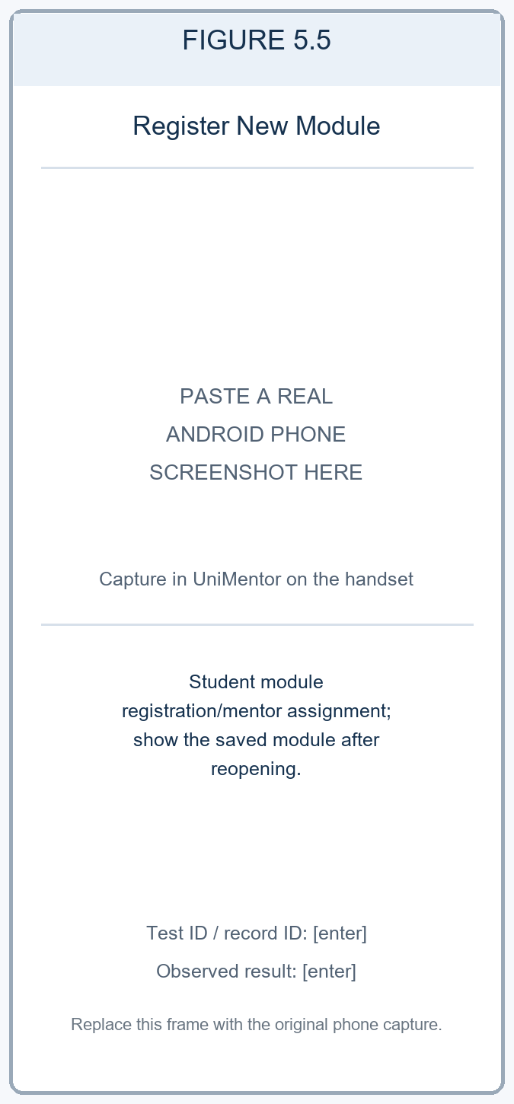  Figure 5.5. Register New Module shows module registration and mentor assignment. Phone evidence: [enter test ID, module code, read-back result].  Role: Student demo. Registration form only; enrollment was not submitted. | 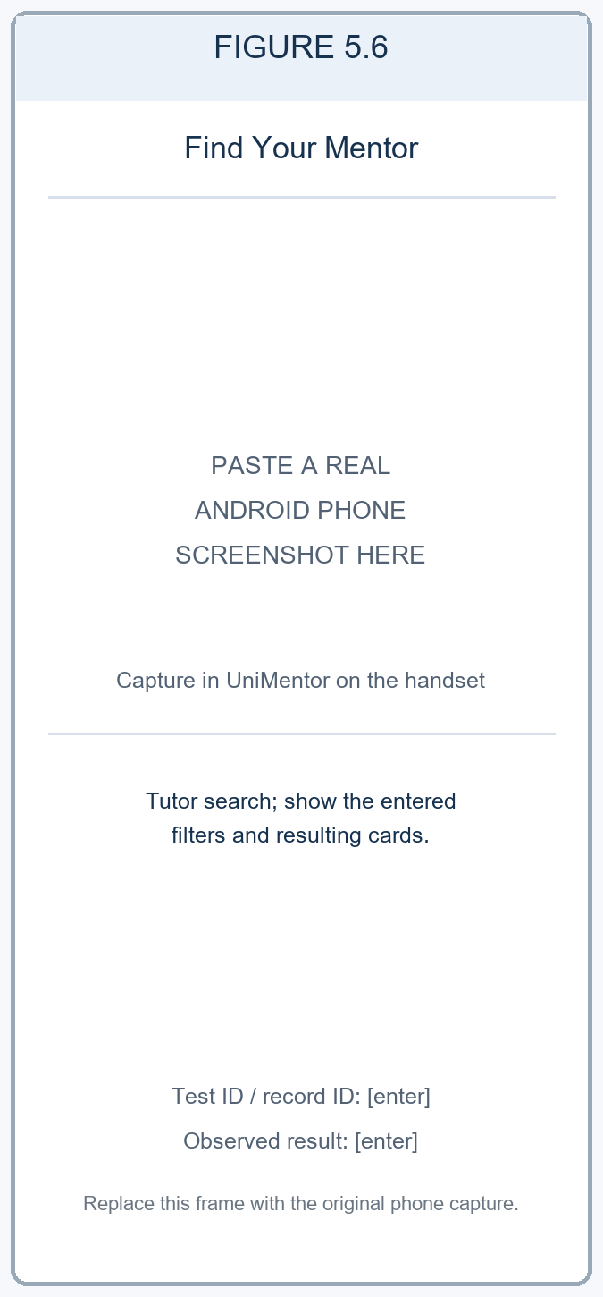  Figure 5.6. Find Your Mentor shows tutor search filters and results. Phone evidence: [enter filter values and test ID].  Role: Student demo. Read-only seeded demo results; no shortlist was changed.
Member 2 interface evidence (2 of 2) — tutor profile and comparison
Figure 5.7 | Tutor Profile presents qualification, availability, taught modules, support areas and review summary. | Figure 5.8 | Compare Tutors presents selected profiles side by side by rating, rate, experience and modules.
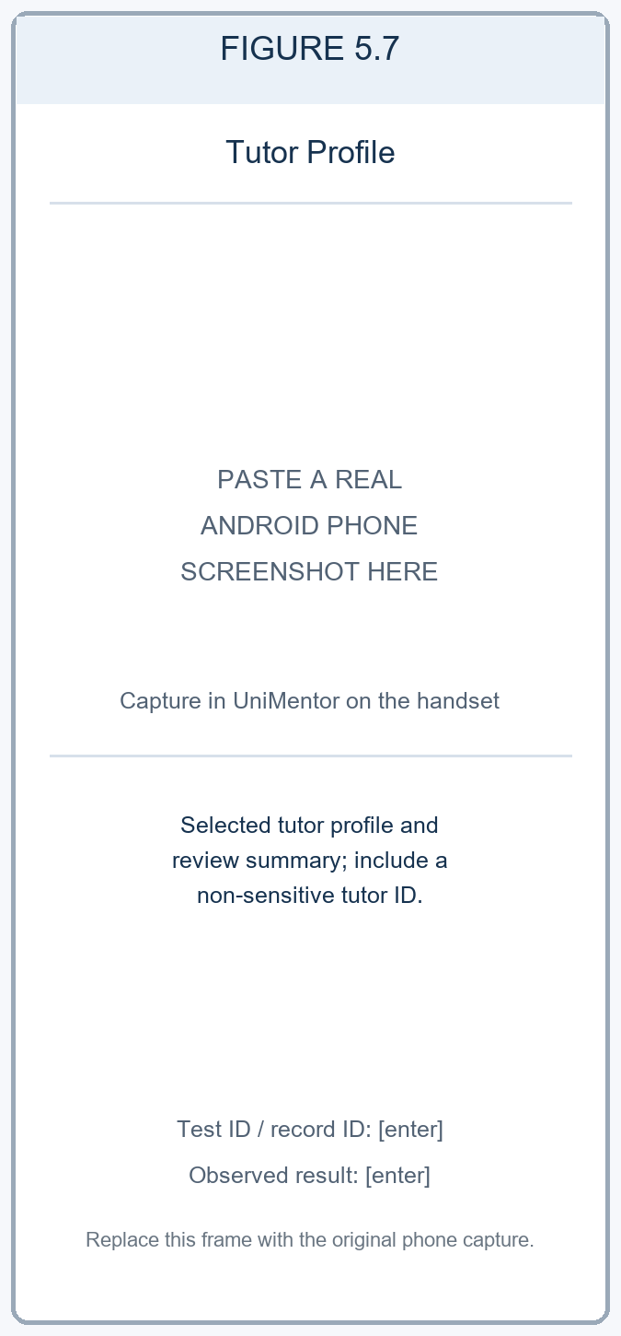  Figure 5.7. Tutor Profile shows the selected tutor profile and reviews. Phone evidence: [enter test ID and tutor ID].  Role: Student demo. Read-only seeded demo state. | 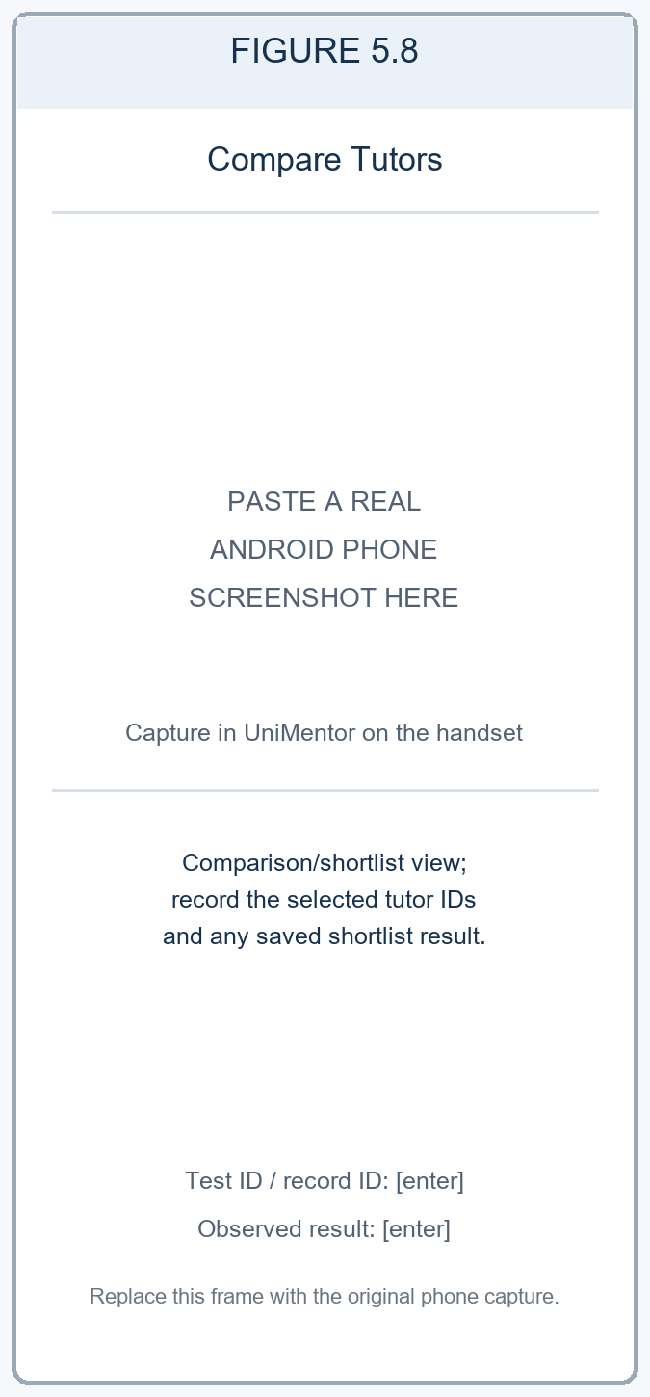  Figure 5.8. Compare Tutors shows selected profiles and shortlist state. Phone evidence: [enter test ID and saved result].  Role: Student demo. Comparison is a view; no shortlist mutation was submitted.
Phone capture instructions: Figures 5.5–5.8 are reserved for actual handset captures. Include the module, filter values, or tutor IDs needed to reproduce the result. For a module or shortlist change, reopen the list and record the persisted outcome. Enter the observed result for FT13 in Table 7.2.
Table 5.2. Tutor discovery and review operation coverage
Operation | Feature / interface | Repository route and method | Verification and evidence
Create | Shortlist and student review | POST /api/users/shortlist; POST /api/reviews/tutors/:tutorId | API execution status: [enter after execution]. Phone result, test ID and record IDs: [enter].
Read | Tutor search, saved tutors and reviews | GET /api/mentors/search; GET /api/users/shortlist; GET /api/reviews/tutors/:tutorId | API execution status: [enter after execution]. Phone search inputs, test ID and screenshot: [enter].
Update | Shortlist note/priority and review | PUT /api/users/shortlist/:mentorId; PUT /api/reviews/:id | API execution status: [enter after execution]. Phone before/after values, test ID and evidence: [enter].
Delete | Shortlist entry and review | DELETE /api/users/shortlist/:mentorId; DELETE /api/reviews/:id | API execution status: [enter after execution]. Phone delete result, test ID and record IDs: [enter].

5.4 Learning Management Assessments and Administration
R. G. C. S. Ranasinghe | IT23725256
The learning component combines resources, goals, study activity and assessments. LearningDashboardScreen shows progress and a weekly target. Students can browse learning materials, open their details, save them and update progress; StoreMaterialScreen creates a resource through the library API. Goal screens connect progress logs, tasks and milestones to an individual learning goal, making the interface useful beyond finding and booking a tutor.
The assessment flow separates tutor preparation, staff review and student work. Tutors create papers and view submissions; students save answers, submit attempts and open results. Staff can review a paper, while tutor grading controls save marks and release grades. Link each action to the relevant assessment and attempt records, and execute the role-specific mobile checks in Section 7.2.
CRUD focus: The repository provides create and read routes for learning materials and tutor papers, and update-style routes for saved material progress, goal progress, assessment attempts and grading. For the assigned CRUD demonstration, record the specific delete action only after confirming the screen, route and result in the final build; use the [enter] field in Table 5.3 if needed.
Learning workflow: Capture tutor preparation, student submission, assessment review, and the resulting feedback or grade using the relevant roles. Reopen the record after each action and link the student attempt to the corresponding assessment.
Four Android phone evidence slots — R. G. C. S. Ranasinghe (IT23725256) | Learning management, assessments and administration. Four captures are reserved for the learner dashboard/resources, material progress, student assessment, and tutor/staff assessment workflow. Scope and linked cases: HMW03, NFR01 and NFR08; record the executed cross-role outcome for FT16 in Table 7.2.
Member 3 interface evidence (1 of 2) — learning dashboard and materials
Figure 5.9 | Learning Dashboard summarizes the weekly study target, module goals, resumed activity and academic sessions. | Figure 5.10 | Learning Materials shows source/type filters, sync status and course resources such as notes, code and recordings.
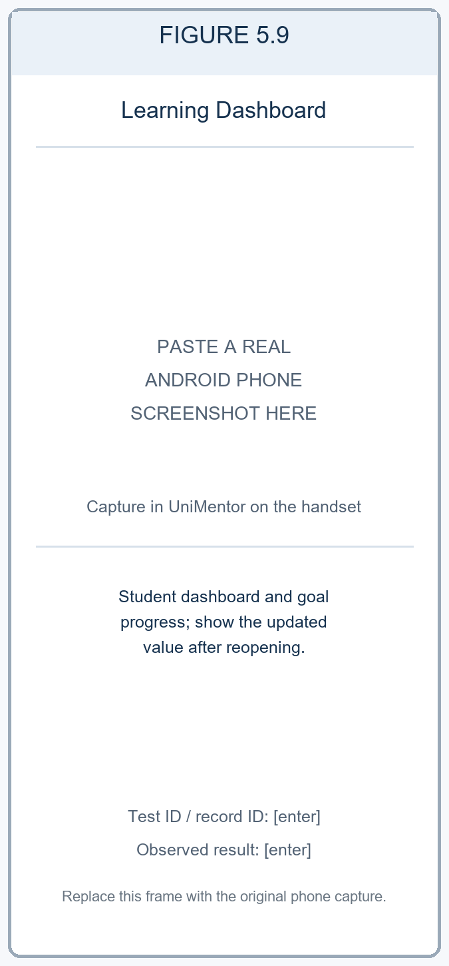  Figure 5.9. Learning Dashboard shows study goals and progress. Phone evidence: [enter test ID and before/after values].  Role: Student demo. Read-only seeded demo state. | 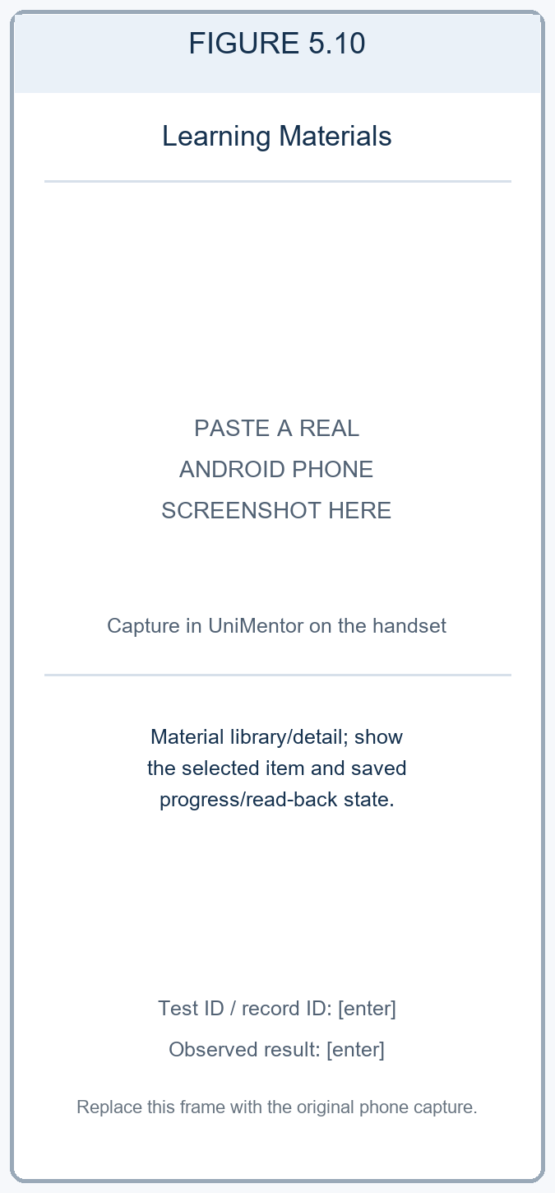  Figure 5.10. Learning Materials shows a resource and saved progress. Phone evidence: [enter test ID, item ID and read-back result].  Role: Student demo. Read-only seeded demo state.
Member 3 interface evidence (2 of 2) — student and tutor assessment views
Figure 5.11 | Assessment Center lists active and due tasks, deadlines, task types and assessment progress. | Figure 5.12 | Tutor Assessment Hub shows the authoring entry point, grading queue, live-test overview and assessment list.
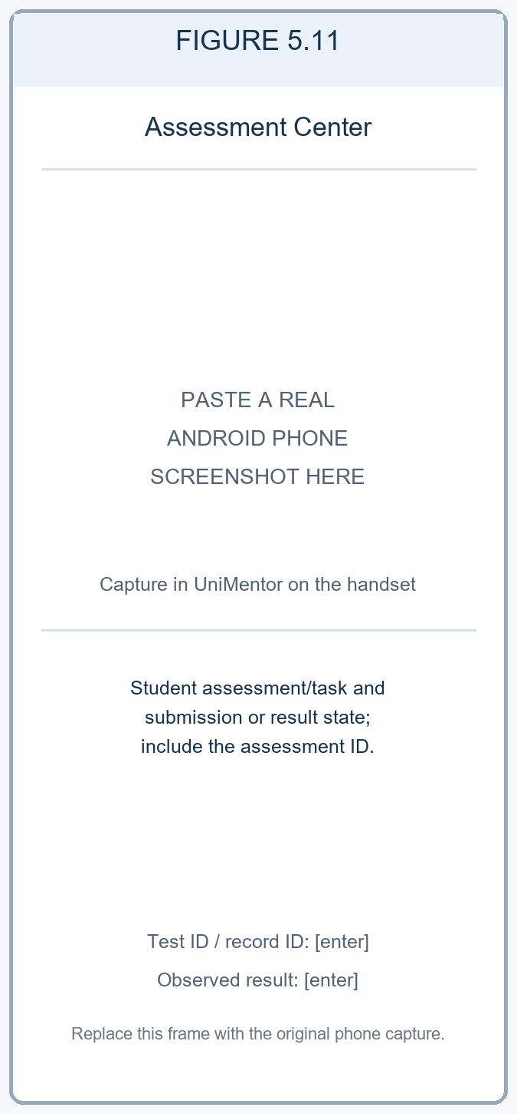  Figure 5.11. Assessment Center shows the student task and submission/result state. Phone evidence: [enter test ID and assessment ID].  Role: Student demo. No assessment attempt was submitted. | 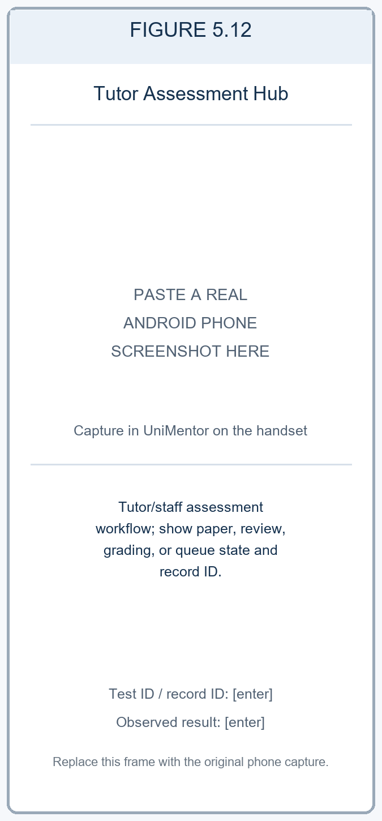  Figure 5.12. Tutor Assessment Hub shows the tutor/staff assessment workflow. Phone evidence: [enter role, test ID, record ID and outcome].  Role: Tutor demo. No assessment was created or graded.
Phone capture instructions: Figures 5.9–5.12 are reserved for actual handset evidence. Use separate student, tutor, and staff test roles as required. For progress, submission, paper creation, review, or grading, reopen the relevant record and include its non-sensitive ID. Enter only actions actually completed and the observed FT16 outcome in Table 7.2.
Table 5.3. Learning and assessment route-to-evidence map
Operation | Feature / interface | Repository route and method | Verification and evidence
Create | Learning material and tutor assessment paper | POST /api/library; POST /api/learning/tutor/papers | Mobile/API result, role, item ID and screenshot: [enter].
Read | Materials, goals and submissions | GET /api/library; GET /api/library/:id; GET /api/learning/goals/board; GET /api/learning/tutor/papers/:id/submissions | Mobile/API result and record ID: [enter].
Update | Saved material progress, goal progress and student attempt | POST /api/library/:id/save; POST /api/library/:id/progress; PATCH /api/learning/goals/:id; PUT /api/learning/papers/:id/progress | Mobile/API result and before/after values: [enter].
Grade / review | Tutor grade and staff review actions | POST /api/learning/tutor/attempts/:attemptId/grade; POST /api/learning/admin/papers/:id/review | Role, assessment/attempt ID, observed result and screenshot: [enter].
Delete demonstration | Assigned learning/assessment entity | [enter implemented screen, route and method] | [enter reproducible test ID, result, record ID and screenshot after final-build verification].

5.5 User Management and Platform Services
N. G. H. Rashini | IT23729384
User management provides registration, sign-in, profile maintenance and tutor evidence review. Authentication routes include password login, campus-login code verification and password recovery. The normal sign-in path returns a JWT, which the API client attaches to requests. Profile screens retrieve and update user information, while subject interests are managed as items within the user profile rather than as separate accounts.
Tutor identity and transcript images are submitted through the document repository. Authorised staff screens can inspect evidence, approve or request re-upload, and change account verification/status. Security settings, notification preferences, password change and session revocation now have API paths. Their saved values should be reopened during evidence capture; saving a setting does not alone prove that every associated policy is enforced.
CRUD focus: Create and read account and evidence records, update profiles, preferences, evidence review and verification status and remove a subject-interest subrecord. Link each operation to its route and the matching test account or record.
User-management workflow: Demonstrate authenticated registration, profile maintenance, document submission/review, and the resulting account status. Record the role used and reopen the status view after the staff action.
Four Android phone evidence slots — N. G. H. Rashini (IT23729384) | User management and platform services. Four captures are reserved for settings, profile maintenance, verification status, and the administrator user directory. Scope and linked cases: FR01–FR07, HMW03, NFR05 and NFR06; record the actual role, staff, and profile workflow results for FT12, FT17, FT18 and FT31 in Table 7.2.
Member 4 interface evidence (1 of 2) — platform services and profile
Figure 5.13 | Settings & Platform Services groups academic account, security, notification, support and reviewer tools. | Figure 5.14 | Student Profile shows the account role, campus wallet, academic summary and profile-management entry point.
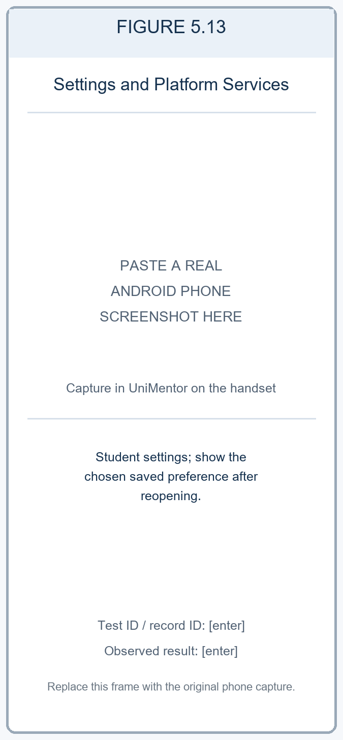  Figure 5.13. Settings & Platform Services shows student preferences. Phone evidence: [enter test ID and saved setting].  Role: Student demo. Read-only seeded demo state. | 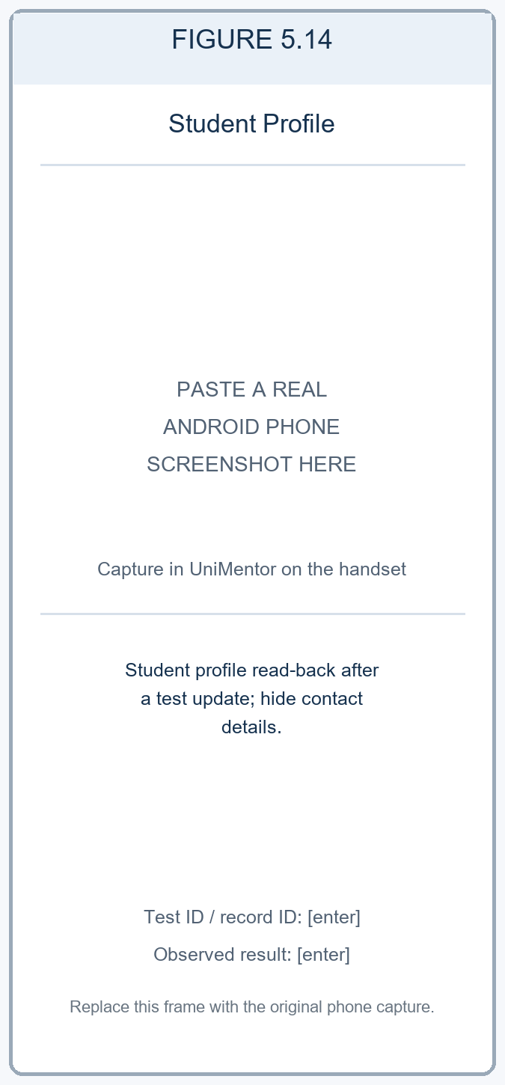  Figure 5.14. Student Profile shows account details after a verified test update. Phone evidence: [enter test ID and read-back result; hide private data].  Role: Student demo. Read-only seeded demo state.
Member 4 interface evidence (2 of 2) — verification status and user directory
Figure 5.15 | Verification Status shows the account review state, module approval breakdown and verification timeline. | Figure 5.16 | User Directory presents role filters, search and registered accounts with role and status labels.
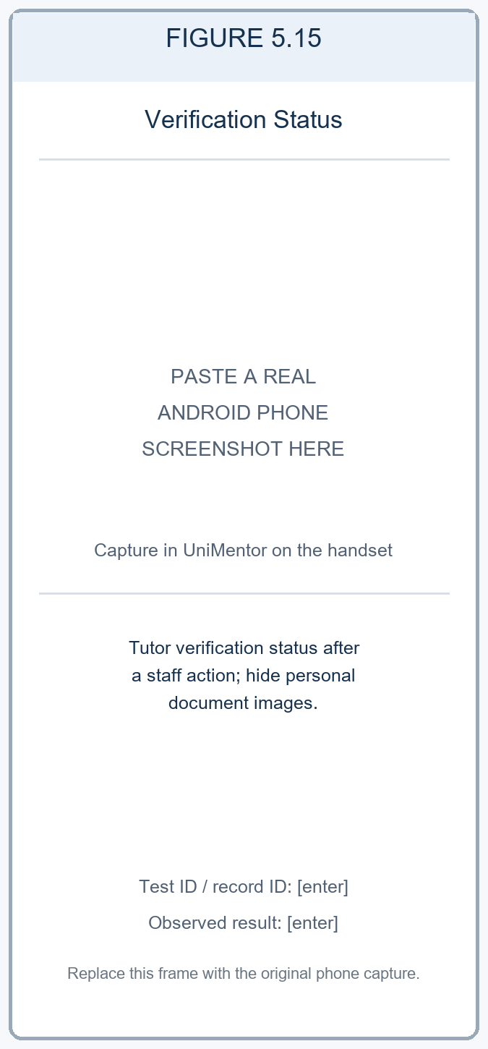  Figure 5.15. Verification Status shows the account review state. Phone evidence: [enter test ID and status; hide personal documents].  Role: Student demo. Status view only; no credential was uploaded. | 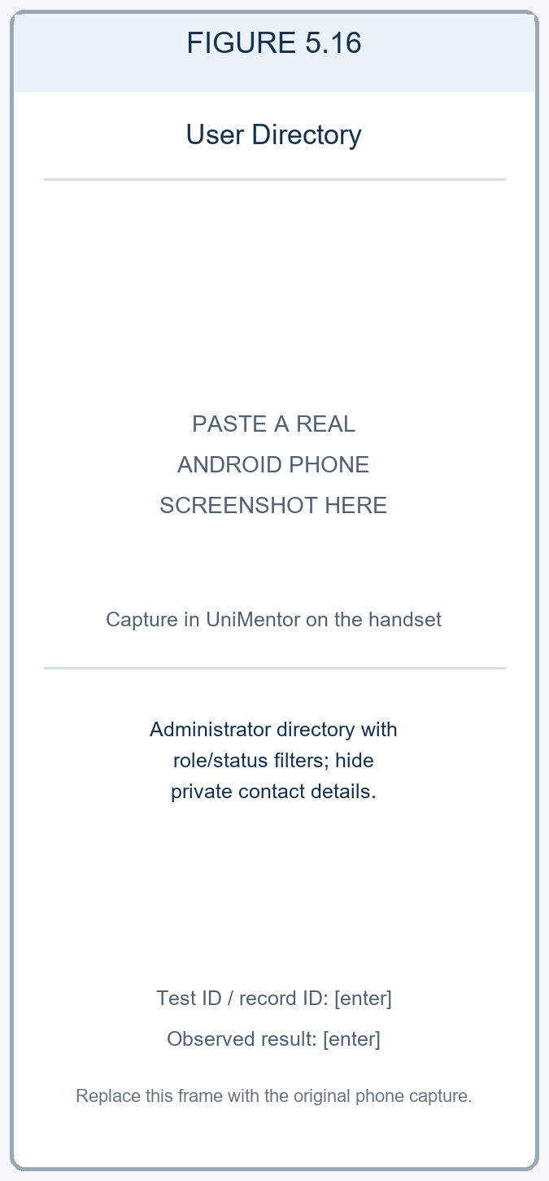  Figure 5.16. User Directory shows administrator role/status filtering. Phone evidence: [enter role, test ID and observed result; hide private data].  Role: Administrator demo. Read-only seeded demo state; no account was changed.
Phone capture instructions: Figures 5.13–5.16 are reserved for actual handset evidence. Use test accounts, avoid displaying passwords, tokens, personal documents, or private contact data, and record the role for each image. For profile or staff changes, reopen the record and enter the observed state and linked test ID.
Table 5.4. User-management and platform-service operation coverage
Operation | Feature / interface | Repository route and method | Verification and evidence
Create | Student/tutor account and submitted evidence | POST /api/auth/register; POST /api/users/documents | API execution status: [enter after execution]. Phone registration/document evidence, role and test ID: [enter].
Read | Current account, profile and submitted evidence | GET /api/auth/me; GET /api/users/profile; GET /api/users/:id/documents | API execution status: [enter after execution]. Phone profile read-back, role and screenshot: [enter].
Update | Profile, settings and verification review | PUT /api/users/profile; PUT /api/users/security; PUT /api/users/notification-settings; PATCH /api/users/:id/documents/:kind; PATCH /api/users/:id/verification | API execution status: [enter after execution]. Phone profile/settings/staff result and evidence: [enter].
Delete | Subject-interest sub record | DELETE /api/users/profile/subjects/:subject | Mobile result, test account, removed value and evidence: [enter].

5.6 Prototype Fidelity and Implementation Deviations
Use the Milestone 02 high-fidelity flow as the prototype baseline. The matrix below traces each member’s requirement set through the prototype flow and implementation screens to the linked test IDs. After capturing the final mobile build, record whether the observed flow matches the prototype or identify a visible deviation and its reason.
Table 5.5. Milestone 02 prototype to working-app comparison
Member and requirements | Milestone 02 prototype flow | Milestone 03 implementation and figures | Linked test cases and evidence result
V. D. Wijesiri (IT23730724)  FR15–FR22; HMW02; NFR08; NFR10 | Booking, scheduling and payment high-fidelity flow (Milestone 02, Section 5.2). Frame ID: [enter if numbered]. | BookingFlowScreen; TutorSlotManagementScreen; SessionsScreen; TutorSessionsScreen. Figures 5.1–5.4. | FT14, FT15, FT19, FT30. Actual phone status, role, record IDs and outcome: [enter]. Prototype match/deviation and reason: [enter after capture].
W. K. Nethmi (IT23721128)  FR08–FR14; HMW01 | Academic management and tutor-discovery high-fidelity flow (Milestone 02, Section 5.2). Frame ID: [enter if numbered]. | Module registration; SearchScreen; TutorProfileScreen; CompareTutorsScreen; recommendation/review flows. Figures 5.5–5.8. | FT13 mobile; FT04, FT06 and FT09 API references. Actual phone status, filter inputs, record IDs and outcome: [enter]. Prototype match/deviation and reason: [enter after capture].
R. G. C. S. Ranasinghe (IT23725256)  HMW03; NFR01; NFR08 | Learning, assessment and administration high-fidelity flow (Milestone 02, Section 5.2). Frame ID: [enter if numbered]. | Learning Dashboard; material detail/library; student Assessment Center; Tutor Assessment Hub and administration screens. Figures 5.9–5.12. | FT16 cross-role workflow. Actual phone status, student/tutor/staff roles, item IDs and outcome: [enter]. Prototype match/deviation and reason: [enter after capture].
N. G. H. Rashini (IT23729384)  FR01–FR07; HMW03; NFR05; NFR06 | User-management and platform-services high-fidelity flow (Milestone 02, Section 5.2). Frame ID: [enter if numbered]. | Login/registration; ProfileScreen; DocumentReviewScreen; SecurityScreen; Notification Settings; User Directory. Figures 5.13–5.16. | FT12, FT17, FT18, FT31. Actual phone status, roles, test IDs and outcome: [enter]. Prototype match/deviation and reason: [enter after capture].

5.7 Evidence of Runtime Behavior and Persistence
Figures 5.1–5.16 reserve four mobile evidence positions for each of the four members. The positions are grouped by Milestone 02 responsibility and cover booking, academic registration and tutor discovery, learning and assessment, and user/platform services. A frame placeholder is not evidence of a running feature; replace every placeholder with a genuine phone capture and link it to the relevant test case and observed result.
Verified repository facts: the mobile manifest declares Expo SDK ~57.0.21, React Native 0.86.3, and app version 1.0.0. Git HEAD at document preparation is 5934335, with local working-tree changes present; record the exact source state used for the phone build as [enter]. Handset model, MyOS/Android build properties, launch method, API host, database, test date, and all phone results: [enter after capture and execution].

