PROJECT REPORT
Bank Customer Segmentation &
Customer Lifetime Value Analysis

Submitted by
Vineel Gundala
Post Graduate Diploma in Business Analytics (PGDBA)
IIM Calcutta | IIT Kharagpur | ISI Kolkata

GitHub: github.com/VineelGundala/bank-segmentation
Dataset: Home Credit Default Risk — Kaggle
Domain: Banking & Financial Services (BFSI)

1. Executive Summary

Customer segmentation is a foundational capability in retail banking, enabling institutions to allocate marketing budgets efficiently, design targeted retention strategies, and personalize product offerings. This project applies unsupervised machine learning techniques to segment 307,511 real banking customers sourced from the Home Credit Default Risk dataset — one of the most comprehensive publicly available consumer lending datasets.

Features were engineered from five relational source files capturing application data, installment payment history, credit card balances, point-of-sale activity, and external credit bureau records. RFM (Recency, Frequency, Monetary) features were computed directly from transaction-level data rather than using proxies, ensuring behavioral authenticity.

Four unsupervised methods were evaluated — K-Means, Gaussian Mixture Models (GMM), Hierarchical Clustering, and DBSCAN. K-Means with K=4 was selected as the primary model, achieving a Silhouette Score of 0.64, Davies-Bouldin Index of 0.53, and Calinski-Harabasz Score of 466,560. Cross-method validation yielded an Adjusted Rand Index of 0.95 between K-Means and Hierarchical Clustering, confirming structural stability.

Four actionable customer segments were identified: Active High Value, Disciplined Transactors, Mass Market Mainstream, and Dormant/New Customers. Customer Lifetime Value was estimated per segment to support prioritized marketing investment and retention strategy.

2. Problem Statement & Business Objective

Retail banks serve customers with vastly different financial behaviors, risk profiles, and revenue potential. Treating all customers uniformly results in inefficient marketing spend, missed cross-sell opportunities, and high churn among high-value customers.

Business Questions Addressed:
- Who are our customers and how do they differ in financial behavior?
- Which customers generate the highest lifetime value for the bank?
- Which customers are at risk of churning or are dormant?
- How should marketing budgets be allocated across customer groups?
- Which customers should be prioritized for upsell of premium products?

This project answers these questions by building a data-driven customer segmentation model that groups customers based on behavioral and financial similarity, then estimates CLV per segment to rank business priority.

3. Dataset Description

The Home Credit Default Risk dataset was released by Home Credit Group — a real international consumer lending company operating across India, Eastern Europe, and Asia. The dataset contains real customer application and behavioral data across six relational files.

Source Files Used:
File | Records | Key Features | Role in Project
application_train.csv | 307,511 | Income, credit, demographics | Primary customer file
installments_payments.csv | 13.6M | Payment amount, due date, paid date | RFM — Recency & Frequency
credit_card_balance.csv | 3.8M | CC balance, limit, drawings | Monetary — CC behavior
POS_CASH_balance.csv | 10M | DPD, contract status | Product usage frequency
bureau.csv | 1.7M | Active loans, debt, overdue | External credit history

After merging all five files on customer ID (SK_ID_CURR), the final feature matrix contained 307,511 customers and 51 engineered features — covering financial, demographic, behavioral, and credit bureau dimensions.
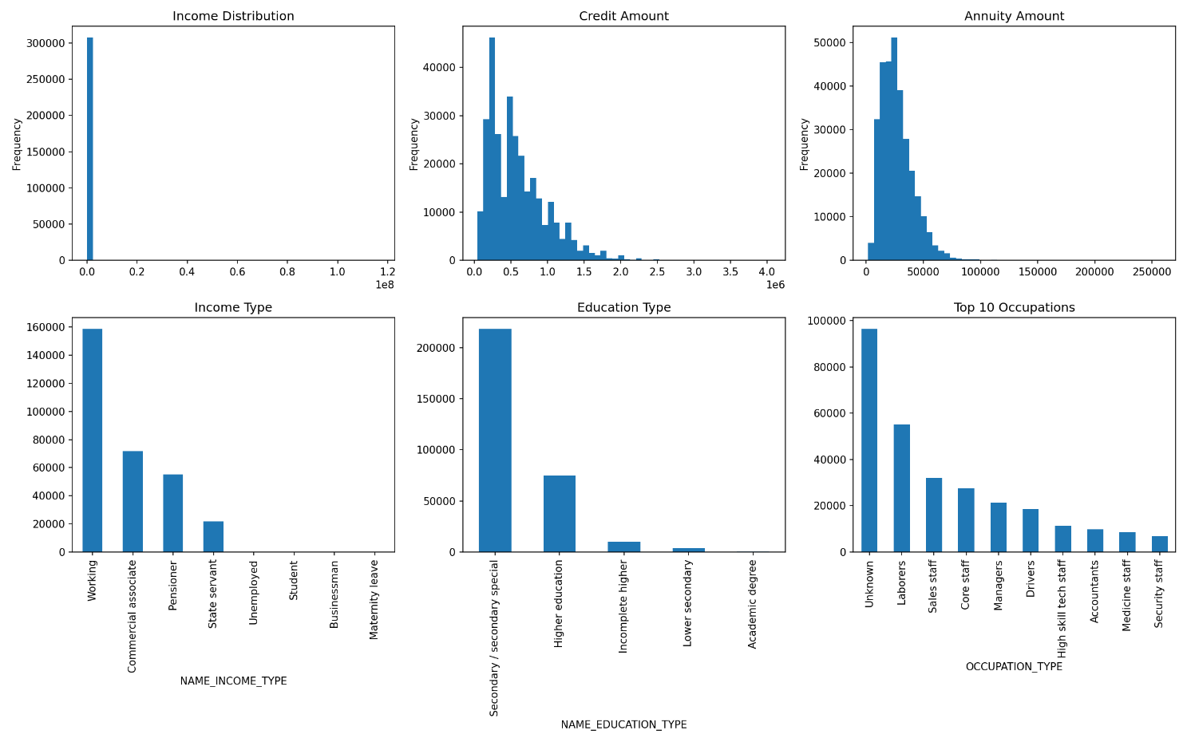

4. Methodology

4.1 Feature Engineering
Feature engineering was performed across three layers:

Layer 1 — Application Features
- Age derived from DAYS_BIRTH (converted to years)
- Years employed derived from DAYS_EMPLOYED (negative values clipped at 0)
- Credit-to-Income Ratio and Annuity-to-Income Ratio computed as financial stress indicators
- Log transformation of AMT_INCOME_TOTAL and AMT_CREDIT to normalize skewed distributions
- Binary encoding of FLAG_OWN_CAR, FLAG_OWN_REALTY, CODE_GENDER

Layer 2 — RFM Features from Transaction Files
- Recency: Most recent payment date per customer from installments_payments.csv (DAYS_INSTALMENT max)
- Frequency: Total count of installment payments made per customer
- Monetary: Total amount paid (TOTAL_PAID) and average payment per transaction (AVG_PAYMENT)
- Payment Discipline: Ratio of amount paid to amount due per installment, averaged per customer
- Payment Delay: Average and maximum days between due date and actual payment date
- Late Payment Count: Number of installments where payment was made after due date

Layer 3 — Credit Card & Bureau Features
- CC_BALANCE_MEAN, CC_BALANCE_MAX: Average and peak credit card balance
- CC_UTILIZATION_RATIO: Average balance as a fraction of credit limit
- CC_LIMIT_USAGE_MAX: Peak utilization ratio — captures credit stress
- BUREAU_LOAN_COUNT: Total number of historical credit bureau loans (tenure proxy)
- BUREAU_ACTIVE_LOANS: Number of currently active external loans
- BUREAU_DEBT_TOTAL: Total outstanding debt across all bureau accounts

4.2 Preprocessing Pipeline
Preprocessing followed a three-step pipeline designed to handle real-world financial data characteristics:

Step | Method | Justification
Outlier Treatment | Clip at 99th percentile | Extreme income and balance values skew cluster centers
Distribution Fix | Log transform (np.log1p) | CC balance, frequency, total paid are highly right-skewed
Scaling | RobustScaler | Median/IQR-based — less sensitive to remaining outliers than StandardScaler
Dimensionality | PCA — 10 components | 94.5% variance retained; reduces noise before clustering
Missing Values | Fill 0 for no-history customers | Customers with no CC/bureau history receive zero behavioral scores

Note: An initial attempt using StandardScaler without log transformation yielded a Silhouette Score of only 0.11, as CC_BALANCE_MEAN (variance 4.3 billion) dominated all PCA components. The preprocessing pipeline above improved the Silhouette Score to 0.64 — a 5.8x improvement.

4.3 Unsupervised Methods Evaluated

K-Means Clustering (Primary Model)
K-Means partitions customers into K clusters by minimizing within-cluster sum of squared distances to the cluster centroid. The elbow method and silhouette analysis were used jointly to select K=4.
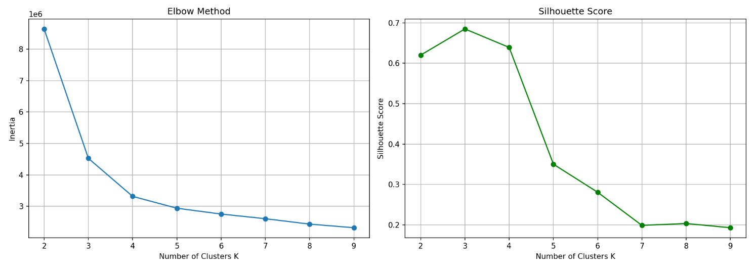
- K=3 yielded the highest Silhouette Score (0.69) but produced only 3 segments
- K=4 selected with Silhouette Score of 0.64 — marginal reduction justified by discovery of the Dormant/New Customer segment, which has direct business value for activation strategy
- Trade-off between statistical optimality and business interpretability is standard practice in industry segmentation

Gaussian Mixture Models (Validation)
GMM assumes data is generated from a mixture of Gaussian distributions. Unlike K-Means (hard assignment), GMM produces soft probabilistic assignments — each customer receives a probability of belonging to each cluster.
- Covariance type: Full — allows clusters to have different shapes and orientations
- Average assignment confidence: 98.9% — GMM is highly certain about customer assignments
- ARI vs K-Means: 0.86 — strong structural agreement

Hierarchical Clustering (Structural Validation)
Agglomerative Hierarchical Clustering builds a dendrogram by successively merging nearest clusters. Used as a structural validator rather than primary model due to O(n²) memory complexity on 307K customers.
- Run on a representative 5,000-customer sample — standard practice for large datasets
- Dendrogram independently confirmed K=4 as the natural cut point
- ARI vs K-Means: 0.95 — near-perfect structural agreement

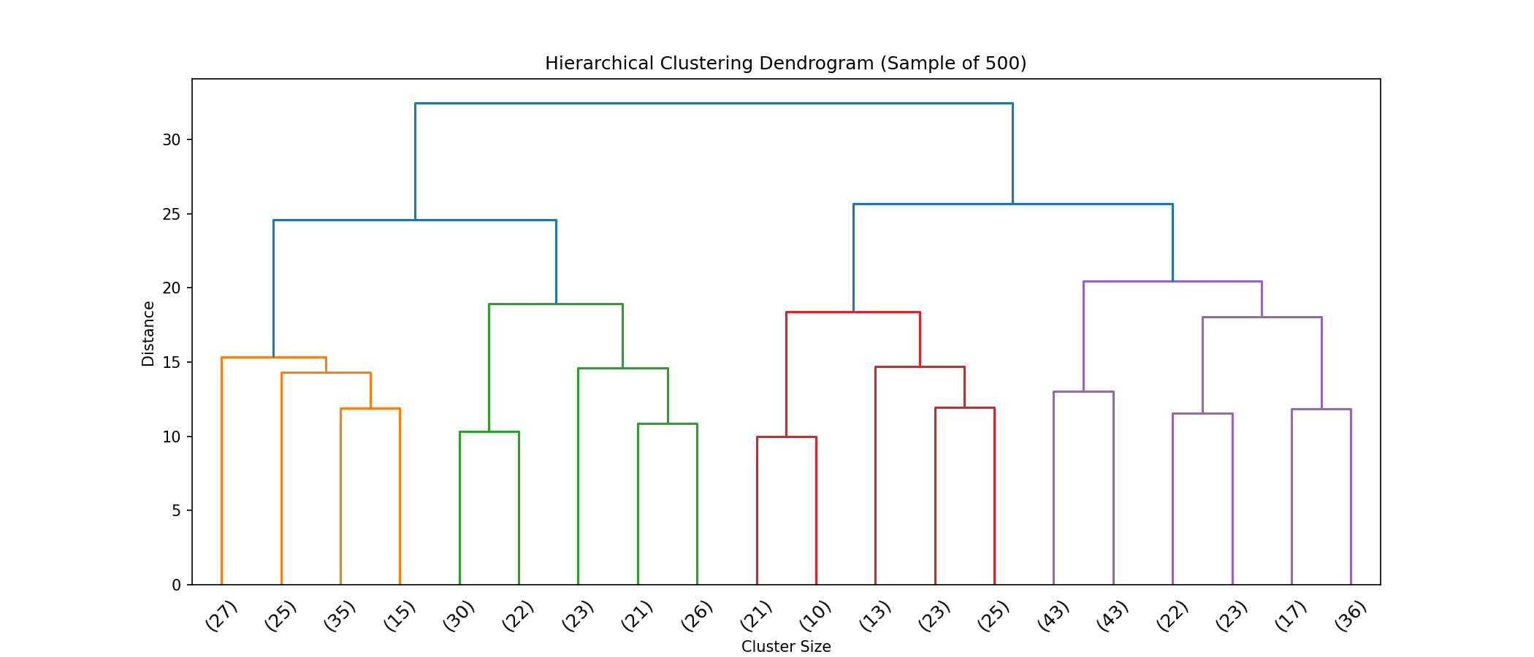

DBSCAN (Evaluated and Rejected)
DBSCAN finds clusters as dense regions separated by low-density gaps. Evaluated and intentionally retained in the notebook to demonstrate methodological rigor.
- Result: 0 clusters found, 58.8% of customers classified as noise
- Root cause: Banking customer data forms a single continuous dense manifold with no low-density boundaries between behavioral groups
- Conclusion: DBSCAN is appropriate for fraud/anomaly detection but unsuitable for customer segmentation on dense behavioral data

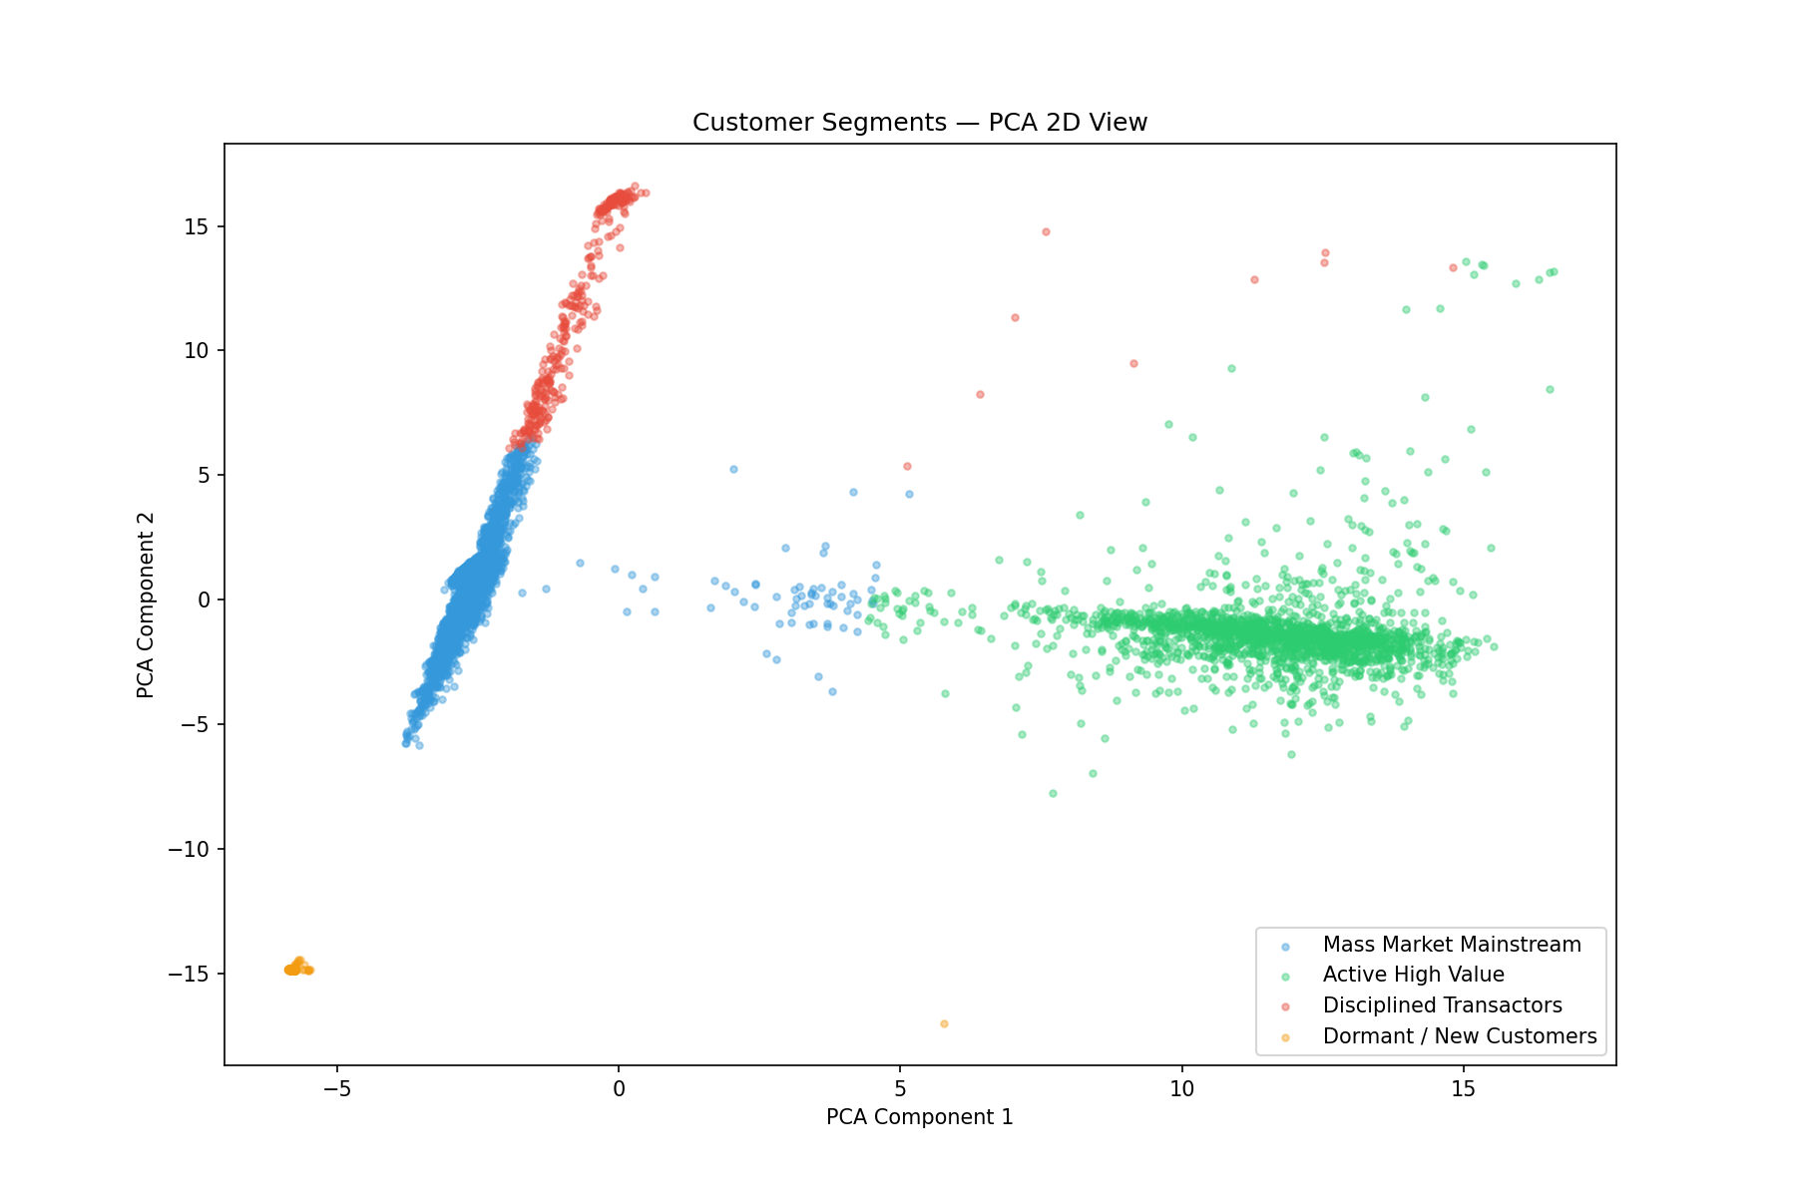

5. Results & Evaluation

5.1 Clustering Evaluation Metrics

Metric | Score | Benchmark | Interpretation
Silhouette Score | 0.64 | >0.5 = Strong | Well-separated, compact clusters
Davies-Bouldin Index | 0.53 | <1.0 = Good | Low intra-cluster scatter relative to separation
Calinski-Harabasz Score | 4,66,560 | Higher is better | Very high between-cluster vs within-cluster variance
ARI: K-Means vs GMM | 0.86 | >0.8 = Strong | Strong cross-method agreement
ARI: K-Means vs Hierarchical | 0.95 | >0.9 = Excellent | Near-perfect structural validation
GMM Assignment Confidence | 98.9% | >90% = High | GMM highly certain about all assignments

5.2 Customer Segments Identified

Segment | Count | % | Avg Income | Avg Frequency | Avg CC Balance | Payment Discipline
Mass Market Mainstream | 2,22,714 | 72.4% | ₹1,63,246 | 27 | ₹9.70 | 0.97
Active High Value | 58,394 | 19.0% | ₹1,78,459 | 90 | ₹1,06,183 | 1.03
Dormant / New Customers | 15,884 | 5.2% | ₹2,00,667 | 0 | ₹35.52 | 0.00
Disciplined Transactors | 10,519 | 3.4% | ₹1,84,594 | 28 | ₹672 | 22.76

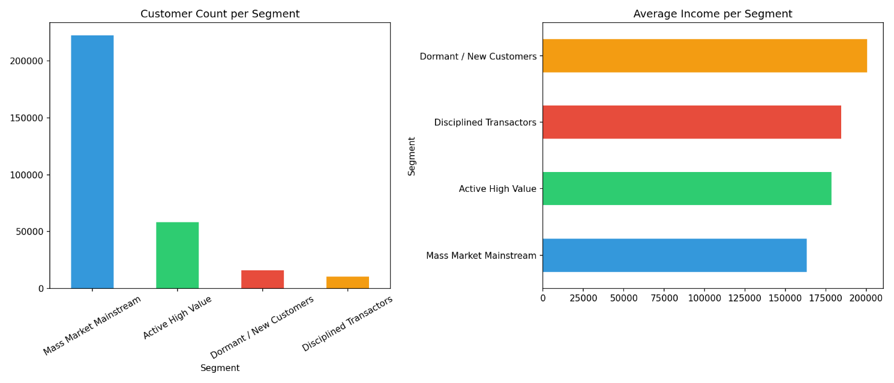

5.3 Segment Profiles

Mass Market Mainstream (72.4% — 2,22,714 customers)
The core customer base. Moderate income, average transaction activity, moderate credit utilization. These customers represent the bulk of the bank's portfolio but contribute average revenue. Low payment discipline score indicates some risk of delinquency.

Active High Value (19.0% — 58,394 customers)
Highest transaction frequency (90 transactions average), highest CC balance (₹1,06,183), strong payment behavior. These are the bank's most engaged and valuable customers. High bureau loan count suggests long credit history and strong relationship with financial institutions.

Dormant / New Customers (5.2% — 15,884 customers)
Zero transaction frequency, zero total paid, zero payment discipline score. These customers either have no product usage history or have recently onboarded. High income (₹2,00,667 average) suggests potential that is yet to be activated. Highest churn risk.

Disciplined Transactors (3.4% — 10,519 customers)
Smallest but most reliable segment. Exceptionally high payment discipline score (22.76 vs average of 1.0), lowest late payment count, high total paid. These customers repay consistently and ahead of schedule. Smallest CC balance indicates preference for debit/cash transactions. Prime candidates for premium loan products.

6. Customer Lifetime Value Analysis

Customer Lifetime Value was estimated using a behaviorally-weighted formula:

CLV = (TOTAL_PAID / FREQUENCY + 1) × BUREAU_LOAN_COUNT × EXT_SOURCE_2

Where: Average Payment per Transaction captures revenue intensity; Bureau Loan Count proxies customer tenure and relationship depth; EXT_SOURCE_2 is an external credit quality score acting as a risk-adjustment multiplier.

Segment | Avg CLV | Median CLV | Business Priority
Active High Value | Highest | High | 1 — Retention
Disciplined Transactors | High | High | 2 — Upsell
Mass Market Mainstream | Moderate | Moderate | 3 — Engagement
Dormant / New Customers | Lowest | Zero | 4 — Activation
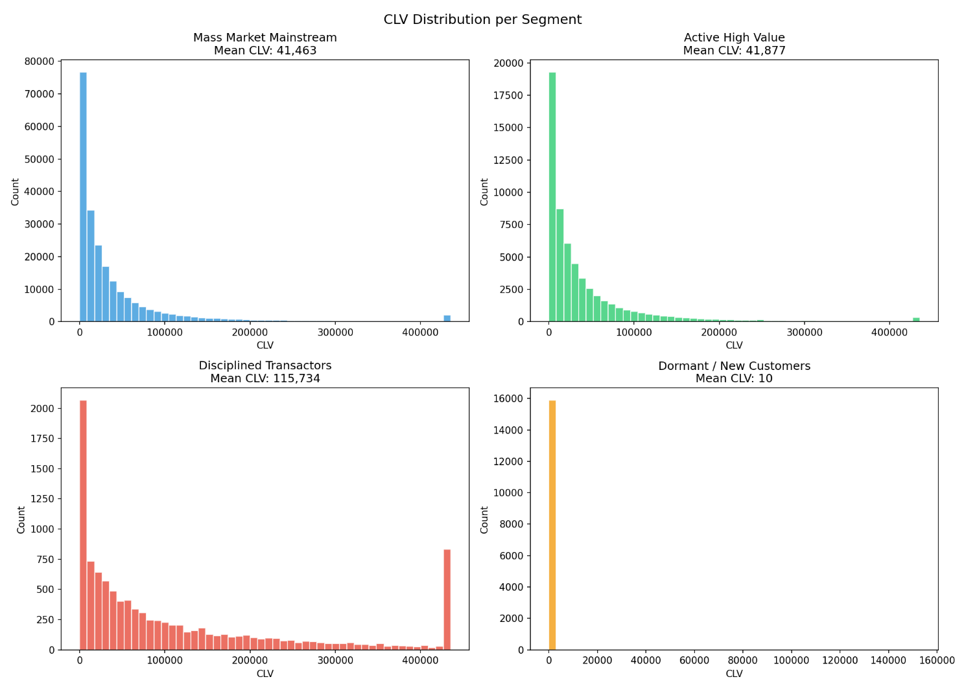

7. Business Recommendations

Active High Value — Retention Priority
- Assign dedicated relationship managers to top 10% of segment by CLV
- Offer loyalty rewards, premium credit card upgrades, and preferential interest rates
- Cross-sell wealth management, term insurance, and investment products
- Monitor CC utilization ratio quarterly — high balance customers carry concentration risk

Disciplined Transactors — Upsell Priority
- Offer higher credit limits proactively — payment discipline confirms repayment reliability
- Target with home loans, auto loans, and education loans at preferential rates
- These customers are the safest upsell candidates in the entire portfolio
- Consider co-branded credit card partnerships — they will adopt and use responsibly

Mass Market Mainstream — Engagement Priority
- Digital engagement campaigns — push notifications, in-app offers, cashback on transactions
- Auto-debit enrollment drives — increases transaction frequency and reduces churn
- Personal loan and EMI offers — they have income but moderate credit utilization
- Set early delinquency alerts — monitor DPD metrics monthly for this segment

Dormant / New Customers — Activation Priority
- Structured onboarding campaigns — first transaction incentive within 30 days of joining
- Branch and call center outreach for high-income dormant customers
- Starter credit cards and small personal loans to initiate credit history
- Track 90-day activation rate as primary KPI for this segment

8. Technical Stack & Project Structure

Component | Tools / Libraries
Language | Python 3.10
Data Processing | Pandas, NumPy
Machine Learning | Scikit-learn (KMeans, GMM, Hierarchical, DBSCAN, PCA, RobustScaler)
Statistical Analysis | SciPy (linkage, dendrogram)
Visualization | Matplotlib, Seaborn
Development Environment | VS Code + Jupyter Notebooks
Version Control | Git + GitHub
Dataset Source | Kaggle — Home Credit Default Risk Competition

Project Notebooks

Notebook | Content | Key Output
01_eda.ipynb | Data loading, EDA, missing value treatment | Clean application dataset, distribution plots
02_feature_engineering.ipynb | Multi-source merge, RFM computation, feature creation | enriched_features.csv — 51 features
03_clustering.ipynb | PCA, KMeans, GMM, Hierarchical, DBSCAN, evaluation | segmented_customers.csv, all metric outputs
04_clv_profiling.ipynb | CLV estimation, segment profiling, recommendations | CLV summary table, heatmap, business strategy

9. Key Learnings

- Preprocessing Impact: Feature distribution quality drives clustering performance more than algorithm choice — preprocessing alone improved Silhouette Score from 0.11 to 0.64
- Real RFM vs Proxies: Real RFM from transaction data produces meaningfully richer behavioral features than application-level proxies
- Cross-Method Validation: High method agreement (ARI 0.95) is stronger evidence of cluster validity than any single metric alone
- Methodological Rigor: Documenting failed methods (DBSCAN) and explaining why they failed demonstrates analytical maturity
- Business vs Statistics: Business interpretability should inform K selection even when statistical metrics suggest a lower K
- Scalability Awareness: Large datasets (300K+) require memory-aware design — Hierarchical Clustering on full data requires 352GB RAM, necessitating sample-based validation

10. Conclusion

This project demonstrates end-to-end unsupervised machine learning on real banking data — from multi-source feature engineering through rigorous clustering validation to actionable business recommendations. The final model segments 307,511 customers into four distinct groups with a Silhouette Score of 0.64, validated by near-perfect cross-method agreement (ARI 0.95).

The project is directly applicable to customer value management (CVM) functions within retail and private banking — a domain that every major Indian bank (HDFC, ICICI, Kotak, Axis) actively invests in. The methodology follows industry-standard practices used by analytics teams and management consulting firms (McKinsey, BCG) in their banking engagements.

The combination of technical rigor, real-world data, and business framing makes this project a strong representation of data science capability for BFSI roles.

GitHub Repository: github.com/VineelGundala/bank-segmentation
Dataset: Home Credit Default Risk — Kaggle Competition

