Home Page

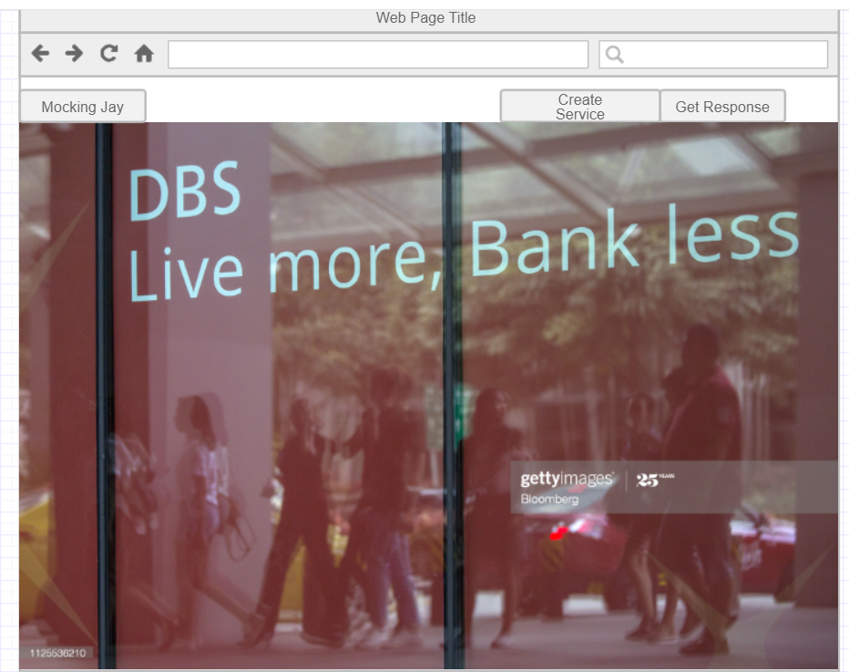

Description:

The home page will have a navbar where two links is provided which will redirect to create a new service or get response from existing service.

Get Response Page:

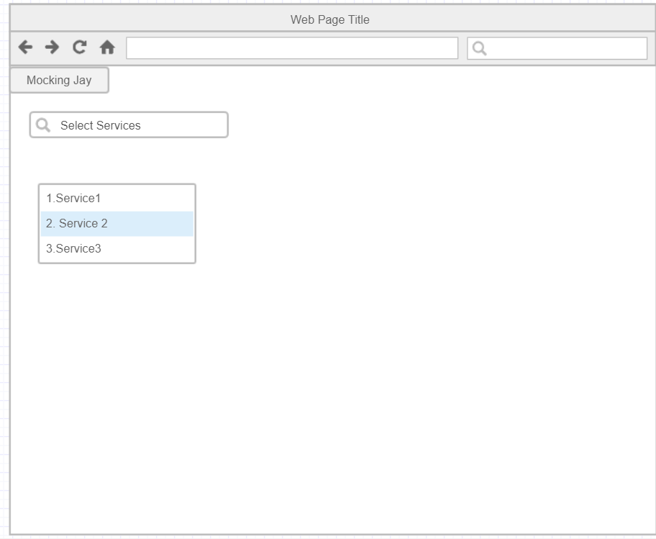

Description:

This page will consist of list of services and a filter box to select. When we select a particular service it will redirect to another page.

Service Request Page

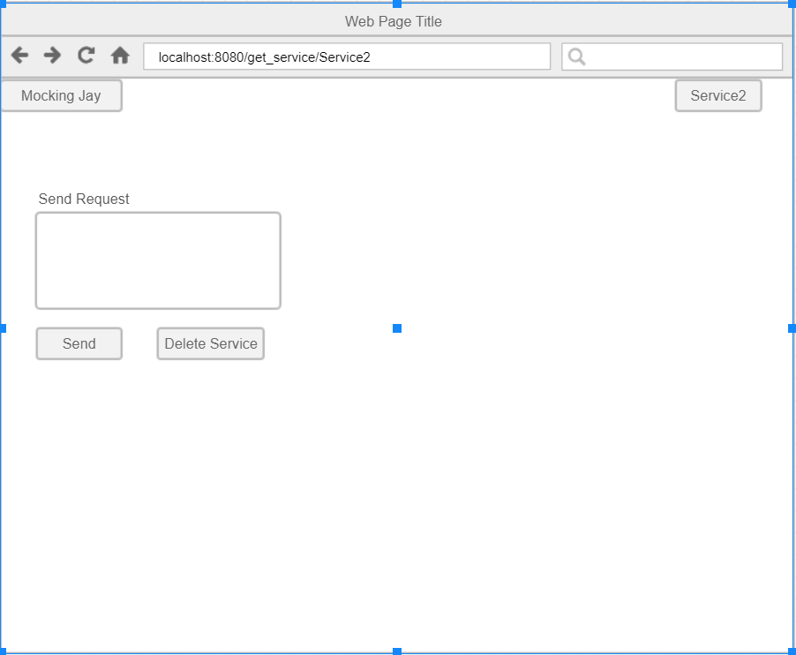

Description:

After selecting a service the above page opens up where there is a textfield to send request to the service and also an option to delete the existing service. When will hit the send button the below page opens up

Service Response page

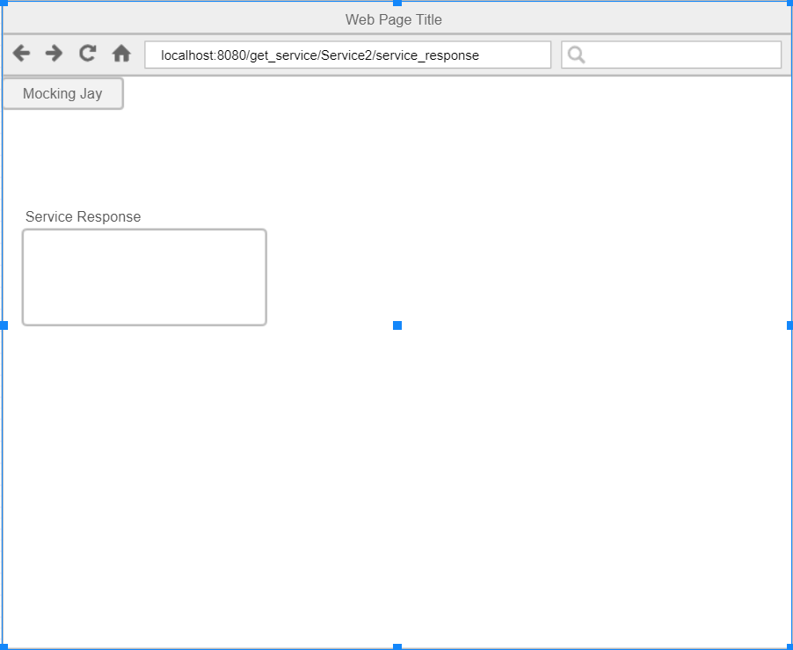

Description:

If a valid request is sent then we get the response in the area shown above.

Create a new Service Page:

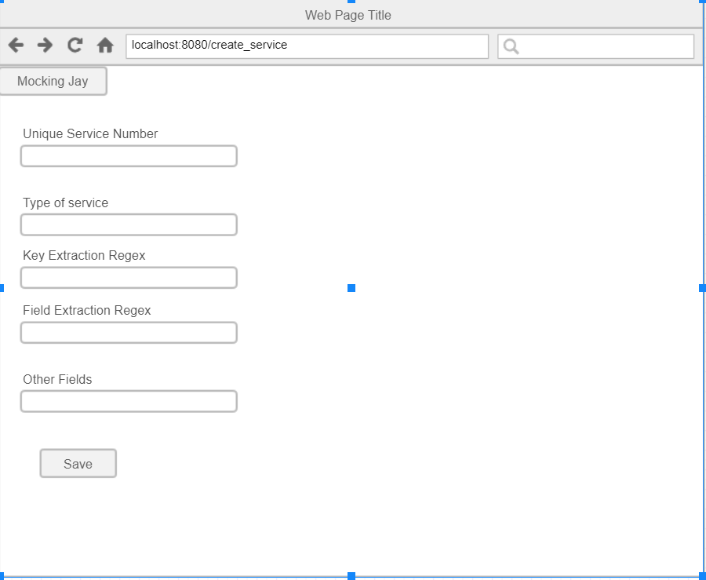

Description:

In this page we’ll have all the fields in database so we can enter and create a new service.

Create responses for new Service Page:

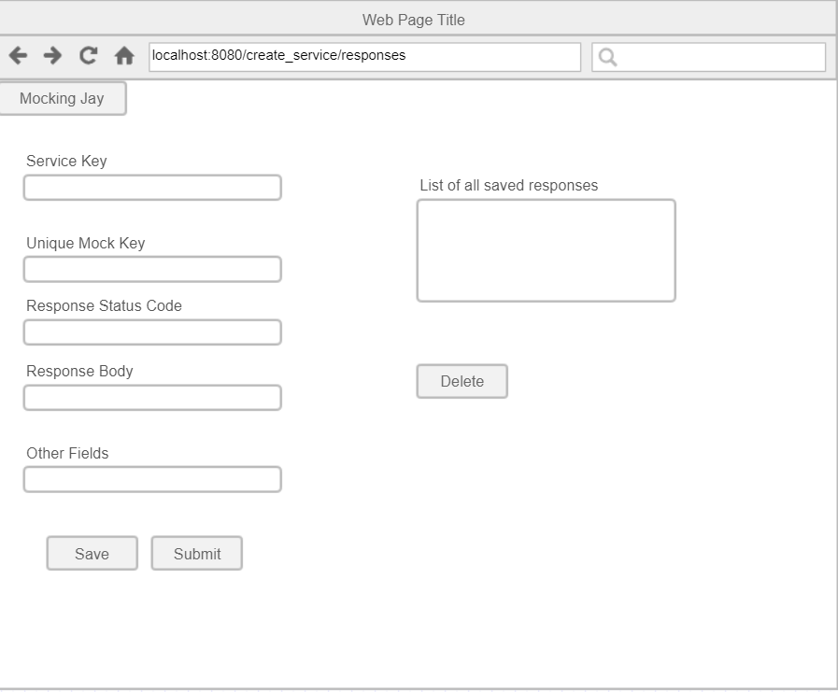

Description:

It will have all fields from database for response-mapping. Also after creating a response it get’s displayed on the right. Once we save the same page opens up so we can create more responses while it simultaneously appears on the right.

When we select a particular service on the right side and hit the delete button we delete that particular response.

Once we hit on the submit all the responses get saved and will be redirected to main page.