Networking : Creating a NAT (Network Address Translation)

The NAT setup consists of 2 clients in the private network, 1 router which translates the private addresses into public addresses and vice-versa and a device in the public network. This can be done using linux namespaces by using the commands as mentioned below.
Step1: Create the namespaces
We use ip netns add <namespace_name> to create a namespace. Four namespaces as mentioned above are created as follows:
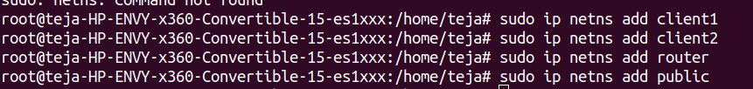
Step2: Create Virtual Ethernet (veth) pairs
We use ip link add <veth_name> type veth peer name <veth_name> to add a virtual Ethernet pair to connect 2 namespaces. Here, we add 3 veth links, first one connecting the client1 and the router, the 2nd one connecting the client2 and the router and the third connecting public device and the router. The following commands help in doing so:
Step3: Add virtual ethernet links to Namespaces
We assign the ends of the created virtual ethernet links to the designated namespaces using the command ip link set <veth_name> netns <namespace name> which is as follows:
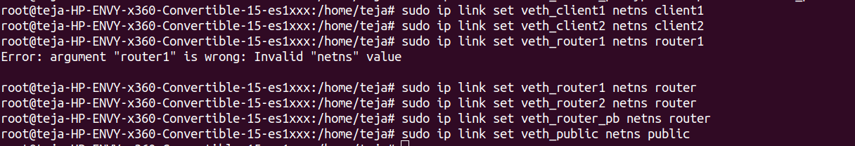
Step4: Configure clients
Now we assign the IP addresses to the clients in the private network and bring their interfaces up. We also assign the default gateway to both the clients. The commands used for this are as follows:
ip netns exec <namespace name> ip addr add <ip address> dev <veth interface name> to assign ip address.
ip netns exec <namespace name> ip link set <veth interface name> up to bring the veth interface up.
ip netns exec <namespace name> ip route add default via <Default Gateway> to assign a default gateway to the device interface.
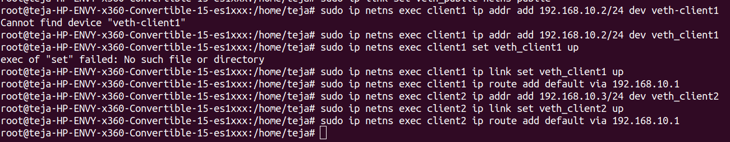
Step5: Configure Router
Here, we configure the router which involves the concept of bridging where we ensure that all the packets the interfaces which are connected to the router and the other ends to clients in the private network are forwarded to the default gateway and setting all the interfaces to active state. This can be done by the following commands as follows:
ip netns exec <namespace name> ip link add <bridge_name> type bridge to add a bridge link on the router.
ip netns exec <namespace name> ip link set <veth name> master <bridge_name> to connect all the router interface to the bridge to forward the data.
ip netns exec <namespace name> ip link set <interface name> up to make the interface active.
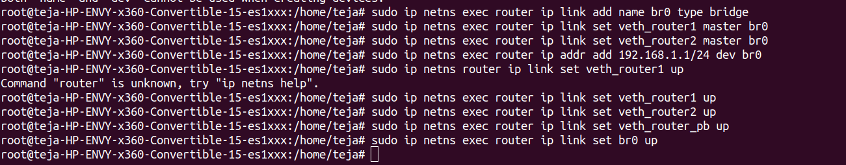

Step6: Configure public network
The device in the public network can be configured the same way we had configured the clients in the private network as shown below:
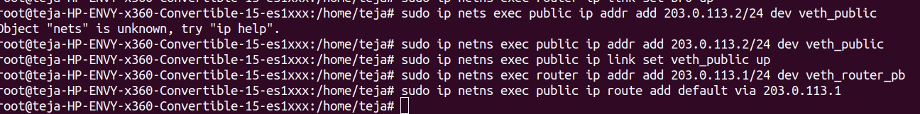
Step7: Enable NAT on the router
The router is now connected to the public network via one interface and the private network via the other. To allow clients in the private network to communicate with the outside world, we enable NAT on the router using the following command:
ip netns exec <namespace name> sysctl –w net.ipv4.ip_forward=1 to enable router forwarding.
ip netns exec <namespace name> iptables –t nat –A POSTROUTING –o <veth interface name connected to public network side> -j MASQUERADE to enable NAT (masquerading) to allow traffic go outside the network.
- To check connectivity from one namespace to the other, the following command can be run:
ip netns exec <namespace name> ping <IP address>.

BONUS TASKS
- Port forwarding:
client1# ip netns exec client1 python3 -m http.server 8080
client1# ip netns exec client1 curl http://192.168.10.3:8080
router# ip netns exec router curl http://192.168.10.3:8080
router# ip netns exec router nano /etc/sysctl.conf
router# sysctl –p
router# sysctl –system
Adding rules
router# ip netns exec router iptables -t nat -A PREROUTING -p tcp -d 203.0.113.1 --dport 80 -j DNAT --to-destination 192.168.10.3:8080
router# ip netns exec router iptables -A FORWARD -p tcp -d 192.168.10.3 --dport 8080 -j ACCEPT
router# ip netns exec router iptables -A FORWARD -m state --state ESTABLISHED,RELATED -j ACCEPT
Verify rules
router# ip netns exec router iptables -t nat -L –v
router# ip netns exec router iptables -L FORWARD -v
Verify port forwarding
curl http://192.168.10.3:8080
curl http://203.0.113.1:8080

- Restricting outbound traffic:
ip netns exec client1 iptables -P OUTPUT DROP
ip netns exec client1 iptables -A OUTPUT -m state --state ESTABLISHED,RELATED -j ACCEPT
ip netns exec client1 iptables -A OUTPUT -p tcp --dport 80 -j ACCEPT
ip netns exec client1 iptables -A OUTPUT -p tcp --dport 443 -j ACCEPT
ip netns exec client1 iptables -L -v

