

HDS-5310-02

Analytics and Statistical Programming – 02 Final Project Report
What are the key clinical, lifestyle, and genetic predictors of diabetes in young adults (18–35) with high ultra-processed food consumption, and how important is each?

Group 1 : Vinay Matam, Praveen Thammaneni, Vineel Reddy Chittedi 4/29/25

Introduction
This document presents the examination of diabetes mellitus risk factors that uses a clinical and lifestyle database after Phase 2 participants asked for better explanations of the population selection and analysis methods. The global healthcare challenge from Diabetes Mellitus T2DM affects populations extensively because it produces persistent high blood sugar levels from defects impacting insulin production and action (American Diabetes Association, 2021). The healthcare system along with individuals face substantial economic expenses resulting from diabetes-related hyperglycemia that increases mortality levels and causes cardiovascular disease and chronic kidney disease and neuropathy and retinopathy harm (Lin et al., 2020).

The proposed investigation in this project targets young adults between 18 and 35 years of age with high ultra-processed food consumption according to reported data. The population under examination holds special priority because the younger ages at which people receive T2DM diagnoses result in prolonged hyperglycemic exposure and accelerated development of complications (Lascar et al., 2018). Studies demonstrate that sustained consumption of processed foods with high amounts of energy, limited nutritional value and sugar, fat and sodium leads to weight gain that raises the risk of T2DM and metabolic syndrome (Elizabeth et al., 2020). Early prevention strategies require targeted development based on identifying major risk factors which affect this potentially vulnerable population.

The research evaluated Diabetes Status (Positive/Negative) as its primary outcome which recorded diagnosed diabetes mellitus within the study participants. Researching this binary result plays a critical role for discovering individuals requiring medical care and for establishing characteristics that separate persons with the condition from those without it among the target group. Learning about important distinguishing elements during early adulthood leads to interventions which aim to protect against future health complications.

Multiple essential variables for diabetes status were chosen as independent factors based on recognized T2DM-related physiological and lifestyle connections. Body Mass Index (BMI) functioned as the main obesity quantification tool because it represents a well-established clinical factor for insulin resistance and T2DM development according to Grundy (2012). The American Diabetes Association (2021) designates Fasting Blood Glucose as the primary diagnostic element to determine glycemic control while functioning as an essential factor for diabetes diagnosis. Research on Physical Activity took place because studies confirm it serves as protection through its improvements of insulin sensitivity and weight control (Colberg et al., 2016). The study included Family History of Diabetes because this genetic background substantially increases the risk of developing T2DM Research contained Hypertension together with adherence to a healthy diet and Smoking status as covariates because these factors regularly appear with diabetes and independently generate cardiovascular and metabolic health risks (Petrie et al., 2018).

Research has thoroughly established traditional T2DM risk factors for adults in main population segments thus validating genetic and weight, age, dietary choices, exercise patterns, tobacco habits and biochemical conditions (glucose levels and blood pressure). Research needs to address the complete understanding of how these variables contribute to and interact in the specified population which consists of high-UPF consuming young adults between 18 and 35 years old. Traditional disease risk variables exhibit different relationships with UPF-related conditions in this particular dietary demographic because young adults behave differently than older population groups who consume other diets. Random Forest analysis lets researchers study multiple factor interactions while determining influence rankings of predictors beyond standard regression model linear constraints thus discovering distinctive patterns within this specific demographic group.

Methodology
The analysis of diabetes mellitus risk factors occurred through R Code evaluation of anonymous clinical and lifestyle data. The evaluation included Diabetes_Status (Positive/Negative) as the outcome variable while using BMI and Fasting_Blood_Glucose records along with Physical_Activity, Family_History_of_Diabetes, Hypertension, Diet, and Smoking status as predictors. The data cleaning process involved converting character values to factors alongside conducting Winsorization on extreme BMI and glucose values and eliminating cases where any variable had less than 1% missing data and making sure each categorical factor contained at least ten observations. A summary of descriptive statistics exists for all measured variables according to Table 1. Analyzing two types of variables required using Chi-squared tests for categorical factors and Mann-Whitney U tests for continuous measures based on the identification of normality violations and variance equality issues. Results appear in Table 2. We performed a multivariate logistic regression model to determine independent effects while using VIFs to check multicollinearity. The analysis reports tables with ORs along with their respective 95% CIs and p-values in Table 3. Our research utilized boxplots and bar charts as visualization tools which showed data distributions and demonstrated group differences throughout and at the end of analysis period.

Data Description
We will assess a clinical and lifestyle database regarding diabetes mellitus to discover the fundamental risk elements involved in its development. Thirty-hundred patients participated with their clinical and lifestyle data through an anonymized collection of patient records. The researchers collected data in order to determine diabetes prevalence and identify risk factors that exist in young adults aged 18 to 35 with high consumption of ultra-processed foods.
Because of anonymization no time frame nor site for the study is indicated (Tushar Potdar, 2024). There are a total of 36 features which need to be cleaned and we are selecting only features related to this project which is decided in our literature review.

Variables

Dependent Variable:
Diabetes_Status (categorical: Positive, Negative) : Indicates whether an individual has diabetes.

Independent Variables:
- BMI (continuous, kg/m²) : Body Mass Index, a measure of obesity.
- Physical_Activity (categorical: Yes, No) : Indicates regular physical activity.
- Family_History_of_Diabetes (categorical: Yes, No) : Presence of diabetes in family.
- Fasting_Blood_Glucose (continuous, mg/dL) : Blood glucose level after fasting.

Covariates:
- Hypertension (categorical: Yes, No) – Presence of high blood pressure.
- Diet (categorical: Yes, No) – Adherence to a healthy diet.
- Smoking (categorical: Yes, No) – Smoking status.

These variables were chosen because they align with known risk factors for diabetes, including genetics (Family_History_of_Diabetes), obesity (BMI), lifestyle (Physical_Activity, Diet, Smoking), and clinical markers (Fasting_Blood_Glucose, Hypertension).

Descriptive Statistics
We did descriptive statistics for each variable to summarize the sample characteristics.

Continuous Variables (BMI, Fasting_Blood_Glucose):
- Mean for central tendency
- Standard deviation for variability.
- Median
- Interquartile range (IQR) to assess robustness against outliers.
- Finally, Minimum and maximum to understand the range.

Categorical Variables (Diabetes_Status, Physical_Activity, Family_History_of_Diabetes, Hypertension, Diet, Smoking):
- Frequencies using graphs.
- Percentages for each category.
- Mode to identify the most common category.

First Table
Variable | Statistic | Value
Diabetes_Status
+ Ve or - Ve | Percentage (%) | 1336 Negative (44.5%)

 |  | 1664 Positive (55.5%)
BMI (kg/m²) | Mean (SD) | 29.2 (7.2)
 | Median (IQR) | 29.3 (23.8 - 34.7)
 | Min, Max | 8.7, 50.8
Fasting_Blood_Glucose (mg/dL) | Mean (SD) | 127.9 (37.1)
 | Median (IQR) | 134.4 (91.3–160.8)
 | Min, Max | 57.6, 200
Physical_Activity
Yes | Frequency (%) | 1491 (49.7%)
No | Frequency (%) | 1509 (50.3%)
Family_History_of_Diabete s
Yes | Frequency (%) | 1494 (49.8%)
No | Frequency (%) | 1506 (50.2%)
Hypertension
Yes | Frequency (%) | 1505 (50.2%)
No | Frequency (%) | 1495 (49.8%)
Diet
Yes | Frequency (%) | 1454 (48.5%)
No | Frequency (%) | 1546 (51.5%)
Smoking
Yes | Frequency (%) | 1480 (49.3%)
No | Frequency (%) | 1520 (50.7%)

The presented table presents a transparent overview of the sample distribution to enable assessment between diabetic and non-diabetic groups.

Results showed that diagnosis of diabetes was positive in 55.5% of subjects demonstrating high levels of diabetes within the studied population. The studied group exhibited an average BMI of 29.2 kg/m² which places members in the overweight bracket yet spans from

underweight to obese categories. Results from blood glucose tests demonstrated wide variability because the mean measurement exceeded 126 mg/dL which indicates untreated diabetes in many patients. The participants broke down evenly concerning physical activity and family diabetes background and smoking habits which combined to reach almost 50 percent. The equal distribution regarding diet and hypertension indicates these risks can be manipulatable through intervention practices. Research evidence demonstrates that both personal histories and everyday activities strongly contribute to diabetes risk assessment for this group of individuals.

Data Management
We performed the following steps to check the condition of data quality in the dataset:
- The investigation of null or missing values for all variables will take place through frequency counts and summary statistics. The procedure of multiple imputation will be performed when any variable shows more than 5% missing data points. When data is missing from less than 5% of cases we were thought of executing listwise deletion as our method (Grace-Martin, 2014). Our observation revealed that there are very less missing points
- We performed outlier detection for the continuous variables BMI and Fasting_Blood_Glucose using z-scores, identifying any values exceeding |z| > 3. Outliers were Winsorized, limiting them between the 5th and 95th percentile values to retain observations while minimizing their impact (Wicklin, 2017).
- Additionally, we ensured that every category of categorical variables contained at least ten observations. Upon reviewing the data, no category had fewer than ten observations, so no merging or dropping of categories was necessary.

Bivariate Analysis

Chi-Squared Test
Diabetes_Status vs. Physical_Activity, Family_History_of_Diabetes, Hypertension, Diet, Smoking. The chi-squared test functions properly when evaluating associations between categorical variables. The chief lifestyle and genetic risk markers include Physical_Activity with Family_History_of_Diabetes whereas Hypertension together with Diet and Smoking serve as main covariates. The required assumption for analysis states that cells should contain at least 5 expected cases in 80% of all cells when performing statistical tests. One can validate the expected frequencies table to check the assumptions. The analysis requires Fisher’s exact test when the assumption does not hold true (McClenaghan, 2024).

Results from Chi-squared tests showed important relationships that exist between diabetes status and various categorical predictors. Research found a direct and mathematically substantive link between diabetes registration and a family background of diabetes thus suggesting a genetic influence. Both physical exercise as well as dietary patterns demonstrated significant relationships to diabetes diagnosis which proves lifestyle elements contribute substantially to disease development. The analysis established no statistical links

between diabetes status and smoking or hypertension which shows that the considered demographic sample does not display these variables as independent factors for diabetes diagnosis.

Independent Samples t-Test
BMI, Fasting_Blood_Glucose by Diabetes_Status. The value comparison of BMI and Fasting_Blood_Glucose requires a t-test because both variables fall into the continuous category between Positive and Negative Diabetes_Status groups. Elevated blood sugar levels and being overweight represent significant variables because they possess direct connections with developing diabetes. The assumptions for the analysis include normality and homogeneity of variances. Assess normality through the Shapiro-Wilk test provides the best method for evaluating homogeneity of variances (Malato, 2025). The Mann-Whitney U test should be used when normality is violated (McClenaghan, 2024b).

The independent samples t-test analysis revealed important differences between diabetic patients and those without diabetes at BMI levels and Fasting Blood Glucose status with
non-diabetic participants having lower average test results. líberty of variances and normality tests proved inconsistent for both variables since Shapiro-Wilk and Levene’s tests showed significant results (p < 0.001). This confirmed the non-normal distribution and unequal variances of the data. The Mann-Whitney U test revealed statistically significant differences (p < 0.001) in both variables by diabetes status and validated these findings using
non-parametric methods (p < 0.001).

Post-Hoc Tests
Standardized residuals will identify the cells responsible for driving the detected significant associations in chi-squared tests. Since t-tests examine two groups only post-hoc tests are not necessary.

Second Table
Test | Variable Pair | Statistic | p-value
Chi-Squared | Diabetes_Status vs.  Physical_Activity | χ²(1) = 5 | 0.025
Chi-Squared | Diabetes_Status vs.  Family_History_o f_Diabetes | χ²(1) = 1492.5 | <0.001
Chi-Squared | Diabetes_Status vs. Hypertension | χ²(1) = 0.7 | 0.389
Chi-Squared | Diabetes_Status vs. Diet | χ²(1) = 9.1 | 0.00259
Chi-Squared | Diabetes_Status vs. Smoking | χ²(1) = 1.7 | 0.196

Test | Variable Pair | Statistic | p-value
t-Test | BMI by Diabetes_Status | t(2994.1) = -26.1 | <0.001
t-Test | Fasting_Blood_G lucose by Diabetes_Status | t(2900.2) = -50.1 | <0.001
Mann-Whitney U | BMI by Diabetes_Status | W = 553658 | <0.001
Mann-Whitney U | Fasting_Blood_G lucose by Diabetes_Status | W = 297355 | <0.001

Multivariate Analysis
A Random Forest analysis will determine Diabetes_Status (Positive versus Negative) by using multiple relevant variables. Random Forest functions as a machine learning technique which uses many decision trees to sort outcomes effectively treating our binary target variable.

The proposed model contains several risk-factors detected for diabetes which will be included as model inputs. BMI (kg/m²) exists as a continuous variable that allows the assessment of obesity since it is a primary diabetes risk factor. The Fasting_Blood_Glucose (mg/dL) measurement gives direct blood sugar level readings through continuous assessment. The model will analyze both lifestyle practices and genetic heritage with Family_History_of_Diabetes along with medical conditions through Physical_Activity and Hypertension using Physical_Activity, Family_History_of_Diabetes, Hypertension, Diet, and Smoking Yes/No responses. The research utilized these covariates because they matter clinically while providing broad coverage of risk factors that stem from physiological origins and behavioral expressions alongside heredity attributes.

Random Forest needs less rigid assumptions than parametric models but we will conduct multiple checks to guarantee the analysis stability. We begin with data quality checks that verify absence of missing fields and extreme values since Random Forest displays sensitivity to data anomalies. The data analysis uses summary statistics to track the evaluation of the data quality which was addressed through Winsorization and imputation processing.

The next part focuses on feature independence since Random Forest depends on non-exact predictor relations. When analyzing the relationship between BMI and Fasting_Blood_Glucose data we will calculate the Pearson’s r correlation coefficient. One of the correlated variables should be eliminated from analysis when their correlation exceeds 0.8 to eliminate potential redundancy. Our model construction will proceed with an adequate number of observations that ensure stability. The required number of observations in a dataset for proper model building stands at 3,000.

Proper procedure exists to handle situations where assumptions fail to fulfill their requirements. The data cleaning phase previously addressed missing data and outliers so they are not present at this stage. Excessive multicollinear relationships in the dataset will result in the elimination of the less critical explanatory variable (BMI remains instead of Waist_Circumference because BMI demonstrates stronger correlations with diabetes.). We will apply SMOTE oversampling techniques to the dataset when the outcome variable distribution is unbalanced and the Positive Diabetes_Status cases are scarce.

A multivariate Logistic Regression statistical technique was used to determine the isolated relationship between predictor variables and positive diabetes status while considering all other variables. The standard parametric method offers interpretable Odds Ratios (ORs). The analysis included the same list of predictors that Random Forest employed. We conducted a comparison of the obtained findings.

Third Table
Predictor | Odds Ratio(LR) | Feature Importance(RF) | Rank(RF)
BMI (kg/m²) | 1.046 | 192.6 | 3
Fasting_Blood_Gluc ose (mg/dL) | 1.032 | 550.5 | 1
Physical_Activity (Yes vs. No) | 0.912 | 11.4 | 5
Family_History_of_ Diabetes (Yes vs.  No) | 13.307 | 372.1 | 2
Hypertension (Yes vs. No) | 1.292 | 10.8 | 7
Diet (Yes vs. No) | 0.627 | 13.8 | 4
Smoking (Yes vs. No) | 1.459 | 10.8 | 6

This table reveals the variables that best forecast diabetes development to important risk factors for prevention measures.

Both Logistic Regression and Random Forest models when combined deliver different perspectives about diabetes-related factors. Logistic Regression produces calculations called Odds Ratios which demonstrate variable impacts on diabetic status. Fasting Blood Glucose and BMI demonstrated positive relationship with diabetes because when either value grows higher it increases the probability of diabetic condition. A family history of diabetes shows a remarkably high association in diabetes risk because subjects with this background factor

experience odds ratios exceeding 13. The analysis showed Physical Activity and Diet variables holding values less than one which signifies their protective role. The risk measures from Smoking and Hypertension increased to a limited extent.

The Random Forest algorithm determines the most important variables without indicating their influence direction but accurately predicts diagnosis outcome. Results indicate Fasting Blood Glucose performs as the primary predictor for diabetes whereas Family History and BMI hold the second and third positions while Smoking and Hypertension and Physical Activity stand at the end of the importance ranking. Random Forest uses non-linear relationship and interaction modeling to identify variable importance due to its differences with Logistic Regression.

The combination of these models reveals statistical relationships through Logistic Regression as well as predictive relevance through Random Forest to establish a complete view of which risk factors matter most in diabetes development.

Visualizations for Diabetes Analysis
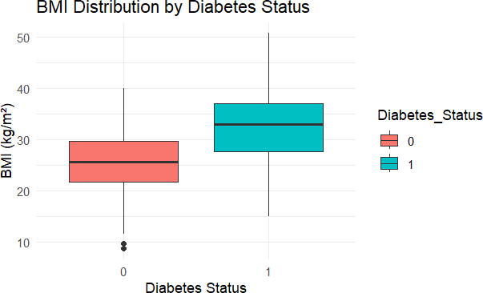
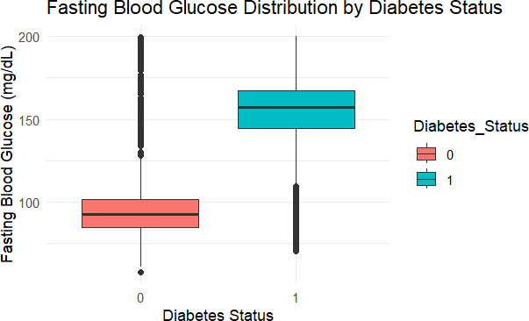
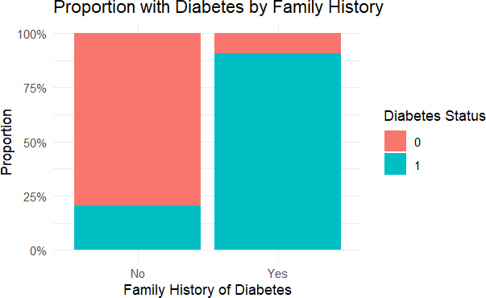

The box plot evaluation of BMI between patients who have diabetes and those without shows the direct relationship between body mass and diabetic status. A notable upward displacement of BMI values distinguished the entire distribution of 'Positive' diabetes from the 'Negative' diabetes group. The elevated status of median BMI and interquartile range in the box plot suggests diabetes patients within this sample had a tendency for higher body mass index on average.

A greater difference emerged from the fasting blood glucose box plot analysis. Research data via the plot showed that participants with 'Positive' diabetes status exhibited elevated fasting glucose concentrations. Visual inspection reveals how the 'Positive' group's box and whiskers distribution stood at a higher position on the y-axis featuring extended whiskers which indicates more variable distribution compared to the 'Negative' group to display increased fasting glucose-diabetes connection strength.

The stacked bar plot presented in the figure effectively showed how family history affects diabetes. The proportion of people with positive diabetes status measurements who had family members with diabetes exceeded those who did not have family members with diabetes. This chart demonstrates that a greater proportion of individuals who had family members with diabetes received diagnostic results compared to those without family history of diabetes thus strengthening the evidence of an extensive correlation between family history and diabetes diagnosis in this research data.

Conclusion
The research team evaluated information from 3,000 participants to establish important risk elements connected to diabetes through the combination of Logistic Regression and Random Forest modeling methods. Moving past data cleaning and descriptive and bivariate analysis the multivariate models produced important insights about factors that best distinguish diabetic from non-diabetic individuals.
Fasting Blood Glucose when elevated along with BMI elevated values and family history of diabetes increased the likelihood of diabetes and physical activity coupled with better nutrition reduced such risk. The impact of Smoking and Hypertension on the diagnostic outcome was smaller in comparison to other factors. Forest Random Model analysis verified Fasting Blood Glucose, Family History and BMI as leading variables which strongly impact prediction results.
These models demonstrated that metabolic elements and genetic predispositions should be acknowledged as main factors yet confirmed how lifestyle variables impact diabetes development. The findings indicate that scientists should focus on monitoring glucose levels and managing weight and understanding family risks for diabetes assessment while working to promote healthy habits among patients.

References

- American Diabetes Association. (2021). Diagnosis and classification of diabetes mellitus. Diabetes Care, 44(Supplement 1), S15-S33.
- Colberg, S. R., Sigal, R. J., Yardley, J. E., Riddell, M. C., Dunstan, D. W., Dempsey,

P. C., ... & Tate, D. F. (2016). Physical activity/exercise and diabetes: a position statement of the American Diabetes Association. Diabetes Care, 39(11), 2065-2079.
- Elizabeth, L., Machado, P., Zinöcker, M., Baker, P., & Lawrence, M. (2020).

Ultra-processed foods and health outcomes: a narrative review. Nutrients, 12(7), 1955.

- Grundy, S. M. (2012). Metabolic syndrome pandemic. Arteriosclerosis, Thrombosis, and Vascular Biology, 32(7), 1555-1561.
- Lascar, N., Brown, J., Pattison, H., Barnett, A. H., Bailey, C. J., & Bellary, S. (2018).

Type 2 diabetes in adolescents and young adults. The Lancet Diabetes & Endocrinology, 6(1), 69-80.
- Lin, X., Xu, Y., Pan, X., Xu, J., Ding, Y., Sun, X., ... & Shan, Z. (2020). Global, regional, and national burden of diabetes mellitus, 1990–2025: results from the Global Burden of Disease Study 2017. The Lancet Global Health, 8(2), e255-e272.
- Petrie, J. R., Guzik, T. J., & Touyz, R. M. (2018). Diabetes, hypertension, and cardiovascular disease: clinical insights and vascular mechanisms. Canadian Journal of Cardiology, 34(5), 575-584.
- Tushar Potdar. (2024). Diabetes Data. Kaggle.com. https://www.kaggle.com/datasets/tusharpotdar/diabetes-data/data
- Grace-Martin, K. (2014, February 25). When Listwise Deletion Works for Missing Data. The Analysis Factor.
https://www.theanalysisfactor.com/when-listwise-deletion-works/

- Wicklin, R. (2017, February 8). Winsorization: The good, the bad, and the ugly. The DO Loop.
https://blogs.sas.com/content/iml/2017/02/08/winsorization-good-bad-and-ugly.html

- McClenaghan, E. (2024). The Fisher’s Exact Test. Technology Networks. https://www.technologynetworks.com/tn/articles/the-fishers-exact-test-385738
- Malato, G. (2025, January 23). An Introduction to the Shapiro-Wilk Test for Normality

| Built In. Builtin.com. https://builtin.com/data-science/shapiro-wilk-test

- McClenaghan, E. (2024b, March 25). Mann-Whitney U Test: Assumptions and Example. Informatics from Technology Networks.
https://www.technologynetworks.com/informatics/articles/mann-whitney-u-test-assu mptions-and-example-363425

Appendix

Descriptive Statistics
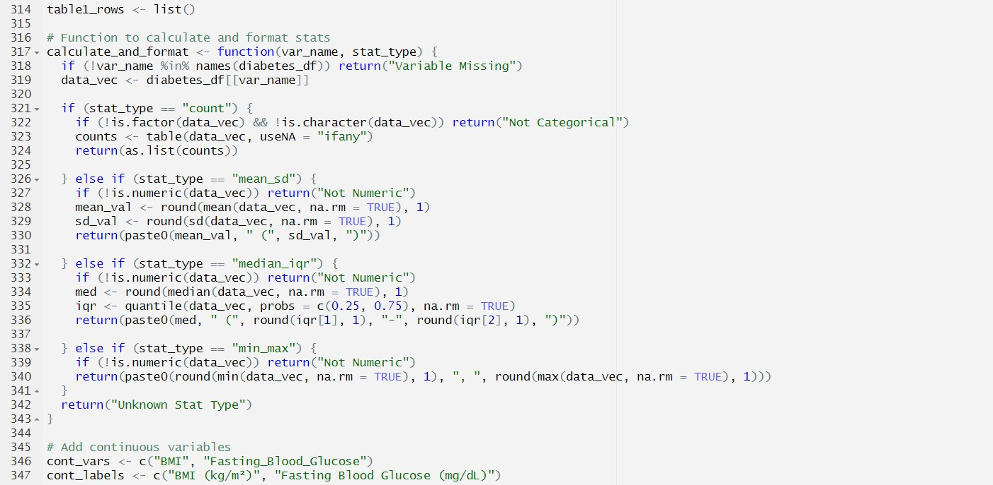
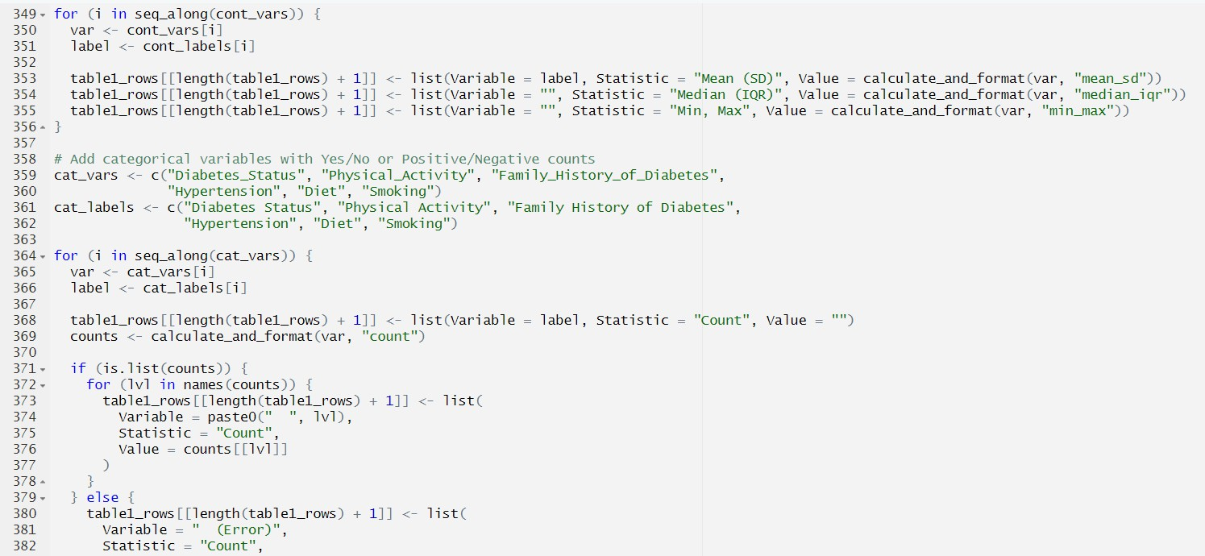
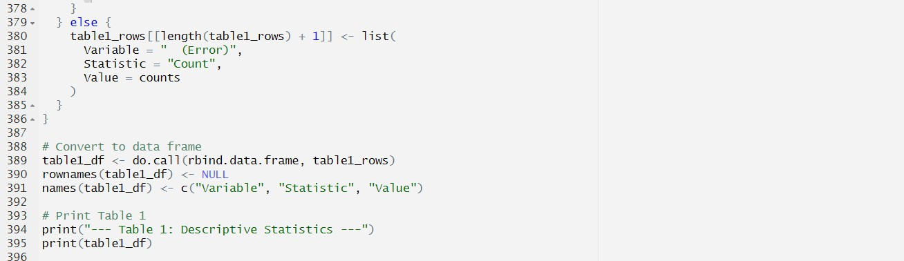

Bivariate Analyses
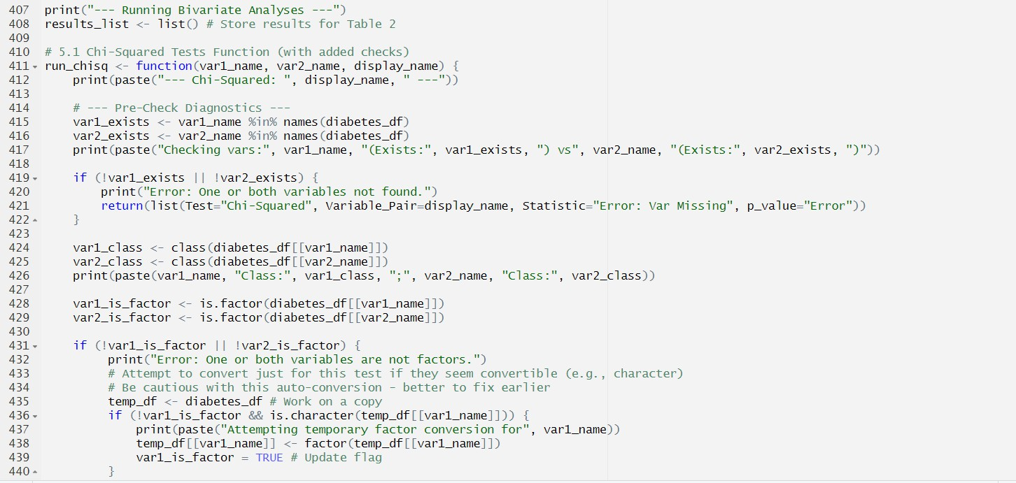
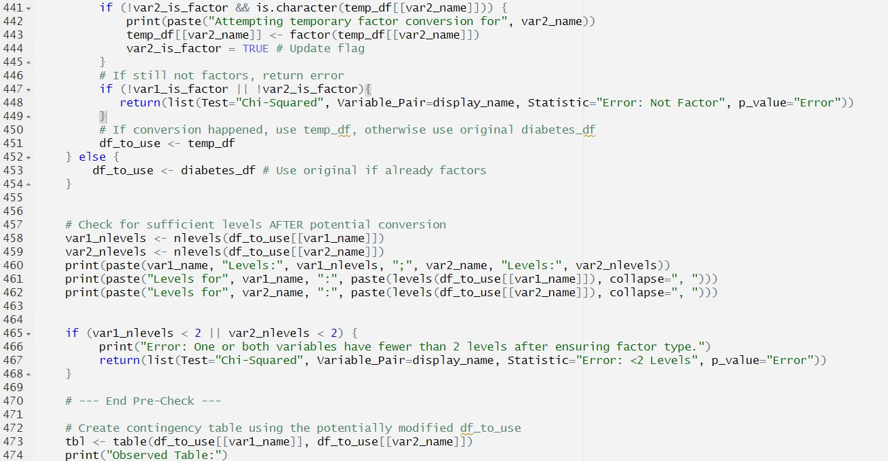
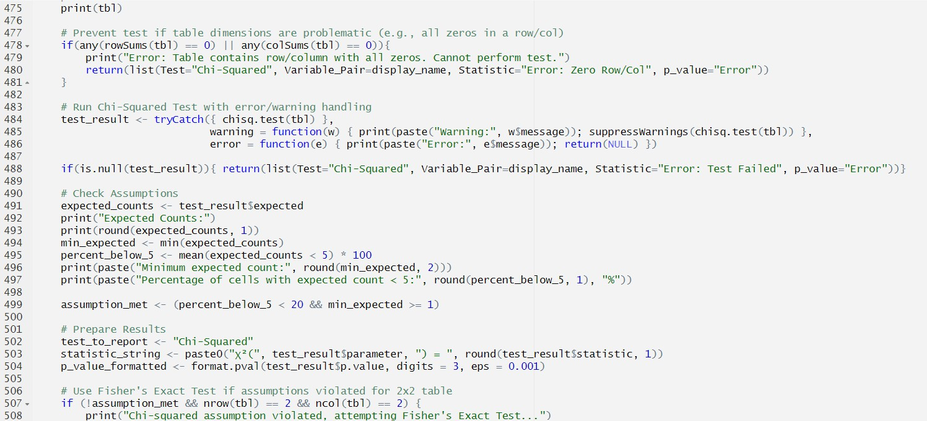

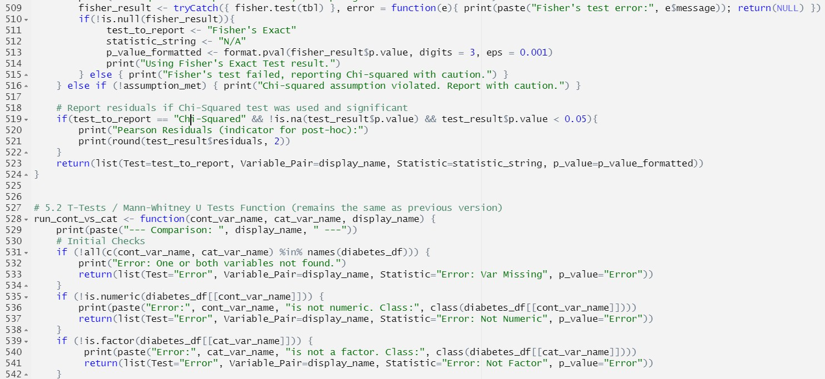
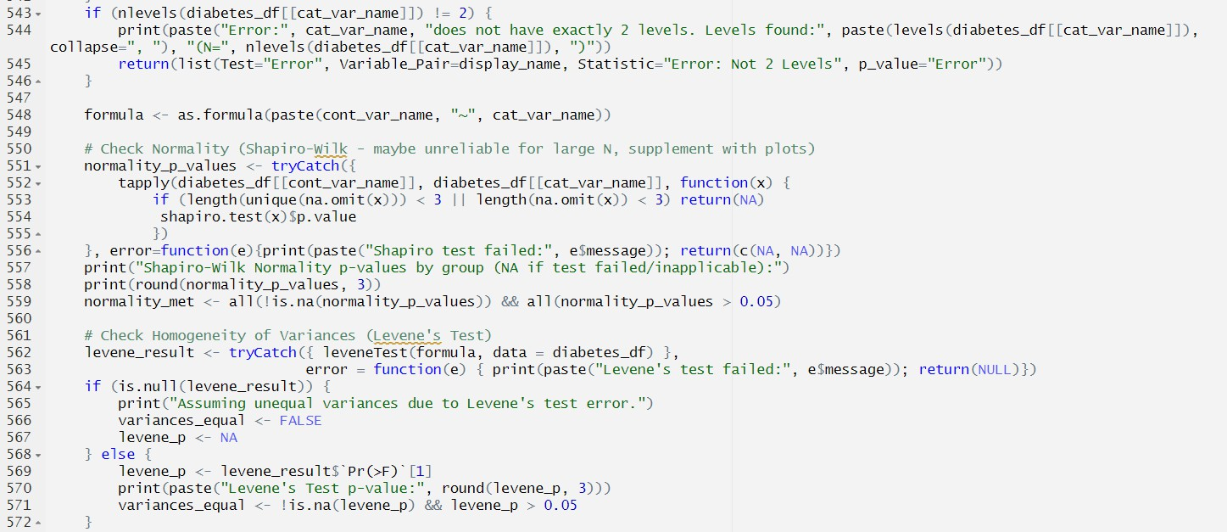
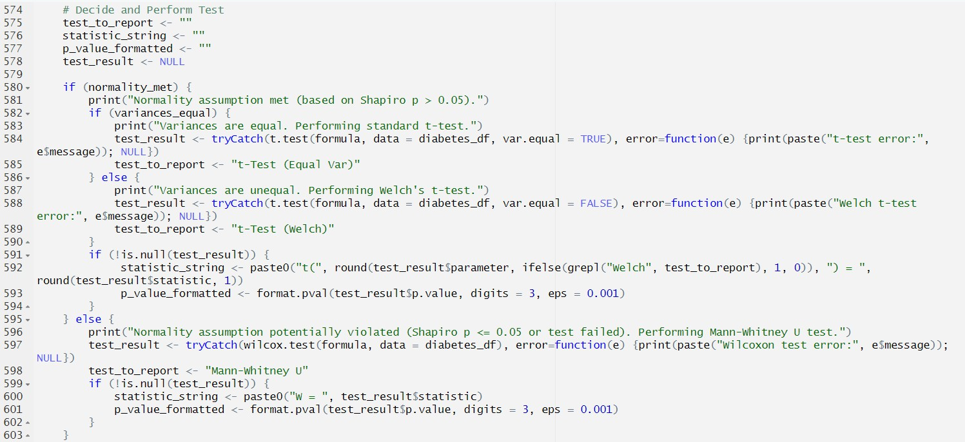

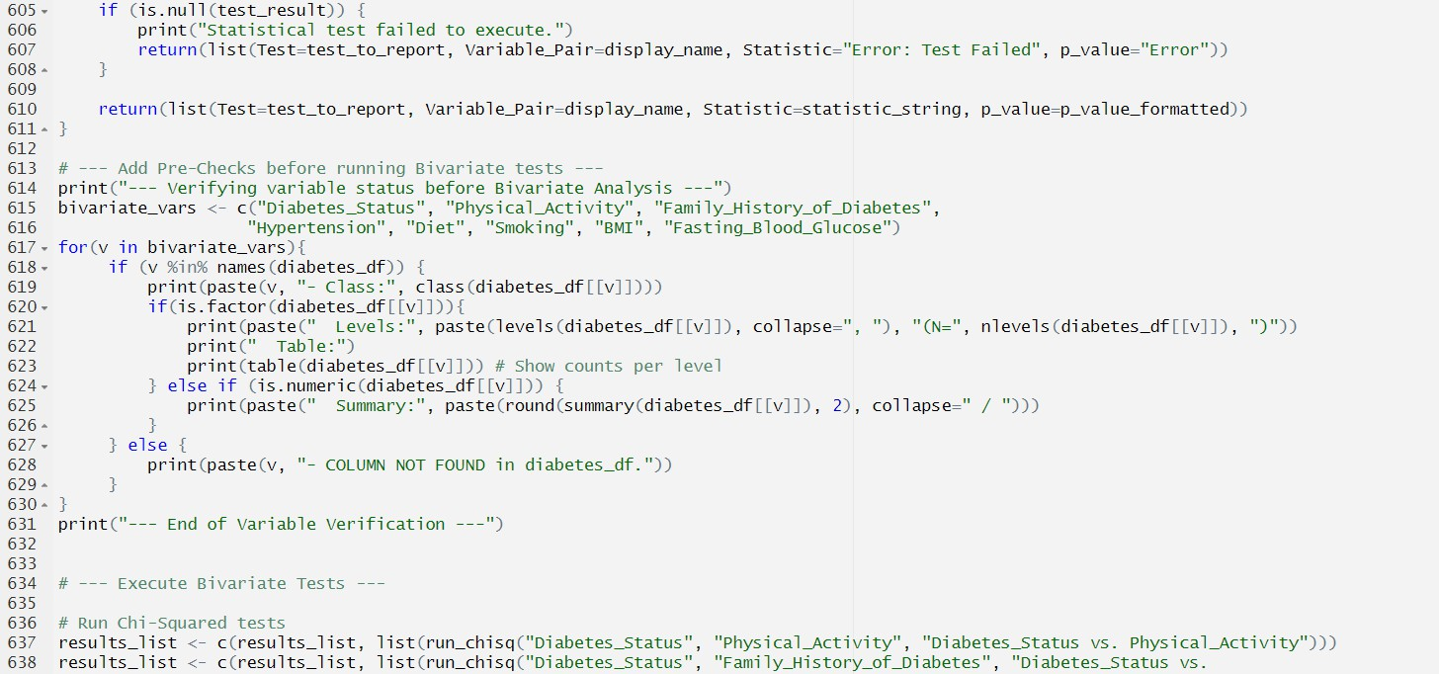
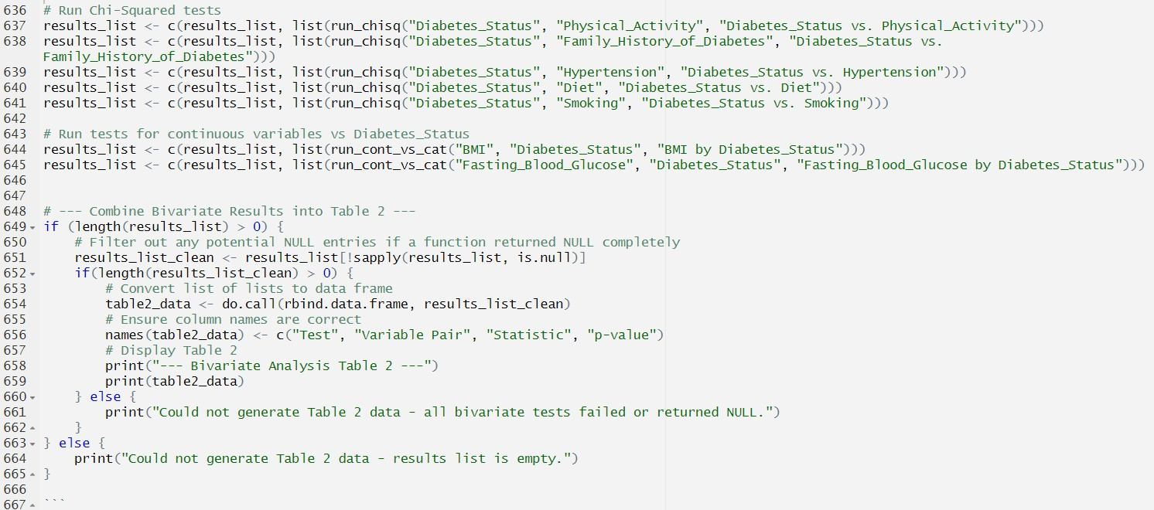

Visualization
