AI ASSISTANT CODING
Assignment-1.4
Hall Ticket No: 2303A51873
Batch: 14
Name: R.Vineesha

Task-1. AI-Generated Logic Without Modularization (Prime Number Check Without Functions)
Scenario
➢ You are developing a basic validation script for a numerical learning
application.
❖ Task Description
Use GitHub Copilot to generate a Python program that:
➢ Checks whether a given number is prime
➢ Accepts user input
➢ Implements logic directly in the main code
➢ Does not use any user-defined functions
❖ Expected Output
➢ Correct prime / non-prime result
➢ Screenshots showing Copilot-generated code suggestions
➢ Sample inputs and outputs

Prompt
#Generate a proper python code to check weather the given number is prime or not without using any functions

Code

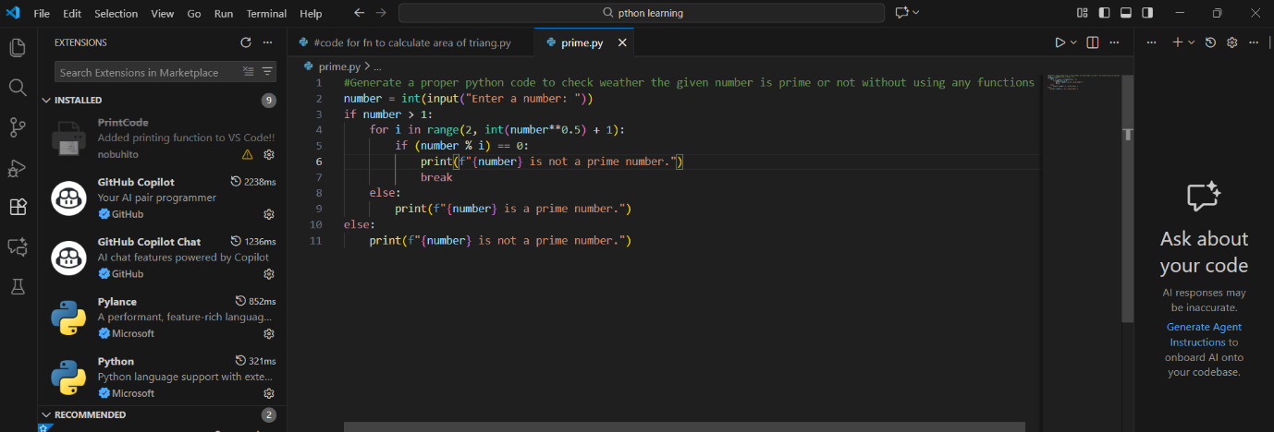

Output:
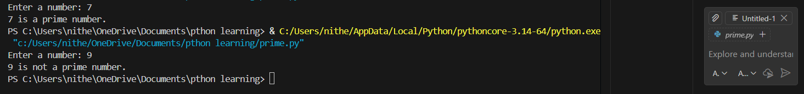

Justification:

This program checks whether a given number is prime using direct conditional logic without defining any functions. All computations are performed sequentially in a single block, making the logic easy to follow and suitable for beginners.

Task-2. Efficiency & Logic Optimization (Cleanup)
❖ Scenario
The script must handle larger input values efficiently.
❖ Task Description
Review the Copilot-generated code from Task 1 and improve it by:
➢ Reducing unnecessary iterations
➢ Optimizing the loop range (e.g., early termination)
➢ Improving readability
➢ Use Copilot prompts like:
▪ “Optimize prime number checking logic”
▪ “Improve efficiency of this code”
Hint:
Prompt Copilot with phrases like
“optimize this code”, “simplify logic”, or “make it more readable”
❖ Expected Output
➢ Original and optimized code versions
➢ Explanation of how the improvements reduce time complexity
Prompt
#Improve readability while keeping the logic simple and improve efficiency of the code by reducing iterations also minimize the code length
Code:
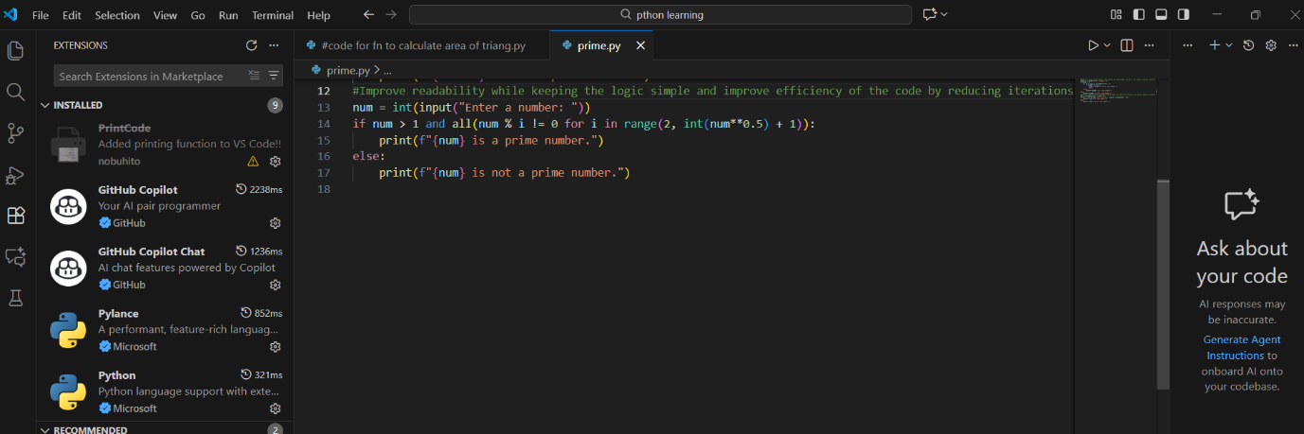

Output:
Justification:
The optimized script improves performance by reducing unnecessary iterations and limiting the loop range, enabling faster execution for larger input values.
Early termination and simplified conditions lower the overall time complexity while maintaining correct prime number validation.

Task-3. Modular Design Using AI Assistance (Prime Number Check Using Functions)
❖ Scenario
The prime-checking logic will be reused across multiple modules.
❖ Task Description
Use GitHub Copilot to generate a function-based Python program that:
➢ Uses a user-defined function to check primality
➢ Returns a Boolean value
➢ Includes meaningful comments (AI-assisted)
❖ Expected Output
➢ Correctly working prime-checking function
➢ Screenshots documenting Copilot’s function generation
➢ Sample test cases and outputs
Prompt:
#The function must return a Boolean value (True if prime, False otherwise)

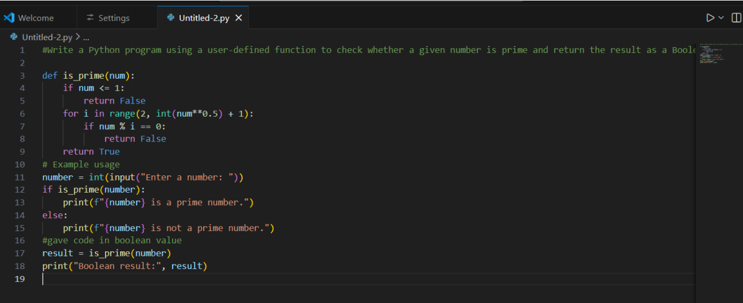
Output:

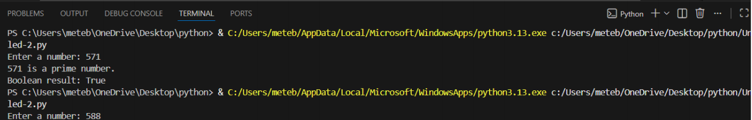
Justification:
Using a user-defined function makes the prime-checking logic reusable across multiple modules, improving code modularity and maintainability. Returning a Boolean value enables easy integration with conditional statements and other program components.

Task-4: Comparative Analysis –With vs Without Functions
Prompt:
# Compare both code with function without function Analyze and compare two Python programs for checking whether a number is prime
❖ Scenario
You are participating in a technical review discussion.
❖ Task Description
Compare the Copilot-generated programs:
➢ Without functions (Task 1)
➢ With functions (Task 3)
➢ Analyze them based on:
➢ Code clarity
➢ Reusability
➢ Debugging ease
➢ Suitability for large-scale applications
❖ Expected Output
Comparison table or short analytical report

Code:
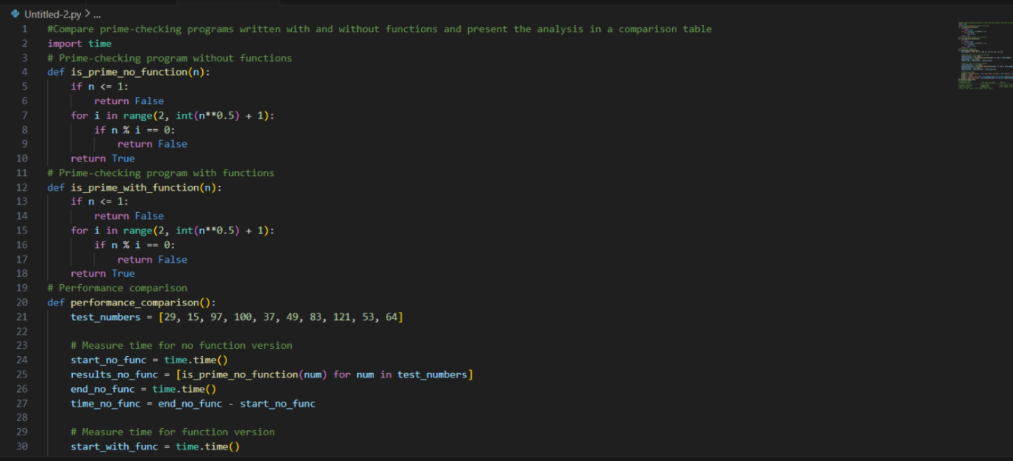
Output:
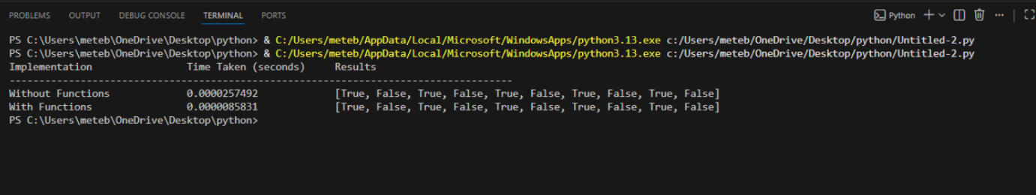
Justification:
Programs written with functions offer better code clarity by separating logic into well-defined blocks, making them easier to read and understand. Function-based designs improve reusability and debugging ease, as changes or fixes can be applied in one place without affecting the entire code.

Task-5: AI-Generated Iterative vs Recursive Fibonacci Approaches (Different Algorithmic Approaches to Prime Checking)
❖ Scenario
Your mentor wants to evaluate how AI handles alternative logical
strategies.
❖ Task Description
Prompt GitHub Copilot to generate:
➢ A basic divisibility check approach
➢ An optimized approach (e.g., checking up to √n)
❖ Expected Output
➢ Two correct implementations
➢ Comparison discussing:
▪ Execution flow
▪ Time complexity
▪ Performance for large inputs
▪ When each approach is appropriate
Prompt: Prime Number Check – Basic vs Optimized Approach
Code:
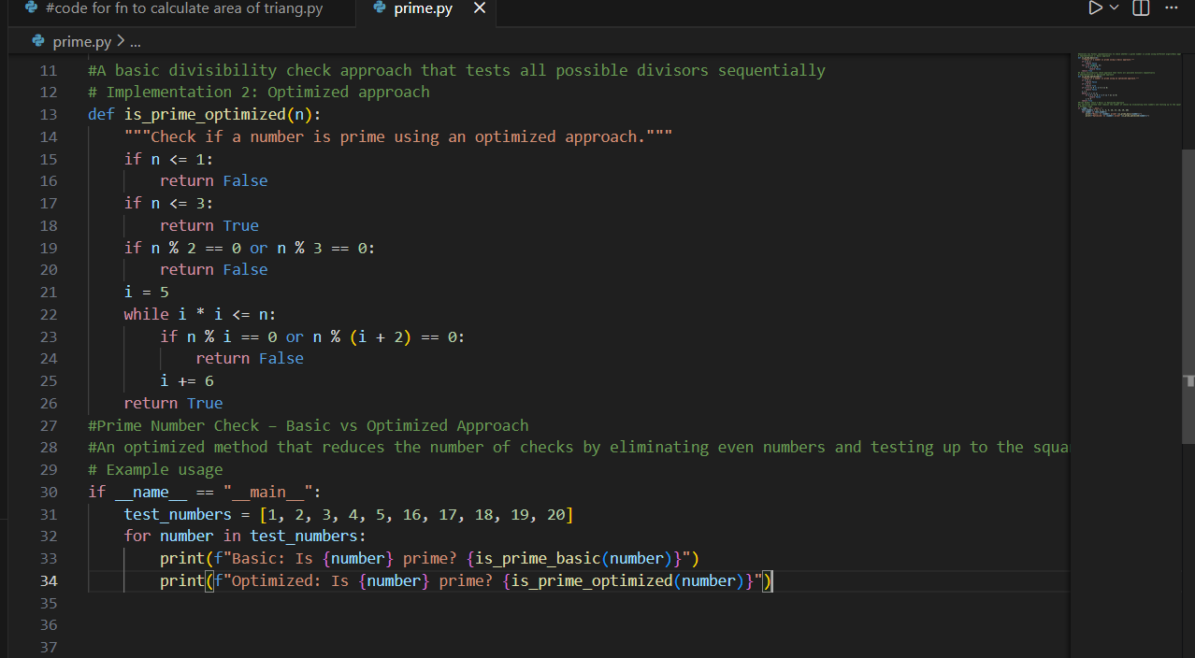

Output:
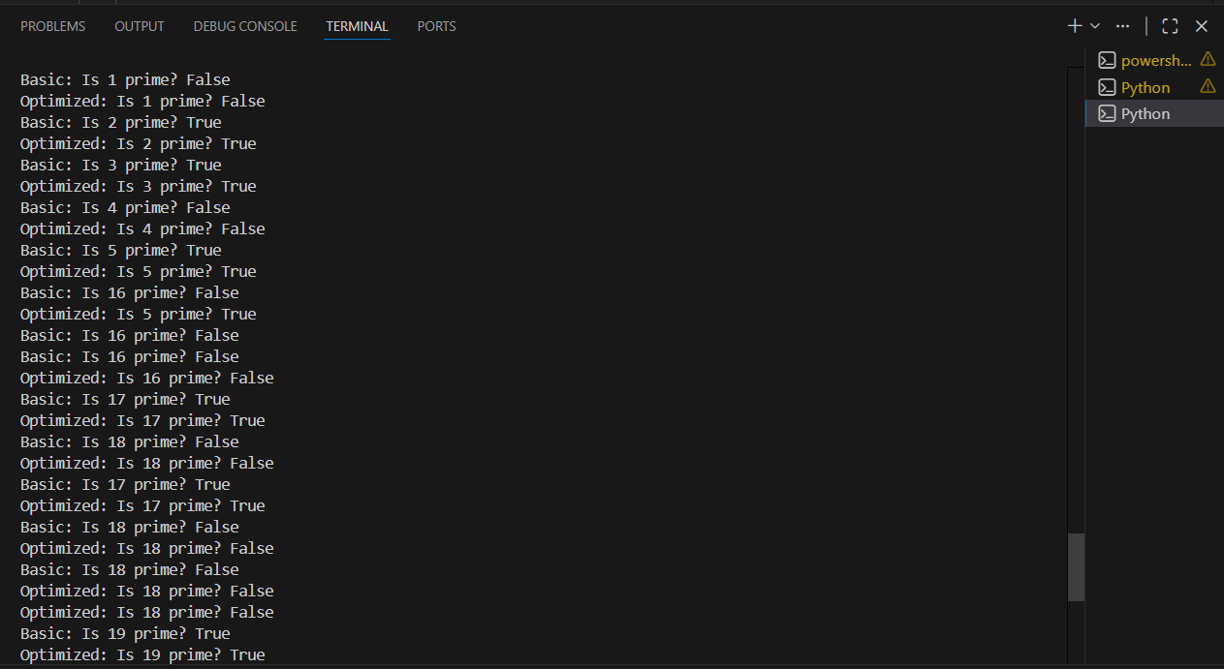
Justification:The basic approach checks divisibility up to N−1, resulting in unnecessary iterations and higher time complexity. The optimized approach checks only up to √N because any factor larger than √N must have a corresponding smaller factor.

