INTERACTIVE TABLEAU DASHBOARD
PLANNING & DESIGN BLUEPRINT
E-Commerce Sales & Profit Performance Dashboard
Prepared as a planning document for Tableau dashboard implementation
Dataset: Ecommerce_Sales_Dashboard_Practice.csv
Recommended tool: Tableau Desktop / Tableau Public

1. Executive Summary
This document provides a complete blueprint for an interactive Tableau dashboard designed to analyze e-commerce sales, profitability, order volume, category performance, regional performance and product-level results. The purpose of the planning stage is to define the business questions, KPIs, visualizations, layout, interaction model, color strategy and user journey before the dashboard is built. The final Tableau dashboard should allow a manager or analyst to move from a high-level performance summary to detailed investigation of trends, categories, regions and products.

2. Dashboard Objective
The primary objective is to create a single interactive analytical view that helps users understand what is driving sales and profit, when performance changes, which categories and regions perform well, and which products may require attention.
- Monitor overall sales, profit, orders and profit margin.
- Identify monthly sales and profitability trends.
- Compare category and sub-category performance.
- Evaluate regional performance.
- Identify top-performing and loss-making products.
- Allow users to filter and investigate the data interactively.
- Support data-driven business decisions rather than relying only on summary numbers.

3. Target Audience
- Sales Managers – monitor revenue and order performance.
- Business Managers – evaluate profitability and identify improvement areas.
- Business/Data Analysts – investigate trends and segment performance.
- Senior Management – obtain a concise overview before drilling into details.

4. Dataset Overview
The supplied practice dataset is an e-commerce transaction-level dataset designed for Tableau dashboard practice. It contains 5,000 transaction-line records covering January 2023 to December 2025. It includes dimensions such as category, product, customer segment, city, state and region, along with measures such as sales, quantity, discount and profit.
Field | Type | Purpose
Order ID | Dimension | Transaction/order identification
Order Date | Date | Time-series analysis
Ship Date | Date | Delivery/shipping analysis
Segment | Dimension | Customer segment comparison
Region | Dimension | Geographic comparison
Category / Sub-Category | Dimension | Product hierarchy
Product Name | Dimension | Product-level analysis
Quantity | Measure | Order volume
Discount | Measure | Discount analysis
Sales | Measure | Revenue
Profit | Measure | Profitability
Profit Margin | Calculated Measure | Profit as a percentage of sales
Important note: This CSV is a practice dataset created for this assignment. If your instructor specifically requires an externally sourced public dataset, use Tableau's official Sample Superstore dataset instead and keep the same dashboard planning structure.

5. Business Questions
1. What is the overall sales and profit performance?
2. How many orders are being generated?
3. How does profit margin change over time?
4. Which categories generate the highest sales?
5. Which categories generate the highest profit?
6. Which regions contribute most to sales and profit?
7. Which products are the strongest performers?
8. Which products have low or negative profitability?
9. Does high sales necessarily result in high profit?
10. How do results change when the user selects a year, region or category?

6. KPI Strategy
KPI | Tableau Calculation | Why It Matters | Position
Total Sales | SUM([Sales]) | Shows overall revenue generated | Top-left
Total Profit | SUM([Profit]) | Shows financial return | Top row
Total Orders | COUNTD([Order ID]) | Measures transaction volume | Top row
Profit Margin | SUM([Profit]) / SUM([Sales]) | Shows profitability relative to sales | Top row

7. Planned Visualizations
View | Chart | Fields | Purpose | Interaction
Monthly Sales & Profit Trend | Line chart | Order Month, Sales, Profit | Detect trends and unusual changes | Click month to filter
Sales by Category | Horizontal bar | Category, Sales | Compare revenue contribution | Category selection filters dashboard
Profit by Category | Horizontal bar | Category, Profit | Compare profitability | Highlights selected category
Regional Performance | Map / filled map | State/Region, Sales or Profit | Identify geographic patterns | Region selection filters
Top & Bottom Products | Ranked bar | Product Name, Sales/Profit | Identify products requiring attention | Responds to filters
Category × Region | Highlight table | Category, Region, Profit Margin | Find combinations with strong/weak performance | Highlight selection

8. Dashboard Layout Strategy
The layout follows a top-to-bottom analytical hierarchy. Users first see the overall business position, then the time trend, followed by category, geographic and product detail. This prevents users from being overwhelmed by detailed charts before understanding the headline metrics.
- Top: dashboard title and global filters.
- Second row: four KPI cards for Sales, Profit, Orders and Profit Margin.
- Middle: large monthly trend chart because time is a key analytical dimension.
- Lower-middle: category sales and profit comparisons.
- Bottom: regional performance, product ranking and category-region comparison.
- Keep whitespace around major sections and avoid excessive decorative elements.

9. Dashboard Wireframe / Mock-up
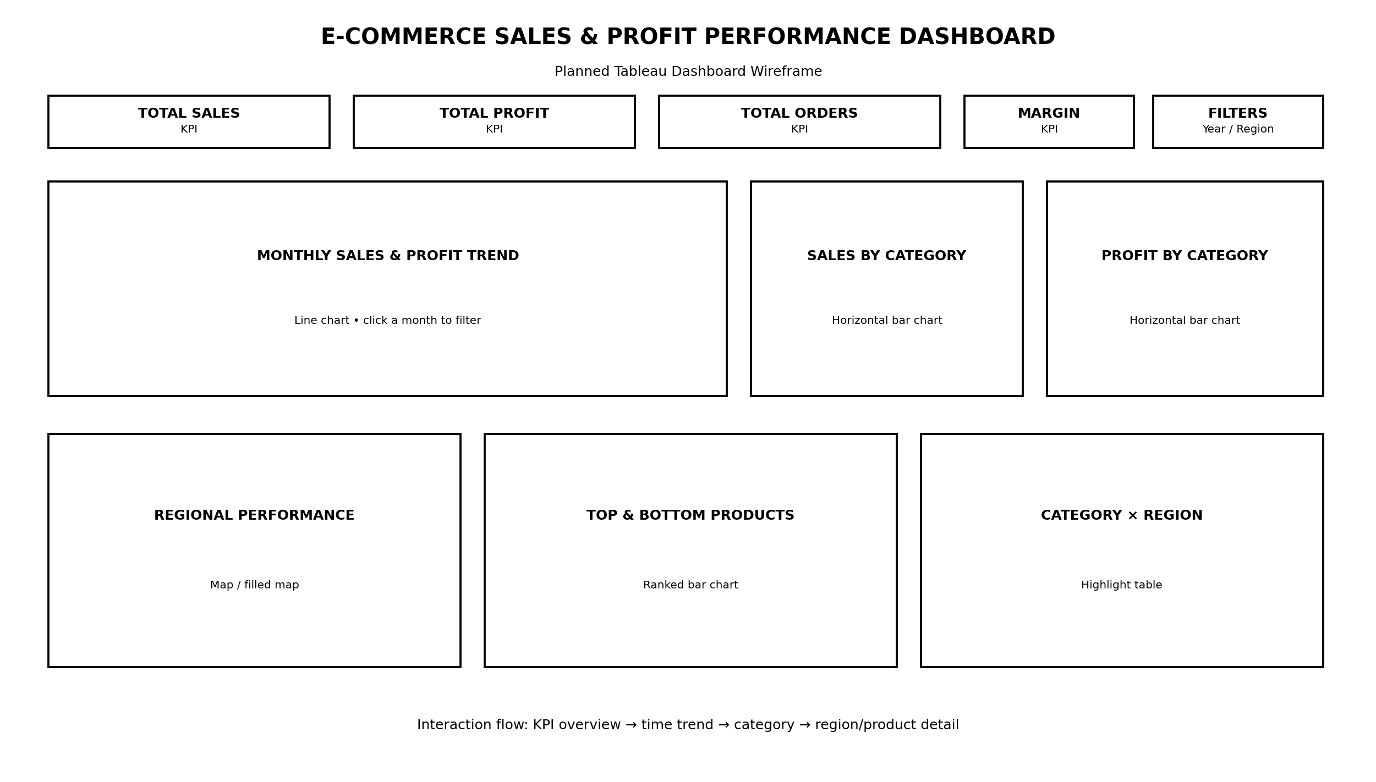
The wireframe is a planning sketch rather than the final Tableau dashboard. The final dashboard should preserve the same information hierarchy while adjusting spacing and sizing based on the actual Tableau canvas.

10. Color and Visual Design Strategy
- Use a clean light background with strong contrast for text.
- Use one consistent visual treatment for Sales across the dashboard.
- Use a consistent positive/negative convention for Profit: positive performance should be visually distinct from losses.
- Reserve warning or negative emphasis for genuinely important exceptions rather than using bright colors everywhere.
- Keep fonts consistent and readable; avoid decorative fonts.
- Use direct labels and concise titles so the user does not have to decode the visualization.
- Avoid unnecessary 3D charts, excessive borders and decorative graphics.

11. Interaction Design
Interaction | Trigger | Effect | Reason
Year filter | Select Year | Updates KPIs and all charts | Compare periods
Region filter | Select Region | Updates all views | Geographic investigation
Category filter | Select Category | Updates trends, products and regions | Category drill-down
Chart filter action | Click a bar/mark | Filters related views | Move from summary to detail
Highlight action | Hover/click mark | Highlights corresponding values | Reduce visual search time
Reset | Clear filters | Returns dashboard to default view | Easy recovery/navigation

12. Data Story / User Journey
1. User opens the dashboard and sees four headline KPIs.
2. User checks the monthly trend to determine whether performance is stable, improving or declining.
3. User compares category sales and profit to find categories that generate revenue but may not generate equivalent profit.
4. User examines regional performance to determine where the strongest or weakest results occur.
5. User investigates top and bottom products to identify the detailed drivers.
6. User uses filters and chart selections to test specific questions and reach an actionable conclusion.

13. Integration Rationale
The visualizations are intentionally connected rather than presented as independent charts. The KPI cards answer 'How are we doing?', the line chart answers 'When is performance changing?', the category charts answer 'What is driving performance?', the map answers 'Where is performance occurring?', and the product ranking answers 'Which specific products require attention?'. Interactive filtering connects these levels so that a user can move from a broad observation to a detailed explanation.

14. Planned Tableau Calculated Fields
Calculated Field | Formula | Use
Profit Margin | SUM([Profit]) / SUM([Sales]) | KPI and profitability views
Order Month | DATETRUNC('month',[Order Date]) | Monthly trend
Order Count | COUNTD([Order ID]) | Total Orders KPI
Profit per Order | SUM([Profit]) / COUNTD([Order ID]) | Optional efficiency KPI

15. Implementation Roadmap
Phase | Activities
Phase 1 – Dataset & Understanding | Download/connect dataset, inspect fields, verify data types, identify dimensions and measures.
Phase 2 – Data Preparation | Check nulls, duplicates, date fields, numerical fields and categorical values.
Phase 3 – EDA | Create quick exploratory views to understand sales, profit, categories, regions and trends.
Phase 4 – Calculations | Create Profit Margin, Order Month, Order Count and any additional calculated fields.
Phase 5 – Individual Worksheets | Build KPI support sheets, line chart, category bars, map, product ranking and highlight table.
Phase 6 – Dashboard Assembly | Arrange worksheets according to the wireframe and set dashboard size.
Phase 7 – Interactions | Add filters, filter actions, highlight actions, tooltips and reset behavior.
Phase 8 – Formatting | Apply typography, spacing, number formats, titles, legends and consistent visual hierarchy.
Phase 9 – Testing | Test filters, actions, edge cases, calculations and usability.
Phase 10 – Final Documentation | Capture screenshots, explain insights, publish/export and prepare final project files.

16. Suggested 30–35 Hour Work Plan
Activity | Target Time
Dataset understanding and data dictionary | 3 hours
Business questions and KPI planning | 3 hours
Exploratory analysis | 4 hours
Visualization selection and rationale | 3 hours
Wireframe/layout design | 4 hours
Interaction and filter planning | 3 hours
Color/UX strategy | 2 hours
Tableau worksheet planning | 4 hours
Documentation and diagrams | 5 hours
Review and refinement | 2 hours

17. Step-by-Step Guide for Completing the Assignment
1. Download/open the supplied CSV dataset and save it inside a dedicated Tableau project folder.
2. Open Tableau and connect to the CSV using Connect → Text File.
3. Go to the Data Source page and check field names, data types and sample values.
4. Confirm Order Date and Ship Date are recognized as dates; Sales, Profit, Quantity and Discount as numeric measures.
5. Create the calculated fields listed in Section 14.
6. Create exploratory worksheets first; do not immediately build the final dashboard.
7. Create the KPI views and verify their aggregation, especially Total Orders using COUNTD(Order ID).
8. Create the Monthly Sales & Profit Trend using Order Month and SUM(Sales)/SUM(Profit).
9. Create Sales by Category and Profit by Category as horizontal bar charts.
10. Create Regional Performance using Region/State and Sales or Profit.
11. Create Top & Bottom Products using Product Name and Profit, with sorting and an appropriate filter.
12. Create the Category × Region highlight table if the dashboard has enough space.
13. Create a new Dashboard and place the worksheets according to the wireframe.
14. Add global filters for Year, Region and Category and apply them to all relevant worksheets.
15. Add dashboard filter/highlight actions so selections in charts affect related views.
16. Format numbers: Sales/Profit as currency or appropriate numeric units, Profit Margin as percentage and Orders as whole numbers.
17. Review the dashboard at the intended screen size and remove unnecessary legends, labels and visual clutter.
18. Test the dashboard using at least three scenarios: no filters, one category selected, and one region/year selected.
19. Capture screenshots of the final dashboard and use them later in the implementation/report phase.
20. Save the Tableau workbook and keep the dataset, workbook and documentation in one project folder.

18. Final Submission Checklist
- DOC/DOCX contains objective and target audience.
- Dataset overview and field descriptions are included.
- Business questions and KPIs are clearly justified.
- Each visualization has a reason for being selected.
- Dashboard wireframe/mock-up is embedded.
- Filters and interactions are documented.
- Color and layout strategy are explained.
- Data-story/user journey is explained.
- Implementation roadmap is included.
- The document is proofread and professionally formatted.
- Dataset and Tableau workbook are stored with clear filenames.

19. Recommended Project Folder
Keep the project organized as follows:
- 01_Data/Ecommerce_Sales_Dashboard_Practice.csv
- 02_Tableau/Ecommerce_Sales_Dashboard.twbx
- 03_Documentation/Tableau_Dashboard_Planning_Blueprint.docx
- 04_Mockups/tableau_dashboard_wireframe.png
- 05_Screenshots/ (final dashboard screenshots)

20. Dataset Source Note
For a fully public and officially supported alternative, Tableau provides Sample Superstore through its Tableau Public sample-data page. Tableau describes Superstore as a useful dataset because it contains dates, geographic data, product hierarchies, sales and profit, and transaction-level records suitable for many visualization types.
Official reference: Tableau Public Sample Data – Superstore: https://public.tableau.com/app/learn/sample-data
If your instructor requires the dataset itself to be publicly sourced, download the official Superstore file from the Tableau page above and replace the practice CSV while keeping this planning document's analytical structure.

Conclusion
This blueprint is designed to be used as the specification for the next stage of the project. The final Tableau workbook should implement the same hierarchy: KPI summary → time trend → category analysis → geographic analysis → product detail, with filters and dashboard actions connecting the views. This approach keeps the dashboard focused on decisions and insights rather than simply displaying a collection of charts.

