1. Pwd

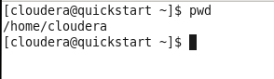

1. ls – Command used to list files under the path given.

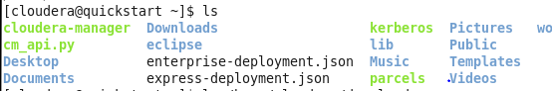



1. vi – It shows the linux version

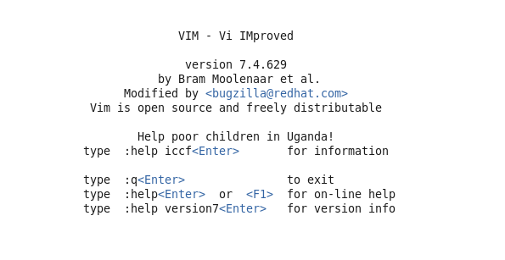

1. mkdir – To create new directory

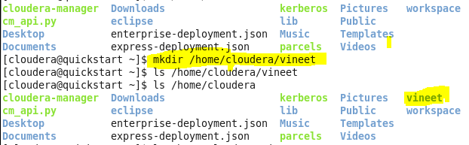

1. cd – To change directory path



1. Date – Gives you system date and time



1. mv – To move files/folder to one path to another

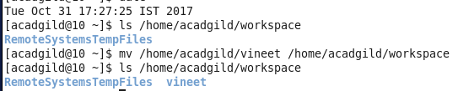

1. rm – To remove files

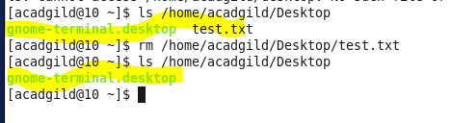

1. echo – It will print the text typed after the command. You can also use this command to save that text into file.

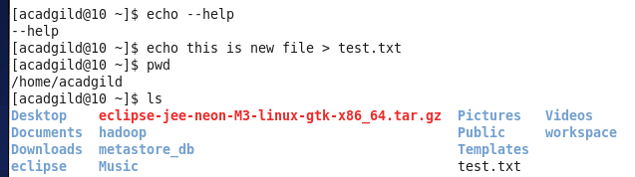

1. cat – Used to read text inside a file.

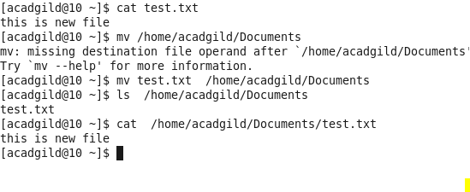

1. cp – To copy file/folder from destination path to other path. Please make sure there is no file of same name is present on new path else it will copy the file without any error.

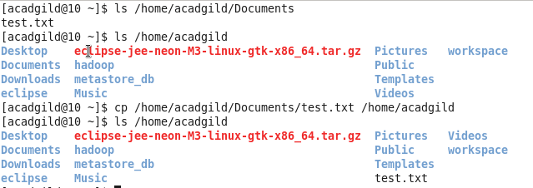

1. who - The who command prints information about all users who are currently logged in.

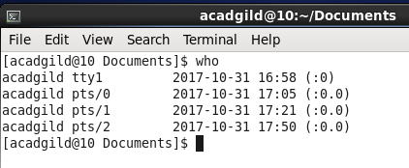

1. cal – Shows Calendar

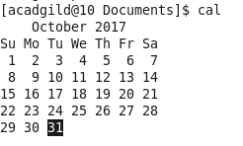

1. touch - It changes file timestamps. It is also an easy way to create empty files.

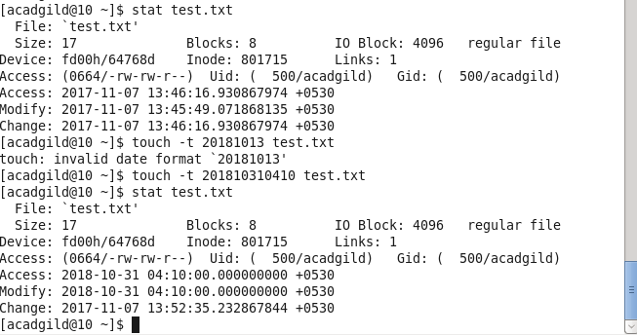

1. which – Locate the executable file associated with a given command.It returns the pathnames of the files (or links) which would be executed in the current environment.

