1.Fetch date and temperature from temperature_data where zip code is greater than

300000 and less than 399999.

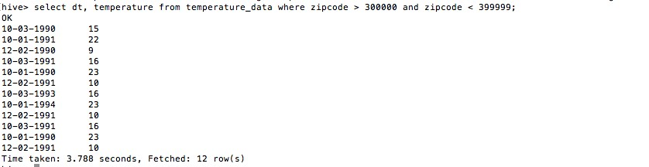

1. Calculate maximum temperature corresponding to every year from temperature_data table.

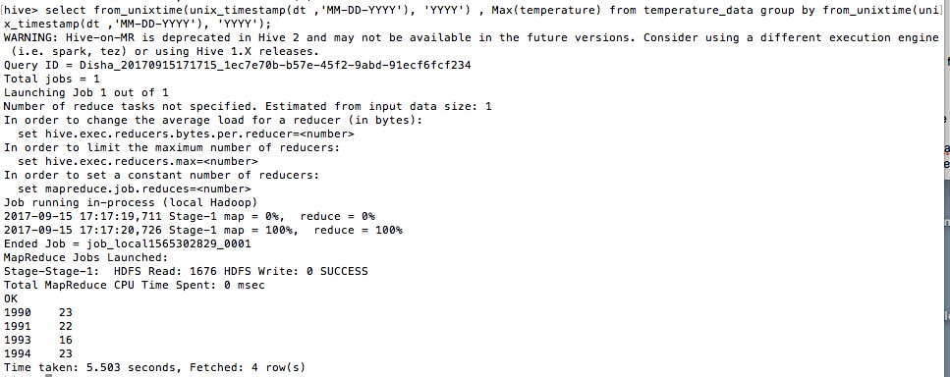

1. Calculate maximum temperature from temperature_data table corresponding to those years which have at least 2 entries in the table.

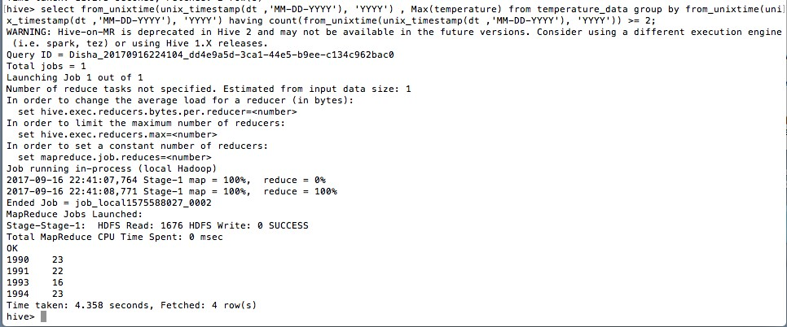

1. Create a view on the top of last query, name it temperature_data_vw.



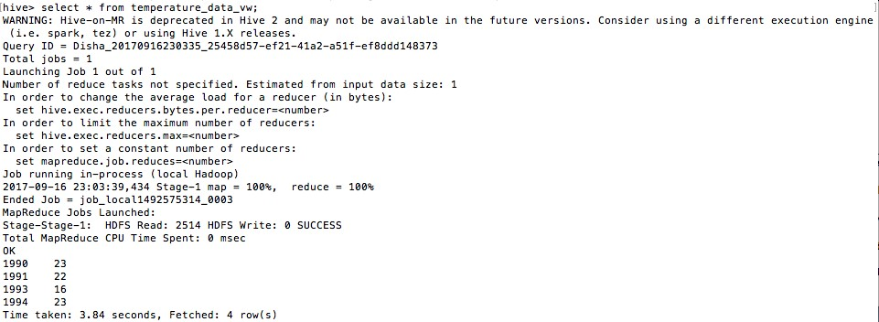

1. Export contents from temperature_data_vw to a file in local file system, such that each

file is '|' delimited.

