**EXPLORATORY DATA ANALYSIS**

**On Hotel Booking**

In our analysis, we observed a compelling insight regarding reservation cancellations. It is evident that a substantial portion of reservations remains unaffected by cancellations. Impressively, a significant majority of our clients, representing 63% of the total reservations, follow through with their booking commitments, contributing significantly to the hotel's earnings. However, it is worth noting that approximately 37% of clients choose to cancel their reservations, highlighting the substantial impact this decision has on the hotel's revenue. Understanding the dynamics of this cancellation rate can help us implement strategies to optimize occupancy and mitigate potential revenue losses."

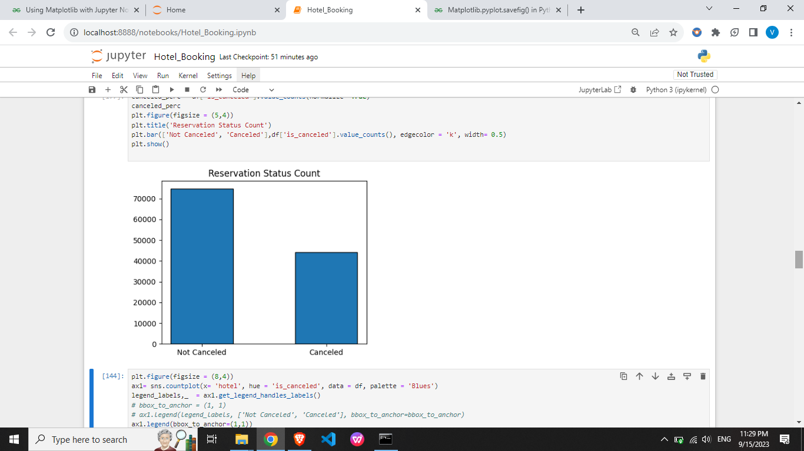

When comparing resort hotels to city hotels, we notice that city hotels tend to attract more bookings. This variation in booking frequency hints at the likelihood that resort hotels may offer a premium experience, often associated with higher pricing compared to city hotels.

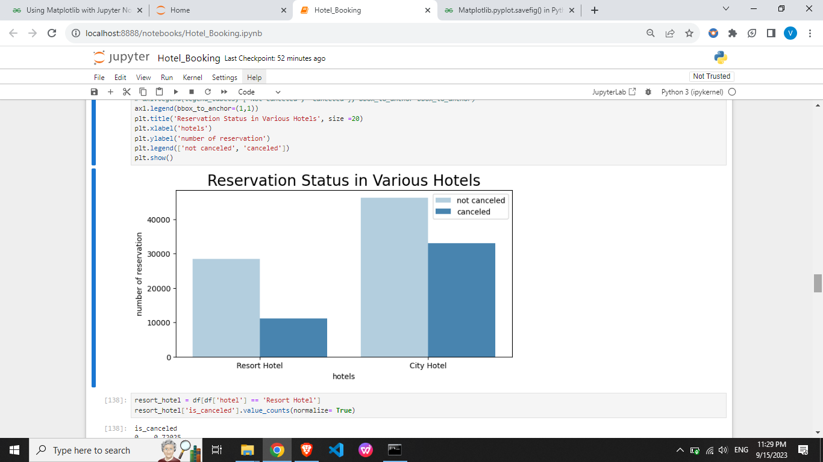

The line graph below reveals fluctuations in the average daily rates for city and resort hotels. Interestingly, there are instances where the average rate for a city hotel falls below that of a resort hotel. Furthermore, it becomes evident that weekends and holidays frequently witness an upsurge in resort hotel rates, reflecting the impact of these special occasions on pricing dynamics.

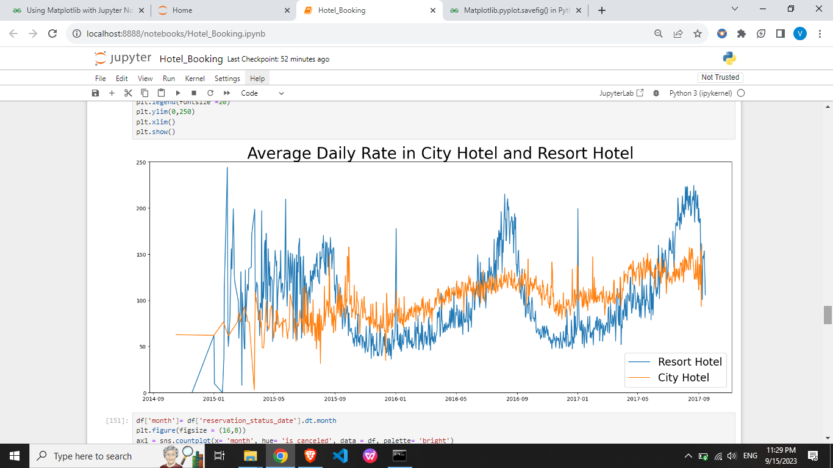

In our data analysis journey, I crafted a grouped bar graph to uncover the months with the highest and lowest reservation levels, categorized by their confirmation status. It's like delving into a story told by the data itself.

Here's what I found: August turned out to be the star of the show, with the highest number of both confirmed and canceled reservations. It's a month of high activity in our booking calendar. But the real twist comes in January, which surprises us with the most canceled reservations.

These two months paint a vivid picture of our reservation dynamics, showing how they ebb and flow throughout the year.

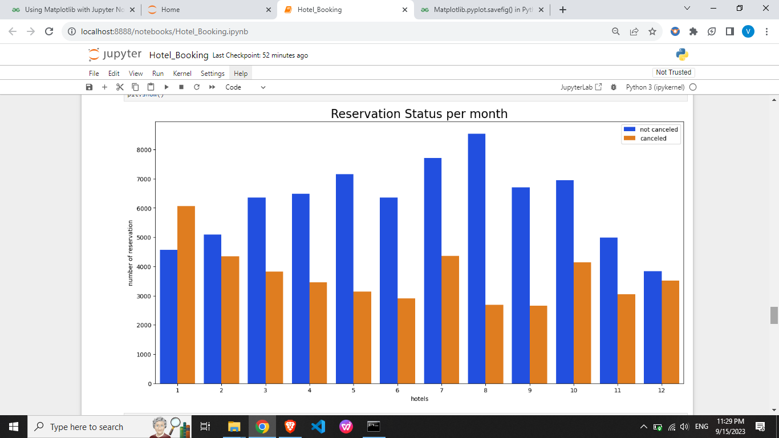

The bar graph below tells a straightforward story: when accommodation prices are at their highest, cancellations become more common. Conversely, when prices are lower, cancellations decrease. It strongly suggests that the cost of accommodation is the main factor driving cancellations. When we look at the data again with this filter in mind, it becomes even clearer that price is a key factor influencing guests' decisions

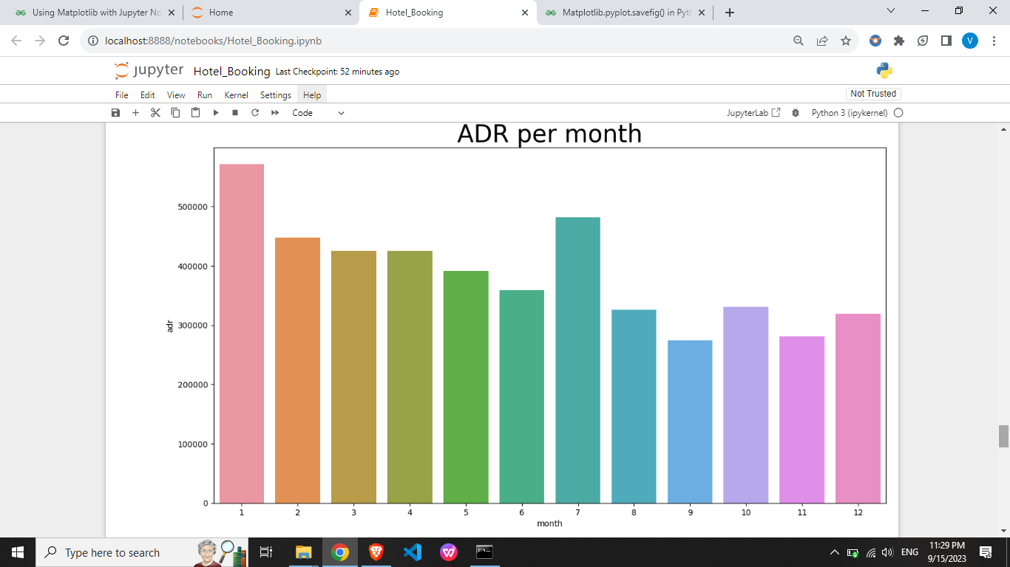

**Now let’s see which country has the highest reservation cancelled.**

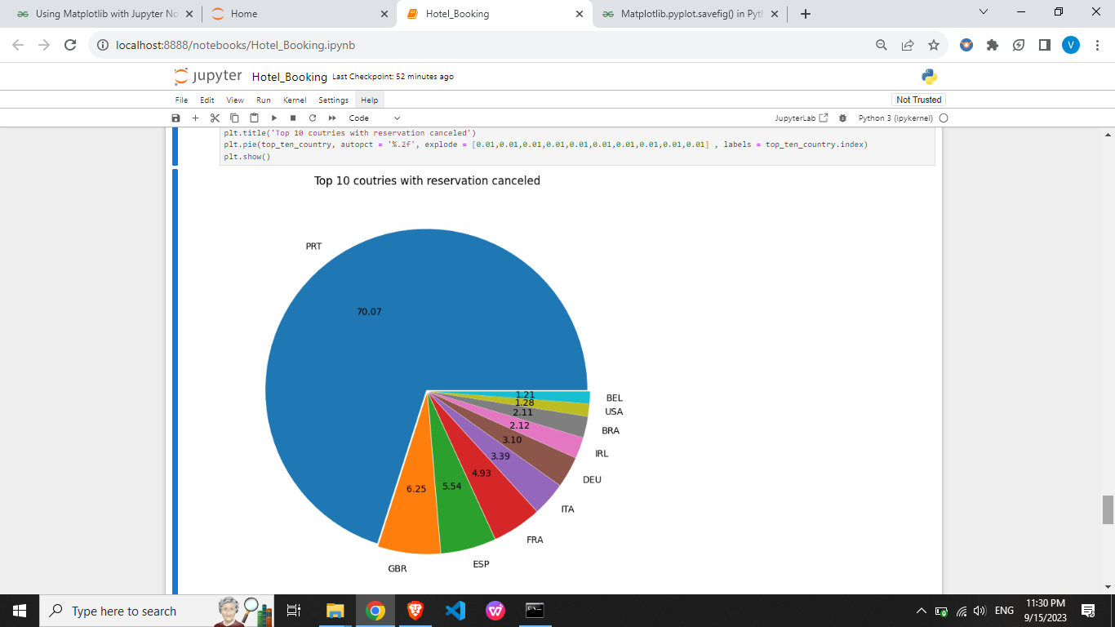

The country with highest number of cancellations is **Portugal.**

Examining the graph, we observe a consistent pattern: reservations tend to be canceled more frequently when the average daily rate is higher, as opposed to when it's not canceled. This observation aligns seamlessly with our earlier analyses, providing further compelling evidence that elevated prices are a driving force behind increased reservation cancellations. It underscores the correlation we've uncovered between higher costs and a greater likelihood of cancellations

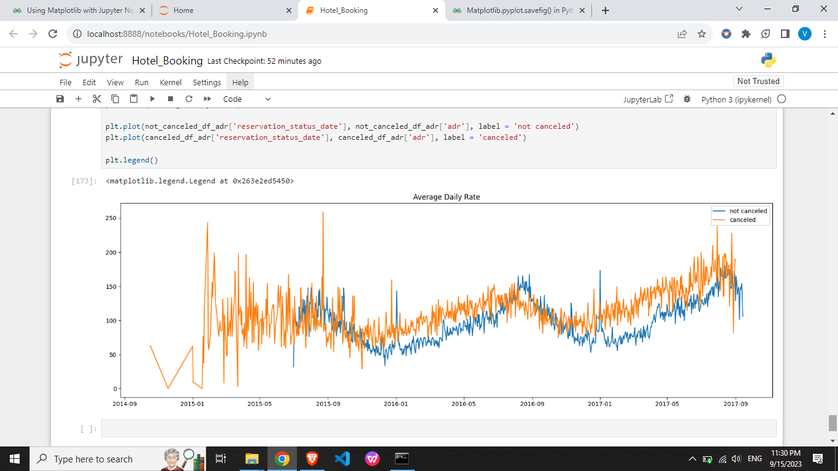

**SUGGESTIONS**

**Pricing Strategies**: Lower rates for specific hotels in high-cancellation areas, offer location-based discounts, and consider consumer discounts to reduce cancellations.

**Weekend and Holiday Discount**s: Provide discounts on resort hotel room prices during weekends and holidays to balance the cancellation ratio.

**January Campaigns**: Launch marketing campaigns with enticing offers in January, the month with the highest cancellations, to boost revenue.

**Quality Improvement**: Enhance hotel quality and services, particularly in high-cancellation regions like Portugal, to decrease cancellation rates.

@https://github.com/Vineet-Tanwar