LAB-3

# AIM : FUNCTION, CLASS and NULLABILITY

# Prac-1 : Check for prime

# Code :

# import 'dart:math';

# bool isPrime({required int number}) {

# if (number == 2 || number == 3) {

# return true;

# } else {

# for (int i = 2; i <= sqrt(number); i++) {

# if (number % i == 0) {

# return false;

# }

# }

# }

# return true;

# }

# void main(List<String> arguments) {

# print(isPrime(number: 12));

# print(isPrime(number: 5));

# }

# Output :

# 

# Prac-2 : reapeatTask using Anonymous function

# Code :

# int repeatTask(int times, int input, int Function(int) task) {

# int result = input;

# for (int i = 0; i <= times; i++) {

# result = task(result);

# }

# return result;

# }

# void main() {

# print(repeatTask(2, 4, (int x) {

# return x * x;

# }));

# }

# Output :

# 

# Prac-3 : repeatTask using Arrow Function

# Code :

# int repeatTask(int times, int input, int Function(int) task) {

# int result = input;

# for (int i = 0; i <= times; i++) {

# result = task(result);

# }

# return result;

# }

# void main() {

# int ans = repeatTask(2, 4, (int x) => x * x);

# print(ans);

# }

# Output :

# 

# Prac-4 : Bert and Ernie

# Code :

# *class Student {*

# *final String firstName;*

# *final String lastName;*

# *final int grade;*

# *Student(this.firstName, this.lastName, this.grade);*

# *void show() {*

# *print("Firstname = $firstName");*

# *print("Lastname = $lastName");*

# *print("Grade = $grade");*

# *}*

# *}*

# *void main(List<String> arguments) {*

# *Student bert = Student("Bert", "Scofield", 95);*

# *Student ernie = Student("Ernie", "Queen", 85);*

# *bert.show();*

# *ernie.show();*

# *}*

# Output :

# 

# Prac-5 : find volume and surface of sphere

# Code :

# class Sphere {

# final double radius;

# static const double pie = 3.1415926535897932;

# const Sphere({required *this*.radius});

# double getSurface() {

# return (4 * pie * radius * radius);

# }

# double getVolume() {

# return ((4 / 3) * pie * (radius * radius * radius));

# }

# }

# void main() {

# Sphere sphere = Sphere(radius: 12);

# print(sphere.getSurface());

# print(sphere.getVolume());

# }

# Output :

# 

Prac-6 :get random number or null if return null then print 0

**Code:**

import 'dart:math';

int? getRandomNumberOrNull() {

  int randomNumber = Random().nextInt(2);

  if (randomNumber == 0) {

    return null;

  } else {

    return 42;

  }

}

void main() {

  final result = getRandomNumberOrNull() ?? 0;

  print(result);

}

**Output:**

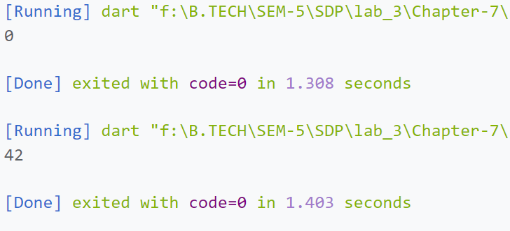

Prac-7 :print name and surname based on user selection using boolean property surnameFirst

**Code:**

class Name {

  final String name;

  String surName = "";

  bool surNameFirst;

  Name(*this*.name, *this*.surNameFirst, [*this*.surName = ""]);

  @override

  String toString() {

    if (surNameFirst) {

      return ("$surName $name");

    } else {

      return (name);

    }

  }

}

void main() {

  Name micheal = Name("Micheal", true, "Scofield");

  Name oliver = Name("Oliver", false, "Queen");

  print(micheal.toString());

  print(oliver.toString());

}

**Output:**

