**LAB-1**

AIM :To learn the basics of Python programming language**.**

Q-1 Calculate the sum of all numbers from 1 to a given number

**Code :**

n = input("Enter Number : ")

sum = 0

for i in range(0, (*int*(n) + 1)) :

    sum += i

print("Sum = " + *str*(sum))

**Output**

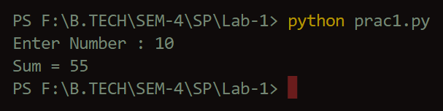

Q-2 Write a program to display all prime numbers within a range

**Code :**

a = *int*(input("Enter Lower Bound : "))

b = *int*(input("Enter Upper Bound : "))

for i in range(a, *int*(b) + 1) :

    if i == 1 :

        continue

    for j in range(2, i) :

        if (i % j == 0) :

            break

    else :

        print(i)

**Output**

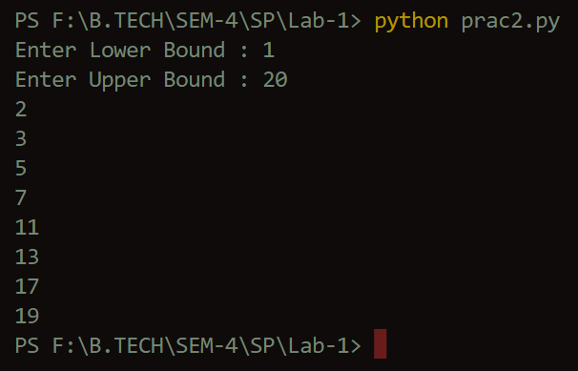

Q-3 A shop will give discount of 10% if the cost of purchased quantity is more than 1000. Ask user for quantity Suppose, one unit will cost 100. Judge and print total cost for user.

**Code :**

quantity = *int*(input("Enter Quantity : "))

totalCost = *int*(100 * quantity)

if(totalCost >= 1000) :

    discount = (10 * totalCost) / 100

    totalCost -= discount

print("Total cost = " + *str*(totalCost))

**Output**

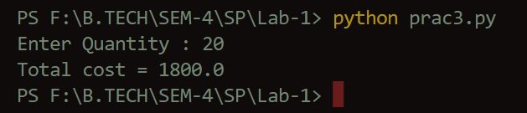

Q-4 A school has following rules for grading system:

a. Below 25 - F

b. 25 to 45 - E

c. 45 to 50 - D

d. 50 to 60 - C

e. 60 to 80 - B

f. Above 80 - A

Ask user to enter marks and print the corresponding grade.

**Code :**

marks = *int*(input("Enter Marks : "))

if(marks > 80) :

    print("A")

elif(marks > 60 and marks <= 80) :

    print("B")

elif(marks > 50 and marks <= 60) :

    print("C")

elif(marks > 45 and marks <= 50) :

    print("D")

elif(marks > 25 and marks <= 45) :

    print("E")

else :

    print("F")

**Output**

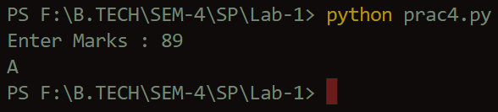

Q-5 Write a program to find largest number out of three numbers enterd by the user.

**Code :**

no1 = *int*(input("Enter no 1 : "))

no2 = *int*(input("Enter no 2 : "))

no3 = *int*(input("Enter no 3 : "))

if(no1 > no2 and no1 > no3) :

    print("Largest is " + *str*(no1))

elif(no2 > no1 and no2 > no3) :

    print("Largest is " + *str*(no2))

else :

    print("Largest is " + *str*(no3))

**Output**

