**LAB-2**

AIM :To learn about various data structures in Python  
- List  
- Tuple  
- Dictionary  
- String

Q-1 Given the participants' score sheet for your University Sports Day, you are required to find the runner-up n score. You are given scores. Store them in a list and find the score of the runner-up.

**Code :**

participants = *int*(input("Enter Number of participants : "))

score = []

for i in range(1, participants + 1) :

    score_var = *int*(input("Enter Score for Participant " + *str*(i) + " : "))

    score.append(score_var)

score.sort()

print("Runner UP Score : " + *str*(score[participants - 2]))

**Output**

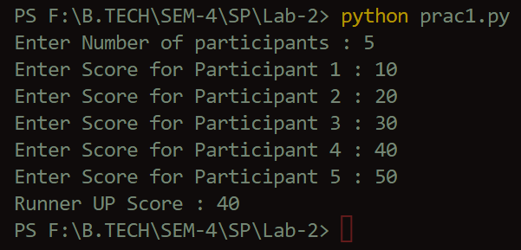

Q-2 Write a Python script to print a dictionary where the keys are numbers between 1 and 15 (both included) and the values are square of keys.

**Code :**

d=*dict*()

for x in range(1,16):

    d[x] = x * x

print(d)

**Output**



Q-3 Create a list of intergers and print squares of all numbers using list Comprehension.

**Code :**

*list* = [1,2,3,4,5]

Square = []

for i in *list* :

    Square.append(i * i)

print(Square)

**Output**

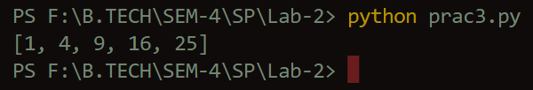

Q-4 Create a dictionary of country and their capital. Take n inputs from the user. After the dictionary is created, perform the following operations :

- Search based on a key

- Delete an element based on a key

**Code :**

number = *int*(input("Enter number of operation : "))

print("1 for search | 2 for delete")

countyDic = {

    "India" : "Delhi",

    "England" : "London",

    "Nepal" : "Katmandu",

    "Itly" : "Rome",

    "Australia" : "Canbbera",

    "Newzealand" : "Wellington",

}

for i in range(1,number + 1) :

    choice = *int*(input("Enter Choice : "))

    if(choice == 1) :

        key = *str*(input("Search : "))

        capital = countyDic.get(key)

        print("Capital = " + *str*(capital))

    if(choice == 2) :

        key = *str*(input("Delete : "))

        capital = countyDic.pop(key)

        print(*str*(capital) + " is Deleted")

        print(countyDic)

**Output**

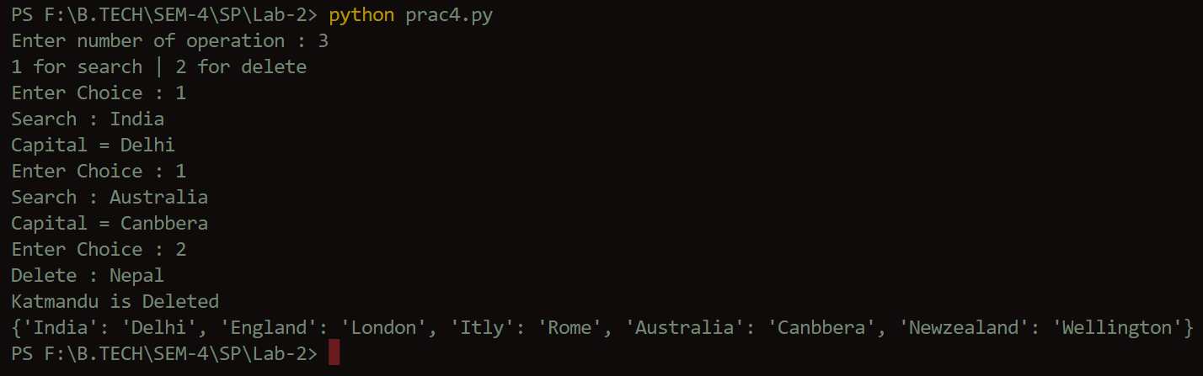

Q-5 Write a Python program to count the number of characters (character frequency) in a string.

**Code :**

string = *str*(input("Enter String : "))

print("Number of Character in String is : " + *str*(len(string)))

**Output**

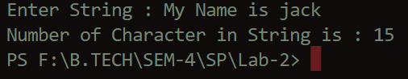

Q-6 Write a Python program to convert a given string into a list of words, modify one word and convert it back to the string.

**Code :**

string = *str*(input("Enter String : "))

*list* = string.split(" ")

print(*list*)

list[2] = "cute"

new_string = ""

for i in *list* :

    new_string += I + “ ”

print(new_string)

**Output**

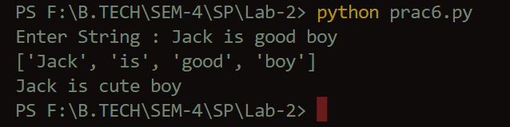

Q-7 Write a Python program to count the occurrences of each word in a given sentence.

**Code :**

def word_count(*str*) :

    count = *dict*()

*list* = *str*.split()

    for i in *list* :

        if i in count :

            count[i] += 1

        else :

            count[i] = 1

    return count

string = *str*(input("Enter String : "))

print(word_count(string))

**Output**



Q-8 Write a Python program to count occurrences of a substring in a string.

**Code :**

string = *str*(input("Enter String : "))

sub_string = *str*(input("Enter Sub-string : "))

count = *int*(string.count(sub_string))

print("Occurance of " + *str*(sub_string) + " is " + *str*(count) + " times")

**Output**

