**LAB-3**

AIM :Functions and OOP in Python.

Q-1 Write a Python function to check whether a string is a pangram or not.

Note : Pangrams are words or sentences containing every letter of the alphabet at least once.

For example : "The quick brown fox jumps over the lazy dog"

**Code :**

def isPanagram(*str*) :

    alphabet = "abcdefghijklmnopqrstuvwxyz"

    for char in alphabet :

        if char not in *str*.lower() :

            return False

    return True

string = *str*(input("Enter String : "))

if(isPanagram(string)) :

    print(string + " is Panagram")

else :

    print(string + " is not Panagram")

**Output**

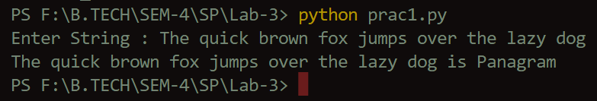

Q-2 Write a Python function that takes a list and returns a new list with unique elements of the first list.

**Code :**

def give_unique(*list*) :

    unique = []

    for item in *list* :

        if item not in unique :

            unique.append(item)

    return unique

List = [1,2,3,4,5,5,4,3,2,1]

print("With non-unique : " + *str*(List))

print("With unique : " + *str*(give_unique(List)))

**Output**

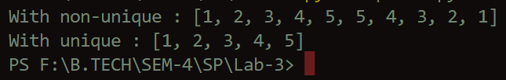

Q-3 Write a Python function that takes a list and returns product of all elements in the list.

**Code :**

def get_product(*list*) :

    product = []

    mul = 1

    for item in *list* :

        mul *= item

    product.append(mul)

    return product

List = [1,2,3,4,5]

print("Product of List : " + *str*(get_product(List)))

**Output**

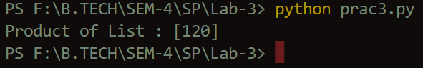

Q-4 Write a Python function student_data () which will print the id of a student (student_id). If the user passes an argument student_name or student_class the function will print the student name and class.

**Code :**

def student_data(\*\**data*):

    for element in data:

     print(*str*(element) + " = " + *str*(data[element]))

student_data(*student_id* = "059", *student_name* = "Vineet", *student_class* = "A3")

**Output**

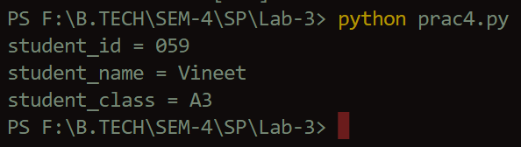

Q-5 Write a program to find largest number out of three numbers enterd by the user.

**Code :**

no1 = *int*(input("Enter no 1 : "))

no2 = *int*(input("Enter no 2 : "))

no3 = *int*(input("Enter no 3 : "))

if(no1 > no2 and no1 > no3) :

    print("Largest is " + *str*(no1))

elif(no2 > no1 and no2 > no3) :

    print("Largest is " + *str*(no2))

else :

    print("Largest is " + *str*(no3))

**Output**

