LAB -5

Q.1 WAP for HEX to BCD conversion of a byte.

Input: (2201H) = FFH

Output: (2202H) = 02

(2203H) = 55

LXI H, 2201H

MVI D, 00H

MOV C,M

LOOP:

ADI 01H

DAA

JNC SKIP

INR D

SKIP :

DCR C

JNZ LOOP

MOV L,D

MOV H,A

SHLD 2202H

HLT

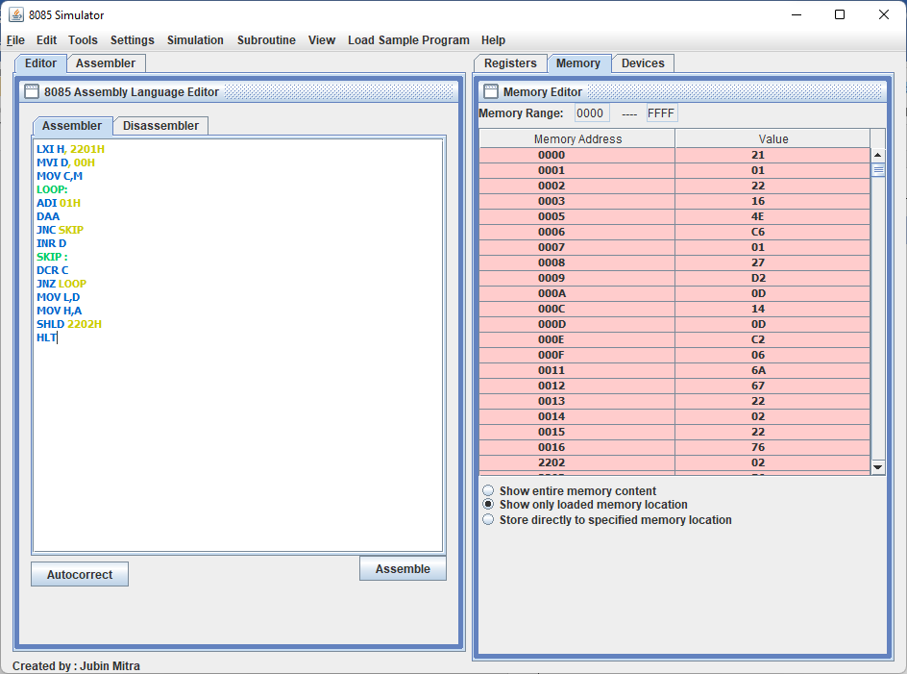

Q.2 WAP for BCD to HEX conversion of a byte.

Input: (2201H) = 28

Output: (2202H) = 1CH

LXI H,2201

MOV A,M

ADD A

MOV B,A

ADD A

ADD A

ADD B

INX H

ADD M

INX H

MOV M,A

HLT

