LAB -6

Q.1 WAP to arrange an array of data in ascending order.

Input: (2201H) = 05H (Array size)

(2202H) = 15H

(2203H) = 07H

(2204H) = 12H

(2205H) = 03H

(2206H) = 08H

Output: (2201H) = 05H (Array size)

(2202H) = 02H

(2203H) = 03H

(2204H) = 07H

(2205H) = 08H

(2206H) = 15H

LXI H,2201

MOV C,M

DCR C

REPEAT: MOV D,C

LXI H,2202

LOOP: MOV A,M

INX H

CMP M

JC SKIP

MOV B,M

MOV M,A

DCX H

MOV M,B

INX H

SKIP: DCR D

JNZ LOOP

DCR C

JNZ REPEAT

HLT

#ORG 2201

#DB 05H, 15H, 07H, 02H, 03H, 08H

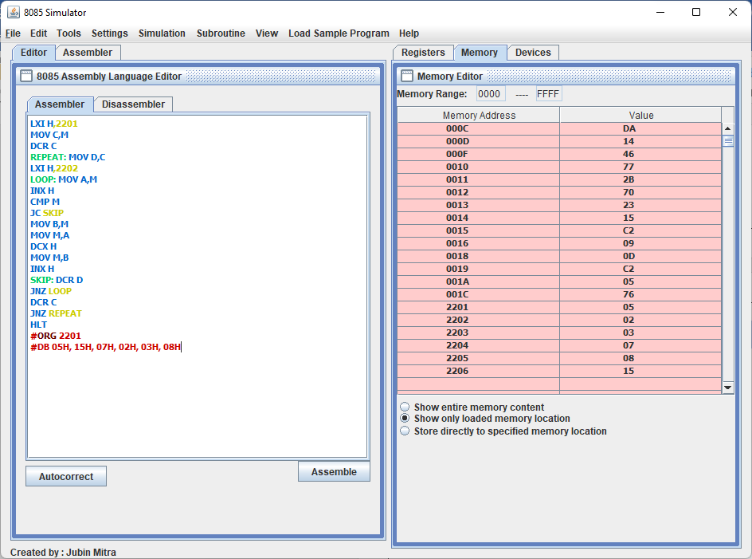

Q.2 WAP to find the factorial of a number.

Input: (2201H) = 05H

Output: (2202H) = 78H

LXI H,2201

MVI A,00

MOV B,M

MOV A,M

START2: MOV D,B

JNZ START

MOV D,A

START: DCR B

MOV E,B

DCR E

JZ CNT

MUL: ADD D

DCR E

JNZ MUL

JMP START2

CNT: STA 2202

HLT

#ORG 2201

#DB 05H

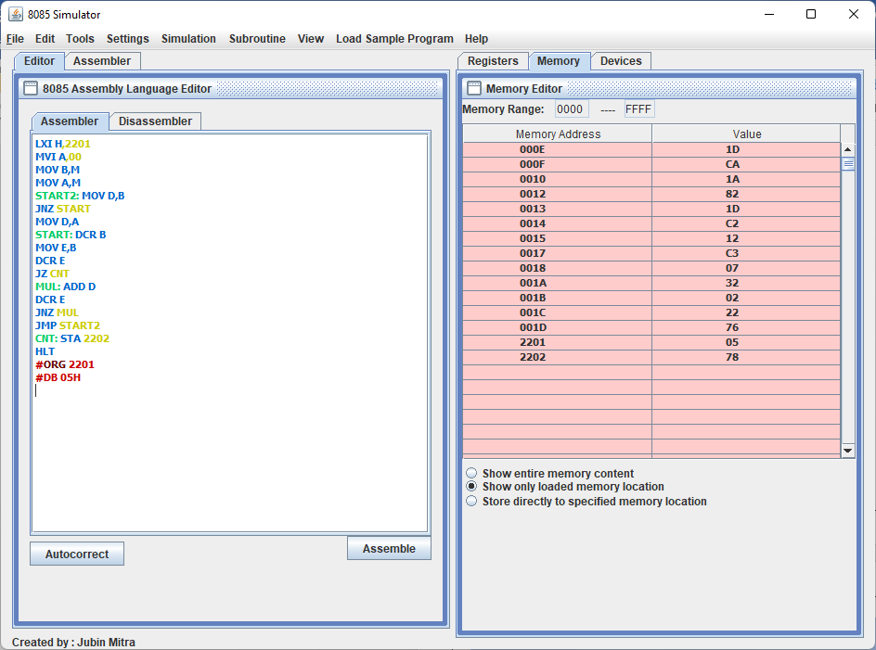

Q.3 WAP to generate Fibonacci Series having ten elements.

After Execution

Output: (2200H): 00H

(2201H): 01H

(2202H): 01H

(2203H): 02H

(2204H): 03H

(2205H): 05H

(2206H): 08H

(2207H): 0DH

(2208H): 15H

(2209H): 22H

MVI A,00

MVI B,00

MVI C,01

LXI H,2200

MVI D,09

MOV M,A

INX H

MOV M,C

JNZ SKIP

LOOP: MOV M,A

SKIP: INX H

MVI A,00

ADD B

ADD C

MOV B,C

MOV C,A

DCR D

JNZ LOOP

HLT

