- Git Setup https://confluence.atlassian.com/bitbucket/set-up-git-744723531.html
Ans:
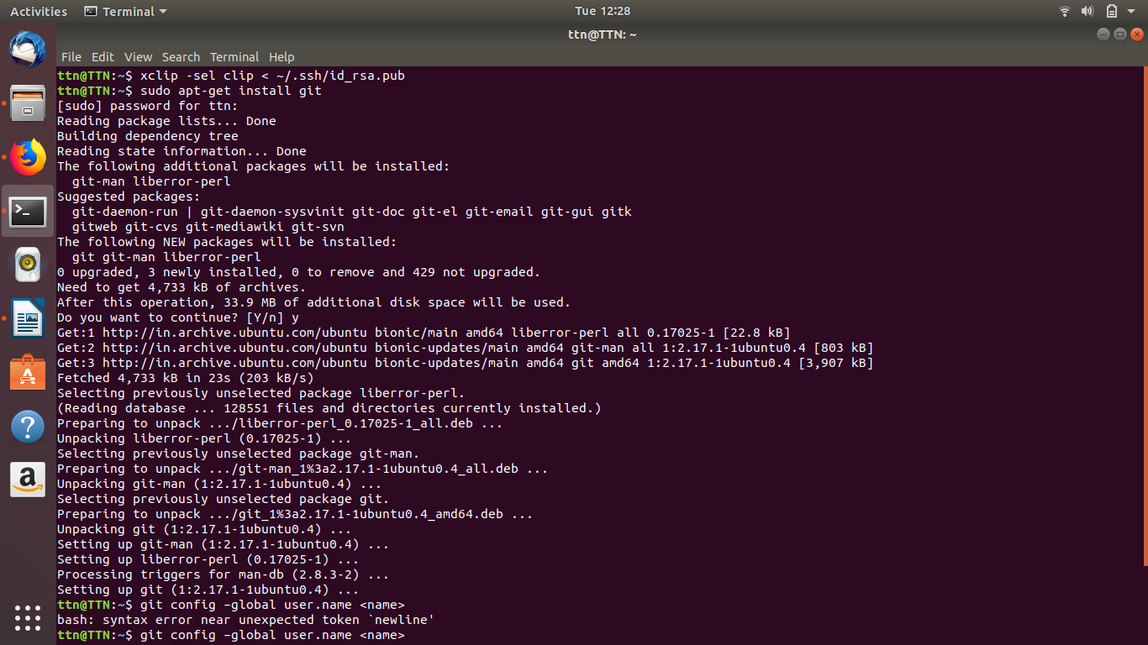
- Initialize a Git Repository
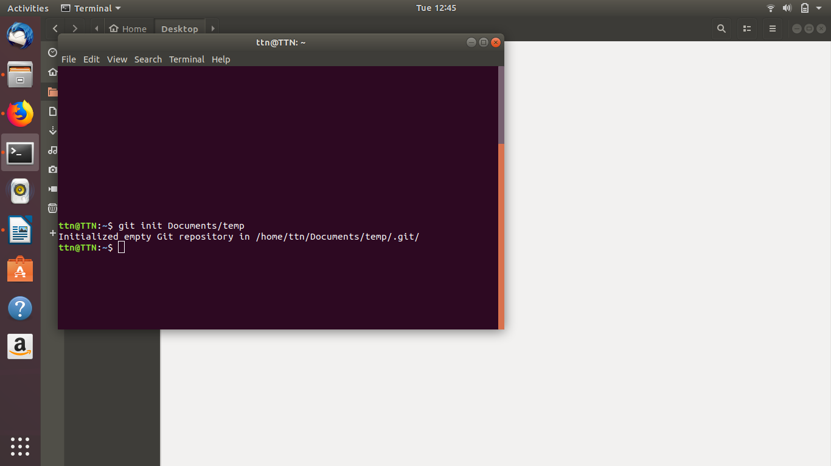

- Add files to the repository
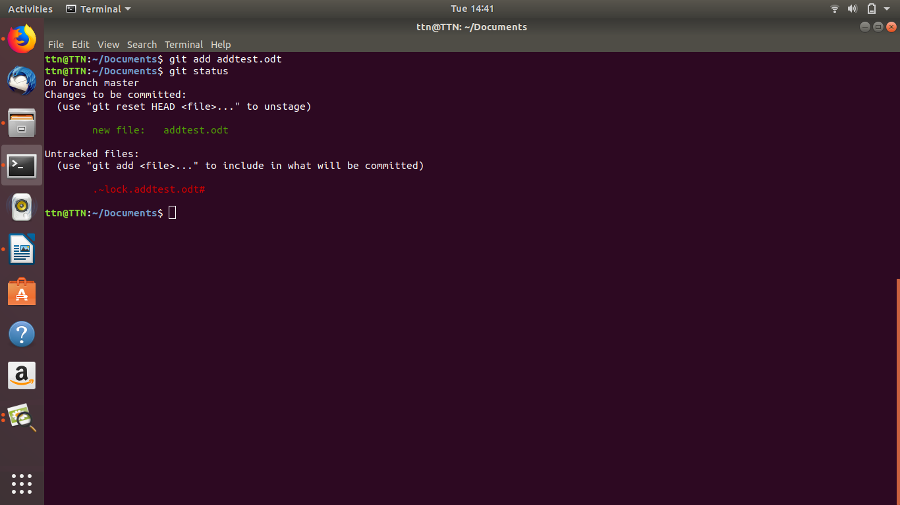
- Unstage 1 file
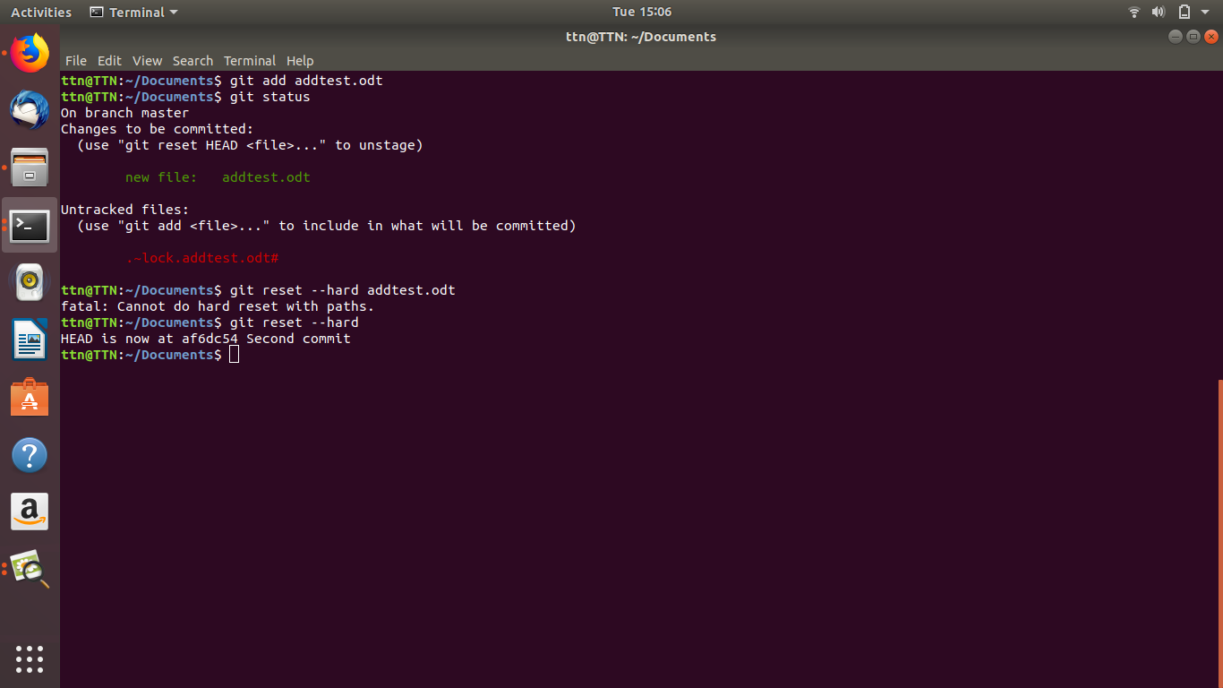

- Commit the file
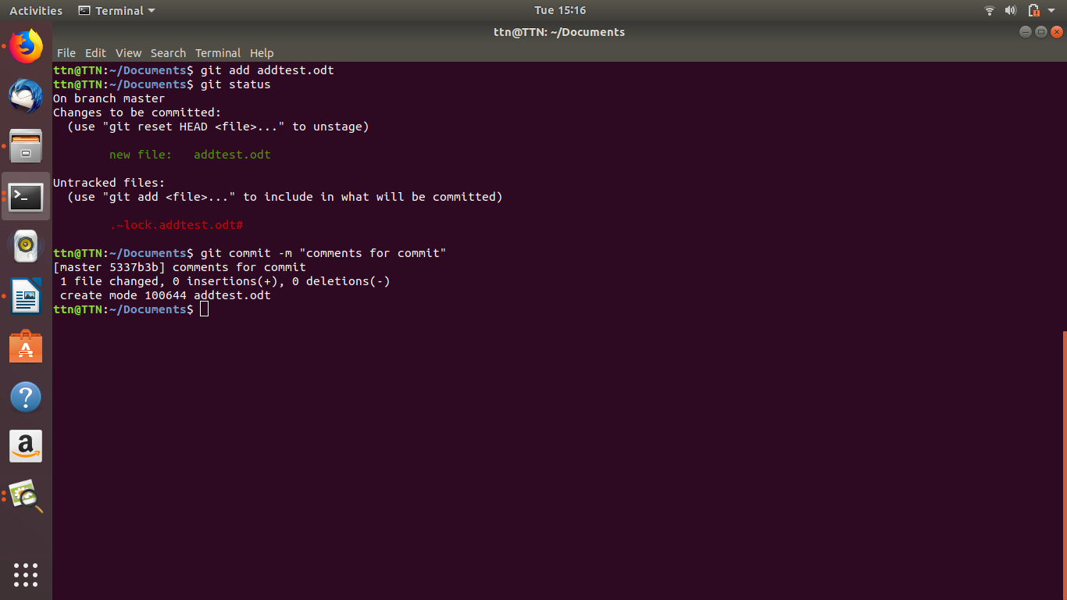
- Add a remote
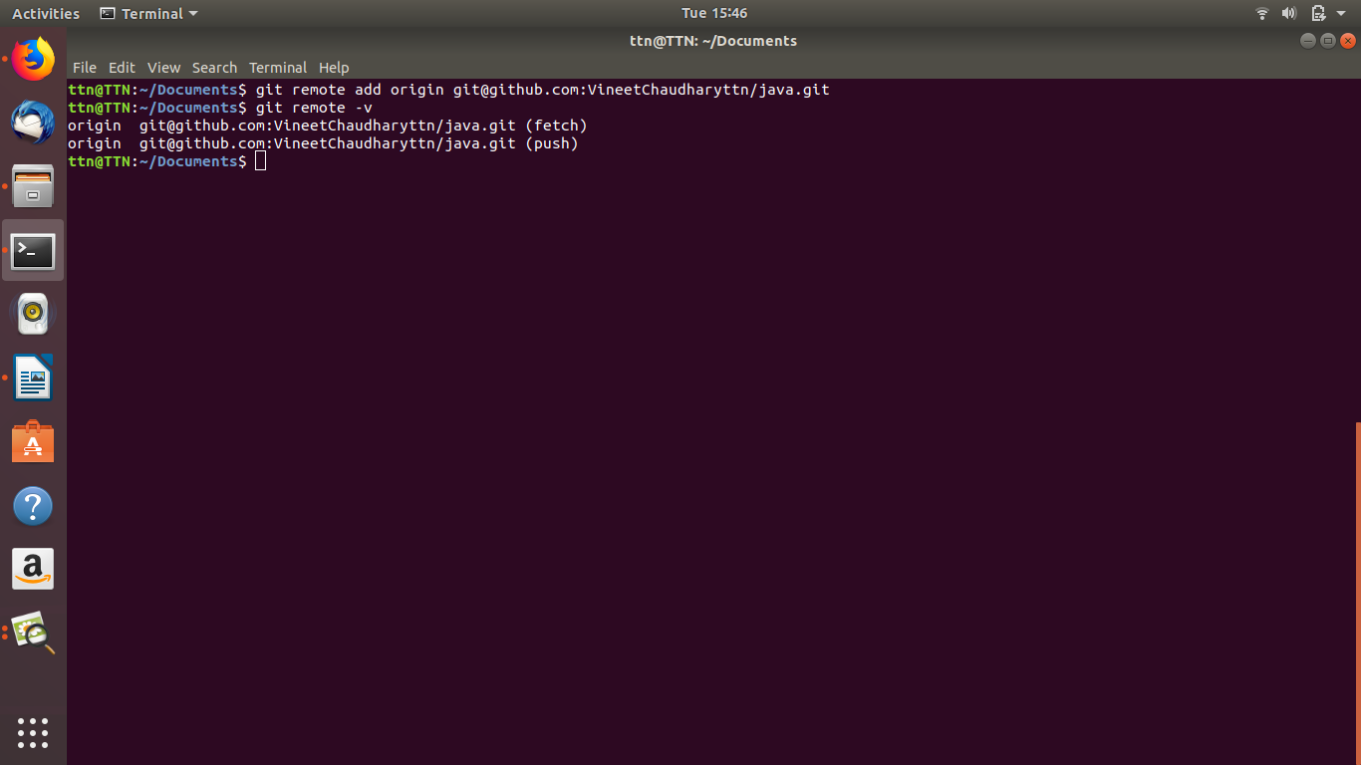

- Undo changes to a particular file
git checkout FILENAME
git checkout sample.txt

- Push changes to Github
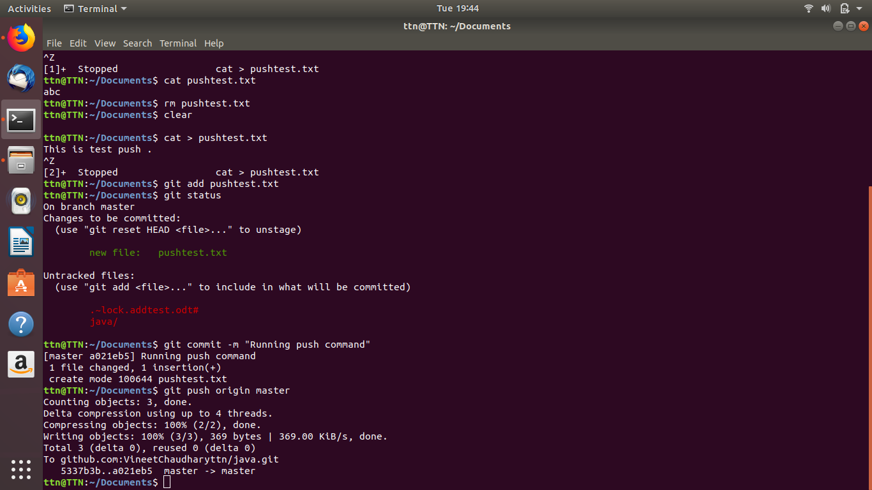
- Diverge them with commit
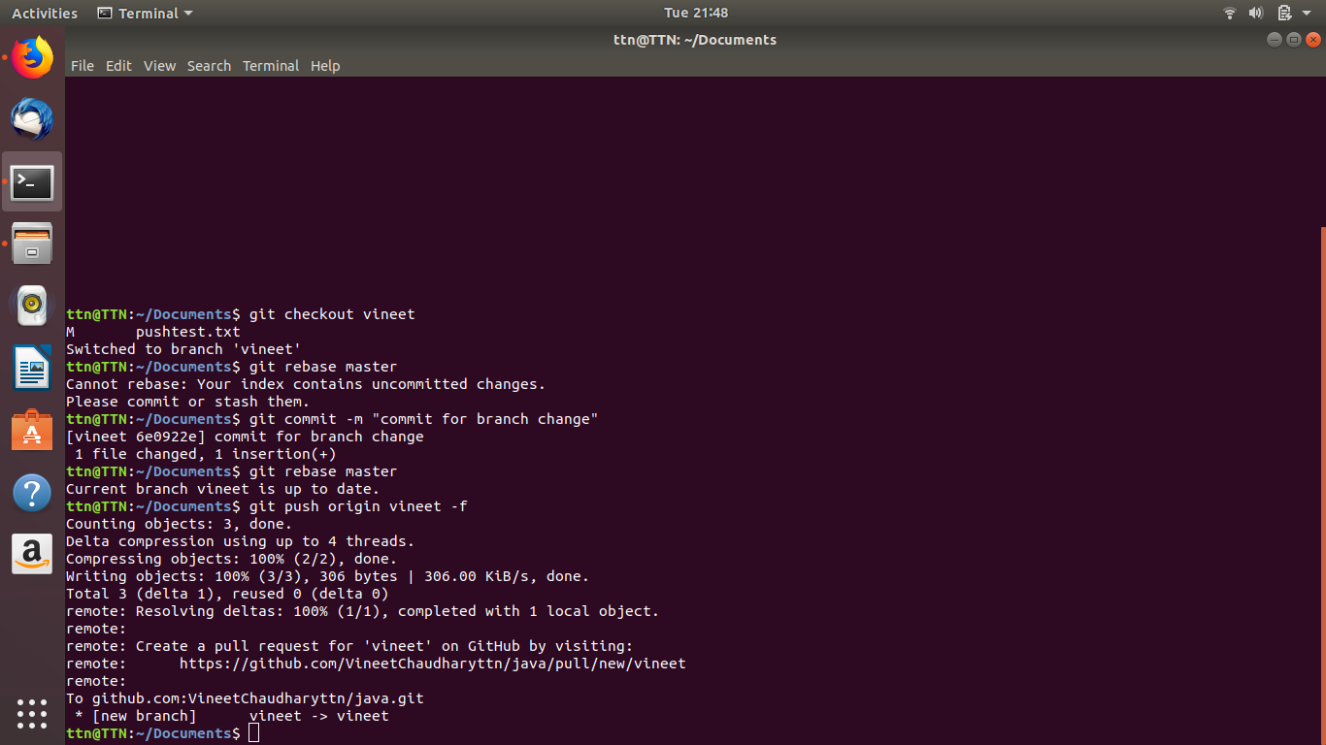

- Clone the repository
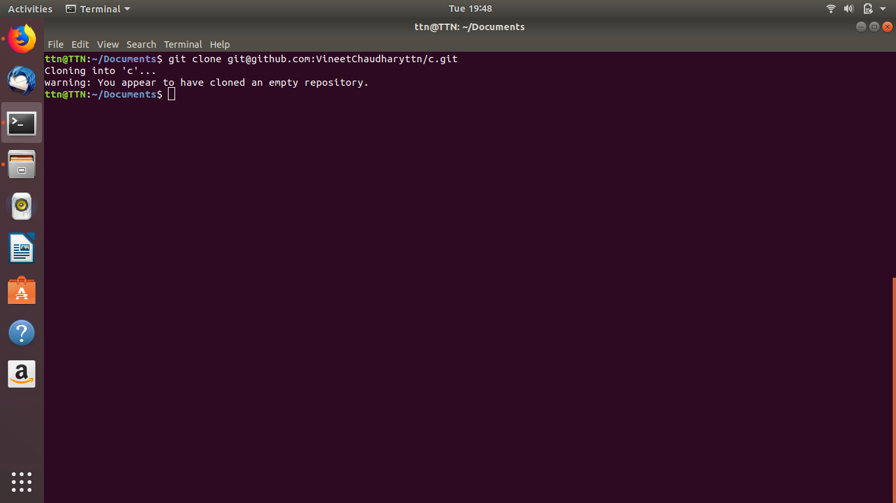
- Add changes to one of the copies and pull the changes in the other.

- Check differences between a file and its staged version
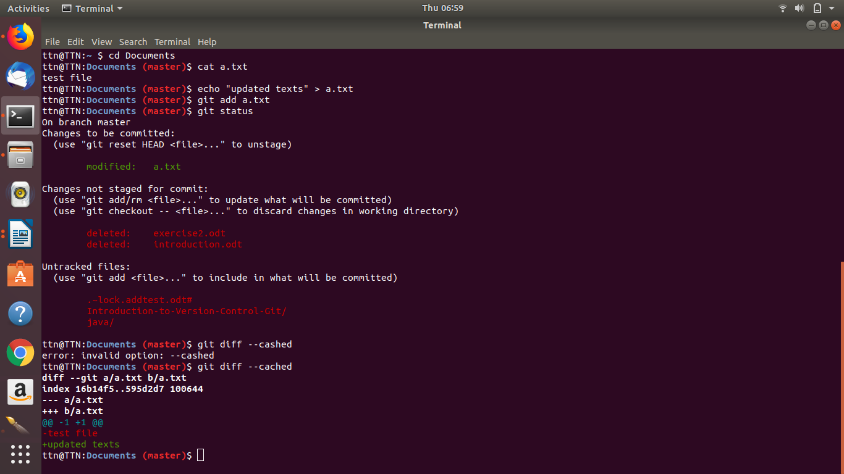
- Ignore a few files to be checked in

- Create a new branch.
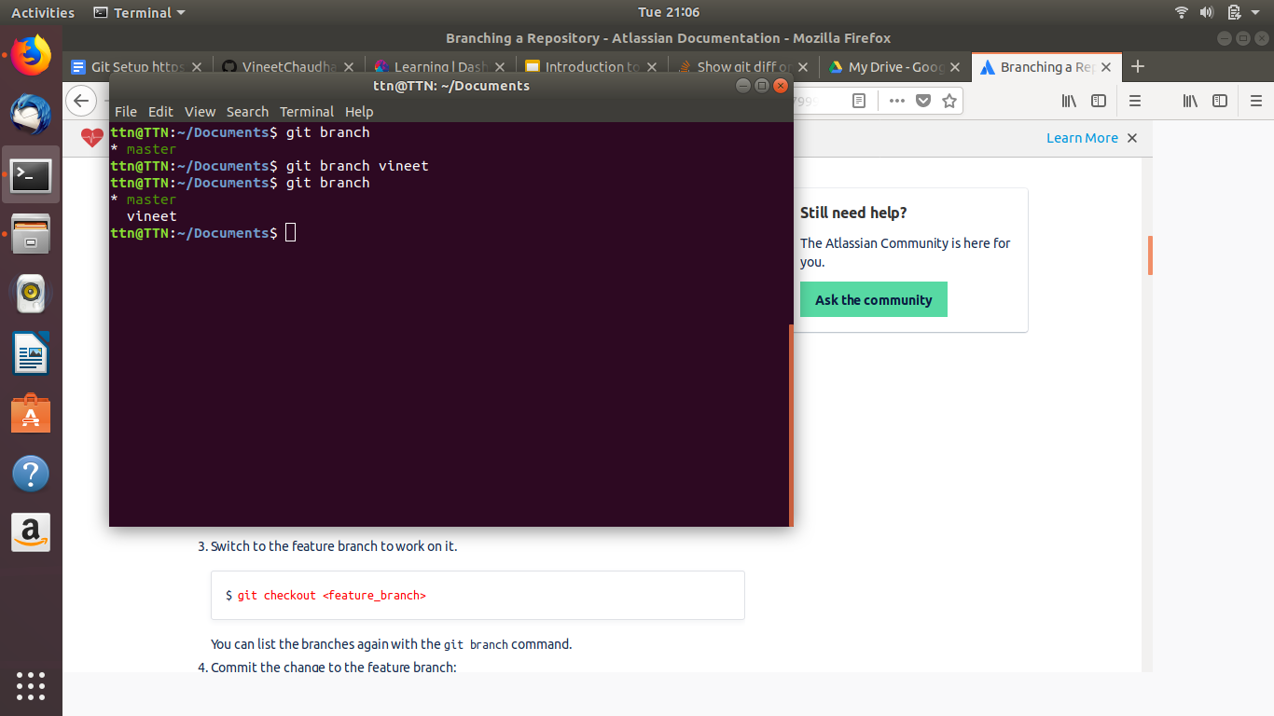
- Edit the same file at the same line on both branches and commit

- Try merging and resolve merge conflicts
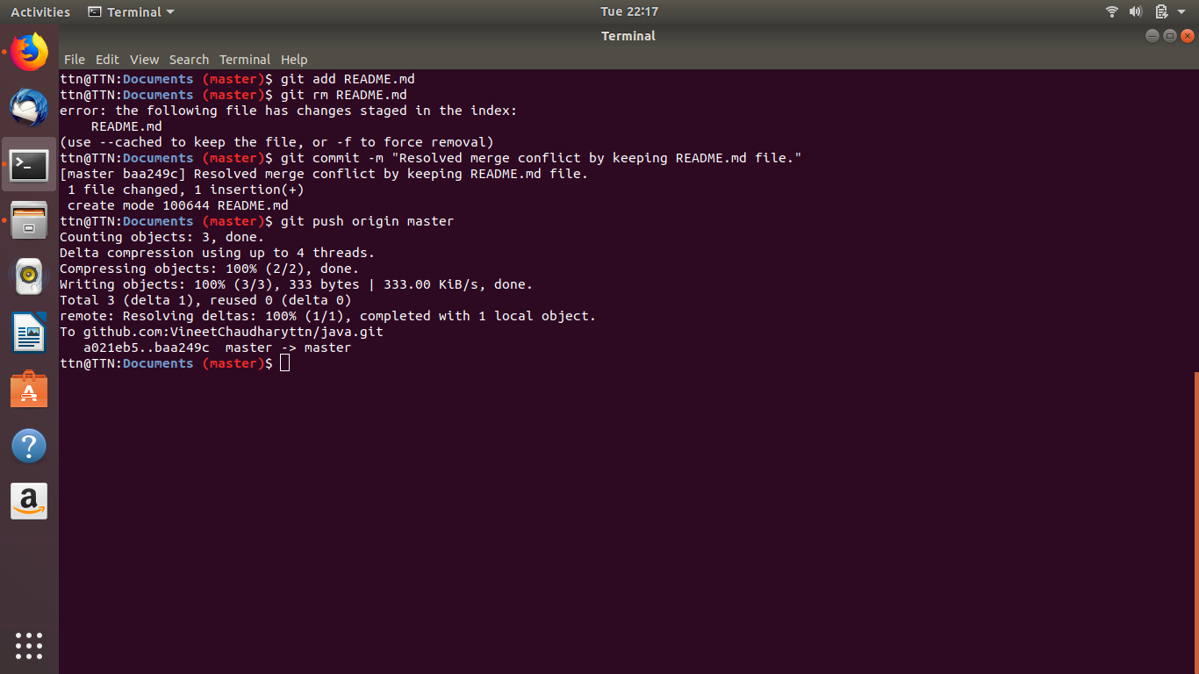
- Stash the changes and pop them

- Add the following code to your .bashrc file : color_prompt="yes"
parse_git_branch() {
git branch 2> /dev/null | sed -e '/^[^*]/d' -e 's/* \(.*\)/(\1)/'
}
if [ "$color_prompt" = yes ]; then
PS1='\u@\h\[\033[00m\]:\[\033[01;34m\]\W\[\033[01;31m\] $(parse_git_branch)\[\033[00m\]\$ '
else
PS1='\u@\h:\W $(parse_git_branch)\$ '
fi
unset color_prompt force_color_prompt
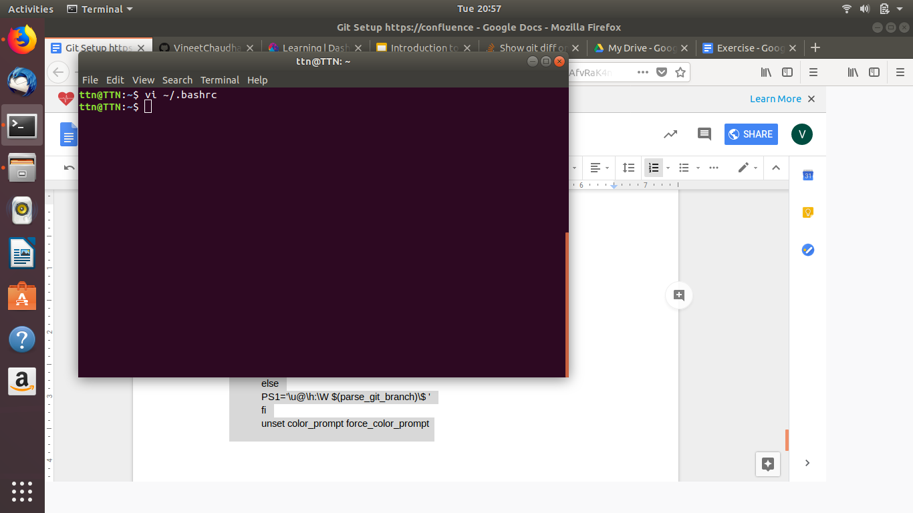
Fristly we have to open the bashrc file in vi mode.
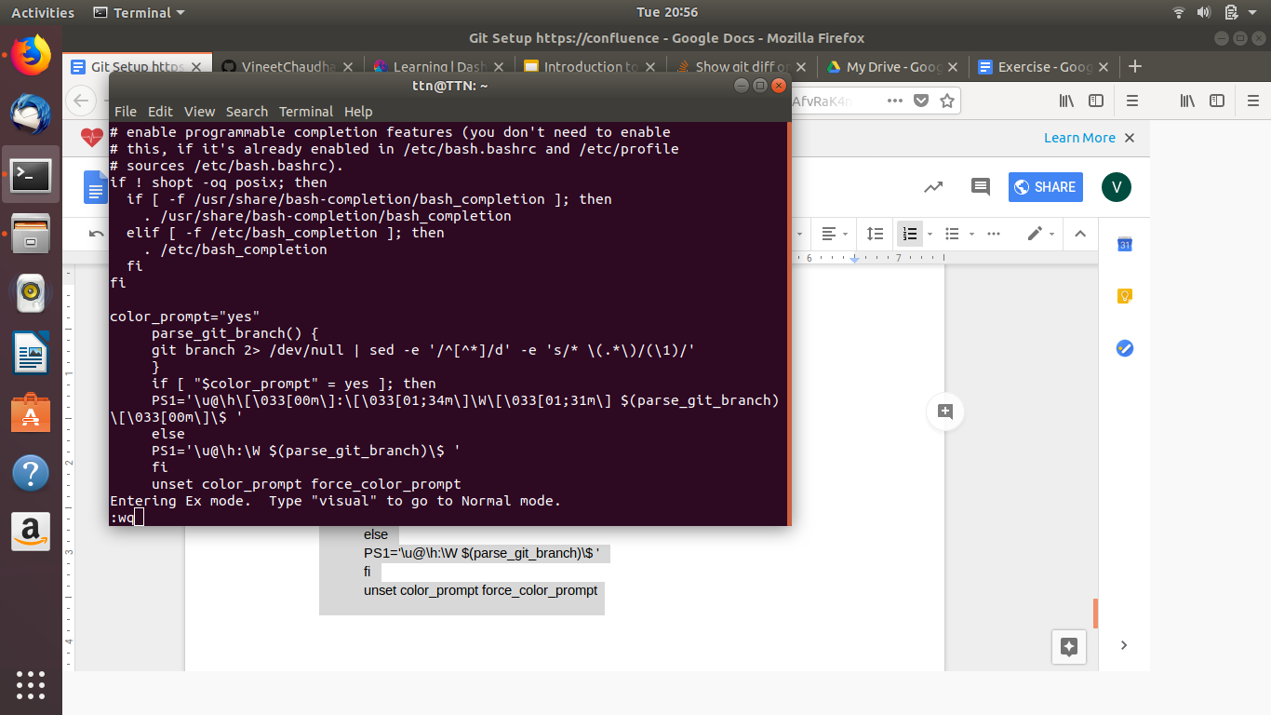
Insert with the help of i and type the code . after that save and quit by wq to vi mode.
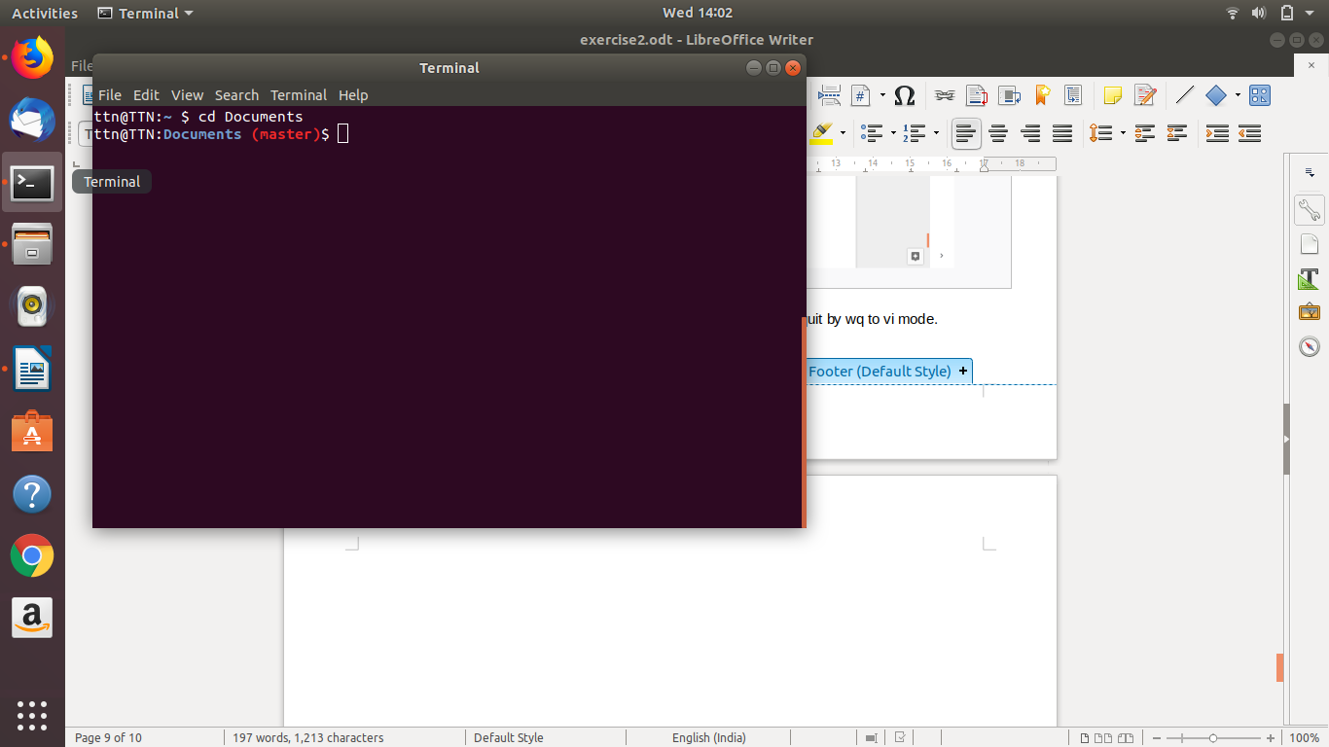
When we will re-enter in the git directory are able to see the branch .

