1.How are inline and block elements different from each other?
Solution:Inline:- Inline Elements are the elements which contain the reqired size on display only. e.g.<a>,<spain>
Block:- Block Elements are the elements which contain the avalable size on the display. e.g.<p>,<h>,<div>
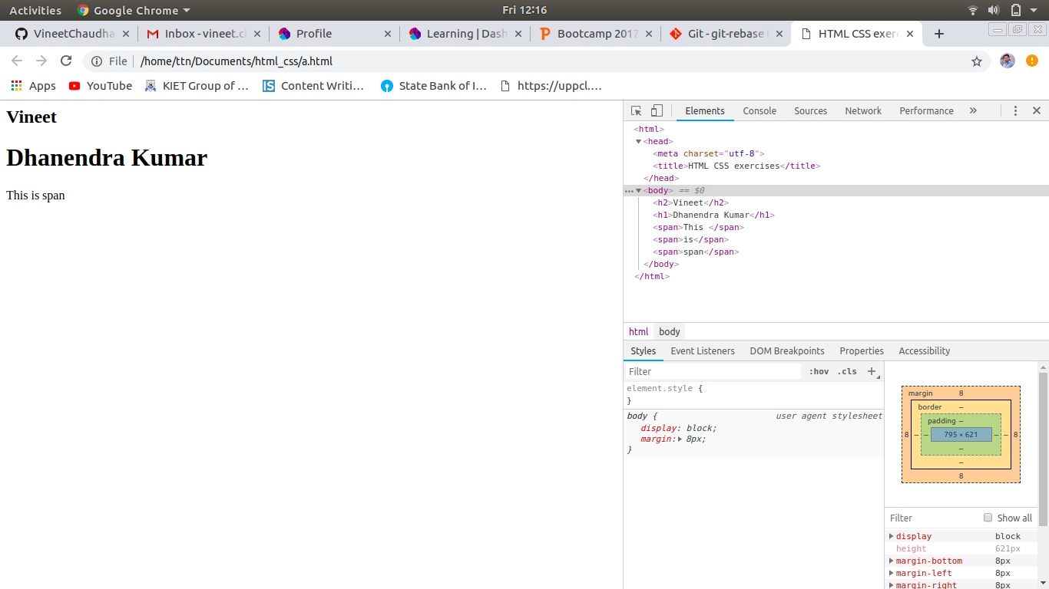
2.Explain the difference between visibility:hidden and display:none
Solution: Visibility:hidden refers to hide the element but it will not remove, space of visibility hidden element will black but not removed. But it is not like opacity.
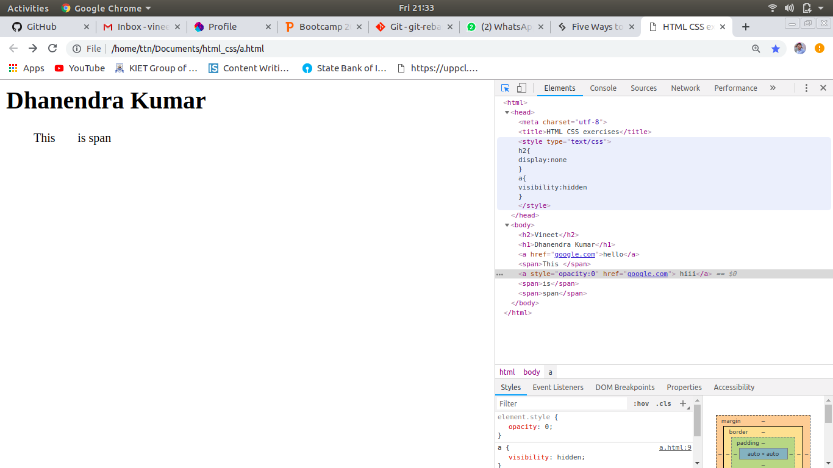
Display:none refers to hide the element and there’ll not be any blanked space of that element.

3. Explain the clear and float properties.
Solution: The float property is used for positioning and formatting content. The float property can have one of the following values:
- left - The element floats to the left of its container
- right- The element floats to the right of its container
- none - The element does not float (will be displayed just where it occurs in the text). This is default
- inherit - The element inherits the float value of its parent
The clear property can have one of the followingvalues:
- none - Allows floating elements on both sides. This is default
- left - No floating elements allowed on the left side
- right- No floating elements allowed on the right side
- both - No floating elements allowed on either the left or the right side
- inherit - The element inherits the clear value of its parent

4. explain difference between absolute, relative,fixed and static.
Solution: Position:static :- html elements are positioned static by default. It is always positioned according to the normal flow the page.
Position : relation:- Relative is positioned relative to its normal position. Setting the top, right, bottom, and left properties of a relatively-positioned element will cause it to be adjusted away from its normal position. Other content will not be adjusted to fit into any gap left by the element.
Position: fixed :- An element with position: fixed is poitioned relative to the viewport, which means it always stays in the same place even if the page is scrolled.A fixed element does not leave a gap in the page where it would normally have been located.
Position:absolute :- An element with position: absolute is positioned relative to the nearest positioned ancestor, if an absolute positioned element has no positioned ancestors, it uses the document body, and moves along with page scrolling.

5. Write the HTML code to create a table in which there are 4 columns( ID , Employee Name, Designation, Department) and at least 6 rows. Also do some styling to it.
Solution: HTML file is also uploaded named as TableQ5.html.
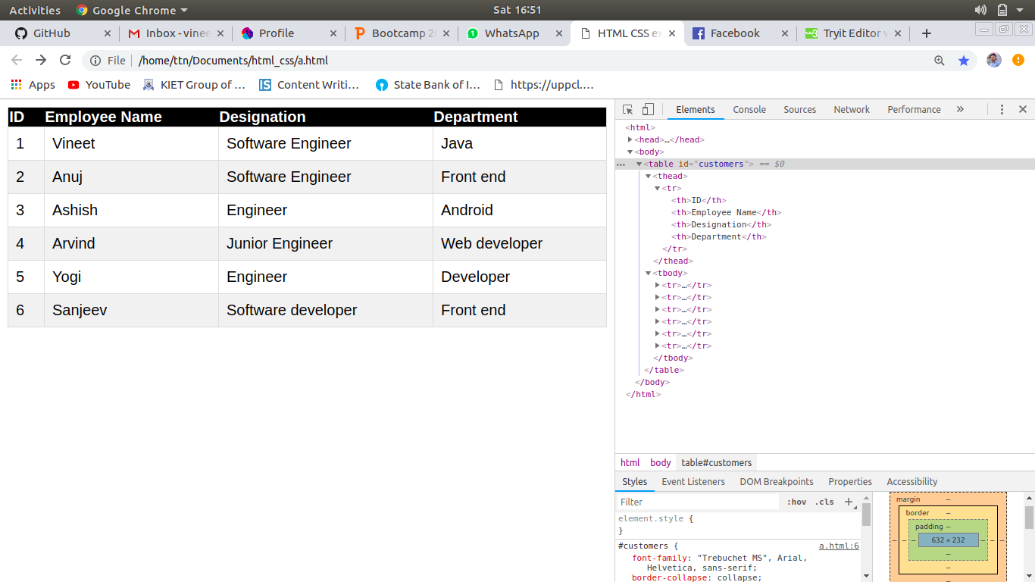
6. Why do we use meta tags?
Solution:Meta tags holds meta data, meta data is the deta that describes the data of any html document. Meta tags never be displayed over the html page. But it is use for search engines, Description of web page, Author of web page.
Syntex: <meta name=”<name of tag>” content=”<content of tag>”>
e.g. <meta name=”tothenew” content=”TTN is the company which provide the sarvice for software development.”>
7. Explain box model.
Solution:
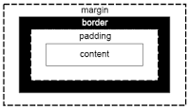

8. What are the different types of CSS Selectors?
Solution:There are two type of selectors:-
1:-ID's are unique
Each element can have only one ID
Each page can have only one element with that ID
2:-Classes are NOT unique
You can use the same class on multiple elements.
You can use multiple classes on the same element.
Syntax:
#id {property: value}
.class {property: value}

9. Define Doctype.
Solution:The <!DOCTYPE> declaration is not an HTML tag; it is an instruction to the web browser about what version of HTML the page is written in.
Always add the <!DOCTYPE> declaration to your HTML documents, so that the browser knows what type of document to expect.
There are three different <!DOCTYPE> declarations in HTML 4.01. In HTML5 there is only one:
HTML 5:-<!DOCTYPE html>
HTML 4.01 Strict :-<!DOCTYPE HTML PUBLIC "-//W3C//DTD HTML 4.01//EN" "http://www.w3.org/TR/html4/strict.dtd">
HTML 4.01 Transitional :-<!DOCTYPE HTML PUBLIC "-//W3C//DTD HTML 4.01 Transitional//EN" "http://www.w3.org/TR/html4/loose.dtd">

HTML 4.01 Frameset <!DOCTYPE HTML PUBLIC "-//W3C//DTD HTML 4.01 Frameset//EN" "http://www.w3.org/TR/html4/frameset.dtd">
10. Explain 5 HTML5 semantic tags.
Solution:The commonly used new tags of HTML5 are:
<article> - Defines an article in the document
<aside> - Defines content aside from the page content like sidebar.
<footer> - Defines a footer for the document or a section
<header> - Defines a header for the document or a section
<nav> - Defines navigation links in the document

11. Create HTML for web-page.jpg(check resources, highest weightage for answers)
Solution:
12. Create HTML for form.png (check resources, highest weightage for answers)
Solution:

