- Create a Rest API for Student using noun plurals for endpoint and http verbs for different operations.(1 Mark)
StudentController.java:-------------------------------------
package com.ttn.restSpring.controller;
import com.ttn.restSpring.entity.Student;
import com.ttn.restSpring.service.StudentService;
import org.springframework.beans.factory.annotation.Autowired;
import org.springframework.web.bind.annotation.GetMapping;
import org.springframework.web.bind.annotation.PathVariable;
import org.springframework.web.bind.annotation.PostMapping;
import org.springframework.web.bind.annotation.RestController;
import java.util.List;
@RestController
public class StudentController {
@Autowired
StudentService studentService;
@PostMapping("/registerStudents")
Student registerStudents(Student student) {
studentService.saveStudent(student);
return student;
}
@GetMapping("/fatchStudents")
List<Student> fatchAllStudents(){
return studentService.allStudent();
}
@GetMapping("/fatchStudent/{id}")
Student fatchStudent(@PathVariable Integer id){
return studentService.specificStudent(id).orElse(null);
}
@GetMapping("/delete/{id}")
Student deleteById(@PathVariable Integer id){
return studentService.deleteStudent(id).orElse(null);
}
}

StudentService.java:-------------------------------
package com.ttn.restSpring.service;
import com.ttn.restSpring.entity.Student;
import com.ttn.restSpring.repository.StudentRepo;
import org.springframework.beans.factory.annotation.Autowired;
import org.springframework.stereotype.Service;
import java.util.List;
import java.util.Optional;
@Service
public class StudentService {
@Autowired
StudentRepo studentRepo;
public void saveStudent(Student student){
studentRepo.save(student);
}
public List<Student> allStudent() {
return (List<Student>) studentRepo.findAll();
}
public Optional<Student> specificStudent(Integer id) {
return studentRepo.findById(id);
}
public Optional<Student> deleteStudent(Integer id){
Optional<Student> student=studentRepo.findById(id);
studentRepo.deleteById(id);
return student;
}
}

}
StudentRepo.java:----------------------------------
package com.ttn.restSpring.repository;
import com.ttn.restSpring.entity.Student;
import org.springframework.data.repository.CrudRepository;
public interface StudentRepo extends CrudRepository<Student,Integer> {
}
Student.java:-------------------------------------
package com.ttn.restSpring.entity;
import javax.persistence.Entity;
import javax.persistence.GeneratedValue;
import javax.persistence.GenerationType;
import javax.persistence.Id;
@Entity
public class Student {
@Id
@GeneratedValue(strategy = GenerationType.IDENTITY)
private Integer id;
private String name;
private String gender;
private Integer age;
public Student() {
}
public Student(Integer id, String name, String gender, Integer age) {
this.id = id;
this.name = name;
this.gender = gender;
this.age = age;
}
public Integer getId() {
return id;
}
public void setId(Integer id) {
this.id = id;
}
public String getName() {
return name;
}
public void setName(String name) {
this.name = name;
}
public String getGender() {
return gender;
}
public void setGender(String gender) {
this.gender = gender;
}
public Integer getAge() {
return age;
}
public void setAge(Integer age) {
this.age = age;
}
}

- Create a Customise Exception Handler.(1 Mark)
StudentController.java:-----------------------------------controller throeing Execption
package com.ttn.restSpring.controller;
import com.ttn.restSpring.customExecption.StudentNotFoundExecption;
import com.ttn.restSpring.entity.Student;
import com.ttn.restSpring.service.StudentService;
import org.springframework.beans.factory.annotation.Autowired;
import org.springframework.web.bind.annotation.*;
import java.util.List;@Bean
public ResourceBundleMessageSource messageSource() {
ResourceBundleMessageSource source = new ResourceBundleMessageSource();
source.setBasenames("i18n/messages");
source.setUseCodeAsDefaultMessage(true);
return source;
}
@RestController
public class StudentController {
@Autowired
StudentService studentService;
@PostMapping("/registerStudents")
Student registerStudents(@RequestBody Student student) {
studentService.saveStudent(student);
return student;
}
@GetMapping("/fatchStudents")
List<Student> fatchAllStudents(){
List<Student> student=studentService.allStudent();
if(student==null){
throw new StudentNotFoundExecption("There is no such record to delete");
}
return student;
}
@GetMapping("/fatchStudent/{id}")
Student fatchStudent(@PathVariable Integer id){
if (studentService.specificStudent(id).orElse(null)==null) {
throw new StudentNotFoundExecption("There is no such records with this "+id+" id");
}
return studentService.specificStudent(id).orElse(null);
}
@DeleteMapping("/delete/{id}")
Student deleteById(@PathVariable Integer id){
Student student=studentService.specificStudent(id).orElse(null);
if(student==null){
throw new StudentNotFoundExecption("There is no such record to delete");
}
studentService.deleteStudent(id);
return student;
}
}
StudentNouFoundExecption.java:---------------------------------------creating Execption
package com.ttn.restSpring.customExecption;
import org.springframework.http.HttpStatus;
import org.springframework.web.bind.annotation.ResponseStatus;
@ResponseStatus(HttpStatus.NOT_FOUND)
public class StudentNotFoundExecption extends RuntimeException {
public StudentNotFoundExecption(String massage){
super(massage);
}
}
ExecptionCustomResponce.java:--------------------------------creating Responce
package com.ttn.restSpring.customExecption;
import java.util.Date;
public class ExecptionCustomResponce {
private Date timestamp;
private String message;
private String details;
public ExecptionCustomResponce(Date timestamp, String message, String details) {
this.timestamp = timestamp;
this.message = message;
this.details = details;
}
public Date getTimestamp() {
return timestamp;
}
public void setTimestamp(Date timestamp) {
this.timestamp = timestamp;
}
public String getMessage() {
return message;
}
public void setMessage(String message) {
this.message = message;
}
public String getDetails() {
return details;
}
public void setDetails(String details) {
this.details = details;
}
}
CustomResponceEntityExecptionHandler.java:-------Execption Handler
package com.ttn.restSpring.customExecption;
import org.springframework.http.HttpStatus;
import org.springframework.http.ResponseEntity;
import org.springframework.web.bind.annotation.ControllerAdvice;
import org.springframework.web.bind.annotation.ExceptionHandler;
import org.springframework.web.bind.annotation.RestController;
import org.springframework.web.context.request.WebRequest;
import org.springframework.web.servlet.mvc.method.annotation.ResponseEntityExceptionHandler;
import java.util.Date;
@ControllerAdvice
@RestController
public class CustomResponceEntityExecptionHandler extends ResponseEntityExceptionHandler {
@ExceptionHandler(Exception.class)
public final ResponseEntity<Object> handleAllExecption(Exception ex, WebRequest webRequest){
ExecptionCustomResponce execptionCustomResponce=new ExecptionCustomResponce(new Date(),ex.getMessage(),webRequest.getDescription(false));
return new ResponseEntity<>(execptionCustomResponce, HttpStatus.INTERNAL_SERVER_ERROR);
}
@ExceptionHandler(StudentNotFoundExecption.class)
public final ResponseEntity<Object> handleUserNotFoundExecption(Exception ex,WebRequest webRequest){
ExecptionCustomResponce execptionCustomResponce=new ExecptionCustomResponce(new Date(),ex.getMessage(),webRequest.getDescription(false));
return new ResponseEntity<>(execptionCustomResponce,HttpStatus.NOT_FOUND);
}
}

- Print the Validation Messages of student Entity in response.(1 Mark)
CustomResponceEntityExecptionHandler.java:-------validation Execption Handler
@Override
public ResponseEntity<Object> handleMethodArgumentNotValid(
MethodArgumentNotValidException ex, HttpHeaders headers, HttpStatus status, WebRequest request) {
List<String> errorMessageList=ex.getBindingResult().getAllErrors().stream().filter(e->e instanceof FieldError).map((e)->{
FieldError fieldError = (FieldError) e;
return messageSource.getMessage(fieldError, null);
}).collect(Collectors.toList());
ExecptionCustomResponce exceptionResponse = new ExecptionCustomResponce(new Date(),errorMessageList.toString(),request.getDescription(false));
return new ResponseEntity(exceptionResponse, HttpStatus.BAD_REQUEST);
}
Student.java:----------------------------place validation with message
package com.ttn.restSpring.entity;
import javax.persistence.Entity;
import javax.persistence.GeneratedValue;
import javax.persistence.GenerationType;
import javax.persistence.Id;
import javax.validation.constraints.Size;
@Entity
public class Student {
@Id
@GeneratedValue(strategy = GenerationType.IDENTITY)
private Integer id;
@Size(max = 2,message = "You cann't study now.")
private String name;
private String gender;
private Integer age;
public Student() {
}
public Student(Integer id, String name, String gender, Integer age) {
this.id = id;
this.name = name;
this.gender = gender;
this.age = age;
}
public Integer getId() {
return id;
}
public void setId(Integer id) {
this.id = id;
}
public String getName() {
return name;
}
public void setName(String name) {
this.name = name;
}
public String getGender() {
return gender;
}
public void setGender(String gender) {
this.gender = gender;
}
public Integer getAge() {
return age;
}
public void setAge(Integer age) {
this.age = age;
}
}
StudentController.java:-----------------------
@PostMapping("/registerStudents")
ResponseEntity<Student> registerStudents(@Valid @RequestBody Student student) {
studentService.saveStudent(student);
URI uri= ServletUriComponentsBuilder
.fromCurrentRequest()
.path("{id}").buildAndExpand(student.getId()).toUri();
return ResponseEntity.created(uri).build();
}

- Perform Internationalization for a greeting message in your app.(1 Mark)
StudentController.java:----------------------
@GetMapping("/")
String helloWorld(@RequestHeader(name = "Accept-Language",required = false) Locale locale){
return messageSource.getMessage("good.morning.message",null,locale);
}
messages.properties:---------------
good.morning.message=Good morning
messages_fr.properties:--------------------
good.morning.message=Bonjour

- Return XML Response when new Student is created.(1 Mark)
compile ('com.fasterxml.jackson.dataformat:jackson-dataformat-xml')
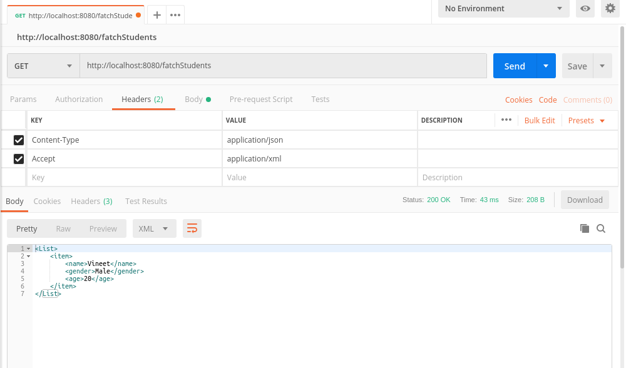
- Ignore ID field in the Response.(1 Mark)
@JsonIgnoreProperties(value = "id")
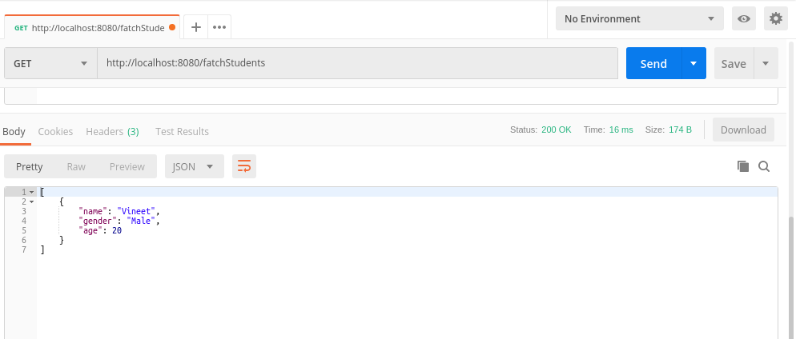
- Create 2 versions of your API one take reprsent name of the Student as single string and other showing firstname and lastname seperately. (Create the Versions of the API using URI, parameter and header versioning) (2 Marks)
StutentV1.java:--------------------------------
package com.ttn.restSpring.entity;
public class StudentV1 {
private String name;
public StudentV1(String name) {
this.name = name;
}
public String getName() {
return name;
}
public void setName(String name) {
this.name = name;
}
}
StudentV2.java:--------------------------------
package com.ttn.restSpring.entity;
public class StudentV2 {
private Name name;
public StudentV2(Name name) {
this.name = name;
}
public Name getName() {
return name;
}
public void setName(Name name) {
this.name = name;
}
}
StudentController.java:---------------
@GetMapping("/person/V1")
StudentV1 getPersonV1() {
return new StudentV1("Vineet Chaudhary");
}
@GetMapping("/person/V2")
StudentV2 getPersonV2() {
return new StudentV2(new Name("Dhanendra","Kumar"));
}
@GetMapping(value = "/person/param",params = "version=1")
StudentV1 getPersonParam1() {
return new StudentV1("Vineet Chaudhary");
}
@GetMapping(value = "/person/param",params = "version=2")
StudentV2 getPersonParam2() {
return new StudentV2(new Name("Dhanendra","Kumar"));
}
@GetMapping(value = "/person/header",headers = "API-VERSION=1")
StudentV1 getPersonHeader1() {
return new StudentV1("Vineet Chaudhary");
}
@GetMapping(value = "/person/header",headers = "API-VERSION=2")
StudentV2 getPersonHeader2() {
return new StudentV2(new Name("Dhanendra","Kumar"));
}
Name.java:----------------------
package com.ttn.restSpring.entity;
public class Name {
private String firstName;
private String secondName;
public Name(String firstName, String secondName) {
this.firstName = firstName;
this.secondName = secondName;
}
public String getFirstName() {
return firstName;
}
public void setFirstName(String firstName) {
this.firstName = firstName;
}
public String getSecondName() {
return secondName;
}
public void setSecondName(String secondName) {
this.secondName = secondName;
}
}

- Perform CRUD operations on the resource below using RestTemplate https://jsonplaceholder.typicode.com/posts (2 Marks)
ApiController.java:-----------------------------------
package com.ttn.restSpring.controller;
import com.ttn.restSpring.entity.Post;
import org.springframework.core.ParameterizedTypeReference;
import org.springframework.http.*;
import org.springframework.web.bind.annotation.*;
import org.springframework.web.client.RestTemplate;
import java.util.List;
//Perform CRUD operations on the resource below using RestTemplate
// https://jsonplaceholder.typicode.com/posts (2 Marks)
@RestController
public class ApiController {
@PostMapping("/createPost")
public ResponseEntity<Post> createPost(){
String url="https://jsonplaceholder.typicode.com/posts";
RestTemplate restTemplate= new RestTemplate();
HttpHeaders httpHeaders= new HttpHeaders();
httpHeaders.add("Content-type","application/json; charset=UTF-8");
HttpEntity<Post> request=new HttpEntity<>(new Post(10000L,10000L,"Newers","Employee of TO THE NEW "),httpHeaders);
Post post=restTemplate.postForObject(url,request,Post.class);
System.out.println(post);
return new ResponseEntity<Post>(post, HttpStatus.CREATED);
}
@GetMapping("/postList")
public List<Post> getPostList(){
RestTemplate restTemplate = new RestTemplate();
String url="https://jsonplaceholder.typicode.com/posts";
ResponseEntity<List<Post>> response = restTemplate
.exchange(url, HttpMethod.GET, null,
new ParameterizedTypeReference<List<Post>>(){});
return response.getBody();
}
@PutMapping("/updatePost")
public ResponseEntity<Post> updatePost(){
String url="https://jsonplaceholder.typicode.com/posts/1";
RestTemplate restTemplate= new RestTemplate();
HttpHeaders httpHeaders= new HttpHeaders();
httpHeaders.add("Content-type","application/json; charset=UTF-8");
HttpEntity<Post> request=new HttpEntity<>(new Post(10000L,10000L,"Newers","Employee of TO THE NEW "),httpHeaders);
return restTemplate.exchange(url,HttpMethod.PUT,request,Post.class);
}
@DeleteMapping("/deletePost")
public void deletePost(){
String url="https://jsonplaceholder.typicode.com/posts/1";
RestTemplate restTemplate= new RestTemplate();
HttpHeaders httpHeaders= new HttpHeaders();
httpHeaders.add("Content-type","application/json; charset=UTF-8");
HttpEntity<Post> request=new HttpEntity<>(httpHeaders);
restTemplate.exchange(url,HttpMethod.DELETE,request,Post.class);
}
}
Post.java:--------------------------------------
package com.ttn.restSpring.entity;
import javax.persistence.Entity;
import javax.persistence.Id;
@Entity
public class Post {
private Long userId;
@Id
private Long id;
private String title;
private String body;
public Post() {
}
public Post(Long userId, Long id, String title, String body) {
this.userId = userId;
this.id = id;
this.title = title;
this.body = body;
}
public Long getUserId() {
return userId;
}
public void setUserId(Long userId) {
this.userId = userId;
}
public Long getId() {
return id;
}
public void setId(Long id) {
this.id = id;
}
public String getTitle() {
return title;
}
public void setTitle(String title) {
this.title = title;
}
public String getBody() {
return body;
}
public void setBody(String body) {
this.body = body;
}
@Override
public String toString() {
return "Post{" +
"userId=" + userId +
", id=" + id +
", title='" + title + '\'' +
", body='" + body + '\'' +
'}';
}
}

