Question1:- Create a Restful API using Spring Boot for Student.
StudentController.java------------
package com.ttn.springbootdemo.controller;
import com.ttn.springbootdemo.entity.Student;
import com.ttn.springbootdemo.services.StudentService;
import org.springframework.beans.factory.annotation.Autowired;
import org.springframework.web.bind.annotation.RequestMapping;
import org.springframework.web.bind.annotation.RestController;
import java.util.List;
@RestController
public class StudentController {
@Autowired
StudentService studentService;
@RequestMapping("/")
public List<Student> studentController(){
return studentService.getStudents();
}
}
StudentServise.java---------
package com.ttn.springbootdemo.services;
import com.ttn.springbootdemo.entity.Student;
import org.springframework.stereotype.Service;
import java.util.Arrays;
import java.util.List;
@Service
public class StudentService {
public List<Student> getStudents(){
return Arrays.asList(new Student("Vineet","Chaudhary",1),new Student("Shivam","Saxsena",2));
}
}
Student.java----------
package com.ttn.springbootdemo.entity;
public class Student {
private String firstname;
private String lastname;
int id;
public Student() {
}
public Student(String firstname, String lastname, int id) {
this.firstname = firstname;
this.lastname = lastname;
this.id = id;
}
public int getId() {
return id;
}
public void setId(int id) {
this.id = id;
}
public String getFirstname() {
return firstname;
}
public void setFirstname(String firstname) {
this.firstname = firstname;
}
public String getLastname() {
return lastname;
}
public void setLastname(String lastname) {
this.lastname = lastname;
}
}
Output:--------------
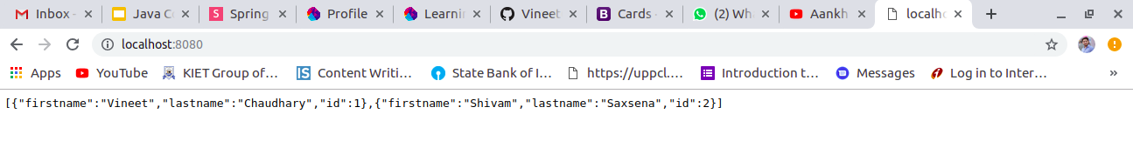

Question2:-Run Spring Boot Application with all the three ways.
Ans:-
1:- Run by gradle through terminal (gradle buildRun).
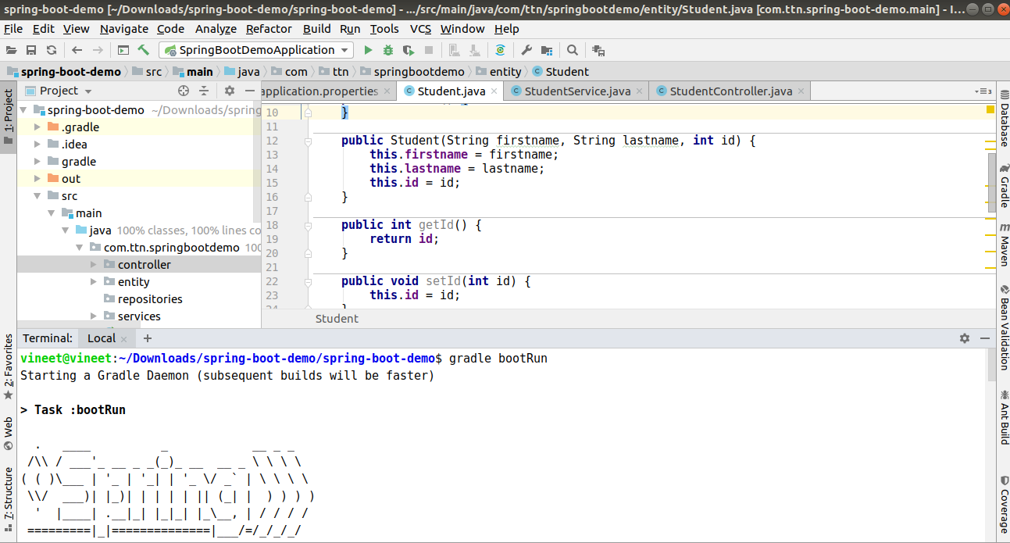
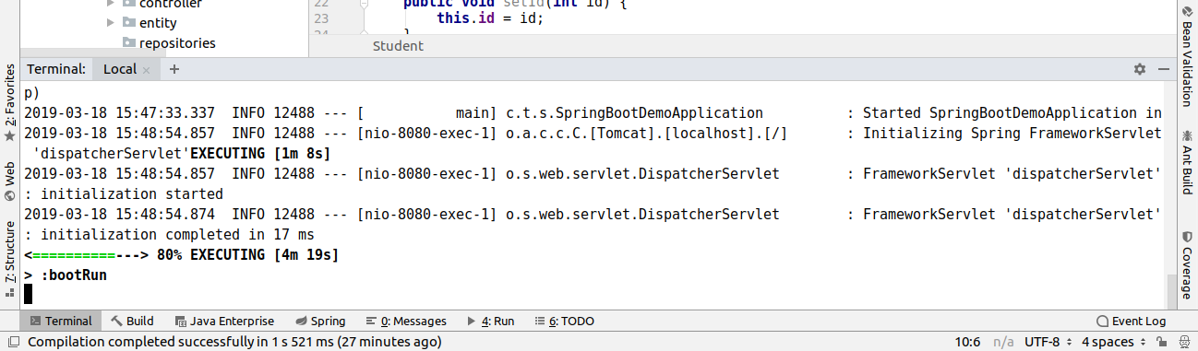

Output:-
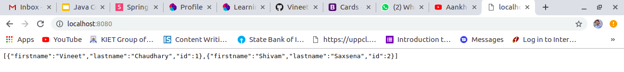

2:- Run by running application main class i.e. SpringBootDemoApplication.java

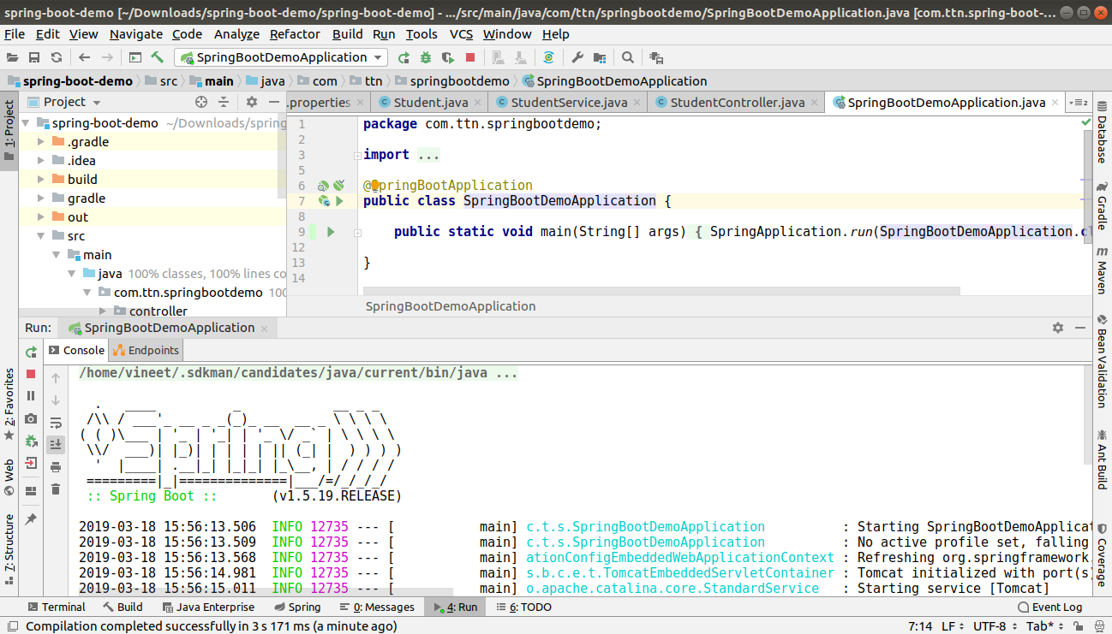
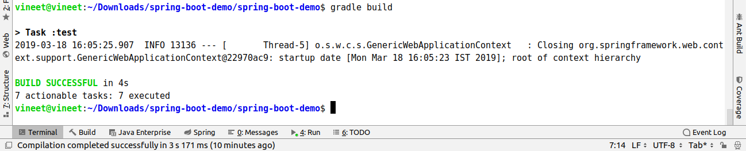
Output:-

3:-Run the application by executing jar file.
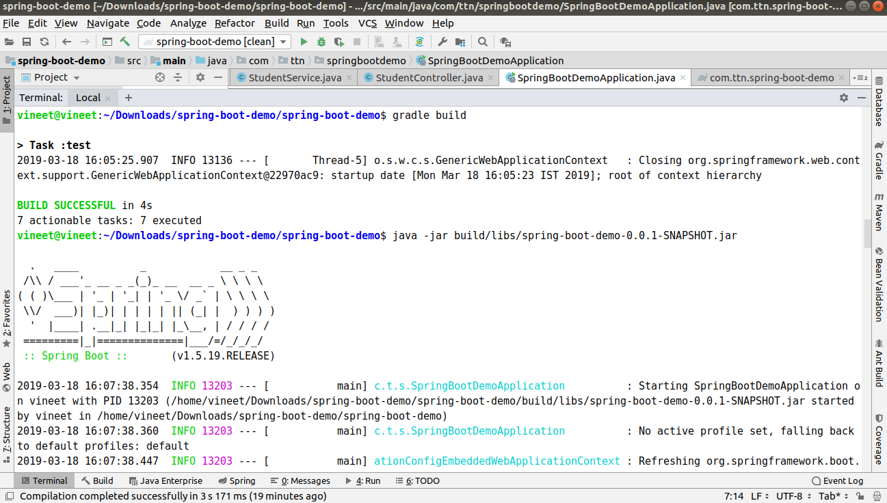
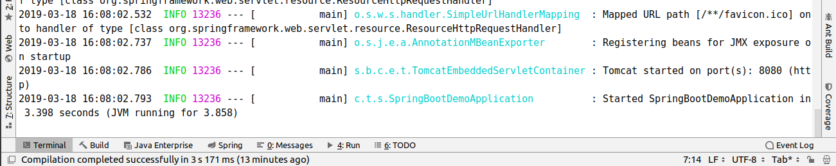
Output:-

Question3:-Create Bean User containing two field username and password with Spring Context File.
User.java:-----------------
package com.ttn.springbootdemo.entity;
public class User {
private String username;
private String password;
public User(String username, String password) {
this.username = username;
this.password = password;
}
public String getUsername() {
return username;
}
public void setUsername(String username) {
this.username = username;
}
public String getPassword() {
return password;
}
public void setPassword(String password) {
this.password = password;
}
@Override
public String toString() {
return "User{" +
"username='" + username + '\'' +
", password='" + password + '\'' +
'}';
}
}
UserController.java:------------------------
package com.ttn.springbootdemo.controller;
import com.ttn.springbootdemo.entity.User;
import org.springframework.beans.factory.annotation.Autowired;
import org.springframework.stereotype.Controller;
import org.springframework.web.bind.annotation.RequestMapping;
import org.springframework.web.bind.annotation.ResponseBody;
@Controller
public class UserController {
@Autowired
User user;
@RequestMapping("/user")
@ResponseBody
public String getUserData(){
return user.toString();
}
}

SpringBootDemoApplication.java:----------------------------
package com.ttn.springbootdemo;
import com.ttn.springbootdemo.entity.User;
import org.springframework.boot.SpringApplication;
import org.springframework.boot.autoconfigure.SpringBootApplication;
import org.springframework.context.annotation.Bean;
@SpringBootApplication
public class SpringBootDemoApplication {
@Bean
public User user(){
return new User("vineet.Chaudhary@tothenew.com","password");
}
public static void main(String[] args) {
SpringApplication.run(SpringBootDemoApplication.class, args);
}
}

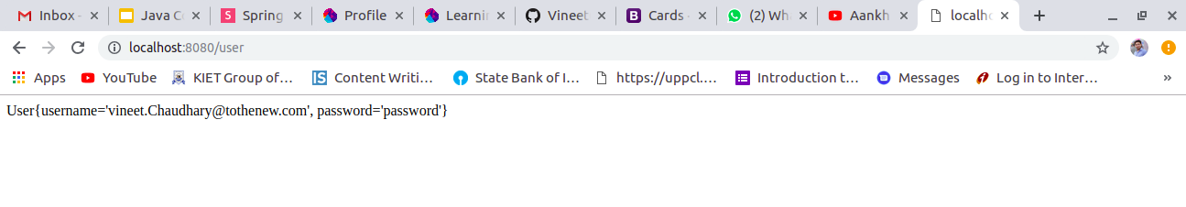
Question4:-Create a Bean Database with two fields port and name and Access its values using application.properties.
Database.java:----------
package com.ttn.springbootdemo.entity;
import org.springframework.beans.factory.annotation.Value;
public class DataBase {
@Value("${server.port}")
private int port;
@Value("${server.name}")
private String name;
public int getPort() {
return port;
}
public void setPort(int port) {
this.port = port;
}
public String getName() {
return name;
}
public void setName(String name) {
this.name = name;
}
@Override
public String toString() {
return "DataBase{" +
"port=" + port +
", name='" + name + '\'' +
'}';
}
}

DatabaseController.java:------------
package com.ttn.springbootdemo.controller;
import com.ttn.springbootdemo.entity.DataBase;
import org.springframework.beans.factory.annotation.Autowired;
import org.springframework.stereotype.Controller;
import org.springframework.web.bind.annotation.RequestMapping;
import org.springframework.web.bind.annotation.ResponseBody;
@Controller
public class DatabaseController {
@Autowired
DataBase dataBase;
@RequestMapping("/database")
@ResponseBody
public String database(){
return dataBase.toString();
}
}
SpringBootDemoApplication.java:----------------------------
package com.ttn.springbootdemo;
import com.ttn.springbootdemo.entity.User;
import org.springframework.boot.SpringApplication;
import org.springframework.boot.autoconfigure.SpringBootApplication;
import org.springframework.context.annotation.Bean;
@SpringBootApplication
public class SpringBootDemoApplication {
@Bean
public User user(){
return new User("vineet.Chaudhary@tothenew.com","password");
}

@Bean
public DataBase dataBase(){
return new DataBase();
}
public static void main(String[] args) {
SpringApplication.run(SpringBootDemoApplication.class, args);
}
}
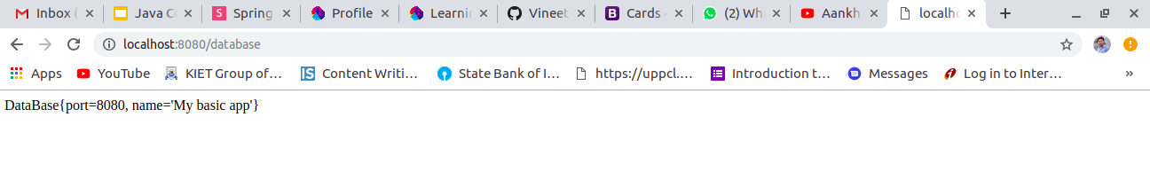
Question5:-Configure environment specfic values form Database Bean .

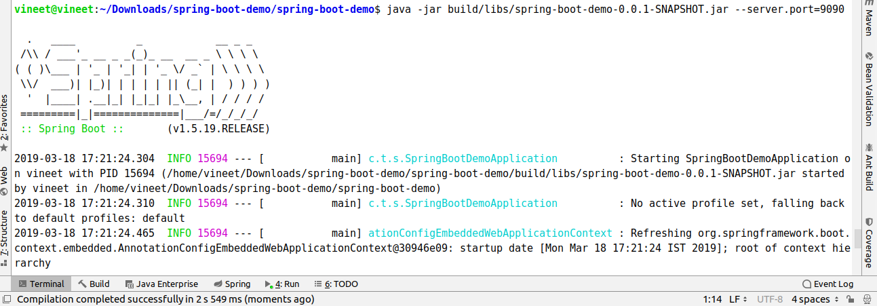
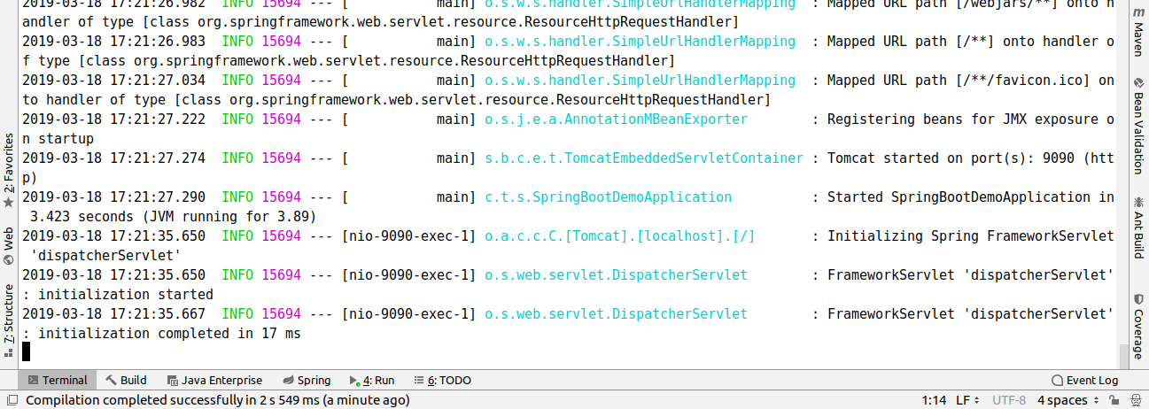
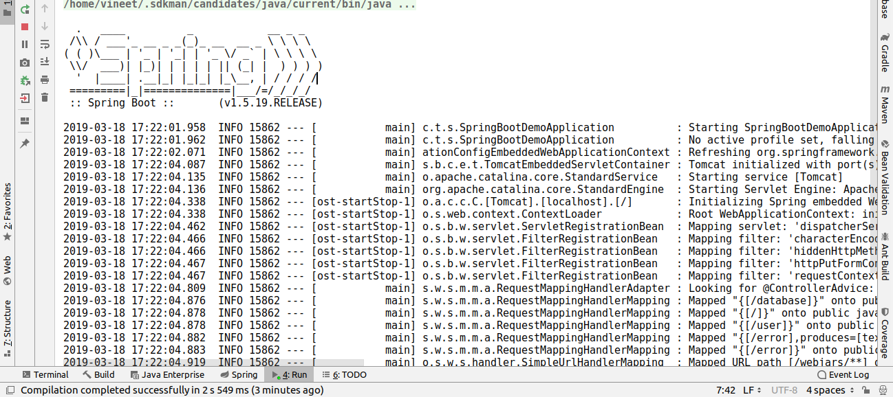

Question6:-Apply Logging whereever you feel is necessity.

application.properties ----------------------
server.port=8080
server.name=My basic app
logging.level.com.ttn.springbootdemo.controller=INFO

DatabaseController.java---------
package com.ttn.springbootdemo.controller;
import com.ttn.springbootdemo.entity.DataBase;
import org.slf4j.LoggerFactory;
import org.springframework.beans.factory.annotation.Autowired;
import org.springframework.stereotype.Controller;
import org.springframework.web.bind.annotation.RequestMapping;
import org.springframework.web.bind.annotation.ResponseBody;
@Controller
public class DatabaseController {
@Autowired
DataBase dataBase;
@RequestMapping("/database")
@ResponseBody
public String database(){
LoggerFactory.getLogger(DatabaseController.class).info("you are accessing database action ");
return dataBase.toString();
}
}
StudentController.java---------
package com.ttn.springbootdemo.controller;
import com.ttn.springbootdemo.entity.Student;
import com.ttn.springbootdemo.services.StudentService;
import org.slf4j.LoggerFactory;
import org.springframework.beans.factory.annotation.Autowired;
import org.springframework.web.bind.annotation.RequestMapping;
import org.springframework.web.bind.annotation.RestController;
import java.util.List;
@RestController
public class StudentController {
@Autowired
StudentService studentService;
@RequestMapping("/")
public List<Student> studentController(){
LoggerFactory.getLogger(StudentController.class).info("you are accessing Student action.");
return studentService.getStudents();
}
}

UserController.java---------
package com.ttn.springbootdemo.controller;
import com.ttn.springbootdemo.entity.User;
import org.slf4j.LoggerFactory;
import org.springframework.beans.factory.annotation.Autowired;
import org.springframework.stereotype.Controller;
import org.springframework.web.bind.annotation.RequestMapping;
import org.springframework.web.bind.annotation.ResponseBody;
@Controller
public class UserController {
@Autowired
User user;
@RequestMapping("/user")
@ResponseBody
public String getUserData(){
LoggerFactory.getLogger(UserController.class).info("You are accessing User action.");
return user.toString();
}
}

Question7:-Bootstrap Data for Student Domain
StudentController.java----------------------------
package com.ttn.springbootdemo.controller;
import com.ttn.springbootdemo.entity.Student;
import com.ttn.springbootdemo.services.StudentService;
import org.springframework.beans.factory.annotation.Autowired;
import org.springframework.web.bind.annotation.RequestMapping;
import org.springframework.web.bind.annotation.RestController;
import java.util.List;
@RestController
public class StudentController {
@Autowired
StudentService studentService;
@RequestMapping("/")
public List<Student> studentController(){
return studentService.getStudents();
}
}

StudentInitializer.java----------------
package com.ttn.springbootdemo.event;
import com.ttn.springbootdemo.controller.StudentController;
import com.ttn.springbootdemo.entity.Student;
import com.ttn.springbootdemo.repositories.StudentRepository;
import org.slf4j.LoggerFactory;
import org.springframework.beans.factory.annotation.Autowired;
import org.springframework.context.event.ContextRefreshedEvent;
import org.springframework.context.event.EventListener;
import org.springframework.stereotype.Component;
@Component
public class StudentInitialize {
@Autowired
StudentRepository studentRepository;
@EventListener(ContextRefreshedEvent.class)
public void init(){
for (int i=1;i<=10;i++){
LoggerFactory.getLogger(StudentController.class).error("-------------init "+i);
Student student=new Student("Firstname","Lastname",i);
studentRepository.save(student);
System.out.println("Student "+i+" is created.");
}
}
}

StudentServices.java---------------
package com.ttn.springbootdemo.services;
import com.ttn.springbootdemo.controller.StudentController;
import com.ttn.springbootdemo.entity.Student;
import com.ttn.springbootdemo.repositories.StudentRepository;
import org.slf4j.LoggerFactory;
import org.springframework.beans.factory.annotation.Autowired;
import org.springframework.stereotype.Service;
import java.util.ArrayList;
import java.util.Iterator;
import java.util.List;
@Service
public class StudentService {
@Autowired
StudentRepository studentRepository;
public List<Student> getStudents(){
LoggerFactory.getLogger(StudentController.class).error("get Student");
List<Student> students=new ArrayList<>();
Iterator<Student> studentIterator=studentRepository.findAll().iterator();
studentIterator.forEachRemaining(students::add);
return students;
}
}

