Question1:-Create a class Author with instance variables firstName, lastName and age.
Answer:-
Author.java-----------------
public class Author {
private String firstname;
private String lastname;
private Integer age;
public String getFirstname() {
return firstname;
}
public void setFirstname(String firstname) {
this.firstname = firstname;
}
public String getLastname() {
return lastname;
}
public void setLastname(String lastname) {
this.lastname = lastname;
}
public Integer getAge() {
return age;
}
public void setAge(Integer age) {
this.age = age;
}
@Override
public String toString() {
return "Author{" +
"firstname='" + firstname + '\'' +
", lastname='" + lastname + '\'' +
", age=" + age +
'}';
}
}

Question2:-Perform CRUD operation for Author class.
Answer:-
Main.java----------------crud create
package com.ttn.hibernate;
import org.hibernate.Session;
import org.hibernate.SessionFactory;
import org.hibernate.cfg.Configuration;
public class Main {
public static void main(String[] args) {
Author author=new Author();
author.setFirstname("ABC");
author.setLastname("def");
author.setAge(24);
SessionFactory sessionFactory=new Configuration().configure().buildSessionFactory();
Session session=sessionFactory.openSession().getSession();
session.beginTransaction();
session.save(author);
session.getTransaction().commit();
session.close();
sessionFactory.close();
}
}
hibernate.cfg.xml--------------------create------
<?xml version="1.0" encoding="UTF-8"?>
<!DOCTYPE hibernate-configuration PUBLIC "-//Hibernate/Hibernate Configuration DTD 3.0//EN"
"http://hibernate.sourceforge.net/hibernate-configuration-3.0.dtd">
<hibernate-configuration>
<session-factory>
<property name="hibernate.connection.driver_class">com.mysql.jdbc.Driver</property>
<property name="hibernate.connection.url">jdbc:mysql://localhost:3306/hibernate</property>
<property name="hibernate.connection.username">ttn</property>
<property name="hibernate.connection.password">root</property>
<!--JDBC connection pool-->
<property name="connection.pool_size">10</property>
<!-- SQL Dialect-->
<property name="hibernate.dialect">org.hibernate.dialect.MySQLDialect</property>
<!--echo all executed SQL-->
<property name="show_sql">true</property>
<!--drop or re-create database schema at startup-->
<property name="hbm2ddl.auto">create</property>
<!--Annotated entity class-->
<mapping class="com.ttn.hibernate.Author"/>
</session-factory>
</hibernate-configuration>
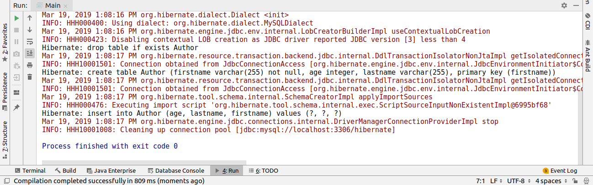
Main.java----------------crud read
package com.ttn.hibernate;
import org.hibernate.Session;
import org.hibernate.SessionFactory;
import org.hibernate.cfg.Configuration;
public class Main {
public static void main(String[] args) {
SessionFactory sessionFactory=new Configuration().configure().buildSessionFactory();
Session session=sessionFactory.openSession().getSession();
session.beginTransaction();
Author author=session.get(Author.class,"ABC");
session.getTransaction().commit();
session.close();
sessionFactory.close();
System.out.println(author);
}
}

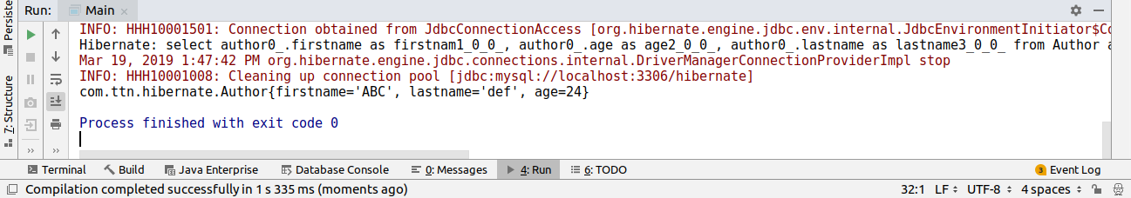

Main.java----------------crud update
package com.ttn.hibernate;
import org.hibernate.Session;
import org.hibernate.SessionFactory;
import org.hibernate.cfg.Configuration;
public class Main {
public static void main(String[] args) {
SessionFactory sessionFactory=new Configuration().configure().buildSessionFactory();
Session session=sessionFactory.openSession().getSession();
session.beginTransaction();
Author author=session.get(Author.class,"ABC");
author.setLastname("ghi");
session.update(author);
session.getTransaction().commit();
session.close();
sessionFactory.close();
System.out.println(author);
}
}

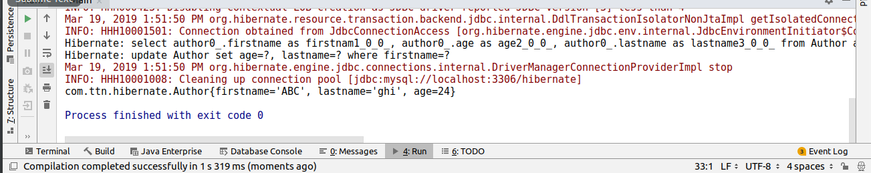
Main.java----------------crud delete
package com.ttn.hibernate;
import org.hibernate.Session;
import org.hibernate.SessionFactory;
import org.hibernate.cfg.Configuration;
public class Main {
public static void main(String[] args) {
SessionFactory sessionFactory=new Configuration().configure().buildSessionFactory();
Session session=sessionFactory.openSession().getSession();
session.beginTransaction();
Author author=session.get(Author.class,"ABC");
session.delete(author);
session.getTransaction().commit();
session.close();
sessionFactory.close();
System.out.println(author);
}
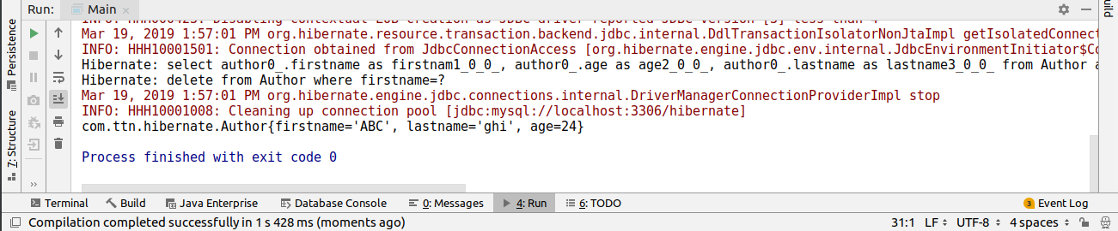
}

Question3:-Use hbm2ddl create to introduce Date of Birth for Author.
Answer:-
Main.java----------------
package com.ttn.hibernate;
import org.hibernate.Session;
import org.hibernate.SessionFactory;
import org.hibernate.cfg.Configuration;
import java.util.Date;
public class Main {
public static void main(String[] args) {
SessionFactory sessionFactory=new Configuration().configure().buildSessionFactory();
Session session=sessionFactory.openSess
Author author=session.get(Author.class,"ABC");
author.setDate(new Date(1999-02-12));
session.save(author);
session.getTransaction().commit();
session.close();
sessionFactory.close();
System.out.println(author);
}
}
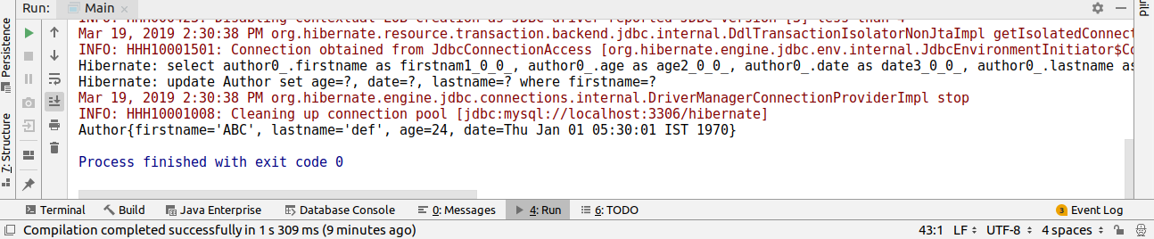
Question4:-Use hbm2dll update to insert at least 4 records for Author.
Answer:-
package com.ttn.hibernate;
import org.hibernate.Session;
import org.hibernate.SessionFactory;
import org.hibernate.cfg.Configuration;
import java.sql.Date;
public class Main {
public static void main(String[] args) {
Author author=new Author();
author.setFirstname("bcd");
author.setLastname("efg");
author.setAge(24);
author.setDate(Date.valueOf(1999-02-12));
Author author1=new Author();
author1.setFirstname("cde");
author1.setLastname("fgh");
author1.setAge(24);
author1.setDate(Date.valueOf(1999-02-12));
Author author2=new Author();
author2.setFirstname("def");
author2.setLastname("ghi");
author2.setAge(24);
author2.setDate(Date.valueOf(1999-02-12));
Author author3=new Author();
author3.setFirstname("efg");
author3.setLastname("hij");
author3.setAge(24);
author3.setDate(Date.valueOf(1999-02-12));
SessionFactory sessionFactory=new Configuration().configure().buildSessionFactory();
Session session=sessionFactory.openSession().getSession();
session.beginTransaction();
session.save(author);
session.save(author1);
session.save(author2);
session.save(author3);
session.getTransaction().commit();
session.close();
sessionFactory.close();
System.out.println(author);
}
}
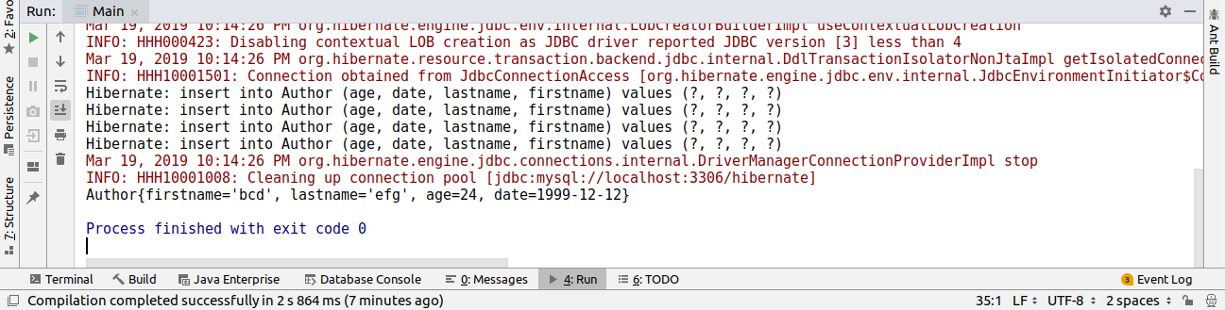

Question5:-Perform hbm2dll create-drop by closing session factory.
Answer:-
Set tha property hbm2ddl.auto value create-drop in hibernate.cfg.xml--------------
<!--drop or re-create database schema at startup and drop at close again-->
<property name="hbm2ddl.auto">create-drop</property>
Main.java-------------------
package com.ttn.hibernate;
import org.hibernate.Session;
import org.hibernate.SessionFactory;
import org.hibernate.cfg.Configuration;
import java.sql.Date;
public class Main {
public static void main(String[] args) {
Author author=new Author();
author.setFirstname("bcd");
author.setLastname("efg");
author.setAge(24);
author.setDate(Date.valueOf("1999-12-12"));
SessionFactory sessionFactory=new Configuration().configure().buildSessionFactory();
Session session=sessionFactory.openSession().getSession();
session.beginTransaction();
session.save(author);
session.getTransaction().commit();
session.close();
sessionFactory.close();
SessionFactory sessionFactory1=new Configuration().configure().buildSessionFactory();
Session session1=sessionFactory1.openSession().getSession();
Author author1=session1.get(Author.class,"bcd");
System.out.println(author1);
session1.close();
sessionFactory1.close();
}
}

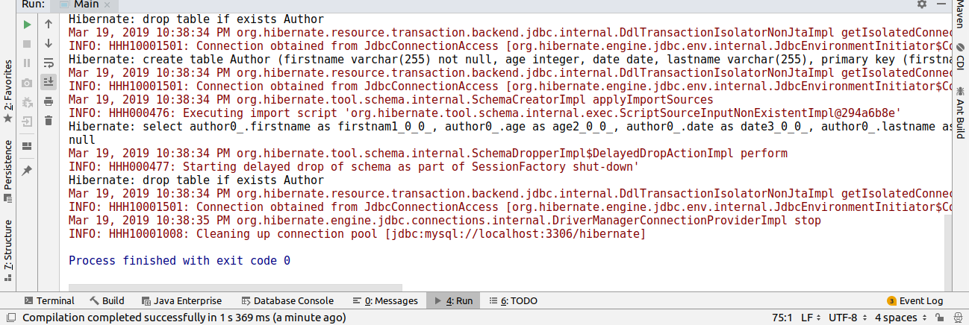
Question6:-Rename all the fields using column annotation.
Answer:-
Author.java--------------------------------------------
package com.ttn.hibernate;
import javax.persistence.*;
import java.util.Date;
@Entity
public class Author {
@Id
@Column(name = "fname") //Question6
private String firstname;
@Column(name = "lname") //Question6
private String lastname;
@Column(name = "Age") //Question6
private Integer age;
@Column(name = "dob") //Question6
private Date date;
@Override
public String toString() {
return "Author{" +
"firstname='" + firstname + '\'' +
", lastname='" + lastname + '\'' +
", age=" + age +
", date=" + date +
'}';
}
public Date getDate() {
return date;
}
public void setDate(Date date) {
this.date = date;
}
public String getFirstname() {
return firstname;
}
public void setFirstname(String firstname) {
this.firstname = firstname;
}
public String getLastname() {
return lastname;
}
public void setLastname(String lastname) {
this.lastname = lastname;
}
public Integer getAge() {
return age;
}
public void setAge(Integer age) {
this.age = age;
}
}

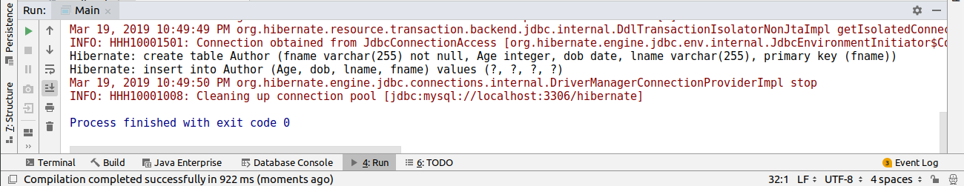
Question7:-Mark lastName as @Transient.
Answer:-
Author.java-----------------
package com.ttn.hibernate;
import javax.persistence.Entity;
import javax.persistence.Id;
import javax.persistence.Transient;
import java.util.Date;
@Entity
public class Author {
@Id
private String firstname;
@Transient //Question7
private String lastname;
private Integer age;
private Date date;
@Override
public String toString() {
return "Author{" +
"firstname='" + firstname + '\'' +
", lastname='" + lastname + '\'' +
", age=" + age +
", date=" + date +
'}';
}
public Date getDate() {
return date;
}
public void setDate(Date date) {
this.date = date;
}
public String getFirstname() {
return firstname;
}
public void setFirstname(String firstname) {
this.firstname = firstname;
}
public String getLastname() {
return lastname;
}
public void setLastname(String lastname) {
this.lastname = lastname;
}
public Integer getAge() {
return age;
}
public void setAge(Integer age) {
this.age = age;
}
}
main.java---------------------------
package com.ttn.hibernate;
import org.hibernate.Session;
import org.hibernate.SessionFactory;
import org.hibernate.cfg.Configuration;
import java.util.Date;
public class Main {
public static void main(String[] args) {
Author author=new Author();
author.setFirstname("ABC");
author.setLastname("def");
author.setAge(24);
author.setDate(Date.valueOf(1999-02-12));
SessionFactory sessionFactory=new Configuration().configure().buildSessionFactory();
Session session=sessionFactory.openSession().getSession();
session.beginTransaction();
session.save(author);
session.getTransaction().commit();
session.close();
sessionFactory.close();
System.out.println(author);
}
}
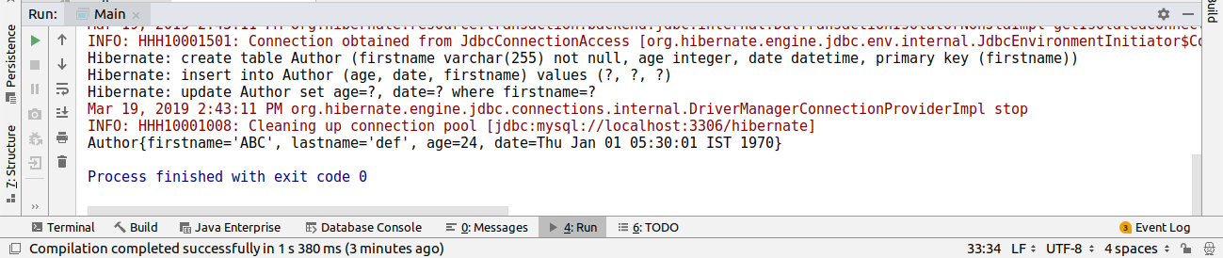

Question8:-Use @Temporal for date of birth of Author.
Answer:-
Author.java----------------------------
package com.ttn.hibernate;
import javax.persistence.*;
import java.util.Date;
@Entity
public class Author {
@Id
@Column(name = "fname")
private String firstname;
@Transient
@Column(name = "lname")
private String lastname;
@Column(name = "Age")
private Integer age;
@Temporal(TemporalType.DATE) //Question8
@Column(name = "dob")
private Date date;
@Override
public String toString() {
return "Author{" +
"firstname='" + firstname + '\'' +
", lastname='" + lastname + '\'' +
", age=" + age +
", date=" + date +
'}';
}
public Date getDate() {
return date;
}
public void setDate(Date date) {
this.date = date;
}
public String getFirstname() {
return firstname;
}
public void setFirstname(String firstname) {
this.firstname = firstname;
}
public String getLastname() {
return lastname;
}
public void setLastname(String lastname) {
this.lastname = lastname;
}
public Integer getAge() {
return age;
}
public void setAge(Integer age) {
this.age = age;
}
}

Question9:-Generate Id for Author Using IDENTITY and TABLE starategy.
Answer:-
Author.java-----------------------------
package com.ttn.hibernate;
import javax.persistence.*;
import java.util.Date;
@Entity
public class Author {
@Id
@GeneratedValue(strategy = GenerationType.IDENTITY)
private Integer id;
@Column(name = "fname")
private String firstname;
@Transient
@Column(name = "lname")
private String lastname;
@Column(name = "Age")
private Integer age;
@Temporal(TemporalType.DATE)
@Column(name = "dob")
private Date date;
@Override
public String toString() {
return "Author{" +
"firstname='" + firstname + '\'' +
", lastname='" + lastname + '\'' +
", age=" + age +
", date=" + date +
'}';
}
public Integer getId() {
return id;
}
public void setId(Integer id) {
this.id = id;
}
public Date getDate() {
return date;
}
public void setDate(Date date) {
this.date = date;
}
public String getFirstname() {
return firstname;
}
public void setFirstname(String firstname) {
this.firstname = firstname;
}
public String getLastname() {
return lastname;
}
public void setLastname(String lastname) {
this.lastname = lastname;
}
public Integer getAge() {
return age;
}
public void setAge(Integer age) {
this.age = age;
}
}
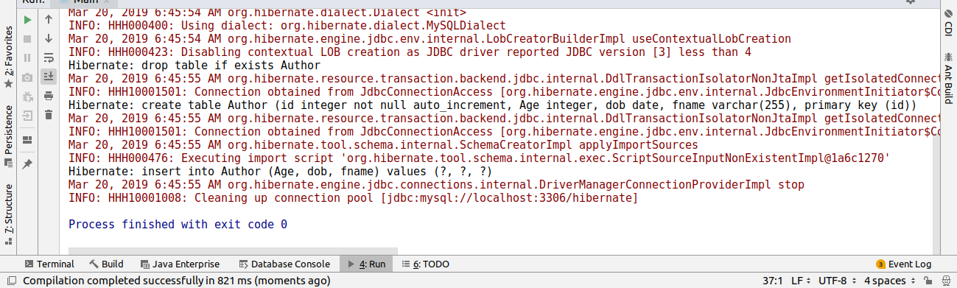
Question10:-Create a class Address for Author with instance variables streetNumber, location, State.
Answer:-
Address.java---------------------------------
package com.ttn.hibernate;
import javax.persistence.Embeddable;
@Embeddable
public class Address {
private Integer streetNumber;
private String location;
private String State;
public Integer getStreetNumber() {
return streetNumber;
}
public void setStreetNumber(Integer streetNumber) {
this.streetNumber = streetNumber;
}
public String getLocation() {
return location;
}
public void setLocation(String location) {
this.location = location;
}
public String getState() {
return State;
}
public void setState(String state) {
State = state;
}
}

Question11:-Create instance variable of Address class inside Author class and save it as embedded object.
Answer:-
Author.java--------------------
package com.ttn.hibernate;
import javax.persistence.*;
import java.util.Date;
@Entity
public class Author {
@Id
@GeneratedValue(strategy = GenerationType.IDENTITY)
private Integer id;
@Column(name = "fname")
private String firstname;
@Transient
@Column(name = "lname")
private String lastname;
@Column(name = "Age")
private Integer age;
@Temporal(TemporalType.DATE)
@Column(name = "dob")
private Date date;
@Embedded
private Address address;
@Override
public String toString() {
return "Author{" +
"id=" + id +
", firstname='" + firstname + '\'' +
", lastname='" + lastname + '\'' +
", age=" + age +
", date=" + date +
", address=" + address +
'}';
}
public Address getAddress() {
return address;
}
public void setAddress(Address address) {
this.address = address;
}
public Integer getId() {
return id;
}
public void setId(Integer id) {
this.id = id;
}
public Date getDate() {
return date;
}
public void setDate(Date date) {
this.date = date;
}
public String getFirstname() {
return firstname;
}
public void setFirstname(String firstname) {
this.firstname = firstname;
}
public String getLastname() {
return lastname;
}
public void setLastname(String lastname) {
this.lastname = lastname;
}
public Integer getAge() {
return age;
}
public void setAge(Integer age) {
this.age = age;
}
}
Main.java---------------------
package com.ttn.hibernate;
import org.hibernate.Session;
import org.hibernate.SessionFactory;
import org.hibernate.cfg.Configuration;
import java.sql.Date;
public class Main {
public static void main(String[] args) {
Author author=new Author();
author.setFirstname("bcd");
author.setLastname("efg");
author.setAge(24);
author.setDate(Date.valueOf("1999-12-12"));
Address address=new Address();
address.setLocation("Noida");
address.setState("Utter Pradesh");
address.setStreetNumber(12);
author.setAddress(address);
SessionFactory sessionFactory=new Configuration().configure().buildSessionFactory();
Session session=sessionFactory.openSession().getSession();
session.beginTransaction();
session.save(author);
session.getTransaction().commit();
session.close();
sessionFactory.close();
}
}

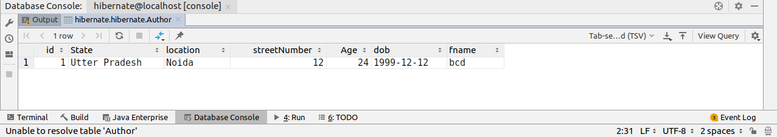
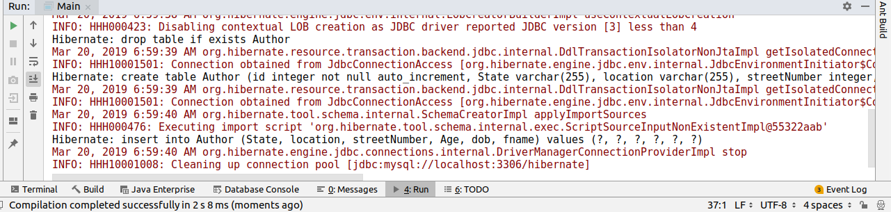
Question12:-Introduce a List of subjects for author.
Answer:-
Author.java-----------------------------------
package com.ttn.hibernate;
import javax.persistence.*;
import java.util.Date;
import java.util.HashSet;
import java.util.List;
import java.util.Set;
@Entity
public class Author {
@GeneratedValue(strategy = GenerationType.IDENTITY)
@Id
private Integer id;
@Column(name = "fname")
private String firstname;
@Transient
@Column(name = "lname")
private String lastname;
@Column(name = "Age")
private Integer age;
@Temporal(TemporalType.DATE)
@Column(name = "dob")
private Date date;
@Embedded
private Address address;
@ElementCollection
private Set<String> subject=new HashSet<>();
@Override
public String toString() {
return "Author{" +
"id=" + id +
", firstname='" + firstname + '\'' +
", lastname='" + lastname + '\'' +
", age=" + age +
", date=" + date +
", address=" + address +
", subject=" + subject +
'}';
}
public Set<String> getSubject() {
return subject;
}
public void setSubject(Set<String> subject) {
this.subject = subject;
}
public Address getAddress() {
return address;
}
public void setAddress(Address address) {
this.address = address;
}
public Integer getId() {
return id;
}
public void setId(Integer id) {
this.id = id;
}
public Date getDate() {
return date;
}
public void setDate(Date date) {
this.date = date;
}
public String getFirstname() {
return firstname;
}
public void setFirstname(String firstname) {
this.firstname = firstname;
}
public String getLastname() {
return lastname;
}
public void setLastname(String lastname) {
this.lastname = lastname;
}
public Integer getAge() {
return age;
}
public void setAge(Integer age) {
this.age = age;
}
}

Main.java-----------------------------------
package com.ttn.hibernate;
import org.hibernate.Session;
import org.hibernate.SessionFactory;
import org.hibernate.cfg.Configuration;
import java.sql.Date;
import java.util.Arrays;
import java.util.HashSet;
import java.util.Set;
public class Main {
public static void main(String[] args) {
Author author=new Author();
author.setFirstname("bcd");
author.setLastname("efg");
author.setAge(24);
author.setDate(Date.valueOf("1999-12-12"));
Address address=new Address();
address.setLocation("Noida");
address.setState("Utter Pradesh");
address.setStreetNumber(12);
author.setAddress(address);
Set<String> sub= new HashSet<>(Arrays.asList("Math","Physics","Arts"));
author.setSubject(sub);
SessionFactory sessionFactory=new Configuration().configure().buildSessionFactory();
Session session=sessionFactory.openSession().getSession();
session.beginTransaction();
session.save(author);
session.getTransaction().commit();
session.close();
sessionFactory.close();
}
}
Tables
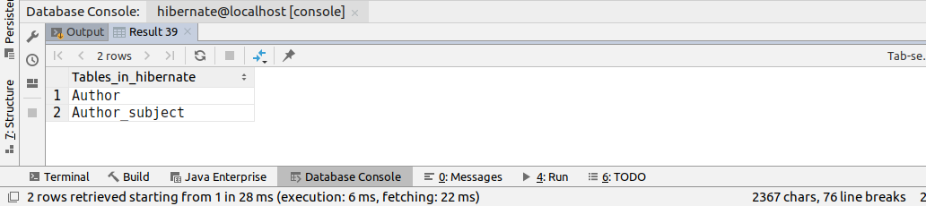

Data in Author_subject table-----------------------
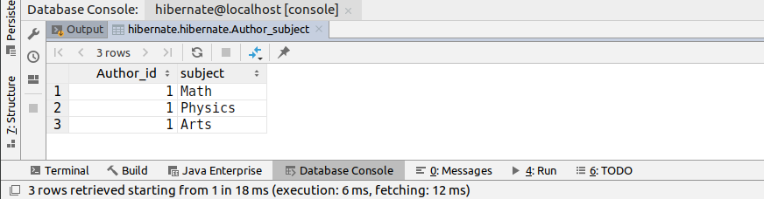

Question13:-Persist 3 subjects for each author.
Answer:-
Main.java-------------------
package com.ttn.hibernate;
import org.hibernate.Session;
import org.hibernate.SessionFactory;
import org.hibernate.cfg.Configuration;
import java.sql.Date;
import java.util.Arrays;
import java.util.HashSet;
public class Main {
public static void main(String[] args) {

Author author=new Author();
author.setFirstname("bcd");
author.setLastname("efg");
author.setAge(24);
author.setDate(Date.valueOf("1999-12-12"));
Address address=new Address();
address.setLocation("Noida");
address.setState("Utter Pradesh");
address.setStreetNumber(12);
author.setAddress(address);
author.setSubject(new HashSet<>(Arrays.asList("Math","Physics","Arts")));

Author author1=new Author();
author1.setFirstname("cde");
author1.setLastname("fgh");
author1.setAge(24);
author1.setDate(Date.valueOf("1999-12-12"));
author1.setAddress(address);
author1.setSubject(new HashSet<>(Arrays.asList("Math","Physics","Arts")));

Author author2=new Author();
author2.setFirstname("def");
author2.setLastname("ghi");
author2.setAge(24);
author2.setDate(Date.valueOf("1999-12-12"));
author2.setAddress(address);
author2.setSubject(new HashSet<>(Arrays.asList("Math","Physics","Arts")));

Author author3=new Author();
author3.setFirstname("efg");
author3.setLastname("hij");
author3.setAge(24);
author3.setDate(Date.valueOf("1999-12-12"));
author3.setAddress(address);
author3.setSubject(new HashSet<>(Arrays.asList("Math","Physics","Arts")));

SessionFactory sessionFactory=new Configuration().configure().buildSessionFactory();
Session session=sessionFactory.openSession().getSession();
session.beginTransaction();
session.save(author);
session.save(author1);
session.save(author2);
session.save(author3);
session.getTransaction().commit();
session.close();
sessionFactory.close();
}
}
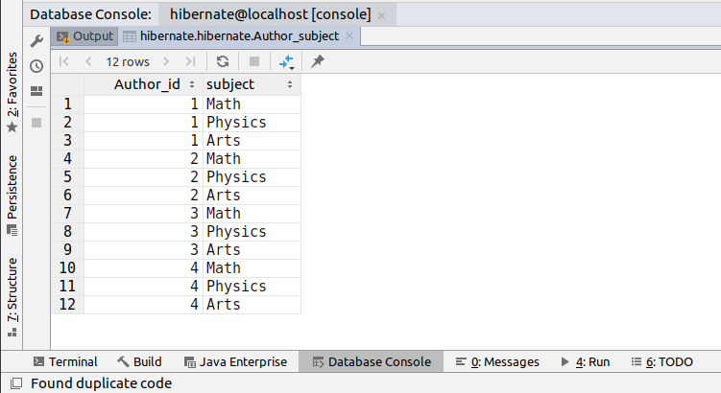
Author_subject table--------------------------

Author Table------------------------------------
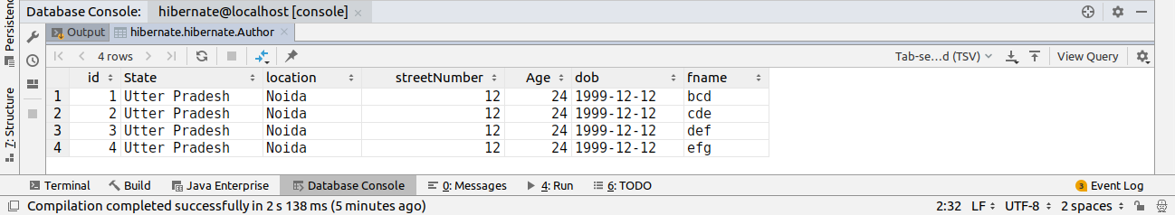
Question14:-Create an Entity book with an instance variable bookName.
Answer:-
Entity.java-------------------------
package com.ttn.hibernate;
import javax.persistence.Entity;
import javax.persistence.GeneratedValue;
import javax.persistence.GenerationType;
import javax.persistence.Id;
@Entity
public class Book {
@Id
@GeneratedValue(strategy = GenerationType.IDENTITY)
private Integer id;
private String bookName;
public Integer getId() {
return id;
}
public void setId(Integer id) {
this.id = id;
}
public String getBookName() {
return bookName;
}
public void setBookName(String bookName) {
this.bookName = bookName;
}
}

Question15:-Implement One to One mapping between Author and Book.
Answer:-
Main.java------------------------
package com.ttn.hibernate;
import org.hibernate.Session;
import org.hibernate.SessionFactory;
import org.hibernate.cfg.Configuration;
import java.sql.Date;
import java.util.Arrays;
import java.util.HashSet;
public class Main {
public static void main(String[] args) {
Author author=new Author();
author.setFirstname("bcd");
author.setLastname("efg");
Address address=new Address();
address.setLocation("Noida");
address.setState("Utter Pradesh");
address.setStreetNumber(12);
author.setAge(24);
author.setDate(Date.valueOf("1999-12-12"));
author.setAddress(address);
author.setSubject(new HashSet<>(Arrays.asList("Math","Physics","Arts")));
Book book=new Book();
book.setBookName("Complete Reference Java ");
author.setBook(book);
Author author1=new Author();
author1.setFirstname("cde");
author1.setLastname("fgh");
author1.setAge(24);
author1.setDate(Date.valueOf("1999-12-12"));
author1.setAddress(address);
author1.setSubject(new HashSet<>(Arrays.asList("Math","Physics","Arts")));
Book book1=new Book();
book1.setBookName("Little Marrim");
author1.setBook(book1);
Author author2=new Author();
author2.setFirstname("def");
author2.setLastname("ghi");
author2.setAge(24);
author2.setDate(Date.valueOf("1999-12-12"));
author2.setAddress(address);
author2.setSubject(new HashSet<>(Arrays.asList("Math","Physics","Arts")));
Book book2=new Book();
book2.setBookName("Two States");
author2.setBook(book2);
Author author3=new Author();
author3.setFirstname("efg");
author3.setLastname("hij");
author3.setAge(24);
author3.setDate(Date.valueOf("1999-12-12"));
author3.setAddress(address);
author3.setSubject(new HashSet<>(Arrays.asList("Math","Physics","Arts")));
Book book3=new Book();
book3.setBookName("Last Night");
author3.setBook(book3);
SessionFactory sessionFactory=new Configuration().configure().buildSessionFactory();
Session session=sessionFactory.openSession().getSession();
session.beginTransaction();
session.save(author);
session.save(book);
session.save(author1);
session.save(book1);
session.save(author2);
session.save(book2);
session.save(author3);
session.save(book3);
session.getTransaction().commit();
session.close();
sessionFactory.close();
}
}
Author.java------------------------------
package com.ttn.hibernate;
import javax.persistence.*;
import java.util.Date;
import java.util.HashSet;
import java.util.Set;
@Entity
public class Author {
@GeneratedValue(strategy = GenerationType.IDENTITY)
@Id
private Integer id;
@Column(name = "fname")
private String firstname;
@Transient
@Column(name = "lname")
private String lastname;
@Column(name = "Age")
private Integer age;
@Temporal(TemporalType.DATE)
@Column(name = "dob")
private Date date;
@Embedded
private Address address;
@OneToOne
@JoinColumn(name="book")
private Book book;

@Override
public String toString() {
return "Author{" +
"id=" + id +
", firstname='" + firstname + '\'' +
", lastname='" + lastname + '\'' +
", age=" + age +
", date=" + date +
", address=" + address +
", book=" + book +
", subject=" + subject +
'}';
}
public Book getBook() {
return book;
}
public void setBook(Book book) {
this.book = book;
}
public Set<String> getSubject() {
return subject;
}
public void setSubject(Set<String> subject) {
this.subject = subject;
}
@ElementCollection
private Set<String> subject=new HashSet<>();
public Address getAddress() {
return address;
}
public void setAddress(Address address) {
this.address = address;
}
public Integer getId() {
return id;
}
public void setId(Integer id) {
this.id = id;
}
public Date getDate() {
return date;
}
public void setDate(Date date) {
this.date = date;
}
public String getFirstname() {
return firstname;
}
public void setFirstname(String firstname) {
this.firstname = firstname;
}
public String getLastname() {
return lastname;
}
public void setLastname(String lastname) {
this.lastname = lastname;
}
public Integer getAge() {
return age;
}
public void setAge(Integer age) {
this.age = age;
}
}

Question16:-Implement One to Many Mapping between Author and Book(Unidirectional, BiDirectional and without additional table ) and implement cascade save.
Answer:-
Main.java------------------------
package com.ttn.hibernate;
import org.hibernate.Session;
import org.hibernate.SessionFactory;
import org.hibernate.cfg.Configuration;
import java.sql.Date;
import java.util.Arrays;
import java.util.HashSet;
public class Main {
public static void main(String[] args) {
Author author=new Author();
author.setFirstname("bcd");
author.setLastname("efg");
Address address=new Address();
address.setLocation("Noida");
address.setState("Utter Pradesh");
address.setStreetNumber(12);
author.setAge(24);
author.setDate(Date.valueOf("1999-12-12"));
author.setAddress(address);
author.setSubject(new HashSet<>(Arrays.asList("Math","Physics","Arts")));
Book book=new Book();
book.setBookName("Complete Reference Java ");
Book book1=new Book();
book1.setBookName("Little Marrim");
Book book2=new Book();
book2.setBookName("Two States");
author.setBook(new HashSet<>(Arrays.asList(book,book1,book2)));
SessionFactory sessionFactory=new Configuration().configure().buildSessionFactory();
Session session=sessionFactory.openSession().getSession();
session.beginTransaction();
session.save(author);
session.save(book);
session.save(book1);
session.save(book2);
session.getTransaction().commit();
session.close();
sessionFactory.close();
}
}
Author.java-------------------
package com.ttn.hibernate;
import javax.persistence.*;
import java.util.Date;
import java.util.HashSet;
import java.util.Set;
@Entity
public class Author {
@GeneratedValue(strategy = GenerationType.IDENTITY)
@Id
private Integer authId;
@Column(name = "fname")
private String firstname;
@Transient
@Column(name = "lname")
private String lastname;
@Column(name = "Age")
private Integer age;
@Temporal(TemporalType.DATE)
@Column(name = "dob")
private Date date;
@Embedded
private Address address;
@OneToMany
@JoinTable(joinColumns = @JoinColumn(name="AUTH_ID"),inverseJoinColumns = @JoinColumn(name = "BOOK_ID"))
private Set<Book> book;
@Override
public String toString() {
return "Author{" +
"id=" + authId +
", firstname='" + firstname + '\'' +
", lastname='" + lastname + '\'' +
", age=" + age +
", date=" + date +
", address=" + address +
", book=" + book +
", subject=" + subject +
'}';
}
public Set<Book> getBook() {
return book;
}
public void setBook(Set<Book> book) {
this.book = book;
}
public Set<String> getSubject() {
return subject;
}
public void setSubject(Set<String> subject) {
this.subject = subject;
}
@ElementCollection
private Set<String> subject=new HashSet<>();
public Address getAddress() {
return address;
}
public void setAddress(Address address) {
this.address = address;
}
public Integer getAuthId() {
return authId;
}
public void setAuthId(Integer id) {
this.authId = id;
}
public Date getDate() {
return date;
}
public void setDate(Date date) {
this.date = date;
}
public String getFirstname() {
return firstname;
}
public void setFirstname(String firstname) {
this.firstname = firstname;
}
public String getLastname() {
return lastname;
}
public void setLastname(String lastname) {
this.lastname = lastname;
}
public Integer getAge() {
return age;
}
public void setAge(Integer age) {
this.age = age;
}
}

Question17:-Implement Many to Many Mapping between Author and Book.
Answer:-
Main.java-------------------------------------
package com.ttn.hibernate;
import org.hibernate.Session;
import org.hibernate.SessionFactory;
import org.hibernate.cfg.Configuration;
import java.sql.Date;
import java.util.Arrays;
import java.util.HashSet;
public class Main {
public static void main(String[] args) {
Author author=new Author();
author.setFirstname("bcd");
author.setLastname("efg");
Address address=new Address();
address.setLocation("Noida");
address.setState("Utter Pradesh");
address.setStreetNumber(12);
author.setAge(24);
author.setDate(Date.valueOf("1999-12-12"));
author.setAddress(address);
author.setSubject(new HashSet<>(Arrays.asList("Math","Physics","Arts")));
Book book=new Book();
book.setBookName("Complete Reference Java ");
author.setBooks(Arrays.asList(book));
Author author1=new Author();
author1.setFirstname("cde");
author1.setLastname("fgh");
author1.setAge(24);
author1.setDate(Date.valueOf("1999-12-12"));
author1.setAddress(address);
author1.setSubject(new HashSet<>(Arrays.asList("Math","Physics","Arts")));
Book book1=new Book();
book1.setBookName("Little Marrim");
author1.setBooks(Arrays.asList(book,book1));
Author author2=new Author();
author2.setFirstname("def");
author2.setLastname("ghi");
author2.setAge(24);
author2.setDate(Date.valueOf("1999-12-12"));
author2.setAddress(address);
author2.setSubject(new HashSet<>(Arrays.asList("Math","Physics","Arts")));
Book book2=new Book();
book2.setBookName("Two States");
author2.setBooks(Arrays.asList(book,book1,book2));
Author author3=new Author();
author3.setFirstname("efg");
author3.setLastname("hij");
author3.setAge(24);
author3.setDate(Date.valueOf("1999-12-12"));
author3.setAddress(address);
author3.setSubject(new HashSet<>(Arrays.asList("Math","Physics","Arts")));
Book book3=new Book();
book3.setBookName("Last Night");
author3.setBooks(Arrays.asList(book,book1,book2,book3));
SessionFactory sessionFactory=new Configuration().configure().buildSessionFactory();
Session session=sessionFactory.openSession().getSession();
session.beginTransaction();
session.persist(author);
session.persist(author1);
session.persist(author2);
session.persist(author3);
session.getTransaction().commit();
session.close();
sessionFactory.close();
}
}

Author.java------------------------------
package com.ttn.hibernate;
import javax.persistence.*;
import java.util.*;
@Entity
public class Author {
@GeneratedValue(strategy = GenerationType.IDENTITY)
@Id
private Integer id;
@Column(name = "fname")
private String firstname;
@Transient
@Column(name = "lname")
private String lastname;
@Column(name = "Age")
private Integer age;
@Temporal(TemporalType.DATE)
@Column(name = "dob")
private Date date;
@Embedded
private Address address;
@ManyToMany(cascade = CascadeType.PERSIST)
List<Book> books=new ArrayList<>();
@Override
public String toString() {
return "Author{" +
"id=" + id +
", firstname='" + firstname + '\'' +
", lastname='" + lastname + '\'' +
", age=" + age +
", date=" + date +
", address=" + address +
", books=" + books +
", subject=" + subject +
'}';
}
public List<Book> getBooks() {
return books;
}
public void setBooks(List<Book> books) {
this.books = books;
}
public Set<String> getSubject() {
return subject;
}
public void setSubject(Set<String> subject) {
this.subject = subject;
}
@ElementCollection
private Set<String> subject=new HashSet<>();
public Address getAddress() {
return address;
}
public void setAddress(Address address) {
this.address = address;
}
public Integer getId() {
return id;
}
public void setId(Integer id) {
this.id = id;
}
public Date getDate() {
return date;
}
public void setDate(Date date) {
this.date = date;
}
public String getFirstname() {
return firstname;
}
public void setFirstname(String firstname) {
this.firstname = firstname;
}
public String getLastname() {
return lastname;
}
public void setLastname(String lastname) {
this.lastname = lastname;
}
public Integer getAge() {
return age;
}
public void setAge(Integer age) {
this.age = age;
}
}

Book.java--------------------------------
package com.ttn.hibernate;
import javax.persistence.*;
import java.util.ArrayList;
import java.util.List;
@Entity
public class Book {
@GeneratedValue(strategy = GenerationType.IDENTITY)
@Id
private Integer id;
private String bookName;
@ManyToMany(mappedBy = "books")
List<Author> authorList=new ArrayList<>();
public Integer getId() {
return id;
}
public void setId(Integer id) {
this.id = id;
}
public String getBookName() {
return bookName;
}
public void setBookName(String bookName) {
this.bookName = bookName;
}
}

