Binary Search Application: User Guide

INTRODUCTION:

It is a Visual Basic.Net application to search for an element in an list using Binary Search Algorithm and show how the Binary Search Algorithm works.

USAGE:

People who want to search for a value in a list of similar values can use this application to get their job done instantaneously. Beginners who are interested in the Binary Search Algorithm, can use this application to see step-by-step process of how the Binary Search Algorithm works on different inputs.

INTERFACE:

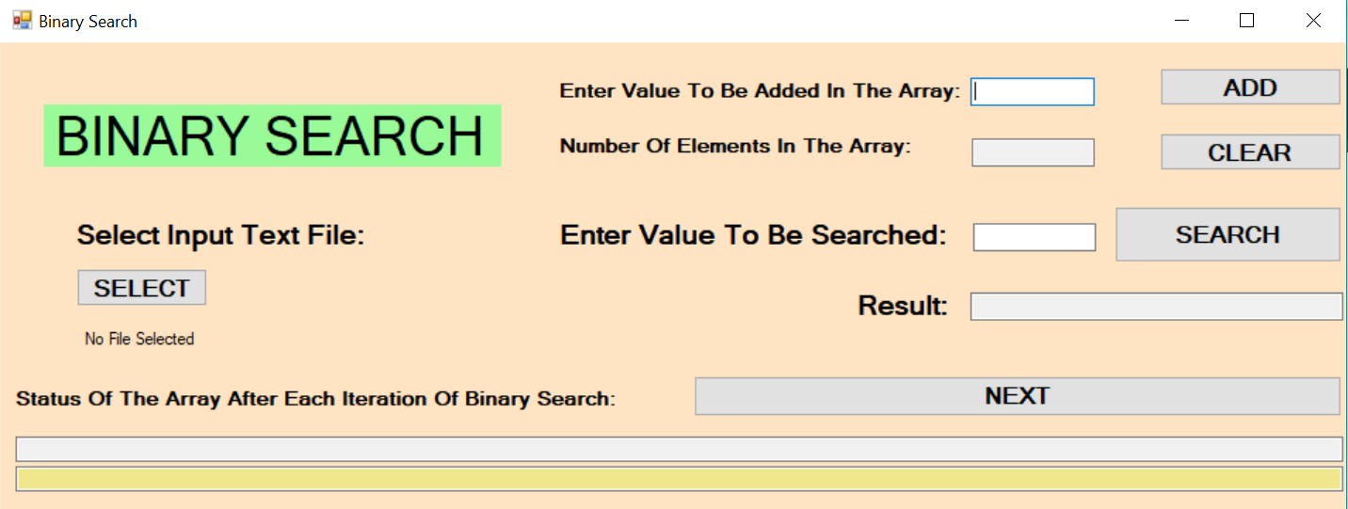

( Window Size: 1459, 568 )

As can be seen in the diagram that the application contains three elements:

1. INPUT BOX: User can write values in it.

2. BUTTONS: Each button has a specific task and those tasks are performed when the user presses the button.

3. OUTPUT BOX: Displays some values. User can not write in an output box.

OUTPUT BOX: Shows the number of elements in the array at every instant.

ADD BUTTON: Adds the entered value in the input box(on the left) to the end of the array.

INPUT BOX: Enter the value to be searched in the array.

OUTPUT BOX: Shows the result of search operation.

INPUT BOX: Type a value to be added at the back in the array.



NEXT BUTTON: To shift to the next iteration of binary search.

OUTPUT BOX: Displays the position of LOW, MID, HIGH values in the array during each iteration of binary search.

SEARCH BUTTON: To search the value entered in the input box(on the left).

OUTPUT BOX: Displays the status of the array.

SELECT BUTTON: For selecting text file for input.

CLEAR BUTTON: Resets everything to initial state.

SELECT BUTTON:



This shows that no file is selected yet for the input.

When you click on the select button a new window appears:

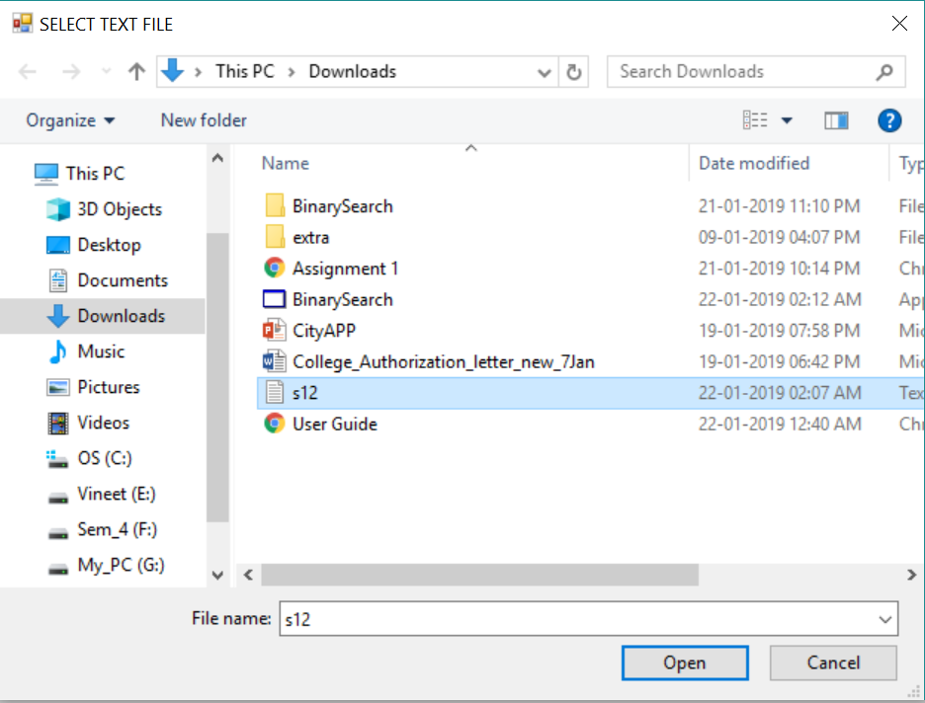

Now choose the text file with inputs, and click “Open”.

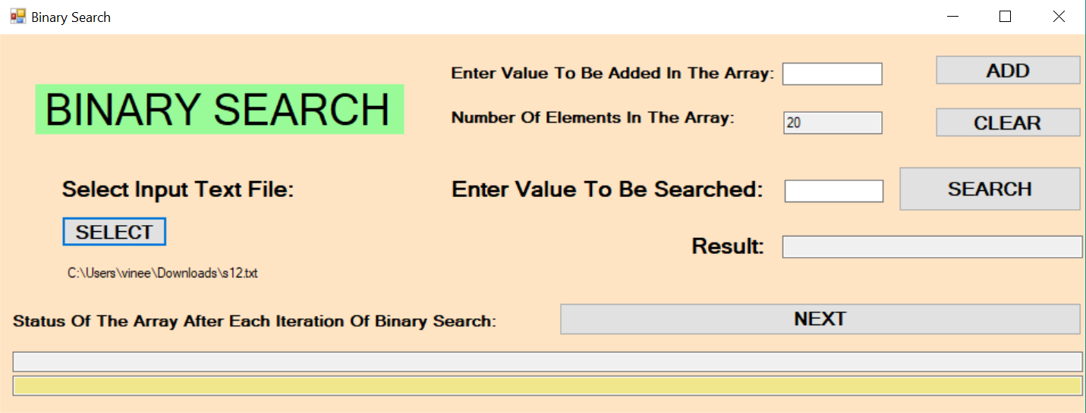

This is the file which has been selected for input.

Limitations/Precautions of the Application:

1. Array size cannot be greater than 1,000,000.

2. Input array should be sorted. The program won’t work for an unsorted array.

3. Array values should be of the same data type.

4. Selected file should be a text file, with each array value written on a separate line.

5. The visualization feature will only be helpful for arrays with number of elements <= 20, due to the limitation of the window size.