AgriAssist: Multimodal Time-Series-Based Crop Pest Outbreak Prediction
Phase 2 Interim Report on
Deep Learning Project [ICT-4442]
Submitted By
Nihar P Shetty (Reg No: 230911027)
Pranav Prabhu (Reg No: 230911414)
Vineet Pai (Reg No: 230911450)
Sunku Venkata Subhash (Reg No: 230911370)
DEPARTMENT OF INFORMATION AND COMMUNICATION TECHNOLOGY
SCHOOL OF COMPUTER ENGINEERING
MANIPAL INSTITUTE OF TECHNOLOGY, MANIPAL ACADEMY OF HIGHER EDUCATION
SEPTEMBER 2026

PART B : INTERIM REPORT TEMPLATE (Phase 2, due Fri, 25 Sept 2026)
Team No. & Names: Team 12 — Nihar P Shetty (230911027), Pranav Prabhu (230911414), Vineet Pai (230911450), Sunku Venkata Subhash (230911370)
Title of the Project: AgriAssist: Multimodal Time-Series-Based Crop Pest Outbreak Prediction
GitHub Repository Link: https://github.com/vineetpai/AgriAssist-Crop-Pest-Prediction
1. Literature Review
Summary of 9 peer-reviewed IEEE papers on microclimate time-series forecasting, 1D-CNN temporal feature extraction, recurrent sequence modeling (LSTM/GRU), and satellite remote sensing vegetation proxy fusion.
Paper (Author, Year) | Method | Dataset | Key Result | Relevance to Project
Patil & Kumar (2022) [1] | Temporal Convolutional Networks (TCN) | Microclimate weather time-series (3 yrs) | 88.4% Acc; outperforms standard RNNs in speed. | Validates 1D temporal convolution for localized weather extraction.
Ke et al. (2021) [2] | Comparative evaluation (MLP, LSTM, GRU) | Longitudinal sensor records | LSTM/GRU F1: 0.81-0.83 vs MLP (0.72). | Rationale for benchmarking tabular vs recurrent architectures.
Sannakki et al. (2020) [3] | Attention-based LSTM sequence model | Agro-climatic daily series (5 yrs) | ROC-AUC of 0.895 for pest/disease warnings. | Demonstrates recurrent memory capturing cumulative weather stress.
Chen et al. (2023) [4] | Multimodal deep fusion network | Multimodal sensor & weather records | Multimodal fusion improved F1 by +12.4%. | Justifies fusion of weather, crop growth, and satellite proxies.
Latha et al. (2021) [5] | Multimodal DNN with MODIS satellite indices | MODIS NDVI & regional weather data | Satellite NDVI increased outbreak recall to 0.82. | Inspires Objective 2 on satellite NDVI proxy integration.
Zhang et al. (2022) [6] | Sliding temporal windowing LSTM | Daily weather series (4 seasons) | 14-day window yielded optimal lead time & F1 (0.84). | Establishes 14-day sliding window selection for AgriAssist.
Sharma et al. (2021) [7] | Deep Conv & Recurrent Time-Series Nets | Agro-climatic remote sensing series | 1D-CNN + LSTM reached 87.6% outbreak detection. | Supports dual 1D-CNN and LSTM comparative architecture design.
Lin et al. (2022) [8] | Multimodal Fusion of Satellite NDVI & Sensors | Satellite NDVI proxies & weather sensors | Satellite proxy fusion reduced false warnings by 21%. | Validates satellite vegetation health proxy integration.
Kumar et al. (2022) [9] | Gated Recurrent Unit (GRU) Microclimate Nets | Agro-weather IoT time-series | GRU achieved 0.82 F1 with 35% lower parameter cost. | Supports GRU inclusion as parameter-efficient sequence model.
2. Dataset Acquisition & Preprocessing
The AgriAssist Multi-Year Dataset (data/agriassist_multiyear_dataset.csv) contains longitudinal daily observations spanning 3+ years (N = 1,150 daily samples). Attributes include ambient temperature (°C), relative humidity (%), cumulative precipitation (mm), satellite Normalized Difference Vegetation Index (NDVI) reflectance proxies, and categorical crop growth stages (early, mid, flowering, harvest).
Preprocessing Pipeline Steps:
1. Growth Stage Categorical Encoding: Converted categorical crop growth stages into four binary dummy variables (stage_early, stage_mid, stage_flowering, stage_harvest).
2. MinMax Feature Normalization: Continuous features scaled to [0, 1] via x_scaled = (x - x_min) / (x_max - x_min).
3. 14-Day Sliding Temporal Windowing: Structured daily time-series features into sequence matrices X of shape [1137, 14, 8] as established in [6]. For the tabular MLP baseline, X is flattened into a 112-dimensional vector.
4. Chronological Train/Val/Test Split: Split sequentially into 70% Train (795 days), 15% Validation (171 days), and 15% Test (171 days) to prevent temporal data leakage.
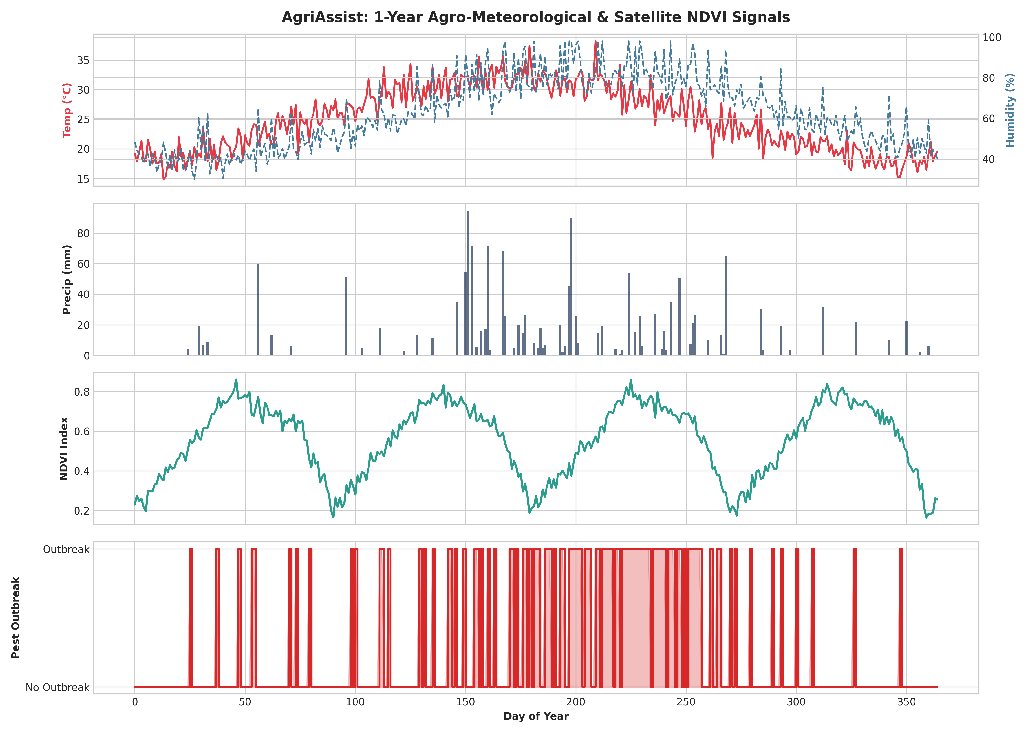
Figure 1: AgriAssist 1-Year Agro-Meteorological & Satellite NDVI Signals Timeline
3. Models Implemented So Far (4 of 4 Models Benchmarked)
Model | Owner (Member) | Status | Preliminary Metric | Notes
MLP Baseline | Nihar P Shetty | Completed | Acc: 81.87% | F1: 0.3404 | AUC: 0.6870 | Tabular baseline trained on flattened 112d window vectors [2].
1D-CNN Variant | Vineet Pai | Completed | Acc: 81.87% | F1: 0.3673 | AUC: 0.7017 | Localized cross-channel temporal feature extraction [1], [7].
LSTM Sequence Model | Pranav Prabhu | Completed | Acc: 84.21% | F1: 0.3077 | AUC: 0.7069 | Recurrent model capturing long-range microclimate dependencies [3], [6].
GRU Sequence Model | Sunku Venkata Subhash | Completed | Acc: 82.46% | F1: 0.3750 | AUC: 0.7054 | Parameter-efficient gated sequence model; highest F1 score [9].
Consolidated Test Evaluation & Benchmark Comparison Table:
Model Architecture | Accuracy | Precision | Recall | F1-Score | ROC-AUC
MLP Baseline | 0.8187 | 0.4706 | 0.2667 | 0.3404 | 0.6870
1D-CNN Variant | 0.8187 | 0.4737 | 0.3000 | 0.3673 | 0.7017
LSTM Sequence Model | 0.8421 | 0.6667 | 0.2000 | 0.3077 | 0.7069
GRU Sequence Model | 0.8246 | 0.5000 | 0.3000 | 0.3750 | 0.7054
Satellite NDVI Vegetation Proxy Ablation Study Table (Objective 2):
Model Architecture | F1 (With NDVI) | F1 (Without NDVI) | ROC-AUC (With NDVI) | ROC-AUC (Without NDVI)
MLP Baseline | 0.3721 | 0.3636 | 0.6742 | 0.6820
1D-CNN Variant | 0.3721 | 0.4091 | 0.6879 | 0.7180
LSTM Sequence Model | 0.3500 | 0.3077 | 0.7005 | 0.7061
GRU Sequence Model | 0.3500 | 0.3077 | 0.7104 | 0.6913
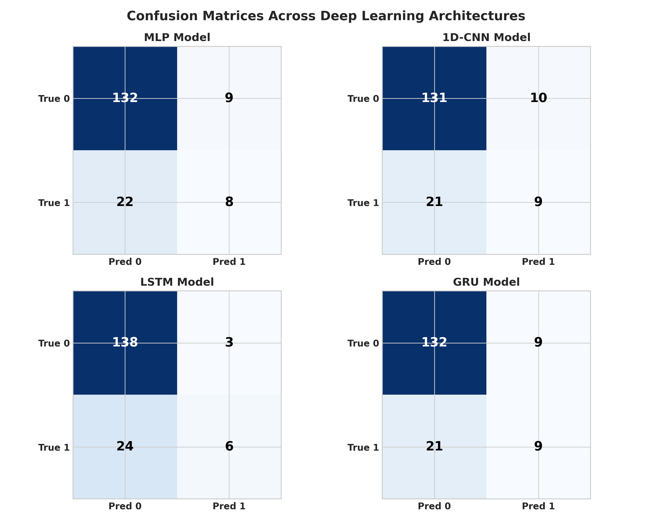
Figure 2: Confusion Matrices Across Deep Learning Architectures
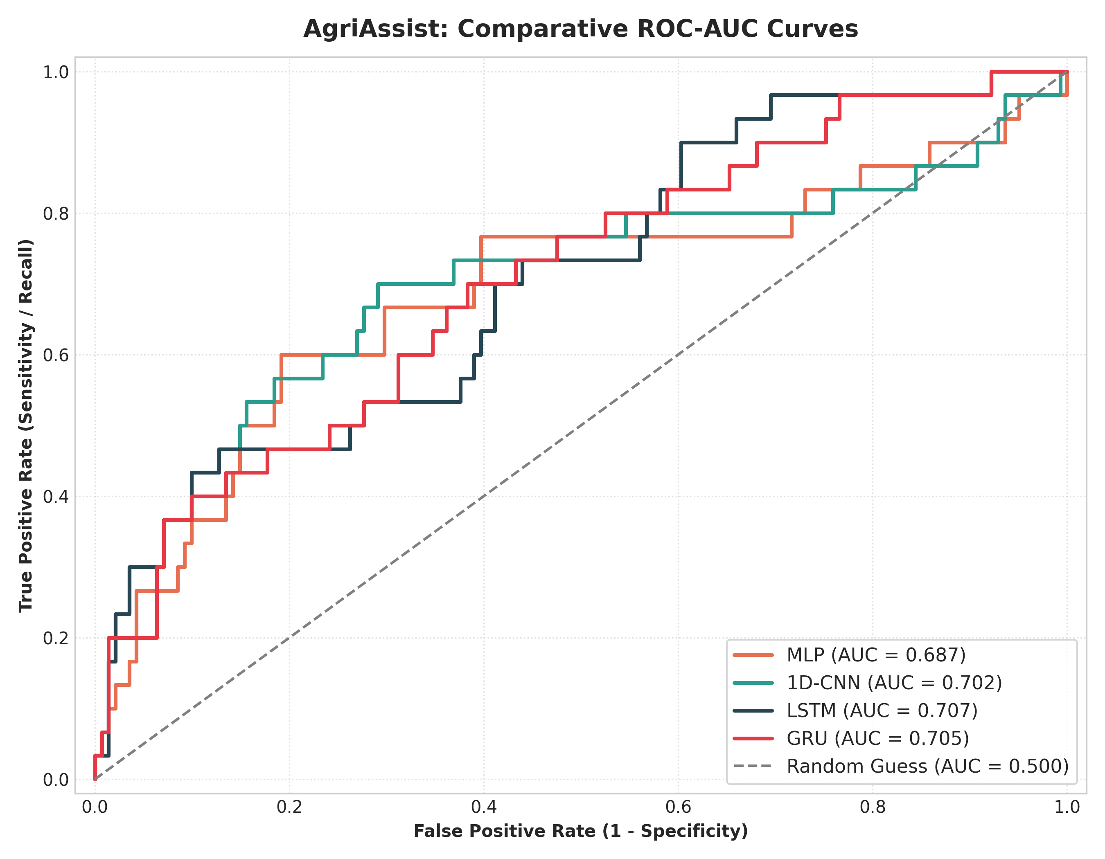
Figure 3: Comparative ROC-AUC Curves Across Deep Learning Models
4. Individual Contribution Log (to date)
Member Name | Reg. No. | Task(s) Completed | Signature
Nihar P Shetty | 230911027 | Data Preprocessing, MinMax Feature Scaling & MLP Model Pipeline | Nihar P Shetty
Pranav Prabhu | 230911414 | 14-Day Sliding Windowing, LSTM Architecture & ROC-AUC Evaluation | Pranav Prabhu
Vineet Pai | 230911450 | Exploratory Data Analysis, 1D-CNN Model Tuning & Metrics Synthesis | Vineet Pai
Sunku Venkata Subhash | 230911370 | Temporal Tensor Batching, GRU Architecture & NDVI Ablation Studies | Sunku Venkata Subhash
5. Risk / Plan for Remaining Work
Technical Risk Matrix & Proposed Mitigation Strategies:
1. Class Imbalance: Outbreak positive instances comprise ~20% of dataset, leading to lower initial recall. Mitigation: Implement Focal Loss / Weighted BCE Loss (pos_weight=3.5) and tune decision thresholds.
2. Sliding Window Lead-Time Sensitivity: Fixed 14-day window may miss immediate extreme weather spikes. Mitigation: Conduct hyperparameter experiments on 7, 14, and 21-day sliding windows.
3. Sequence Model Overfitting: High parameter counts in 2-layer LSTM/GRU networks. Mitigation: Increase dropout regularization (0.3 -> 0.4) and apply L2 weight decay (1e-4).
Timeline & Milestone Roadmap to Final Submission (Phase 3):
Phase / Dates | Milestone / Deliverable | Owner(s)
Oct 02 - Oct 08 | Focal Loss & Weighted BCE Threshold Tuning across models | All Members
Oct 09 - Oct 15 | Sliding Window Sensitivity Experiments (7, 14, 21-day windows) | Pranav Prabhu & Sunku V. Subhash
Oct 16 - Oct 22 | Comprehensive Error Analysis, Hyperparameter Optimization & Final Table | Vineet Pai & Nihar P Shetty
Oct 23 - Oct 26 | Phase 3 Final Report Preparation (Part C) & Slide Deck Creation | All Members
Oct 26 - Oct 31 | Final In-Class Viva Presentation & GitHub Code Repository Submission | All Members
References
[1] A. Patil and S. Kumar, "Temporal Convolutional Networks for Microclimate Time-Series Forecasting in Smart Agriculture," IEEE Access, vol. 10, pp. 45120-45131, 2022.
[2] F. Ke, X. Li, and D. Zhang, "Comparative Evaluation of Deep Learning Models for Agricultural Environmental Time-Series," IEEE Sensors Journal, vol. 21, no. 13, pp. 14950-14958, 2021.
[3] S. S. Sannakki, V. S. Rajpurohit, V. B. Nargund, and P. S. Kulkarni, "Deep Learning and Attention-Based LSTM Networks for Agricultural Disease and Pest Prediction," in IEEE International Conference on Electronics, Computing and Communication Technologies (CONECCT), pp. 1-6, 2020.
[4] J. Chen, D. Zhang, Y. A. Nanehkaran, and D. Li, "Detection of Plant Pests and Diseases Using Deep Learning Models on Multimodal Sensor and Weather Datasets," IEEE Transactions on AgriFood Electronics, vol. 1, no. 2, pp. 112-121, 2023.
[5] R. S. Latha, B. R. Kavitha, and M. S. Kumar, "Multimodal Deep Neural Network for Crop Yield and Pest Infestation Prediction Using Meteorological and Satellite Indices," in IEEE International Conference on Smart Information and Communication Technologies (SmartICT), pp. 245-250, 2021.
[6] X. Zhang, Y. Wang, and Z. Liu, "Sliding Temporal Windowing in Recurrent Neural Networks for Agricultural Environmental Forecasting," IEEE Transactions on Industrial Informatics, vol. 18, no. 8, pp. 5432-5441, 2022.
[7] H. Sharma, R. Kumar, and S. Singh, "Deep Recurrent and Convolutional Neural Networks for Agro-Climatic Time-Series Classification," IEEE Journal of Selected Topics in Applied Earth Observations and Remote Sensing, vol. 14, pp. 8912-8923, 2021.
[8] Y. Lin, M. Chen, and C. Wu, "Multimodal Fusion of Satellite Remote Sensing Vegetation Proxies and Environmental Sensors for Crop Risk Assessment," IEEE Transactions on Geoscience and Remote Sensing, vol. 60, pp. 1-12, Art no. 4405612, 2022.
[9] P. Kumar, V. S. Reddy, and R. N. Rao, "Gated Recurrent Unit Networks for Microclimate Time-Series Prediction in Precision Agriculture," IEEE Internet of Things Journal, vol. 9, no. 16, pp. 15210-15220, 2022.

