**Electric Taser Gun For Women Safety**

**ABSTRACT**

The electronic taser gun is the primary self-defense tool intended to be used by women against an attacker in case of a dangerous situation, this tool is not easily available and very expensive in India, our objective is to reduce the cost of this tool.

As India enters the modern age, we see heinous acts being committed against women and the helpless. Our aim is to provide a tool in the form of a smart electronic taser gun to these helpless souls, which might just be enough in dire situations to save their lives.

The project aims at designing a handheld gun, keeping in mind the accessibility of the product, which when used on the attacker will result in strong involuntary muscle contractions and temporarily disarm the attacker.

The high voltage will be generated using rechargeable Li-ion batteries whereas the current will be very low to not cause permanent damage to any muscle.

Using the GPS module the location can be tracked and monitored and the information will be sent through the GSM-GPRS modem and a database will be updated.

The GPS and GSM-GPRS modules have been interfaced with STM32F103 which is an ARM-based microcontroller. The location is continuously being sent to a database and stored to keep a track of the location of the equipment.

The aim of this project is to make India safe for everyone.

**INDEX**

|  |  |  |
| --- | --- | --- |
| **Sr. No.** | **TOPIC** | **Page No.** |
| **1** | **ABSTRACT** |  |
| **2** | **LIST OF TABLES** |  |
| **3** | **LIST OF FIGURES** |  |
| **4** | **Chapter 1: INTRODUCTION** |  |
| **5** | **Chapter 2 : BLOCK DIAGRAM** |  |
| **6** | **Chapter 3 : SYSTEM DESIGN** |  |
| **7** | **Chapter 4: IMPLEMENTATION, TESTING AND DEBUGGING** |  |
| **8** | **Chapter 5: RESULT** |  |
| **9** | **Chapter 6: CONCLUSION** |  |
| **10** | **REFERENCE** |  |
| **11** | **DATASHEET** |  |

**LIST OF TABLES:**

1. CIRCUIT TO STEP UP LOW DC VOLTAGE TO HIGH DC VOLTAGE
2. GSM MODULE
3. GPS MODULE
4. DATABASE CONNECTION
5. CHAPTER 2

Table 2.2.1- Comparison between STM32F103 & ATMEGA328

**LIST OF FIGURES:**

1. STM32F103C86 - Fig 2.2.1
2. Gsm Gprs module - Fig 2.2.2
3. Ublox Neo-6M - Fig 2.2.3
4. Block diagram of Taser gun - Fig 2.1.1
5. Digital Control circuit PCB - Fig 4.1
6. Power Circuit - Fig 4.2
7. Database - Fig 4.5

**CHAPTER 1: INTRODUCTION**

**1.1 BACKGROUND AND CONTEXT :**

* To increase a sense of safety especially among women we have decided to make an electric taser gun.
* The microcontroller used is STM32F103C6 and all project components are interfaced with it.
* The main objective was to enable women to be able to use the gun for their own protection.
* It generates a high voltage spark and also is interfaced with a GSM(SIM 900A) and GPS module.
* This is done so that an emergency distress message can be sent to the emergency contact and gps will help triangulate the location.

**1.2** **RELEVANCE:**

* The relevance of a project includes how efficient an outcome can be with respect to the given goal.
* In this project we are targeting the issue of women safety and are trying to have a small scale impact.
* This will definitely give a feeling of safety and security to women especially considering the events transpired in the society.

**1.3 LITERATURE SURVEY:**

Current Distribution in Tissues with Conducted Electrical Weapons Operated in Drive-Stun Mode :

This research paper discusses the effect of various amounts of currents on human tissues. The effect of fat on the current distribution and attenuation of current. And the threshold of current required to incapacitate a person and cause ventricular fibrillation. A peak current of 2.9A and an open circuit voltage of 57kV, however this study was restricted to TASER X26, X26P, X2 CEWs.

High Voltage Generator Using Rapid Response Boost/ Flyback Converters for stun Gun Applications :

This paper presents a high voltage generator for stun gun applications. The proposed high voltage generator consists of coupled-inductor boost and flyback converter, which adopts active clamps circuit to recover energy trapped in leakage inductance of coupled inductor and transformer in two converters simultaneously. With this approach, coupled-inductor boost converter can boost voltage of battery up to a high output voltage, while flyback converter is adopted to step up the output voltage to the desired voltage.

Crafting the perfect shock by Mark W. Kroll :

This paper discusses the details of a shock. The commercial tase used by the US police delivers a peak voltage of 1.2kV in a series of 100us pulses at a rate of 19 per sec at an average current of 1.9A. This strategy forces the muscles to contract without risking electrocution, exploiting the difference between skeletal muscles and cardiac muscles. The cells in the heart generate a longer electric impulse than those in skeletal muscle do, and it takes much more current to trigger cardiac muscle cells. The paper also discusses the levels of electric shock and their effect on the human body and heart.

**1.4 MOTIVATION:**

* Sexual harassment against women can be observed every day, be it in newspapers, various articles or soial media platforms. It is disturbing to see such crimes being committed against women on a daily basis.
* The situation has become alarming and requires attention from the government as well as the citizens.
* Not enough measures have been taken to provide safety for the women in India. Protecting ourselves has become a necessity.
* This served as a motivation to create such a tool that can be used at any point of time whenever the person feels that they are in a dangerous situation and protect them from it.

**1.5 AIM OF THE PROJECT :**

* The project is aimed towards making our surroundings a safer place for everyone, especially for the women, to live in.
* Provide a cheaper tool than the one already existing along with added features for immediate communication.
* Thus our aim is to address this issue in a technical aspect by designing a product which can be used to increase women security in the society.

**1.6 SCOPE AND OBJECTIVE:**

* The project created is currently at its infant stage. It can be modified to create a further advanced, more powerful tool with added features such as a heart rate monitor which can sense the heartbeat of the person and accordingly switch on the tool and inform the close friends of the person of a dangerous situation.
* A voice command can also be included to further advance the tool, which will sense certain commands uttered by the person in danger and automatically set the gun to send the message. The objective of this project is to decrease the number of crimes committed against women and to provide a tool which will help protect them in dire situations.

**1.7 TECHNICAL APPROACH:**

* Basic Hardware circuit built to step up low DC voltage to High DC Voltage.
* GSM code is written with basic AT commands to send SMS and Calls with the help of button click.
* Location is obtained by the method of TRIANGULATION from the gps module and is stored in the database(LATITUDE & LONGITUDE)
* The location will be a part of the distress message.
* The circuit is designed to generate a high voltage spark, the objective being that of the self defense.
* AT commands used:
* AT - attention
* For sending text SMS:
* AT+CMGF - SMS mode
* AT+CMGS - send a text message
* Internet Protocol(IP) is used to connect with phpmyAdmin MYSql Database. With the ID column as the primary key.

**CHAPTER 2 : BLOCK DIAGRAM**

2.1 BLOCK DIAGRAM:

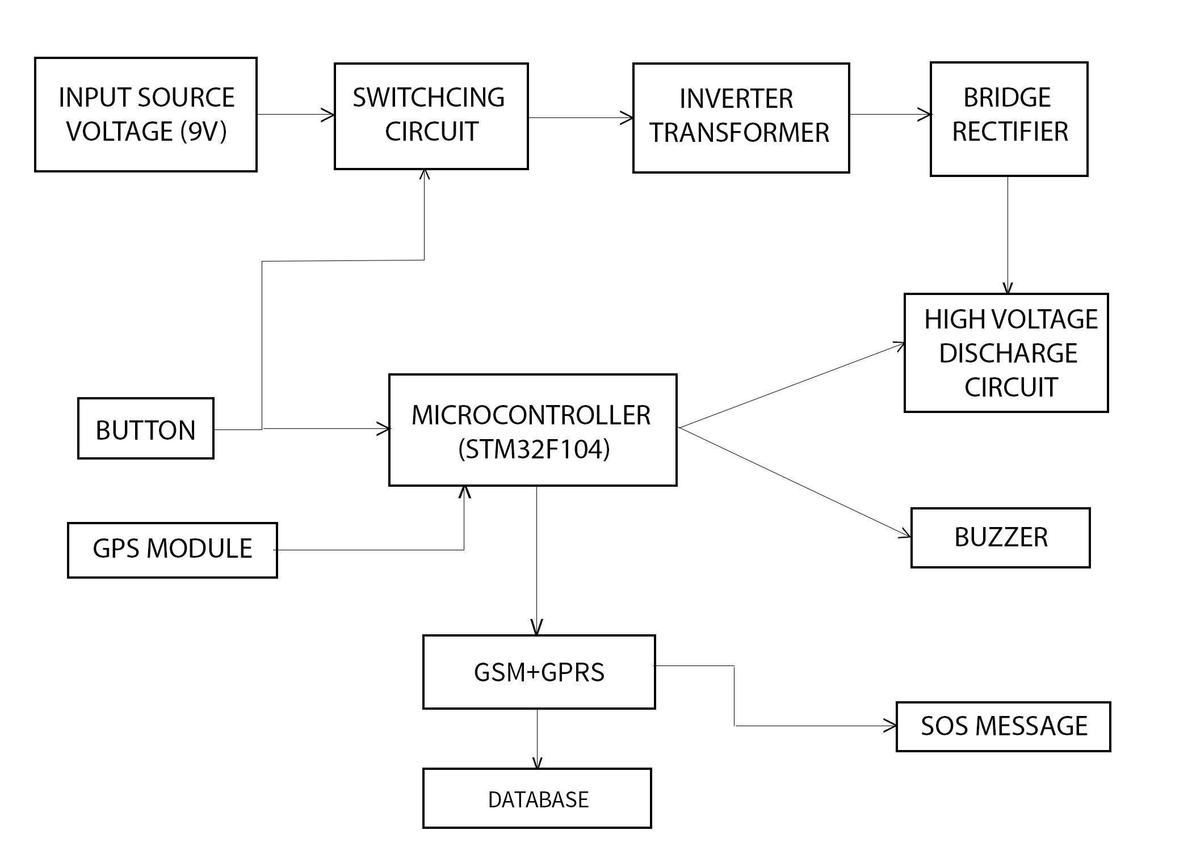

**2.2 THEORETICAL BACKGROUND**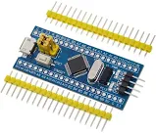

**2.2.1 STM32f103c8t6 :**

STM32 is a family of 32-bit microcontroller integrated circuits by [STMicroelectronics](https://en.wikipedia.org/wiki/STMicroelectronics).

**Fig 2.2.1**-**STM32f103c8t6**

The STM32F103xx medium-density performance line family includes devices in six different package types: from 36 pins to 100 pins.

Depending on the device chosen, different sets of peripherals are included.

It offers products combining very high performance, real-time capabilities,digital signal processing, low-power / low-voltage operation, and connectivity while maintaining full integration and ease of development.

These features make it suitable for a wide range of applications such as motor drives, application control, medical and handheld equipment, PC and gaming peripherals, GPS platforms, industrial applications.

COMPARISON BETWEEN STM32F AND ATMEGA328:

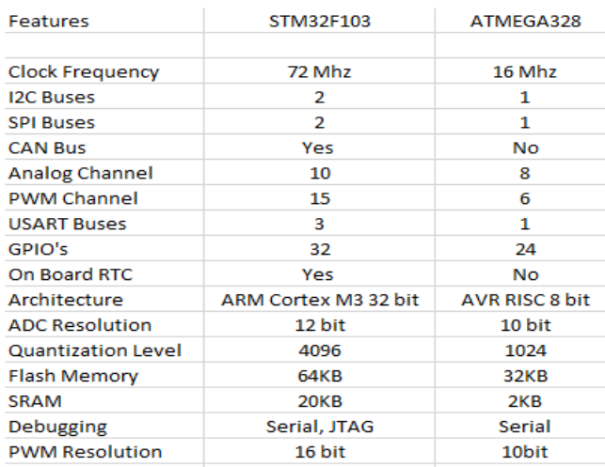

**Table 2.2.1 Comparison between STM32F103 & ATMEGA3284**

**2.2.2 GSM GPRS MODULE:**

The SIM900A is a complete Dual-band GSM and GPRS solution in a SMT module which can be embedded in the customer applications.

Featuring an industry-standard interface, the SIM900A delivers GSM/GPRS 900/1800MHz performance for voice, SMS, Data, and Fax in a small form factor and with low power consumption.

The GSM module is designed with power-saving techniques so that current consumption is as low as 1.5 mA.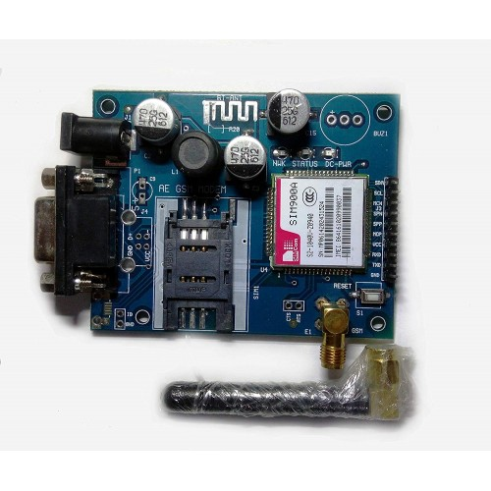

The GSM-GPRS module transfers data via UART.

AT commands used:

AT - attention

For sending text SMS:

AT+CMGF - SMS mode

AT+CMGS - send a text message

**Fig 2.2.2-GSM-GPRS module**

For updating database:

AT+CIPMUX = 0 - normal mode TCP/IPO application

AT+CGATT=1 - attach to GPRS service

give delay of 2 seconds

AT+CSTT=\”ISP_PROVIDER_NAME\”,\”\”,\”\” - start task and set APN

AT+CIICR - bring up wireless connection with GPRS

AT+CIFSR - get local IP address

AT+CIPSTART=\”TCP\”,”api.thingspeak.com”,\”80\” -start-up TCP connection

AT+CIPSEND - send data through TCP connection

“GET http://api.thingspeak.com/update?api_key=<apikey>&&field=1\r\n\x1A” - send data to server

AT+CIPSHUT - deactivate GPRS PDP

2.2.3 **GPS MODULE- UBLOX NEO-6M** :

The NEO-6 module series is a family of stand-alone GPS receivers featuring the high-performance u-blox 6 positioning engine.

These flexible and cost-effective receivers offer numerous connectivity options in a miniature 16 x 12.2 x 2.4 mm package.

The compact architecture and power and memory options make NEO-6 modules ideal for battery operated mobile devices with very strict cost and space constraints. It transfers data via UART.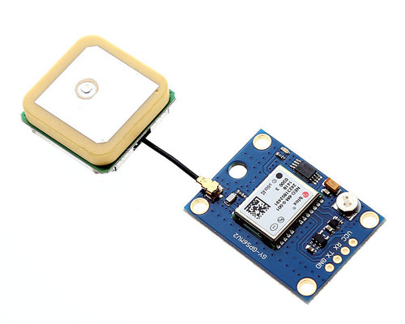

**Fig 2.2.3 Ublox Neo-6M**

**HARDWARE CIRCUIT COMPONENTS:**

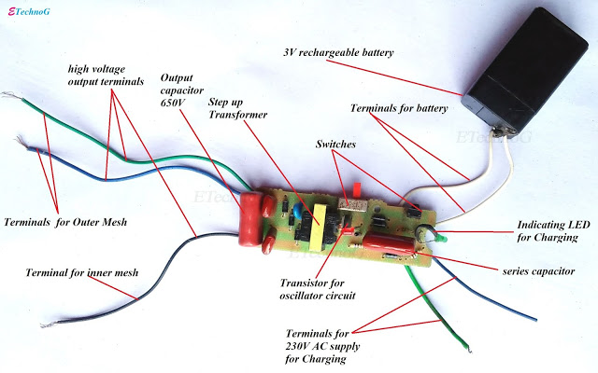

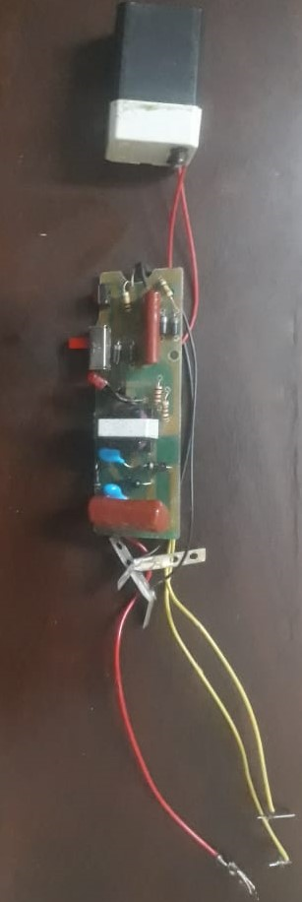

**CHAPTER 3: SYSTEM DESIGN**

3.1.1 **COMPONENTS USED :**

|  |  |
| --- | --- |
| **Components** | **Cost ( INR)** |
| SIM900A(GSM-GPRS) | 1005/- |
| Ublox Neo-6M (GPS) | 850/- |
| STM32f103c8t6 (ARM microcontroller) | 207/- |
| Capacitor - 2.5kV 18nF | salvaged from old CRT (300/-) |
| Diode - 1N4007 | 4/- |
| Li-ion Batteries | 160/- |
| BJT - 2N1711 | 10/- |
| Transformer 1:1000 | salvaged from old CRT(300/-) |
| LED | 1/- |
| Resistor - 1M ohm, 10k ohm | 4/- |
| Jumper cable | 20/- |

**CHAPTER 4: IMPLEMENTATION, TESTING AND DEBUGGING**

4.1- **Digital Control Circuit** 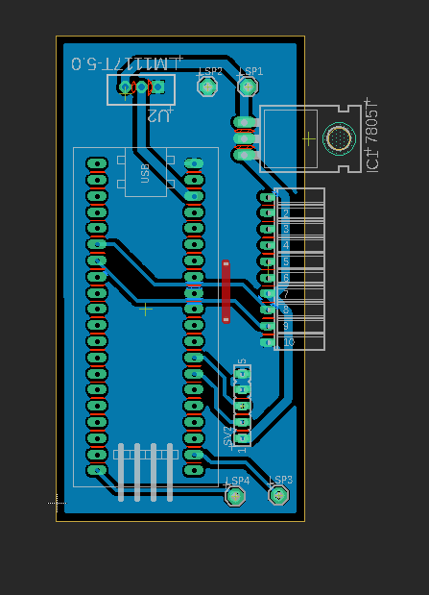

**Fig 4.1 - PCB for Digital Circuit**

4.2 **Power Circuit** :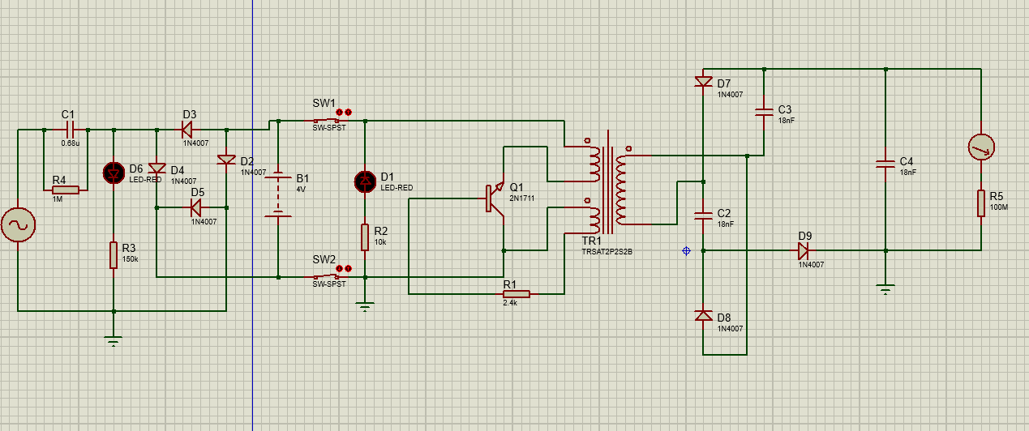

**Fig 4.2 - Power Circuit (Voltage discharge circuit)**

4.3 **Algorithm**:

1. The ON button is pressed.
2. A high voltage arc is generated across the open ends of the taser gun.
3. The current output at the ends is in the range of 10mA to 100mA.
4. After the button is pressed an interrupt is generated at the pin PC13 of the STM32.
5. The STM32 then takes the GPS data from UART 1 PA9(Rx) and PA10(Tx) and extracts the current time, latitude and longitude from the data received.
6. This data is then serially communicated using UART2 PA2(Rx), PA2(Tx) to the SIM900A modules.
7. First, the SIM900A module is set into GSM mode and an SOS message containing programmed text and the time and location coordinates are sent via SMS to the programmed contacts.

“This is a SOS message from the taser gun. Location: [http://www.google.com/maps/place/latitude,%longitude](http://www.google.com/maps/place/latitude,%25longitude)”

1. Then the SIM900A module is set to GPRS mode using AT commands.
2. The current time and location (latitude and longitude) are updated in a database present on the server.
3. The location keeps being updated on the server every 2 minutes to keep a track of the taser gun.

4.5 **Database**:

1. We made a database using phpmyadmin localhost.
2. Here we have used xampp and the columns included are ID latitude and longitude.
3. This is for storage purposes and to keep a record.
4. The gsm module was connected to the local host and using a php script a database table was generated.
5. The location will be stored with the help of gps module.
6. Data is inserted with the help of SQL commands and the table is made through a php code.

**Fig 4.5 -Database**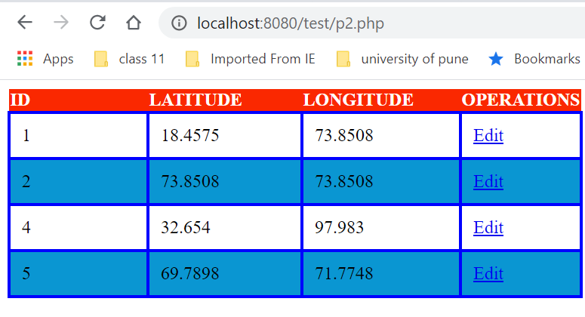

4.6 **Testing** :

The circuit was tested using various testing tools such as Multimeters and DSO.

Verified the outputs of the Digital Circuits on the COM terminals of Arduino IDE.

The voltages of the 7805 and LM117 and discharge circuit were verified using Multimeters.

4.7 **Debugging** :

The problems encountered during the project include software and hardware problems.

Software problems include - Errors in codes for STM32f103 and errors in implementation of database.

Hardware problems include - Voltage spikes, broken tracks on PCB, short circuiting.

**CHAPTER 5: RESULT**

We tested the circuit successfully. Upon pressing the push button a high voltage arc is generated across the terminals of the taser gun. Simultaneously, we verified getting an SOS SMS on the specified phone number. We also verified that the location data updated on the database. Thus, the entire system executed as planned and we obtained the expected outcome towards the end.

**CHAPTER 6: CONCLUSION**

We have built an electric taser gun and used to generate a high voltage spark across its open terminals. The GPS module was used to send the current location of the instrument via - SMS using GSM and update the database via - GPRS.

The project has high reliability, is portable and is extremely suitable for the current Indian market both in terms of price and necessity.

**REFERENCES:**

1. IEEE - Current distribution in tissues with conducted electrical weapons operated in drive - Stun Mode. Dorin Panescu, PhD, FIEEE, Mark W Kroll, Phd, FIEEE, Micheal, MS J.D.
2. High voltage generator using rapid response boost/flyback converters for stun gun applications. Sheng yu Tseng ‘Guan Wei Hsu’ Yi Ren Jhuung Shu Fan Geen Kwei Chong
3. Crafting perfect shockwave- Mark W Kroll
4. News conducted Electrical Weapons: Electrical Safety Relative to relevant standards.
5. Component Datasheets and reference manuals.

**DATASHEETS:**

1. STM32f103c8t6 - Programming manual , reference manual, datasheet
2. SIM900A - programming manual, datasheet
3. Ublox Neo 6M -programming manual, datasheet
4. LM1117 - datasheet
5. 7805 - datasheet
6. 1N4007 - datasheet
7. 2N1711 - datasheet.