Assignment – 1

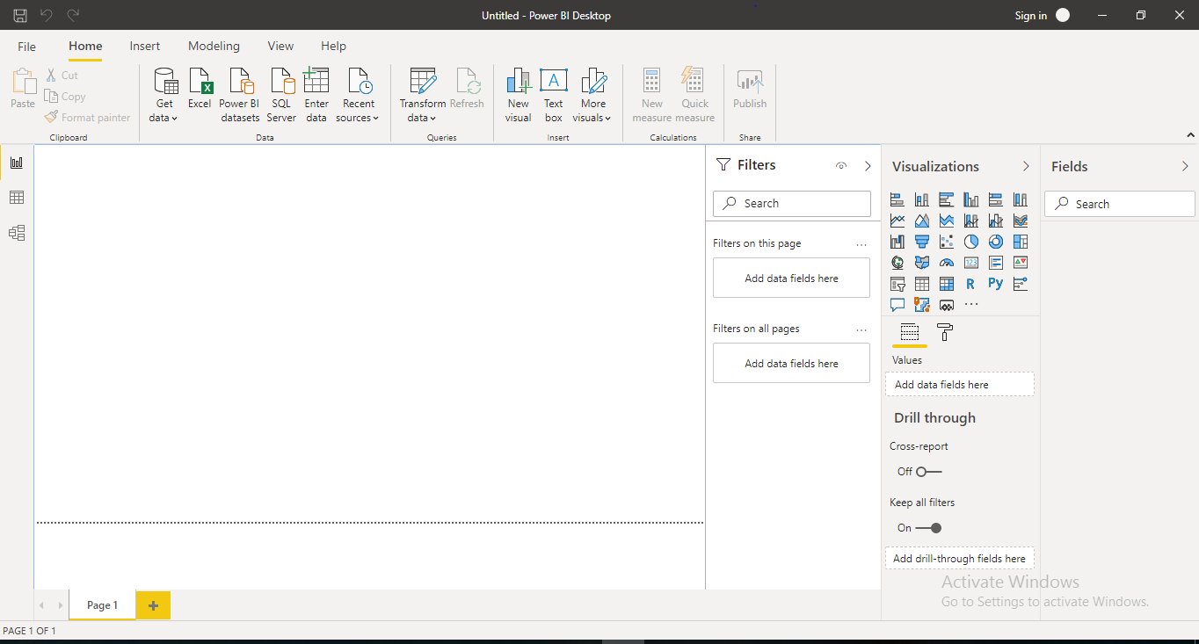• Install Power BI Desktop and share the final screenshot of the report view page which appears when power desktop starts.

• Prepare a document and with the following screenshot − Report View − Data View − Model View − Power Query Editor − Advance Editor

* Report View:- where we can create any number of report pages with visualizations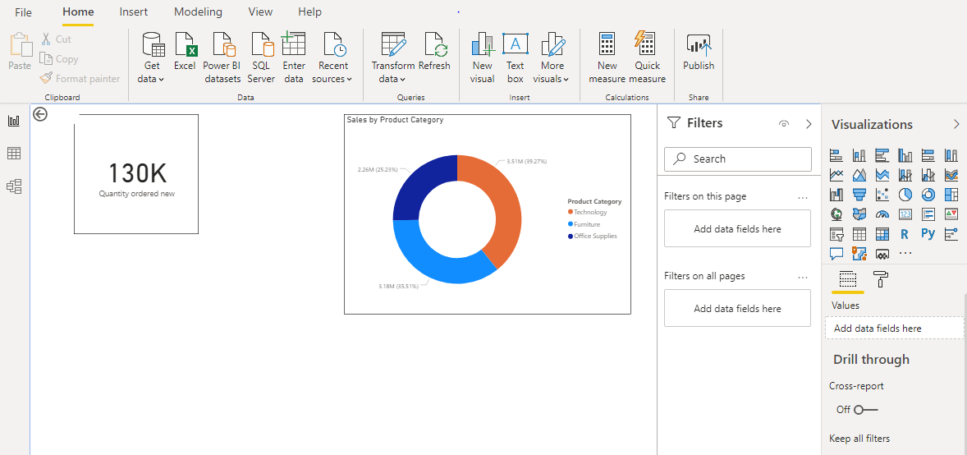
* Data View:- helps us inspect, explore, and understand data in our *Power BI Desktop* model

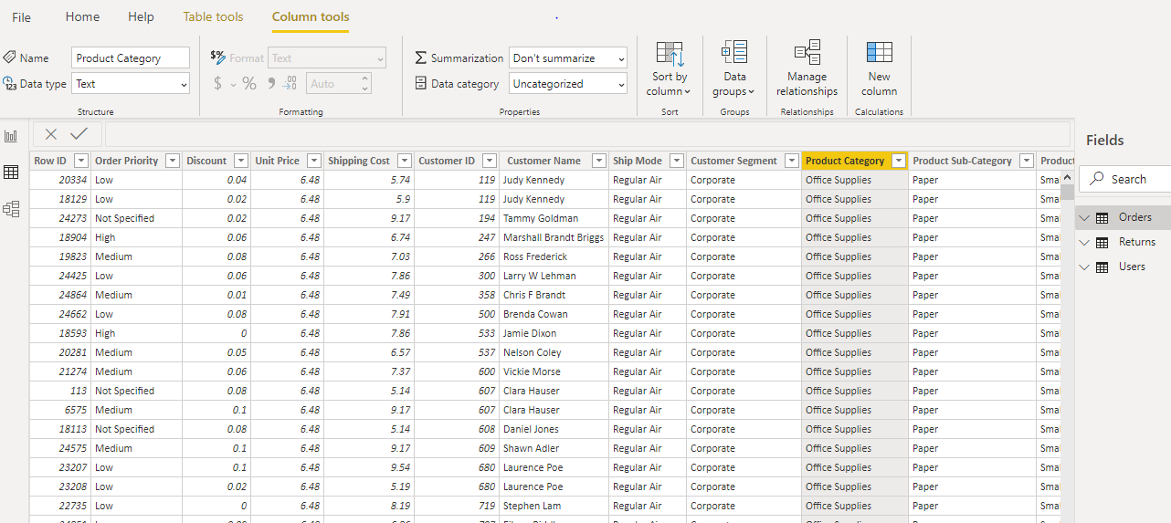

* Model View:- shows all of the tables, columns, and relationships in our model

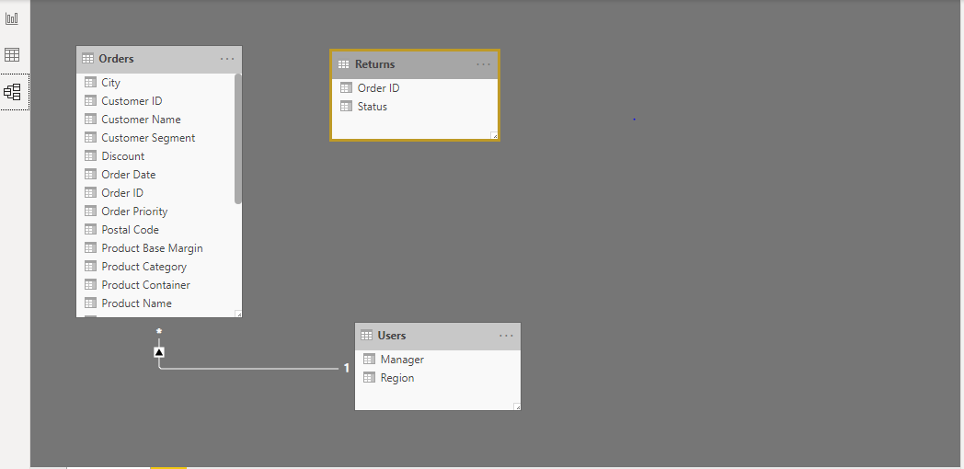

* Power Query Editor:- we can connect to many different data sources, transform the data into the shape we want, and quickly be ready to create reports and insights.

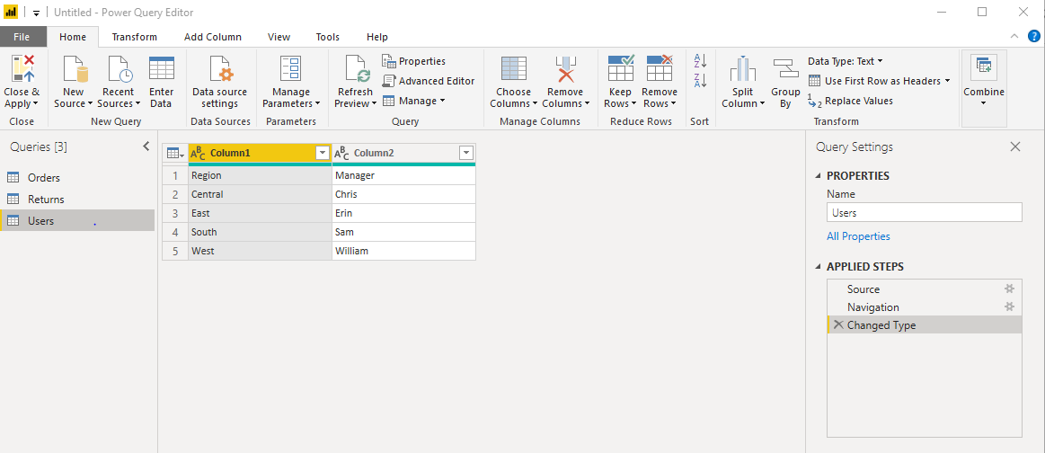

* Advance Editor:- lets us see the code that Power Query Editor is creating with each step

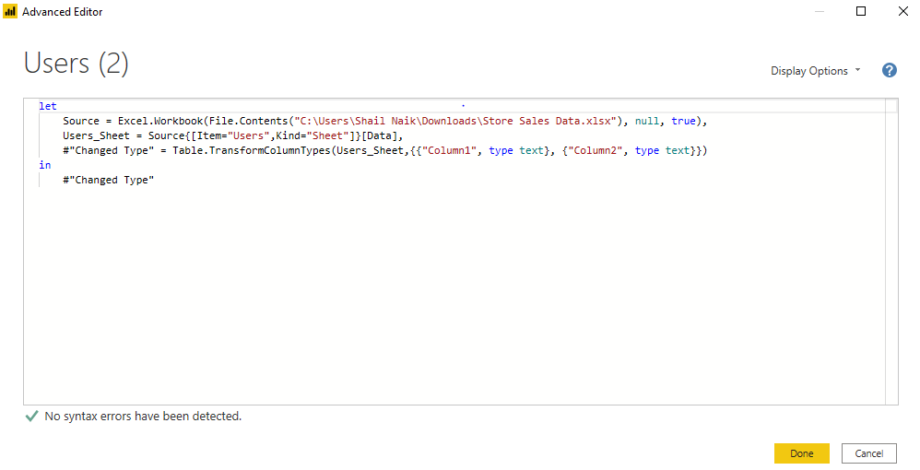

• Prepare a document with details of the following along with their price

− Power BI Desktop − Power BI Pro − Power BI Premium

* Power BI Desktop (Price:- Free)

*Power BI Desktop* is a free application you install on your local computer that lets you connect to, transform, and visualize your data. With Power BI Desktop, you can connect to multiple different sources of data, and combine them (often called *modeling*) into a data model. This data model lets you build visuals, and collections of visuals you can share as reports, with other people inside your organization. Most users who work on business intelligence projects use Power BI Desktop to create reports, and then use the *Power BI service* to share their reports with others.

* Power BI Pro (Price:- 660 INR)

Power BI Pro is the full version of Power BI, complete with the ability to use Power BI for both building dashboards and reports and unlimited viewing, sharing and consumption of your created reports (and reports shared by others) - the latter not possible with Power BI Desktop. Power BI Pro is licensed by individual user.

* Power BI Premium (Price:- 3,30,190 INR)

Power BI Premium differs from the free version and Power BI pro in its licensing model, which only suits a specific size and type of organization and business scenario. With Power BI Premium, you are licensing capacity for your datasets, dashboards and reports, not just licensing all users of that content. In other words, you’re not buying individual licenses, you’re buying them in bulk to allow a large number of your users to use Power BI to view reports. All of your content is stored in Premium and can then be viewed by as many users in your organization as you want, without additional per-user costs.