**Assignment – 2**

1. Connect to the Store Sales Data and do the following: -

− Remove all the blank rows.

− Update the column header if they are not updated

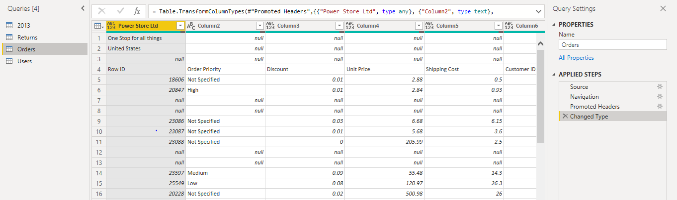Before removing blank rows, removing top 3 rows and adding 1st row as header:

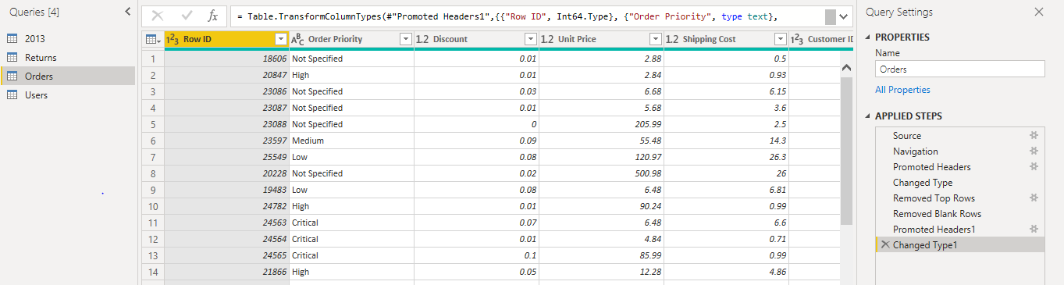After removing blank rows, removing top 3 rows and adding 1st row as header:

− Create a text table and show the sales in terms of

* (A) Customers (B) Product and (C) Category Regions

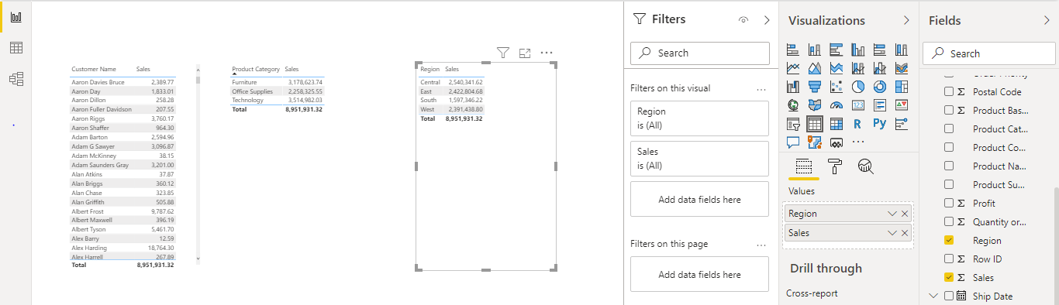

• Create a line and Clustered Column Chart showing the Sales and Discount as per the State or Province

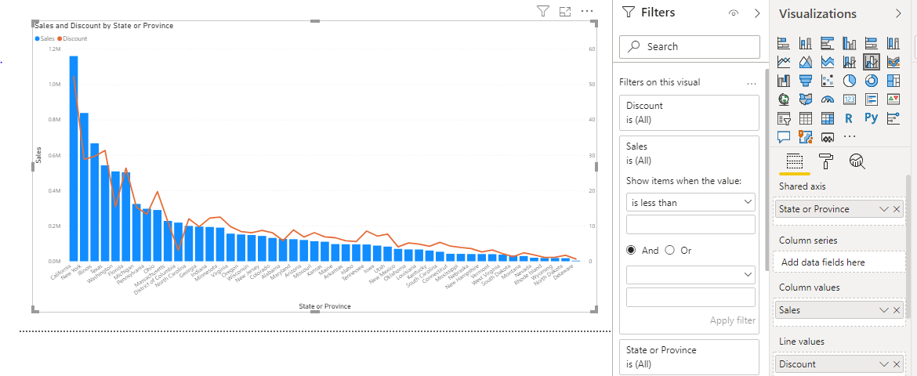− Format the bars and line with different colors − Which state has the highest sales in terms Technology

New York state has the highest sales in Technology product category.

• Create a Donut Chart showing sales in terms of Product category

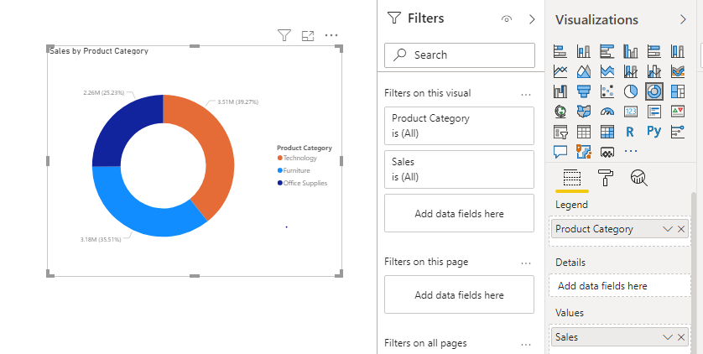

• Create a Slicer and show the regions in dropdown. See how all the visuals mentioned above behaving when a particular region is selected.

