**Assignment 1**

Task 1:

1. Install Jupyter notebook and run the first program and share the screenshot of the output.

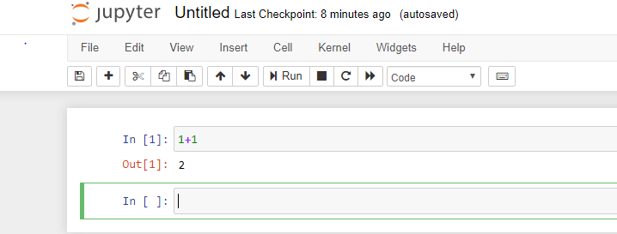

2. Write a program which will find all such numbers which are divisible by 7 but are not a multiple of 5, between 2000 and 3200 (both included). The numbers obtained should be printed in a comma-separated sequence on a single line.

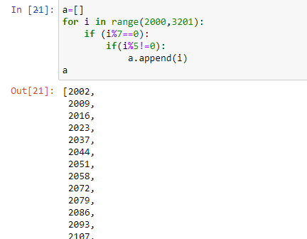

3. Write a Python program to accept the user's first and last name and then getting them printed in the the reverse order with a space between first name and last name.

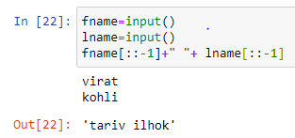

4.Write a Python program to find the volume of a sphere with diameter 12 cm.

Formula: V=4/3 * π * r 3

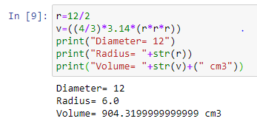

Task 2:

1. Write a program which accepts a sequence of comma-separated numbers from console and generate a list.

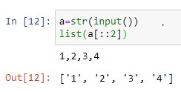

2. Create the below pattern using nested for loop in Python.

* * * * * * * * * * * * * * * * * * * * * * * * *

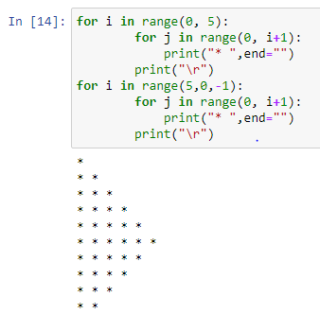

3. Write a Python program to reverse a word after accepting the input from the user.

Sample Output:

Input word: AcadGild

Output: dilGdacA

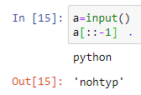

4. Write a Python Program to print the given string in the format specified in the ​sample output. WE, THE PEOPLE OF INDIA, having solemnly resolved to constitute India into a SOVEREIGN, SOCIALIST, SECULAR, DEMOCRATIC REPUBLIC and to secure to all its citizens.

Sample Output:

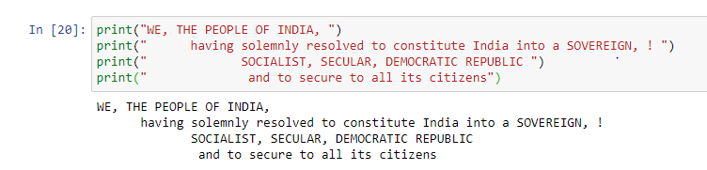WE, THE PEOPLE OF INDIA, having solemnly resolved to constitute India into a SOVEREIGN, ! SOCIALIST, SECULAR, DEMOCRATIC REPUBLIC and to secure to all its citizens

NOTE:​ ​The​ ​solution​ ​shared​ ​through​ ​Github​ ​should​ ​contain​ ​the​ ​source code​ ​used​ ​ and​ ​the​ ​screenshot​ ​of​ ​the​ ​output.

Code:

