Q-1)

NewServlet.java

import java.io.IOException;

import java.io.PrintWriter;

import java.util.Date;

import javax.servlet.ServletException;

import javax.servlet.annotation.WebServlet;

import javax.servlet.http.HttpServlet;

import javax.servlet.http.HttpServletRequest;

import javax.servlet.http.HttpServletResponse;

import javax.servlet.http.HttpSession;

@WebServlet(urlPatterns = {"/NewServlet"})

public class NewServlet extends HttpServlet {

public void doGet(HttpServletRequest request, HttpServletResponse response)

throws ServletException, IOException {

// Create a session object if it is already not created.

HttpSession session = request.getSession(true);

// Get session creation time.

Date createTime = new Date(session.getCreationTime());

// Get last access time of this web page.

Date lastAccessTime = new Date(session.getLastAccessedTime());

String title = "Welcome Back to my website";

Integer visitCount = new Integer(0);

String userID = new String("ABCD");

// Check if this is new comer on your web page.

if (session.isNew()) {

title = "You are new";

} else {

title = "You are back";

}

// Set response content type

response.setContentType("text/html");

PrintWriter out = response.getWriter();

String docType =

"<!doctype html public \"-//w3c//dtd html 4.0 " +

"transitional//en\">\n";

out.println(docType +

"<html>\n" +

"<head><title>" + title + "</title></head>\n" +

"<body bgcolor = \"#f0f0f0\">\n" +

"<h1 align = \"center\">" + title + "</h1>\n" +

"<h2 align = \"center\">Session Infomation</h2>\n" +

"<table border = \"1\" align = \"center\">\n" +

"<tr bgcolor = \"#white\">\n" +

" <th>Session info</th><th>value</th></tr>\n" +

"<tr>\n" +

" <td>id</td>\n" +

" <td>" + session.getId() + "</td> </tr>\n" +

"<tr>\n" +

" <td>Time of Last Access</td>\n" +

" <td>" + lastAccessTime + " </td></tr>\n"

+"</body> </html>"

);

}

}

web.xml

<?xml version="1.0" encoding="UTF-8"?>

<web-app xmlns="http://xmlns.jcp.org/xml/ns/javaee"

xmlns:xsi="http://www.w3.org/2001/XMLSchema-instance"

xsi:schemaLocation="http://xmlns.jcp.org/xml/ns/javaee http://xmlns.jcp.org/xml/ns/javaee/web-app_3_1.xsd"

version="3.1">

<servlet>

<servlet-name>NewServlet</servlet-name>

<servlet-class>NewServlet</servlet-class>

</servlet>

<servlet-mapping>

<servlet-name>NewServlet</servlet-name>

<url-pattern>/NewServlet</url-pattern>

</servlet-mapping>

<session-config>

<session-timeout>

30

</session-timeout>

</session-config>

</web-app>

OUTPUT

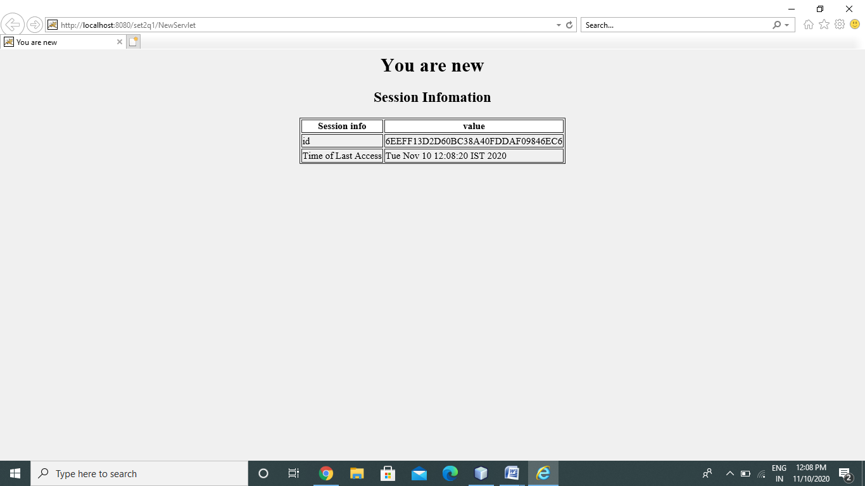

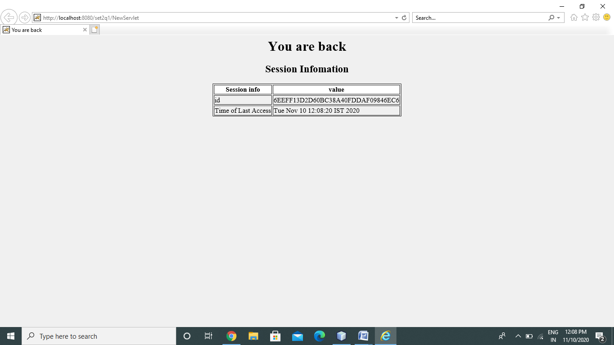

Q-2

NewServlet.java

import static java.io.FileDescriptor.out;

import java.io.IOException;

import java.io.PrintWriter;

import javax.servlet.RequestDispatcher;

import javax.servlet.ServletException;

import javax.servlet.annotation.WebServlet;

import javax.servlet.http.HttpServlet;

import javax.servlet.http.HttpServletRequest;

import javax.servlet.http.HttpServletResponse;

@WebServlet(urlPatterns = {"/NewServlet"})

public class NewServlet extends HttpServlet {

public void doGet(HttpServletRequest request, HttpServletResponse response)

{

try {

response.setContentType("text/html");

PrintWriter out = response.getWriter();

String n = request.getParameter("url");

out.print("URL Visit" + n);

out.print("<a href='Servlet?uname=" + n + "'>visit</a>");

out.close();

}

catch (Exception e) {

System.out.println(e);

}

}

}

Servlet.java

/*

* To change this license header, choose License Headers in Project Properties.

* To change this template file, choose Tools | Templates

* and open the template in the editor.

*/

import java.io.IOException;

import java.io.PrintWriter;

import javax.servlet.ServletException;

import javax.servlet.annotation.WebServlet;

import javax.servlet.http.HttpServlet;

import javax.servlet.http.HttpServletRequest;

import javax.servlet.http.HttpServletResponse;

@WebServlet(urlPatterns = {"/Servlet"})

public class Servlet extends HttpServlet {

public void doGet(HttpServletRequest request, HttpServletResponse response)

{

try {

response.setContentType("text/html");

/*

* The response's character encoding is only set from the given

* content type if this method is called before getWriter is called.

* This method may be called repeatedly to change content type and

* character encoding.

*/

PrintWriter out = response.getWriter();

/*

* The Java PrintWriter class ( java.io.PrintWriter ) enables you to

* write formatted data to an underlying Writer . For instance,

* writing int, long and other primitive data formatted as text,

* rather than as their byte values

*/

// getting value from the query string

String n = request.getParameter("uname");

out.print("Hello " + n);

/* out.println is used to print on the client web browser */

out.close();

}

catch (Exception e) {

System.out.println(e);

}

}

}

Web.xml

<?xml version="1.0" encoding="UTF-8"?>

<web-app xmlns="http://xmlns.jcp.org/xml/ns/javaee"

xmlns:xsi="http://www.w3.org/2001/XMLSchema-instance"

xsi:schemaLocation="http://xmlns.jcp.org/xml/ns/javaee http://xmlns.jcp.org/xml/ns/javaee/web-app_3_1.xsd"

version="3.1">

<servlet>

<servlet-name>NewServlet</servlet-name>

<servlet-class>NewServlet</servlet-class>

</servlet>

<servlet-mapping>

<servlet-name>NewServlet</servlet-name>

<url-pattern>/NewServlet</url-pattern>

</servlet-mapping>

<session-config>

<session-timeout>

30

</session-timeout>

</session-config>

</web-app>

