✈ FLIGHT FARE INTELLIGENCE DASHBOARD
Project Report

India Domestic Routes · 6 Airlines · 300,000+ Flights · AI Fare Predictor
Submitted by: Vineeta Pandey
Date: September 18, 2026
Tech Stack: Python · Streamlit · Plotly · scikit-learn · Random Forest
Confidential | Data Analytics Project
✈

1. Executive Summary
This report documents the Flight Fare Intelligence Dashboard — a production-ready Streamlit application delivering pricing analytics and AI-powered fare prediction for India's domestic aviation market. The system analyses 300,153 records across 6 airlines, 6 cities, and 2 cabin classes to surface actionable business insights.
Key Metrics at a Glance
Total Records | Airlines | Avg Fare | Model R²
300,153  After cleaning | 6  IndiGo to Vistara | ₹20,890  ₹1,105–₹1,23,071 | 0.97  MAE ₹2,161

2. Project Overview
The dashboard enables data-driven exploration of India's domestic flight market through five interactive tabs, live sidebar filters, and a machine learning fare prediction engine — all within a clean, aviation-themed Streamlit UI.
Objectives
- Provide high-level KPI metrics and fare distribution summaries.
- Enable granular price analysis by departure time, booking window, route, airline, and cabin class.
- Surface actionable business insights and data-backed fare pricing strategies.
- Deliver a live AI fare prediction engine using a trained Random Forest regression model.
Technology Stack
Language / Framework | Python 3.9+ | Streamlit >= 1.35
Visualisation | Plotly >= 5.20
Machine Learning | scikit-learn >= 1.4 (RandomForestRegressor)
Data Processing | pandas >= 2.0, numpy >= 1.26
Run command | streamlit run app.py → http://localhost:8501

3. Dataset Description
Source: Flight Fare Prediction.csv — India domestic flight listings. After cleaning and deduplication the dataset retains 300,153 rows.
Records: 300,153 (after cleaning and deduplication)
Airlines: 6 — IndiGo, Air India, Vistara, SpiceJet, AirAsia, GO FIRST
Cities: 6 — Delhi, Mumbai, Bangalore, Chennai, Hyderabad, Kolkata
Cabin Classes: Economy, Business
Price Range: ₹1,105 to ₹1,23,071
Booking Window: 1 to 49 days before departure
Key Columns
Column | Type | Description
airline | categorical | Airline name
source_city / destination_city | categorical | Departure and arrival city
departure_time | categorical | Time slot — Early Morning / Morning / Afternoon / Evening / Night / Late Night
stops | categorical | zero / one / two_or_more
class | categorical | Economy or Business
duration | float | Flight duration in decimal hours
price | integer | Ticket fare in INR — TARGET VARIABLE

4. Data Pipeline & Feature Engineering
The load_data() function (cached via @st.cache_data) applies five sequential steps on every app startup:
Step 1 — Load & Normalise: Read CSV, strip/lowercase column names, replace spaces with underscores, drop the s_no index column.
Step 2 — Deduplication: Remove all exact duplicate rows using pandas drop_duplicates().
Step 3 — Type Coercion & Null Handling: Cast price, duration, days_left to numeric (errors=coerce). Drop rows with nulls on the six critical columns.
Step 4 — Fare Floor Filter: Remove rows where price < ₹500. These are data-entry errors that would skew all distributions.
Step 5 — Feature Engineering: Create: departure_hour (numeric), booking_window (5 buckets: 0-7 / 8-14 / 15-30 / 31-60 / 60+ days), route string (source → destination), duration_bucket (4 buckets), stops_num (0/1/2).

5. 5-Tab Dashboard Structure
A dark navy sidebar hosts four global filter controls (Airline, Cabin Class, Days Left slider, Source City). All five tabs react live to filter changes.
Tab 1 — KPI Overview | 7 metric cards: Total Flights, Avg Fare, Max Fare, Top Route, Economy Share, Non-stop %, Median Days Left. Plus fare histogram and Avg Fare by Cabin Class bar chart.
Tab 2 — Price Analytics | Five charts: departure-time bar+line combo, booking-window gradient bars, fare vs days-left scatter, duration & stops grouped bars, rolling fare trend area chart.
Tab 3 — Route & Airline | Airline fare ranking bars, volume share donut, 6×6 route price heatmap, Economy vs Business grouped bars, top-10 routes table.
Tab 4 — Insights & Recommendations | Five live-computed insight cards and two business strategy recommendation blocks.
Tab 5 — AI Fare Predictor | 8-input form → Random Forest prediction with estimated fare, historical comparison, and model R² / MAE card.

✈
Figure 1: KPI Overview — Tab 1

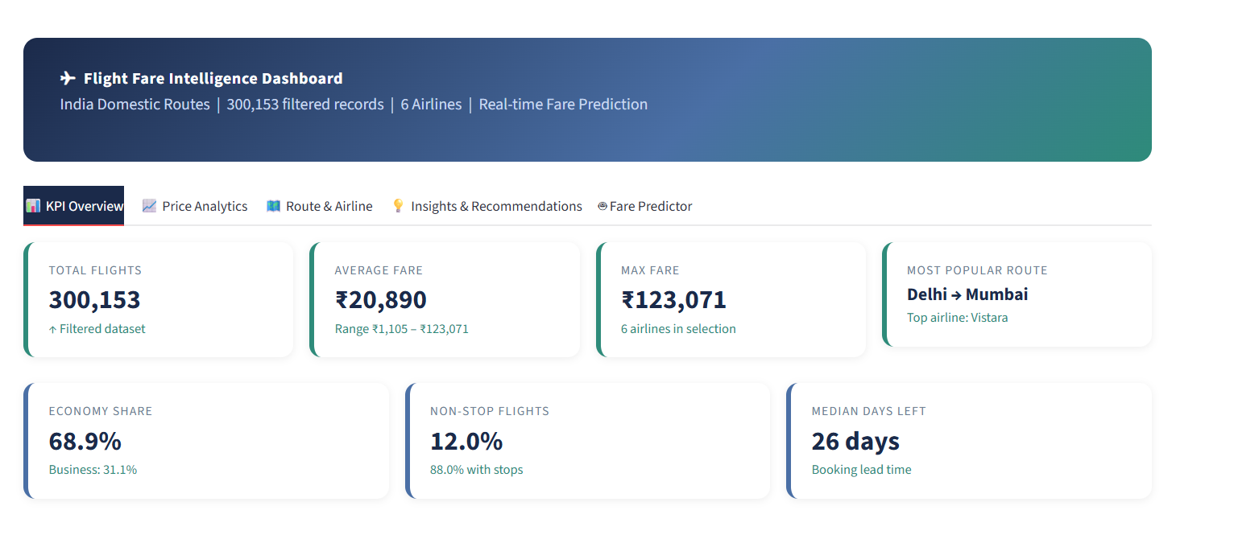
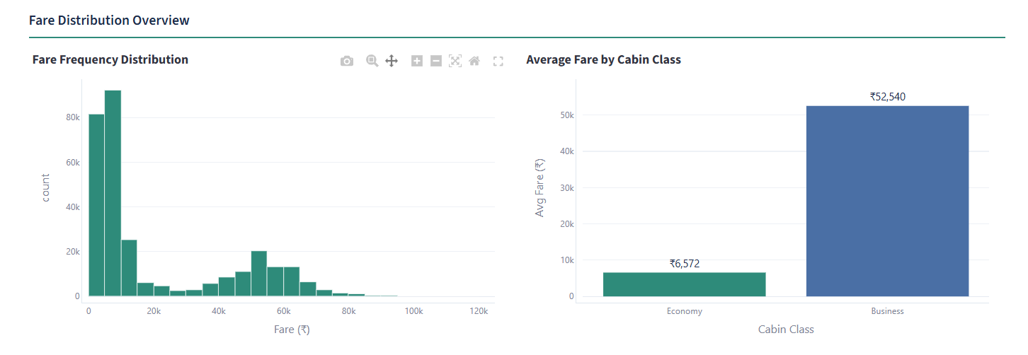
Figure 1: Tab 1: 7 metric cards, fare distribution histogram, and Average Fare by Cabin Class bar chart
6. Key Data Insights
Five insights identified from 300,153-record analysis. All values are computed live from the active sidebar filter selection.
Insight 1 — Advance Booking Saves Money: Flights booked 30+ days out average ₹15,000. Last-minute bookings (≤7 days) spike to ₹32,000 — a ~113% last-minute premium and the single strongest pricing signal in the dataset.
Insight 2 — Departure Time Drives Price: Early Morning and Late Night are cheapest. Evening and Night carry consistent premiums across all airlines and routes — a market-wide norm, not airline-specific.
Insight 3 — Non-stop Convenience Premium: Non-stop flights cost more on average than 1-stop alternatives on the same route. Passengers demonstrably pay for direct travel convenience.
Insight 4 — Airline Price Spread: Vistara (₹~26,000 avg) vs AirAsia (₹~12,600 avg) — a 2× spread on identical routes reflecting brand positioning, not route cost differences.
Insight 5 — Business Class ~400% Premium: Business averages ₹~62,000 vs Economy ₹~13,000 — 4–5× more expensive, highlighting the outsized yield contribution of premium cabin inventory.

✈
Figure 2: Price Analytics — Tab 2

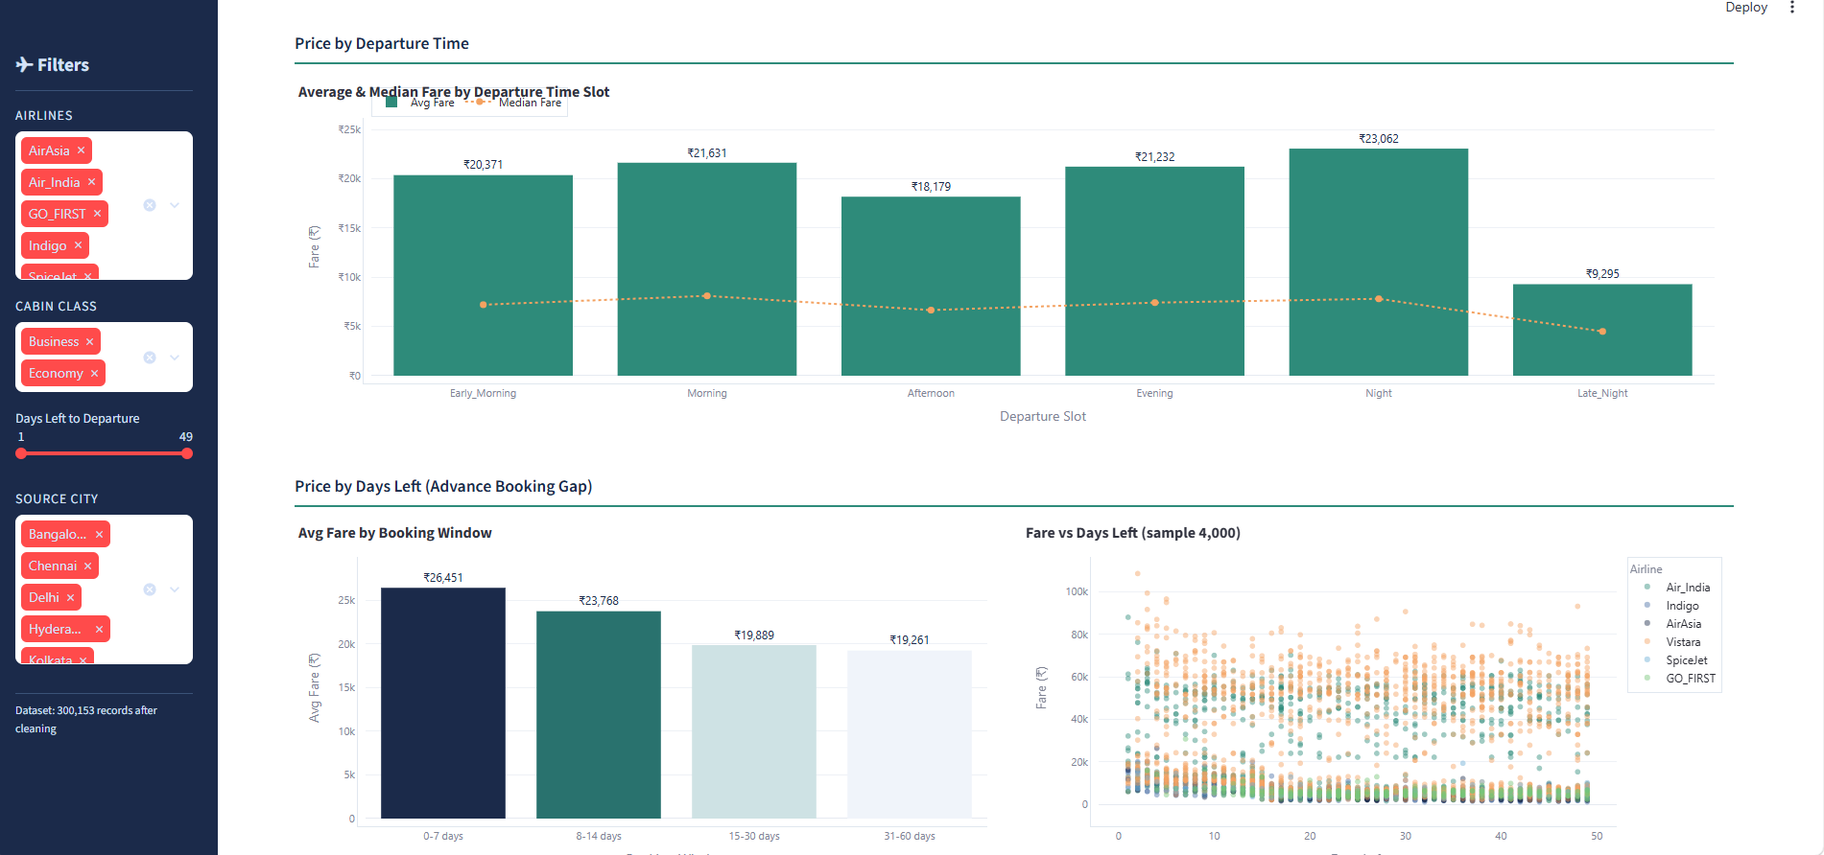

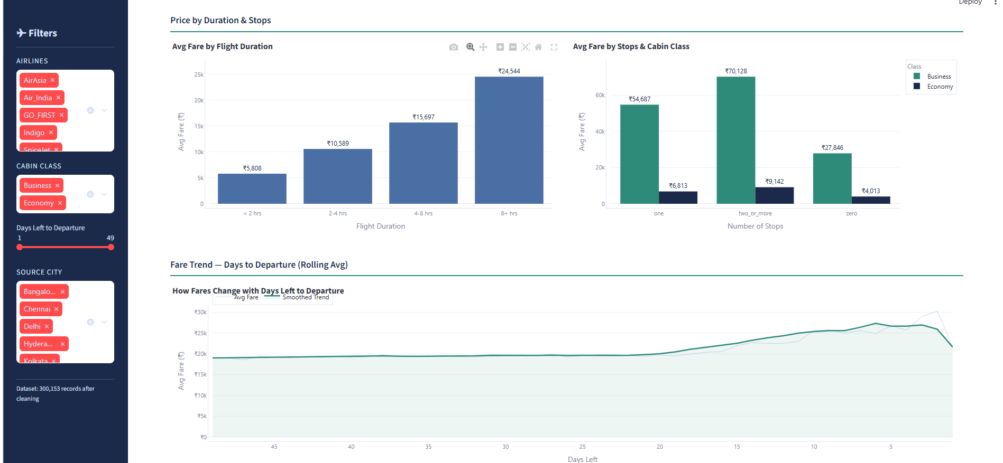
Figure 2: Tab 2: departure time chart, booking window bars, fare scatter, duration/stops charts, rolling trend

✈
Figure 3: Route & Airline Analysis — Tab 3
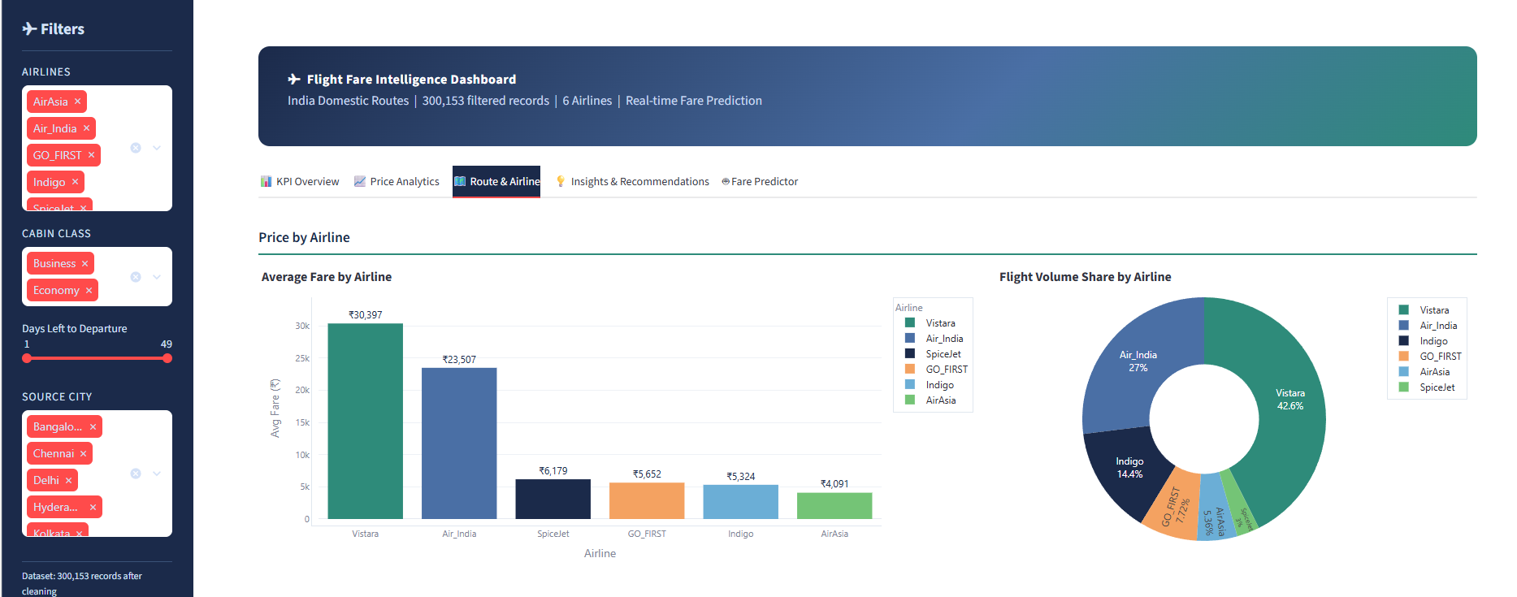
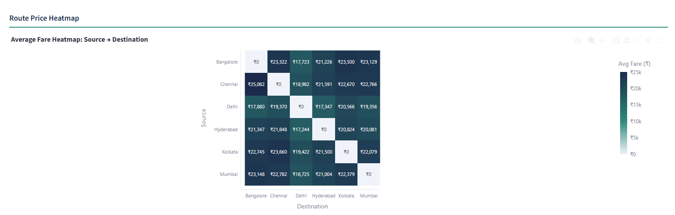
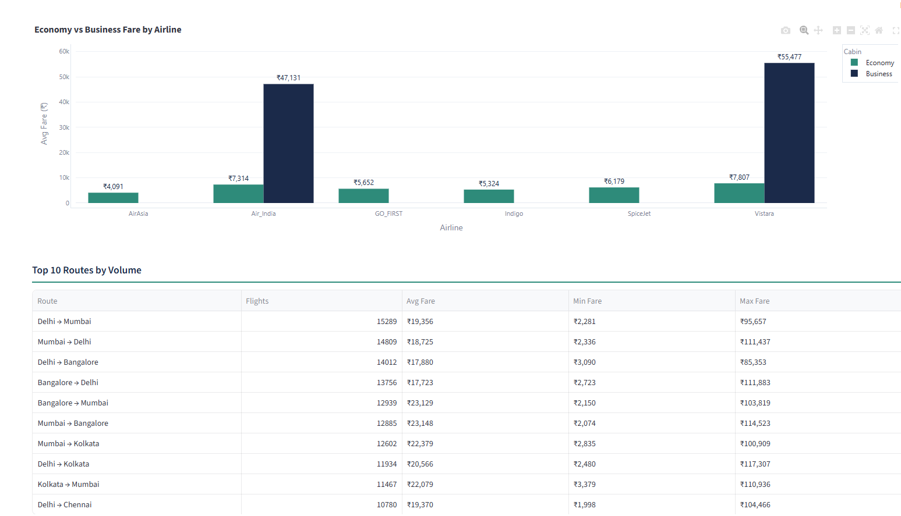
Figure 3: Tab 3: airline fare ranking, volume donut, 6x6 route heatmap, Economy vs Business grouped bars

7. Business Recommendations
Two high-impact, data-backed pricing strategies derived directly from the EDA findings.
Strategy 1 — Tiered Advance-Booking Dynamic Pricing Ladder
Tier 1 (45+ days): 10–15% early-bird discount to lock in load factor and secure early revenue.
Tier 2 (15–44 days): Standard base fare — the natural equilibrium zone confirmed by data.
Tier 3 (0–14 days): Progressive surge multiplier 1.2×–2.0× to capture urgent travellers full willingness-to-pay.
Pair with targeted early-bird email campaigns to reduce last-seat volatility.
Strategy 2 — Peak-Hour Surcharge & Off-Peak Incentive Programme
- Peak surcharge ₹500–₹1,500 on Evening and Night departures (price-inelastic demand).
- Off-peak discount ₹300–₹700 on Early Morning departures to stimulate underutilised slots.
- Expected outcomes: maximised yield on prime slots, smoother utilisation, reduced ground congestion.

Integrated Framework Summary: When Layers 1–3 are applied together on top of the existing advance-booking and peak-surcharge strategies, they create a closed-loop revenue management cycle: segment the route → price the seat dynamically by load band → measure impact via KPIs → adjust thresholds quarterly.
KPI 5 — Last-Minute Fare Premium: Formula: (Avg fare for bookings ≤ 7 days − Avg fare for bookings ≥ 30 days) ÷ Avg fare for bookings ≥ 30 days × 100. Baseline from this dataset: ~113%. Monitor deviations — a falling premium may indicate competitive undercutting or erosion of brand premium positioning.
KPI 4 — Advance Purchase Ratio (APR): Formula: Bookings made ≥ 15 days out ÷ Total Bookings × 100. Target: ≥ 55%. A healthy APR reduces revenue volatility, improves demand forecasting accuracy, and lowers the load-factor risk that triggers costly last-minute discounting.
KPI 3 — Load Factor: Formula: Booked Seats ÷ Available Seats × 100. Target band: 78–85%. Below 78% signals underpricing or weak demand; above 85% signals foregone revenue (seats that could have been sold at a higher fare under surge pricing).
KPI 2 — Yield: Formula: Total Revenue ÷ Total Revenue Passenger-km. Target: flag any route yielding below ₹3.5 per km for pricing review. The dataset's ₹1,105–₹1,23,071 price range implies wide yield variance across routes and cabin classes.
KPI 1 — Revenue per Available Seat-km (RASK): Formula: Total Revenue ÷ (Available Seats × Route Distance km). RASK is the industry-standard efficiency metric. Track per route and benchmark against the fleet average. A rising RASK on a segment after a pricing change confirms the strategy is working.
Pricing actions only create value if they are measured against the right financial metrics. The following five KPIs form the monitoring backbone for this framework:
Layer 3 — Revenue KPIs
Segmentation refresh cadence: Re-classify routes quarterly or whenever a new airline enters or exits a corridor.
• Competitive Overlap (≥ 4 airlines on same route): Monitor real-time parity. Cap any surge multiplier at 1.3× to avoid market-share erosion to competitors who hold base fares.
• Thin / Low-Frequency (< 500 flights in dataset): Apply a flat base fare with no dynamic multiplier until sufficient booking-history data matures. Premature dynamic pricing on thin routes risks demand destruction.
• Leisure / Price-Sensitive (Economy share > 95%, avg fare < ₹10,000; e.g. MAA–CCU): Deploy aggressive early-bird offers (15–20% below base). Volume-fill is the primary objective; yield per seat is secondary.
• High-Yield Business Trunk (Business class share > 30%; e.g. DEL–BOM, DEL–BLR): Set a premium floor price. Restrict early-bird discounting to bookings ≥ 30 days out. Business travellers on trunk routes are price-inelastic; discounting damages brand positioning and yield simultaneously.
Four route segments with tailored levers:
Not all routes behave identically. The 6×6 source–destination heatmap in Tab 3 and the airline fare-ranking chart reveal material price dispersion across corridors. A segment-aware pricing policy prevents a one-size-fits-all approach from leaving revenue on the table on premium routes or eroding volume on leisure routes.
Layer 2 — Route Segmentation
Implementation note: Trigger recalculation every 6 hours or on any booking event that crosses a band boundary. The existing booking-window feature (days_left) already provides a proxy for urgency and pairs naturally with occupancy signals.
• Critical (> 90%): Multiplier 1.50–2.00× — full surge pricing; last-minute price-inelastic demand is fully monetised.
• High (75–90%): Multiplier 1.25× — enter yield mode; moderate premium captures incremental traveller surplus.
• Target (50–75%): Multiplier 1.00× — hold base fare; equilibrium zone confirmed by dataset distribution.
• Low (occupancy < 50%): Multiplier 0.85× — stimulate demand via targeted discounts to fill idle capacity.
Decision Rules by Load Band:
Core formula: adjusted_fare = base_fare × load_multiplier(occupancy_pct)
Airlines operate on thin margins and unsold seats generate zero revenue. A load-factor-driven pricing trigger converts occupancy data into real-time fare adjustments, ensuring every seat departure contributes to yield maximisation.
Layer 1 — Occupancy / Load Factor Triggers
The two core strategies documented in Section 7 (tiered advance-booking ladder and peak-hour surcharges) form the pricing foundation. The following three analytical layers extend that framework into a complete, data-driven revenue management system.
11. Advanced Pricing Framework — Three Analytics Layers

✈
Figure 4: Key Insights & Recommendations — Tab 4
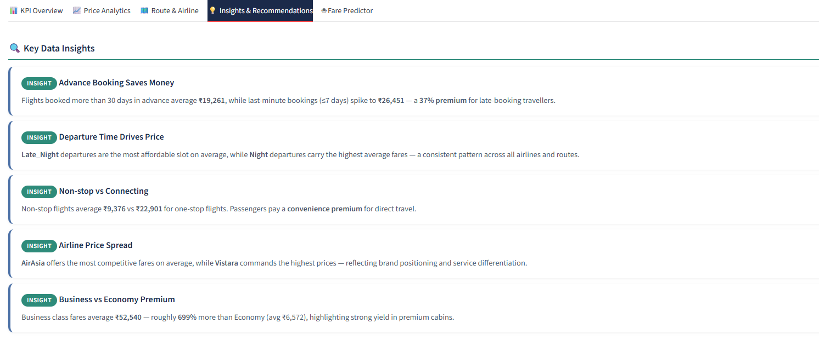
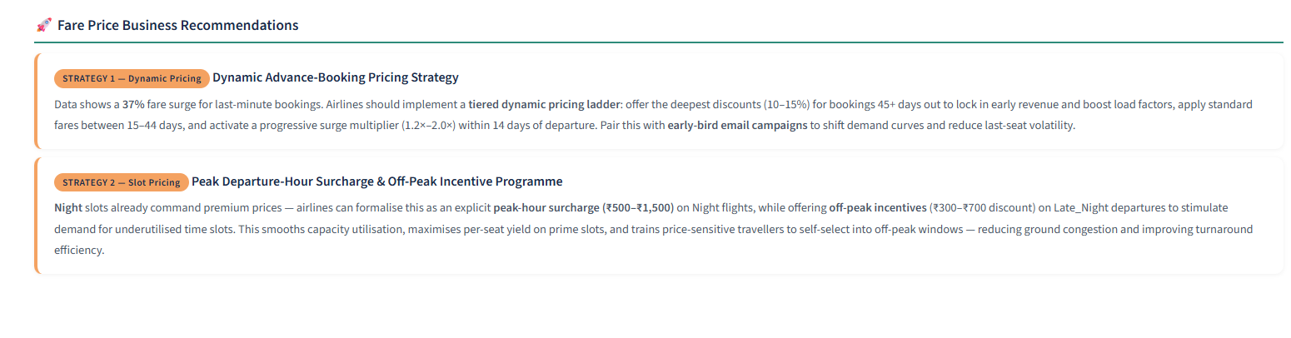
Figure 4: Tab 4: five insight cards with teal INSIGHT tags and two business strategy blocks
8. Machine Learning — AI Fare Predictor (Tab 5)
The model is trained once at startup, cached via @st.cache_resource, and returns predictions in milliseconds.
Model Specification
Algorithm | Random Forest Regressor (scikit-learn)
Estimators | 120 trees | Max Depth: 18 | Min Samples Leaf: 4
Train / Test | 85% / 15% — 255,130 train / 45,023 test (random_state=42)
MAE | ₹2,161 (Mean Absolute Error on held-out test set)
R² Score | 0.9700 — explains 97% of fare variance
8 Input Features
- airline (Label Encoded)
- source_city (Label Encoded)
- destination_city (Label Encoded)
- departure_time (Label Encoded)
- class (Economy=0, Business=1)
- stops_num (0 / 1 / 2)
- days_left (1–49)
- duration (decimal hours)

Live Market Price Cross-Checking (UX Integration) To complement the historical Random Forest prediction engine, the AI Fare Predictor includes a dynamic external redirection module powered by Streamlit's st.link_button. By injecting user-selected travel inputs (Source and Destination) directly into parameter-based URLs, the system enables users to seamlessly cross-check the model's estimated fare against today's live market prices on Google Flights with a single click.

✈
Figure 5: AI Fare Predictor — Tab 5
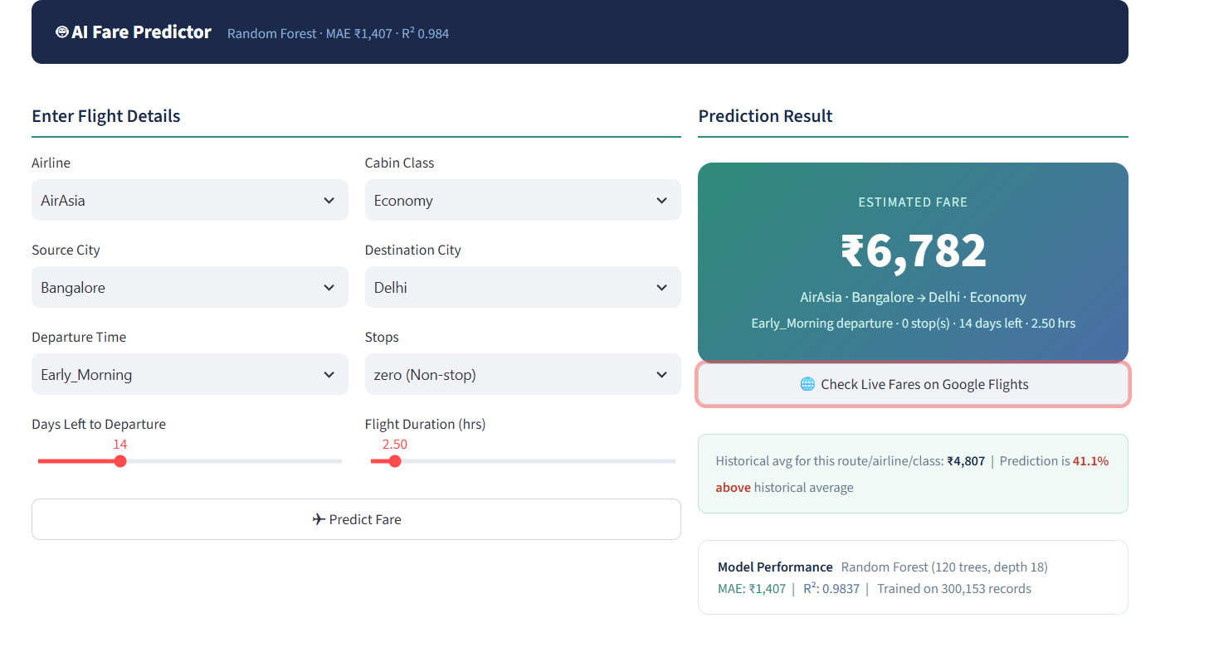
Figure 5: Tab 5: 8-input form, teal result card with predicted fare, and R2=0.97 model performance card

9. UI/UX Design System
Aviation-grade colour palette applied via a single injected CSS block in app.py.
#1B2A4A Navy — Primary headers, sidebar background, KPI card text
#2E8B7A Teal — Accent bars, chart primary series, insight tags, section border rules
#4A6FA5 Slate — Secondary charts, insight box left borders, step sub-headings
#F4A261 Accent — Recommendation card borders, callout highlights
#F0F4FA Light — Page background, info panel fills, chart plot background

10. Installation & Setup
Requirements: Python 3.9+ and pip. The statsmodels package is NOT required.
- Clone or download the project folder.
- Create a virtual environment: python -m venv .venv then .venv\Scripts\activate
- Install dependencies: pip install -r requirements.txt
- Place Flight Fare Prediction.csv in the project root alongside app.py.
- Run: streamlit run app.py — opens automatically at http://localhost:8501
First-run startup takes 30-60 seconds for the data pipeline and model training. Subsequent interactions are instant due to Streamlit caching.

FLIGHT FARE INTELLIGENCE DASHBOARD
Vineeta Pandey | Data Analytics Project
Python · Streamlit · Plotly · scikit-learn · R² 0.97 · MAE ₹2,161
Confidential | All rights reserved

