

RAJALAKSHMI ENGINEERING COLLEGE RAJALAKSHMI NAGAR, THANDALAM 602 105

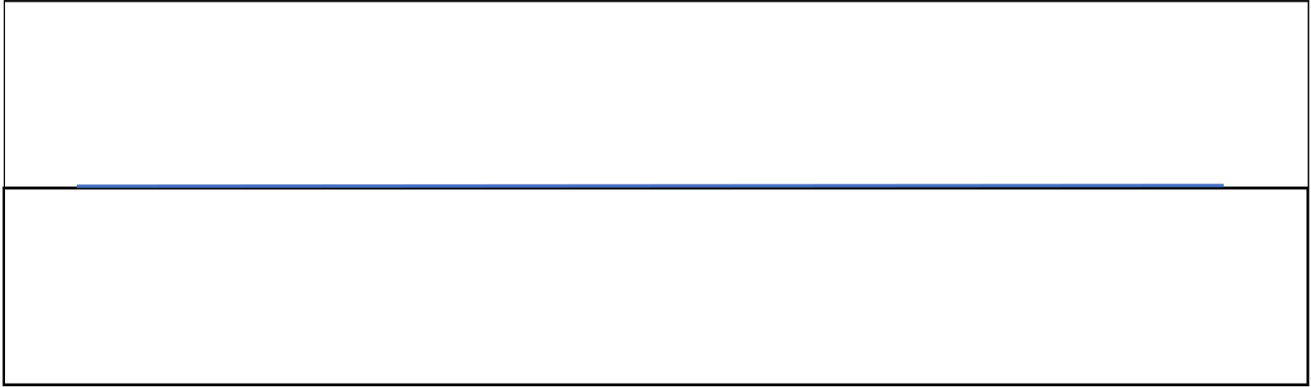
CS23331 Design and Analysis of Algorithms
Laboratory Record Note Book

Name :
Year / Branch / Section :
University Register No. :
College Roll No. :
Semester :
Academic Year :

 | RAJALAKSHMI ENGINEERING COLLEGE  An Autonomous Institution

BONAFIDE CERTIFICATE

Name: | …………………………… VINEETH P ……………………………………
Academic Year: …2025-26… Semester: …3rd…… Branch: ……CSE………
Register No.
  2116240701589
Certified that this is the bonafide record of work done by the above student in
the....................Design and Analysis of Algorithm.................Laboratory
during the academic year 2025- 2026
Signature of Faculty in-charge
Submitted for the Practical Examination held on…21-11-2025…
Internal Examiner External Examiner

INDEX
EX.NO | DATE | NAME OF THE EXPERIMENT | GITHUB QR
1 |  | Basic C Programming | 
2 |  | Time Complexity
3 |  | Brute Force
4 |  | Divide and Conquer
5 |  | Greedy Technique
6 |  | Dynamic Programming

