EMOTIFY
Feature Walkthrough
Counsellor Web Portal and Student Mobile App

A screen-by-screen guide to what each feature does, following a new student from sign-up through screening to every support tool, and what counsellors see on the web portal.

Prepared: October 2026
Source: 57 screenshots in the project’s SS folder (12 web portal, 45 mobile app)
Data: All names, phone numbers, scores and records shown are dummy test data.

Contents
1. Introduction 3
About Emotify 3
The two applications 3
How to read this document 3
2. Journey at a glance 4
Part A. Counsellor and Admin Web Portal 5
A1. Signing in to the staff portal 5
A2. Counsellor Dashboard 6
A3. Managing students 7
A4. Safety alerts and triage 8
A5. Appointments and sessions 10
A6. Counsellor call requests 10
A7. Clinical Screening Centre 11
A8. AI Safety & Companion Logs 12
A9. Notifications 13
Part B. Student Mobile App 14
B1. Account access 14
B2. First-time onboarding 16
B3. Initial wellness screening 21
B4. Home and the daily check-in 28
B5. How I’m Feeling: guided emotion check-in 32
B6. Therapy Hub (Tools tab) 37
B7. Support tools in use 42
B8. Insights 55
B9. Profile 57
Appendix A. Review observations 59
Appendix B. Screenshot index 60

1. Introduction

About Emotify
Emotify is a confidential student wellbeing platform. Students use the mobile app to check in on how they feel, complete validated screening questionnaires, and use short evidence-based support tools with Emoty, a friendly AI companion. Counsellors and administrators use the web portal to follow students’ wellbeing, respond to safety alerts, manage appointments and review screening results.

The two applications
Application | Who uses it | What it is for
Web portal (Part A) | Counsellors and administrators | Caseload overview, student management, safety alerts and triage, appointments, counsellor call requests, screening analytics, AI conversation monitoring and notifications.
Mobile app (Part B) | Students | Account creation and onboarding, wellness screening, daily check-ins, guided emotion check-in, support tools (breathing, grounding, muscle relaxation, thought reframing, small steps), the Emoty companion, appointments, insights and profile.

How to read this document
Each screenshot has a figure number and title. Below it are three things:
- What this screen shows: the purpose of the screen and where it fits in the journey.
- Features on this screen: each visible element and what it does.
- Note: where useful, extra context, such as behaviour confirmed in the app’s code or a link to the matching screen in the other application.
The screenshots are arranged in journey order, not file order. Part A covers the web portal and Part B follows a new student through the mobile app. Each screen was checked against the current application code so the descriptions match how the product works.

2. Journey at a glance
The table below lists every stage covered in this document, with its figures.
Stage | Figures | What happens
A1. Signing in to the staff portal | A1 | Staff Portal sign-in
A2. Counsellor Dashboard | A2 to A3 | Dashboard: navigation, key numbers and items needing attention; Dashboard: recent activity, trends and today’s sessions
A3. Managing students | A4 | Students list
A4. Safety alerts and triage | A5 to A6 | Alerts overview; Triage actions dialog
A5. Appointments and sessions | A7 | Appointment requests
A6. Counsellor call requests | A8 | Counsellor call requests (intervention queue)
A7. Clinical Screening Centre | A9 to A10 | Screening Centre: headline figures and risk distribution; Screening Centre: severity chart and score summary
A8. AI Safety & Companion Logs | A11 | AI monitoring of Emoty conversations
A9. Notifications | A12 | Notifications centre
B1. Account access | B1 to B2 | Sign in; Create Student Account
B2. First-time onboarding | B3 to B7 | Welcome and Meet Your Companion; Before we begin; Step 1 of 3: Informed Consent; Step 2 of 3: Emergency Contact; Step 3 of 3: Tell us about you
B3. Initial wellness screening | B8 to B14 | Wellness Check-Ins (screening hub); Wellness Check-Ins (scrolled), with Submit; Mood & Energy Check: question 1 of 9; Mood & Energy Check: question 2 of 9 (answered); Calm & Focus Check: question 1 of 7; Perception & Thoughts Check: question 1 of 16; Home before screening is complete (tools locked)
B4. Home and the daily check-in | B15 to B18 | Home with the daily check-in; Daily check-in: Good selected; Home: Today’s Habits; Home: quick tools, appointments and wellbeing indicators
B5. How I’m Feeling: guided emotion check-in | B19 to B23 | How does it feel in your body?; Help me notice: head and face; Help me notice: shoulders; How strong does it feel right now?; Recommended activity
B6. Therapy Hub (Tools tab) | B24 to B28 | Therapy Hub: Mindfulness; Therapy Hub: Relaxation; Therapy Hub: Cognitive; Therapy Hub: Habits; Therapy Hub: Sessions
B7. Support tools in use | B29 to B41 | Think Differently: choosing a starting point; Small Steps: Your daily goals; Small Steps: Emoty’s suggestion; Breathing: a short breathing break; Sensory Grounding: step 1 of 5 (See); Sensory Grounding: step 2 of 5 (Touch); Sensory Grounding: step 3 of 5 (Hear); Sensory Grounding: step 4 of 5 (Smell); Sensory Grounding: step 5 of 5 (Taste); Relax Now: Jacobson Progressive Muscle Relaxation; Emoty chat: starting a conversation; Emoty chat: conversation; Appointments
B8. Insights | B42 to B43 | Your Journey; Mood Trend, Activity Stats and Mindful Relaxation
B9. Profile | B44 to B45 | Profile and Wellness Identity; Companion settings and Emoty Preferences

Part A. Counsellor and Admin Web Portal
The web portal is the staff side of Emotify. The screens below follow a counsellor from signing in, through the dashboard and student list, to the clinical review areas (alerts, triage, screening, AI monitoring) and notifications.

A1. Signing in to the staff portal
Counsellors and administrators use the Emotify web portal to follow the students who use the mobile app. Everything starts at the staff sign-in page.

Figure A1 Staff Portal sign-in
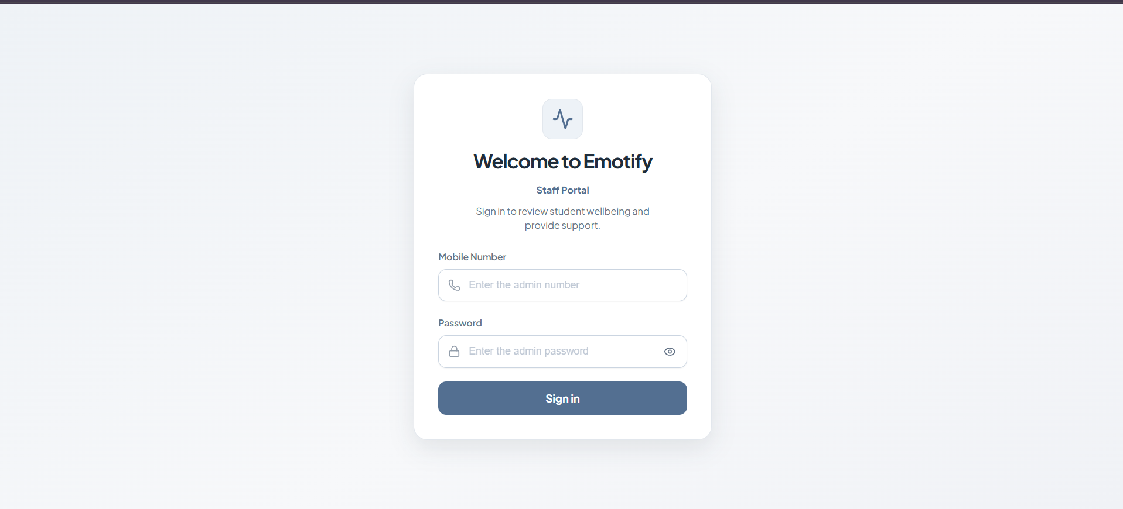
Figure A1. Staff Portal sign-in
WHAT THIS SCREEN SHOWS
The entry point to the web portal. Staff sign in with their registered mobile number and password before they can see any student information.
FEATURES ON THIS SCREEN
- Staff Portal heading: Confirms this is the staff side of Emotify, with the line “Sign in to review student wellbeing and provide support”.
- Mobile Number: The staff member’s login identifier, the same kind of identifier students use in the app.
- Password: Masked by default, with an eye icon to show or hide what was typed.
- Sign in: Checks the credentials and opens the Counsellor Dashboard.

A2. Counsellor Dashboard
After signing in, the counsellor lands on the dashboard: a one-page summary of who needs attention, what students have been doing and how screening results are trending.

Figure A2 Dashboard: navigation, key numbers and items needing attention
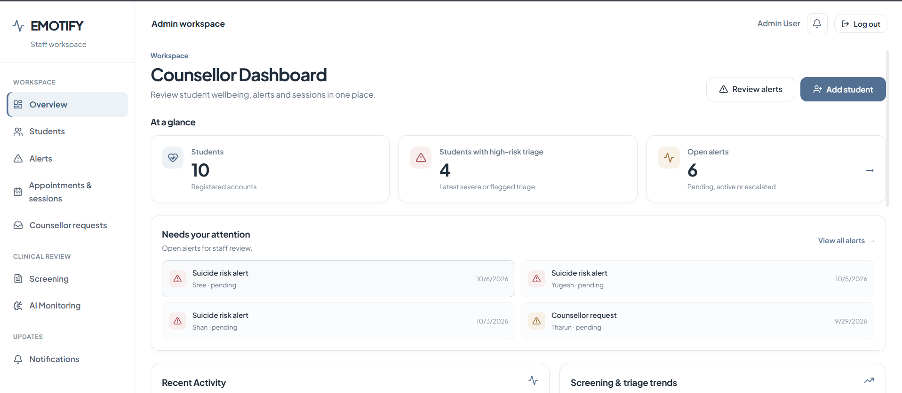
Figure A2. Dashboard: navigation, key numbers and items needing attention
WHAT THIS SCREEN SHOWS
The top of the dashboard. A left-hand menu gives access to every area of the portal, and the main panel summarises the caseload and lists the newest items that need a response.
FEATURES ON THIS SCREEN
- Navigation menu: Grouped into Workspace (Overview, Students, Alerts, Appointments & sessions, Counsellor requests), Clinical Review (Screening, AI Monitoring) and Updates (Notifications).
- Header bar: Shows the signed-in user (Admin User), a notification bell and Log out.
- Quick actions: Review alerts jumps to the Alerts page; Add student opens the form for registering a new student.
- At a glance: Three counters: Students (10 registered), Students with high-risk triage (4, based on the latest severe or flagged triage) and Open alerts (6, counting pending, active or escalated alerts).
- Needs your attention: The most recent open items, newest first: suicide-risk alerts for Sree, Yugesh and Shan, and a counsellor request from Tharun, each with its status and date. View all alerts opens the full list.

Figure A3 Dashboard: recent activity, trends and today’s sessions
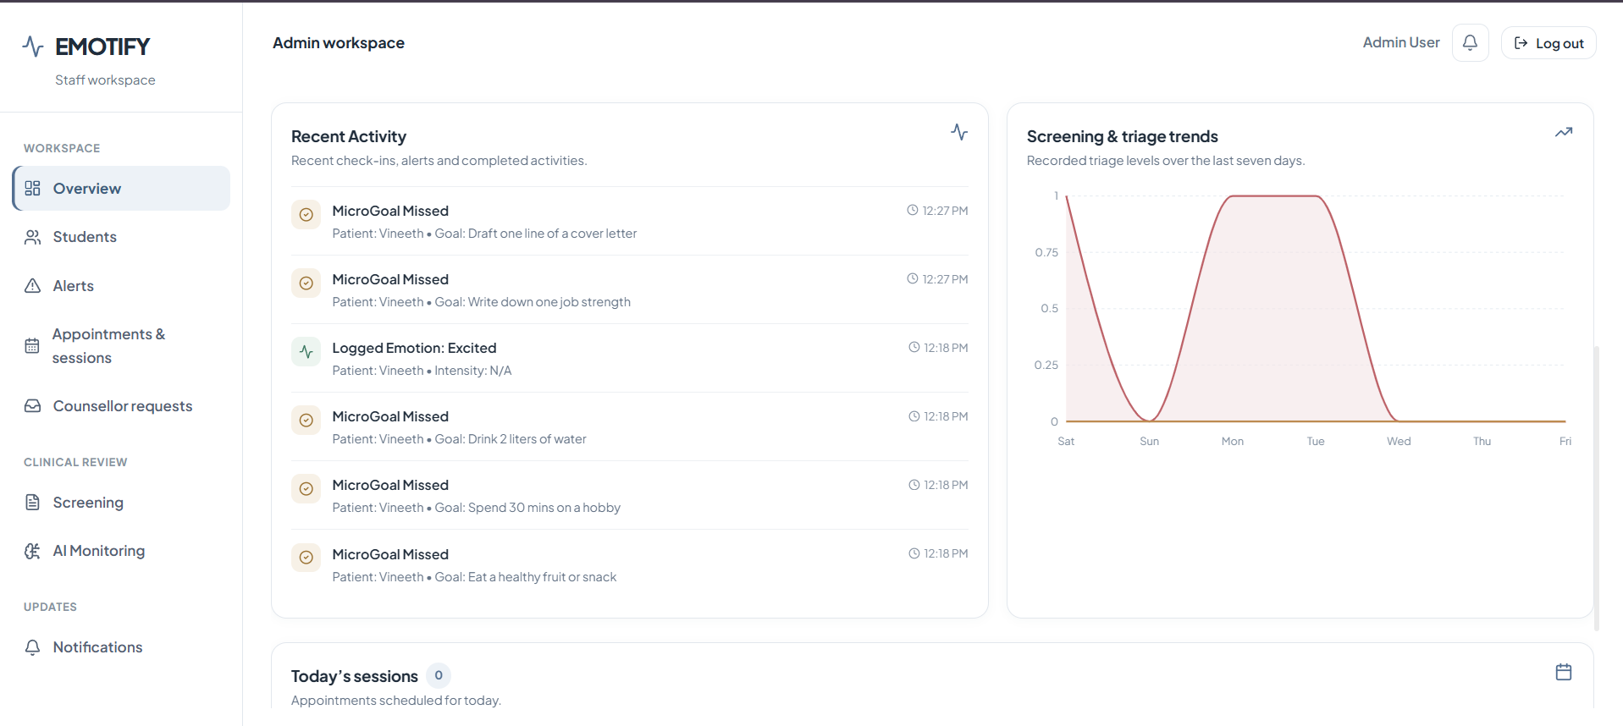
Figure A3. Dashboard: recent activity, trends and today’s sessions
WHAT THIS SCREEN SHOWS
Further down the dashboard, the counsellor sees what students have done recently in the app, how screening and triage results have moved over the past week, and how many sessions are booked for today.
FEATURES ON THIS SCREEN
- Recent Activity: A live feed of student actions, for example a missed micro-goal and an emotion a student logged (“Excited”).
- Screening & triage trends: A chart of screening and triage results over the last seven days.
- Today’s sessions: The number of appointments scheduled for today (0 in this example).

A3. Managing students

Figure A4 Students list
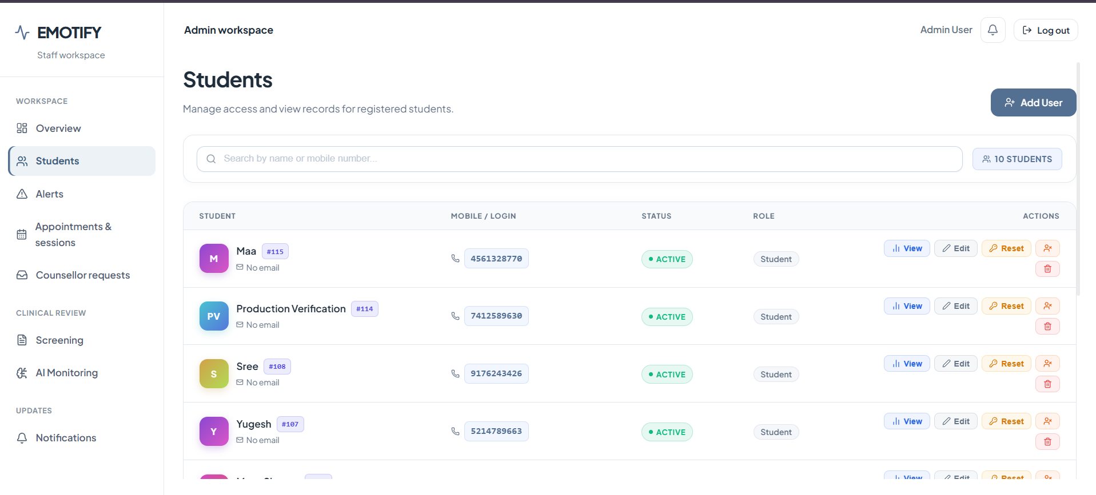
Figure A4. Students list
WHAT THIS SCREEN SHOWS
The directory of every registered student account. From here staff can find a student, open their profile and manage their account.
FEATURES ON THIS SCREEN
- Search: Finds a student by name or mobile number.
- Student table: Lists each student’s name, ID and email, their mobile number (the login), account status (Active) and role (Student). The header shows the total (10 students).
- Row actions: View opens the student profile, Edit changes account details, Reset sets a new password, the person icon assigns a counsellor, and the bin icon deletes the account.
- Add User: Creates a new account from the portal.

A4. Safety alerts and triage
Emotify raises alerts automatically, for example when a screening answer shows suicide risk or a student’s scores get worse. Counsellors review each alert and decide what happens next.

Figure A5 Alerts overview
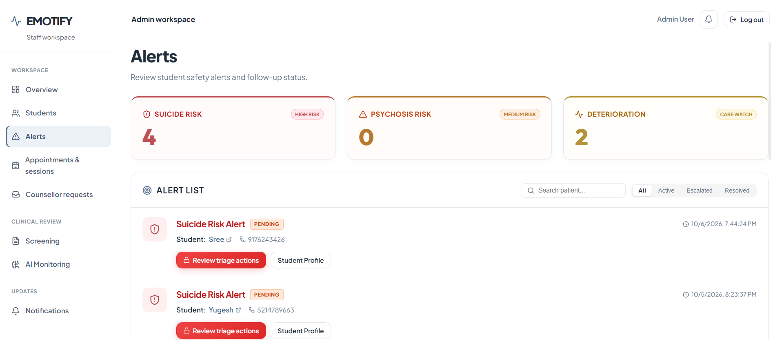
Figure A5. Alerts overview
WHAT THIS SCREEN SHOWS
Every safety alert raised for the counsellor’s students, grouped by type with a count for each, and a list of individual alerts below.
FEATURES ON THIS SCREEN
- Alert categories: Suicide risk (High risk) 4, Psychosis risk (Medium risk) 0 and Deterioration (Care watch) 2.
- Search and status filter: Narrow the list to All, Active, Escalated or Resolved alerts.
- Alert card: Shows the alert type, its status (Pending), the student’s name and phone number, and when the alert was raised.
- Review triage actions: Opens the triage decision dialog (next figure).
- Student Profile: Opens the student’s full profile and history.

Figure A6 Triage actions dialog
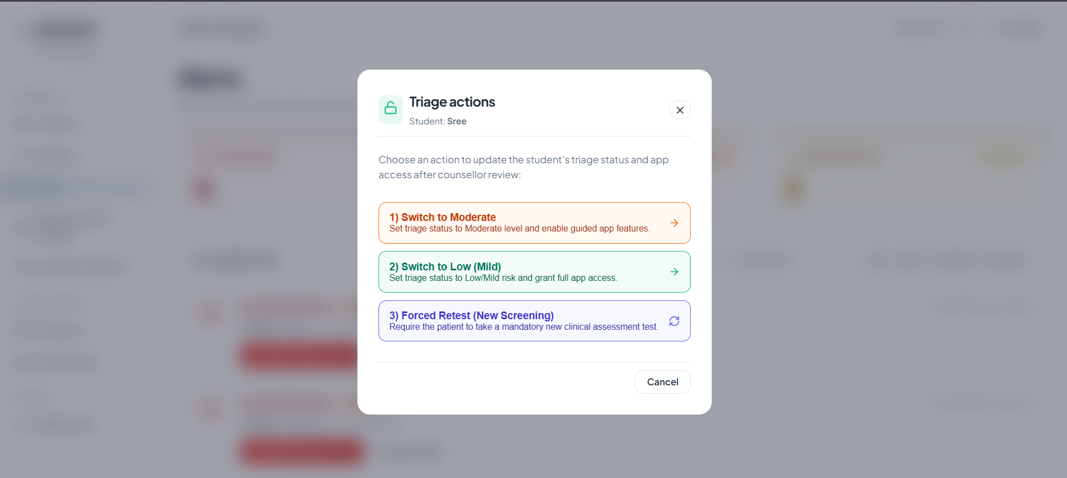
Figure A6. Triage actions dialog
WHAT THIS SCREEN SHOWS
After reviewing an alert, the counsellor picks the student’s triage level. The choice controls what the student can use in the mobile app.
FEATURES ON THIS SCREEN
- 1) Switch to Moderate: Sets the student’s triage to Moderate and turns on guided app features.
- 2) Switch to Low (Mild): Gives the student full access to the app.
- 3) Forced Retest (New Screening): Makes the student complete a new screening assessment.
- Cancel: Closes the dialog without making any change.
Note: This was checked against the app code. While a forced retest is pending, the student’s Tools and Insights tabs are hidden and the Home tools stay locked until the new screening is finished (compare Figure B14).

A5. Appointments and sessions

Figure A7 Appointment requests
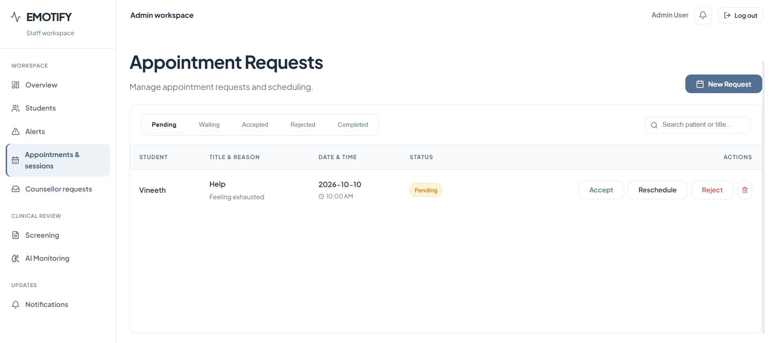
Figure A7. Appointment requests
WHAT THIS SCREEN SHOWS
Appointment requests that students made from the mobile app (see Figure B41), grouped by stage so the counsellor can respond to each one.
FEATURES ON THIS SCREEN
- Status tabs: Pending, Waiting, Accepted, Rejected and Completed.
- Request row: Shows the student (Vineeth), the reason they gave (“Help / Feeling exhausted”), the requested date and time (2026-10-10, 10:00 AM) and the status.
- Actions: Accept, Reschedule, Reject or delete the request.
- New Request: Lets staff book an appointment for a student.

A6. Counsellor call requests

Figure A8 Counsellor call requests (intervention queue)
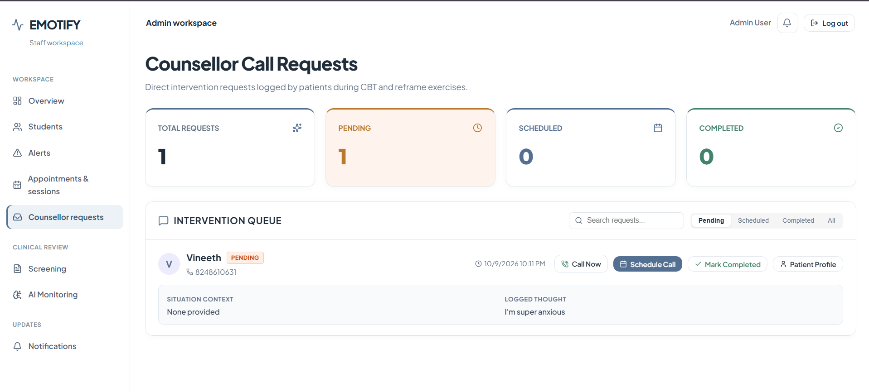
Figure A8. Counsellor call requests (intervention queue)
WHAT THIS SCREEN SHOWS
Requests for direct contact that students send while doing CBT and thought-reframing exercises (Think Differently, Figure B29). They appear here so a counsellor can call the student back.
FEATURES ON THIS SCREEN
- Summary counters: Total 1, Pending 1, Scheduled 0, Completed 0.
- Queue tabs: Pending, Scheduled, Completed and All.
- Request card: The student (Vineeth), their phone number, when they asked, the situation context and the thought they logged (“I’m super anxious”).
- Actions: Call Now, Schedule Call, Mark Completed and Patient Profile.

A7. Clinical Screening Centre
Students complete three screening questionnaires in the app (Section B3). The Screening Centre combines the results for every enrolled student. The friendly names in the app match these clinical scales: Mood & Energy Check is the PHQ-9 (depression), Calm & Focus Check is the GAD-7 (anxiety) and Perception & Thoughts Check is the PQ-16 (psychosis risk).

Figure A9 Screening Centre: headline figures and risk distribution
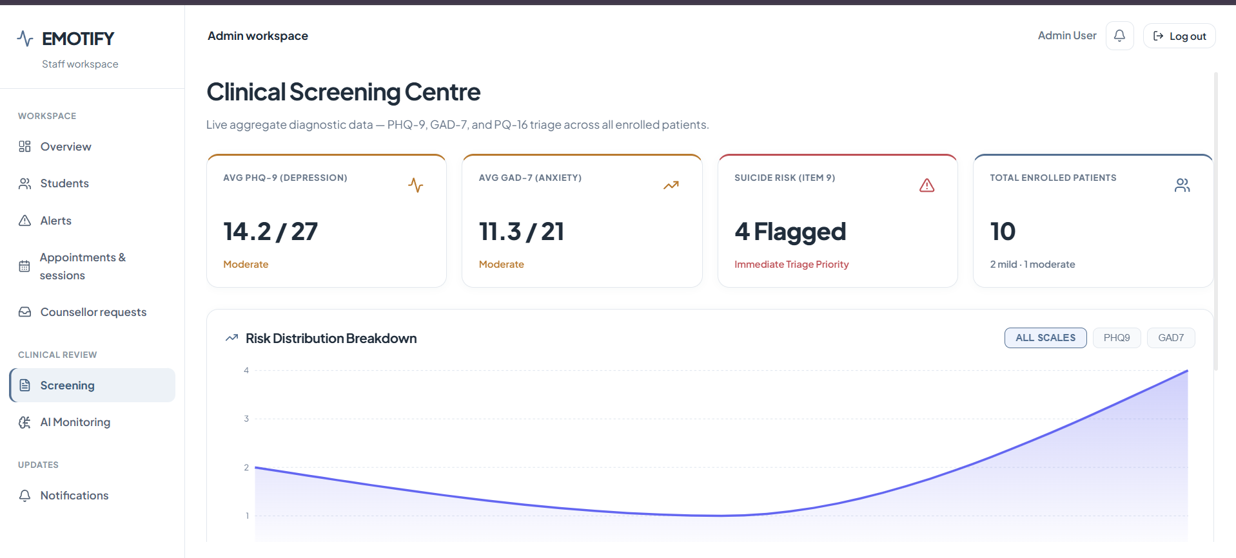
Figure A9. Screening Centre: headline figures and risk distribution
WHAT THIS SCREEN SHOWS
Live combined screening data for all enrolled students, with the highest-priority signal (PHQ-9 item 9, which asks about suicidal thoughts) shown on its own.
FEATURES ON THIS SCREEN
- Average PHQ-9: 14.2 out of 27, in the Moderate range.
- Average GAD-7: 11.3 out of 21, in the Moderate range.
- Suicide risk (Item 9): 4 students flagged, marked as an immediate triage priority.
- Total enrolled: 10 students, with a breakdown by severity.
- Risk Distribution Breakdown: A chart that can show all scales together or PHQ-9 and GAD-7 separately.

Figure A10 Screening Centre: severity chart and score summary
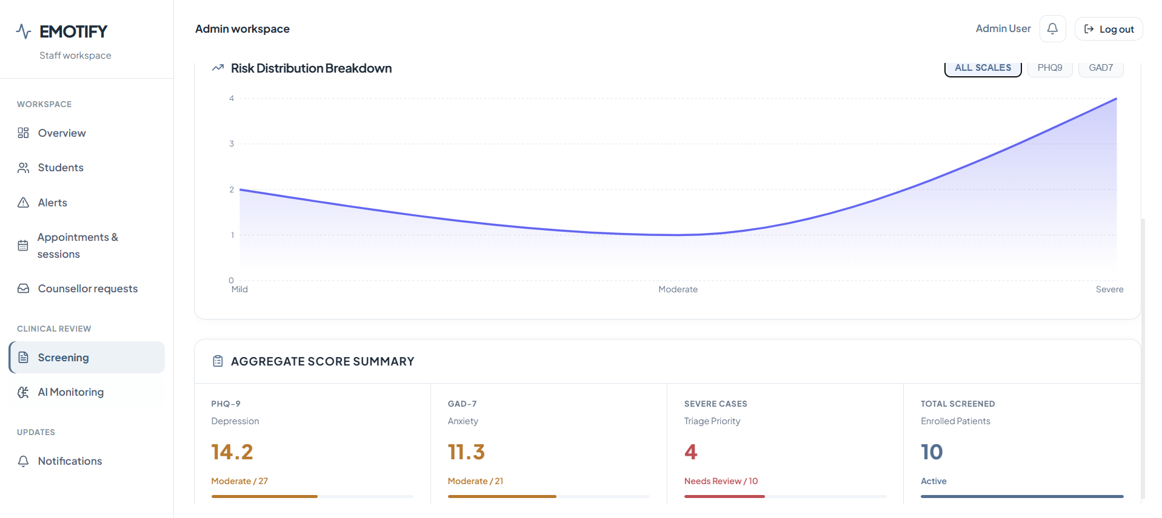
Figure A10. Screening Centre: severity chart and score summary
WHAT THIS SCREEN SHOWS
The lower part of the Screening Centre: how many students fall into each severity band, and a summary table of the combined scores.
FEATURES ON THIS SCREEN
- Severity chart: Number of students in the Mild, Moderate and Severe bands.
- Aggregate Score Summary: PHQ-9 14.2/27 (Moderate), GAD-7 11.3/21 (Moderate), 4 severe cases that need review, and 10 students screened.

A8. AI Safety & Companion Logs

Figure A11 AI monitoring of Emoty conversations
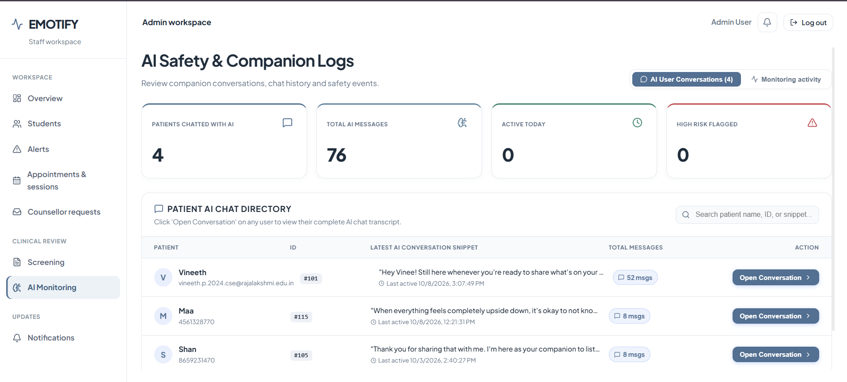
Figure A11. AI monitoring of Emoty conversations
WHAT THIS SCREEN SHOWS
Staff can monitor students’ conversations with Emoty, the AI companion in the app (Figure B39 and Figure B40), and see how many have been flagged for safety.
FEATURES ON THIS SCREEN
- View toggle: Switches between AI User Conversations and Monitoring activity.
- Summary counters: Students who have chatted with the AI (4), total AI messages (76), active today (0) and high-risk conversations flagged (0).
- Patient AI chat directory: A searchable list of students with their message counts. Open Conversation shows the full chat history.

A9. Notifications

Figure A12 Notifications centre
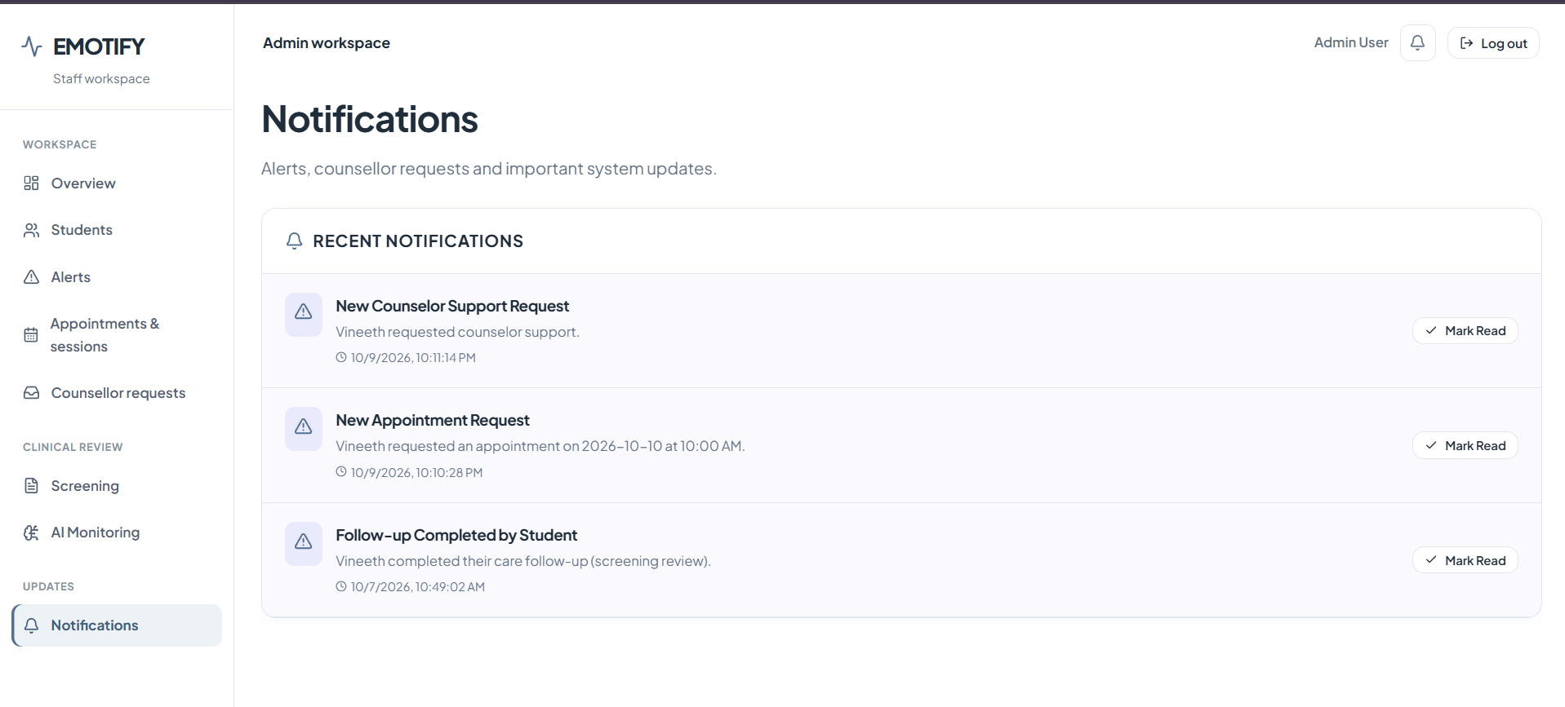
Figure A12. Notifications centre
WHAT THIS SCREEN SHOWS
A single place for system notifications about student activity that needs a counsellor’s attention.
FEATURES ON THIS SCREEN
- New Counselor Support Request: Raised when a student asks for counsellor contact (see A6).
- New Appointment Request: Raised when a student books a session (see A5), with the requested date and time.
- Follow-up Completed by Student: Confirms that a student has finished a follow-up task, such as a screening review.
- Mark Read: Marks a notification as read once it has been dealt with.

Part B. Student Mobile App
Part B follows a new student from installing the app to using every feature: account creation, onboarding, the initial wellness screening, Home and the daily check-in, the guided emotion check-in, the Therapy Hub and each support tool, Insights and Profile.

B1. Account access
A new student downloads Emotify and creates an account. Returning students sign in on the same screen.

Figure B1 Sign in
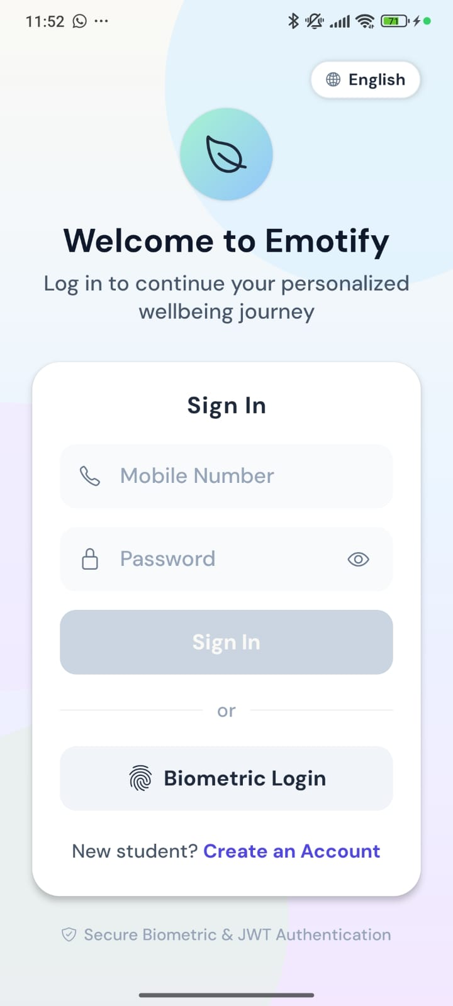
Figure B1. Sign in
WHAT THIS SCREEN SHOWS
The first screen of the app. Students who already have an account sign in here; new students go to account creation.
FEATURES ON THIS SCREEN
- Language selector: The English chip in the top corner changes the app language.
- Mobile Number and Password: The student’s login details. The eye icon shows or hides the password.
- Sign In: Turns on once both fields are filled in.
- Biometric Login: Signs in with the phone’s fingerprint or face unlock, where available.
- Create an Account: Opens the registration screen for new students.
- Security note: The footer reads “Secure Biometric & JWT Authentication”.

Figure B2 Create Student Account
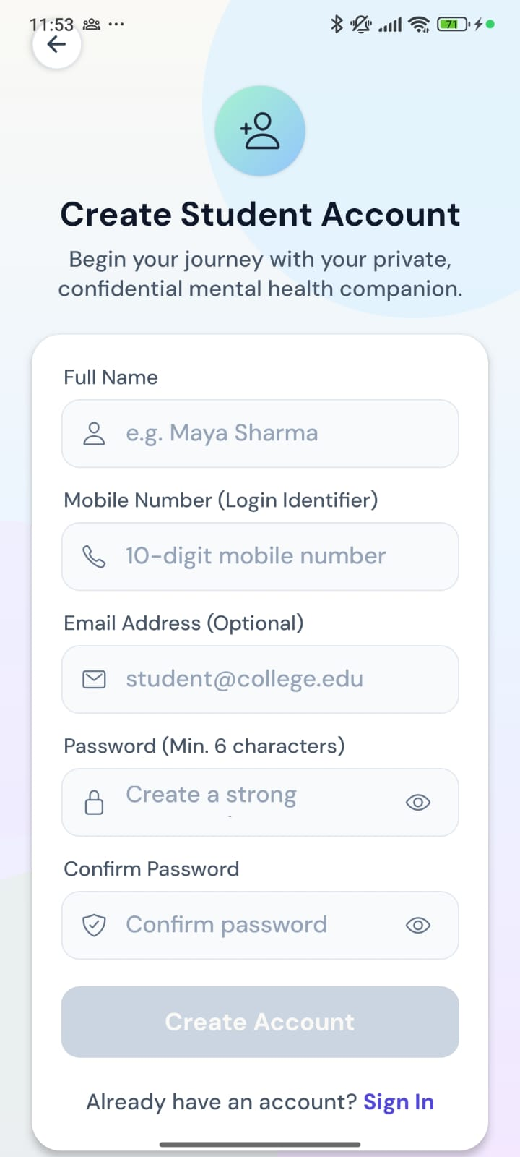
Figure B2. Create Student Account
WHAT THIS SCREEN SHOWS
Registration for a new student. The mobile number becomes the student’s login.
FEATURES ON THIS SCREEN
- Full Name: The student’s name.
- Mobile Number (Login Identifier): A 10-digit mobile number, used to sign in.
- Email Address (Optional): Can be left blank.
- Password and Confirm Password: At least 6 characters, entered twice to avoid typos, with show/hide icons.
- Create Account: Turns on once the form is valid, creates the account and starts onboarding.
- Sign In link: Returns to the sign-in screen for students who already have an account.

B2. First-time onboarding
On first sign-in the student meets Emoty, reads the key safety information, gives consent and adds an emergency contact and some profile details. A “Step X of 3” indicator shows progress.

Figure B3 Welcome and Meet Your Companion
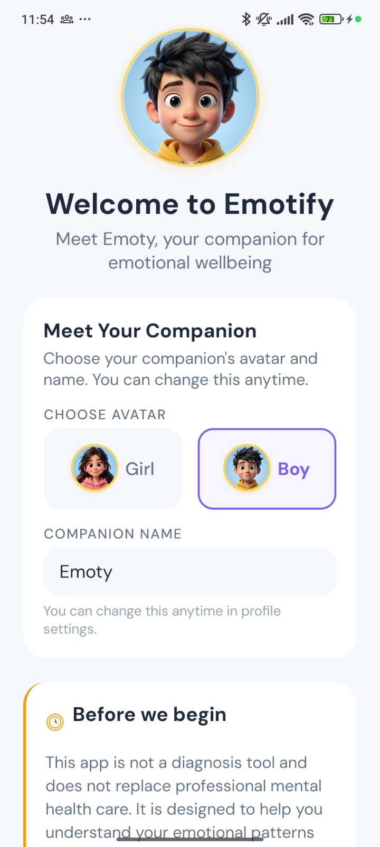
Figure B3. Welcome and Meet Your Companion
WHAT THIS SCREEN SHOWS
The student is introduced to Emoty, the in-app companion, and chooses how Emoty looks.
FEATURES ON THIS SCREEN
- Emoty avatar: The companion character that appears throughout the app.
- Choose Avatar: Pick the Girl or Boy look (Boy is selected here).
- Companion Name: Shows “Emoty”. The student can change the avatar and name later in Profile settings.
- Before we begin: The start of the safety information, continued in the next figure.

Figure B4 Before we begin
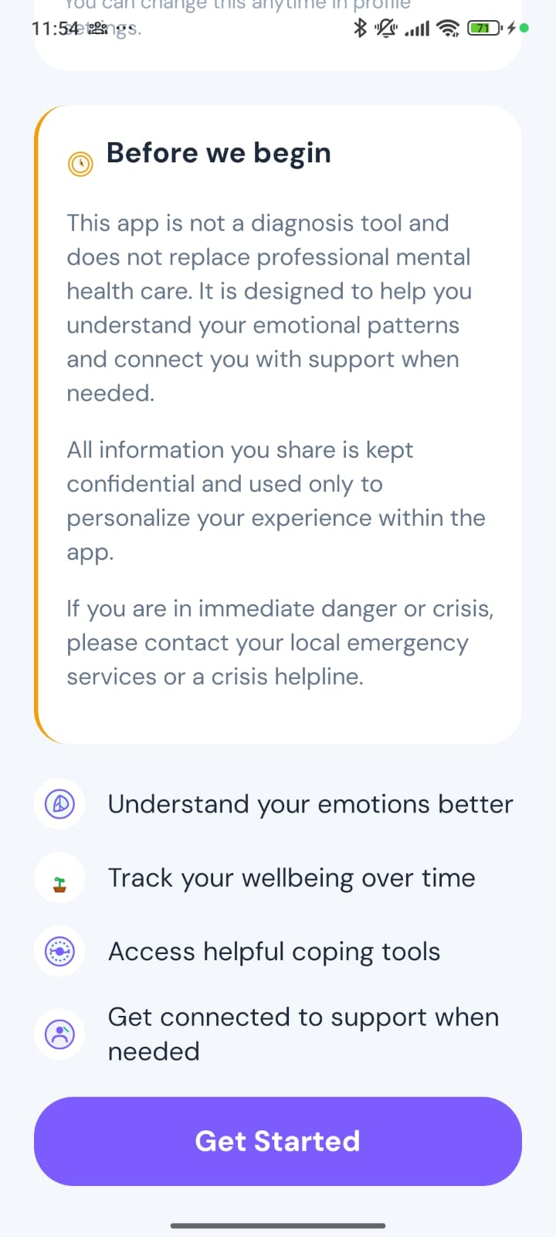
Figure B4. Before we begin
WHAT THIS SCREEN SHOWS
The rest of the welcome screen, which sets clear expectations before the student starts.
FEATURES ON THIS SCREEN
- Not a diagnosis tool: The app does not replace professional mental health care; it helps students understand their emotional patterns and connects them with support when needed.
- Confidentiality: What the student shares is kept confidential and used only to personalise their experience in the app.
- Crisis guidance: Students in immediate danger or crisis are told to contact local emergency services or a crisis helpline.
- What the app offers: Understand your emotions better, track your wellbeing over time, use helpful coping tools and get connected to support when needed.
- Get Started: Moves on to the consent step.

Figure B5 Step 1 of 3: Informed Consent
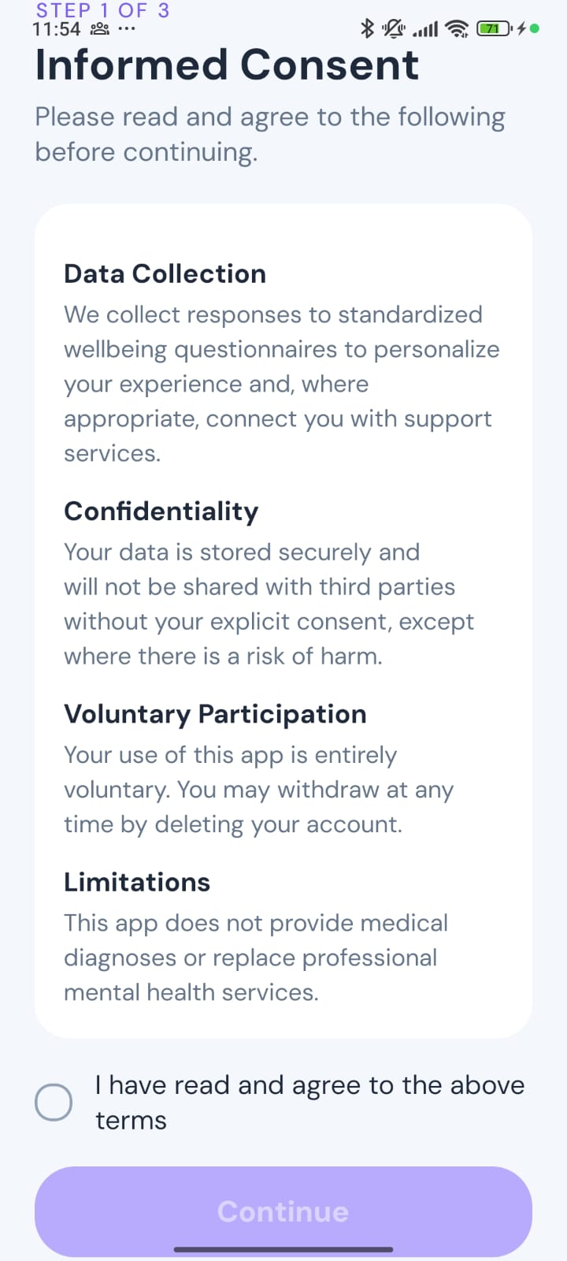
Figure B5. Step 1 of 3: Informed Consent
WHAT THIS SCREEN SHOWS
The student reads and accepts the terms before any data is collected.
FEATURES ON THIS SCREEN
- Data Collection: Answers to standard wellbeing questionnaires are used to personalise the experience and, where appropriate, to connect the student with support services.
- Confidentiality: Data is stored securely and not shared with third parties without the student’s explicit consent, except where there is a risk of harm.
- Voluntary Participation: Using the app is voluntary, and the student can withdraw at any time by deleting their account.
- Limitations: The app does not provide medical diagnoses or replace professional mental health services.
- Agreement checkbox and Continue: Continue is only enabled after the student ticks “I have read and agree to the above terms”.

Figure B6 Step 2 of 3: Emergency Contact
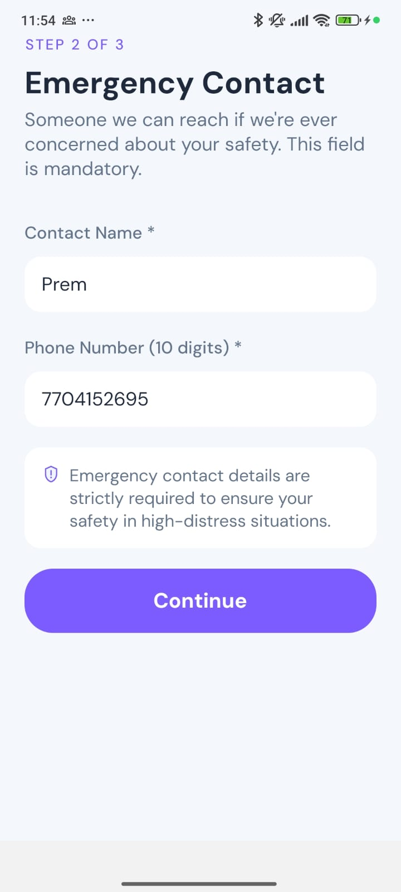
Figure B6. Step 2 of 3: Emergency Contact
WHAT THIS SCREEN SHOWS
The student names someone the service can contact if there is a concern about their safety. This step is mandatory.
FEATURES ON THIS SCREEN
- Contact Name: Required (sample value: Prem).
- Phone Number (10 digits): Required.
- Safety note: Explains that emergency contact details are needed to keep the student safe in high-distress situations.
- Continue: Saves the contact and moves to step 3.

Figure B7 Step 3 of 3: Tell us about you
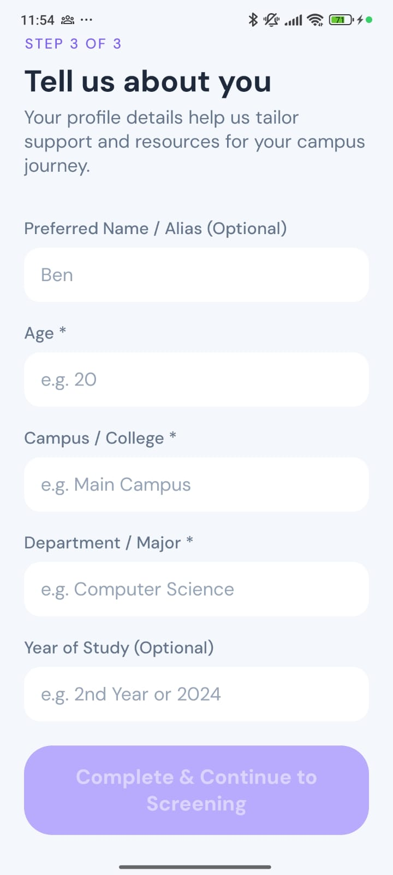
Figure B7. Step 3 of 3: Tell us about you
WHAT THIS SCREEN SHOWS
Basic profile details that help tailor support and resources to the student’s campus.
FEATURES ON THIS SCREEN
- Preferred Name / Alias (Optional): The name the app uses when talking to the student. This student entered “Beny”, which appears later on Home.
- Age, Campus / College, Department / Major: Required fields.
- Year of Study (Optional): For example “2nd Year” or “2024”.
- Complete & Continue to Screening: Finishes onboarding and opens the wellness screening.

B3. Initial wellness screening
Before the support tools unlock, the student completes three short, confidential questionnaires. These are the validated scales counsellors see in the Screening Centre (A7).

Figure B8 Wellness Check-Ins (screening hub)
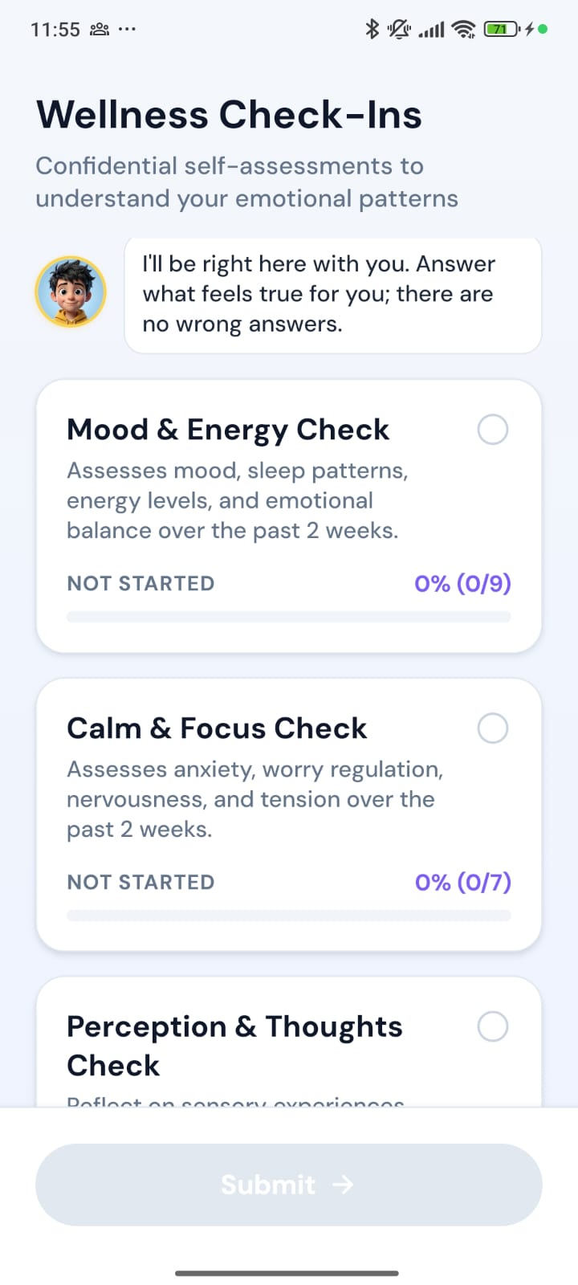
Figure B8. Wellness Check-Ins (screening hub)
WHAT THIS SCREEN SHOWS
The list of screening questionnaires, each showing its progress, with Emoty offering reassurance at the top.
FEATURES ON THIS SCREEN
- Emoty’s message: “I’ll be right here with you. Answer what feels true for you; there are no wrong answers.”
- Mood & Energy Check: Mood, sleep, energy and emotional balance over the past 2 weeks (9 questions, PHQ-9).
- Calm & Focus Check: Anxiety, worry, nervousness and tension over the past 2 weeks (7 questions, GAD-7).
- Perception & Thoughts Check: Sensory experiences, unusual thoughts and perceptions (16 questions, PQ-16).
- Progress indicators: Each card shows its status (Not Started) and percentage (0%).

Figure B9 Wellness Check-Ins (scrolled), with Submit
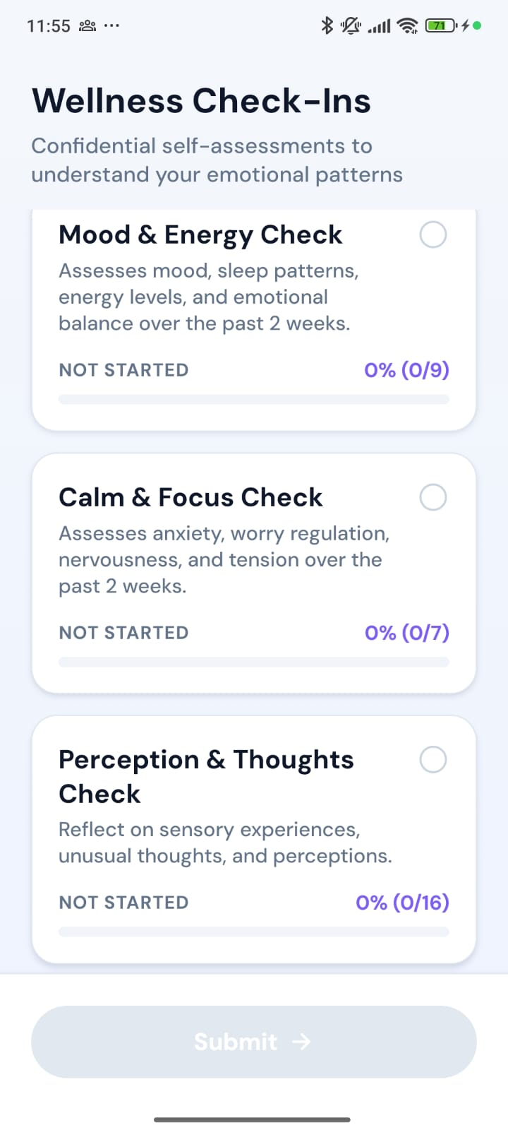
Figure B9. Wellness Check-Ins (scrolled), with Submit
WHAT THIS SCREEN SHOWS
The same hub scrolled down, showing all three checks and the Submit button.
FEATURES ON THIS SCREEN
- Third check visible: Perception & Thoughts Check, 0% (0/16).
- Submit: Disabled until all three checks are complete, so a partial screening cannot be sent.

Figure B10 Mood & Energy Check: question 1 of 9
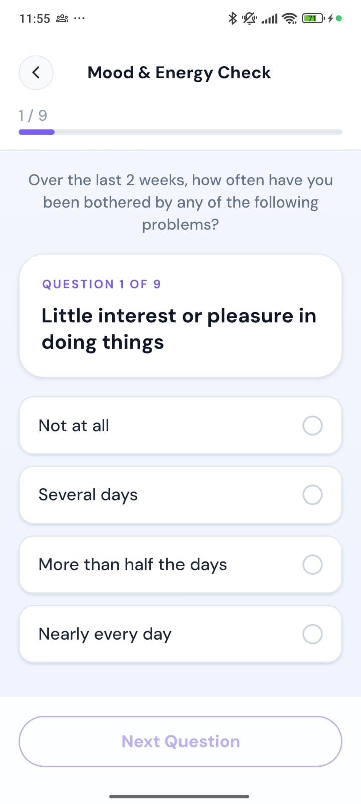
Figure B10. Mood & Energy Check: question 1 of 9
WHAT THIS SCREEN SHOWS
One question per screen, with a progress bar. The wording follows the validated questionnaire.
FEATURES ON THIS SCREEN
- Progress: 1 / 9 at the top, with a progress bar.
- Question: “Over the last 2 weeks, how often have you been bothered by… Little interest or pleasure in doing things.”
- Answer options: Not at all, Several days, More than half the days, Nearly every day.
- Next Question: Turns on once an answer is chosen.

Figure B11 Mood & Energy Check: question 2 of 9 (answered)
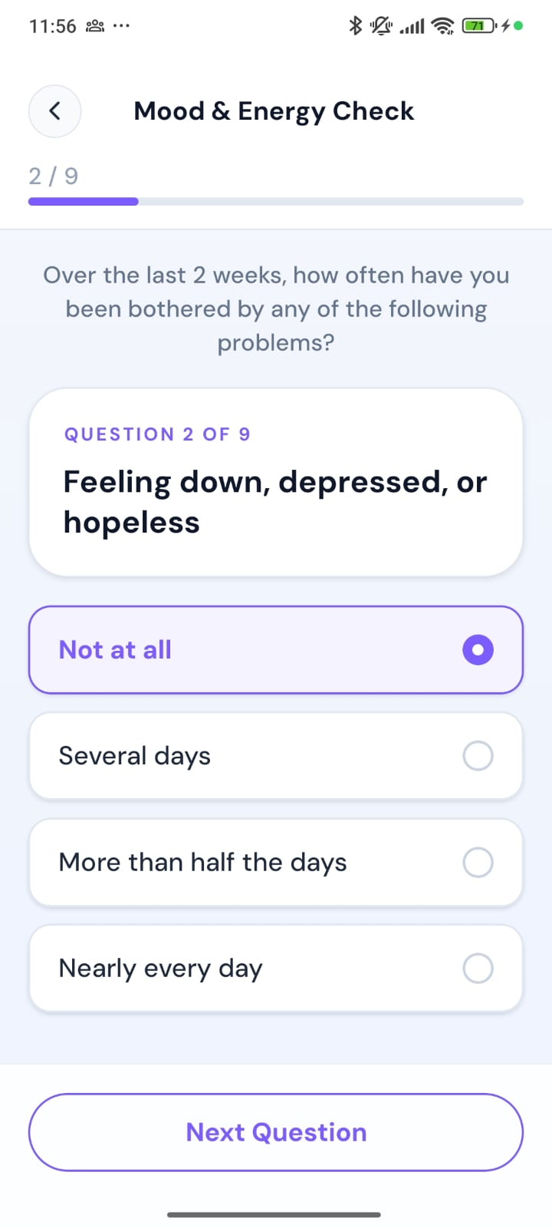
Figure B11. Mood & Energy Check: question 2 of 9 (answered)
WHAT THIS SCREEN SHOWS
The selected-answer state: the chosen option is highlighted and Next Question is active.
FEATURES ON THIS SCREEN
- Question: “Feeling down, depressed, or hopeless.”
- Selected answer: “Not at all” is highlighted with a filled radio button.
- Next Question: Now active.

Figure B12 Calm & Focus Check: question 1 of 7
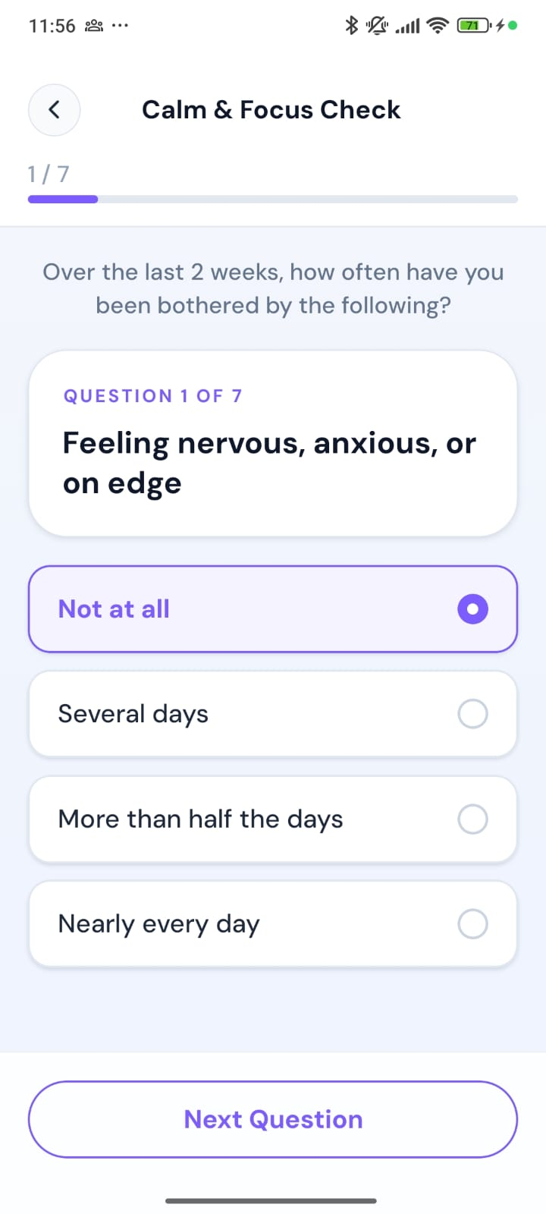
Figure B12. Calm & Focus Check: question 1 of 7
WHAT THIS SCREEN SHOWS
The anxiety questionnaire, using the same one-question-per-screen layout.
FEATURES ON THIS SCREEN
- Question: “Feeling nervous, anxious, or on edge.”
- Answer options: The same four frequency options as the Mood & Energy Check (“Not at all” is selected).

Figure B13 Perception & Thoughts Check: question 1 of 16
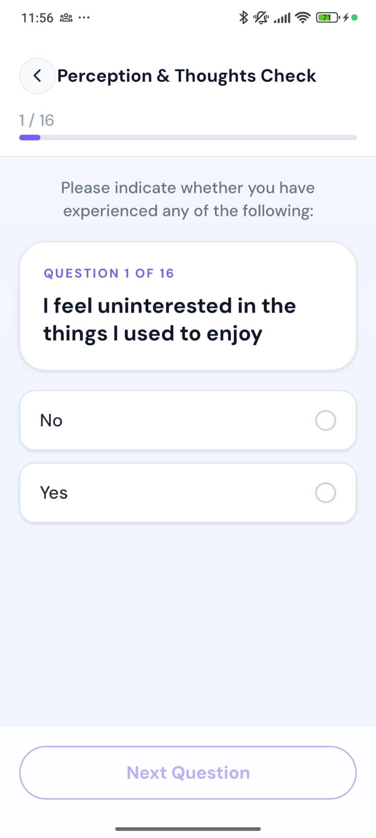
Figure B13. Perception & Thoughts Check: question 1 of 16
WHAT THIS SCREEN SHOWS
The perception questionnaire, which has simple Yes/No answers.
FEATURES ON THIS SCREEN
- Instruction: “Please indicate whether you have experienced any of the following.”
- Question: “I feel uninterested in the things I used to enjoy.”
- Answer options: No or Yes.

Figure B14 Home before screening is complete (tools locked)
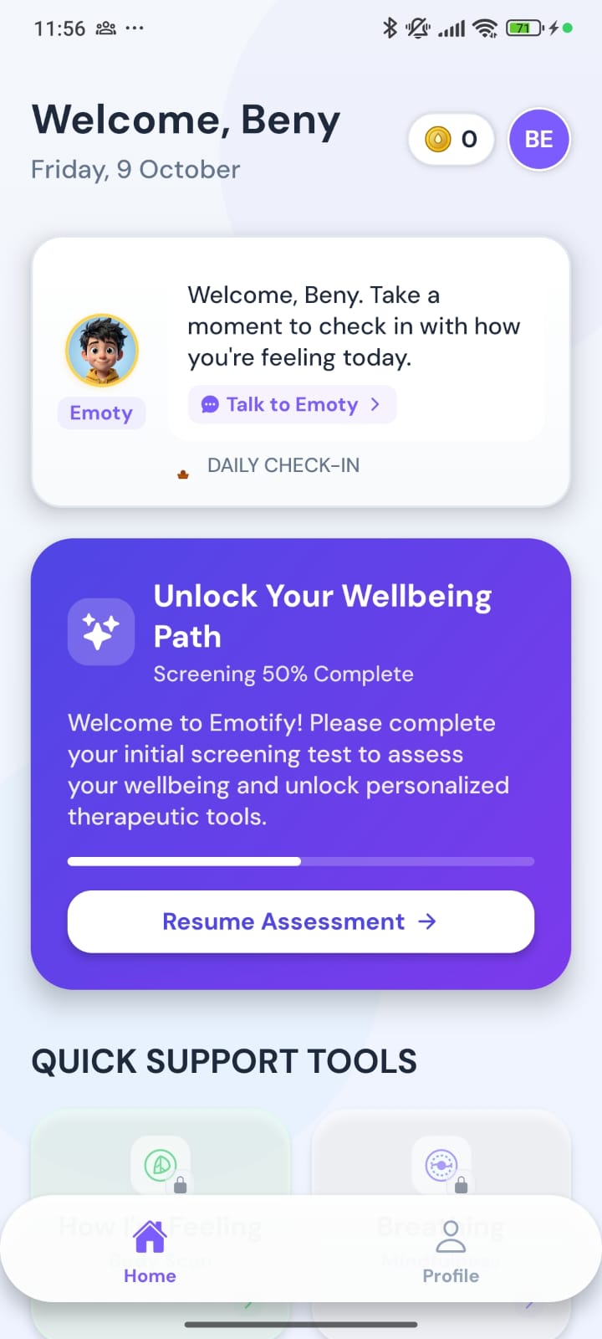
Figure B14. Home before screening is complete (tools locked)
WHAT THIS SCREEN SHOWS
If the student leaves the screening part-way, Home asks them to finish it. Support tools stay locked until they do.
FEATURES ON THIS SCREEN
- Greeting and date: “Welcome, Beny”, with the date, a points counter and the profile initials.
- Emoty card: A welcome message and a Talk to Emoty shortcut.
- Unlock Your Wellbeing Path: Shows screening progress (here 50%) and a Resume Assessment button that continues where the student stopped. Answers are saved on the device.
- Quick Support Tools (locked): Tools are dimmed and show a lock icon. Tapping one explains that the initial screening must be finished first.
- Reduced tab bar: Only Home and Profile are shown. Tools and Insights appear once screening is complete.

B4. Home and the daily check-in
Once screening is complete, the full app opens: four tabs (Home, Tools, Insights, Profile), a daily mood check-in, habits, quick tools, appointments and wellbeing indicators.

Figure B15 Home with the daily check-in
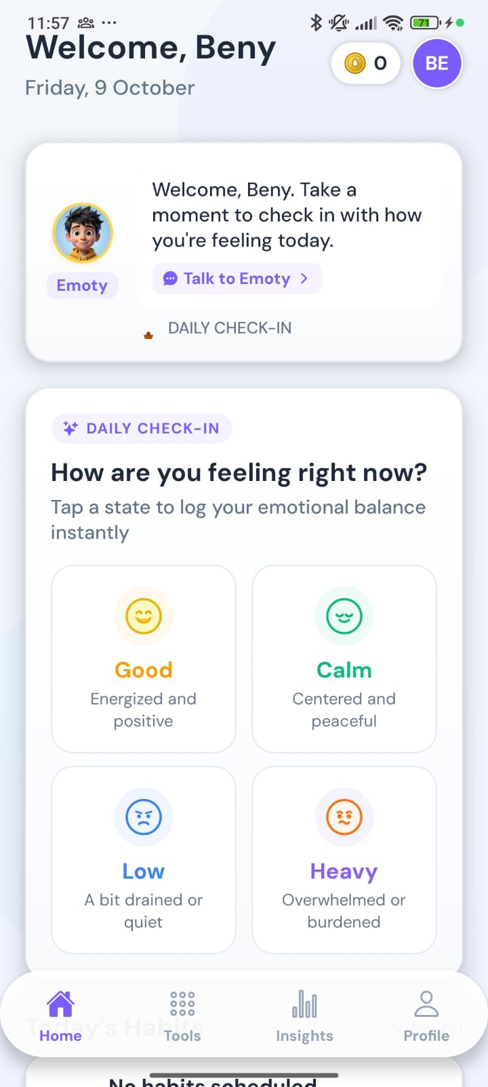
Figure B15. Home with the daily check-in
WHAT THIS SCREEN SHOWS
The student’s main screen after screening. The daily check-in is the first thing they see.
FEATURES ON THIS SCREEN
- Header: Greeting, date, Calm Points balance and profile initials.
- Emoty card: A personal welcome with Talk to Emoty.
- Daily Check-in: “How are you feeling right now?” with four states: Good (energised and positive), Calm (centred and peaceful), Low (a bit drained or quiet) and Heavy (overwhelmed or burdened).
- Full tab bar: Home, Tools, Insights and Profile are now available.

Figure B16 Daily check-in: Good selected
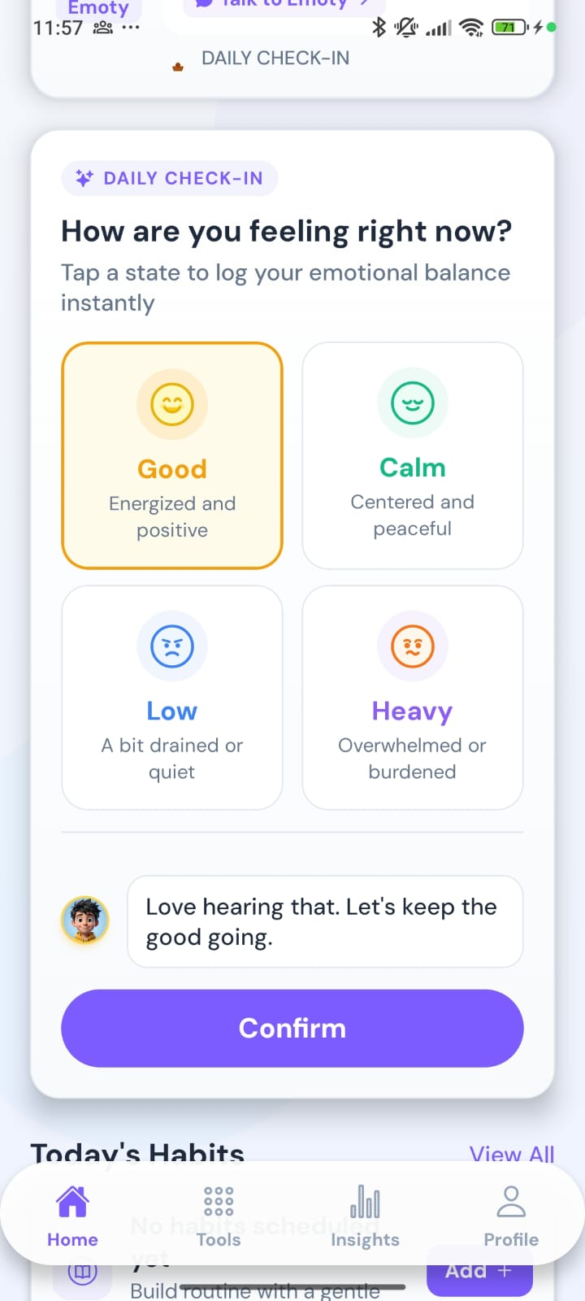
Figure B16. Daily check-in: Good selected
WHAT THIS SCREEN SHOWS
After choosing a state, Emoty responds and the student confirms the check-in.
FEATURES ON THIS SCREEN
- Selected state: Good is highlighted.
- Emoty’s response: “Love hearing that. Let’s keep the good going.”
- Confirm: Saves today’s check-in. The result appears on the Insights mood calendar (Figure B42).

Figure B17 Home: Today’s Habits
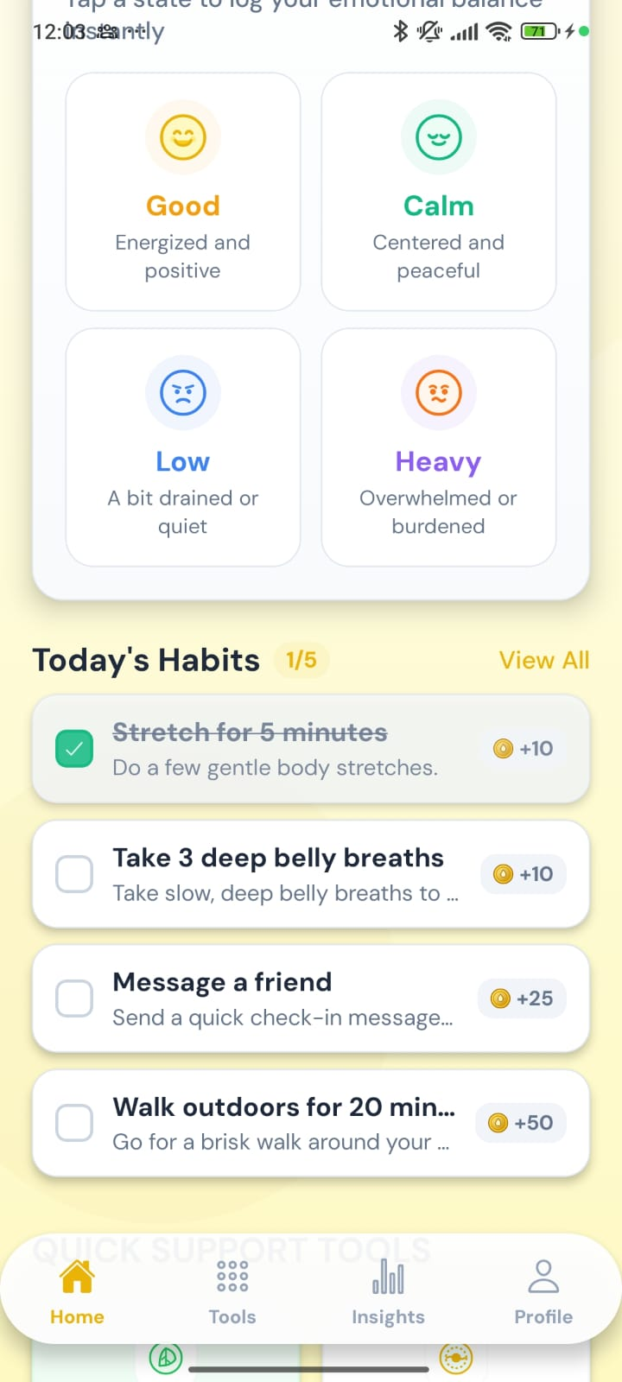
Figure B17. Home: Today’s Habits
WHAT THIS SCREEN SHOWS
Below the check-in, today’s small habits each earn Calm Points when completed.
FEATURES ON THIS SCREEN
- Today’s Habits (1/5): Shows how many of today’s habits are done. View All opens the full list.
- Completed habit: “Stretch for 5 minutes” is ticked and struck through (+10 points).
- Open habits: “Take 3 deep belly breaths” (+10), “Message a friend” (+25) and “Walk outdoors for 20 min” (+50).

Figure B18 Home: quick tools, appointments and wellbeing indicators
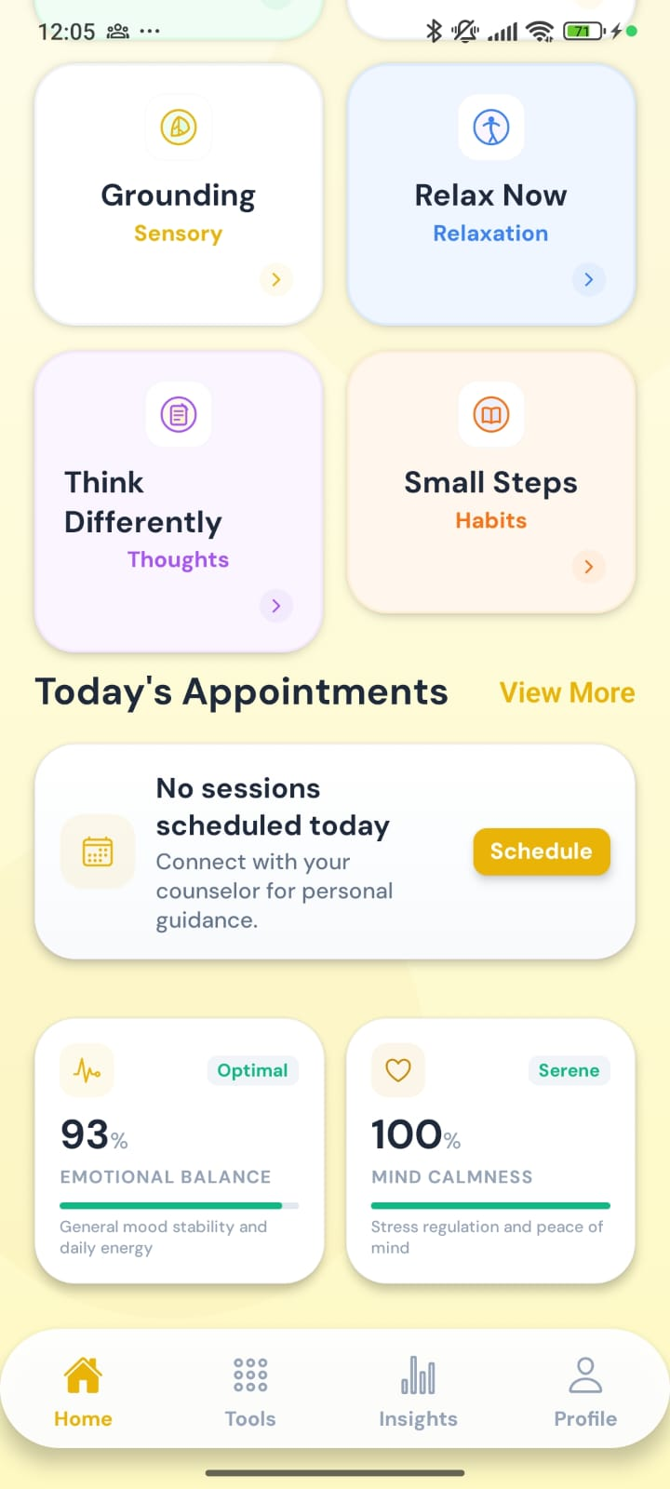
Figure B18. Home: quick tools, appointments and wellbeing indicators
WHAT THIS SCREEN SHOWS
The lower part of Home, with shortcuts to the main tools, today’s appointments and two simple wellbeing scores.
FEATURES ON THIS SCREEN
- Quick Support Tools: Shortcuts to Grounding (Sensory), Relax Now (Relaxation), Think Differently (Thoughts) and Small Steps (Habits), alongside How I’m Feeling and Breathing higher up.
- Today’s Appointments: “No sessions scheduled today”, with a Schedule button. View More opens Appointments.
- Emotional Balance (93%, Optimal): Based on the latest Mood & Energy (PHQ-9) score: the lower the score, the higher the percentage.
- Mind Calmness (100%, Serene): Based on the latest Calm & Focus (GAD-7) score in the same way.

B5. How I’m Feeling: guided emotion check-in
How I’m Feeling is a guided check-in. The student names the emotion, notices how it feels in the body, rates how strong it is, and then gets a matching activity. The screenshots begin at the body step.

Figure B19 How does it feel in your body?
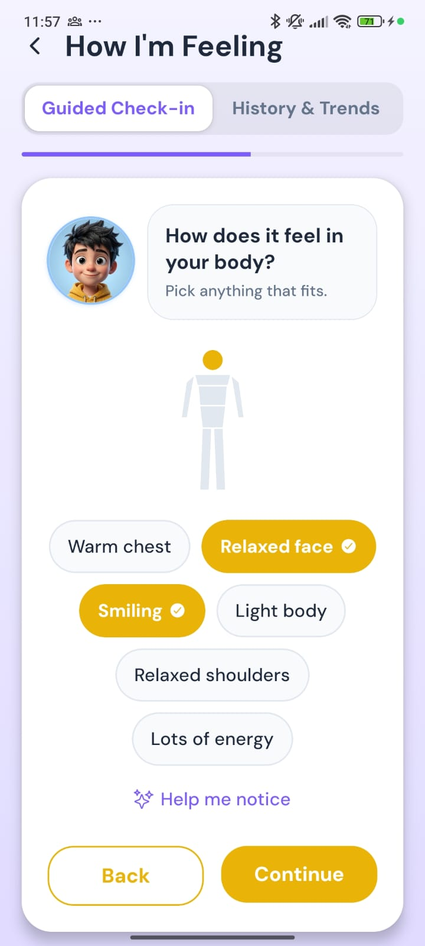
Figure B19. How does it feel in your body?
WHAT THIS SCREEN SHOWS
The body step. The student picks any sensations that fit the feeling they chose, and the body figure lights up the matching areas.
FEATURES ON THIS SCREEN
- Tabs: Guided Check-in (shown) and History & Trends.
- Emoty prompt: “How does it feel in your body? Pick anything that fits.”
- Body figure: Highlights the body areas linked to the chosen sensations (the head here). It is for feedback only and cannot be tapped.
- Sensation chips: Suggestions for a positive feeling: Warm chest, Relaxed face, Smiling, Light body, Relaxed shoulders, Lots of energy. Relaxed face and Smiling are selected.
- Help me notice: Starts a short guided body scan (next two figures).
- Back and Continue: Continue works even if nothing is selected.

Figure B20 Help me notice: head and face
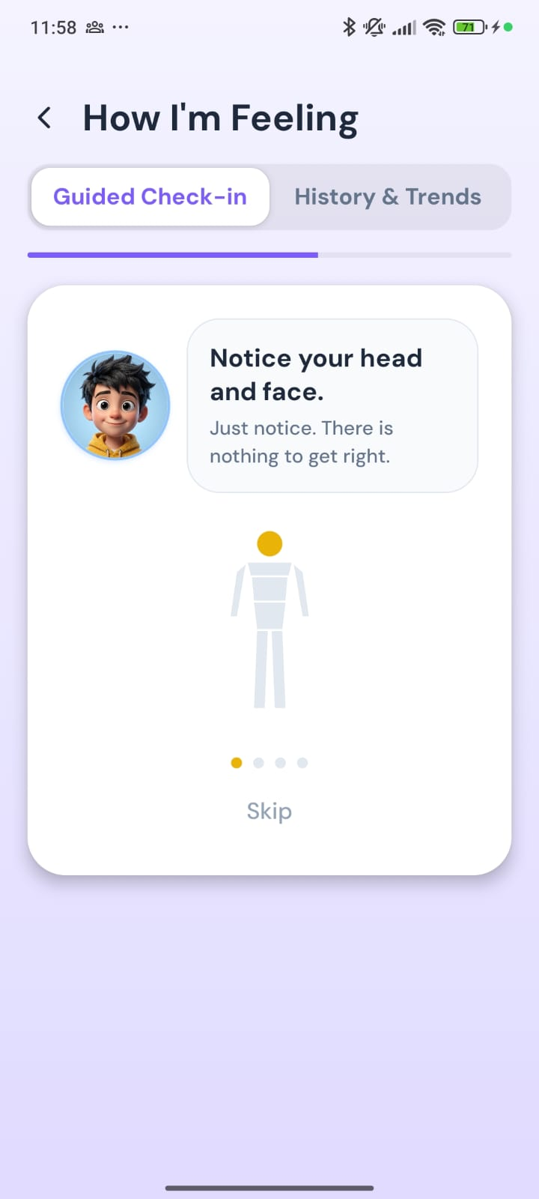
Figure B20. Help me notice: head and face
WHAT THIS SCREEN SHOWS
The guided body scan moves attention gently through four areas, a few seconds each, with the matching area highlighted on the figure.
FEATURES ON THIS SCREEN
- Prompt: “Notice your head and face. Just notice. There is nothing to get right.”
- Progress dots: Four dots for head, shoulders, chest and stomach (first dot active).
- Skip: Ends the scan early and returns to the sensation choices.

Figure B21 Help me notice: shoulders
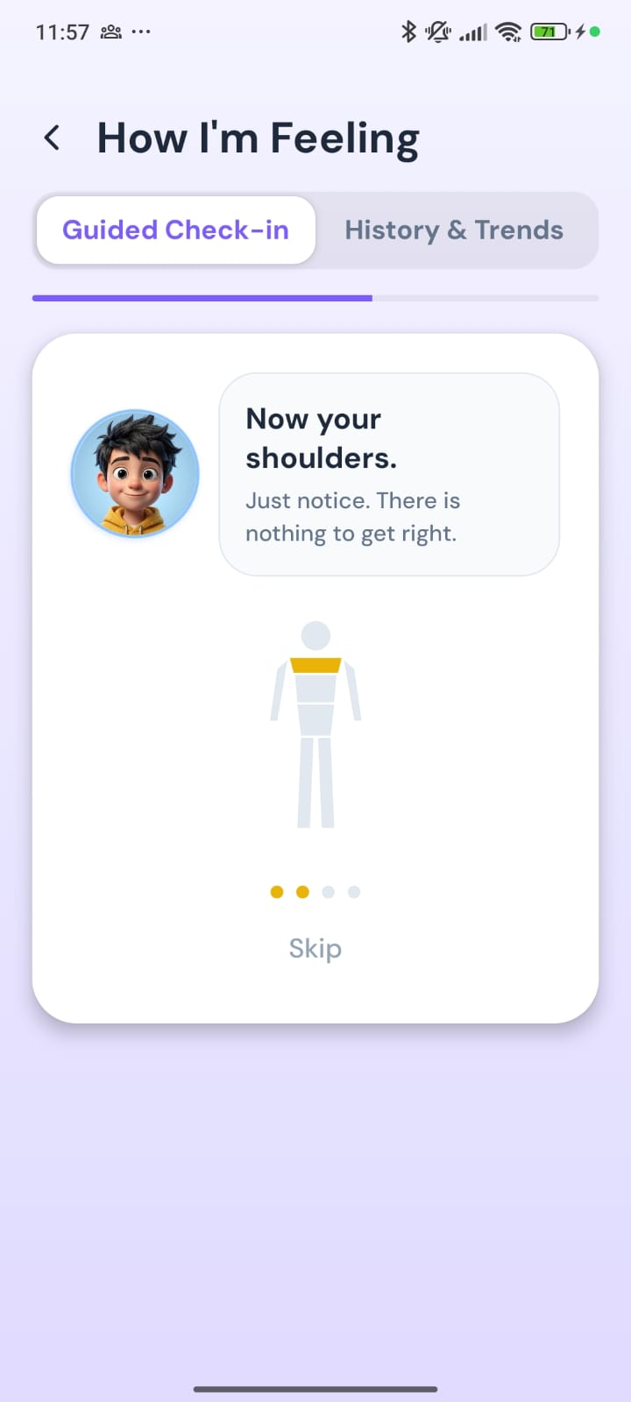
Figure B21. Help me notice: shoulders
WHAT THIS SCREEN SHOWS
The second area of the body scan.
FEATURES ON THIS SCREEN
- Prompt: “Now your shoulders. Just notice. There is nothing to get right.”
- Figure: The shoulders are highlighted, and the second progress dot is active.
Note: After the scan, the student is asked “Anything stand out?” and can pick sensations or choose “Not really”. No breathing pattern is used, so the scan does not overlap with the Breathing tool.

Figure B22 How strong does it feel right now?
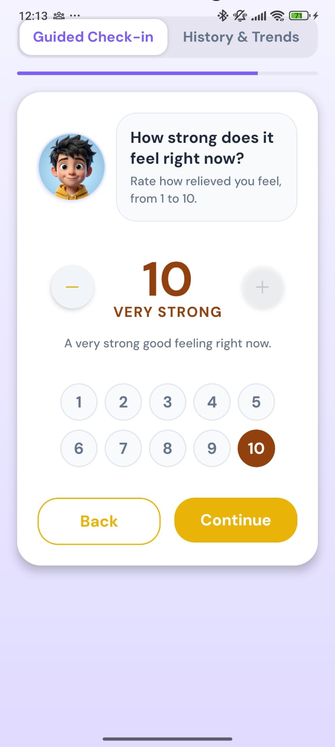
Figure B22. How strong does it feel right now?
WHAT THIS SCREEN SHOWS
The student rates how strong the feeling is on a 1–10 scale. The prompt names the feeling they chose (here “Relieved”, under Good).
FEATURES ON THIS SCREEN
- Prompt: “Rate how relieved you feel, from 1 to 10.”
- Scale: Large number with − / + buttons, and a 1–10 grid for quick selection.
- Label and caption: “Very strong” with “A very strong good feeling right now.” The wording and colour match the tone of the feeling, so a strong positive feeling is never described as distress.
- Back and Continue: Continue saves the check-in and shows the recommendation.

Figure B23 Recommended activity
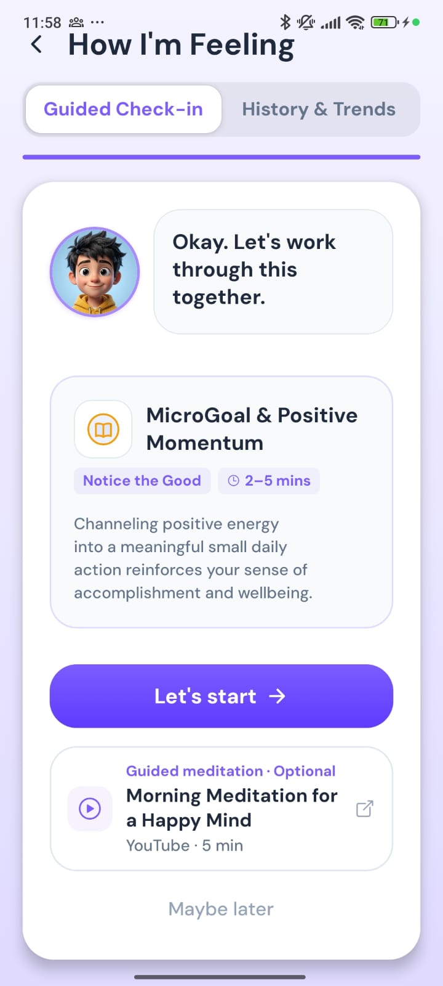
Figure B23. Recommended activity
WHAT THIS SCREEN SHOWS
Based on the emotion and its strength, Emoty suggests one activity, with an optional guided meditation.
FEATURES ON THIS SCREEN
- Emoty message: “Okay. Let’s work through this together.”
- Recommendation card: MicroGoal & Positive Momentum: “Notice the Good”, about 2–5 minutes, with a short explanation of why it helps.
- Let’s start: Opens the recommended activity.
- Guided meditation · Optional: “Morning Meditation for a Happy Mind” (YouTube, about 5 minutes), which opens outside the app.
- Maybe later: Closes the recommendation without starting anything.

B6. Therapy Hub (Tools tab)
The Tools tab, called the Therapy Hub, groups every support tool by category. A row of filter chips at the top switches between categories.

Figure B24 Therapy Hub: Mindfulness
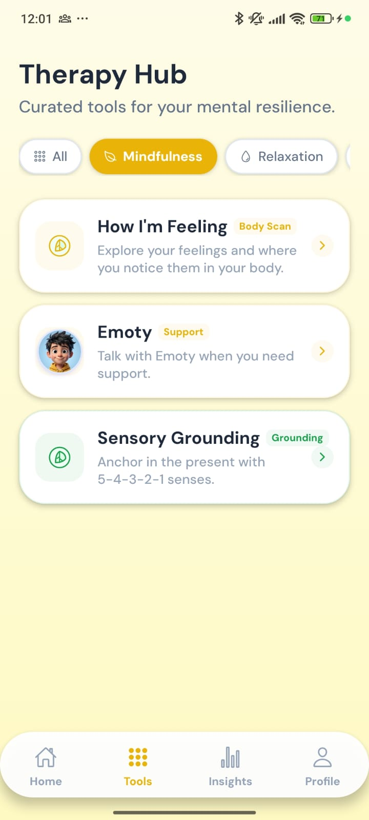
Figure B24. Therapy Hub: Mindfulness
WHAT THIS SCREEN SHOWS
Tools for noticing feelings and staying present.
FEATURES ON THIS SCREEN
- Category chips: All, Mindfulness (selected), Relaxation and more, scrolling sideways.
- How I’m Feeling (Body Scan): The guided emotion check-in from Section B5.
- Emoty (Support): Opens a chat with Emoty.
- Sensory Grounding (Grounding): The 5-4-3-2-1 grounding exercise.

Figure B25 Therapy Hub: Relaxation
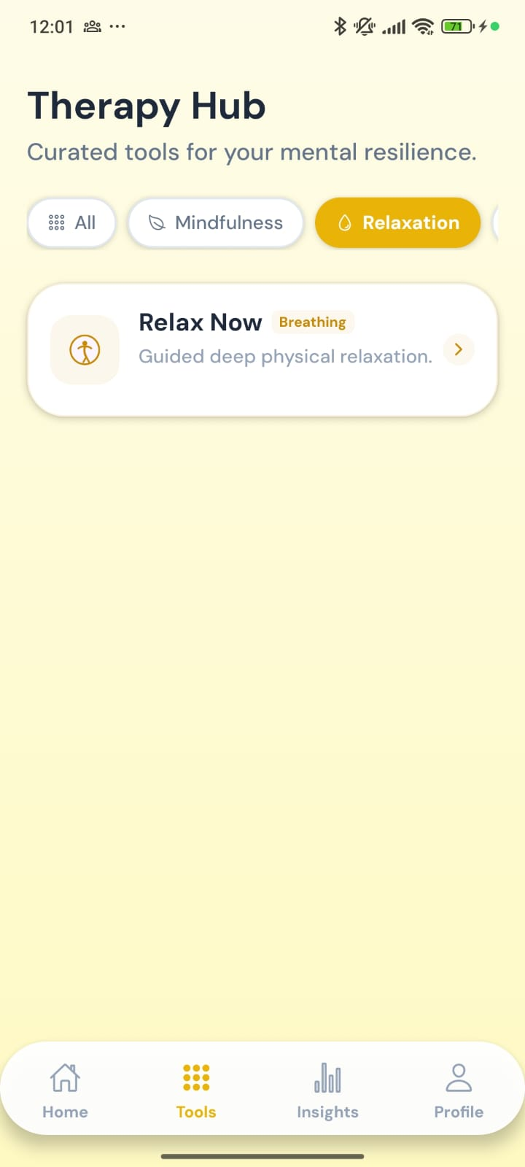
Figure B25. Therapy Hub: Relaxation
WHAT THIS SCREEN SHOWS
Tools for physical relaxation.
FEATURES ON THIS SCREEN
- Relax Now (Breathing): Guided deep physical relaxation (see Figure B38).

Figure B26 Therapy Hub: Cognitive
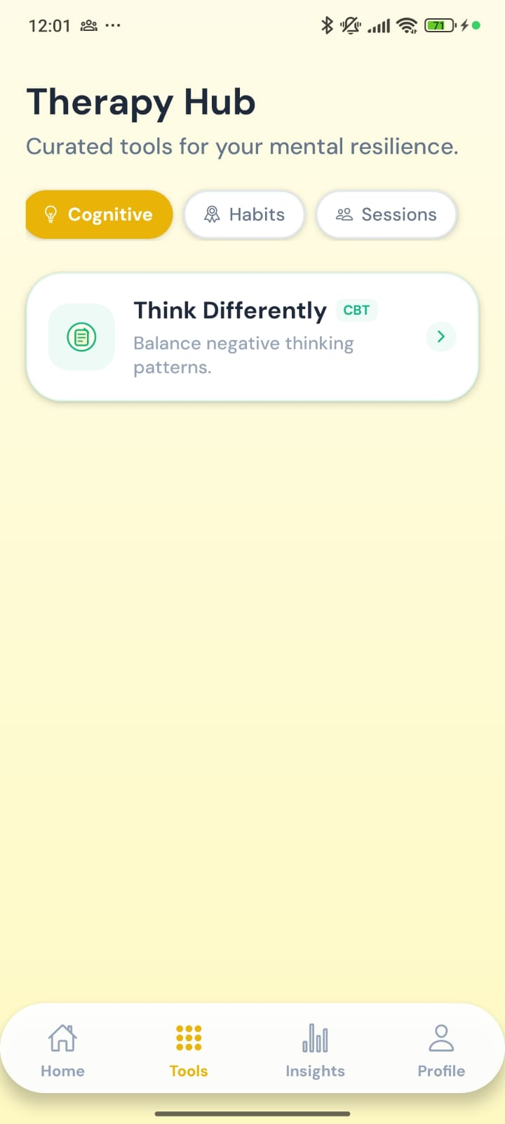
Figure B26. Therapy Hub: Cognitive
WHAT THIS SCREEN SHOWS
Tools for working with thoughts.
FEATURES ON THIS SCREEN
- Think Differently (CBT): Helps the student rebalance negative thinking patterns (see Figure B29).

Figure B27 Therapy Hub: Habits
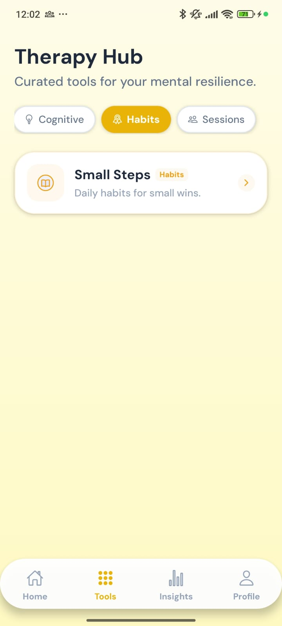
Figure B27. Therapy Hub: Habits
WHAT THIS SCREEN SHOWS
Tools for building small daily routines.
FEATURES ON THIS SCREEN
- Small Steps (Habits): Daily habits for small wins (see Figure B30 and Figure B31).

Figure B28 Therapy Hub: Sessions
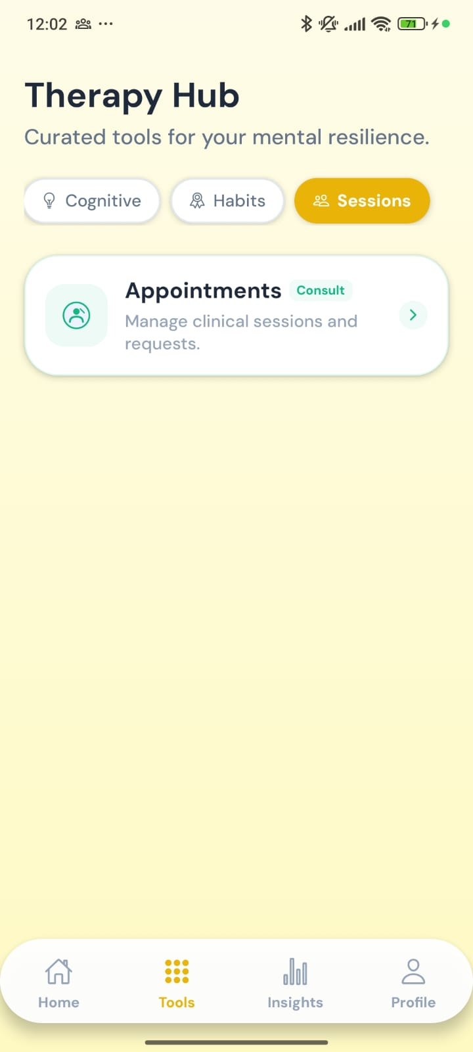
Figure B28. Therapy Hub: Sessions
WHAT THIS SCREEN SHOWS
Access to professional support.
FEATURES ON THIS SCREEN
- Appointments (Consult): Manage clinical sessions and requests with a counsellor (see Figure B41).

B7. Support tools in use
This section shows each tool after it is opened.

Figure B29 Think Differently: choosing a starting point
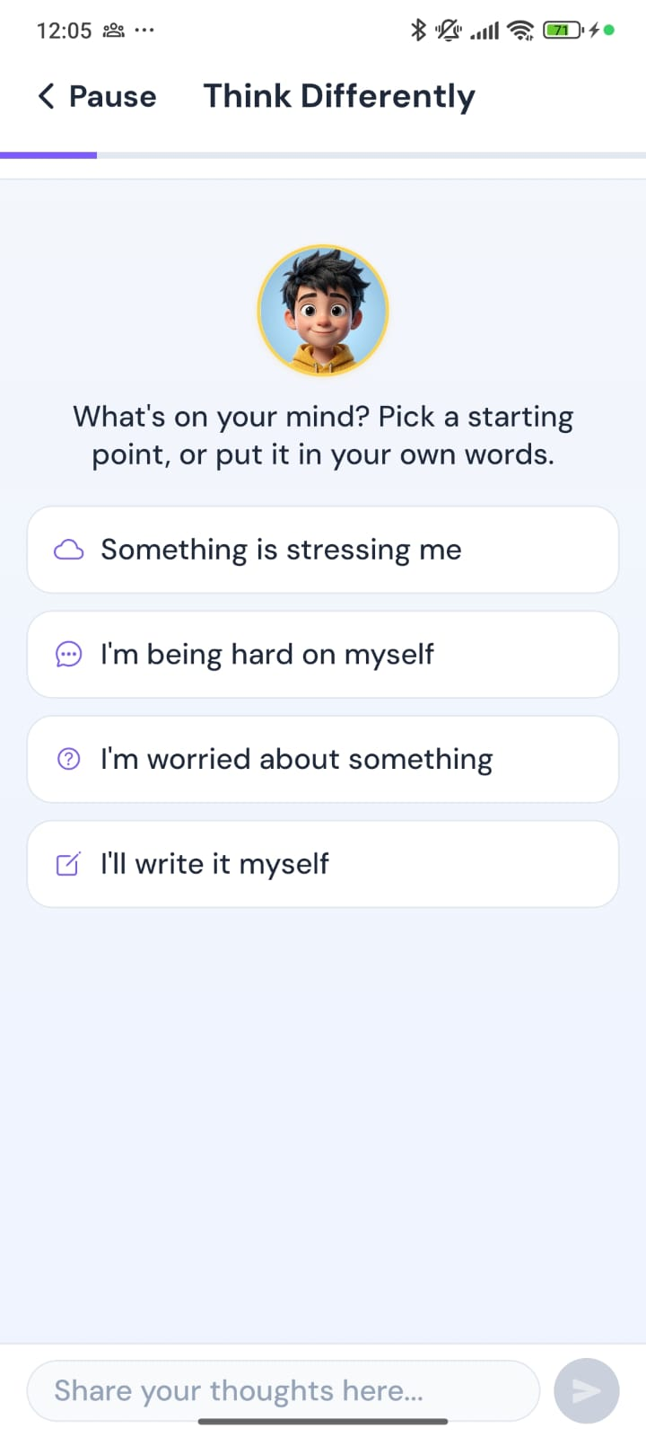
Figure B29. Think Differently: choosing a starting point
WHAT THIS SCREEN SHOWS
The CBT thought-reframing tool. Emoty asks what is on the student’s mind and offers simple ways to begin.
FEATURES ON THIS SCREEN
- Emoty prompt: “What’s on your mind? Pick a starting point, or put it in your own words.”
- Starting points: Something is stressing me; I’m being hard on myself; I’m worried about something; I’ll write it myself.
- Free-text box: “Share your thoughts here…” with a send button.
- Pause: Leaves the exercise. The progress bar at the top shows how far through the exercise the student is.
Note: If a student asks to speak to a counsellor during this exercise, the request appears in the counsellor’s Call Requests queue (Figure A8).

Figure B30 Small Steps: Your daily goals
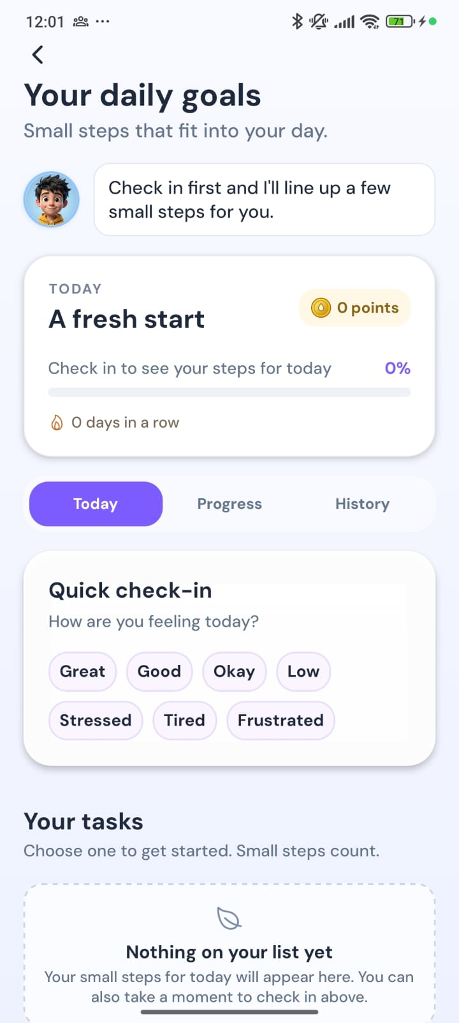
Figure B30. Small Steps: Your daily goals
WHAT THIS SCREEN SHOWS
The micro-goal tracker: small, achievable steps for the day, with points and a streak.
FEATURES ON THIS SCREEN
- Today card: “A fresh start”, 0 points, 0% progress and “0 days in a row”.
- Tabs: Today, Progress and History.
- Quick check-in: “How are you feeling today?”: Great, Good, Okay, Low, Stressed, Tired, Frustrated. Emoty suggests steps based on the answer.
- Your tasks: Empty until the student checks in (“Nothing on your list yet”).

Figure B31 Small Steps: Emoty’s suggestion
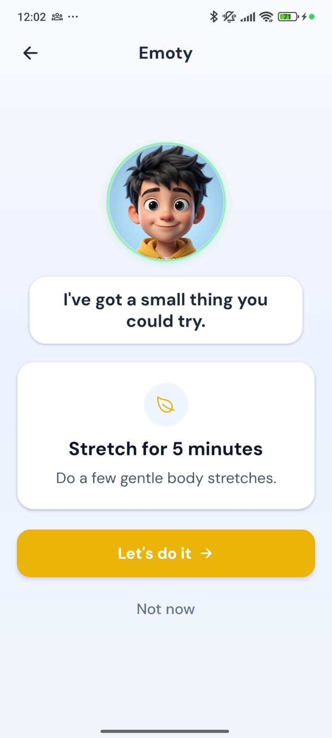
Figure B31. Small Steps: Emoty’s suggestion
WHAT THIS SCREEN SHOWS
Emoty suggests one small, concrete action the student can do now.
FEATURES ON THIS SCREEN
- Suggestion: “I’ve got a small thing you could try”: Stretch for 5 minutes (“Do a few gentle body stretches”).
- Let’s do it: Accepts the step. It appears as a habit on Home, ticked in Figure B17.
- Not now: Declines without penalty.

Figure B32 Breathing: a short breathing break
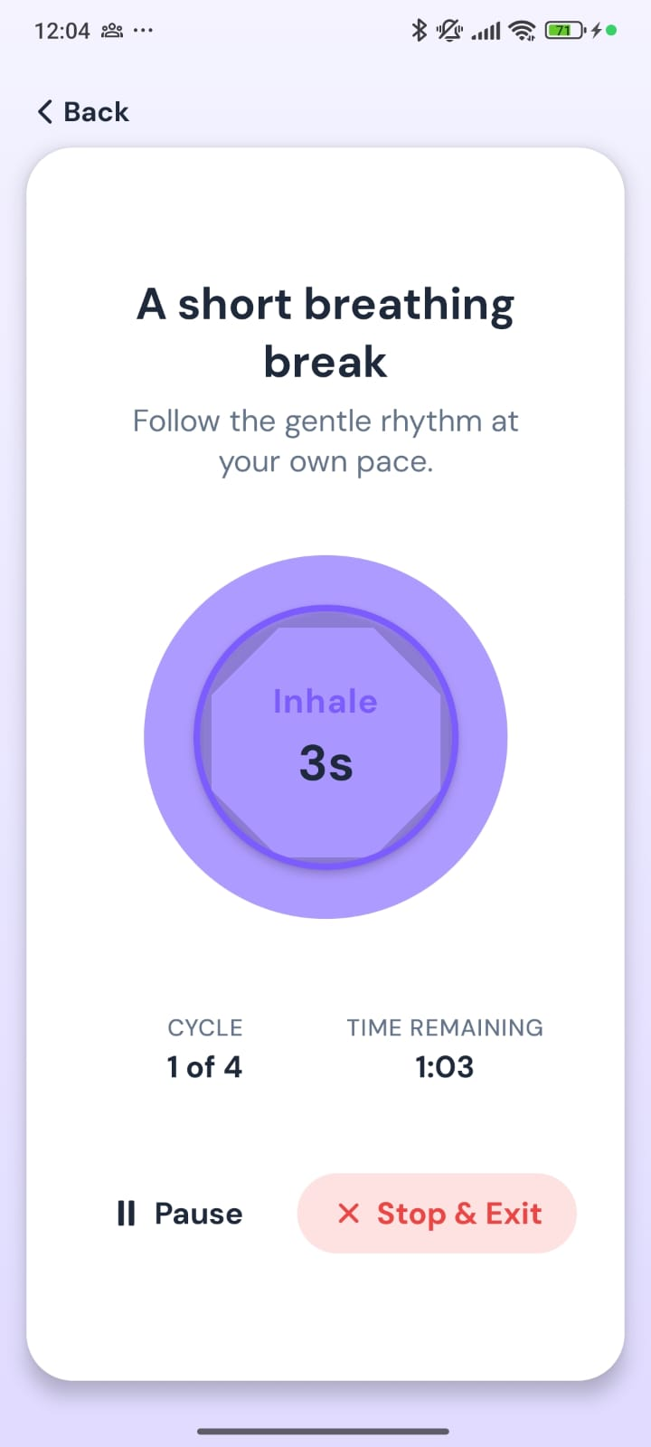
Figure B32. Breathing: a short breathing break
WHAT THIS SCREEN SHOWS
A guided breathing exercise with an animated circle that grows and shrinks with the breath.
FEATURES ON THIS SCREEN
- Breathing circle: Shows the current phase (Inhale) and a countdown (3s).
- Cycle and time remaining: Cycle 1 of 4, with 1:03 remaining.
- Pause and Stop & Exit: Pause and resume, or stop the session.

Figure B33 Sensory Grounding: step 1 of 5 (See)
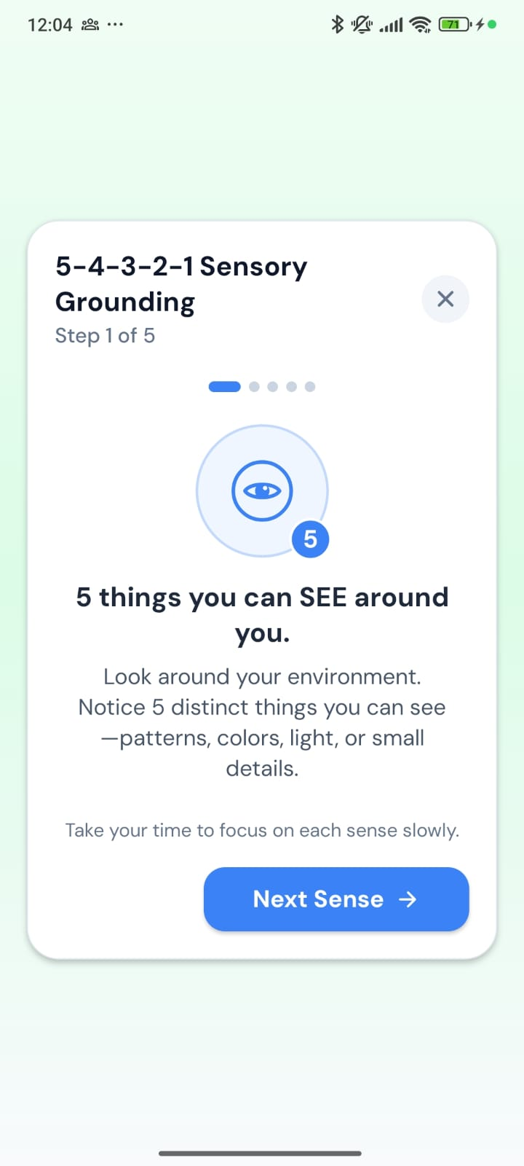
Figure B33. Sensory Grounding: step 1 of 5 (See)
WHAT THIS SCREEN SHOWS
The 5-4-3-2-1 grounding exercise brings attention back to the present through the five senses, one step at a time.
FEATURES ON THIS SCREEN
- Step indicator: Step 1 of 5, with progress dots.
- Instruction: “5 things you can SEE around you”: patterns, colours, light or small details.
- Next Sense: Moves to the next sense. The X closes the exercise.

Figure B34 Sensory Grounding: step 2 of 5 (Touch)
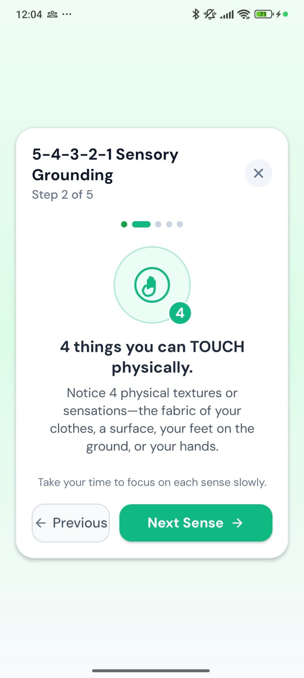
Figure B34. Sensory Grounding: step 2 of 5 (Touch)
WHAT THIS SCREEN SHOWS
The second sense.
FEATURES ON THIS SCREEN
- Instruction: “4 things you can TOUCH physically”: the fabric of your clothes, a surface, your feet on the ground, or your hands.
- Previous and Next Sense: Move between steps.

Figure B35 Sensory Grounding: step 3 of 5 (Hear)
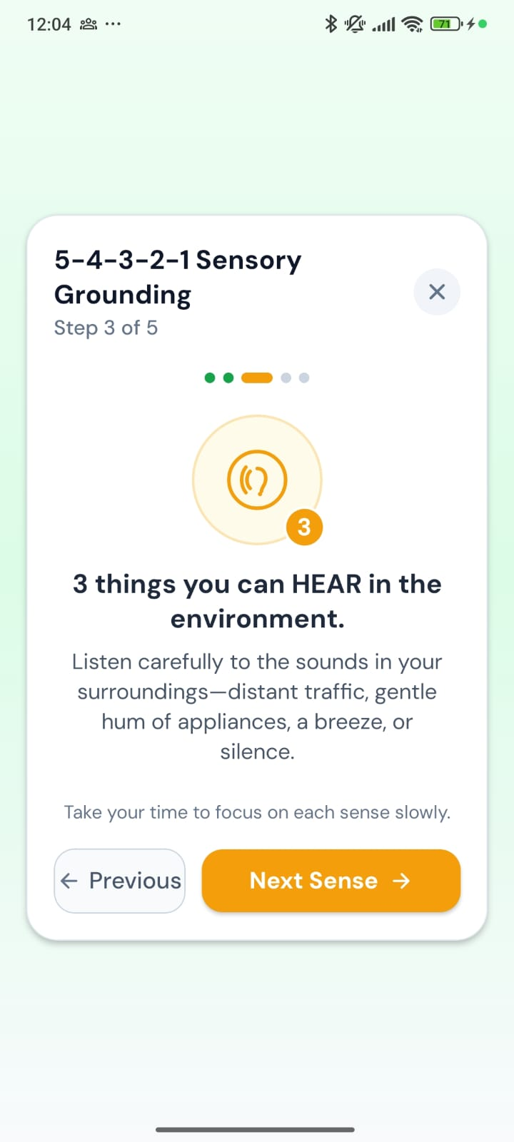
Figure B35. Sensory Grounding: step 3 of 5 (Hear)
WHAT THIS SCREEN SHOWS
The third sense.
FEATURES ON THIS SCREEN
- Instruction: “3 things you can HEAR in the environment”: distant traffic, the hum of appliances, a breeze, or silence.

Figure B36 Sensory Grounding: step 4 of 5 (Smell)
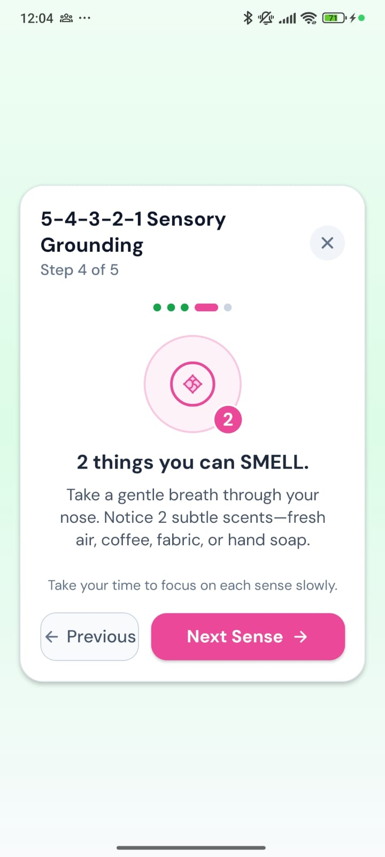
Figure B36. Sensory Grounding: step 4 of 5 (Smell)
WHAT THIS SCREEN SHOWS
The fourth sense.
FEATURES ON THIS SCREEN
- Instruction: “2 things you can SMELL”: fresh air, coffee, fabric or hand soap.

Figure B37 Sensory Grounding: step 5 of 5 (Taste)
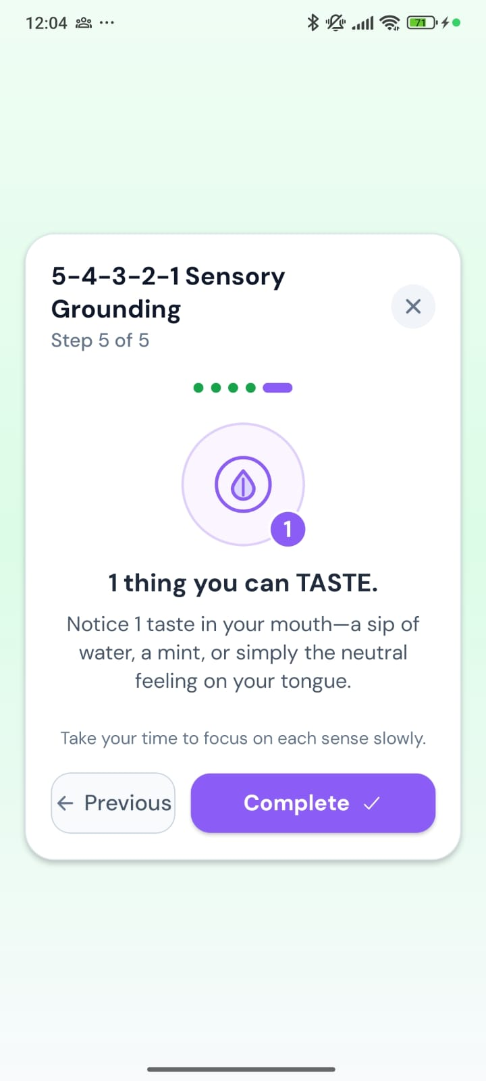
Figure B37. Sensory Grounding: step 5 of 5 (Taste)
WHAT THIS SCREEN SHOWS
The last sense, which finishes the exercise.
FEATURES ON THIS SCREEN
- Instruction: “1 thing you can TASTE”: a sip of water, a mint, or simply the neutral feeling on your tongue.
- Complete: Finishes the session, which counts towards Mindful Relaxation in Insights.

Figure B38 Relax Now: Jacobson Progressive Muscle Relaxation
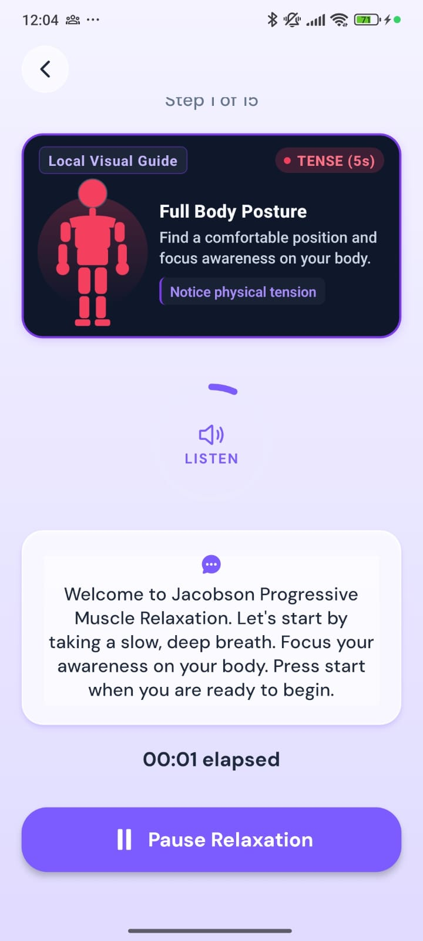
Figure B38. Relax Now: Jacobson Progressive Muscle Relaxation
WHAT THIS SCREEN SHOWS
A guided progressive muscle relaxation session. The student tenses and then relaxes muscle groups, with a visual guide and spoken instructions.
FEATURES ON THIS SCREEN
- Local Visual Guide: A body figure with the current exercise (Full Body Posture) and the current phase (Tense, 5 seconds).
- Step counter: Step 1 of 15.
- Listen: Plays the spoken instructions.
- Instruction card: The current spoken instruction, also shown as text.
- Elapsed time and Pause Relaxation: Shows session time and pauses the session.

Figure B39 Emoty chat: starting a conversation
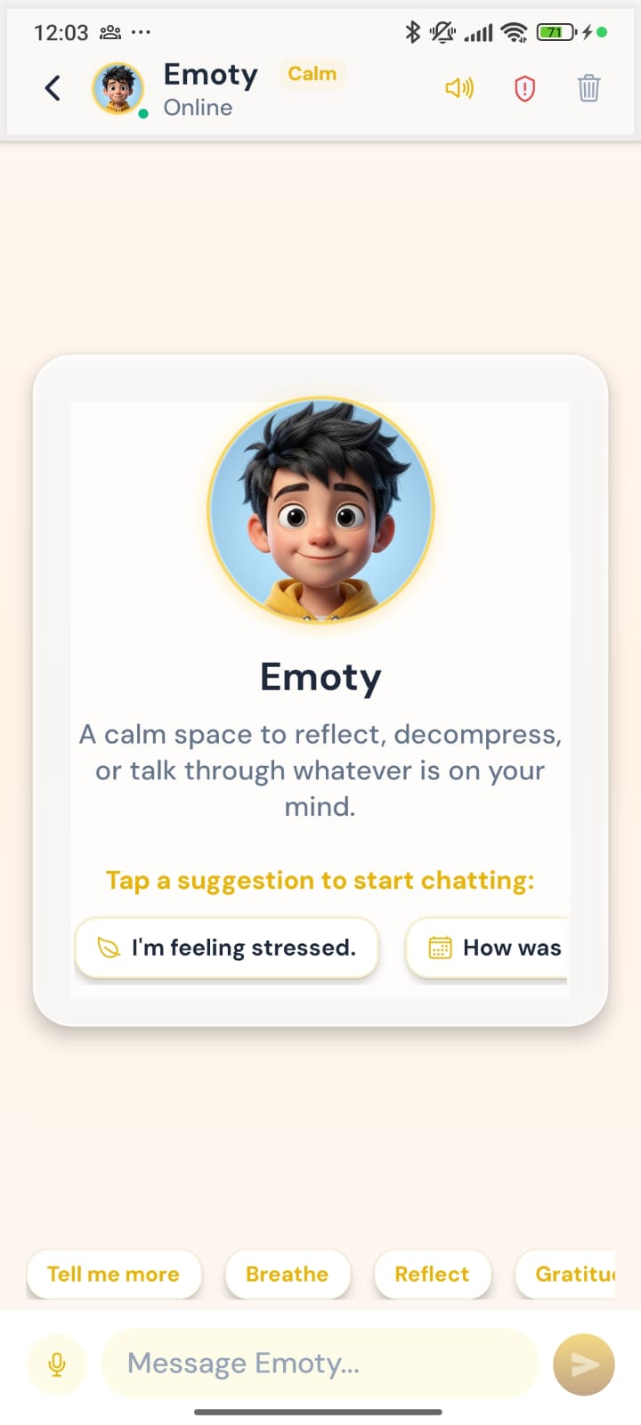
Figure B39. Emoty chat: starting a conversation
WHAT THIS SCREEN SHOWS
Students can talk to Emoty, the AI companion, at any time.
FEATURES ON THIS SCREEN
- Header: Emoty’s status (Online), the current mood theme (Calm), a voice on/off toggle, a safety (shield) button and clear chat.
- Welcome card: “A calm space to reflect, decompress, or talk through whatever is on your mind.”
- Suggestions: Tap-to-start prompts such as “I’m feeling stressed”, plus quick replies: Tell me more, Breathe, Reflect, Gratitude.
- Message box: Type a message or use the microphone for voice input.

Figure B40 Emoty chat: conversation
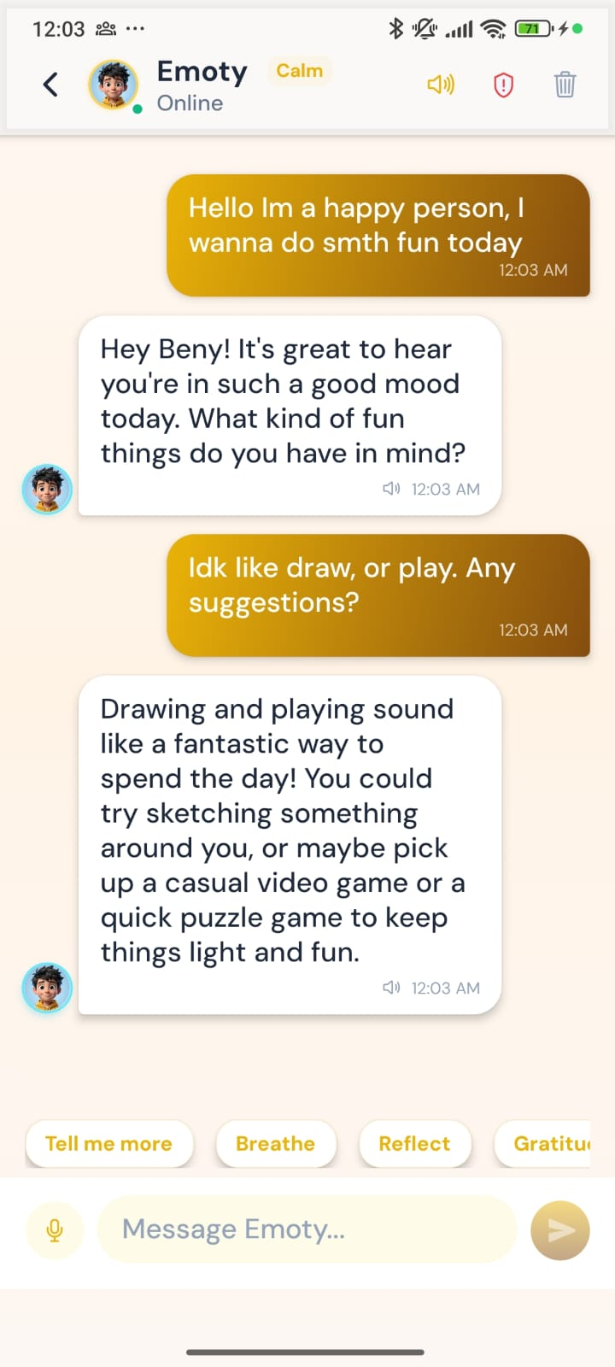
Figure B40. Emoty chat: conversation
WHAT THIS SCREEN SHOWS
A sample conversation. Emoty replies supportively and in context, using the student’s preferred name.
FEATURES ON THIS SCREEN
- Student messages: Shown on the right, with a timestamp.
- Emoty replies: Shown on the left with Emoty’s avatar. A speaker icon reads the reply aloud.
- Monitoring: Conversations are visible to staff in AI Safety & Companion Logs (Figure A11).

Figure B41 Appointments
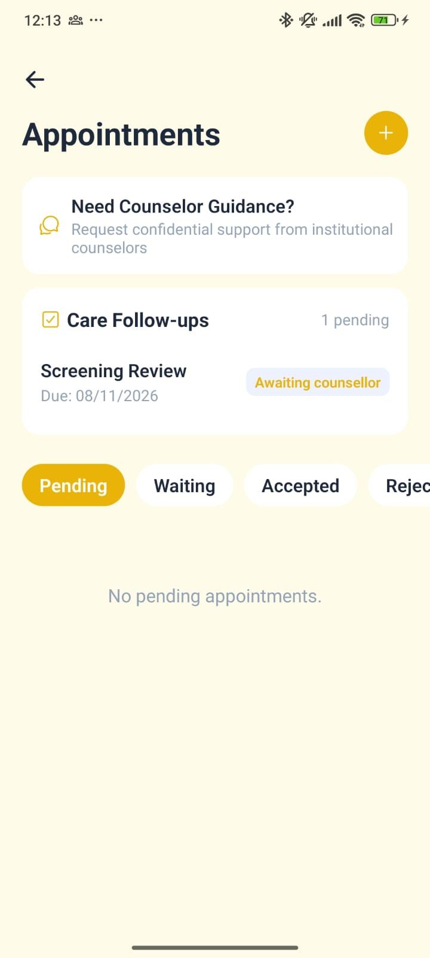
Figure B41. Appointments
WHAT THIS SCREEN SHOWS
The student’s view of counselling support: asking for help, follow-ups from the counsellor, and appointment status.
FEATURES ON THIS SCREEN
- Need Counselor Guidance?: Sends a confidential support request to the institution’s counsellors.
- Care Follow-ups: Tasks from the care team, for example “Screening Review”, with a due date and status (Awaiting counsellor).
- Status tabs: Pending, Waiting, Accepted, Rejected and so on, matching the counsellor’s view (Figure A7).
- + button: Requests a new appointment.

B8. Insights
The Insights tab shows the student’s progress over time.

Figure B42 Your Journey
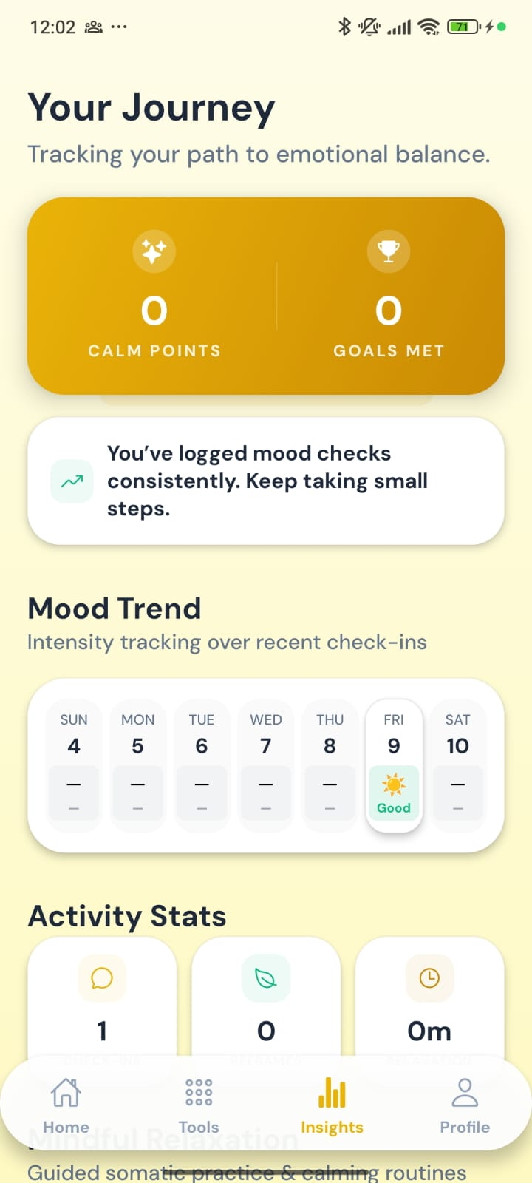
Figure B42. Your Journey
WHAT THIS SCREEN SHOWS
A summary of the student’s engagement and recent mood.
FEATURES ON THIS SCREEN
- Calm Points and Goals Met: Totals earned so far (both 0 in this example).
- Encouragement: A short message based on activity, for example “You’ve logged mood checks consistently. Keep taking small steps.”
- Mood Trend: A week calendar of daily check-ins. Friday 9 shows “Good”.

Figure B43 Mood Trend, Activity Stats and Mindful Relaxation
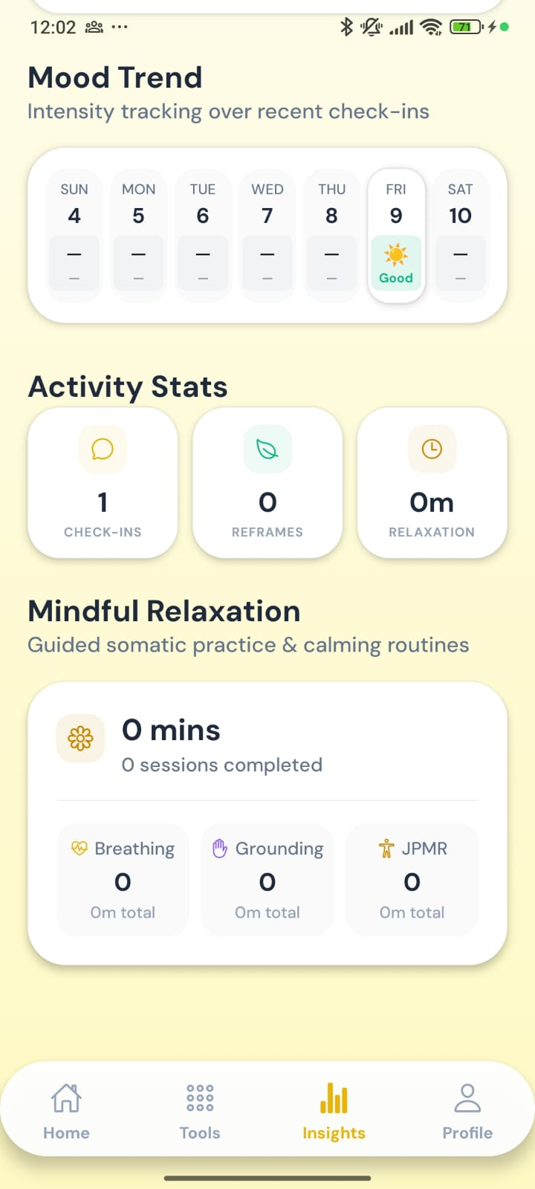
Figure B43. Mood Trend, Activity Stats and Mindful Relaxation
WHAT THIS SCREEN SHOWS
Detailed activity statistics further down Insights.
FEATURES ON THIS SCREEN
- Activity Stats: Check-ins (1), Reframes (0) and Relaxation minutes (0m).
- Mindful Relaxation: Total minutes and sessions completed, split into Breathing, Grounding and JPMR.

B9. Profile

Figure B44 Profile and Wellness Identity
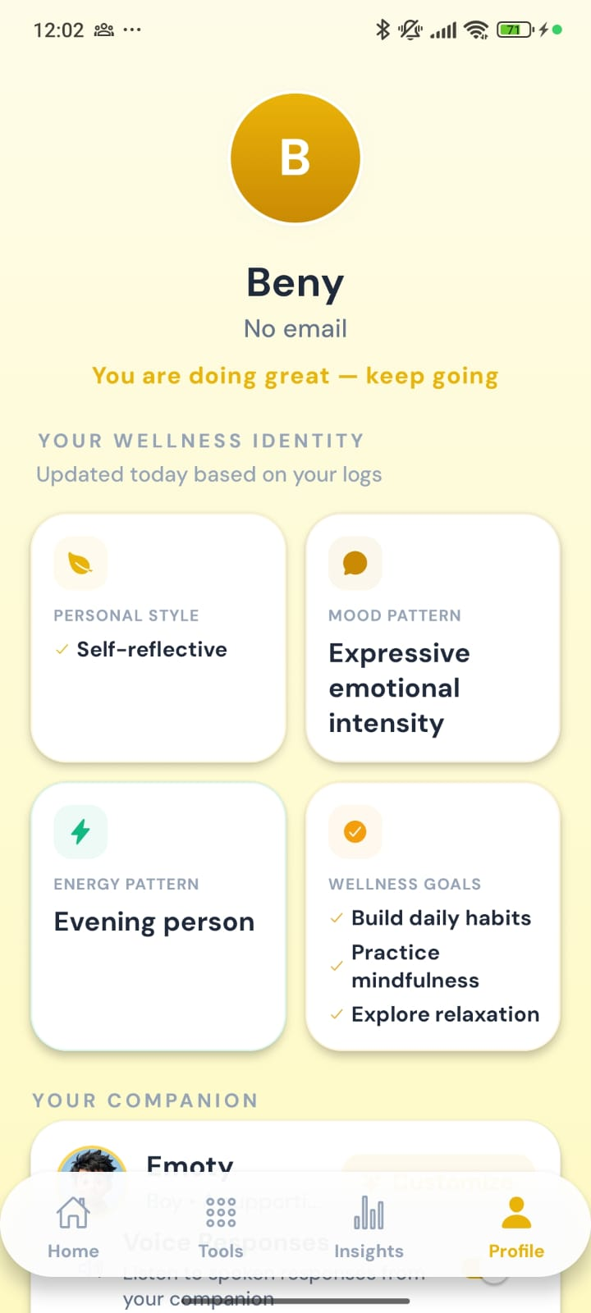
Figure B44. Profile and Wellness Identity
WHAT THIS SCREEN SHOWS
The student’s profile, with a wellness summary built from their activity in the app.
FEATURES ON THIS SCREEN
- Header: Initial avatar, alias (Beny), email (none given) and an encouraging status line.
- Your Wellness Identity: Four cards updated from the student’s logs: Personal Style (Self-reflective), Mood Pattern (Expressive emotional intensity), Energy Pattern (Evening person) and Wellness Goals (Build daily habits, Practice mindfulness, Explore relaxation).
- Your Companion: The start of the companion settings (next figure).

Figure B45 Companion settings and Emoty Preferences
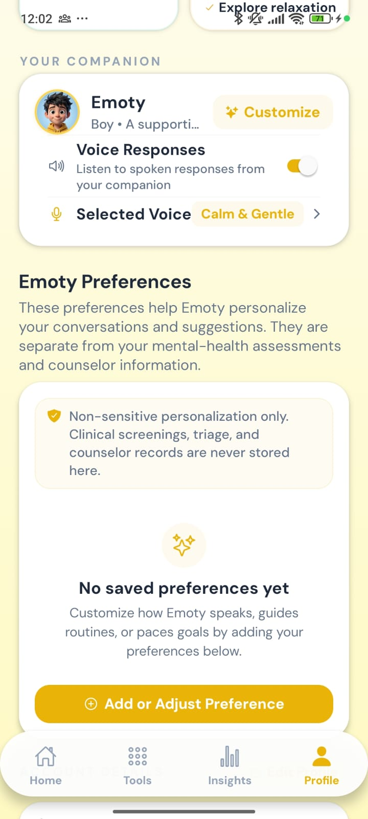
Figure B45. Companion settings and Emoty Preferences
WHAT THIS SCREEN SHOWS
Settings for how Emoty looks and sounds, and optional preferences that personalise Emoty’s suggestions.
FEATURES ON THIS SCREEN
- Your Companion: Emoty (Boy), with Customize to change the avatar or name.
- Voice Responses: A toggle for hearing Emoty’s replies spoken aloud.
- Selected Voice: The current voice style (Calm & Gentle). Tap to change it.
- Emoty Preferences: Non-sensitive personalisation only. Clinical screenings, triage and counsellor records are never stored here. Add or Adjust Preference adds one.

Appendix A. Review observations
Points noted while preparing this walkthrough.
- Screens not in the set: The guided check-in (Section B5) starts at the body step. The first two steps, choosing the broad emotion and then the specific feeling, were not captured. Other screens that could be added later: the History & Trends tab, the screening completion screen, the staff Student Profile and Add Student forms, and the other appointment tabs.
- Order of capture: The phone status-bar times (11:52 to 12:13) were used to confirm the order. The intensity screen (Figure B22) was captured later, at 12:13, and is placed where it belongs in the check-in.
- Spelling of “counsellor”: Both spellings appear. The web portal mostly uses “Counsellor” (Counsellor Dashboard, Counsellor requests), but the Notifications page says “New Counselor Support Request”. In the app, Appointments says “Need Counselor Guidance?” but also “Awaiting counsellor”, and Profile says “counselor records”. We recommend using one spelling throughout.
- Match with the current code: Each screen was compared with the current application code. Wording, options and behaviour matched, including the screening lock, the Home wellbeing percentages (from the latest PHQ-9 and GAD-7 scores), the sensation choices for a positive feeling, the intensity wording, the recommended activity and the optional guided meditation.
- Test data: All people, phone numbers, dates, counts and scores in the screenshots are dummy data created for testing and do not describe real students.

Appendix B. Screenshot index
Each figure mapped to its source file in the SS folder.
Figure | Screen | Source file
A1 | Staff Portal sign-in | SS/WebApp/AdminLogin.png
A2 | Dashboard: navigation, key numbers and items needing attention | SS/WebApp/01_dashboard.png
A3 | Dashboard: recent activity, trends and today’s sessions | SS/WebApp/02_dashboard.png
A4 | Students list | SS/WebApp/03_student_profile.png
A5 | Alerts overview | SS/WebApp/04_alerts.png
A6 | Triage actions dialog | SS/WebApp/Triage_alert.png
A7 | Appointment requests | SS/WebApp/05_appointments.png
A8 | Counsellor call requests (intervention queue) | SS/WebApp/06_counsellor_call.png
A9 | Screening Centre: headline figures and risk distribution | SS/WebApp/07_screening.png
A10 | Screening Centre: severity chart and score summary | SS/WebApp/08_screening.png
A11 | AI monitoring of Emoty conversations | SS/WebApp/09_Ai_monitoring.png
A12 | Notifications centre | SS/WebApp/10_notifications.png
B1 | Sign in | SS/MobileApp/WhatsApp Image 2026-10-10 at 12.14.15 AM.jpeg
B2 | Create Student Account | SS/MobileApp/WhatsApp Image 2026-10-10 at 12.14.16 AM.jpeg
B3 | Welcome and Meet Your Companion | SS/MobileApp/WhatsApp Image 2026-10-10 at 12.14.16 AM (1).jpeg
B4 | Before we begin | SS/MobileApp/WhatsApp Image 2026-10-10 at 12.14.17 AM.jpeg
B5 | Step 1 of 3: Informed Consent | SS/MobileApp/WhatsApp Image 2026-10-10 at 12.14.18 AM.jpeg
B6 | Step 2 of 3: Emergency Contact | SS/MobileApp/WhatsApp Image 2026-10-10 at 12.14.18 AM (1).jpeg
B7 | Step 3 of 3: Tell us about you | SS/MobileApp/WhatsApp Image 2026-10-10 at 12.14.22 AM.jpeg
B8 | Wellness Check-Ins (screening hub) | SS/MobileApp/WhatsApp Image 2026-10-10 at 12.14.22 AM (1).jpeg
B9 | Wellness Check-Ins (scrolled), with Submit | SS/MobileApp/WhatsApp Image 2026-10-10 at 12.14.23 AM.jpeg
B10 | Mood & Energy Check: question 1 of 9 | SS/MobileApp/WhatsApp Image 2026-10-10 at 12.14.23 AM (1).jpeg
B11 | Mood & Energy Check: question 2 of 9 (answered) | SS/MobileApp/WhatsApp Image 2026-10-10 at 12.14.24 AM.jpeg
B12 | Calm & Focus Check: question 1 of 7 | SS/MobileApp/WhatsApp Image 2026-10-10 at 12.14.23 AM (2).jpeg
B13 | Perception & Thoughts Check: question 1 of 16 | SS/MobileApp/WhatsApp Image 2026-10-10 at 12.14.24 AM (2).jpeg
B14 | Home before screening is complete (tools locked) | SS/MobileApp/WhatsApp Image 2026-10-10 at 12.14.24 AM (1).jpeg
B15 | Home with the daily check-in | SS/MobileApp/WhatsApp Image 2026-10-10 at 12.14.25 AM.jpeg
B16 | Daily check-in: Good selected | SS/MobileApp/WhatsApp Image 2026-10-10 at 12.14.25 AM (1).jpeg
B17 | Home: Today’s Habits | SS/MobileApp/WhatsApp Image 2026-10-10 at 12.14.30 AM (1).jpeg
B18 | Home: quick tools, appointments and wellbeing indicators | SS/MobileApp/WhatsApp Image 2026-10-10 at 12.14.33 AM (2).jpeg
B19 | How does it feel in your body? | SS/MobileApp/WhatsApp Image 2026-10-10 at 12.14.25 AM (2).jpeg
B20 | Help me notice: head and face | SS/MobileApp/WhatsApp Image 2026-10-10 at 12.14.26 AM.jpeg
B21 | Help me notice: shoulders | SS/MobileApp/WhatsApp Image 2026-10-10 at 12.14.25 AM (3).jpeg
B22 | How strong does it feel right now? | SS/MobileApp/WhatsApp Image 2026-10-10 at 12.14.26 AM (1).jpeg
B23 | Recommended activity | SS/MobileApp/WhatsApp Image 2026-10-10 at 12.14.26 AM (2).jpeg
B24 | Therapy Hub: Mindfulness | SS/MobileApp/WhatsApp Image 2026-10-10 at 12.14.27 AM (1).jpeg
B25 | Therapy Hub: Relaxation | SS/MobileApp/WhatsApp Image 2026-10-10 at 12.14.27 AM (2).jpeg
B26 | Therapy Hub: Cognitive | SS/MobileApp/WhatsApp Image 2026-10-10 at 12.14.27 AM (3).jpeg
B27 | Therapy Hub: Habits | SS/MobileApp/WhatsApp Image 2026-10-10 at 12.14.28 AM.jpeg
B28 | Therapy Hub: Sessions | SS/MobileApp/WhatsApp Image 2026-10-10 at 12.14.28 AM (1).jpeg
B29 | Think Differently: choosing a starting point | SS/MobileApp/WhatsApp Image 2026-10-10 at 12.14.33 AM (1).jpeg
B30 | Small Steps: Your daily goals | SS/MobileApp/WhatsApp Image 2026-10-10 at 12.14.27 AM.jpeg
B31 | Small Steps: Emoty’s suggestion | SS/MobileApp/WhatsApp Image 2026-10-10 at 12.14.30 AM.jpeg
B32 | Breathing: a short breathing break | SS/MobileApp/WhatsApp Image 2026-10-10 at 12.14.31 AM (1).jpeg
B33 | Sensory Grounding: step 1 of 5 (See) | SS/MobileApp/WhatsApp Image 2026-10-10 at 12.14.31 AM (2).jpeg
B34 | Sensory Grounding: step 2 of 5 (Touch) | SS/MobileApp/WhatsApp Image 2026-10-10 at 12.14.31 AM (3).jpeg
B35 | Sensory Grounding: step 3 of 5 (Hear) | SS/MobileApp/WhatsApp Image 2026-10-10 at 12.14.32 AM.jpeg
B36 | Sensory Grounding: step 4 of 5 (Smell) | SS/MobileApp/WhatsApp Image 2026-10-10 at 12.14.32 AM (1).jpeg
B37 | Sensory Grounding: step 5 of 5 (Taste) | SS/MobileApp/WhatsApp Image 2026-10-10 at 12.14.32 AM (2).jpeg
B38 | Relax Now: Jacobson Progressive Muscle Relaxation | SS/MobileApp/WhatsApp Image 2026-10-10 at 12.14.33 AM.jpeg
B39 | Emoty chat: starting a conversation | SS/MobileApp/WhatsApp Image 2026-10-10 at 12.14.30 AM (2).jpeg
B40 | Emoty chat: conversation | SS/MobileApp/WhatsApp Image 2026-10-10 at 12.14.31 AM.jpeg
B41 | Appointments | SS/MobileApp/WhatsApp Image 2026-10-10 at 12.14.33 AM (3).jpeg
B42 | Your Journey | SS/MobileApp/WhatsApp Image 2026-10-10 at 12.14.29 AM.jpeg
B43 | Mood Trend, Activity Stats and Mindful Relaxation | SS/MobileApp/WhatsApp Image 2026-10-10 at 12.14.29 AM (1).jpeg
B44 | Profile and Wellness Identity | SS/MobileApp/WhatsApp Image 2026-10-10 at 12.14.29 AM (2).jpeg
B45 | Companion settings and Emoty Preferences | SS/MobileApp/WhatsApp Image 2026-10-10 at 12.14.29 AM (3).jpeg

