# VISVESVARAYA TECHNOLOGICAL UNIVERSITY

**Jnana Sangama, Belagavi - 590018**



**Mini project**

***On***

## “MORSE CODE CONVERTER”

**By**

**VINEETH SHETTIGAR 4MT21CS181**

**SATHVIK 4MT21CS135**

**ADARSH SHETTY 4MT21CS142**

**SRINIDHI SHETTY 4MT21CS162**

**ANANYA 4MT21CS143**

### 

### Department of Computer Science &Engineering



**DEPARTMENT OF COMPUTER SCIENCE& ENGINEERING**

**(*Accredited by NBA*)**

### MANGALORE INSTITUTE OF TECHNOLOGY & ENGINEERING

*Accredited by NAAC with A+ Grade, An ISO 9001: 2015 Certified Institution*

(*A Unit of Rajalaxmi Education Trust®, Mangalore - 575001*)

Affiliated to VTU, Belagavi, Approved by AICTE, New Delhi

*Badaga Mijar, Moodabidri-574225, Karnataka*

**ABSTRACT**

A Morse code converter is a software application designed to facilitate the conversion between text and Morse code, enabling efficient communication through a series of dots and dashes. This abstract outline the essential components and functionalities of a Morse code converter code.

The Morse code converter program provides a user-friendly interface for users to input either plain text or Morse code. It employs two dictionaries to map characters (letters, numbers, and symbols) to their corresponding Morse code representations and vice versa. The dictionaries facilitate the translation process, ensuring accuracy in conversion.

**Key features of the code include:**

1.**Text to Morse Code Conversion:** Users can input alphanumeric text, and the program converts it into Morse code using predefined mappings.

2.**Morse Code to Text Conversion:** Users can input Morse code sequences, and the program deciphers them into readable text, maintaining spaces between words.

3.**Input Validation:** The program includes basic input validation to handle invalid characters and gracefully inform users of errors.

4.**Case Insensitivity:** The code supports both uppercase and lowercase characters for text input, ensuring flexibility.

5.**User Interaction:** It offers a simple command-line interface for user interaction, enabling easy conversion between text and Morse code.

In summary, this Morse code converter code provides a compact and functional solution for translating text to Morse code and vice versa. It is a valuable tool for scenarios where Morse code communication is required, such as emergency situations or amateur radio operations.

**INTRODUCTION**

In a world characterized by rapid technological advancements, the Morse code, though seemingly archaic, remains a significant means of communication, especially in emergency and specialized situations. A Morse code converter is a software tool that bridges the gap between traditional Morse code and modern text communication. This introduction presents a Morse code converter code, which serves as a versatile tool for translating between Morse code and text, offering users a simple yet powerful means of communication.

**The Need for a Morse Code Converter:** In modern times, Morse code is not widely known or practiced. Thus, the need for a Morse code converter becomes apparent, as it enables seamless communication between Morse code users and those who rely on standard text communication. This converter is a versatile tool with applications ranging from emergency signaling to ham radio enthusiasts.

**Overview of the Morse Code Converter Code:** The Morse code converter code presented here is a software application designed to fulfill this need. It offers the following essential functionalities:

**1.Text to Morse Code Conversion:** Users can input alphanumeric text, and the program will convert it into Morse code using predefined mappings.

**2.Morse Code to Text Conversion:** Users can input Morse code sequences, and the program will decipher them into readable text, preserving spaces between words.

**3.Input Validation:** The code includes basic input validation to handle invalid characters gracefully and guide users through the conversion process.

**4.Case Insensitivity:** The converter is case-insensitive, allowing users to input text in uppercase or lowercase letters.

**5.User-Friendly Interface:** It provides a user-friendly interface, making the conversion process intuitive and accessible to a wide range of users.

In conclusion, this Morse code converter code represents a bridge between the rich history of Morse code and the digital age. It ensures that Morse code remains a relevant and accessible means of communication, offering a valuable tool for various communication scenarios and preserving an essential part of our technological heritage.

**TECHNOLOGIES USED**

Here's a basic outline of the technologies and libraries you might consider using:

* **C Programming Language:** You will primarily use C to write the core logic of your Morse code converter.
* **Standard Input/Output:** C provides standard input/output functions (e.g., printf, scanf) for handling user input and displaying output.
* **Data Structures:** You can use C data structures like arrays and linked lists to store Morse code mappings and convert between characters and Morse code.
* **String Handling:** C's string manipulation functions (e.g., strlen, strcpy, strtok) can be useful for processing input and output strings.
* **Error Handling:** Implement error handling mechanisms to handle unexpected user input or file read errors gracefully.
* **Unit Testing (Optional):** Consider using a unit testing framework like Unity or Ceedling if you want to thoroughly test your Morse code converter functions.

**SYSTEM ARCHITECTURE**

A Morse code converter is a software application that translates text input into Morse code and vice versa. Its system architecture can be designed in a modular and organized manner to facilitate efficient operation. Here's an overview of the system architecture of a Morse code converter:

**User Interface Layer:**

The user interface layer is the front-end of the Morse code converter, responsible for interacting with the user. It includes graphical user interfaces (GUIs) or command-line interfaces (CLIs) that allow users to input text or Morse code and view the converted output. User input is captured here and passed to the processing layer for conversion.

**Processing Layer:**

The processing layer contains the core logic of the Morse code converter. It consists of several modules or components responsible for handling various tasks:

* **Text-to-Morse Code Converter:** This module translates text input into Morse code. It maps characters (letters, numbers, and symbols) to their corresponding Morse code representations using predefined dictionaries or algorithms.
* **Morse Code-to-Text Converter:** This module deciphers Morse code input into readable text. It reverses the mapping process, identifying Morse code symbols and converting them back into characters.
* **Input Validation:** Input validation modules check user input for errors or invalid characters. They ensure that only valid input is processed and provide feedback to the user in case of errors.
* **Case Insensitivity:** If the converter is designed to be case-insensitive, this module converts all characters to uppercase or lowercase to ensure consistency.
* **Error Handling:** This component handles any unexpected errors or exceptions that may occur during conversion.
* **Data Layer:** In some implementations, a data layer may be used to store and retrieve predefined mappings of characters to Morse code and vice versa. This can be implemented as a database or flat files.

The data layer can provide an easy way to update or extend the converter's dictionary of Morse code representations.

* **Output Layer:** The output layer is responsible for presenting the converted results to the user.

It takes the converted Morse code or text from the processing layer and displays it through the user interface, whether as text on the screen or audible Morse code sounds via a speaker.

* **Configuration and Settings:** Configuration settings may be included to allow users to customize the converter's behavior, such as setting the tone or speed of Morse code output.

These settings are typically managed by the user interface and can be stored in configuration files or memory.

* **Error Logging and Reporting:** An optional component for logging errors and usage statistics can be included for debugging and analytics purposes.
* **Integration:** Depending on the application, the Morse code converter may be integrated into other systems or devices, such as radio communication equipment or emergency signaling devices.

In summary, the system architecture of a Morse code converter is designed to efficiently handle the conversion process, provide a user-friendly interface, and ensure accuracy in translating between text and Morse code. It may also include optional components and layers based on specific requirements and use cases.

**DESIGN AND IMPLEMENTATION**

1. **Text to morse (text):** This function iterates through each character in the input **text**, checks if it is in the **morse_code_dict** (the dictionary mapping characters to Morse code), and appends the corresponding Morse code to the **morse_code** list. If a character is not in the dictionary (e.g., special characters or symbols), it is represented as '?' in Morse code. Finally, the Morse code representations are joined together with spaces between characters and returned as a single string.Top of Form
2. **morse_to_text (morse code):** This function first splits the input **morse_code** by spaces to obtain individual Morse code characters. It then iterates through the **morse_code_dict** dictionary to find the character that matches each Morse code. If a match is found, the corresponding character is appended to the **text** list. If the Morse code is not found in the dictionary, it is represented as '?' in the text. Finally, the characters are joined together to form the converted text, which is returned as a string.

These two functions work together to convert text to Morse code and Morse code back to text using the predefined **morse_code_dict**. The program provides a simple user interface for choosing the conversion direction and input, making it interactive and user-friendly.

**FEATURES AND FUNCTIONALITY**

Features and Functionality of a Morse Code Converter:

A Morse code converter is a software application that enables the translation of text into Morse code and vice versa. It plays a crucial role in various scenarios, including emergency communication, amateur radio, and historical preservation. Here are the key features and functionalities of a Morse code converter:

* **Text to Morse Code Conversion:** Users can input alphanumeric text, and the converter translates it into Morse code. Letters, numbers, and common symbols are mapped to their corresponding Morse code representations.
* **Morse Code to Text Conversion:** Users can input Morse code sequences, and the converter deciphers them into readable text. Spaces between Morse code words are preserved, allowing for accurate decoding.
* **Case Insensitivity:** The converter may support both uppercase and lowercase text input, ensuring flexibility for users.
* **Input Validation:** Basic input validation is implemented to handle invalid characters or symbols gracefully.Users receive feedback on incorrect input to aid in correction.
* **User-Friendly Interface:** The converter offers an intuitive user interface, whether through a graphical interface (GUI) or a command-line interface (CLI).Clear instructions and prompts guide users through the conversion process.
* **Customization Options:** Users may have options to customize the Morse code converter's behavior, such as adjusting the speed or tone of Morse code output.Configuration settings provide flexibility to meet individual preferences.
* **Error Handling:** Robust error handling ensures that the converter can manage unexpected situations, such as input errors or system issues.Users receive informative error messages in case of problems.
* **Data Storage:** A database or file system may be used to store and retrieve predefined mappings of characters to Morse code and vice versa.This allows for easy updates and expansions of the converter's dictionary.
* **Audio Output:** Some Morse code converters can produce audible Morse code sounds using speakers or headphones.Users can hear Morse code output in addition to visual text representation.
* **Integration:** Depending on the application, the converter may be integrated into other systems or devices, such as radio equipment, to facilitate communication in Morse code.
* **Logging and Reporting:** An optional component can log usage statistics, errors, and other relevant data for analysis and debugging purposes.
* **International Character Support:** Some Morse code converters may support international characters beyond the basic Latin alphabet, accommodating various languages and character sets.
* **Real-Time Conversion:** The converter performs conversions in real time, allowing users to see or hear Morse code output as they input text, enhancing communication efficiency.

In conclusion, a Morse code converter is a versatile tool that simplifies Morse code communication, making it accessible to a wide range of users. Its features and functionality cater to both beginners and experienced Morse code enthusiasts, ensuring accurate and efficient translation between text and Morse code.

Top of Form

**CHALLENGES**

While a Morse code converter may seem relatively straightforward, there are several challenges and considerations involved in its design and implementation:

* **Character Mapping**: Morse code represents each character as a sequence of dots and dashes, and there is a specific mapping for each character. Implementing and maintaining this mapping accurately can be a challenge.
* **User Input Validation**: Handling user input is essential. You need to validate the input string to ensure it only contains valid characters (letters, numbers, and spaces) and no special characters or symbols.
* **Case Insensitivity**: Morse code is typically case-insensitive, but your converter should handle both uppercase and lowercase input characters and convert them to the corresponding Morse code.
* **Word Separation**: Properly separating words in the Morse code output is essential. Morse code uses space to separate letters within a word and three spaces to separate words.
* **Memory Management**: If you're dealing with long input strings, memory management becomes crucial. You may need to dynamically allocate memory to store the Morse code output, and you should free this memory when it's no longer needed to avoid memory leaks.
* **Handling Unknown Characters**: Not all characters may have a Morse code representation. Your converter should gracefully handle unknown characters and possibly display an error message or substitute them with a placeholder.
* **Testing and Validation**: Testing your Morse code converter with various inputs to ensure its accuracy and reliability can be challenging, especially when dealing with a large character set.
* **Performance**: While Morse code conversion is not computationally intensive, if you need to handle very long strings or convert Morse code into text, you should consider performance optimization.
* **Localization**: Morse code is used internationally, but different languages may have additional characters not covered in the standard Morse code representation. Handling these additional characters or non-standard Morse codes may require additional considerations.
* **Error Handling**: Implementing robust error handling to deal with unexpected situations, such as memory allocation failures or invalid input, is essential to ensure your converter behaves predictably.
* **User Interface**: If you're building a Morse code converter as part of a larger application, you may need to consider the user interface and how users will interact with it.
* **Extensibility**: If you plan to expand your converter's functionality in the future, you should design it with extensibility in mind to make adding new features or character mappings easier.

In summary, while a Morse code converter may appear simple on the surface, addressing these challenges can lead to a more robust and reliable implementation. It's important to carefully plan and test your converter to ensure it meets your requirements and handles various scenarios gracefully.

RESULT

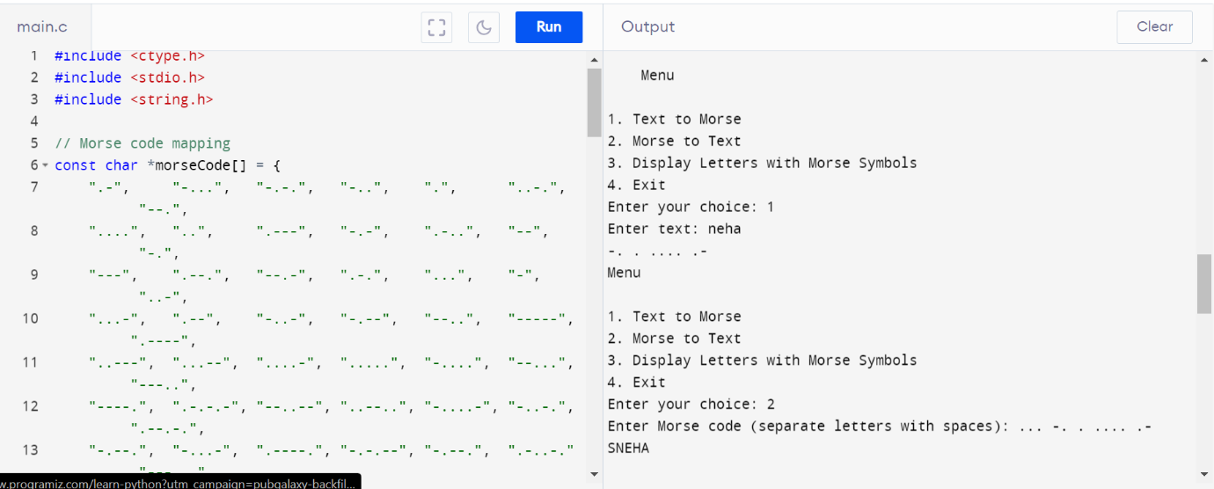

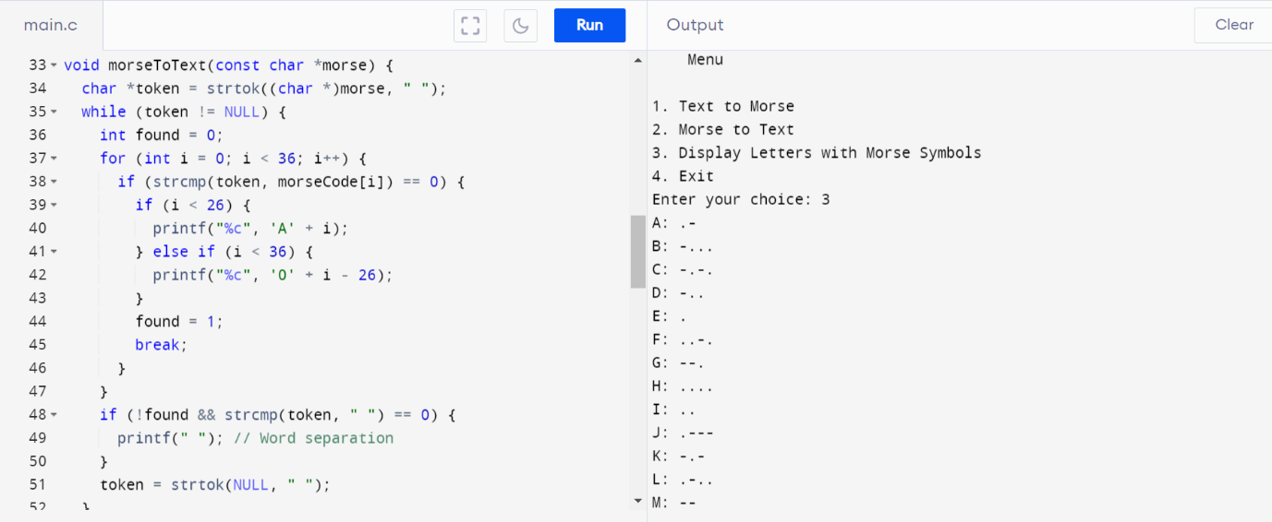

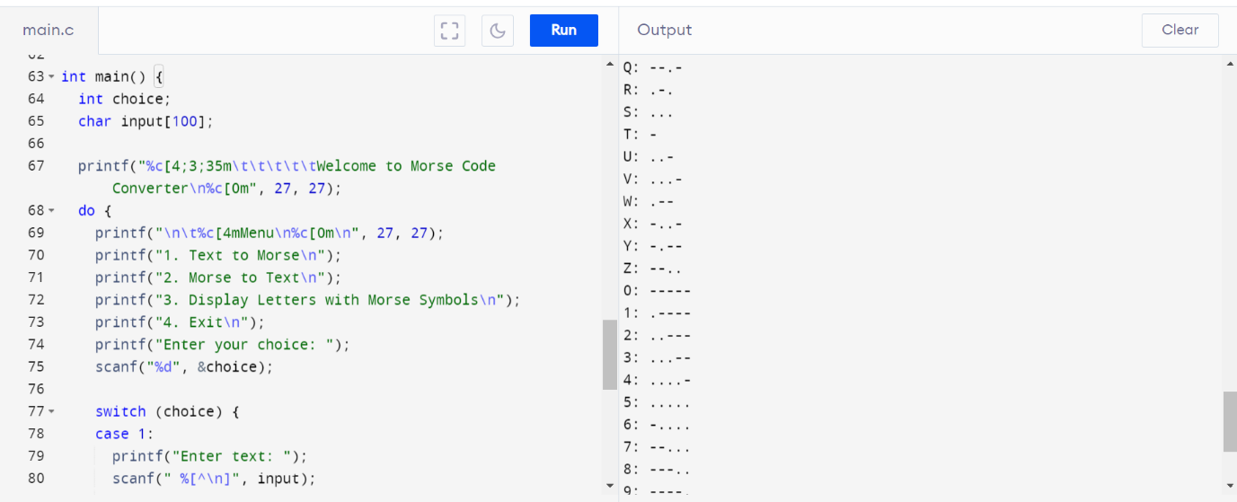

**CONCLUSION**

In conclusion, a Morse code converter is a simple yet fascinating tool that enables the translation of text into Morse code and vice versa. It serves as a practical example of character encoding and decoding, offering a bridge between human-readable text and the historical Morse code communication system. Here are some key takeaways regarding a Morse code converter:

1. **Historical Significance**: Morse code was a pivotal means of long-distance communication before the advent of modern telecommunication systems. A Morse code converter pays homage to this historical method and highlights its continued relevance in certain applications today.
2. **Character Mapping**: The converter relies on a predefined character mapping that associates letters, numbers, and special characters with their corresponding Morse code representations. This mapping is essential for accurate conversion.
3. **Case Insensitivity**: Morse code is typically case-insensitive, treating uppercase and lowercase letters the same way. A well-designed converter should account for both cases.
4. **User-Friendly Interface**: A user-friendly interface can enhance the usability of the converter. Providing options for users to choose between text-to-Morse and Morse-to-text conversions simplifies the process.
5. **Error Handling**: Handling unknown characters gracefully is important. When encountering characters that do not have corresponding Morse code representations, the converter should indicate this with a placeholder (e.g., '?').
6. **Memory Management**: If handling large input strings, memory management is crucial to avoid memory leaks. Properly allocating and deallocating memory for storage is essential for efficient operation.
7. **Extensibility**: Consideration for future updates and additions, such as support for additional characters or improved user interfaces, is valuable in the design of a Morse code converter.
8. **Educational Value**: Beyond practical utility, Morse code converters have educational value. They can be used to teach Morse code, coding principles, and character encoding to learners of various levels.
9. **Testing**: Rigorous testing is necessary to ensure the accuracy and reliability of the converter. Comprehensive testing with various inputs helps identify and rectify potential issues.
10. **Overall Utility**: While Morse code may no longer be a primary means of communication, Morse code converters are still used in specific domains, such as amateur radio, navigation, and aviation, where Morse code proficiency remains valuable.

In essence, a Morse code converter combines history, technology, and communication principles into a single tool. Whether used for educational purposes or in niche applications, it showcases the enduring legacy of Morse code in the modern world.

**REFERENCES**

. ***Some notable references include:***

* [*https://practice.geeksforgeeks.org*](https://practice.geeksforgeeks.org)
* [*https://stackoverflow.com/*](https://stackoverflow.com/)
* [*https://whimsical.com/*](https://whimsical.com/)
* [*https://www.programiz.com/c-programming/online-compiler/*](https://www.programiz.com/c-programming/online-compiler/)
* [*https://www.wikipedia.org/*](https://www.wikipedia.org/)