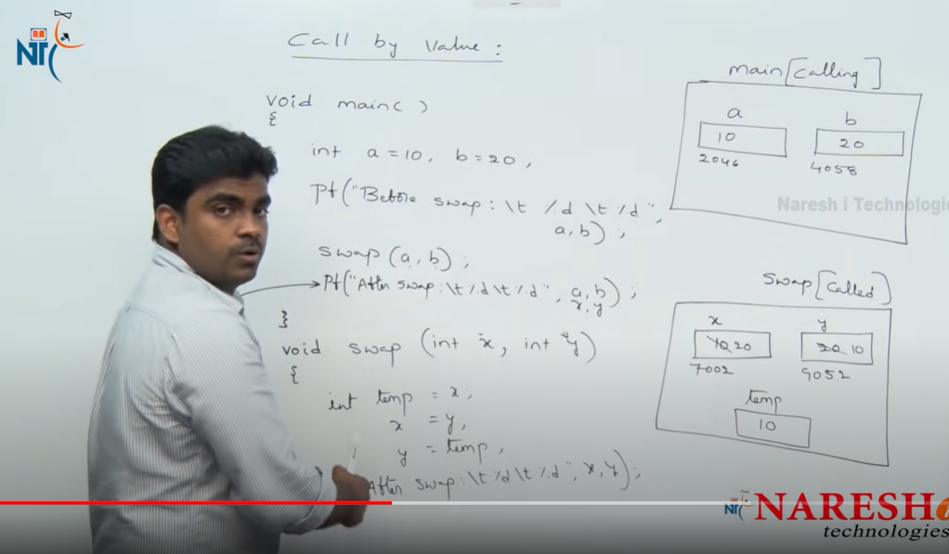

call by value:

1.CBV means we are passing the only values

2.changess will be done only in called function not in calling function

vaid main()

{

int a=10;

b=20;

printf("before swap:\t%d\t%d" a,b);

swap(a,b);

}

void swap(int a,int b)

{

temp=a;

a=b;

b=temp;

printf("after swap:\t%d\t%d" a,b);

}

o/p:

before swap:10,20

after swap"20,10

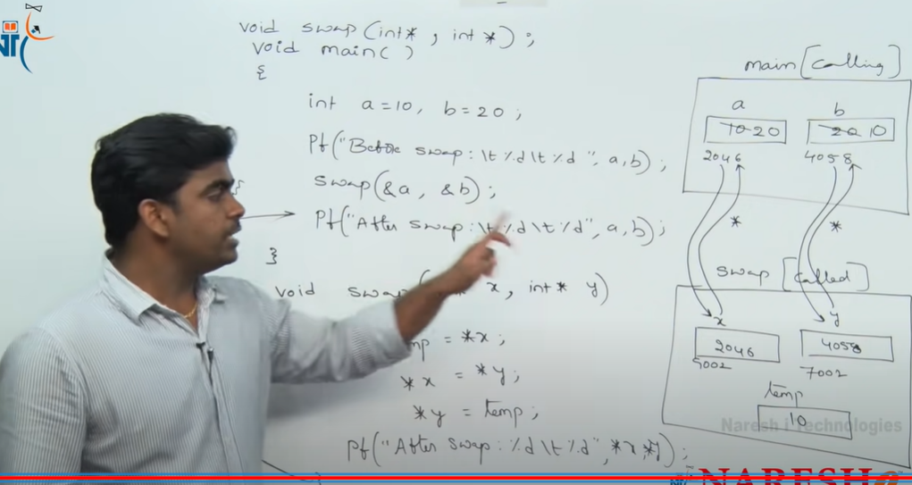

call by reference:

1.here we are passing the address only

2.pointers will holds the address

3.changes will be done in the calling function

void swap(int\*,int\*)

void main()

a=10;

b=20;

printf("Before swapping:"\t%d\t%d a,b);

swap(&a,&b)

void swap(int\*a,int\*b)

int temp=\*a;

\*a=\*b;

\* b=temp;

printf("after swap:\t%d\t%d"\* a,\*b);

o/p:

Before swapping:10,20

after swapping:10,20