**EX: 1 Duplicate Character from String and Count**

**package** com.DuplicateCharacters;

**import** java.util.HashMap;

**import** java.util.Map;

**import** java.util.Set;

**public** **class** DuplicateCharacters

{

**public** **static** **void** printDulicateCharacters(String str)

{

**if**(str==**null**)

{ System.***out***.println("NULL String");

**return**;

}

**if**(str.isEmpty())

{ System.***out***.println("Empty String");

**return**;

}

**if**(str.length()==1)

{ System.***out***.println("Single Character String");

**return**;

}

**char** words[]=str.toCharArray();

HashMap<Character, Integer> charMap=**new** HashMap<Character, Integer>();

**for**(Character ch: words)

{

**if**(charMap.containsKey(ch))

{

charMap.put(ch, charMap.get(ch)+1);

}

**else**{

charMap.put(ch, 1);

}

}

// Print the map

Set<Map.Entry<Character, Integer>> entrySet =charMap.entrySet();

**for**(Map.Entry<Character, Integer> entry: entrySet)

{ **if**(entry.getValue()>1)

{

System.***out***.println(entry.getKey()+" : "+entry.getValue());

}

}

}

**public** **static** **void** main(String[] args) {

// **TODO** Auto-generated method stub

*printDulicateCharacters*("A");

*printDulicateCharacters*("");

*printDulicateCharacters*(**null**);

*printDulicateCharacters*("katherine langford");

*printDulicateCharacters*("tesla");

*printDulicateCharacters*("1000");

*printDulicateCharacters*("007 james bond");

}

}

**Example: 2 Duplicate Characters of String**

class FindDuplicateElements1

{ public static void main(String[]args)

{

String st="katherine langford";

int length=st.length();

char ch[]=st.toCharArray();

for(int i=0; i<length; i++)

{

for(int j=i+1; j<length; j++)

{

if(ch[i]==ch[j])

{

System.out.println("Duplicate Characters are: "+ ch[j]);

}

}

}

}

}

**Example: 3 Duplicate numbers**

public static void main(String[]args)

{

int a[]={2,3,3,6,7,6,5,2,6};

System.out.print("Duplicate values are: ");

for(int i=0; i<a.length-1; i++)

{

for(int j=i+1; j<a.length; j++)

{

if((a[i]==a[j])&&(i!=j))

{

System.out.print(a[j]+", ");

}

}

}

}

}

**Example 4: Reverse String**

**import** java.io.BufferedReader;

**import** java.io.InputStreamReader;

**public** **class** StringReverse

{ **public** **static** **void** main(String[] args)

{ **try**{

InputStreamReader ii=**new** InputStreamReader(System.***in***);

BufferedReader br=**new** BufferedReader(ii);

System.***out***.println("Enter the String value:");

String name=br.readLine();

// String name="Margott Robbie";

String res="";

**for**(**int** i=name.length()-1; i>=0; i--)

{

res=res+name.charAt(i);

}

System.***out***.println("Reverse string of string value is:"+res);

}

**catch** (Exception e) {

// **TODO**: handle exception

e.printStackTrace();

}

}

}

**Example 5: Armstrong number**

**public** **class** Amstrong

{ **public** **static** **void** main(String[] args)

{ **int** sum=0, a, temp;

**int** number=153;

temp=number;

**while**(number>0)

{

a=number%10; // will get last digit

number=number/10; // removing last digit

sum=sum+(a*a*a);

}

**if**(temp==sum)

{

System.***out***.println(temp+" : is an amstrong number");

}

**else**

{

System.***out***.println(temp+" : is not an amstrong number");

}

}

}

**Example 6 : To Find Perfect Number**

**public** **class** PerfectNo {

**static** **boolean** check(**int** number)

{ **int** sum=1;

**for**(**int** j=2; j*j<=number; j++)

{ **if**(number%j==0)

{ **if**(j*j!=number){

sum=sum+j+number/j;

}

**else**{

sum=sum+j;

}

}

}

**if**(sum==number && number !=1)

**return** **true**;

**return** **false**;

}

**public** **static** **void** main(String[] args) {

System.***out***.println("Perfect numbers between 1 to 5000");

**for**(**int** n=2; n<500; n++)

{ **if**(*check*(n))

{

System.***out***.println(n+" is perfect number");

}

/* else{ System.out.println(n+"is not a perfect number");

}

*/

}

}

}

**Logics on Arrays**

**Example 7: Length of an Array**

**public** **class** Arrays

{ **public** **static** **void** main(String[] args)

{ // Length of Array

Integer A[]=**new** Integer[5]; //{1,2,3,4,7,8,2};

System.***out***.println("Length of Array A is: "+A.length);

Integer B[]=**new** Integer[]{1,2,5,8,2,9,7};

System.***out***.println("Length of Array B is: "+B.length);

String s[]=**new** String[]{"Hai darling","How r u ","Darling"};

System.***out***.println("Length of String is: "+s.length);

String s1=**new** String("Hai darling");

System.***out***.println("Length of String is: "+s1.length()); }

}

**Example 8: Find the Sum of Array**

**public** **static** **void** main(String[] args)

{ //1. Find the sum of array

Integer arr1[]=**new** Integer[8];

Integer sum=0;

arr1[0]=1;

arr1[1]=2;

arr1[2]=3;

arr1[3]=4;

arr1[4]=5;

arr1[5]=6;

arr1[6]=7;

arr1[7]=8;

**for**(**int** i=0; i<arr1.length; i++)

{

sum=sum+arr1[i];

}

System.***out***.println("Sum of Array is: "+sum);

//2. Find the sum of array

Integer arr2[]=**new** Integer[]{8, 7, 6, 5, 4, 3, 2, 1};

Integer sum1=0;

**for**(**int** i=0; i<arr2.length; i++)

{

sum1=sum1+arr2[i];

}

System.***out***.println("Sum of Array is: "+sum1);

}

**Example 9: Find the Average of an Array**

**public** **static** **void** main(String[] args)

{ // Find the avarage of array

Integer arr3[]=**new** Integer[5];

Integer sum2=0;

Integer avg;

Scanner sc=**new** Scanner(System.***in***);

System.***out***.println("Enter Array elements"+"\n");

**for**(**int** i=0; i<5; i++)

{

arr3[i]=sc.nextInt();

}

System.***out***.println("Array Elements are: ");

**for**(**int** i=0; i<5; i++)

{

System.***out***.print(arr3[i]+" ");

}

**for**(**int** i=0; i<5; i++)

{

sum2=arr3[i]+sum2;

}

avg=sum2/arr3.length;

System.***out***.println("\n"+"Sum of Array Elements is: "+sum2+"\n"+"Avarage of Array Elements is: "+avg);

}

**Example 10: Compare two Arrays in Java**

 public static void main(String[] args)

{   // declare and initialize arrays

   int arr1[] = {10,20,30,40,50};

int arr2[] = arr1;

int arr3[] = {10,20,30,40,50};

int arr4[] = {15,25,35,45,55};

    // compare arrays using == operator

    // compare arr1 and arr2

     if(arr1 == arr2){

       System.out.println("arr1 & arr2 are same");

}

else{

System.out.println("arr1 & arr2 are not same");

}

// compare arr1 and arr3

if(arr1 == arr3){

System.out.println("arr1 & arr3 are same");

}

else{

System.out.println("arr1 & arr3 are not same");

     }

// compare arr1 and arr4

if(arr1 == arr4){

System.out.println("arr1 & arr4 are same");

}

else{

System.out.println("arr1 & arr4 are not same");

   }

}

**Example 11: To Find the Sum of Two Array Elements**

To calculate the sum of two arrays element by element in Java both arrays must be of equal type and equal size. If they have different types or different sizes then we will get IllegalArgumentException. To solve this problem we have to create a third array of the same size and then store the sum of corresponding elements of the given arrays.

Note that we can’t add two arrays that are of different types or incompatible types. Both arrays should be similar types or compatible with each other.

**Example:-**  
array1[] = {10, 20, 30, 40, 50};  
array2[] = {9, 18, 27, 36, 45};

The resultant array will be,  
array3[] = {19, 38, 57, 76, 95};  
And it was calculated as,  
array3[] = {10+9, 20+18, 30+27, 40+36, 50+45};

**public** **static** **void** main(String[] args)

{

// Find the Sum of Two Array Elements

// take number of elements in both array

Scanner sc=**new** Scanner(System.***in***);

System.***out***.print("Enter number of elements in first array: ");

**int** array1size = sc.nextInt();

System.***out***.print("Enter number of elements in second array: ");

**int** array2size = sc.nextInt();

// both array must have same number of elements

**if**(array1size != array2size) {

System.***out***.println("Both array must have same number of elements");

**return**;

}

// declare three array with given size

**int** array1[] = **new** **int**[array1size];

**int** array2[] = **new** **int**[array1size];

**int** array3[] = **new** **int**[array1size];

// take input for array1 elements

System.***out***.println("Enter first array elements: ");

**for** (**int** i=0; i<array1.length; i++) {

array1[i] = sc.nextInt();

}

// take input for array2 elements

System.***out***.println("Enter second array elements: ");

**for** (**int** i=0; i<array2.length; i++) {

array2[i] = sc.nextInt();

}

// loop to iterate through the array

**for** (**int** i=0; i<array3.length; i++) {

// add array elements

array3[i] = array1[i] + array2[i];

}

// display the third array

System.***out***.println("Resultant Array: "+ Arrays.*toString*(array3));

}

**Example 12:** Duplicate Elements of an Array

// To Find the Duplicate Values in Array

**public** **static** **void** main(String[] args)

{

Integer arr3[]=**new** Integer[] {2,3,2,3,7,8,7};

**for**(**int** i=0; i<arr3.length; i++)

{

**for**(**int** j=i+1; j<arr3.length; j++)

{

**if**(arr3[i]==arr3[j])

{

System.out.println("Duplicate Elements in a Array are: "+arr3[j]);

}

}

}

}

**Example 13:**

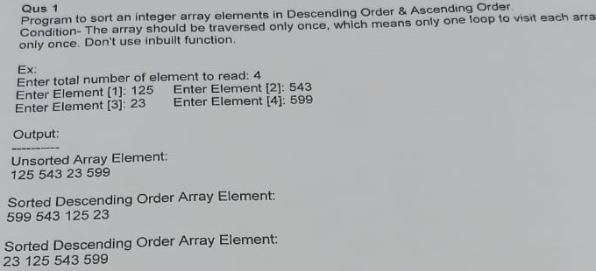

**public** **static** **void** main(String[] args)

{

// Sort an integer array elements in Descending & Ascending order

Scanner sc=**new** Scanner(System.***in***);

System.***out***.println("Enter total number of elements to read:");

**int** len=sc.nextInt();

**int** arr1[]=**new** **int**[len];

System.***out***.println("Enter Array Element:");

**for**(**int** i=0; i<arr1.length; i++)

{

arr1[i]=sc.nextInt();

}

System.***out***.println("Unsorted Array Elements:"+Arrays.*toString*(arr1));

**for**(**int** i=0; i<arr1.length; i++)

{

**for**(**int** j=i+1; j<arr1.length; j++)

{

**int** temp=0;

**if**(arr1[i]<arr1[j])

{

temp=arr1[i];

arr1[i]=arr1[j];

arr1[j]=temp;

}

}

}

System.***out***.println("Sortted Descending Order Array Elements:"+Arrays.*toString*(arr1));

**for**(**int** i=0; i<arr1.length; i++)

{

**for**(**int** j=i+1; j<arr1.length; j++)

{

**int** temp=0;

**if**(arr1[i]>arr1[j])

{

temp=arr1[i];

arr1[i]=arr1[j];

arr1[j]=temp;

}

}

}

System.***out***.println("Sortted Ascending Order Array Elements:"+Arrays.*toString*(arr1));

}

**Output:**

Enter total number of elements to read:

4

Enter Array Element:

125

543

23

599

Unsorted Array Elements:[125, 543, 23, 599]

Sortted Descending Order Array Elements:[599, 543, 125, 23]

Sortted Ascending Order Array Elements:[23, 125, 543, 599]

**Example: 14**

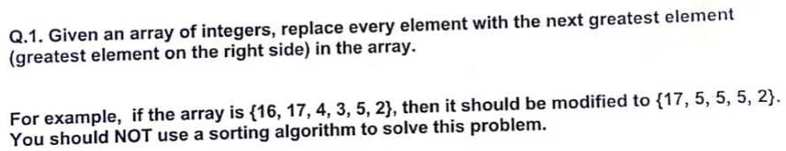

**import** java.util.Arrays;

**import** java.util.Scanner;

**public** **class** NextGreatsetElem

{

**public** **static** **void** nextgreatest(**int** a[], **int** n)

{

**int** max=a[n-1], temp;

a[n-1]=0;

**for**(**int** i=n-2; i>=0; i--)

{

temp=a[i];

a[i]=max;

**if**(max<temp)

{

max=temp;

}

}

System.***out***.println("After Replacement with Next Greatest Elements of Given Array is: "+Arrays.*toString*(a));

}

**public** **static** **void** main(String[] args) {

Scanner sc=**new** Scanner(System.***in***);

System.***out***.println("Enter Length of an array");

**int** len=sc.nextInt();

**int** a[]= **new** **int**[len];

System.***out***.println("Enter Array Elements: ");

**for**(**int** i=0; i<a.length; i++)

{

a[i]=sc.nextInt();

}

System.***out***.println("Entered Array is: "+Arrays.*toString*(a));

*nextgreatest*(a, len);

}

}

**Output:**

Enter Length of an array

6

Enter Array Elements:

16

17

3

4

5

2

Entered Array is: [16, 17, 3, 4, 5, 2]

After Replacement with Next Greatest Elements of Given Array is: [17, 5, 5, 5, 2, 0]

**Example 15:**

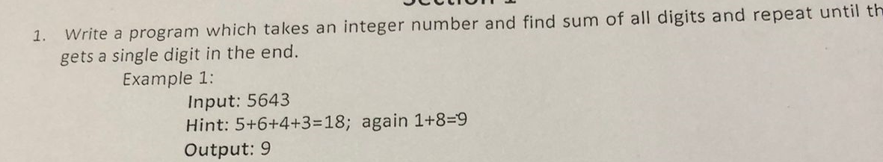

import java.util.Scanner;

class SumOfNumbers

{

public static void main(String...args)

{

int n, sum=0;

Scanner sc=new Scanner(System.in);

System.out.println("Enter Number :");

n=sc.nextInt();

while( n>0 || sum>9)

{

if(n==0)

{

n=sum;

sum=0;

}

sum =sum + n%10;

n= n/10;

}

System.out.println("After Sum of Single Digit is: "+sum);

}

}

**Example 16:**

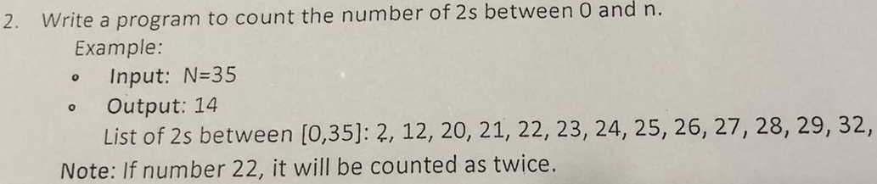

**i**mport java.util.Scanner;

class CountNo

{

public static int numberof2s(int n)

{

int count=0;

while(n > 0)

{

if(n % 10 == 2)

{

count++;

}

n=n/10;

}

return count;

}

public static int numberof2sinRange(int n)

{

int count=0;

for(int i=2; i<=n; i++)

{

count=count + numberof2s(i);

}

return count;

}

public static void main(String...args)

{

Scanner sc=new Scanner(System.in);

System.out.println("Enter 'n' value: ");

int n=sc.nextInt();

System.out.println("Totol number of 2's in between 0 to n: "+numberof2sinRange(n));

}

}

**Example 17:**

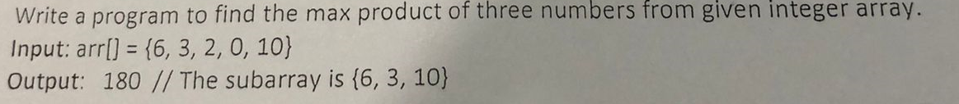

import java.util.*;

class Max3product

{

public static int maxpro(int arr[])

{

// find min1, min2, max1, max2, max3

int min1=Integer.MAX_VALUE;

int min2=min1;

int max1=Integer.MIN_VALUE;

int max2=max1;

int max3=max1;

for(int i=0; i<arr.length; i++)

{

// check Max value

int val=arr[i];

if(val >= max1)

{

max3=max2;

max2=max1;

max1=val;

}

else if(val >=max2)

{

max3=max2;

max2=val;

}

else if(val >=max3)

{

max3=val;

}

// Chenk Min values

if(val <= min1)

{

min2=min1;

min1=val;

}

else if(val <= min2)

{

min2=val;

}

}

// Compare

return Math.max(min1*min2*max1, max1*max2*max3); // if two -ve min integers occured

// return max1*max2*max3; // if all +ve integers occured

}

public static void main(String...args)

{

Scanner sc=new Scanner(System.in);

System.out.println("Enter Length of an Array");

int n=sc.nextInt();

int arr[]=new int[n];

System.out.println("Enter Array Elements");

for(int i=0; i<n; i++)

{

arr[i]=sc.nextInt();

}

int prod=maxpro(arr);

System.out.println("Product of Max 3 numbers: "+prod);

}

}

**Example 18:** Find the age from DOB to Current Date

import java.util.*;

class DOB

{

int d1,m1,y1, d2,m2,y2, d3,m3,y3;

public void getsysdate()

{

Calendar c=Calendar.getInstance();

d1=c.get(Calendar.DATE);

m1=c.get(Calendar.MONTH);

y1=c.get(Calendar.YEAR);

}

public void getbirthdate(int d, int m, int y)

{

d2=d;

m2=m;

y2=y;

}

public void calculate()

{

if(d1<d2)

{

m1=m1-1;

d1=d1+30;

}

if(m1<m2)

{

y1=y1-1;

m1=m1+12;

}

d3=d1-d2;

m3=m1-m2;

y3=y1-y2;

System.out.println("You are - Day : "+ d3 + ", Month : "+ m3 + ", Year :"+y3 +" Years old" );

}

}

class age

{

public static void main(String...args)

{

int d,m,y;

Scanner sc=new Scanner(System.in);

System.out.println("Enter Day:");

d=sc.nextInt();

System.out.println("Enter Month:");

m=sc.nextInt();

System.out.println("Enter Year:");

y=sc.nextInt();

DOB a=new DOB();

a.getsysdate();

a.getbirthdate(d, m, y);

a.calculate();

}

}

**Example 19:**

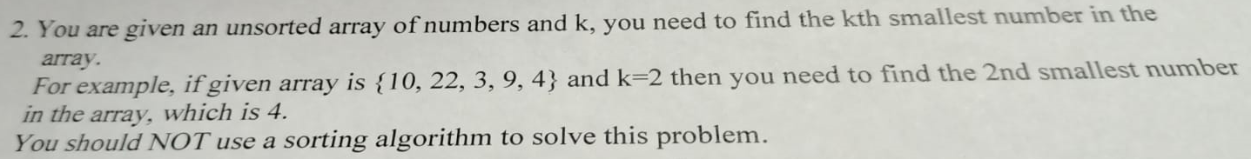

import java.util.*;

class SmallestNumberInArray

{

public static void main(String[]args)

{

Scanner sc=new Scanner(System.in);

System.out.println("Enter length of an array: ");

Integer length=sc.nextInt();

Integer a[]=new Integer[length];

Integer smallnumber;

System.out.println("Entered array elements:");

for(int i=0; i<length; i++)

{

a[i]=sc.nextInt();

}

System.out.println("Entered array elements are: "+Arrays.toString(a));

System.out.println("Enter 'k' th smallest number from array: ");

int k=sc.nextInt();

/* // fixed values an array

Integer count=0;

Integer a[]=new Integer[]{52,64,113,46,224,66,1,9,220};

for(int x:a)

{

count++;

}

*/

for(int i=0;i<length;i++)

{

for(int j=i+1;j<length;j++)

{

if(a[i]<a[j]) //smallest number && for largest number if(a[i]>a[j])

{

smallnumber=a[i];

a[i]=a[j];

a[j]=smallnumber;

}

}

}

smallnumber=a[length-k];

System.out.println("The 'k' th : " + k + " smallest number in an array is : "+smallnumber);

}

}

**Example 20:** Write a program to Read a String and find the Sum of all Digits in the String and find the Sum Value is even or odd number.

**Ex:** Input: NXZ123;

Output:

No. of digits in the given String = 3

Sum of all given digits in the given String = 6

Sum is Even number

**import** java.util.Scanner;

**public** **class** SumofDigits

{

**public** **static** **void** main(String[] args)

{

Scanner sc=**new** Scanner(System.***in***);

System.***out***.println("Enter String Values: ");

String str=sc.next();

System.***out***.println("Given String is: "+str);

String temp="0";

Integer sum=0, count=0, sumofdigit;

**char** word[]=str.toCharArray();

**for**(**int** x:word)

{

count++;

}

**for**(**int** i=0; i<count; i++)

{

**if**(Character.*isDigit*(word[i]))

{

System.***out***.print("No of digits in the given String: "+word[i]);

System.***out***.println();

sumofdigit=Integer.*parseInt*(String.*valueOf*(word[i]));

sum=sum + sumofdigit;

}

}

System.***out***.println("Sum of all digits in a given string: "+sum);

**if**(sum%2==0)

{

System.***out***.println("Sum is Even Number");

}

**else**

{

System.***out***.println("Sum is Odd Number");

}

}

}

**Example 21:** Write a program to find the pair of elements from an array whose sum is equal to 5

**Ex:** Input: [0, 1, 2, 3, 5, 7, 11, 12, 14, 20]

Output:

1. 0 + 5 = 5
2. 2 + 3 = 5

**import** java.util.Arrays;

**import** java.util.Scanner;

**public** **class** PairElementsSum

{

**public** **static** **void** main(String[] args)

{

Scanner sc=**new** Scanner(System.***in***);

System.***out***.println("Enter Length of an Array:");

Integer length=sc.nextInt();

Integer count=0;

Integer arr[]=**new** Integer[length];

System.***out***.println("Enter an Array Elements:");

**for**(**int** i=0; i<length; i++)

{

arr[i]=sc.nextInt();

}

System.***out***.println("Given Array is: "+Arrays.*toString*(arr));

System.***out***.println("Enter Sum value of Pair Elements :");

Integer sum=sc.nextInt();

System.***out***.println("Sum of Pair Elements of "+ sum +" is:");

**for**(**int** i=0; i<length; i++)

{

**for**(**int** j=i+1; j<length; j++)

{

**if**((arr[i] + arr[j])== sum)

{

System.***out***.println(arr[i]+" + "+arr[j]+" = "+sum);

count++;

}

}

}

System.***out***.println("Number of Pair Elements are: "+count);

}

}

**Example 22:** Write a program to find the character with the least frequency.

**Ex i:** Input: aaagbbcccce

Output: g,e

**Ex ii:** Input: kgfkfcgcgc

Output: k,f