### **VINEETHA**

G34-ML AND PYTHON

### **Loading Data into SPSS:**

1. **Start by opening SPSS.**  
   Navigate to **File > Open > Data...**, and then locate the file named teacherratings.sav on your computer. Select it and open it to load the dataset.
2. **Switch to Variable View:**  
   After the data appears, look at the bottom-left corner of the SPSS window and click on **Variable View** (next to Data View). This view allows you to manage and edit information about each variable.
3. **Edit the eval variable’s label:**  
   Find the variable named eval. You'll see a column called **Label**, which currently is blank for this variable. Double-click in that blank space and type a short explanation such as **"Teaching Evaluation Score"** to describe what the variable represents.
4. **Get basic statistics for the Age variable:**  
   Now, switch back to **Data View** and go to the menu:  
   Click on **Analyze > Descriptive Statistics > Descriptives...**

* Select the variable age and move it to the right box.
* Click **Options**, check **Minimum** and **Maximum**, and then click **Continue**.
* Finally, click **OK** to see a table with the minimum and maximum age values.

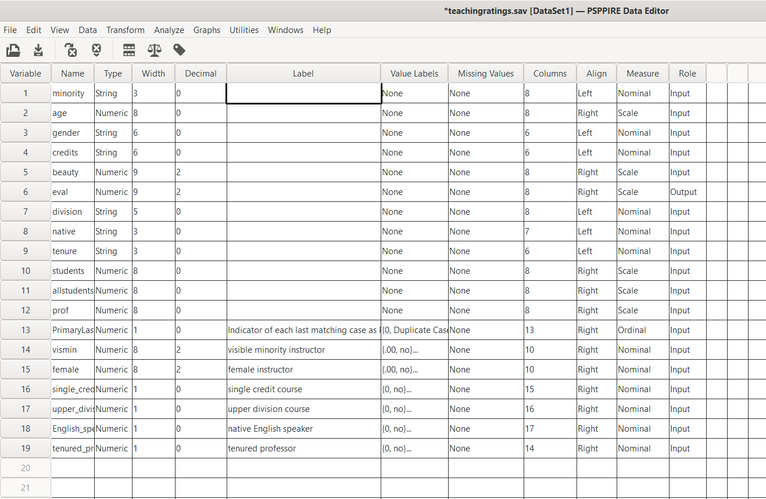

OUTPUT:

