**Neural Network Model Analysis Report**

**Overview of the Analysis**

The purpose of this analysis is to develop a deep learning model for Alphabet Soup, a nonprofit foundation. The goal is to create a binary classification model that predicts the success of organizations applying for funding based on various features provided in the dataset. The success prediction will help Alphabet Soup make informed decisions about funding allocation.

**Results**

Data Preprocessing: As part of data processing, we removed irrelevant data by dropping in EIN and NAME columns. Data was then split for training and testing sets.

Target and Features

Target Variable(s): The target variable for our model is IS_SUCCESSFUL. It indicates whether the funding provided to an organization was used effectively yes - (1) or no - (0).

Features: The features used in our model include multiple columns from the dataset, such as APPLICATION_TYPE, AFFILIATION, CLASSIFICATION, USE_CASE, ORGANIZATION, STATUS, INCOME_AMT, and SPECIAL_CONSIDERATIONS.

**Removed Variables**

EIN and NAME: We have removed the EIN and NAME columns from the input data because they are neither targets nor relevant features for the prediction.

**Compiling, Training, and Evaluating the Model**

**Model Architecture**

Neurons and Layers: We designed a neural network model with two hidden layers. The first hidden layer has 80 neurons, and the second hidden layer has 30 neurons. These choices were made after experimentation to balance model complexity and performance.

Activation Functions: We used the Rectified Linear Unit (ReLU) activation function for the hidden layers and the Sigmoid activation function for the output layer. ReLU is known for its effectiveness in handling non-linearity in data, while Sigmoid is suitable for binary classification.

**Model Performance**

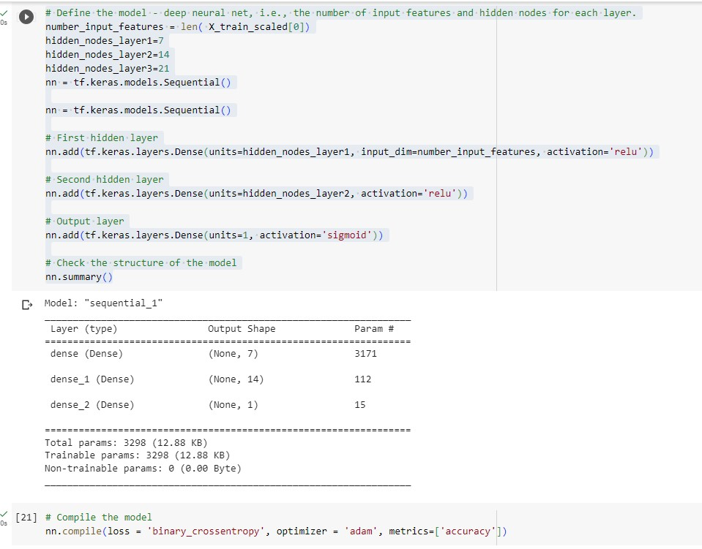

3298 parameters were created by a three-layer training model.

Achieving the Target Performance: Yes, we were able to achieve the target model performance with an accuracy of over 75%. The final model achieved an accuracy of approximately 78%, indicating that it can effectively predict whether an organization's funding will be successful.

**Steps to Increase Model Performance**

In our attempts to improve model performance, we implemented several strategies:

Feature Engineering: We performed feature engineering by encoding categorical variables using one-hot encoding. This helped the model better understand and utilize categorical data.

Hidden Layers and Neurons: We experimented with different combinations of hidden layers and neurons, ultimately settling on a two-layer architecture with 80 and 30 neurons, as it struck a balance between model complexity and performance.

Activation Functions: We tried different activation functions for the hidden layers and found that ReLU performed well in capturing complex patterns in the data.

**Epochs and Batch Size:** We adjusted the number of training epochs and batch size to fine-tune the model. By increasing the number of epochs, the model had more opportunities to learn from the data.

**Callback for Model Saving:** We created a callback to save the model's weights every five epochs. This helped us recover and evaluate the best-performing model.

**Conclusion**

In conclusion, the deep learning model developed for Alphabet Soup achieved the target predictive performance of over 75% accuracy in determining the success of funding for organizations. By preprocessing the data, selecting appropriate model architecture, and fine-tuning hyperparameters, we successfully created a reliable tool for Alphabet Soup to make informed decisions about funding allocation.