Claude Code Tutorial by Testing Academy

PART - 1
1: Install Node JS. If Already installed check with this commands, node --version, npm --version.
2: Install claude using this command : npm install -g @anthropic-ai/claude-code and click enter. You’ll get some errors follow give it to AI and just follow its instructions

Claude Code Subscription Plans Explanations:
Free
Pro: It has a quota, you can use it for 1 hour or 2 hours and have to wait for 3 hours.
Max: Max has 2 versions, 5x and 20x, for 5x the price is 100$ and 20x is 200$, 5x finishes its limit in 3 hours and 20x will finish its limit in 4 to 5 hours

AI is our servant don’t use terms like please, can you ….

Modes in Claude code:
There are 4 modes in claude code:
1: Plan Mode
2: Accept and edit
3: Auto Accept
4: All Permission
Plan mode: In this plan mode, if you give a instruction or a prompt to the model it just plans or gives you the answers. For example if you have to solve an error or a bug in a code, and you give instruction to claude like go to this file and solve the bug from the code. Now what it does is it just gives you whats the error and all other possible explanations. You give questions and it answers that’s it.
Accept and edit: In this mode, if you enable to go to this mode, the model asks your permission to edit the file, and if you give yes or access, the model itself goes to our file, and edits the code.

Auto Accept: In this mode, claude performs many actions without asking your permission. And its one of the risky thing and is not recommended if you system has confidential data.
All Permission : This is one of the most dangerous modes any AI model can have. Auto mode atleast might ask you permission to delete some files if needed, but this mode don’t even ask you permission to delete, it might also delete the most important files. Never use it

NOTE: Use either Plan mode or Accept and edit mode ONLY………

Commands:
1: /init
This command in claude code analyses the current project folder and generates a project instruction file which is called as Claude.md file. So it reads our dependency file (which we download for example for selenium we download some dependency files from website), key source files (the code we write), configuration files (the files are settings files, they tell software how to behave we have configuration file in our UTS where we used to have all the IP of all the hardwares).

This claude.md file can be created a local scope, global scope. For example you can create a claude.md file for a single folder, and as well we can create a claude.md file for a folder where a dozens of folders reside.

2: /help: When you type this command it gives you all the features, and commands that are available.
3: /clear: clears all the context.
4: /compact: After 3 to 4 hours of continuously working with claude and the limit reaches to its max generally claude AI looses or forgets the data we were working with (basically like a RAM when the computer gets shut down or power loss) so to make the Claude AI remember the old data use /compact command. /compact “your custom message” it starts archiving like it compresses the data.

5: /resume: This command basically helps us to resume the conversation we had earlier with the model. Usually in ChatGPT you can’t chat with the prompt or conversation you had for suppose you chat about multiple topics with chatgpt and suddenly you wanted to chat again on a certain topic so meanwhile the AI can forget the data. So use this /resume command once you type /resume it asks you to type a conversation term or id if you remember any terms related to the conversation you had type and enter.

6: /status: Checks how many tokens left or gives the stats of the usage.

7: /export: In case if your limit is over and you want to continue chatting with other AI agents, like copilot, chatgpt etc.. you can export the file and can paste. So when you type /export it creates a .txt file. Or .md file so this file contains all the conversations you had with claude and this file can be copied and pasted to other AI agents to chat. This command does not export the project files or folders coz it might contain GB of data.

8: We can create our own custom command by giving a prompt. “Give a word and say whenever I say this word you have to do a task and also create a command /word”.

9: Go to Claude plugins and there are lot of plugins available for example if you want to design a front end page you have a frontend plugin you can install and give your inputs from claude and create a frontend webpage.

10: Use /agents or give your prompt “spawn 5 agents and create article on each agent with 500 words.” When you give this prompt it creates 5 agents and do tasks.

Caveman:
Install caveman in claude. Why? It basically reduces the token usage by the AI model. For example if you say hi few AI models reply as hi, how are you how’s your day, how may I help you? Blah blah so instead if you want your AI model to just reply with hi use caveman (not just for hi).

QA Claude code Plugins if you want to know plugins for QA search in claude code and it will list a bunch of plugins. And install them in claude.
How to install claude code Plugins?
Copy the command of the plugin which is displayed on the right side, and paste it in the claude code and before pasting add this “claude plugin install” therefore it becomes “claude plugin install skill-creator@claude-plugins-official”

------------------------------------------------------------------------------------------------
You can run multiple claude code agents through the terminal and run different tasks simultaneously.

SKILL FILE:
What is a skill file?
A skill file is an instruction file to perform a particular task for example Claude.md is also a skill file.
Why to create a skill.md file? Imagine you join a project and every day you get a new requirement document. On day 1 you tell claude like you’re a 15 yr exp senior QA and when I provide req you need to create test scenarios, test cases, negative test cases, edge cases, priority, severity etc …. And next day it forgets everything and you have to explain everything and it goes on till day 100. But what if you create a skill file with all the instructions saying whenever a req is given create test scenarios, test cases, negative test cases, edge cases, priority, severity etc …. And now you can use this skill file everytime without explaining.

The motive of skill.md file is to teach claude your preferred testing process and output format so you get the same quality and structure every time.
So you have a plugin especially to create a skill. (install a plugin called as skill creator claude plugin install skill-creator@claude-plugins-official ).
Easiest way to create a skill file is to use the skill creator plugin.
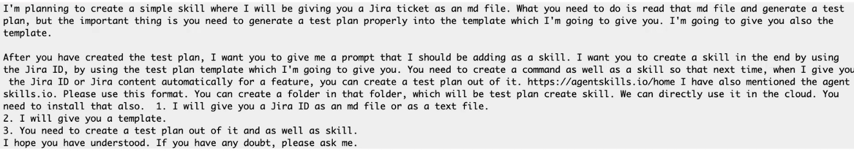

This was the prompt given by the testing academy to create a skill file. So basically what this prompt is saying is, if a user has given a JIRA ID, and a test plan template the AI should create a test plan with the help of this skill.md file.
So What are we including in this Skill.md file? We are creating like this:
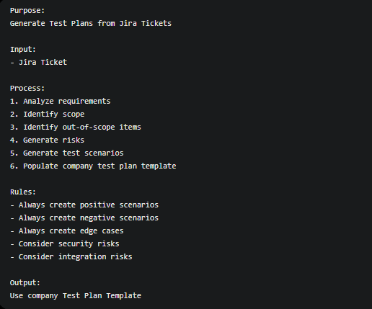
We are writing the purpose, input in the sense we have to provide the JIRA ID file where all the requirements are there. When a JIRA ticket is raised, it not only might be a bug but can also be a new feature addition request also etc.. So suppose if you want to add a forgot password feature in your login page, you can raise the JIRA ticket by adding all the requirements and how to test etc.. this is one file, test plan template is another file you provide and as well this skill.md file so if you provide all these three files to the AI, it analyses all of them and creates a test plan on how to test the forgot password feature.

There are three ways where you can give the JIRA Id or JIRA to the claude
1: Attach (copy paste the JIRA file) to the claude
2: Use MCP, MCP basically establishes a connection between the JIRA application and the claude. And for MCP we use Atlassian website which is not for free.
3: Use Claude Chrome Extension.
Most of the companies don’t allow claude chrome extension, or might be MCP also.

So in final What are we including in a skill.md file???
1: Purpose: Generate test plans from JIRA tickets
2: Input: JIRA ticker (which we give separately, and a test plan template both should be attached seperately)
3: Rules
- Generate positive scenarios
- Generate Negative Scenarios
- Generate Edge Cases
- Generate Risks
- Generate Scope
4: Output: Populate the supplied test plan template
NOTE: Test plan template can be based on the company.

So as we know what is included in a skill.md file now what exactly will be in the test plan template?
- Example: Think of a restaurant and skill.md file is like a chef’s recipe book where it tells how to cook, how to add ingredients, how much oil etc.. and test plan template tells where the starter goes, where the main course goes, etc..
- In the same way in QA as we know skill.md files generates us the test cases, scope, risks everything etc. and whereas template has what sections should appear in the final document. So there are sections like “Feauture name,Business Impact, Dependencies, Scenarios etc…

- 