Links de consulta:

# Braille maker (Github):

<https://cta-ifrs.github.io/Text2Braille3d/>

# Tradutor de Braile 1:

<https://symbl.cc/pt/tools/braille/>

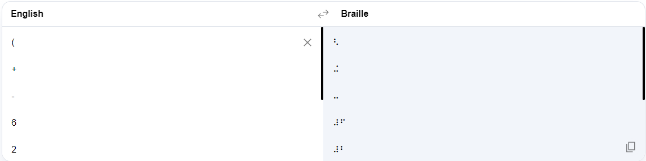

# Tradutor de Braille 2:

<https://www.tradutorbraille.com.br/>

# Apostila de braile:

chrome-extension://efaidnbmnnnibpcajpcglclefindmkaj/viewer.html?pdfurl=https%3A%2F%2Ftrocandosaberes.com.br%2Fwp-content%2Fuploads%2F2022%2F03%2F02-Apostila-de-Sistema-Braille.pdf&clen=1082238&chunk=true

# Distância dos pontos do braile

chrome-extension://efaidnbmnnnibpcajpcglclefindmkaj/https://www.prefeitura.sp.gov.br/cidade/secretarias/upload/chamadas/resolucao_n_4_sehab_cpa_de_18_de_agosot_de_2000_1384449887.pdf

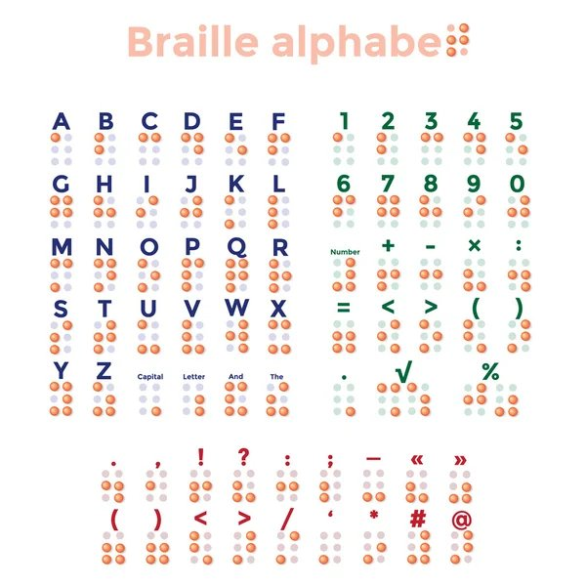

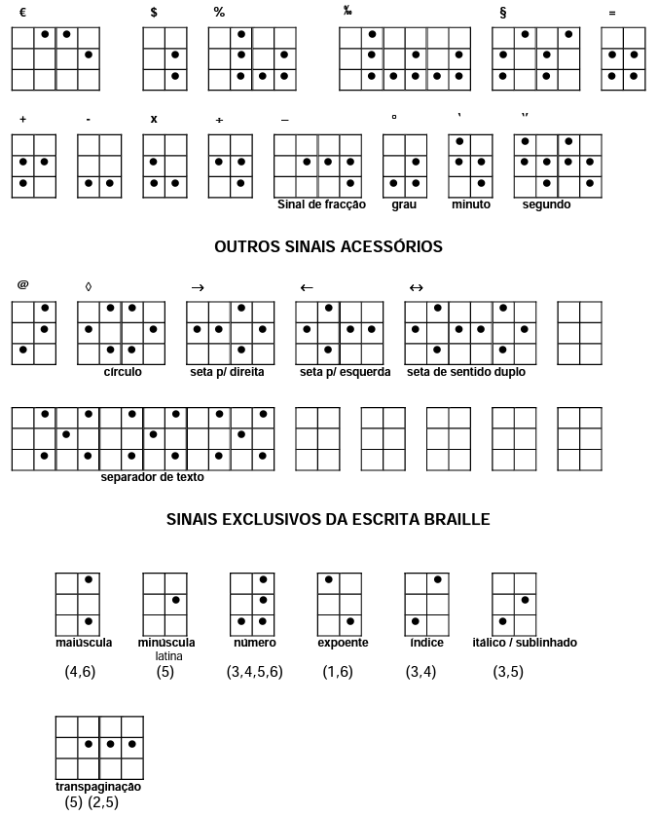

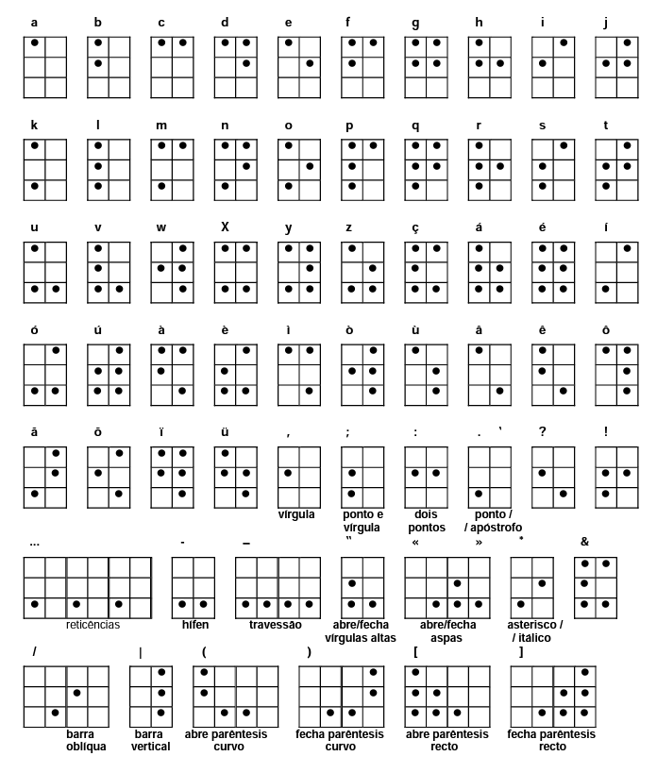Referências: chrome-extension://efaidnbmnnnibpcajpcglclefindmkaj/viewer.html?pdfurl=https%3A%2F%2Fwww.prefeitura.sp.gov.br%2Fcidade%2Fsecretarias%2Fupload%2Fchamadas%2Fresolucao_n_4_sehab_cpa%2C_de_18_de_agosot_de_2000_1384449887.pdf&clen=104486&chunk=true

chrome-extension://efaidnbmnnnibpcajpcglclefindmkaj/viewer.html?pdfurl=http%3A%2F%2Fwww.apadev.org.br%2Fpages%2Fdownloads%2FAlfabetoBraille.pdf&clen=65386&chunk=true