**Task 05:**

#include <stdio.h>

int main (){

    int course ;

    char g;

    printf("Enter the course number(1,2,3): ");

    scanf("%d",&course);

    switch (course)

    {

    case 1:

    case 2:

    case 3:

         printf("Enter the grade for course %d: ",course);

         scanf(" %c", &*g*);

         switch (g)

         {

            case 'A':

            case 'a':

              printf("Excellent! you got A Grade in course %d",course);

              break;

            case 'B':

            case 'b':

              printf("Good Job! you got B Grade in course %d",course);

              break;

            case 'C':

            case 'c':

              printf("You got C grade in course %d.Not bad but little bit more efforts are needed ",course);

              break;

            case 'D':

            case 'd':

              printf("You got D grade in course %d.Try to improve",course);

              break;

            case 'E':

            case 'e':

              printf("Your passed the course %d with E grade.Work Hard!", course);

              break;

            case 'F':

            case 'f':

              printf("Sorry! You failed the course %d",course);

              break;

        default:

              printf("Enter appropriate grade");

              break;

        }

        break;

        default:

            printf("Enter Valid course number");

            break;

    }

    return 0;

}

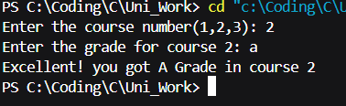**Output :**

**Task 06:**

#include <stdio.h>

int main(){

    int x, y, z;

    printf("Enter first number: ");

    scanf("%d", &x);

    printf("Enter second number: ");

    scanf("%d", &y);

    printf("Enter third number: ");

    scanf("%d", &z);

    x>y ? (x>z ? (printf("%d is Maximum number",x)):(printf("%d is Maximum number",z))):(y>z ? (printf("%d is Maximum number",y)):(printf("%d is Maximum number",z)));

    return 0;

}

**Output:**

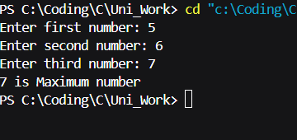

**Task 07:**

#include <stdio.h>

int main(){

    int a, b;

    printf("Enter a: ");

    scanf("%d", &a);

    printf("Enter b: ");

    scanf("%d", &b);

    printf("Sum of numbers: %d\n", a+b);

    printf("Difference between a and b: %d\n", a-b);

    printf("Product of numbers: %d\n", a*b);

    printf("Quotient of a and b: %d\n", a/b);

    printf("Remainder when a is divided by b: %d\n", a%b);

    return 0;

}

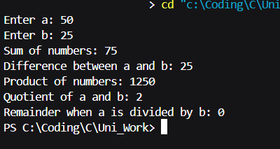**Output:**

**Task 08:**

#include <stdio.h>

int main(){

   int a,b;

   printf("Enter a: ");

   scanf("%d", &a);

   printf("Enter b: ");

   scanf("%d", &b);

   printf("a == b: %d\n", a==b);

   printf("a < b: %d\n", a<b);

   printf("a > b: %d\n", a>b);

   printf("a != b: %d\n", a!=b);

   printf("a >= b: %d\n", a>=b);

   printf("a <= b: %d\n", a<=b);

   return 0;

}

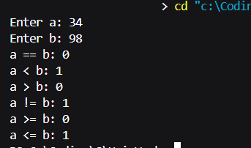**Output:**

**Task 09:**

#include <stdio.h>

int main(){

   int a,b;

   printf("Enter a: ");

   scanf("%d", &a);

   printf("Enter b: ");

   scanf("%d", &b);

   printf("a & b (Bitwise AND): %d\n", a&b);

   printf("a | b (Bitwise OR): %d\n", a|b);

   printf("a ^ b (Bitwise XOR): %d\n", a^b);

   printf("~a (Bitwise NOT): %d\n", ~a);

   printf("~b (Bitwise NOT): %d\n", ~b);

   printf("a << 1 (Shift left): %d\n", a<<1);

   printf("a >> 1 (Shift right): %d\n", a>>1);

   printf("b << 1 (Shift left): %d\n", b<<1);

   printf("b >> 1 (Shift right): %d\n", b>>1);

   return 0;

}

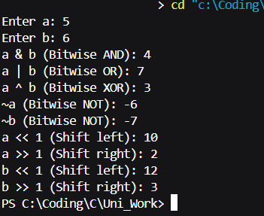**Output:**

**Task 10:**

#include <stdio.h>

int main(){

   int x,y,z;

   printf("Enter first number: ");

   scanf("%d", &x);

   printf("Enter second number: ");

   scanf("%d", &y);

   printf("Enter third number: ");

   scanf("%d", &z);

   if(x > y){

    if(x>z){

        printf("%d is the largest",x);

    }else{

        printf("%d is the largest",z);

    }

   }else{

    if(y>z){

        printf("%d is the largest",y);

    }else{

        printf("%d is the largest",z);

    }

    }

    return 0;

}

**Output:**

