**Task 01**

#include <stdio.h>

int main() {

float a, b;

printf("Enter first number: ");

scanf("%f", &a);

printf("Enter second number: ");

scanf("%f", &b);

float expression = a - b + (a * b) / 5;

printf("\nThe Expression is: a - b + (a * b) / 5\n");

printf("The Answer is: %f\n", expression);

printf("\nStep-by-step evaluation:");

printf("\n1. First brackets are solved (a * b): %f", a * b);

printf("\n2. Then division is solved (a * b) / 5: %f", (a * b) / 5);

printf("\n3. Then subtraction is solved (a - b): %f", a - b);

printf("\n4. Finally addition is solved a - b + (a * b) / 5: %f\n", a - b + (a * b) / 5);

return 0;

}

**Output**

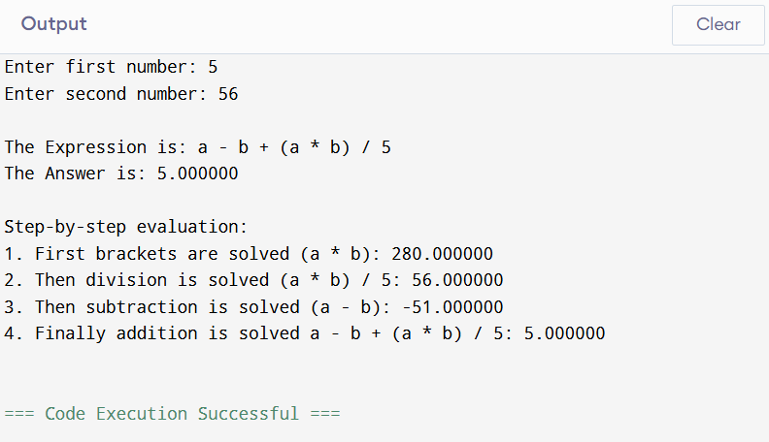

**TASK 02**

#include <stdio.h>

int main() {

int x, y;

printf("Enter first number: ");

scanf("%d", &x);

printf("Enter second number: ");

scanf("%d", &y);

printf("\nLogical Expressions:\n");

printf("(x > 5) && (y < 10): %d\n", (x > 5) && (y < 10));

printf("(x == 10) || (y == 5): %d\n", (x == 10) || (y == 5));

printf("!(x == y): %d\n", !(x == y));

return 0;

}

**Output**

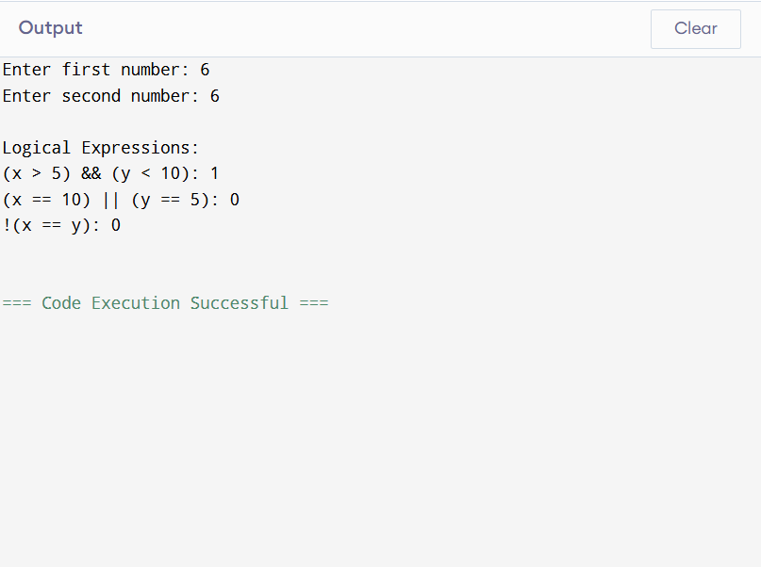

**Task 03**

#include <stdio.h>

#include <math.h>

int main() {

float x;

printf("Enter number: ");

scanf("%f", &x);

printf("The square root of number is: %f", sqrt(x));

return 0;

}

**Output**

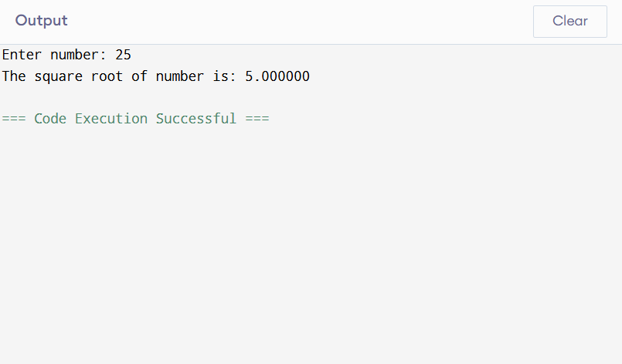

**Task 04**

**#include <stdio.h>**

**int main() {**

**int m, n;**

**printf("Enter m: ");**

**scanf("%d", &m);**

**printf("Enter n: ");**

**scanf("%d", &n);**

**(m > n) ? printf("%d is greater than %d\n", m,n) : printf("%d is greater than %d\n", n,m);**

**return 0;**

**}**

**Output**

