GOVERNMENT DENTAL COLLEGE & HOSPITAL, KADAPA.

DEPARTMENT OF PERIODONTOLOGY & IMPLANTOLOGY



SEMINAR PRESENTATION- “ JUNCTIONAL EPITHELIUM”.

GUIDED BY: PRESENTED BY:

DR.P.SURESH, DR.K.LATHA,

PROF & HOD. 1ST YEAR PG.

CONTENTS

* Introduction
* Development of junctional epithelium
* Structure of junctional epithelium
* Functions of junctional epithelium
* Concepts and epithelial attachment apparatus
* Dynamic aspects of junctional epithelium
* Role of JE in initiation of pocket formation
* Regeneration of junctional epithelium
* Junctional epithelium around implants
* Conclusion
* References

INTRODUCTION

* The gingival epithelium around a tooth is divided into three functional compartments.
* These include

1. Oral or outer epithelium

2. Sulcular epithelium

3. Junctional epithelium

* The outer epithelium extends from the mucogingival junction to the gingival margin where as crevicular/sulcular epithelium lines the sulcus Connection between gingiva and tooth is mediated with JUNCTIONAL EPITHELIUM.

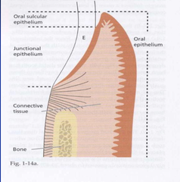

**DEVELOPMENT OF JE**

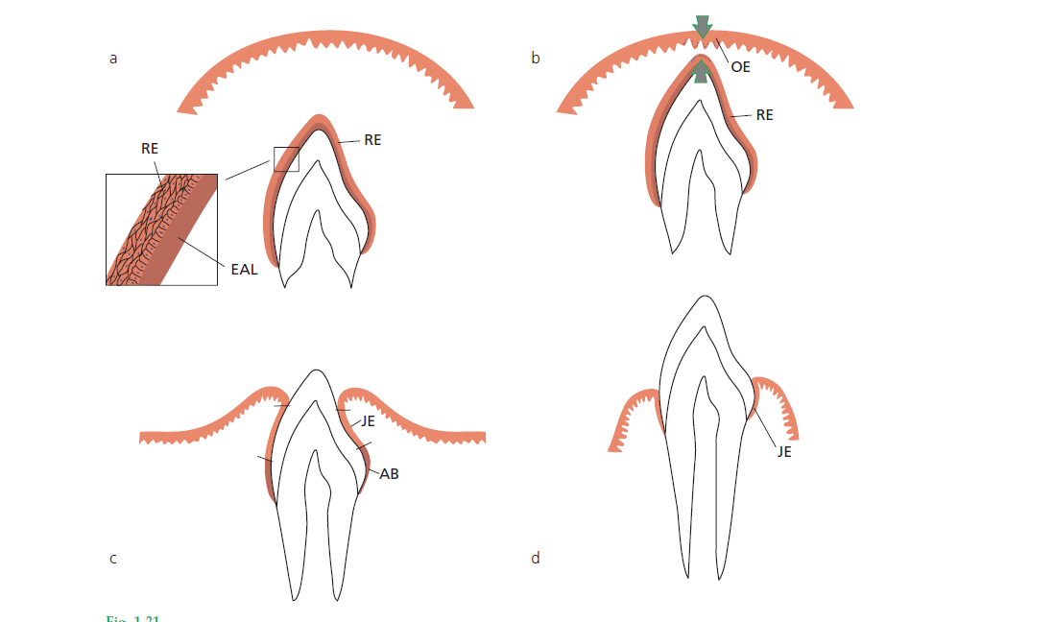

STRUCTURE OF JE

* JE is the epithelial component of the dentogingival unit, affixed to the tooth on one side and to the oral sucular epithelium and connective tissue on the other side
* Toward the tooth surface the junctional epithelial cells form and maintain the epithelial attachment.
* Marginal free gingiva---- Forms a collar
* Interproximal area ---- fuse to form epithelial lining of interdental col
* The coronal termination of the junctional epithelium corresponds usually to the bottom of the gingival sulcus.
* Under pristine conditions, the epithelial seal extends from the cementoenamel junction to the gingival margin, averaging about 2 mm in height. (Gargiulo *et al.*, 1961).
* Normal gingiva, expresses sub-clinical signs of slight inflammation(Brecx et al 1987) therefore, the coronal termination of the JE corresponds usually to the bottom of the gingival sulcus.
* The attachment of the junctional epithelium to the tooth is reinforced by the gingival fibers, which brace the marginal gingiva against the tooth surface. For this reason, the junctional epithelium and the gingival fibers are considered a functional unit, referred to as the *dentogingival unit****.***
* The junctional epithelium exhibits several unique structural and functional features and this is through;
  + First, junctional epithelium is firmly attached to the tooth and thus forms an epithelial barrier against the plaque bacteria.
  + Second, it allows the access of GCF, inflammatory cells and components of the immunological host defense,to the gingival margin.
  + Third, junctional epithelial cells exhibit rapid turnover, which contributes to the host–parasite equilibrium and rapid repair of damaged tissue.

JE AND INTERSTITIAL CELLS

* JE is a collar-like band of non-keratinised stratified squamous epithelium extending from cemento-enamel junction to bottom of gingival sulcus
* Coronally it is 15-30 cells thick and apically narrows to 1-3 cells.
* Its length varies from 0.25 – 1.35mm.
* Made up of 2 layers:
  + stratum basale( towards CT)
  + stratum suprabasale (facing tooth surface).
* The basal cells face the gingival connective tissue. The basal cells and the adjacent 1 to 2 suprabasal cell layers are cuboidal to slightly spindle shaped.
* All remaining cells of the suprabasal layer are flat, oriented parallel to the tooth surface, and closely resemble each other.
* The innermost suprabasal cells (facing the tooth surface) are also called DAT cells (= directly attached to the tooth) (Salonen *et al.*, 1989).
* They form and maintain the 'internal basal lamina' that faces the tooth surface.
* Organelles- lysosomal bodies, golgi fields, polyribosomes, cisternae of RER(rough endoplasmic reticulum) are abundant.
* Absence of keratinosomes or odland bodies.
* Fluid filled intercellular spaces may vary in width.
* PMN’s are found in the central region of the JE and near the tooth region, lymphocytes and macrophages reside in and near the basal cell layer( schroeder and listgarten 1997)
* JE, particularly its basal cell layers, is well innervated by sensory nerve fibers(Byers and Holland, 1997)

FUNCTIONS OF JE

* Has attachment role and protective role.
* Permeability allows GCF and defence cells to pass across to & protect underlying tissues from disease processes (periodontal disease).
* GCF contains gamma globulins and poly-morphonuclear leukocytes (PMNs) giving it immunological/phagocytic properties to combat disease processes.
* Such molecules pass readily across JE to underlying tissues.
* JE may contain neutrophils & other inflammatory cells indicating disease & state of health of periodontium.
* The junctional epithelium plays a crucial role since it essentially seals off periodontal tissues from the oral environment.
* Its integrity is thus essential for maintaining a healthy periodontium.
* Periodontal disease sets in when the structure of the junctional epithelium starts to fail, an excellent example of how structure determines function.

CONCEPTS OF EPITHELIAL ATTACTMENTS:

* *Gottlieb (1921)* was the first to describe the junctional epithelium
* *Schroeder and Listgarten (1971)*  junction in their monograph: ‘Fine structure of developing epithelial attachment of human teeth’.

GOTTLIEB’S CONCEPT (1921)

* Soft tissue of gingiva is organically united to enamel surface.
* He termed the epithelium contacting the tooth surface along with the interface substance “epithelial attachment”.

ORBAN’S CONCEPT (1944)

* He stated that the separation of the epithelial attachment cells from the tooth surface involved preparatory degenerative changes in the epithelium.

WAERHAUG’S CONCEPT (1952)

* He presented the concept of epithelial cuff. This concept was based on insertion of thin blades between the surface of tooth and the gingiva.
* Blades could be easily passed apically to the connective tissue attachment at CEJ without resistance.
* It was concluded that gingival tissue and tooth are closely adapted but not organically united.

SCHROEDER AND LISTGARTEN CONCEPT (1971)

* The previous controversy was resolved after evolution of transmission electron microscopy.
* ***Primary epithelial attachment*** refers to the lamina released by the REE.
* It lies in direct contact with enamel and epithelial cells attached to it by hemi-desmosomes.
* When REE cells transform into JE cells the primary epithelial attachment becomes ***secondary epithelial attachment .***
* It is made of epithelial attachment between basal lamina and hemi-desmosomes.

EPITHELIAL ATTACHMENT APPARATUS

* The attachment of the JE to the tooth is mediated through an ultramicroscopic mechanism defined as the ***Epithelial Attachment Apparatus.***
* It consists of ***hemidesmosomes*** at the plasma membrane of the cells***(DAT cells)*** and a basal lamina-like extra-cellular matrix, termed the internal basal lamina on the tooth surface.
* By morphological criteria the internal basal lamina between the junctional epithelial DAT cells and the enamel is quite similar to the basement membrane between the epithelium and the connective tissue.
* However, by bio-chemical criteria, the internal basal lamina differs essentially from the established basement membrane composition and thus form the external basal lamina.
* The internal basal lamina proteins include laminin and type VIII collagen.
* Laminin identified as type 5, is localized mainly to the electrodense part of the internal basal lamina and it seems to be associated with hemidesmosomes.
* Characteristically, the internal basal lamina lacks laminin-1 and type IV collagen which are components of true basement membrane.

BASAL LAMINA

* Ultra structural investigations have revealed a basal lamina between the junctional epithelium & the tooth surface, which is often regarded as evidence of an organic union between epithelium and tooth.
* The junctional epithelium is the only gingival epithelium with two distinct basal laminas. It has a basal lamina on each surface.

***External basal lamina:***

* This basal lamina mediates the attachment of the junctional epithelium to the connective tissue of the gingiva.

***Internal Basal Lamina:***

* This attaches the junctional epithelium to the tooth surface.

The 2 zones of basal lamina are the:

* Lamina lucida (electron lucent zone) &
* The lamina densa (electron dense zone).

Electron dense zone is beyond the lamina lucida, This zone has anchoring fibrils on the connective tissue side, but absent on the enamel side.

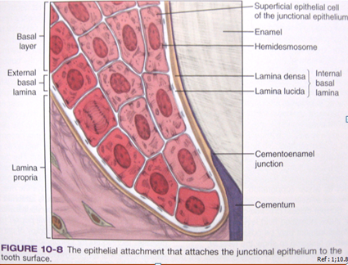

* The internal basement membrane was initially described as an 80-120nm wide homogeneous layer. It directly faces the enamel, with an intervening laminated or non-laminated layer of cuticles *(Listgarten, 1966)* or afibrillar cementum *(Kobayashi et al., 1976).*
* There are numerous fine strands crossing the lamina densa of the internal basement membrane at the hemidesmosomes. These strands may have been the anchoring filaments of hemidesmosomes (*Eady, 1994; Garrod, 1993).*
* In the cytoplasm of the cells of the junctional epithelium, the tonofibrils are associated with hemidesmosomes.
* The internal basement membrane of the dentogingival border is uniquely specialized for mechanical strength, sealing off the periodontal tissues from the oral environment *(Sawada & Inoue, 1996).*
* The internal basement membrane takes the form of both thin and multilayered thick basement membranes.
* Multilayered internal basement membrane may provide mechanical strength for firm attachment of the tooth to the gingiva and the sealing off of the periodontal tissues from the oral environment.
* The finer level structure of the internal basement membrane is, the “cord” network. The basic texture of the lamina densa is made up of a 3-dimensional network formed by anatomizing, irregular, thread-like structures referred to as “cords” *(Inoue, 1994; Sawada & Inoue, 2001).*

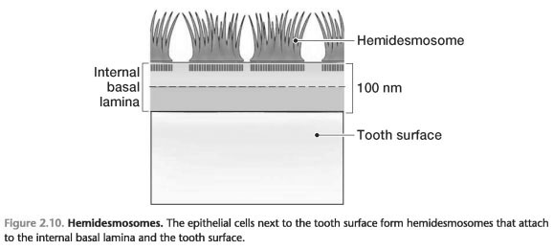

* These proteins mediate the attachment of the epithelial cell cytoplasmic keratin filaments to two transmembrane components of the hemidesmosome known as the - 180kDa bullous pemphigoid antigen (BP180)
* In general, the interaction between the different components of the extracellular matrix and the cell surface molecules linked to the intercellular cytoskeleton is fundamental for cell adhesion, cell motility, synthetic capacity, tissue stability, regeneration and responses to external signals.

PERMEABILITY OF JE

* The bi-directional arrows indicate that the junctional epithelium is the most permeable portion of the gingival epithelia.
* Because of its permeability to bacterial products and other assorted antigens, the connective tissue adjacent to the junctional epithelium tends to become infiltrated with chronic inflammatory cells, primarily lymphocytes and plasma cells.

TURN OVER RATE OF JE

* The turnover rate of JE cells is rapid.
* The DAT cells express a high density of transferrin receptors supporting the idea of active metabolism and high turnover.
* DAT cells have an important role in tissue dynamics and reparative capacity of the JE.
* The existence of a dividing population of DAT cells in a suprabasal location, several layers from connective tissue is a unique feature of JE.

MECHANISM

1. The daughter cells are produced by dividing DAT cells and replace degenerating cells on the tooth surface.
2. The daughter cells enter the exfoliation pathway and gradually migrate coronally between the basal cells and the DAT cells to eventually break off into the sulcus, or
3. Epithelial cells move/migrate in the coronal direction along the tooth surface and are replaced by basal cells migrating round the apical termination of the junctional epithelium.

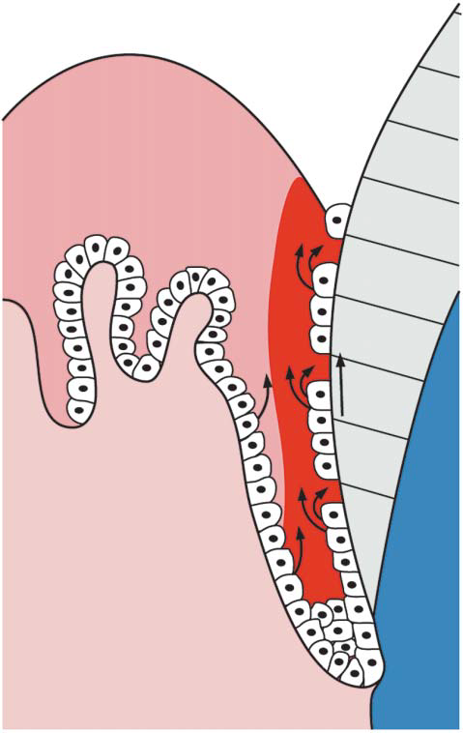

* Exfoliation must occur at extremely high rate ( Loe & Karring 1969)
* Since DAT cells are connected to basal lamina via hemidesmosomes, a remodelling of epithelial attachment must occur.
* Thus epithelial attachment normally is not static but dynamic.

JE IN THE ANTI-MICROBIAL DEFENSE

* Junctional epithelium consists of active populations of cells and antimicrobial functions, which together form the first line of defense against microbial invasion into tissue.
* Junctional epithelial cell layers provide a barrier against bacteria many bacterial substances, such as lipopolysaccharide, pass easily through the epithelium but have only limited access through the external basal lamina into the connective tissue (Shwartz et al 1972).
* Several antimicrobial mechanisms exist in the junctional epithelium. In the coronal part, the quick cell exfoliation:

(1) Because of rapid cell division

(2) Funnelling of junctional epithelial cells towards the sulcus hinder bacterial colonization. Laterally, the (external) basement membrane forms an effective barrier against invading microbes

(3) Active antimicrobial substances are produced in junctional epithelial cells. These include defensins and lysosomal enzymes

4). Epithelial cells activated by microbial substances secrete chemokines, e.g. interleukin- 8 and cytokines, e.g. interleukins -1 and -6, and tumour necrosis factor-a that attract and activate defense cells, such as lymphocytes (LC) and polymorphonuclear leukocytes (PMN). Their secreted product, in turn, cause further activation of the junctional epithelial cells.

ROLE OF ENZYMES IN THE DEFENSE MECHANISM OF JE

* Recently, it has been found that the junctional epithelial cells lateral to DAT cells produce matrilysin (matrix metalloproteinase-7) (Uitto VJ et al 2002).
* Matrilysin contributes to the mucosal defense by the release of bioactive molecules from the cell surfaces which play a role in the inflammatory reaction.

ROLE OF JE IN THE INTIATION OF POCKET FORMATION

* Conversion of the JE to pocket epithelium is regarded as a hallmark in the development of periodontitis.
* Pocket formation is attributed to a loss of cellular continuity in the coronal most portion of the JE
* Thus the initiation of pocket formation may be attributed to the detachment of the DAT cells from the tooth surface or to the development of intraepithelial split. (*Schluger et al 1977)*

THE DETACHMENT OF DAT CELLS FROM TOOTH SURFACE

* In the healthy sulcus, the amount of GCF is very small. However, its constituents participate in the normal maintenance of function of the junctional epithelium throughout its lateral and vertical dimensions, including the most coronal DAT cells.
* During inflammation the GCF flow increases and its composition starts to resemble that of an inflammatory exudate (Cimasoni et al 1983).

Intercellular spaces of JE

provides pathway for fluid & transmigratory leukocytes

a variety of molecules + leukocytes ( host defense system)

* Although all the junctional epithelial cells are constantly exposed to the GCF and its various constituents, the nutritional and other vital conditions in the different parts of the junctional epithelium depend on a large number of local factors.

ROLE OF POLYMORPHONUCLEAR LEUKOCYTES

* Polymorphonuclear leukocytes form the most important line of defense against bacterial plaque at the gingival margin (Page RC et al).
* Polymorphonuclear leukocytes are a major contributor in the host–parasite equilibrium but have a limited capacity to reclaim any tooth surface once lost to the plaque bacteria. The polymorphonuclear leukocytes are most effective in aerobic conditions close to the gingival margin (Dennison et al 1997), suggesting a different role for them in anaerobic periodontal lesions.
* The degeneration and detachment of DAT cells exposes tooth surface and creates a sub-gingival niche suitable for the colonization of anaerobic gram-negative bacteria and apical growth of dental plaque.

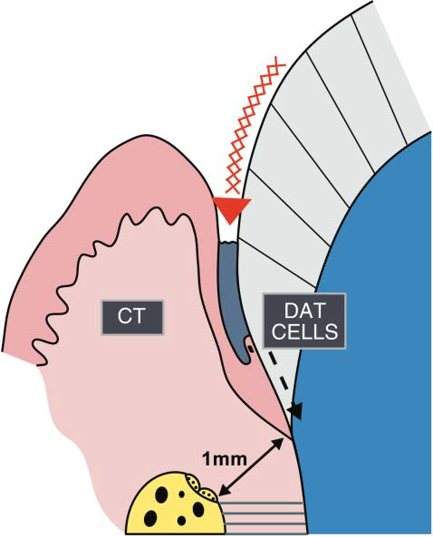

* Lactoferrin is an important antimicrobial protein present in the secondary granules of polymorphonuclear leukocytes.
* High concentrations of lactoferrin do, however, hamper epithelial cell growth by interfering with their adhesion and spreading.
* The molecule may, thus, have a role in delaying the repair of the junctional epithelium/DAT cell population during severe inflammation.

WOUND HEALING

* Surgical removal or detachment of the gingiva from the tooth is followed by formation of a new junctional epithelium and epithelial attachment.
* During healing after gingivectomy, hemidesmosomes appear before the lamina densa forms.
* No anchoring fibrils forms at the basal lamina abutting the tooth. wound healing studies at longer intervals shows normal junctional structure but derived from adjacent gingival epithelial basal cells.

REGENERATION OF JE

* Injury to JE may occur due to intentional or accidental trauma.
* Accidental trauma can occur during probing, flossing or tooth margin preparations for restorations.
* Intentional trauma occurs during periodontal surgeries where the JE is completely lost.
* *Frank et al 1972:* A study demonstrated that newly differentiated attachment apparatus with normal hemidesmosomal attachment is possible following surgery
* This new attachment apparatus was seen on cementum as well as dentin.
* *Listgarten 1972:*Hemidesmosomes appeared to form prior to the basal lamina. The basal lamina is initially formed in close proximity to the hemidesmosomes at both the tooth and connective tissue interface. At 4 to 7 weeks, the basal lamina appeared completely. Studies have shown that regeneration of JE after procedure usually occurs within 20 days.

JE AROUND IMPLANTS

* The junctional epithelium around implants always originates from epithelial cells of the oral mucosa, as opposed to the junctional epithelium around teeth which originates from the reduced enamel epithelium.
* Structurally, the periimplant epithelium closely resembles the junctional epithelium around teeth, although dissimilarities have also been reported (Inoue *et al.*, 1997; Ikeda *et al.*, 2000, 2002; Fujiseki *et al.*, 2003;Shimono *et al.*, 2003); (Berglundh *et al.*, 1991; Listgarten *et al.*, 1991; Buser *et al.*, 1992; Listgarten, 1996; Koka, 1998; Cochran, 2000)
* There is also evidence that several of the mentioned marker molecules involved in the defense mechanisms against the bacterial challenge are also expressed in the peri-implant epithelium (Schmid *et al.*, 1992).

|  |  |
| --- | --- |
| **NATURAL TOOTH** | **IMPLANT** |
| * Epithelium tapers   towards the depth | * Epithelium is thicker |
| * Large number of cell   Organelles | * Few organelles |
| * Fibers are arranged perpendicular | * Fibers are arranged   parallely |
|  | * Numerous kerato-   hyaline granules |

* Despite different origins of the 2 epithelia, a functional adaptation occurs when oral epithelia form an epithelial attachment around implants.

CONCLUSION

* DENTOGINGIVAL UNIT is important because of its anatomical location.
* It is the site of host-bacterial interaction in initiation of periodontal disease.
* There is a constant presence of bacteria and their products in the gingival sulcus which makes this an important structural component of periodontal defense mechanism.
* The conversion of the junctional epithelium to pocket epithelium is regarded as hallmark in the development of periodontitis.

REFERENCES

* *CARRANZA’s Clinical Periodontology.11TH EDITION.*
* *Clinical Periodontology and Implant Dentistry. JAN LINDHE 5TH EDITION.*
* *DD Bosshardt and NP Lang. The Junctional Epithelium: from health to disease. J Dent Res 2005, 84 (1): 9-20.*
* *Marja T. Pollanen. Jukka I,salonen& Veli-Jukka Uitto . Structue and function of the tooth- interface in health and disease Periodontology 2000, Vol.31, 2003, 12-31.*
* *Mark Bartold, Laurence J. Walsh & A. Sampath Narayanan. Molecular and cell biology of the gingiva.P. Periodontology 2000, Vol. 24, 2000, 28–55.*
* Huberte . Schroede & R M Listgarten. The gingival tissues: The architecture of periodontal Protection. Periodontology 2000, Vol. 13, 1997, 91-120.
* Takashi Sawada1 and Sadayuki Inoue. Ultrastructure of Dentogingival Border of Normal and Replanted Tooth and Dental Implant, chapter 11 www.intechopen.com/books/implantdentistry.