IN3101 - Enterprise Application Development

SwiftDrop Design Report
Parcel Delivery & Courier Management System



Department of Information Technology
Faculty Of Information Technology
University Of Moratuwa
Group Details

Group Number- 16
Index Number | Name
234175C | I V S Ranathunga
234040J | K T Chandupa
235069M | N H Kuruppu
235083B | P M N Perera
235055R | M H M A S Jayathissa
234022G | A G S Asalya
235068J | K A D N Keragala
235008D | Rangana
235111L | T.M.M.S. Thennakoon
235116G | K.J.S. Wathsala

Table of Contents
1. Introduction…………………………………………………………………………………1
1.1 Purpose………………………………………………………………………………….
1.2 Scope ……………………………………………………………………………………
1.2.1 Functional scope ………………………………………………………………….
1.2.2 External systems……………………………………………………………………
1.2.3 Assumptions and constraints …………………………………………………….
2. Use Cases …………………………………………………………………………………
2.1 Actors …………………………………………………………………………………….
2.1.1 Primary actors……………………………………………………………………...
2.1.2 External actors …………………………………………………………………….
2.2 Customer use cases …………………………………………………………………….
2.3 Merchant use cases ……………………………………………………………………..
2.4 Courier use cases ……………………………………………………………………….
2.5 Dispatcher and Admin use cases ………………………………………………………
2.6 Account use cases (every signed-in role) …………………………………………….
3. Data Model…………………………………………………………………………………….
3.1 Key modelling decisions…………………………………………………………………
3.2 ER diagram ……………………………………………………………………………..
4. Architecture Proposal ………………………………………………………………………
4.1 Architecture …………………………………………………………………………
4.2 Services …………………………………………………………………………………….
4.3 Justification…………………………………………………………………………………
4.4 Deployment…………………………………………………………………………………
5. Integration Design……………………………………………………………………………
5.1 Patterns used………………………………………………………………………………
5.2 Event contracts……………………………………………………………………………
5.3 Reliability rules………………………………………………………………………………
6. Key Flows……………………………………………………………………………………
6.1 Customer delivery flow……………………………………………………………………
6.2 Merchant API order creation………………………………………………………………
6.3 Courier status update triggering notifications……………………………………………
6.4 OAuth 2.0 login with Google ………………………………………………………………
6.5 Password reset ……………………………………………………………………………
6.6 Parcel status state machine………………………………………………………………
7. Security Design………………………………………………………………………………
8. Design Patterns and Principles……………………………………………………………
9. Summary…………………………………………………………………………………….
10. Appendix: UI wireframes…………………………………………………………………

1. Introduction

1.1 Purpose
SwiftDrop is a parcel delivery and courier management system for Sri Lanka. It puts the whole delivery chain on one platform: a customer or online merchant requests a delivery and sees the fee first, a dispatcher assigns a courier, the courier moves the parcel through its statuses and records proof of delivery, and anyone can follow the parcel with its tracking number.
Regional courier businesses commonly run this chain on phone calls, paper manifests and spreadsheets. That causes four problems:
- Prices are estimated by hand, so the same route can cost different amounts.
- Customers and merchants cannot see where a parcel is without calling.
- Merchants re-enter orders by hand and receive no automatic status updates.
- Status changes are neither controlled nor recorded, so lost parcels and disputed deliveries are hard to resolve.
SwiftDrop addresses these with zone-based fee rules, a fixed parcel life cycle enforced in code, an append-only status history, signed webhooks for merchants, and role-based access control.

Objectives
- Fee transparency. Show customers a rule-based fee before they confirm, and give every parcel a unique tracking number when it is created.
- Merchant integration. Give approved merchants API keys, an order API and signed webhooks with up to six delivery attempts.
- Controlled workflow. Let dispatchers assign couriers and monitor workload; let only the assigned courier change a parcel's status, with a reason required for a failed delivery and a recipient name required for a completed one.
- Auditability and data isolation. Record every status change with its actor and time, and limit each role to its own data.
- Timely updates. Send email notifications and live WebSocket updates for status changes, and signed webhooks for merchants, without manual page refreshes.

System in brief
SwiftDrop is a web application with a microservice backend.
Five user roles (customer, merchant, courier, dispatcher, admin) and public visitors use it.
A Next.js web application talks to Go services through one Nginx gateway. The services keep their data in one PostgreSQL 16 server with five schemas, and they exchange events through RabbitMQ, so a single parcel status change can trigger email, merchant webhooks, live tracking and merchant order sync. The architecture is described in Section 4 and the integration design in Section 5.

1.2.1 Functional scope
SwiftDrop covers the full delivery life cycle through nine areas.
- Accounts and access. Email and Google (OAuth 2.0) sign-in, password reset, and five roles that limit each user to what they may reach and own.
- Pricing and zones. Fee = base fee for the zone pair + weight band charge + size surcharge. Anyone can get an estimate, and administrators manage the pricing tables without changing fees already stored on parcels.
- Parcel creation and tracking. Customers create parcels with a price check and idempotency, get a tracking number and a PDF receipt, and see an append-only status history. A public page shows only status, cities and timeline.
- Dispatch. Dispatchers assign and reassign couriers, view courier workload and search every parcel.
- Courier operations. Only the assigned courier moves a parcel to its next allowed status. A failed delivery needs a reason, a completed one needs the recipient's name, and a photo is optional proof.
- Merchant integration. Registration with administrator approval, API keys, an order API that handles duplicates safely, and one signed webhook per merchant with up to six delivery attempts.
- Notifications and live updates. Parcel events trigger emails, merchant webhooks, live WebSocket tracking and merchant order sync.
- Administration and reporting. User, merchant and pricing management with an audit log, plus daily and outcome reports.
- Platform and quality. One-command Docker Compose start, database migrations and CI tests. A Kubernetes deployment and an AI assistant are optional bonus items.

1.2.2 External systems
- Google (OAuth 2.0): identity verification for social sign-in.
- SMTP email provider: delivery of notification and password-reset emails.
- Merchant systems: call the order API and receive signed webhook callbacks.

1.2.3 Assumptions and constraints
- Money and time: all fees are in LKR with two decimals. Timestamps are stored in UTC, and the courier's daily list uses the Asia/Colombo time zone.
- State machine: a parcel moves forward only: CREATED, PICKED_UP, IN_TRANSIT, OUT_FOR_DELIVERY, then DELIVERED or FAILED. DELIVERED and FAILED are final, and only the courier currently assigned to a parcel can change its status.
- Service autonomy: each service owns its tables and writes only to them. No foreign keys cross services; other services' data is reached through REST calls or RabbitMQ events.
- Privacy: public tracking and live updates show no names, addresses, phone numbers or notes. Event messages carry no addresses, phone numbers, tokens or photos. Personal data is kept out of logs.
- Proof of delivery: photos are JPEG or PNG, at most 5 MB, stored under generated file names and never served from a public path.

2. Use Cases

2.1 Actors
SwiftDrop has five authenticated roles plus unauthenticated public visitors. Figure 1 shows all of them.

Actor Type Description | Type | Description
Customer | Primary | Sends and tracks parcel
Merchant | Primary | Online store that creates orders through the API after admin approval
Courier | Primary | Collects and delivers parcels assigned to them
Dispatcher | Primary | Assigns parcels and monitors workload
Admin | Primary | Manages users, merchants, zones, pricing and reports. Includes all dispatcher use cases
Public visitor | Primary | Anyone without an account. Can track by tracking number (UC-C8) and ask the AI assistant (UC-C9)
Google | External | OAuth 2.0 and OpenID Connect identity provider
Merchant system | External | Calls the merchant order API with an API key and receives webhooks
Email service | External | SMTP server (Mailpit locally). Receives parcel notifications from the Notification Worker and reset links from Identity
AI model provider | External | Language model API for the assistant

2.2 Customer use cases
Customers send parcels through the SwiftDrop web application. They create an account (or sign in with Google), check the fee, request a delivery, and follow each parcel through its history, receipt and live tracking. Several of these use cases are also open to public visitors without an account (UC-C1, UC-C2, UC-C4, UC-C8, UC-C9). A customer can read only their own parcels: another person's parcel returns 404, so parcel IDs cannot be probed. Login, logout, profile and password reset are shared by every role and are in Section 2.6.

ID | Use case | Description | API
UC-C1 | Register and log in | Create an account and sign in with email and password. Passwords need at least 8 characters with upper case, lower case and a digit | 2.1 (POST /api/v1/auth/register), 2.2 (POST /api/v1/auth/login)
UC-C2 | Log in with Google | Sign in using the Google OAuth 2.0 authorization code flow | 2.5 (GET /api/v1/auth/google/login), 2.6 (GET /api/v1/auth/google/callback)
UC-C3 | Request a delivery | Enter pickup and drop-off details, zones, weight and size. The server recalculates the fee | 3.2 (GET /api/v1/zones), 4.1 (POST /api/v1/parcels)
UC-C4 | View estimated fee | See the fee breakdown (base fee, weight charge and size surcharge, in LKR) before confirming. Included in UC-C3. | 3.1 (POST /api/v1/pricing/estimate)
UC-C5 | Track a parcel in real time | See live status changes on the tracking page | 4.3 (GET /api/v1/parcels/{parcelId}), 9 (WS /ws, subscribe by trackingNumber)
UC-C6 | View delivery history | List past and current parcels, filter by status and date, and see each status history | 4.2 (GET /api/v1/parcels), 4.4 (GET /api/v1/parcels/{parcelId}/history)
UC-C7 | Download receipt | Download a PDF receipt with the tracking number, parties, cities, weight, size, the stored fee breakdown, status and dates. | 4.5 (GET /api/v1/parcels/{parcelId}/receipt)
UC-C8 | Track by public number | Anyone can look up a parcel by tracking number on a mobile friendly page. Only public fields are shown | 4.6 (GET /api/v1/tracking/{trackingNumber})
UC-C9 | Ask the AI assistant | Ask about parcel status or prices (optional bonus). | 12.1 (POST /api/v1/ai/chat)

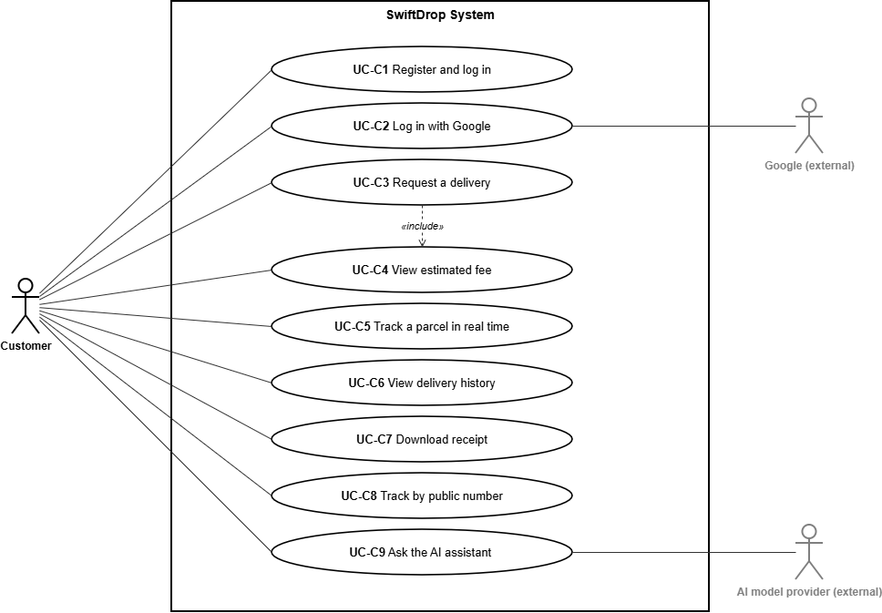

2.3 Merchant use cases

2.4 Courier use cases
Couriers interact with SwiftDrop through a mobile-friendly interface to view their daily delivery manifest, progress parcels through the delivery lifecycle, and capture proof of delivery. To maintain strict operational accountability, couriers can only view and update parcels that are actively assigned to them (403 FORBIDDEN is returned if a courier attempts to access or modify an unassigned parcel or one assigned to another courier).

ID | Use case | Description | API
UC-D1 | Log in | Authenticate as a courier using email and password (COURIER role). Sessions use HttpOnly cookies (sd_access and sd_refresh) or Bearer tokens for API testing. | 2.2 (POST /api/v1/auth/login)
UC-D2 | View assigned deliveries | See active deliveries plus those finished (DELIVERED or FAILED) on the selected day (in the Asia/Colombo time zone), with sender/recipient contacts, status history, and proof metadata. | 6.1 (GET /api/v1/courier/deliveries), 6.2 (GET /api/v1/courier/deliveries/{parcelId})
UC-D3 | Update parcel status | Move a parcel through Picked Up (PICKED_UP), In Transit (IN_TRANSIT), Out for Delivery (OUT_FOR_DELIVERY) and Delivered (DELIVERED). Delivered needs the recipient name (recipientName). | 6.3 (POST /api/v1/courier/deliveries/{parcelId}/status)
UC-D4 | Add proof or note | Upload proof of delivery (multipart/form-data): recipient name (recipientName, up to 150 chars), note (note, up to 500 chars), or a JPEG or PNG photo up to 5 MB. | 6.4 (POST /api/v1/courier/deliveries/{parcelId}/proof)
UC-D5 | Record failed delivery | Mark FAILED with a mandatory failure reason (failureReason) of 5 to 255 characters. | 6.3 (POST /api/v1/courier/deliveries/{parcelId}/status)

Design Rationale (Section 2.4)
- Object-Level Ownership Enforcement: Every courier endpoint in the Parcel Operations service verifies parcels.current_courier_id against the authenticated courier's JWT sub claim before reading or mutating data.
- Safe Proof File Handling (UC-D4): Uploaded delivery proof photos are restricted to JPEG and PNG formats up to 5 MB (413 PAYLOAD_TOO_LARGE and 415 UNSUPPORTED_MEDIA_TYPE enforce limits), saved under generated safe filenames, and never served from a public static path.
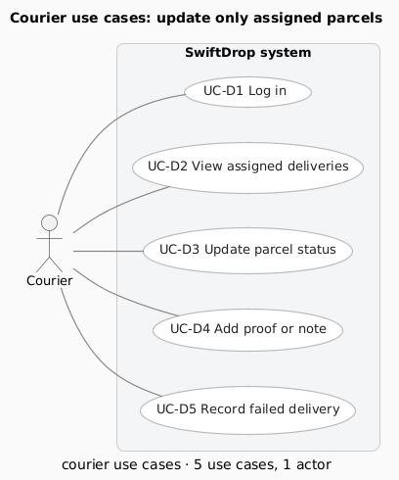

2.5 Dispatcher and Admin use cases
Dispatchers manage daily delivery operations by assigning unassigned parcels to eligible couriers, balancing courier workload, and monitoring live parcel movements across the island. Administrators (ADMIN) inherit every DISPATCHER permission (UC-A1, UC-A2, UC-A3, UC-A7, UC-A8) and additionally control staff user accounts, merchant approvals, and service zones and pricing rules (UC-A4, UC-A5, UC-A6).

ID | Use case | Description | API
UC-A1 | View unassigned parcels | List parcels with no current courier, filtered by pickup zone (zoneId) and date range (from, to), sorted oldest first (createdAt:asc) for dispatch planning. | 5.1 (GET /api/v1/dispatch/unassigned)
UC-A2 | Assign or reassign courier | Assign an active, available courier, or reassign to a different courier with an optional reason. Closed parcels (DELIVERED or FAILED) cannot be assigned (409 PARCEL_CLOSED). | 2.15 (GET /api/v1/couriers), 5.2 (PUT /api/v1/dispatch/parcels/{parcelId}/assignment)
UC-A3 | Monitor courier workload | View availability (isAvailable) and active deliveries per courier, broken down by status (CREATED, PICKED_UP, IN_TRANSIT, OUT_FOR_DELIVERY). | 5.3 (GET /api/v1/dispatch/workload)
UC-A4 | Manage users | Create staff accounts (COURIER, DISPATCHER, ADMIN), view and edit profiles, and activate or deactivate users (Admin only; audited). | 2.10 to 2.14 (/api/v1/admin/users...)
UC-A5 | Approve merchants | List and view merchant applications; approve, reject (with required reason), or suspend merchants (Admin only; audited). | 8.4 to 8.8 (/api/v1/admin/merchants...)
UC-A6 | Manage zones and pricing | Create and update delivery zones, base-fee rules per zone pair, weight bands, and size surcharges (Admin only; audited). | 3.3 to 3.12 (/api/v1/admin/zones..., /api/v1/admin/pricing...)
UC-A7 | View reports | View daily counts of created, delivered, and failed parcels, plus overall success/failure rates and top failure reasons. | 7.1 (GET /api/v1/reports/daily), 7.2 (GET /api/v1/reports/outcomes)
UC-A8 | Search and monitor parcels | Search every parcel by status, courierId, merchantId, customerId, or trackingNumber, and watch all live updates over WebSocket (scope: "all"). | 5.4 (GET /api/v1/admin/parcels), 9.2 (WS /ws with scope: "all")

Design Rationale (Section 2.5)
- Role Inheritance (ADMIN -> DISPATCHER): Rather than duplicating operational screens and endpoints, ADMIN satisfies every DISPATCHER authorization check while isolating sensitive configuration (UC-A4 to UC-A6) to ADMIN alone. All administrative actions write append-only records to the owning service's audit_logs table.
- Decoupled Courier Eligibility Check (UC-A2): Because Identity owns user/courier profiles (identity.users, identity.courier_profiles) and Parcel Operations owns assignments (parcel.parcel_assignments), Parcel Operations verifies that a target courier is active, available, and holds the COURIER role via the synchronous internal API GET /internal/couriers/{courierId}/eligibility before saving an assignment (422 COURIER_NOT_ELIGIBLE if ineligible).
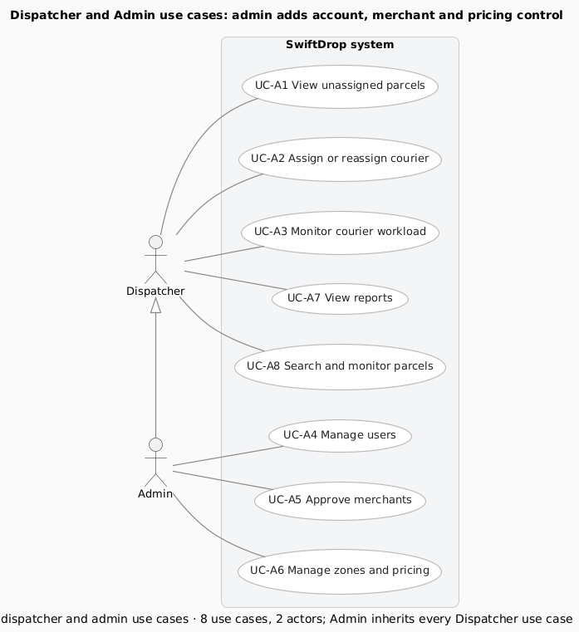

2.6 Account use cases (every signed-in role)

3. Data Model
This section describes the database design of SwiftDrop using the SwiftDrop Database Design Document — Version 1.1 (aligned with API v1.1) as the planned specification. The repository migrations and Figure 6 distinguish that design from the SQL definitions present at revision 0106b4a. A table defined by a migration is not, by itself, evidence that it is deployed in a shared database or used by a completed business workflow.

3.1 Key modelling decisions

3.1.1 Database architecture and service ownership
SwiftDrop uses PostgreSQL 16 as its relational persistence platform. Local development uses one database instance with five service-owned schemas: identity, pricing, parcel, merchant and notification. Schema separation establishes ownership without requiring five database servers. Each service is responsible for its own writes; information owned by another service is obtained through REST APIs or RabbitMQ events rather than direct access to that service's tables (DB v1.1, §§1–2).
Local transactions provide consistency within an owning service. For example, a parcel change, its status-history record and the corresponding outbox entry are designed to commit together. The outbox supports later asynchronous publication, but the existence of its table does not establish that a relay or event-producing business handler is implemented. Realtime and the Webhook Worker own no tables in this 26-table design; the Webhook Worker records delivery attempts through the Merchant service's internal API.

3.1.2 Table inventory and audit ownership
All 26 planned tables have corresponding creation statements in their schema's 000002_tables.up.sql baseline and matching rollback definitions. The three audit_logs instances are separate physical tables, not a shared audit table. Each owning service writes its own audit records.
Schema and owner | Planned tables with verified SQL definitions | Count
identity — Identity and User service | roles; users; courier_profiles; refresh_tokens; oauth_states; audit_logs; password_reset_tokens | 7
pricing — Pricing and Zones service | zones; pricing_rules; weight_bands; size_surcharges; audit_logs | 5
parcel — Parcel Operations service | parcels; parcel_status_history; parcel_assignments; delivery_proofs; outbox_events | 5
merchant — Merchant Integration service | merchants; merchant_api_clients; merchant_webhooks; merchant_orders; webhook_delivery_attempts; merchant_order_status_events; audit_logs | 7
notification — Notification Worker | notification_logs; processed_events | 2
Total | Five schemas; three distinct `audit_logs` tables | 26
Migration bookkeeping tables are infrastructure and are excluded from this inventory. The inspection confirms repository definitions; the current applied state of a shared or production database was not inspected.

3.1.3 Keys and relationships
Most entities use a UUID primary key named id. The PDF specifies application-generated UUIDs, while the baseline also supplies gen_random_uuid() defaults as a database fallback. The documented exceptions are identity.roles.id (SMALLINT), identity.courier_profiles.user_id (a shared primary key and foreign key), identity.oauth_states.state (VARCHAR(64)), and the composite (consumer, event_id) key of notification.processed_events. Timestamps use TIMESTAMPTZ; monetary values use exact NUMERIC(12,2) values with LKR as the documented default.
The migration chain declares 15 actual foreign keys: four in Identity, two in Pricing, three in Parcel and six in Merchant. None crosses a service schema. Unique keys make a courier profile optional and singular for a user, a webhook optional and singular for a merchant, and a merchant order unique for its linked parcel. A parent can exist before its child rows; a foreign key alone does not create a parcel's initial history entry.
The planned design uses 20 column-level cross-service UUID references. M6's migration adds previous_courier_id, giving 21 references in the implementation-aware Figure 6. These include parcel owners, couriers, zones, record creators and merchant order links. They are not database foreign keys; owning-service validation belongs to the application workflow. Event identifiers are correlation and deduplication values, not automatically foreign keys to the outbox. Audit entity identifiers and outbox aggregate identifiers are polymorphic and have no fixed target asserted by the diagram.

3.1.4 Integrity constraints and reporting indexes
Parcel ownership is enforced by an exclusive-or CHECK: exactly one of customer_user_id and merchant_id must be populated. Partial unique indexes enforce (customer_user_id, idempotency_key) and (merchant_id, external_order_id) when the relevant values are present. Tracking numbers are unique, and their prefix must match the owner category. Replay/conflicting-payload response behaviour remains an application responsibility.
Allowed parcel statuses are constrained, and a database trigger rejects invalid transitions. DELIVERED requires delivered_at and delivered_to_name; FAILED requires failed_at and a reason of at least five characters. Status history references its parcel and is append-only. A partial unique assignment index permits at most one current courier per parcel, and a closed assignment requires unassigned_at. The application must coordinate parcel, history, assignment and outbox writes within the appropriate transaction.
Pricing rules permit one active rule per origin/destination zone pair. Active weight bands are protected against overlap by an exclusion constraint. Monetary and weight checks protect the relevant nonnegative or positive values. Parcel migration 000004 requires the stored price-total expression to evaluate to TRUE, preventing JSON-null components from bypassing the PDF's requirement that the total equals the three price components.
Merchant constraints include one merchant per owner, one webhook per merchant, scoped external-order and idempotency uniqueness, and at most five active API keys. Webhook attempts are unique by (webhook_id, event_id, attempt_number), and merchant status-event IDs are unique. Notification logs use (event_id, channel, recipient) uniqueness, while processed_events uses its composite key for consumer deduplication. These schema provisions do not establish that their consumers, authentication or delivery handlers are operational.
The Parcel baseline includes indexes on customer, merchant and current courier IDs; (status, created_at); created_at; delivered_at; failed_at; and (pickup_zone_id, created_at). History uses (parcel_id, created_at) and (new_status, created_at). These support dispatch, timelines and reporting filters. Additional indexes support courier workloads, merchant order lists, webhook delivery logs, and each audit table's (entity_type, entity_id) and created_at lookups. Their presence is verified; performance at production data volumes has not been established.

3.1.5 Migration strategy and implementation status
SwiftDrop uses golang-migrate versioned SQL pairs under migrations/<service>/, with a separate <service>_schema_migrations version table for each service. Version 000001 creates the owning schema and 000002 creates the baseline business tables. The project's bootstrap supplies the shared timestamp-trigger helper. Migrations are run explicitly through the project tooling, not automatically at application startup. Applied migrations remain immutable; corrections are introduced through later versions.
Forward migration | Verified implementation beyond the baseline
Parcel 000003_dispatch_foundations | Adds assignment reassignment/audit metadata, its timestamp trigger, and paired outbox aggregate metadata with an index. It does not recreate baseline tables.
Parcel 000004_price_breakdown_total | Closes the JSON-null price-total CHECK loophole without adding tables or foreign keys.
Merchant 000006_merchant_constraints | Adds stricter nonblank, approval/rejection, hash-format, amount, JSON-object and currency CHECKs.
Recorded isolated PostgreSQL 16.15 verification covers the five-service migration chain, its 26-table inventory, rollback/reapply, relevant constraints and the M5 repository's caller-owned transactions. Recorded CI verification also passed at revision 0106b4a. These results establish tested source behaviour, not the current contents of a shared deployment or completion of every planned service feature. Down migrations can remove tables or schemas and require a confirmed disposable target; no database operation was performed to prepare this report section.

3.1.6 Verified differences and outstanding confirmations
Item | Verified position and outstanding action
Specification wording | The reference is Version 1.1, aligned with API v1.1. The original PDF's shortened internal “v1” heading must not be interpreted as a different technical specification. Title wording can be clarified without changing its requirements.
M6 additions | Assignment previous_courier_id/updated_at and outbox aggregate_type/aggregate_id exist in SQL but are absent from the PDF table lists. Figure 6 marks them with +. Their inclusion in a revised normative specification needs owner agreement; no confirmation is recorded here.
Merchant strengthening | Migration 000006 introduces stricter validation, including LKR-only order currency. Whether these should become explicit normative v1.1 requirements requires the Merchant owner's confirmation.
Outbox contract | The PDF and SQL use legacy unversioned storage labels, whereas the implemented bus contract requires versioned event names and a different envelope. Storage-to-wire mapping and consumer contracts remain a platform/M6 integration decision.
Seeds and guide | The PDF plans demo users, but no user-seeding command was found. The migration guide also still lists Parcel 000004 as available although it is occupied; the next unused Parcel version is 000005. These are documentation/implementation follow-ups, not missing tables.
The original PDF remains unchanged. The missing repository reference-PDF path, the supplied PDF's provenance, exact table/relationship register and source paths are recorded in the Figure 6 verification register. No statement in this section represents an undocumented table-owner approval.

3.2 ER diagram
Figure 6 presents the complete 26-table model in five coloured schema groups. Each table shows its primary key and important relationship columns. Solid arrows identify the 15 migration-declared foreign keys within the owning service. Dashed arrows labelled REF identify logical cross-service references; they do not imply database enforcement. The three audit_logs cards remain distinct. The legend also distinguishes local logical and polymorphic identifiers for which no FK edge is asserted.
The diagram combines the planned DB v1.1 inventory with explicitly marked SQL overlays. All 26 table definitions are verified in migrations; this is not a deployment assertion. Orange + fields and R13 identify M6-only additions. Business columns are abbreviated, and the companion verification register lists every table, primary key and relationship. Figure 6 is supplied as an editable diagrams.net file, a vector SVG and a 5400 × 3819 PNG. A separate A3 landscape sheet preserves readability; it should not be reduced to a small inline image on a portrait report page.
Source basis: *SwiftDrop Database Design Document — Version 1.1 (aligned with API v1.1)*, §§1–11; repository migrations at 0106b4a; and Figure 6 verification register. This section follows the existing report's “3. Data Model”, “3.1 Key modelling decisions” and “3.2 ER diagram” structure.

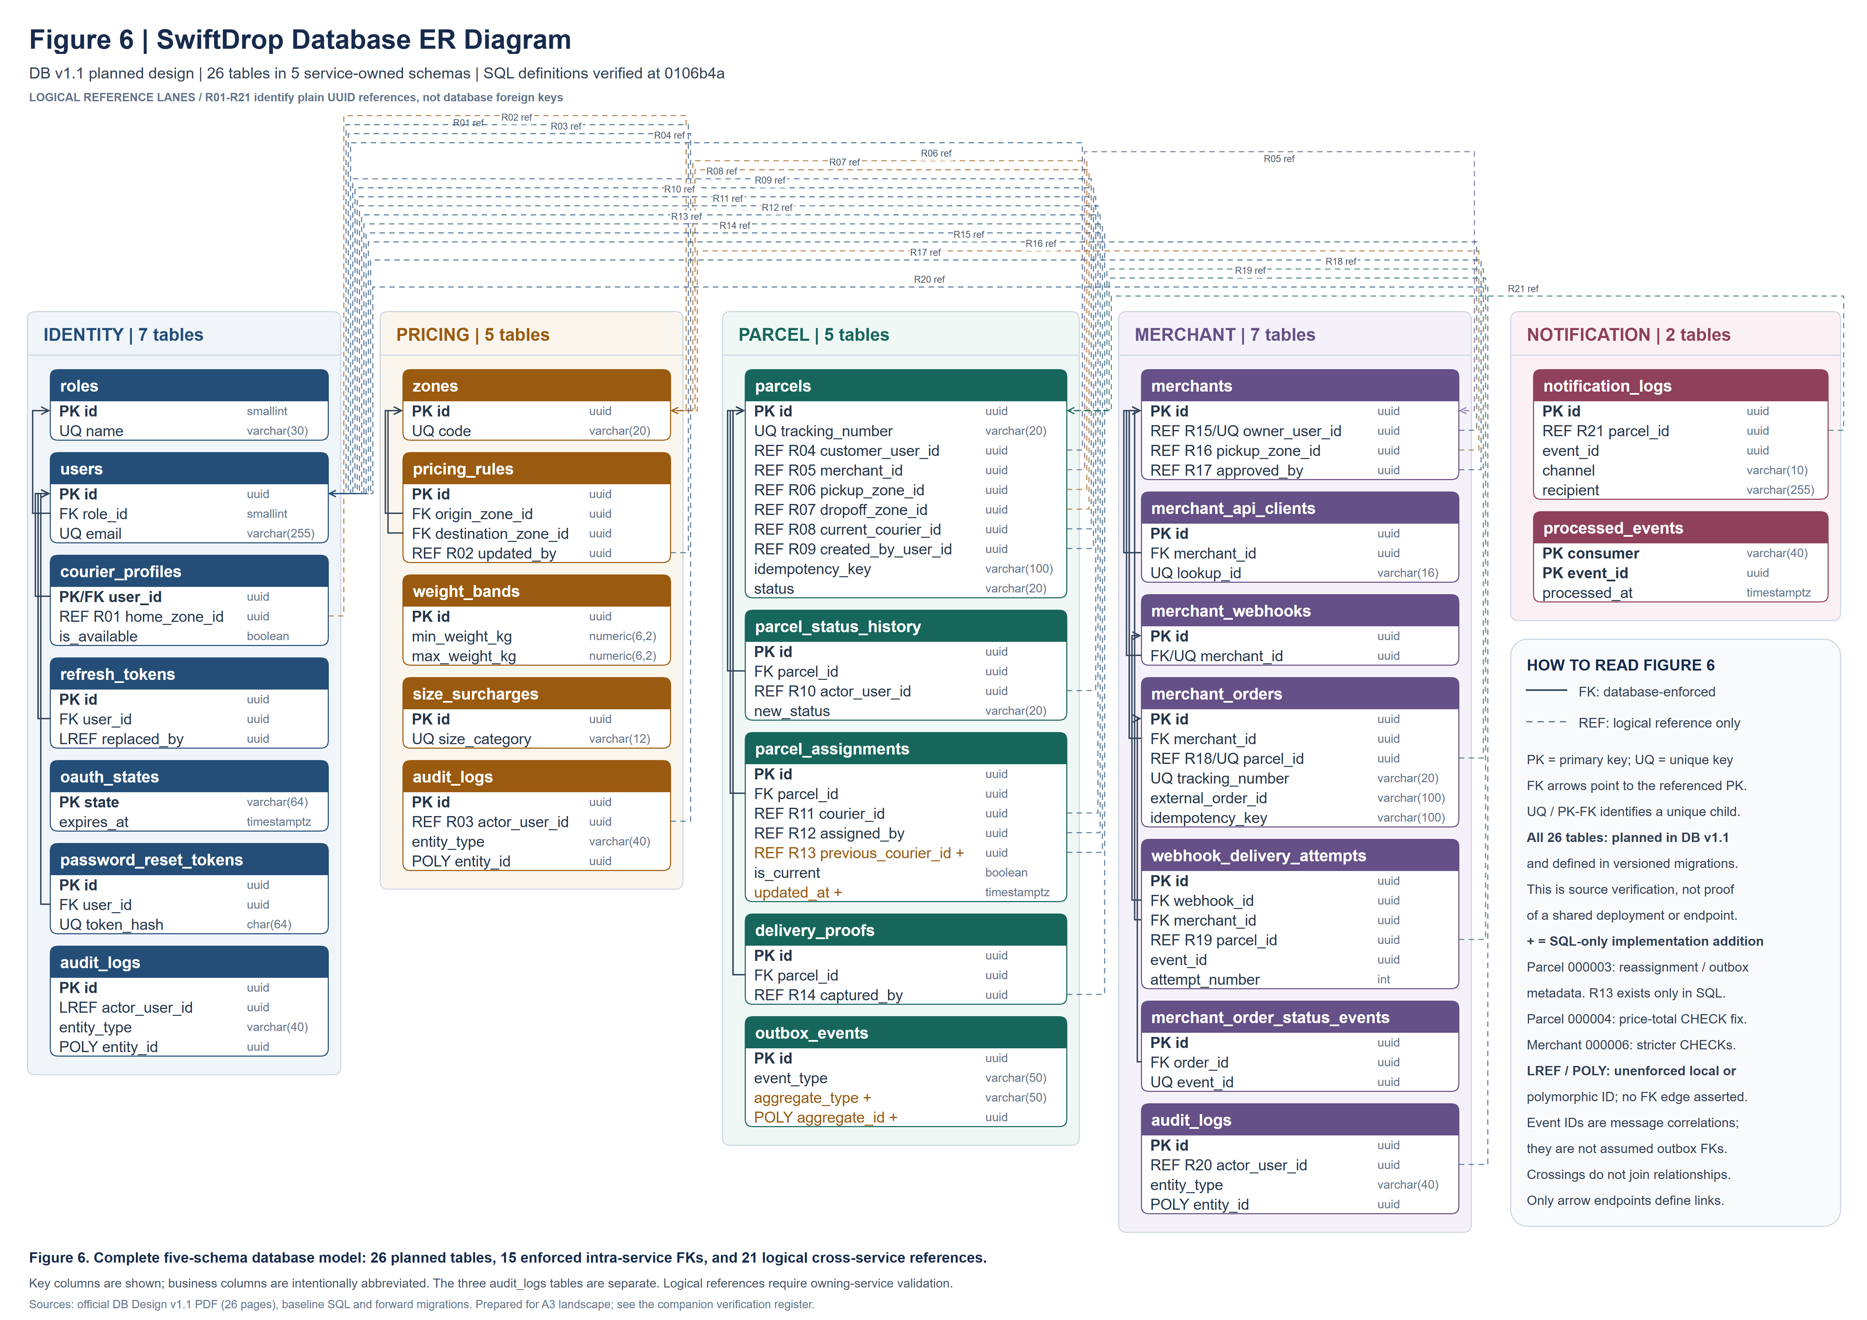
Figure 6: SwiftDrop database ER diagram — 26 planned tables across five service-owned schemas; solid database foreign keys and dashed logical references.

4. Architecture Proposal

4.1 Architecture

4.2 Services
SwiftDrop follows a layered, domain-oriented microservice architecture. The three layers are shown in the table below and in the Architecture diagram.

Layer | Technology | What it holds
Presentation | Next.js web app | Screens for all five roles and the public tracking page. It contains no business rules
Business logic | Go and Gin services and workers, behind the Nginx gateway | Handler, service and repository layers inside each service
Data | PostgreSQL 16 and RabbitMQ | Service-owned tables, and the events sent between services

The business logic layer is split into seven deployable Go units: five HTTP services and two workers. Each unit owns its schema in PostgreSQL and is the only writer of its tables. Other services reach its data through REST (public endpoints, or /internal endpoints protected by X-Internal-Token) or through RabbitMQ events. There are no shared tables and no cross-service foreign keys.

Unit | Responsibility | Does not do
Identity and User | Accounts, password login with lockout, Google OAuth, JWT and refresh tokens, password reset including the reset email, roles, courier profiles, admin user management, courier eligibility checks | Parcel lifecycle, pricing
Parcel Operations | Parcel creation, tracking numbers, status transitions and history, dispatch (assignment, workload, parcel search), proof uploads, receipts, reports, outbox and event publishing | Merchant credentials, pricing rules, sending email
Pricing and Zones | Zones, pricing rules, weight bands, size surcharges, public estimates and internal quotes | Parcel status
Merchant Integration | Merchant registration and approval, API keys, merchant order endpoint, webhook configuration and test, delivery log, order sync consumer, internal API for the Webhook Worker | Sending webhooks inline
Realtime Service | Pushes public-safe updates over WebSocket from parcel.status_changed and parcel.assigned | Being the source of truth, storing state
Notification Worker | Consumes parcel.created and parcel.status_changed, fetches contact details through the internal API, sends email, logs each send | Blocking the status update, sending password reset emails
Webhook Worker | Sends signed webhooks with up to six attempts, reads the secret and records each attempt through the Merchant internal API | Merchant authentication, owning tables

Four consumers act on parcel events independently: the Notification Worker, the Webhook Worker, the Realtime Service and the merchant sync consumer inside Merchant Integration. A slow email or webhook therefore never delays the courier.

4.3 Justification

Three architecture options were considered.

Option | Assessment
Single monolith | Simplest to build, but the assignment expects asynchronous integration and independent containers. A team of ten working in parallel would share one codebase and one release, so a broken change in one area blocks everyone
Modular monolith with a BFF | A reasonable option and easier to operate. However, notifications, webhooks and live tracking still need separate processes, so most of the complexity of services remains without the isolation
Domain-oriented microservices (chosen) | One owner per service, independent containers, failure isolation (an email outage never blocks a status update) and a natural fit for the event-driven requirements
Why microservices fit this system
- The requirements are event driven. One status change must trigger an email, a signed webhook, a live update and a merchant order update, which suits separate consumers on a message broker.
- Failure isolation. The status, history row and outbox event are saved in one transaction and the consumers run afterwards, so notification and webhook failures never roll back or delay the courier’s update.
- Parallel work. Each member owns a service and its tables and builds against agreed contracts.
- Clear data ownership. One schema per service with no cross-service foreign keys stops one team’s change from breaking another’s.
Costs and how the design handles them
- More moving parts: one Docker Compose command starts every container, and each service exposes health and readiness endpoints.
- Consistency across services: the transactional outbox, idempotent consumers (checked by eventId) and idempotency keys prevent lost or duplicated events.
- Over-fragmentation: the design keeps seven deployable units, not one per table, and keeps dispatch and reporting inside Parcel Operations.
- Shared database server: one PostgreSQL server is used locally for simplicity, but each service writes only to its own schema.
Decision: layered, domain-oriented microservices behind a single Nginx gateway, with RabbitMQ carrying the events.

4.4 Deployment

5. Integration Design
SwiftDrop uses a combination of synchronous HTTP communication and asynchronous event-driven messaging to coordinate its independent services. Synchronous communication provides immediate responses for operations such as creating parcels, calculating delivery fees and validating users. Asynchronous communication allows notifications, webhook deliveries, realtime tracking and merchant updates to take place independently of the original parcel operation.

The integration architecture is designed around loose coupling, reliable event delivery, data ownership and secure service-to-service communication.

5.1 Patterns used
Integration Pattern | Where It Is Used | Purpose
Request–Response (REST/HTTP) | Web application to backend services; AI tools to public APIs | Provides immediate responses for requests such as fee estimates, parcel creation and parcel tracking.
Internal Service APIs | Parcel to Pricing and Identity; Merchant to Parcel; workers to relevant internal services | Allows services to retrieve required information without directly accessing another service's database. Internal endpoints use X-Internal-Token and are not exposed through Nginx.
Publish–Subscribe Messaging | Parcel Operations publishes events to the RabbitMQ swiftdrop.events topic exchange | Enables multiple consumers to react to parcel events without blocking the original request.
Durable Queues and Dead-Letter Queues | Notification, Webhook, Realtime and Merchant Sync consumers | Provides independent message processing and preserves repeatedly failed messages for investigation.
Transactional Outbox | parcel.outbox_events and the event relay | Stores the business change and outgoing event within one database transaction, reducing the risk of losing events when RabbitMQ is unavailable.
Idempotent Consumers | Notification Worker, Webhook Worker and Merchant Sync | Uses event identifiers and deduplication records to prevent duplicate processing when messages are redelivered.
Idempotent Requests | Parcel creation and merchant order creation | Prevents repeated client requests from generating duplicate parcels or merchant orders.
WebSocket Server Push | Realtime Service to customer, courier and staff interfaces | Delivers live parcel tracking updates without continuous HTTP polling.
Outbound Webhooks | Webhook Worker to external merchant systems | Notifies merchant platforms of parcel status changes without requiring them to poll SwiftDrop.
API Gateway | Nginx | Provides a single public entry point and forwards requests to the appropriate backend services.
OAuth 2.0 Authorization Code Flow | Identity Service with Google | Supports delegated authentication without handling users' Google passwords.
API Key Authentication | Merchant order endpoints | Supports authenticated server-to-server access using securely stored, hashed API keys.

5.2 Event contracts
SwiftDrop uses RabbitMQ as its asynchronous message broker to enable communication between the Parcel Operations Service and downstream services. Instead of requiring every service to communicate synchronously, parcel-related events are published to a central exchange and routed to the appropriate consumer queues.

5.2.1 Exchange and Queue Configuration
The main RabbitMQ exchange is swiftdrop.events, configured as a durable topic exchange. Parcel Operations publishes events using routing keys that describe the business action.
The dead-letter exchange, swiftdrop.dlx, is configured as a durable direct exchange. Messages that cannot be processed successfully can be transferred to the appropriate dead-letter queue for investigation.
RabbitMQ Exchange and Queue Configuration
Component | Exchange / Queue Name | Routing Key or Binding | Consumer
Main event exchange | swiftdrop.events | Topic exchange | Parcel Operations publishes
Dead-letter exchange | swiftdrop.dlx | Direct exchange | Failed-message handling
Notification queue | notification.queue | parcel.created, parcel.status.changed | Notification Worker
Webhook queue | webhook.queue | parcel.status.changed | Webhook Worker
Realtime queue | realtime.queue | parcel.status.changed, parcel.assigned | Realtime Service
Merchant sync queue | merchant.sync.queue | parcel.status.changed | Merchant Integration

Each consumer queue is durable and has a corresponding dead-letter queue, such as notification.queue.dlq and webhook.queue.dlq, bound to swiftdrop.dlx. Messages are persistent, and consumers acknowledge messages only after successful processing. Consumers also use eventId to identify and prevent duplicate processing.

5.2.2 Event Catalogue

SwiftDrop defines three primary parcel events. The event type identifies the business action, while the routing key determines which queues receive the message.
Event Type | Routing Key | Publisher | Consumers
parcel.created | parcel.created | Parcel Operations | Notification Worker
parcel.assigned | parcel.assigned | Parcel Operations / Dispatch | Realtime Service
parcel.status_changed | parcel.status.changed | Parcel Operations | Notification Worker, Webhook Worker, Realtime Service, Merchant Integration

Parcel Created: Published when a new parcel is successfully created. The event includes the initial CREATED status and identifies the customer or merchant associated with the parcel.

Parcel Assigned: Published when dispatch assigns or reassigns a courier. It contains the courier identifier, previous courier identifier where applicable, and the user who performed the assignment.

Parcel Status Changed: Published when a parcel moves between permitted delivery statuses. It includes the previous and new statuses and supports notifications, merchant webhooks, realtime tracking and merchant status synchronization.

The event type parcel.status_changed uses an underscore, whereas the routing key parcel.status.changed uses dots. This distinction is intentional and must be preserved.

Each event contains a unique eventId, an eventType, a timestamp and a schemaVersion, alongside relevant parcel information. These fields support event identification, compatibility and duplicate-processing prevention. Sensitive information such as addresses, phone numbers and authentication tokens is excluded from event payloads.

5.2.3 RabbitMQ Topology Diagram

The topology diagram illustrates the central swiftdrop.events exchange, the four durable consumer queues, their respective routing-key bindings, and dead-letter handling through swiftdrop.dlx.

Parcel Operations acts as the publisher. Each downstream service consumes only the events relevant to its responsibility, allowing notifications, webhook deliveries, realtime updates and merchant synchronization to operate independently.

This design prevents downstream processing delays from blocking core parcel operations and allows failed event processing to be investigated separately
.
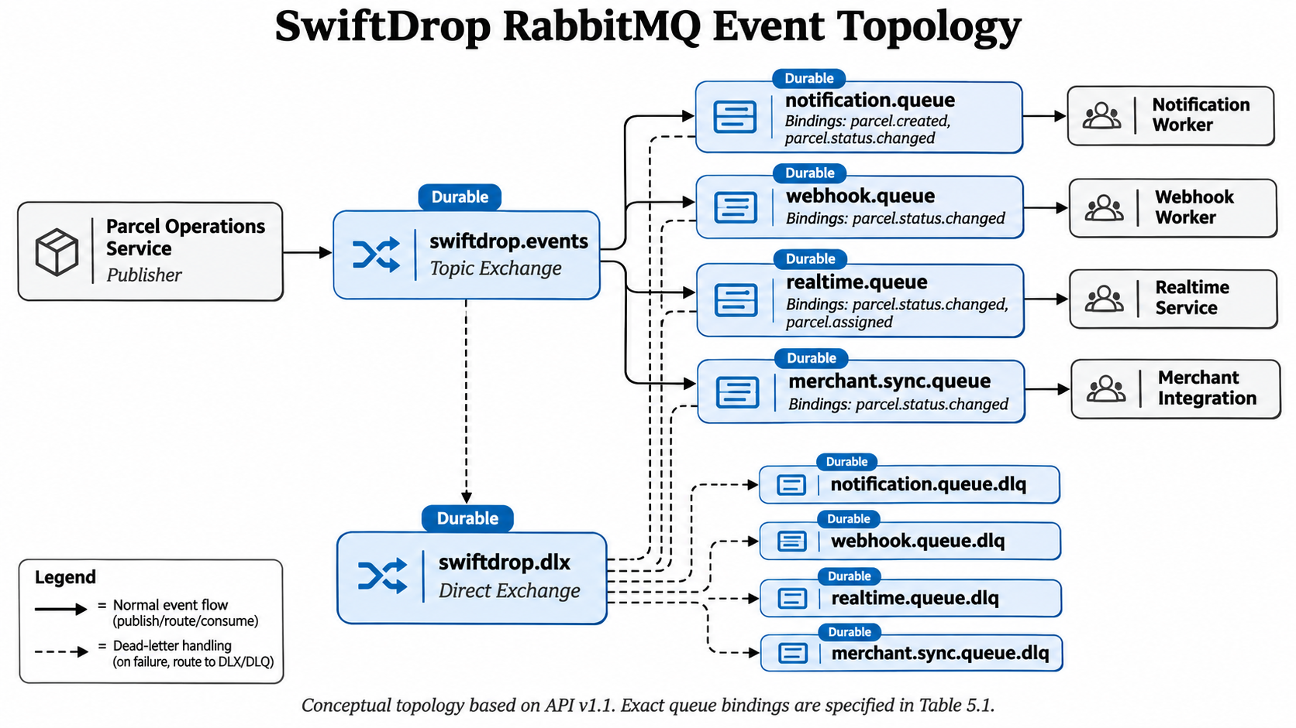

5.3 Reliability rules
SwiftDrop's event-driven architecture is designed to support reliable message delivery, fault tolerance and duplicate-processing prevention.
5.3.1 Reliable Event Publishing
The Parcel Operations Service uses the transactional outbox pattern. Parcel changes and corresponding event records are stored within the same database transaction. An outbox relay subsequently publishes pending events to RabbitMQ, reducing the risk of losing events when the message broker is temporarily unavailable.
5.3.2 Message Durability and Dead-Letter Handling
RabbitMQ exchanges and consumer queues are configured as durable, and published messages are persistent. Consumers acknowledge messages after successful processing. Messages that repeatedly fail are routed to dead-letter queues through the swiftdrop.dlx exchange for investigation.
5.3.3 Webhook Retry Policy
Failed webhook deliveries follow the six-attempt schedule specified in API Documentation v1.1:
Attempt | Retry timing
1 | Now (immediate)
2 | 1 minute
3 | 5 minutes
4 | 30 minutes
5 | 2 hours
6 | 6 hours
The required schedule is: now, 1 minute, 5 minutes, 30 minutes, 2 hours, 6 hours.
After the sixth unsuccessful attempt, the webhook delivery is considered exhausted and requires failure handling. This policy applies to webhook delivery attempts and should not be confused with RabbitMQ's internal consumer-reconnection policy.
5.3.4 Idempotency and Duplicate Prevention
RabbitMQ messaging may result in repeated delivery of the same event. Consumers therefore use the unique eventId to identify previously processed messages.
The notification.processed_events table supports consumer-level deduplication through the composite primary key (consumer, event_id). Additionally, notification.notification_logs prevents duplicate records using the unique combination (event_id, channel, recipient).
These mechanisms support reliable asynchronous processing while reducing duplicate notification and webhook side effects.

6. Key Flows

6.1 Customer delivery flow

6.2 Merchant API order creation

6.3 Courier status update triggering notifications

6.4 OAuth 2.0 login with Google

6.5 Password reset

6.6 Parcel status state machine
Every parcel in SwiftDrop follows a deterministic, single-direction state machine enforced in the Parcel Operations service layer and documented at the data level.

Current status | Allowed next status | Terminal? | Validation & Field Rules
CREATED | PICKED_UP, FAILED | No | Initial status set when a customer (POST /parcels) or merchant (POST /merchant/orders) creates a parcel.
PICKED_UP | IN_TRANSIT, FAILED | No | Courier has collected the parcel from the pickup address.
IN_TRANSIT | OUT_FOR_DELIVERY, FAILED | No | Parcel is moving between origin and destination zones.
OUT_FOR_DELIVERY | DELIVERED, FAILED | No | Courier is on the final delivery leg to the recipient.
DELIVERED | None (terminal) | Yes | Requires recipientName (up to 150 chars); missing returns 422 RECIPIENT_REQUIRED. Sets delivered_at and delivered_to_name on the parcel.
FAILED | None (terminal in this release) | Yes | Requires failureReason (5 to 255 chars); missing or invalid length returns 422 FAILURE_REASON_REQUIRED. Sets failed_at and failure_reason on the parcel.

Key State Machine Rules and Design Decisions
- Mandatory Terminal Fields (422 RECIPIENT_REQUIRED / 422 FAILURE_REASON_REQUIRED): A failure reason of 5 to 255 characters (failureReason) is mandatory for FAILED, and a recipient name (recipientName) is mandatory for DELIVERED. Optional notes (note) up to 500 characters are permitted on any transition.
- Only the Assigned Courier Changes Status (403 FORBIDDEN): Only the courier currently assigned to the parcel can change its status (POST /api/v1/courier/deliveries/{parcelId}/status, API 6.3); dispatchers and admins change who is assigned (PUT /api/v1/dispatch/parcels/{parcelId}/assignment, API 5.2), not the parcel status.
- Strict Transition Enforcement (409 INVALID_TRANSITION): Skipping steps (e.g., CREATED to DELIVERED), backward transitions (e.g., IN_TRANSIT to PICKED_UP), or transitioning out of DELIVERED or FAILED are rejected with 409 INVALID_TRANSITION.
- Closed Parcel Assignment Rule (409 PARCEL_CLOSED): Courier assignment is stored in a separate table (parcel.parcel_assignments) with a partial unique index allowing only one current assignment per parcel (copied to parcels.current_courier_id for fast lookup). A DELIVERED or FAILED parcel cannot be assigned or reassigned (409 PARCEL_CLOSED).
- Transactional Outbox Consistency: Every valid status change runs in a single PostgreSQL transaction that updates parcel.parcels, inserts an append-only row into parcel.parcel_status_history, and writes a parcel.status_changed event (routing key parcel.status.changed) to parcel.outbox_events for asynchronous fan-out via RabbitMQ.

7. Security Design

8. Design Patterns and Principles

9.Requirements Traceability

Assignment requirement | This report | API v1.1 | DB v1.1
Signup, login, Google OAuth and password reset | 2.2, 2.6, 6.4, 6.5 | 2.1 to 2.6, 2.16, 2.17 | 3.2, 3.4, 3.5, 3.7
Delivery request with fee estimate | 2.2, 6.1 | 3.1, 4.1 | 4, 5.1
Real time tracking | 5.1, 6.3 | 9 | None (stateless service)
History and receipt | 2.2 | 4.2 to 4.5 | 5.1, 5.2
Public mobile tracking page | 2.2, 7 | 4.6 | 11
Merchant registration, approval, API order, webhooks, dashboard | 2.3, 6.2 | 8, 10 | 6
Courier functions | 2.4, 6.3, 6.6 | 6 | 5.2 to 5.4, 9
Dispatcher and admin functions | 2.5 | 2.10 to 2.15, 3.3 to 3.12, 5, 7, 8.4 to 8.8 | 3.6, 4, 5.3, 6.1
Role based access control and JWT | 7 | 1.2, 1.3 | 3.1, 3.4
Message broker with notification and webhook consumers | 5, 6.3 | 10, 11 | 5.5, 6.5, 6.6, 7
Containerized deployment | 4.4 | 14 | 1.1
Secure handling of personal data | 7 | 1.6, 4.6, 9.3, 11.3 | 11
Bonus: Kubernetes and AI assistant | 4.2, 4.4 | 12 | None

10.Appendix: UI wireframes

