Deep Learning Dissertation — Project Plan

Topic:
- Brief: build a network, improve it by searching architectures + hyperparameters.
- Usual approach: keep the configuration with the best validation score ⇒ call that "the improvement."
- But a validation score is only a noisy guess at true performance ⇒ the best of many will look better than it really is.
⇒ Topic: measure how much of that "improvement" is real, and how much is just luck.

How: a from-scratch network ⇒ clean data (truth known) ⇒ messy real-world data.

Research question:
“When we improve a neural network by trying many configurations and keeping the one with the best validation score, how much of that "improvement" is real, and how much is an illusion of having picked the luckiest result?”

My approach:
One core fact: a validation score is only a noisy guess at true performance.
⇒ everything in the project grows from this one fact; I add nothing that doesn't follow from it.

Every choice — method, dataset, even how I explain it — follows the same order:
purpose ⇒ why ⇒ then the choice.

Every method: first state its purpose and what I expect
⇒ let the data confirm or disprove it
⇒ report the result honestly, even when it goes against me.

Keep methods simple and well-reasoned ⇒ the aim is results that are trustworthy and work on real data, not just clean on paper.

Datasets: 2
Why 2? ⇒ from the goal:
Goal: measure the gap between apparent and true performance.
⇒ need a place where the truth is known (to measure the gap exactly + inject known noise) = a clean, controlled set.
⇒ need a real, messy, recent place (to see the gap matters in practice) = a real-world set.
Same problem (loan default) on both ⇒ a clean-vs-messy contrast.

Clean lab — UCI "Default of Credit Card Clients" | Messy real-world (recent) — Kaggle "Home Credit – Credit Risk Model Stability" (2024)
Link: https://archive.ics.uci.edu/dataset/350/default+of+credit+card+clients | Link: https://www.kaggle.com/competitions/home-credit-credit-risk-model-stability
30,000 rows × 23 features; binary (default next month / not); no missing values; ~22% default rate. | 2024; ~1.5M rows, ~370 features across multiple tables; missing values, mixed types; needs a free Kaggle account + rules acceptance.
Why: truth is reliable  ⇒ I can inject known label noise and sweep the number of configurations + model capacity, then measure the gap exactly. | Why:  a real messy dataset  ⇒ test whether the gap appears on its own (no injected noise), and which selection protocol (single split / k-fold / nested CV) reduces it.
Expected output:  the gap (best-validation − true) is positive and grows with more configurations searched, more injected noise, and more capacity  ⇒ clear curves. | Expected output: a positive gap even without injected noise; nested CV / k-fold shrink it vs a single split. If instead the gap drowns in noise  ⇒ an honest finding about when the bias is small.
 | Lighter fallback: Home Credit 2018 — https://www.kaggle.com/competitions/home-credit-default-risk — ~300 MB, 307,511 × 122, 67 columns with missing values, ~8% positive (loses recency).

Workflow

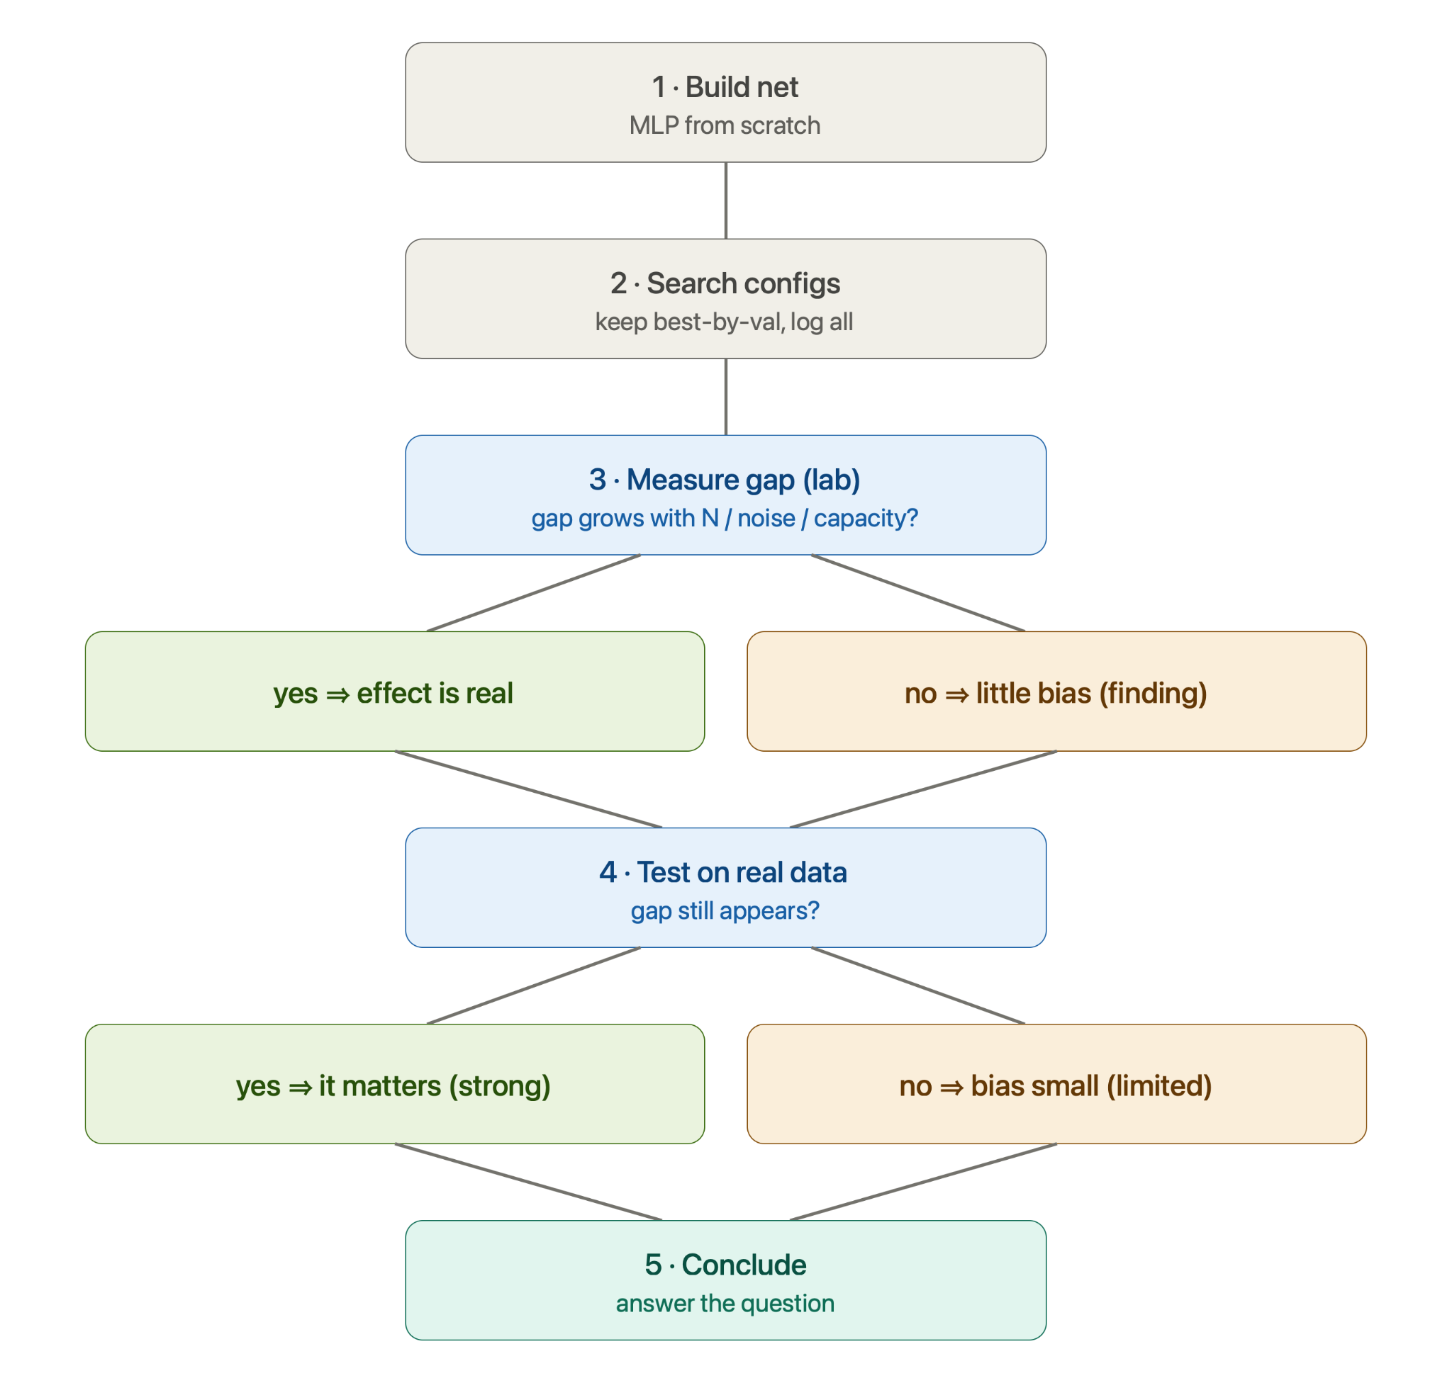
- Build net — purpose: have something to improve ⇒ minimal MLP from scratch; check it learns.
- Search — purpose: create the "improvement" ⇒ try configs, keep best-by-validation, log all.
- Measure the gap on the clean lab (truth known):
- gap > 0 and grows with #configs / noise / capacity?
  - yes ⇒ effect is real ⇒ go to 4
  - no (≈ 0) ⇒ finding "little bias here" ⇒ go to 4 anyway
- Test on the messy real data (honest hold-out; compare single split / k-fold / nested CV):
- does the gap still appear?
  - yes ⇒ it matters in practice ⇒ go to 5 (strong)
  - no / drowns in noise ⇒ finding "bias small here" ⇒ go to 5 (limited)
- Conclude — answer the question: how much is real vs luck, what drives it, what reduces it. Every path lands here.

Expected Outputs:
The contract of results — what each part will produce, and what I'll conclude if it comes out the other way.
(Every line: a prediction ⇒ let the data confirm or refute it ⇒ a finding either way, even against me.)
Headline figure — the true performance of the selected config vs the number of configs searched (N), drawn next to its apparent (best-validation) score.
⇒ expected: apparent keeps rising; true rises, plateaus, then turns down ⇒ search has an optimal budget — past it, more search buys a worse model and more false confidence.
⇒ if true only plateaus (never turns down): the cost is false confidence, not a worse pick — still a sharp finding.
The optimism law — the gap (best-validation − true) on the clean lab, against ln N, against capacity, against injected noise
⇒ expected: positive and growing with each ⇒ the inflation is a law, not an accident.
⇒ if it doesn't grow with N: the bias is small in this regime — an honest finding about when it doesn't matter.
Academic vs real — does the law (and the instability past the turning point) reappear on the messy real dataset, where the truth is unknown.
⇒ expected: the same pattern shows ⇒ the lab is a faithful proxy; the bias bites in practice.
⇒ if it drowns in noise: an honest finding about where the academic picture breaks on real data.
Selection protocol — single split vs k-fold vs nested CV, judged by their effect on the selected model's true quality (the turning point above), not by which scores higher.
⇒ expected: the more honest protocols push the turning point later / shrink the true-quality loss.
⇒ if no protocol changes which config is picked: protocols fix the confidence, not the choice — itself a result worth reporting.
⇒ Every line lands at the same question: how much of the "improvement" is real, how much is luck, what drives it, what reduces it.

Feedbacks:
