Business Requirements Document
WonTon POS - Order Management, Payment & Revenue Analytics System for Wonton Noodle Shop
Group 1
Tutorial 01

VERSION: 3

DATE: 2026-4-18

Version and Approvals
UTORS

Version History
Version # | Date | Revised By (insert instructor name) | Reason for change
0 | 7/3/2026 | Hoang Ngoc Duy | Initial Definition of Project
1 | 14/3/2026 | Hoang Ngoc Duy | Use Case Specification, Process Flowchart and Swimlane Activity Diagram
3 | 18/4/2026 | Hoang Ngoc Duy | Use case diagram, ERD, Class Diagram, Use case specification, Process Flowchart and Swimlane Activity Diagram

This document has been approved as the official Business Requirements Document for WonTon POS - Order Management, Payment & Revenue Analytics System for Wonton Noodle Shop, and accurately reflects the current understanding of business requirements. Following approval of this document, requirement changes will be governed by the project’s change management process, including impact analysis, appropriate reviews and approvals.

TEAM
Member’s Name | Project Role | Signature Approval | Date
Nguyễn Thị Hải My | Project Manager | My
Nguyễn Đạt Vinh | Sysem Analyst | Vinh
Vương Gia Ly | Data Analyst | Ly
Nguyễn Minh Đức | Business Process Analyst | Duc
Đặng Khánh Huyền | User Experience Analyst | Huyen
Lê Thành Đạt | Requirement Analyst | Dat
Nguyễn Đình Chiến | System Analyst | Chien
Nguyễn Thiện Hiếu | Data Analyst | Hieu

Table of Contents

Version and Approvals 2
Project Details 2
Overview 2
Document Resources 2
Glossary of Terms 3
Project Overview 3
4.1 Project Overview and Background 3
4.2 Project Dependencies 3
4.3 Stakeholders 3
Key Assumptions and Constraints 4
5.1 Key Assumptions and Constraints 4
Business Requirements 5
Functional Requirements 5
Non-functional Requirements 5
Use Cases 6
Use Case Diagram 6
Use Case Specification 7
Appendixes 9
Appendix A – Business Process Flows 9
Appendix B – Business Rules Catalog 12
Appendix C- Models 12
Use Case Narrative Instructions 12
Project Details

Project Name | WonTon POS – Order Management, Payment & Revenue Analytics System for Wonton Noodle Shop
Project Type | New Initiative
Project Start Date | 7/3/2026
Project End Date
Project Sponsor | Owner of Wonton Noodle Shop
Primary Driver | Efficiency - Optimize restaurant operations workflow
Secondary Driver | Revenue Growth – Increase revenue through a dedicated online ordering channel
Division | Faculty of Information Technology
Project Manager | Nguyễn Thị Hải My

Overview

This document defines the high-level requirements for the WonTon POS project – an Order Management, Payment, and Revenue Analytics System for a wonton noodle shop. It will be used as the basis for the following activities:
- Creating solution designs
- Developing test plans, test scripts, and test cases
- Determining project completion
- Assessing project success

Document Resources

Name | Business Unit  (Individual, Company or Department….) | Role | Proposed Elicitation Techniques
Nguyen Quang Anh | HongKong A Hai Crispy Roast Duck Restaurant | Stakeholder - CEO | Interview, Questionnaire, Meeting, Observation
FOH Manager Representative | HongKong A Hai Crispy Roast Duck Restaurant - Front-of-House Operations | Stakeholder - FOH Manager | Interview, Questionnaire, Meeting, Observation
BOH Manager Representative | HongKong A Hai Crispy Roast Duck Restaurant - Back-of-House / Kitchen Operations | Stakeholder - BOH Manager | Interview, Questionnaire, Meeting, Observation
Glossary of Terms

Term / Acronym | Definition
BRD | Business Requirements Document – A formal document outlining business needs and requirements
POS | Point of Sale – A system used to manage customer orders, payments, and operational transactions at the point of service
UC | Use Case – A description of a system's behavior in response to a request from an actor
FR | Functional Requirement – A requirement specifying what the system should do
NFR | Non-Functional Requirement – A requirement specifying how the system should perform
Wonton POS | System name, derived from "Wonton" + POS
Admin WebApp | Web application for restaurant staff (Manager, Cashier, Server, Kitchen)
Client WebApp | Web application for customers to order online
Order | A customer's request containing a list of menu items, toppings, and special notes
Menu Item | A dish on the restaurant's menu (e.g., Dry Wonton Noodles, Wonton Soup…)
Topping | Additional ingredients for a dish (e.g., Extra wontons, Extra char siu pork…)
Dine-in | Customer eats at the restaurant
Takeaway | Customer purchases food to go
Pickup | Scheduled order for later collection – customer orders in advance, selects a pickup time, the system validates slot capacity and auto-accepts if service capacity is available, pays online
Guest Checkout | Allows customers to place orders using only Name and Phone Number without creating an account; guest customers can later track orders using Order Code and Phone Number
FOH Staff | Front-of-House Staff – Includes Cashier and Server roles
BOH Staff | Back-of-House Staff – Kitchen staff
KDS | Kitchen Display System – Screen displaying orders in the kitchen
QR Payment | Payment via QR code scanning through banking applications
Dashboard | A control panel displaying an overview of revenue data and shop activities
Real-time | Data is updated instantly without manual refresh
Responsive | UI automatically adjusts to screen size (desktop, tablet, mobile)
SSL/TLS | Secure Sockets Layer / Transport Layer Security – Encryption protocols for secure data transmission
CRUD | Create, Read, Update, Delete – Basic data manipulation operations
API | Application Programming Interface – A set of protocols for building and integrating application software
Order Tracking Code | Order identifier used by guest customers together with their phone number to track an order
Multi-role | Support assigning multiple roles to a single staff account (e.g., both FOH and BOH)
CCU | Concurrent Users – Number of users accessing the system simultaneously
Reorder | Creating a new order from a previously Completed order; current menu availability and prices apply; removed or changed items surface as inline drift notices before checkout.
86'd Item | A menu item marked temporarily unavailable by the kitchen; instantly locked on Client WebApp and POS for new orders.
Refund Pending | Payment status indicating a refund request has been raised and is awaiting processing or Manager confirmation.
Refunded | Payment status indicating a refund has been completed via gateway callback or Manager manual confirmation.
Write-off | Manager-approved loss-recording state for a Dine-in order where the customer left without paying; not counted as revenue.
Comp | Manager-approved voiding of an order (proactive waiver for goodwill or serious error); amount is reclassified as comp expense, not revenue.
Forfeited | Payment status for a Paid Takeaway/Pickup order where the customer did not arrive within the holding window and the Manager decided the shop retains the payment.
Shift Close | End-of-shift procedure covering cash drawer reconciliation, payment-method breakdown, and inherited-exception handover to the next shift.
Audit Log | Immutable record of sensitive financial and operational actions (refund, Comp, Write-off, Forfeited, manager override, shift variance).
Table QR Code | Fixed QR code on each dine-in table that encodes the table identifier for QR ordering.

Project Overview

4.1 Project Overview

4.1.1 Selected System
The selected system is WonTon POS, a web-based point-of-sale and shop operations management system developed for a wonton noodle shop. It integrates customer ordering, payment handling, order monitoring, kitchen coordination, menu administration, table management, and operational reporting within one controlled environment.

4.1.2 Project Description
- WonTon POS is intended for a medium-sized shop operating one or two locations, processing approximately 150 to 300 orders per day, and running with a team of 4 to 8 staff members. The business already receives orders from third-party delivery platforms, but it does not currently operate an internal management platform dedicated to its own workflow.
- The project delivers two connected web applications: a Client WebApp for customers and an Admin WebApp for managers, cashiers, servers, and kitchen staff. Together, these applications support Dine-in, Takeaway, and Pickup operations while improving coordination between front-of-house and back-of-house activities.

4.1.3 Problem Statement
The shop does not have an integrated internal order and operations management system, so core activities such as order capture, kitchen communication, payment control, and business monitoring are handled through fragmented manual processes that reduce accuracy, slow service, limit management visibility, and increase dependence on third-party ordering platforms.

4.1.4 Project Statement
- This project will deliver the WonTon POS System as a two-part web solution consisting of a Client WebApp and an Admin WebApp, together with the requirements artifacts needed to guide analysis, design, implementation, and testing.
- The Client WebApp will enable customers, whether registered or guest, to browse the menu, place orders, make payments where required, schedule pickup, track order progress, and submit ratings after order completion.
- The Admin WebApp will enable managers and staff to receive and process orders, coordinate with the kitchen, manage menu and table information, monitor order and payment status, and review operational and revenue data.
- For developers and testers, the BRD, business rules, use case specifications, and supporting models provide a traceable and testable description of scope, workflows, exceptions, and constraints.
- For the shop owner and board of management, the delivered system provides a foundation for service standardization, stronger operational control, more reliable revenue monitoring, and better decision-making for future growth.
For customers and shop staff, the system is intended to shorten communication gaps, improve order accuracy, and create a more consistent service experience.
The project scope also includes the formal documentation and prototype evidence required to support stakeholder review, implementation planning, and verification.

4.2 Project Dependencies
# | Dependency | Description
1 | Online Payment Gateway | The system depends on APIs from MoMo, VNPay, or ZaloPay to process electronic payments
2 | Hosting/Cloud Service | A server is required to deploy the web system (e.g., AWS, Heroku, Vercel)
3 | Internet Connection | The shop requires a stable Internet connection for the system to function
4 | Hardware Devices | The shop needs at least 1 computer/tablet for the cashier and 1 display screen for the kitchen
5 | Receipt Printer | A thermal printer is needed for printing customer bills and kitchen order tickets (if applicable)

4.3 Stakeholders
The following comprises the internal and external stakeholders whose requirements are represented by this document, including the project sponsor and operational managers from both front-of-house and back-of-house areas:

# | Stakeholders
1 | Nguyen Quang Anh – Stakeholder / CEO of HongKong A Hai Crispy Roast Duck Restaurant. This is the primary stakeholder who provides business direction, operational context, and feedback for the system.
2 | FOH Manager Representative - Stakeholder / Front-of-House Manager. This stakeholder provides requirements for cashier, server, table assignment, counter ordering, payment coordination, handoff, customer service recovery, and day-to-day FOH usability.
3 | BOH Manager Representative - Stakeholder / Back-of-House Manager. This stakeholder provides requirements for kitchen workflow, KDS visibility, item availability, 86'd handling, preparation status, fulfilment exceptions, and BOH operational feasibility.

Key Assumptions and Constraints

5.1 Key Assumptions and Constraints

# | Assumptions
A1 | The system is developed as a web-based application, accessible through browsers, requiring no separate application installation on devices
A2 | Customers place online orders through the Client WebApp on their phone/computer browser, not through a native mobile app
A3 | The shop currently does not use any POS (Point of Sale) system or management software
A4 | The system processes Dine-in, Takeaway, and Pickup orders. Delivery functionality is currently out of scope for the Wonton POS project.
A5 | The shop has a stable Internet connection at all operating locations
A6 | Shop staff have basic computer/tablet proficiency
A7 | The system interface language is Vietnamese
A8 | This document specifies 26 core use cases (UC-01..UC-26) for the approved business scope of the current system version. Additional business capabilities are outside the scope of this document unless formally approved.
# | Constraints
C1 | The project must be completed within 1 academic semester (approximately 15 weeks)
C2 | The development team consists of 8 students, with limited manpower and practical experience
C3 | Development budget is zero (academic project), therefore open-source technologies and free-tier services are prioritized
C4 | The system does not require actual production deployment; it is at the prototype/demo level
C5 | Online payment gateway integration (MoMo, VNPay, ZaloPay) will use sandbox/test environments, not processing real transactions
C6 | The system must be compatible with popular browsers (Chrome, Safari, Firefox) on both desktop and mobile devices

Business Requirements

The following sections document the various business requirements of this project.

The requirements in this document are prioritized as follows:
Value | Rating | Description
1 | Critical | This requirement is critical to the success of the project. The project will not be possible without this requirement.
2 | High | This requirement is high priority, but the project can be implemented at a bare minimum without this requirement.
3 | Medium | This requirement is somewhat important, as it provides some value but the project can proceed without it.
4 | Low | This is a low priority requirement, or a “nice to have” feature, if time and cost allow it.
5 | Future | This requirement is out of scope for this project, and has been included here for a possible future release.

Functional Requirements
REQ# | PRIORITY | DESCRIPTION | RATIONALE | USE CASE
FR-01 | Critical | The system shall allow customers to place orders through the Client WebApp by browsing the menu, adding items to the cart, selecting a service model, and proceeding as either a registered customer or a guest customer. | This capability supports the primary customer ordering flow and preserves both member and guest checkout within the approved BRD lane. | UC-01
FR-02 | Critical | The system shall support prepaid online payment using supported gateway QR flows and bank-transfer QR with valid manual confirmation, and shall prevent duplicate orders or duplicate kitchen tickets caused by retries or repeated callbacks. | This capability enforces required prepayment for applicable service models while keeping payment handling operationally safe. | UC-02
FR-03 | High | The system shall allow customers to place Pickup orders for a selected time slot and shall validate opening hours, Pickup pause status, and slot-level service capacity before automatically accepting the order. | This capability supports the Pickup service model and prevents overbooking or accepting orders when Pickup intake is temporarily paused. | UC-03
FR-04 | Medium | The system shall allow registered customers to view their order history and review the details of selected past orders. | This capability supports post-purchase visibility for registered customers. | UC-04
FR-05 | Critical | The system shall allow Managers to create, update, archive or stop selling menu items, manage categories, and change item availability status. | This capability is required for day-to-day menu administration while preserving historical order and reporting data. | UC-05
FR-06 | High | The system shall allow Managers to create, update, deactivate employee accounts, and assign one or more roles to each employee account. | This capability supports staff administration and the project's multi-role operating model. | UC-06
FR-07 | Medium | The system shall allow Managers to review revenue statistics, top-selling items, peak-hour analytics, and export reports using time-based filters and optional payment-method filters. | This capability provides the reporting data needed for operational and business review. | UC-07
FR-08 | High | The system shall allow Managers to manage table master data and floor layout, while allowing FOH Staff to view table layout information needed for dine-in operations. | This capability supports dine-in seating configuration and day-to-day service coordination. | UC-08
FR-09 | Critical | The system shall allow FOH Staff to create walk-in orders at the counter for Dine-in or Takeaway customers, including additional orders for active dine-in tables. | This capability supports the mandatory counter-based POS workflow within scope. | UC-09
FR-10 | Critical | The system shall allow Cashier or FOH Staff to process counter payments using cash, gateway QR, or bank-transfer QR with manual confirmation, according to the applicable service rules. | This capability is required to complete in-store transactions under the defined service and payment rules. | UC-10
FR-11 | High | The system shall allow customers to track the current status of an order, and shall allow guest customers to retrieve order status using Order Code and Phone Number. | This capability supports post-checkout visibility for both registered and guest customers. | UC-11
FR-12 | High | The system shall allow FOH Staff to assign, transfer, and attach additional dine-in orders to the correct table. | This capability is required to link dine-in orders to the correct table for service delivery. | UC-12
FR-13 | High | The system shall allow BOH Staff to receive new orders on the KDS in operational sequence, accept them into Cooking, and report fulfilment issues without silently dropping affected items. | This capability starts the kitchen workflow and preserves operational control when preparation issues occur. | UC-13
FR-14 | High | The system shall allow BOH Staff to update item or order preparation status to Ready and to send the related notifications for serving or handoff. | This capability supports timely coordination between kitchen, service staff, and customers. | UC-14
FR-15 | Medium | The system shall allow registered customers to submit a review for a completed order within the permitted review period. | This capability captures structured customer feedback after order completion. | UC-15
FR-16 | High | The system shall send real-time order notifications to customers when order status changes, store notification history, and resynchronize missed notifications after reconnection. | This capability supports real-time order communication and notification traceability. | UC-16
FR-17 | High | The system shall allow registered customers to reorder items from a Completed past order by applying current menu availability and prices, preserving valid notes, and flagging any drift (deleted, archived, repriced, 86'd, or removed-topping items) with inline notices before checkout. | Enables repeat purchase while preserving current menu, pricing, availability, and note-carryover controls. | UC-17
FR-18 | Medium | The system shall allow Managers to create, edit, deactivate, and review percentage and fixed-amount promotion codes, including validity period, usage limits, stacking rules, cancellation-related usage recovery, and application/usage audit history. | Supports pricing governance, promotion recovery rules, and auditability; free-item and BOGO promotions are out of scope. | UC-18
FR-19 | Medium | The system shall provide an operational dashboard for Managers showing revenue snapshot, order counts by status, open exceptions (Refund Pending, overdue Pickup, unresolved Write-off), and shift status. | Enables daily at-a-glance operational oversight separated from detailed reporting. | UC-19
FR-20 | High | The system shall allow FOH Staff and Managers to monitor and act on operationally actionable orders and exceptions across Dine-in, Takeaway, and Pickup, including live orders, Dine-in Completed+Unpaid follow-up, confirmation, cancellation, table transfer, and exception escalation. | Supports real-time operational control of actionable orders and settlement/exceptions requiring staff follow-up. | UC-20
FR-21 | High | The system shall allow Cashiers and Managers to close a shift with cash-drawer reconciliation, payment-method breakdown (cash, bank QR, gateway, refund, Comp, Forfeited, Write-off), pre-close review of unresolved operational/financial exceptions, and inherited-exception handover to the next shift. | Supports end-of-day financial accuracy, cash-drawer accountability, and multi-shift reconciliation. | UC-21
FR-22 | High | The system shall allow BOH Staff and Managers to mark a menu item as 86'd and shall instantly propagate availability changes to the Client WebApp and POS, and flag affected not-yet-cooked orders for FOH/Manager action. | Prevents ordering of unavailable items and handles 86'd propagation on in-flight orders. | UC-22
FR-23 | High | The system shall allow FOH Service Staff to confirm order handoff and transition Ready orders to Completed, and shall support wrong-handoff correction by reverting Completed to Ready within the same shift with an audit reason. | Closes the dine-in service lifecycle and supports mistaken-completion correction. | UC-23
FR-24 | High | The system shall allow FOH Staff and Managers to record customer complaints and operational exceptions (wrong item, missing item, quality issue, wrong handoff) and select a resolution from remake, substitution, goodwill discount, partial refund, full refund, Comp, or Write-off with audit. | Supports service recovery and maintains financial integrity across exception paths. | UC-24
FR-25 | Medium | The system shall allow customers to register, log in, log out, update profile, change password, and recover password via OTP. | Supports the authenticated customer lifecycle required for order history, reorder, and rating. | UC-25
FR-26 | Critical | The system shall allow customers to complete checkout by confirming a service model, applying an optional promotion code, capturing Guest or Registered identification, reviewing the total, and routing to payment or tracking based on the service model. | Closes the customer-side ordering funnel and enforces service-model-specific prepayment rules. | UC-26

Non-functional Requirements
REQ# | PRIORITY | DESCRIPTION | RATIONALE | USE CASE
NFR-01 | High | The system shall return responses for core user actions, including ordering, payment, counter order creation, and order tracking, within 2 seconds under normal operating conditions. | This constraint is required to keep customer and staff workflows responsive during normal operations. | UC-01, UC-02, UC-09, UC-10, UC-11
NFR-02 | Critical | The system shall maintain at least 99% availability during the restaurant's operating hours. | This constraint is required to support uninterrupted operations during business hours. | Core system use cases (UC-01..UC-26)
NFR-03 | Critical | The system shall protect passwords using secure hashing, shall encrypt data in transit using HTTPS/TLS, shall enforce role-based access control for employee functions, and shall authenticate payment API interactions. | This constraint is required because the system handles payments and role-restricted functions. | UC-02, UC-06, UC-10
NFR-04 | High | The system shall provide a responsive Client WebApp for mobile and desktop devices and shall optimize the Admin WebApp for tablet and desktop use. | This constraint is required because the in-scope use cases are performed across multiple device types. | UC-01, UC-03, UC-04, UC-05, UC-06, UC-07, UC-08, UC-09, UC-10, UC-11, UC-12, UC-13, UC-14, UC-15, UC-16, UC-17, UC-18, UC-19, UC-20, UC-21, UC-22, UC-23, UC-24, UC-25, UC-26
NFR-05 | Medium | The system shall support at least 200 concurrent users without significant service degradation. | This constraint provides sufficient capacity for the expected demo scope and realistic restaurant workload. | UC-01, UC-02, UC-09, UC-11, UC-16, UC-20, UC-26
NFR-06 | High | The system shall deliver order status updates and notifications to connected clients within 3 seconds of a status change. | This constraint is required for timely coordination across customers, FOH Staff, and BOH Staff. | UC-11, UC-13, UC-14, UC-16
NFR-07 | Medium | The system shall provide user interfaces with clear typography, a minimum color contrast ratio of 4.5:1, and touch-friendly interaction for supported devices. | This constraint is required because the system is used on phones, tablets, and POS terminals. | All user-facing use cases within UC-01..UC-26
NFR-08 | High | The system shall maintain an immutable audit log for sensitive financial and operational actions (refund, Comp, Write-off, Forfeited, manager override, shift-close variance approval) including actor, role, timestamp, related order, affected amount, reason, and approver where applicable. | Supports financial traceability, managerial approval control, and dispute resolution for sensitive operational and financial actions. | UC-10, UC-21, UC-22, UC-24
NFR-09 | Medium | The system shall anonymize Guest customer personal data (Name and Phone Number) 12 months after the related order reaches a terminal state (Completed / Cancelled / Refunded / Write-off / Comp / Forfeited), in line with Vietnam's Decree 13/2023/ND-CP on personal data protection. | Supports compliance with personal-data law while preserving order-level statistical data. | UC-01, UC-11, UC-26

Use Cases

Use Case Diagram

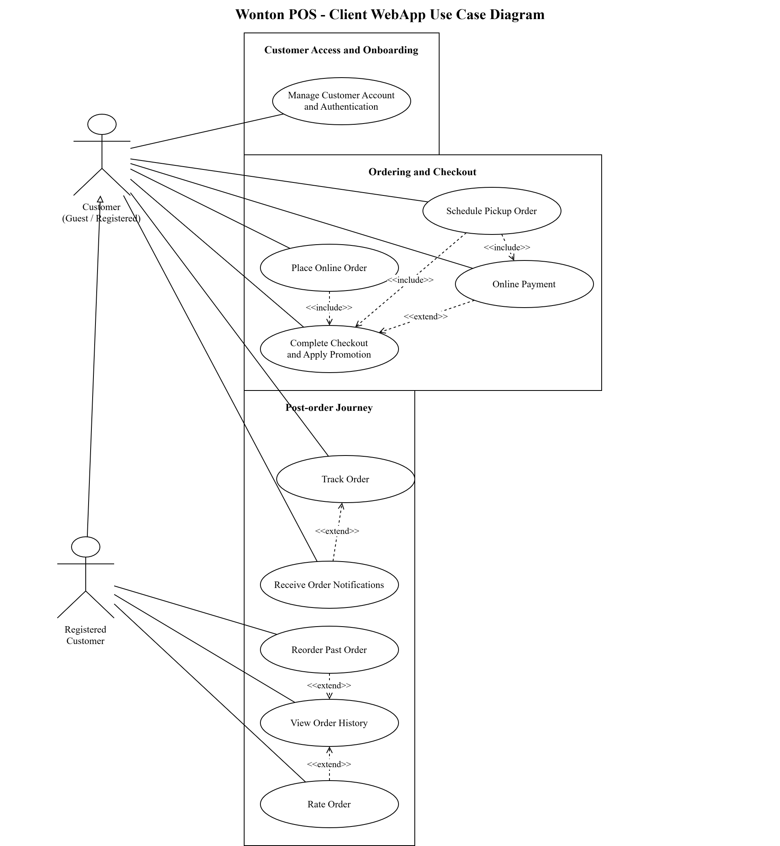
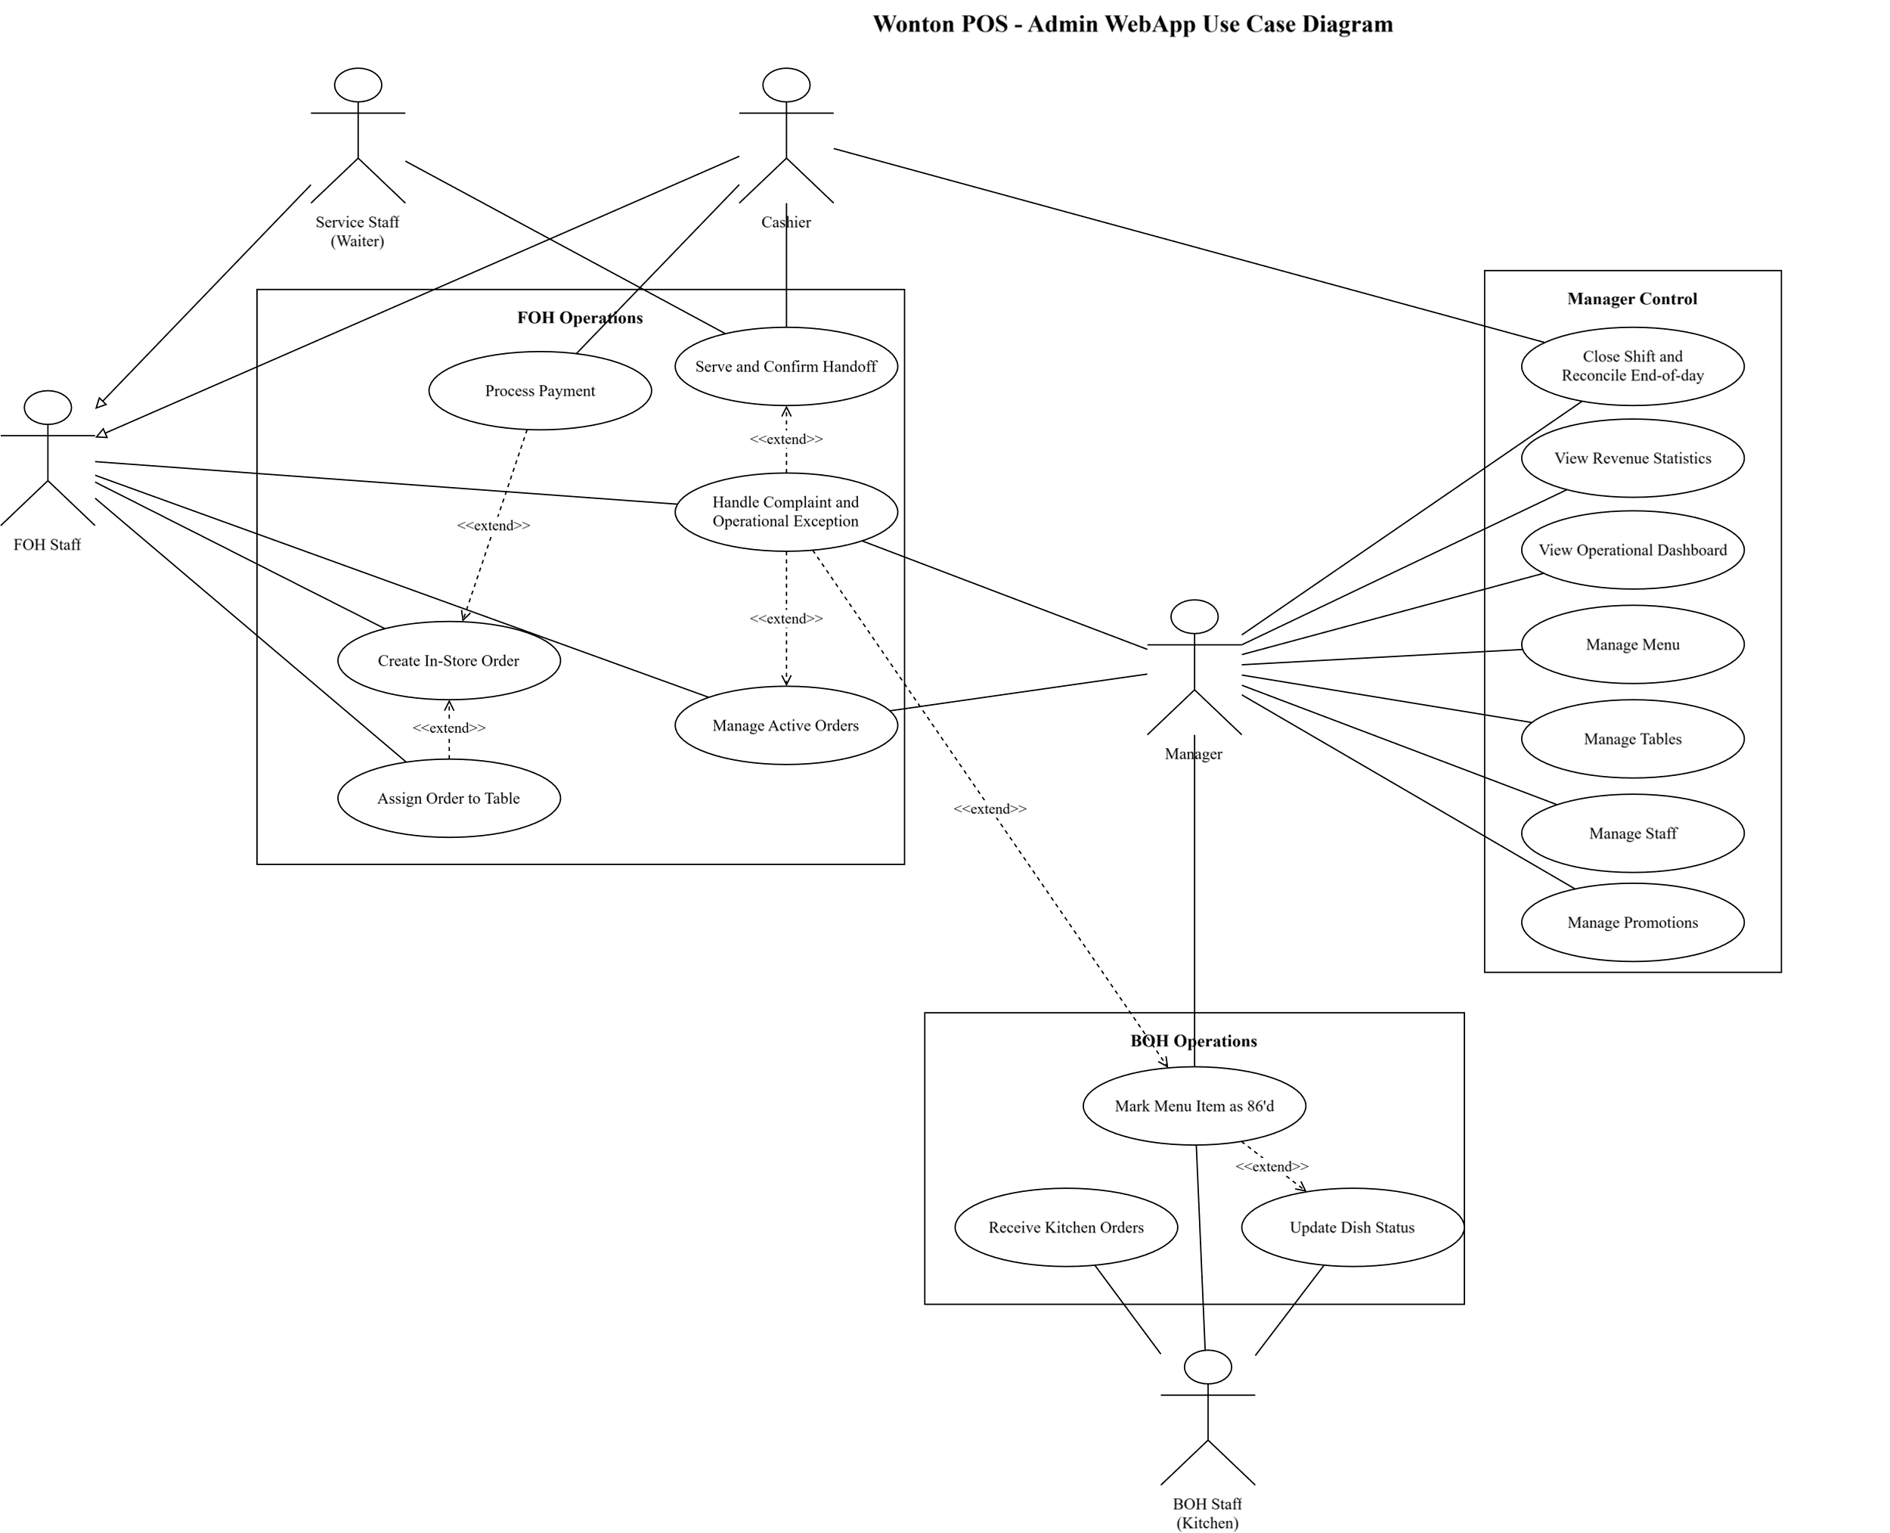

Use Case Specification

ID & Name: | UC-01: Place Online Order
Primary Actor: | Customer (Registered / Guest)
Description: | The customer uses the Client WebApp to browse the menu, add items to the cart, select a service model, and create an online order according to the business rule of the selected service model.
Trigger: | The customer selects "Order Now" or "View Menu" on the homepage.
Pre-conditions: | 1. The Client WebApp is available for ordering. 2. The menu contains at least one item with status `Available`. 3. The selected service model is within the supported scope: `Dine-in`, `Takeaway`, or `Pickup`.
Post-conditions: | Success: An online order is created with the correct service model and order details. If the order is `Dine-in`, the order is created as a valid unpaid order with `payment_status = Unpaid`, the order code is displayed, and the customer is taken to the order-tracking screen. If the order is `Takeaway`, the order is created under the mandatory prepayment rule and the customer is routed to the payment flow before kitchen release. If the order is `Pickup`, the customer is routed to UC-03 for slot validation and mandatory prepayment before the order can continue.  Failure: No incomplete or unintended order is committed, the existing cart content is preserved unless the customer changes it, and the system displays the appropriate error message.
Normal Flow: | 1.1. The customer selects "Order Now" or "View Menu".
Alternative Flows: | 2a. Add more items: After step 1.7, the customer continues browsing the menu and repeats steps 1.2-1.7 until the cart is complete.
Exceptions: | E1. Item unavailable: At step 1.4 or 1.5, if the selected item is no longer available, the system displays an out-of-stock message and keeps the customer on the menu/item-selection flow so another item can be selected.
Priority: | Critical

ID & Name: | UC-02: Online Payment
Primary Actor: | Customer (Registered / Guest)
Description: | After creating an order that requires prepayment, the customer selects an appropriate online payment method (Payment Gateway QR or Bank Transfer QR with manual confirmation) to complete payment
Trigger: | The customer clicks "Pay Now" after cart confirmation or when the system requests payment before processing
Pre-conditions: | 1. The customer is logged in or has completed Guest Checkout with Name + Phone. 2. The cart contains at least 1 item. 3. The order has been created and belongs to a prepayment-required flow or the customer voluntarily chooses to prepay
Post-conditions: | Payment succeeds via a valid gateway callback or a valid manual confirmation. The order changes to `Paid`. If it is Takeaway/Pickup, the system routes the order into the operational flow. The system must not create duplicate orders or duplicate kitchen tickets because of retry attempts or repeated callbacks
Normal Flow: | 1.1. The system displays the total order amount and available payment methods
Alternative Flows: | 2a. Payment Gateway QR: At step 1.2, the customer selects MoMo/VNPay/ZaloPay → The system generates a dynamic QR or redirects to the gateway → The customer confirms in the wallet app → The system receives a successful callback → The order transitions to `Paid`
Exceptions: | E1: Payment failed — At step 1.5, the gateway returns an error → The system displays "Payment failed. Please try again!" → The order remains in `Pending Online Payment`
Priority: | Critical

ID & Name: | UC-03: Schedule Pickup Order (Pickup)
Primary Actor: | Customer (Registered / Guest)
Description: | The customer orders items online and selects a pickup timeslot so the system can validate opening hours, the Pickup pause toggle, and slot-level service capacity before auto-accepting the order if it is valid
Trigger: | The customer selects the Pickup option while creating an online order
Pre-conditions: | The shop is open. Pickup is not paused. At least one menu item is available
Post-conditions: | If the slot is valid and payment is completed, the Pickup order is created successfully, auto-accepted, and passed into the operational flow. The customer is informed of the exact pickup window, warned that arriving early may still require waiting until the order is `Ready`, and notified of the shop-configured holding window after the scheduled time
Normal Flow: | 1.1. The customer selects items (as in the standard online ordering flow)
Alternative Flows: | 2a. Nearly full slot: The system suggests nearby timeslots that still have capacity
Exceptions: | E1: Invalid or overloaded timeslot, or Pickup is currently paused — The system displays a warning and does not allow payment to continue
Priority: | High

ID & Name: | UC-04: View Order History
Primary Actor: | Registered Customer
Description: | The customer reviews a list of previously placed orders, including item details, order status, and payment information
Trigger: | The customer clicks "Order History" in their account section
Pre-conditions: | 1. The customer is logged in. 2. The customer has at least 1 previous order
Post-conditions: | The order history list is displayed successfully
Normal Flow: | 1.1. The customer clicks "Order History"
Alternative Flows: | 2a. Filter by status: At step 1.2, the customer selects a filter (All / In Progress / Completed / Cancelled) → The list is filtered accordingly
Exceptions: | E1: No orders found — At step 1.2, the system displays "You don't have any orders yet. Order now!" with a button linking to the menu
Priority: | Medium

ID & Name: | UC-05: Manage Menu
Primary Actor: | Manager
Description: | The manager adds, edits, archives/stops selling menu items and manages categories, updates prices, images, and availability status
Trigger: | The manager clicks "Menu Management" on the Admin WebApp
Pre-conditions: | 1. The manager is logged in with "Manager" privileges
Post-conditions: | The menu is successfully updated; changes are immediately reflected on the Client WebApp
Normal Flow: | 1.1. The manager selects "Menu Management"
Alternative Flows: | 2a. Edit item: At step 1.2, the manager clicks "Edit" on an item → The system displays the edit form with current data → The manager edits and clicks "Update" → Success
Exceptions: | E1: Duplicate item name — At step 1.5, the system displays "Item name already exists in this category!"
Priority: | High

ID & Name: | UC-06: Manage Staff
Primary Actor: | Manager (Shop Owner)
Description: | The manager creates, updates, deactivates staff accounts and assigns roles within the Admin system
Trigger: | The manager clicks "Staff Management" on the Admin menu
Pre-conditions: | 1. The manager is logged in with "Manager" privileges
Post-conditions: | The staff account is successfully created, updated, or deactivated
Normal Flow: | 1.1. The manager selects "Staff Management"
Alternative Flows: | 2a. Edit info: At step 1.2, select a staff member → Edit information → Click "Update" → Success
Exceptions: | E1: Phone number already exists — At step 1.5, the system displays "This phone number is already in use!"
Priority: | High

ID & Name: | UC-07: View Revenue Statistics
Primary Actor: | Manager (Shop Owner)
Description: | The Manager uses the Admin WebApp to review revenue statistics, top-selling items, and peak-hour analytics by applying time-based and optional payment-method filters.
Trigger: | The Manager selects "Statistics & Reports" in the Admin WebApp.
Pre-conditions: | 1. The Manager is authenticated with permission to access revenue analytics. 2. The analytics module is available. 3. Completed-order data has been recorded for reporting, even if the selected filter may return no result.
Post-conditions: | Success: The requested revenue statistics are displayed using charts and/or data tables for the selected filters, and any requested export file is generated for download. Failure: No reporting data is changed, the last valid filter context is preserved, and the system displays the appropriate no-data or loading-error message.
Normal Flow: | 1.1. The Manager opens "Statistics & Reports".
Alternative Flows: | 2a. Filter by payment method: After step 1.4, 1.6, or 1.8, the Manager selects a payment-method filter (`Cash` / `QR` / `Online`). The system refreshes the displayed analytics data for the current time range.
Exceptions: | E1. No data for selected filters: At step 1.2, 1.4, 1.6, or 1.8, if the selected time range or applied filters return no completed-order data, the system displays "No data available for the selected time period" and keeps the Manager on the analytics screen so another filter can be selected.
Priority: | High

ID & Name: | UC-08: Manage Tables
Primary Actor: | Manager
Description: | The Manager manages dine-in table master data in the Admin WebApp by viewing the current table layout and usage status, then adding, editing, or deleting table records. This use case governs table configuration at the layout level. FOH Staff may view the table layout and usage status for dine-in operations, but configuration actions in this use case remain Manager-only.
Trigger: | The Manager selects "Table Management" in the Admin WebApp.
Pre-conditions: | 1. The Manager is authenticated with permission to manage tables. 2. The table-management module is available and the current table layout/status can be loaded, even if no table records exist yet.
Post-conditions: | Success: The requested table record is created, updated, or deleted; the latest layout and usage status are refreshed and displayed. Failure: No unintended table data change is committed; the system preserves the last committed valid table data and shows the appropriate error message.
Normal Flow: | 1.1. The Manager opens "Table Management".
Alternative Flows: | 2a. Edit table: At step 1.2, the Manager selects an existing table to edit. The system displays the current table data. The Manager updates the allowed fields and selects "Update". The system validates the submitted changes. If the selected table is not currently in use and the update succeeds, the system saves the updated table record, refreshes the layout, and displays a success message.
Exceptions: | E1. Invalid input data: At step 1.6 or Alternative Flow 2a, if required data is missing, duplicated, or invalid, the system rejects the request, displays the validation error, and keeps the Manager on the current form so the data can be corrected.
Priority: | High

ID & Name: | UC-09: Create In-Store Order
Primary Actor: | Front-of-House Staff (FOH Staff)
Description: | FOH Staff use the Admin WebApp to create a walk-in order at the counter for Dine-in or Takeaway service. The FOH Staff selects the service type, adds items to the order, assigns a table when the order is Dine-in, and continues the order according to the payment rule of the selected service model.
Trigger: | The FOH Staff selects "Create New Order" in the Admin WebApp.
Pre-conditions: | 1. The FOH Staff is authenticated with permission to create in-store orders. 2. The menu is available for ordering. 3. For Dine-in orders, at least one table can be viewed for assignment from the current table layout.
Post-conditions: | Success: A new in-store order is created. If the order is Dine-in, the order is linked to the selected table, the table status is updated to `Occupied`, the kitchen ticket is sent immediately, and the order may remain valid with `payment_status = Unpaid`. If the order is Takeaway, the order is created with `payment_status = Unpaid`, the FOH Staff is routed to the counter payment flow, and the kitchen ticket is not sent before payment succeeds. Counter Takeaway orders are exempt from the 15-minute auto-cancel because the Cashier controls the flow directly; the Cashier may collect payment immediately at the counter or cancel manually if the customer abandons the transaction. Failure: No incomplete or unintended order is committed, no table assignment is applied incorrectly, and the system displays the appropriate error message.
Normal Flow: | 1.1. The FOH Staff opens "Create New Order".
Alternative Flows: | 2a. Takeaway order: At step 1.3, the FOH Staff selects "Takeaway". The table-selection step is skipped, and the flow continues at step 1.5.
Exceptions: | E1. Table unavailable: At step 1.4, if the selected table is not available for assignment, the system displays an unavailable-table message and keeps the FOH Staff on the table-selection step so another table can be selected.
Priority: | Critical

ID & Name: | UC-10: Process Payment
Primary Actor: | Front-of-House Staff (FOH)
Description: | The cashier processes payment for an order, including Takeaway orders that must be paid before kitchen release and Dine-in orders settled after service
Trigger: | The cashier clicks "Pay" on the order to be processed
Pre-conditions: | 1. The cashier is logged in. 2. The order exists and is eligible for payment (counter Takeaway awaiting payment — exempt from auto-cancel because the Cashier controls the flow directly, or Dine-in awaiting settlement)
Post-conditions: | The order's `payment_status` changes to `Paid`. If it is Takeaway, the kitchen ticket is printed/sent after payment. If it is a completed Dine-in order, revenue is recorded and the table returns to "Available". The system must not create duplicate receipts or kitchen tickets if the payment gateway sends repeated callbacks
Normal Flow: | 1.1. The cashier selects the order to be paid from the list
Alternative Flows: | 2a. Payment Gateway QR (MoMo/VNPay/ZaloPay): At step 1.3, select e-wallet -> The system generates a dynamic QR with order details -> The customer scans with wallet app -> Gateway callback auto-confirms -> `payment_status = Paid` -> Complete
Exceptions: | E1: Insufficient amount — At step 1.4, the system displays "Insufficient amount. Short by X VND!"
Priority: | Critical

ID & Name: | UC-11: Track Order
Primary Actor: | Customer (Guest / Registered)
Description: | The customer tracks the current order status after placing an order, either through the account or via `Order Code + Phone Number` for guest orders
Trigger: | The customer completes an order, clicks "Track Order", or opens an order notification
Pre-conditions: | 1. The customer has at least 1 active order. 2. If the customer is a Guest, they must have the Order Code and the phone number used at checkout
Post-conditions: | The customer views the latest updated status of the order
Normal Flow: | 1.1. The customer opens the "Track Order" screen
Alternative Flows: | 2a. Track multiple orders: The system allows the customer to select each active order and inspect its status
Exceptions: | E1: Connection lost -> The system cannot auto-update in real-time and prompts the customer to refresh the page manually
Priority: | High

ID & Name: | UC-12: Assign Order to Table
Primary Actor: | Front-of-House Staff (FOH)
Description: | The cashier assigns/transfers an order to a specific table on the floor plan, or attaches an additional order to an already-active table belonging to the same party
Trigger: | The cashier needs to assign a new order to a table, the customer requests a table change, or the same party requests an additional order
Pre-conditions: | 1. The cashier is logged in. 2. A Dine-in order exists that needs table assignment, transfer, or attachment to an active table. 3. The table layout has been configured
Post-conditions: | The order is linked to the appropriate table. If the table was previously Available, it transitions to "Occupied"; if the order is an additional order for the same party, the table remains "Occupied"
Normal Flow: | 1.1. The cashier opens the "Table Layout" section
Alternative Flows: | 2a. Transfer table: The cashier selects an occupied table → Clicks "Transfer Table" → Selects a new available table → Confirms → Old table reverts to "Available", new table becomes "Occupied"
Exceptions: | E1: Table occupied by a different party — If the cashier attempts to assign a new party to an "Occupied" table that does not belong to the same party, the system displays "Table already has another party. Please select a different table or use the additional-order feature for the correct party."
Priority: | High

ID & Name: | UC-13: Receive Kitchen Orders
Primary Actor: | Back-of-House Staff (BOH)
Description: | Kitchen staff views the list of new orders requiring preparation on the kitchen display, accepts orders, and begins cooking
Trigger: | A new order is created (from an online customer or in-store cashier). The system plays a notification sound
Pre-conditions: | 1. Kitchen staff is logged in with "Kitchen" privileges. 2. There is at least 1 new order
Post-conditions: | The order status changes from `Pending Confirmation` to `Cooking`. The customer is notified
Normal Flow: | 1.1. The system displays the kitchen screen with a list of new orders (Order ID, Item List, Notes, Service Type, Order Time)
Alternative Flows: | 2a. Report cannot fulfil before cooking starts: For a Dine-in order that has not yet entered production, the kitchen clicks "Report Cannot Fulfil" → Enters a reason (e.g., out of ingredients) → The system notifies the FOH/Manager to coordinate with the customer and continue handling. Note: `Paid` Takeaway/Pickup orders do not display a "Reject" button; if the kitchen cannot fulfil them, the kitchen clicks "Report Issue" → The system escalates to the Manager for exception handling (substitute item / reschedule / refund).
Exceptions: | E1: Order cancelled before acceptance — At step 1.3, the system displays "Order has been cancelled by the customer" → The order is removed from the list
Priority: | High

ID & Name: | UC-14: Update Dish Status
Primary Actor: | Back-of-House Staff (BOH)
Description: | After finishing cooking, the kitchen staff updates the dish/order status to `Ready` so the system can notify service staff and the customer
Trigger: | Kitchen staff completes the preparation of dishes in an order
Pre-conditions: | 1. Kitchen staff is logged in. 2. The order is in `Cooking` status
Post-conditions: | The order changes to `Ready`. Notifications are sent to service staff and the customer. Note: The order only transitions to `Completed` at the next step when the Server taps "Delivered" (Dine-in) or the Cashier taps "Customer Picked Up" (Takeaway/Pickup) — not in this UC.
Normal Flow: | 1.1. Kitchen staff views the list of orders currently being prepared
Alternative Flows: | 2a. Grouped / batch update: The system does not force the kitchen to tap "Done" per single bowl; the kitchen may group items prepared together across multiple orders and update their status in one action.
Exceptions: | E1: Order already cancelled — At step 1.2, the system displays "Order has been cancelled. Cannot update!"
Priority: | High

ID & Name: | UC-15: Rate Order
Primary Actor: | Registered Customer
Description: | After receiving their order and upon completion, the customer rates the service quality and food using a star rating (1–5) with optional text review. Data is used to improve quality and generate reports for management
Trigger: | The order status changes to "Completed" → The system displays a popup/notification inviting the customer to rate
Pre-conditions: | 1. The customer is logged in (Registered Customer). 2. The order is in "Completed" status. 3. The customer has not rated this order
Post-conditions: | The review is saved successfully. Management can view it in statistics reports
Normal Flow: | 1.1. The system displays a popup "Rate Order #X" after the order is completed
Alternative Flows: | 2a. Rate later: At step 1.1, the customer clicks "Later" → Popup closes. The customer can rate from "Order History" within 7 days
Exceptions: | E1: Already rated — At step 1.1, displays "You have already rated this order!" with the previous review content
Priority: | Medium

ID & Name: | UC-16: Receive Order Notifications
Primary Actor: | Customer (Registered / Guest)
Description: | The customer receives real-time notifications when the order status changes (Pending Confirmation, Cooking, Ready, Completed, Cancelled). Notifications appear as WebApp popups and optionally as browser push notifications
Trigger: | The customer's order status is updated by kitchen staff or cashier
Pre-conditions: | 1. The customer has at least 1 active (incomplete) order. 2. The customer has the Client WebApp open or has granted browser push notification permission
Post-conditions: | The customer receives a notification with the latest status. The notification is saved to history
Normal Flow: | 1.1. Kitchen staff/cashier updates the order status (e.g., `Cooking` -> `Ready`)
Alternative Flows: | 2a. View notification history: The customer clicks the bell icon 🔔 -> The system displays the notification list (newest first) with a badge showing unread count
Exceptions: | E1: Connection lost -> Real-time notification cannot be delivered -> When the customer reopens the WebApp, the system syncs and displays all missed notifications
Priority: | High

ID & Name: | UC-17: Reorder Past Order
Primary Actor: | Registered Customer
Description: | The Registered Customer reorders items from a Completed past order. The system creates a new draft order using the current menu state: deleted or archived items are dropped with a notice, repriced items use the current price, removed toppings/options are dropped with a notice, valid special notes are carried forward when still applicable, and 86'd items remain flagged to block checkout until removed or cleared.
Trigger: | The customer selects Reorder on a past order from Order History.
Pre-conditions: | 1. The customer is authenticated (Registered Customer). 2. The source order is in Completed state. 3. The Reorder feature is enabled on the Client WebApp.
Post-conditions: | Success: A new draft order is created using current menu state, all drift notices are visible to the customer, and the customer can proceed to checkout (UC-26). Failure: No new order is committed; the source order history is unchanged and the system displays an appropriate error.
Normal Flow: | 1.1. The customer opens Order History. 1.2. The customer selects a past Completed order. 1.3. The customer clicks Reorder. 1.4. The system loads items from the source order and applies current menu state. 1.5. The system carries forward valid special notes from the source order to the corresponding new cart lines. 1.6. The system displays a consolidated drift banner plus per-line inline notices. 1.7. The customer reviews items, notes, and totals. 1.8. The customer accepts and is routed to checkout (UC-26).
Alternative Flows: | 2a. No drift: The system loads items directly at current prices without notices. 2b. All items unavailable: The system displays "No items from this order are currently available" with a link to the menu. 2c. Partial drop: Only available items are carried over; dropped items are listed in the summary.
Exceptions: | E1. Source order not Completed: Reorder button is hidden. E2. Item currently 86'd: Kept in cart but blocks checkout until removed or 86'd is cleared. E3. If the original order used a promotion that is no longer valid, the system does not carry it forward and displays a notice at checkout.
Priority: | Medium

ID & Name: | UC-18: Manage Promotions
Primary Actor: | Manager
Description: | The Manager creates, edits, deactivates, and reviews promotion codes (percentage or fixed amount only), including validity period, usage limits, stacking policy, cancellation-related usage recovery, and application/usage audit history. Free-item and BOGO promotions are out of scope.
Trigger: | The Manager opens Promotion Management in the Admin WebApp.
Pre-conditions: | 1. The Manager is authenticated with promotion management permission. 2. The Promotion Management module is available.
Post-conditions: | Success: A promotion code is created, updated, or deactivated with an audit log entry; usage history remains available for review. Failure: No promotion change is persisted; the system shows a validation error.
Normal Flow: | 1.1. The Manager opens Promotion Management. 1.2. The system displays existing promotions with status and current usage. 1.3. The Manager clicks New Promotion. 1.4. The system displays the form (Code, Type, Value, Valid From/To, Conditions, Usage Limit, Stacking Rule, Usage-Recovery Rule). 1.5. The Manager enters data and saves. 1.6. The system validates and persists the promotion. 1.7. The system records an audit entry for the change.
Alternative Flows: | 2a. Edit: The Manager selects an existing promotion, edits fields, and saves. 2b. Deactivate: The Manager deactivates a promotion without deleting usage history. 2c. Usage history: The Manager opens the history view for orders that applied a given promotion. 2d. Failed application attempts: The Manager reviews rejected promotion applications and the recorded reasons.
Exceptions: | E1. Duplicate promotion code. E2. Invalid date range (end before start). E3. Invalid discount value (negative, zero, or greater than 100% for percentage). E4. Attempt to configure free-item/BOGO promotion — rejected as out of scope.
Priority: | Medium

ID & Name: | UC-19: View Operational Dashboard
Primary Actor: | Manager
Description: | The Manager views an operational dashboard summarizing today's revenue, order counts by status, kitchen load, open exceptions (Refund Pending, overdue Pickup, unresolved Write-off, Forfeited pending, Dine-in Completed+Unpaid), and shift status awaiting review.
Trigger: | The Manager opens the Admin WebApp home dashboard.
Pre-conditions: | 1. The Manager is authenticated.
Post-conditions: | Success: The dashboard displays the current operational snapshot with alerts. Failure: The system displays a loading error and preserves the last valid snapshot.
Normal Flow: | 1.1. The Manager logs in and lands on the Dashboard. 1.2. The system displays today's revenue, order counts by status, average order value, and alert cards. 1.3. The Manager clicks any alert card to drill down into the related active orders or exception lists.
Alternative Flows: | 2a. Filter by shift or by day. 2b. Drill-down into UC-20 Active Orders from any alert card. 2c. Drill-down into UC-21 Shift Close from shift-status alerts.
Exceptions: | E1. Data loading failure — retry option is offered. E2. No data yet for the selected day — placeholder message shown.
Priority: | Medium

ID & Name: | UC-20: Manage Active Orders
Primary Actor: | Front-of-House Staff / Manager
Description: | The FOH Staff or Manager monitors and acts on operationally actionable orders and exceptions across Dine-in, Takeaway, and Pickup, including live orders, Dine-in Completed+Unpaid follow-up, confirmation, cancellation (with Manager approval for paid orders), transferring, and escalating exceptions such as complaints, wrong handoff, overdue Pickup/Takeaway, and payment recovery.
Trigger: | The FOH Staff opens Active Orders in the Admin WebApp.
Pre-conditions: | 1. The FOH Staff or Manager is authenticated. 2. At least one operationally actionable order or exception exists, including live orders, overdue Ready orders, payment-recovery cases, or Dine-in orders in Completed + Unpaid status.
Post-conditions: | Success: Targeted orders are updated with the correct next state or escalated to the Manager for exception resolution. Failure: No unintended state change is applied; the action is rejected with a reason.
Normal Flow: | 1.1. The Staff opens Active Orders. 1.2. The system lists operationally actionable orders and exceptions grouped by service model and status. 1.3. The Staff selects an order or exception and opens details. 1.4. The Staff takes an allowed action (confirm, cancel with reason, transfer table, escalate, or route a Completed + Unpaid Dine-in case to settlement follow-up).
Alternative Flows: | 2a. Filter by status, service model, or table. 2b. Escalate to Manager for paid cancellations, refund decisions, Comp, or Forfeited. 2c. Review overdue Pickup/Takeaway and route to UC-24 as needed. 2d. Completed + Unpaid Dine-in follow-up: The Staff opens the case, checks settlement status, and routes it to payment collection or Manager review.
Exceptions: | E1. Order already in a terminal state — action disallowed. E2. Cancellation of a Paid order — must route through refund flow (§3b). E3. Connectivity loss — local changes are blocked until reconnect.
Priority: | High

ID & Name: | UC-21: Close Shift and Reconcile End-of-day
Primary Actor: | Cashier / Manager
Description: | The Cashier or Manager closes a shift by verifying the cash drawer count, reconciling transactions across cash, bank-transfer QR, online gateway, refund, Write-off, Comp, and Forfeited buckets, reviewing unresolved operational and financial exceptions, and confirming inherited exceptions are resolved or explicitly handed over to the next shift.
Trigger: | The Cashier opens Close Shift at end of shift.
Pre-conditions: | 1. An open shift exists owned by the current Cashier (or Manager acts on their behalf). 2. At least one financial event occurred in the shift, or the shift is to be closed empty.
Post-conditions: | Success: The shift is closed, variance is explained or accepted, and the shift report is frozen. Inherited exceptions are listed for the next shift opening. Failure: The shift remains open; blockers and unresolved items are listed.
Normal Flow: | 1.1. The Cashier opens Close Shift. 1.2. The system displays expected cash based on paid cash transactions minus cash refunds. 1.3. The Cashier enters actual counted cash. 1.4. The system computes the variance. 1.5. If variance exceeds the configured threshold, Manager confirmation with reason is required. 1.6. The system displays unresolved items requiring review, including aged Pending Online Payment, overdue Ready orders, Refund Pending, Write-off pending, wrong-handoff incidents, partial-refund differences, duplicate-charge incidents, Forfeited pending, and Dine-in Completed + Unpaid cases. 1.7. The Cashier resolves eligible items and, for approved carry-over categories, marks inherited exceptions with a note. 1.8. The system closes the shift and locks reports.
Alternative Flows: | 2a. Variance above threshold triggers Manager approval flow. 2b. Manager may reopen a shift with audit reason. 2c. End-of-day reconciliation aggregates all shifts of the day. 2d. Approved carry-over cases are shown on the next shift as inherited exceptions.
Exceptions: | E1. Open Refund Pending blocks close unless inherited with reason. E2. Hardware or connectivity issue — allow manual cash count with a flag for later review. E3. Attempt to reopen a reconciled shift without Manager approval — rejected.
Priority: | High

ID & Name: | UC-22: Mark Menu Item as 86'd
Primary Actor: | BOH Staff / Manager
Description: | The BOH Staff or Manager marks a menu item as 86'd (temporarily unavailable). The system immediately hides the item from new orders, flags it on existing not-yet-cooked orders for FOH/Manager action, and supports clearing 86'd when the item is available again. 86'd is independent from manual stock adjustment.
Trigger: | Kitchen detects an ingredient is out of stock or Manager decides to stop selling an item temporarily.
Pre-conditions: | 1. The Staff is authenticated with Kitchen or Manager permission.
Post-conditions: | Success: The item is flagged 86'd; Client WebApp and POS block new selection; in-flight orders containing the 86'd item raise an exception flag routed to UC-24. Failure: No availability state change.
Normal Flow: | 1.1. The Staff locates the item in the availability panel. 1.2. The Staff clicks Mark as 86'd. 1.3. The system prompts for a short reason. 1.4. The Staff confirms. 1.5. The system propagates 86'd status across Client WebApp and POS and flags affected in-flight orders.
Alternative Flows: | 2a. Clear 86'd when the item is available again. 2b. Apply 86'd to a topping, not the base item. 2c. Review affected in-flight orders: The Staff opens the flagged-order list so FOH/Manager can coordinate substitution, refund, or escalation.
Exceptions: | E1. 86'd does not auto-adjust stock balance (independence rule, §3m). E2. Paid order containing a now-86'd item — routed to UC-24 complaint/exception handling.
Priority: | High

ID & Name: | UC-23: Serve and Confirm Handoff
Primary Actor: | Front-of-House Service Staff / Cashier
Description: | The Server confirms actual handoff of a Ready order: for Dine-in, food is delivered to the correct table; for Takeaway/Pickup, the Cashier hands the bag to the correct customer. The order transitions from Ready to Completed. The UC covers wrong-handoff correction by reverting Completed to Ready in the same shift with audit reason.
Trigger: | The kitchen marks the order as Ready.
Pre-conditions: | 1. The order is in Ready state. 2. The handling Staff is authenticated.
Post-conditions: | Success: The order is set to Completed with the confirming actor logged. Failure: The order remains Ready and can be flagged for wrong-handoff correction.
Normal Flow: | 1.1. The Server/Cashier sees the Ready order on their queue. 1.2. The Server delivers food to the correct Dine-in table, or the Cashier hands the Takeaway/Pickup bag to the matching customer. 1.3. The Server/Cashier taps Delivered or Customer Picked Up. 1.4. The system sets order_status = Completed.
Alternative Flows: | 2a. Wrong handoff correction: Manager or FOH reverts Completed to Ready within the same shift with a required audit reason. 2b. Missing item on arrival: the Server flags the order and routes the issue to UC-24. 2c. Multiple ready orders for the same table or customer: The Staff verifies table number or order code and confirms each handoff separately before changing each order to Completed.
Exceptions: | E1. Customer reports a missing or wrong item on receipt — route to UC-24. E2. Late Pickup/Takeaway no-show — escalate to Manager; do not auto-Complete. E3. System connectivity loss — staff uses manual handoff note to reconcile later.
Priority: | High

ID & Name: | UC-24: Handle Complaint and Operational Exception
Primary Actor: | Front-of-House Staff / Manager
Description: | Staff records a customer complaint or operational exception (wrong item, missing item, quality issue, wrong handoff) and routes it to a resolution: remake, substitution, goodwill discount, partial refund, full refund, Comp, or Write-off. All financial outcomes carry audit logs and flow to shift-close reconciliation.
Trigger: | A customer reports an issue, or Staff notices a service error.
Pre-conditions: | 1. The related order exists and is accessible. 2. The acting Staff has permission; Manager approval is required for refunds, Comp, and Write-off.
Post-conditions: | Success: The complaint is logged with a resolution and audit trail; financial effects appear on shift reports. Failure: No resolution is applied; the case remains open for handover.
Normal Flow: | 1.1. The Staff opens the impacted order. 1.2. The Staff selects Report Issue and picks an issue category. 1.3. The Staff enters a description. 1.4. The system routes the decision path (FOH for minor cases, Manager for financial ones). 1.5. The selected resolution is applied (remake / substitution / refund / Comp / Write-off).
Alternative Flows: | 2a. Remake does not create new revenue. 2b. Partial refund keeps the order Completed but flags the refund line. 2c. Comp marks the whole order as zero-revenue under Manager authority. 2d. Write-off marks a Dine-in loss where the customer left without paying.
Exceptions: | E1. Refund, Comp, or Write-off without Manager approval — rejected. E2. Guest PII has been anonymized (12-month retention) — reason is still logged, but PII fields are hidden. E3. Related order already in a terminal Refunded state — further refund requires a new request and Manager justification.
Priority: | High

ID & Name: | UC-25: Manage Customer Account and Authentication
Primary Actor: | Customer
Description: | The Customer manages account access and profile lifecycle, including optional registration, log in, log out, profile update, password change, and password recovery via OTP. Guest checkout remains available without account creation.
Trigger: | The customer opens the Account menu or selects a sign-in, registration, or password-recovery action on the Client WebApp.
Pre-conditions: | 1. The Client WebApp is available. 2. For profile update, password change, and log out, the customer is authenticated.
Post-conditions: | Success: The customer's account state reflects the requested change. Failure: No account change is persisted; the system displays a validation error.
Normal Flow: | 1.1. The customer opens the Account menu. 1.2. The customer enters phone or email and password. 1.3. The system authenticates. 1.4. The system opens the account home.
Alternative Flows: | 2a. Register: customer enters Name, Phone or Email, and password, and confirms via OTP. 2b. Forgot password: customer requests OTP and sets a new password. 2c. Update profile: customer updates editable fields. 2d. Change password: customer verifies the old password and sets a new one. 2e. Log out.
Exceptions: | E1. Invalid credentials. E2. OTP expired or wrong. E3. Password does not meet policy.
Priority: | Medium

ID & Name: | UC-26: Complete Checkout and Apply Promotion
Primary Actor: | Customer (Registered / Guest)
Description: | At checkout, the customer confirms a service model (Dine-in / Takeaway / Pickup), applies an optional promotion code, captures identification (Guest Name + Phone or authenticated profile), reviews the total, and is routed to payment (Takeaway/Pickup) or to order tracking (Dine-in).
Trigger: | The customer clicks Checkout from the cart.
Pre-conditions: | 1. The cart contains at least one available item. 2. The selected service model is supported.
Post-conditions: | Success: An order is created with the correct service model, an applied promotion if any, and identification captured; the customer is routed to payment or tracking. Failure: No order is created; the cart content is preserved.
Normal Flow: | 1.1. The customer opens the cart. 1.2. The system displays the cart summary. 1.3. The customer selects a service model. 1.4. The customer enters an optional promotion code. 1.5. The system validates the promotion and updates the total. 1.6. The customer enters Name and Phone (Guest) or confirms an authenticated profile. 1.7. The customer clicks Place Order. 1.8. The system creates the order and routes the customer to UC-02 for prepay or UC-11 for tracking.
Alternative Flows: | 2a. No promotion code. 2b. Invalid promotion — the system removes it and shows a notice. 2c. Guest continues without logging in.
Exceptions: | E1. Empty cart. E2. Promotion expired or over-used. E3. Promotion not applicable to the cart or service model.
Priority: | Critical

Appendixes

Appendix A – Business Process Flows

Use Case 01
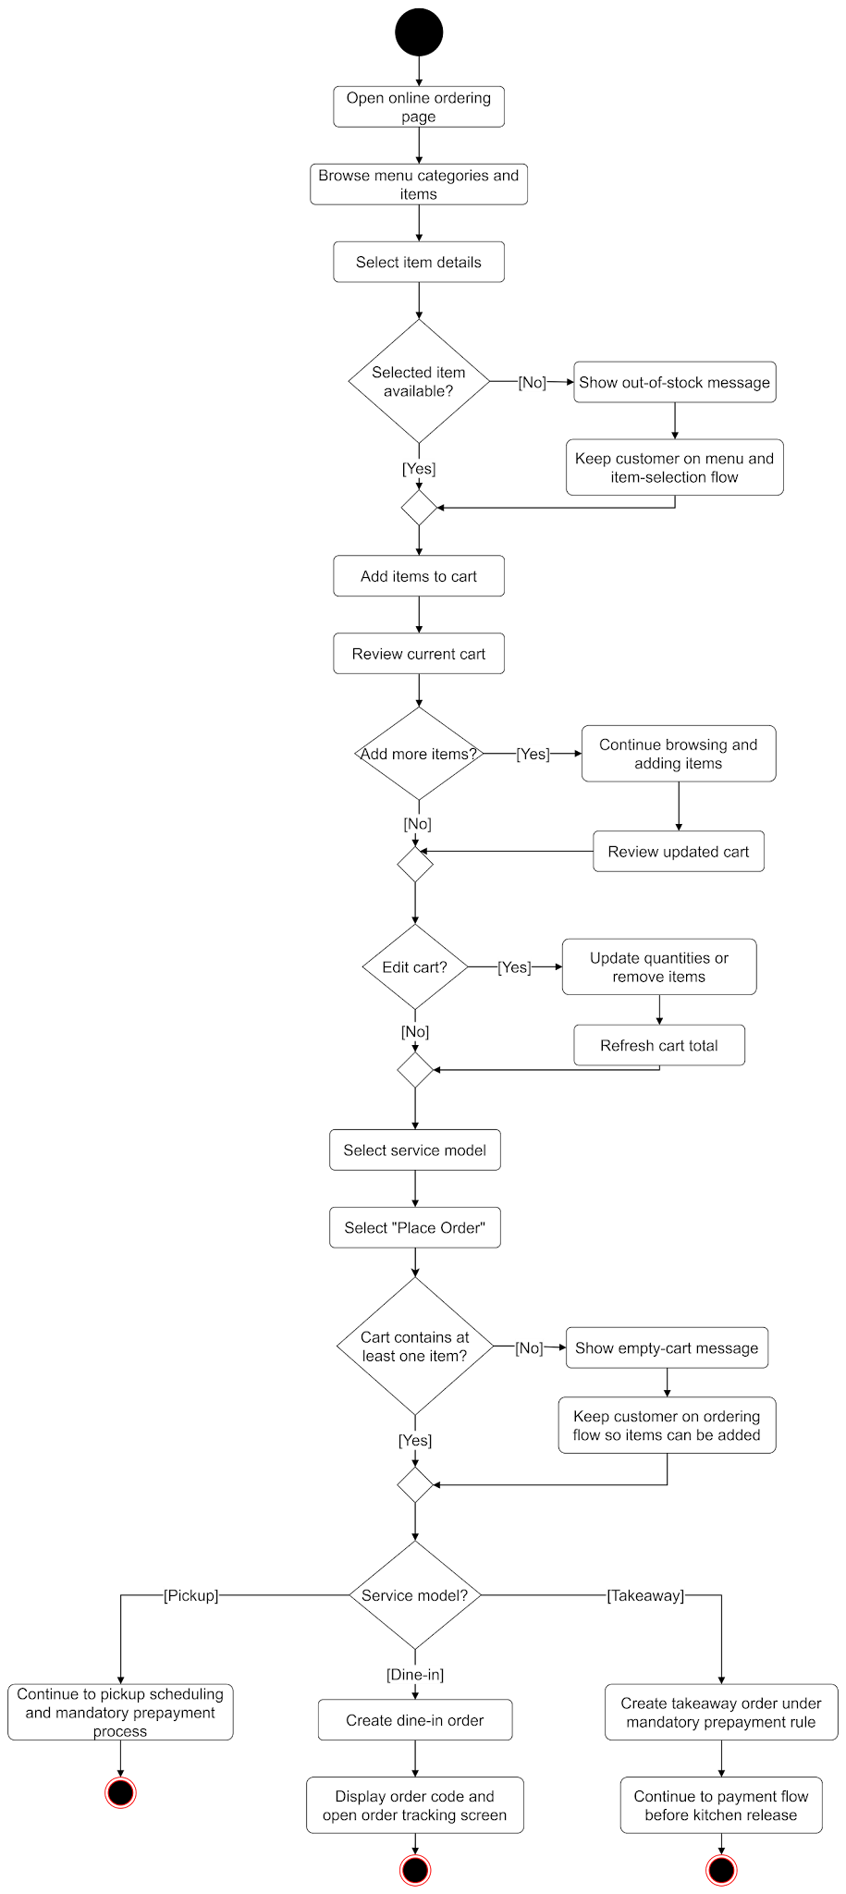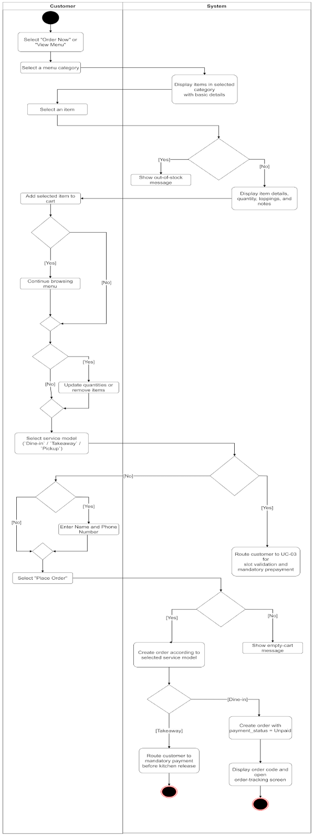

Use Case 02
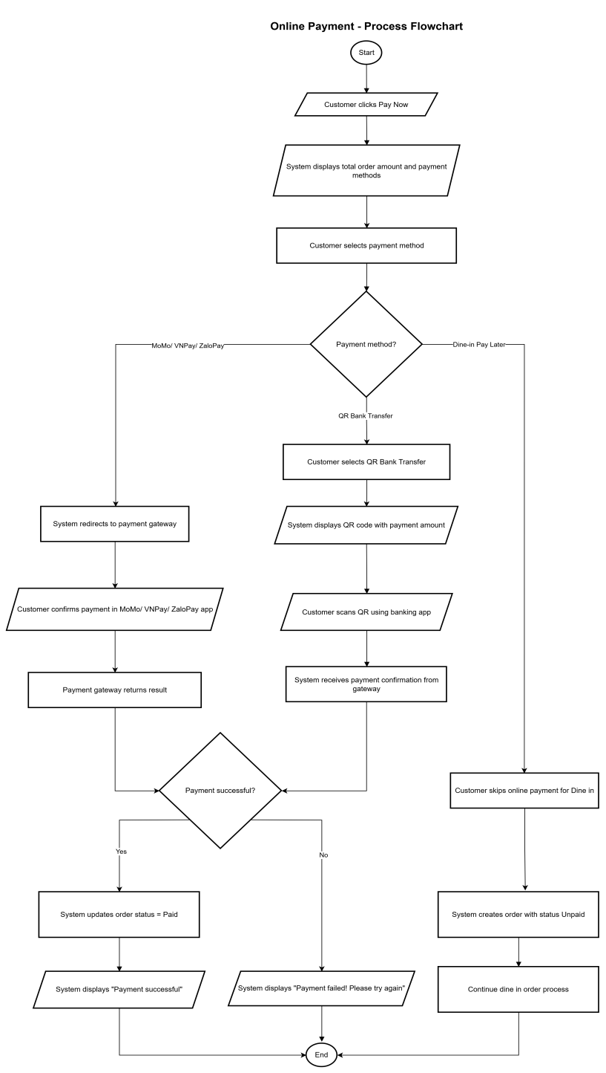

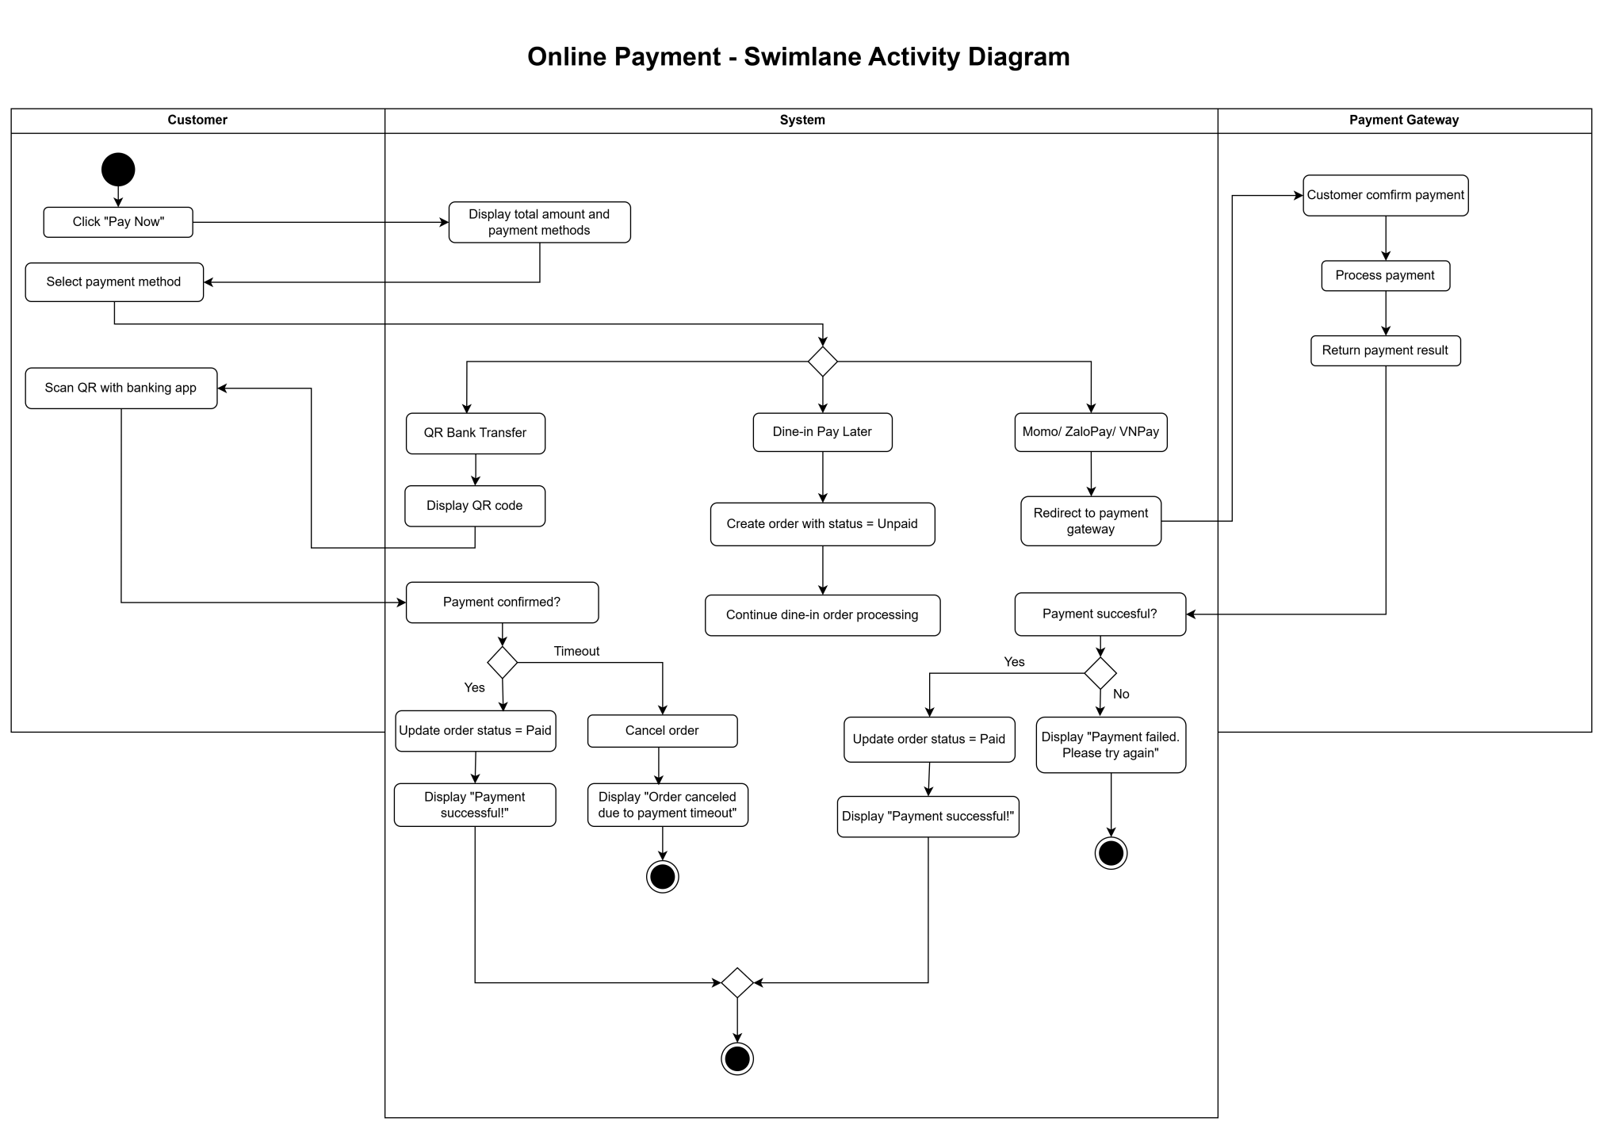

Use Case 03
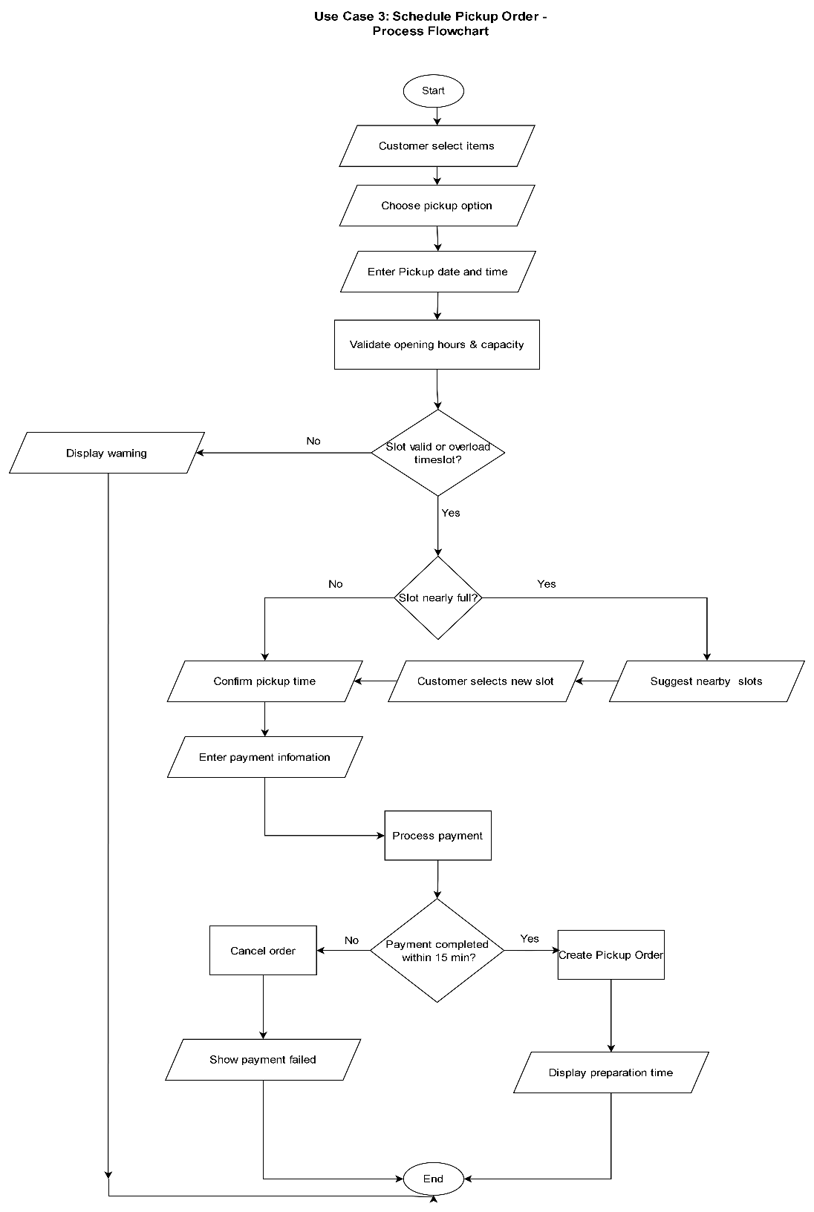
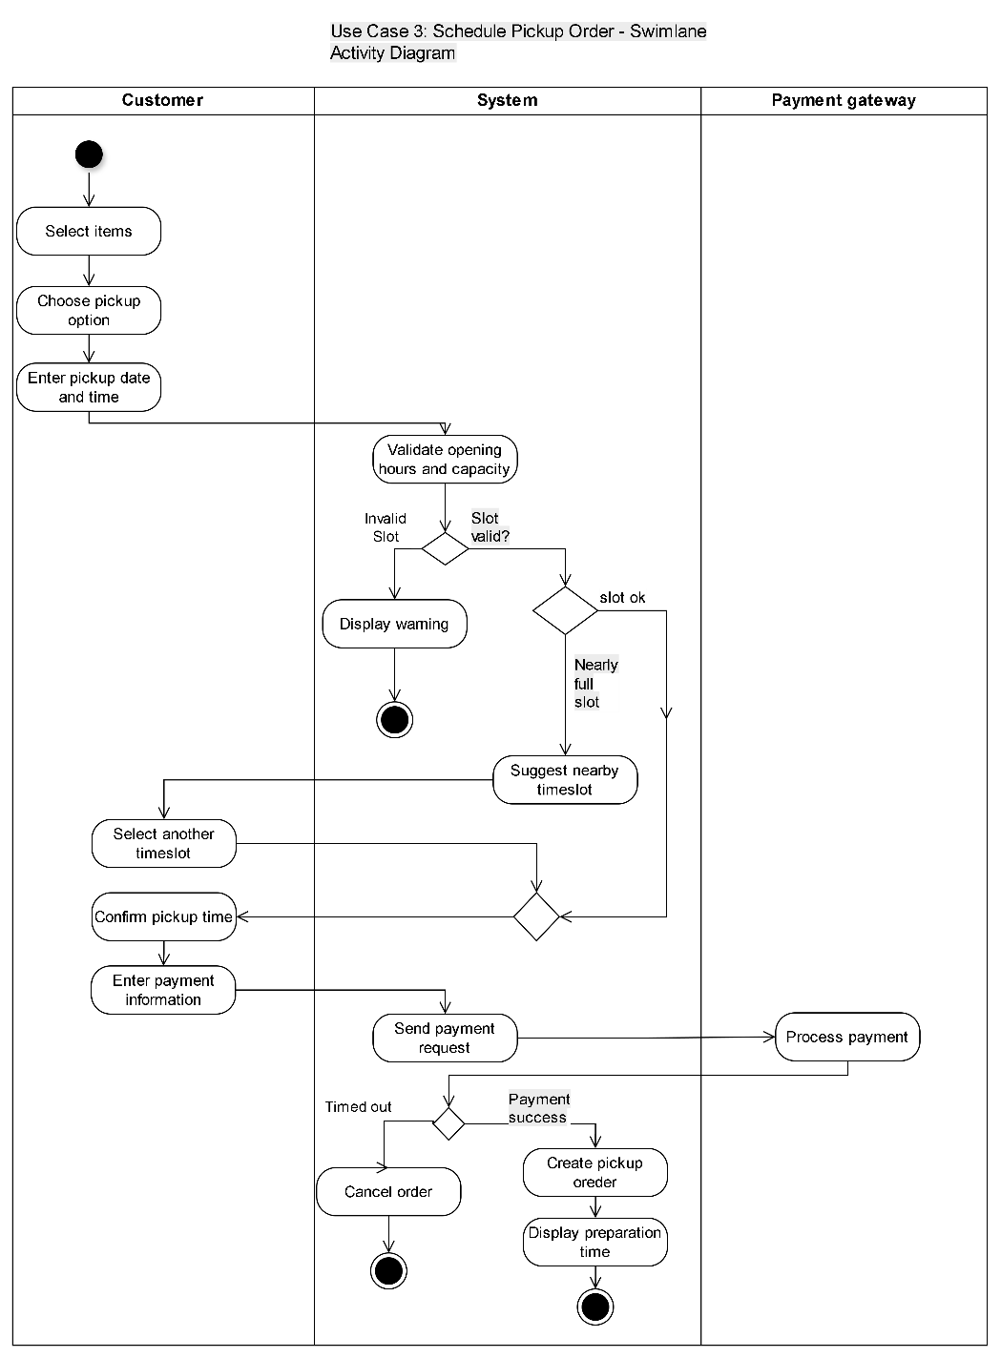

Use Case 04
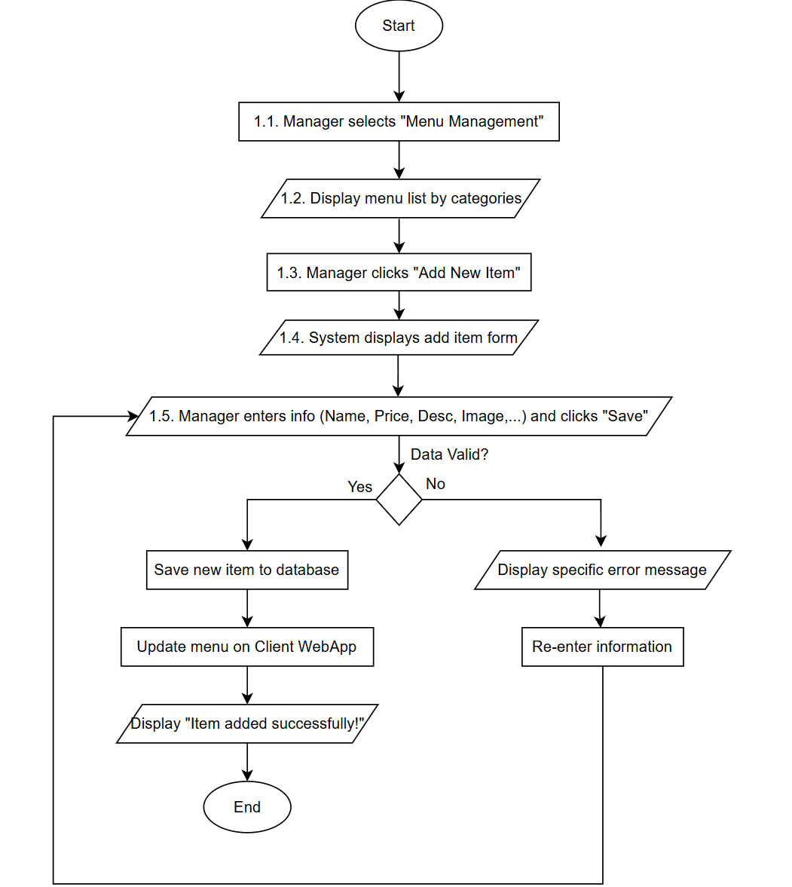
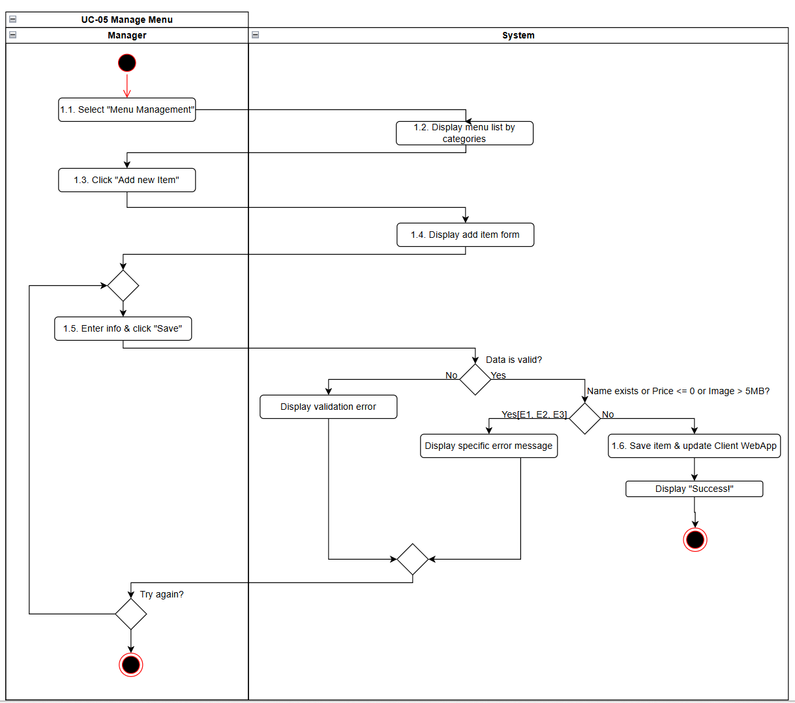
Use Case 05
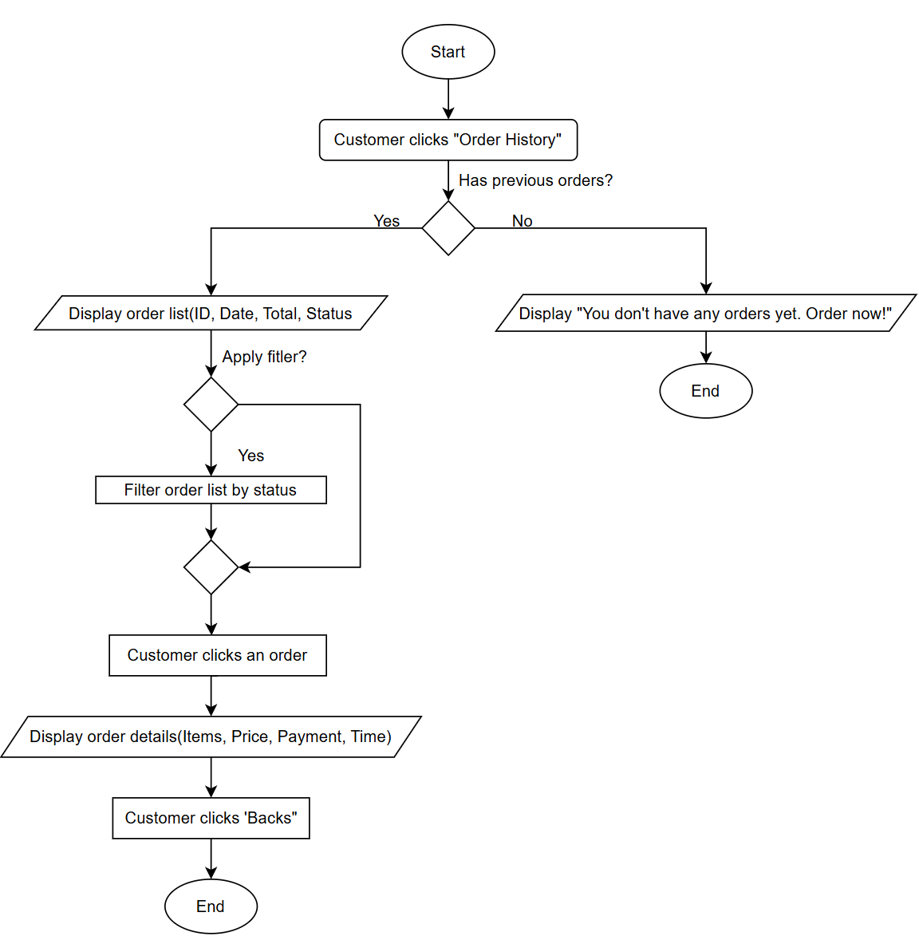
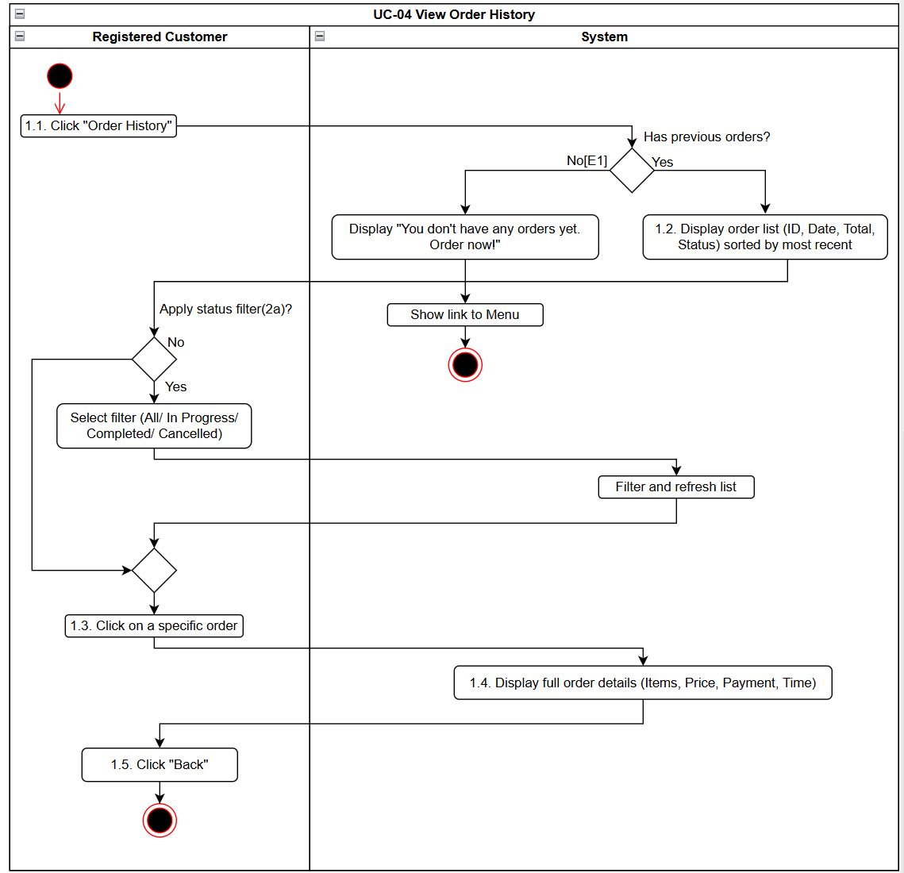
Use Case 06
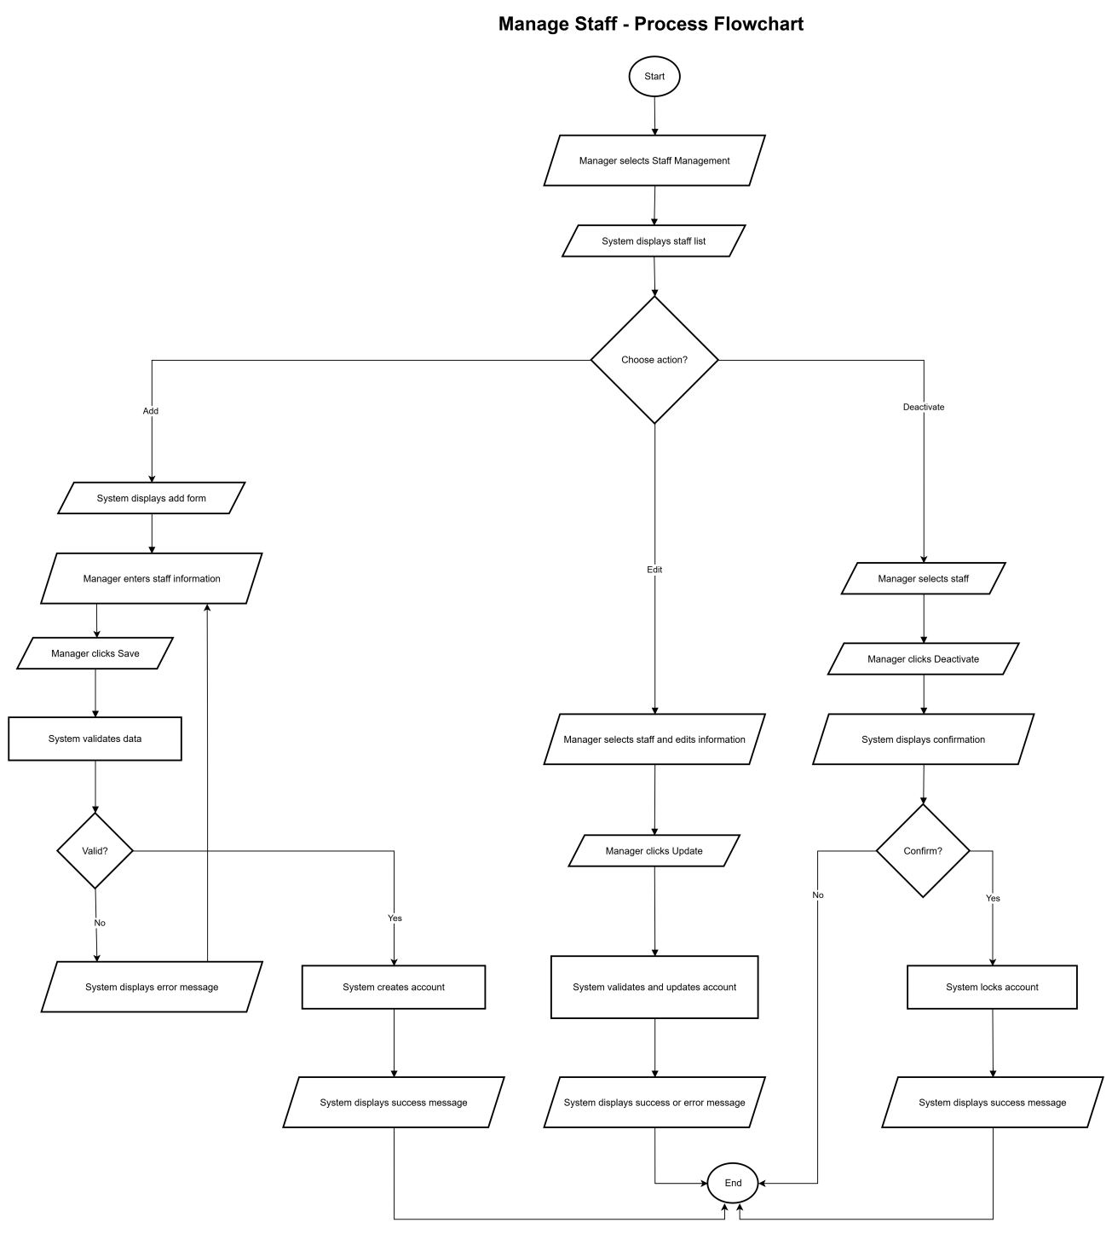
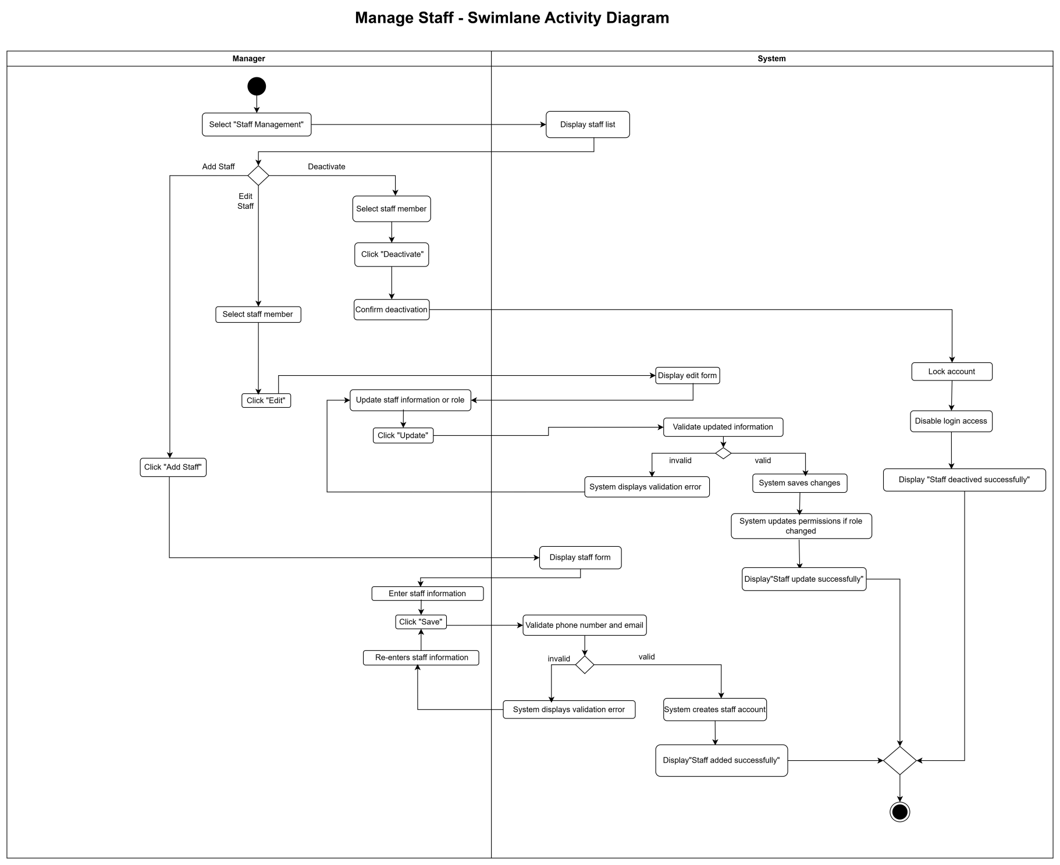

Use Case 07

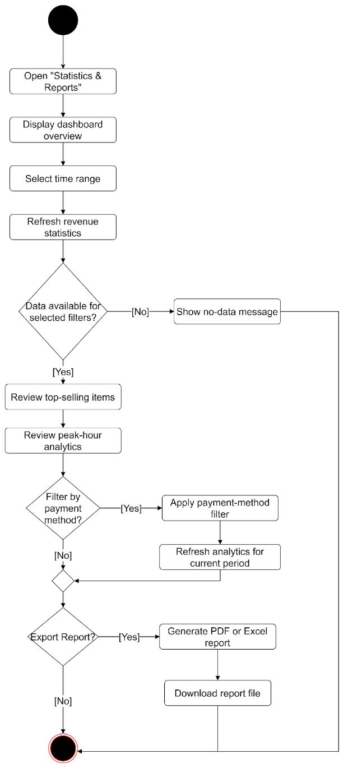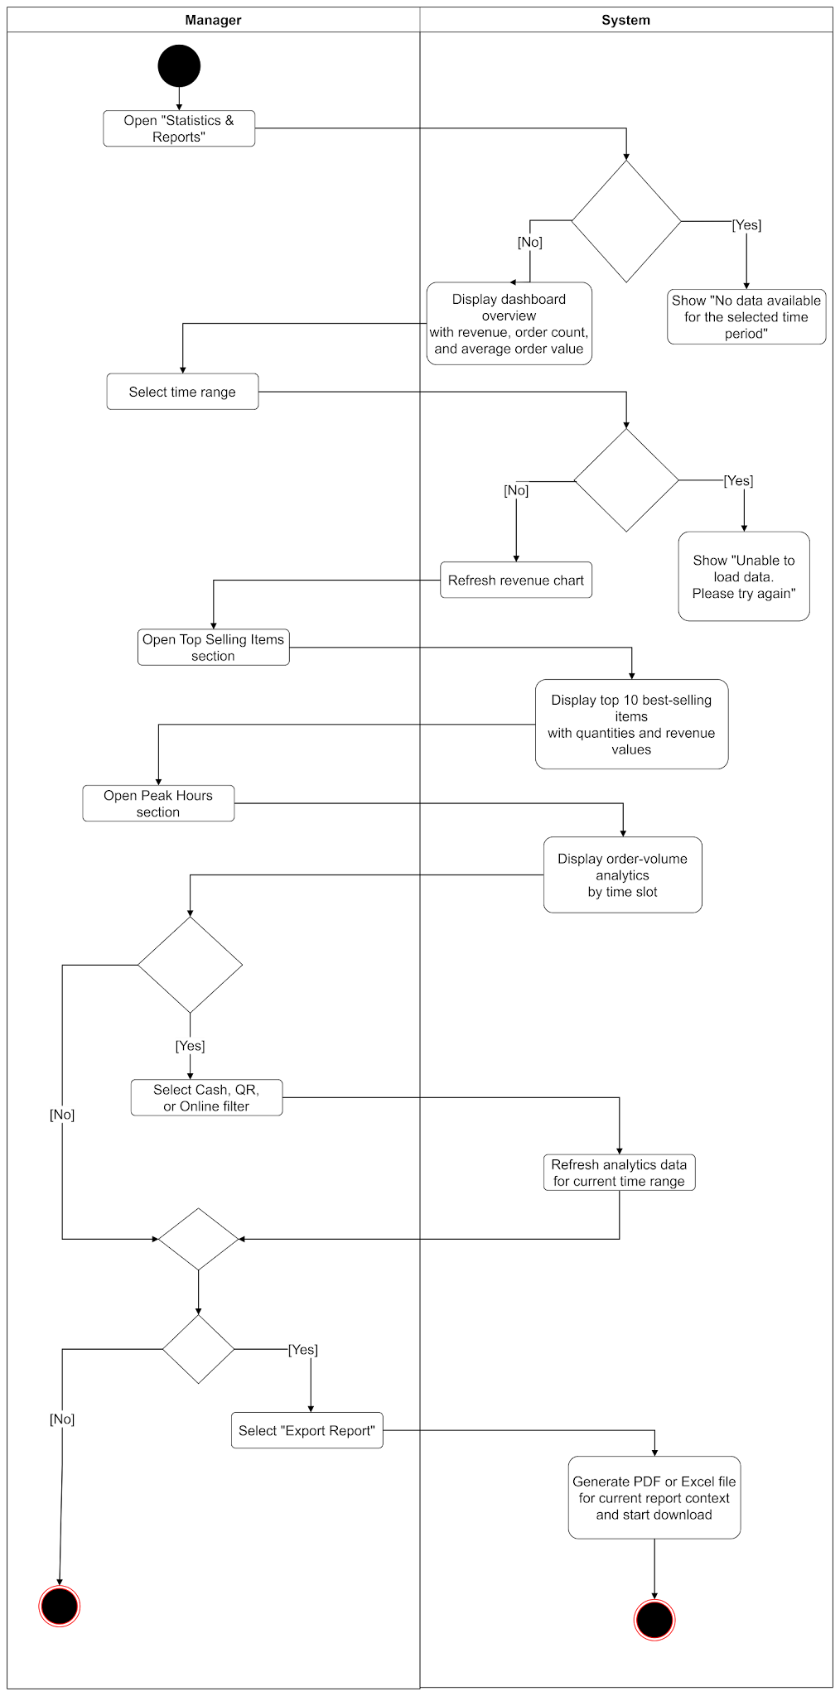

Use Case 08
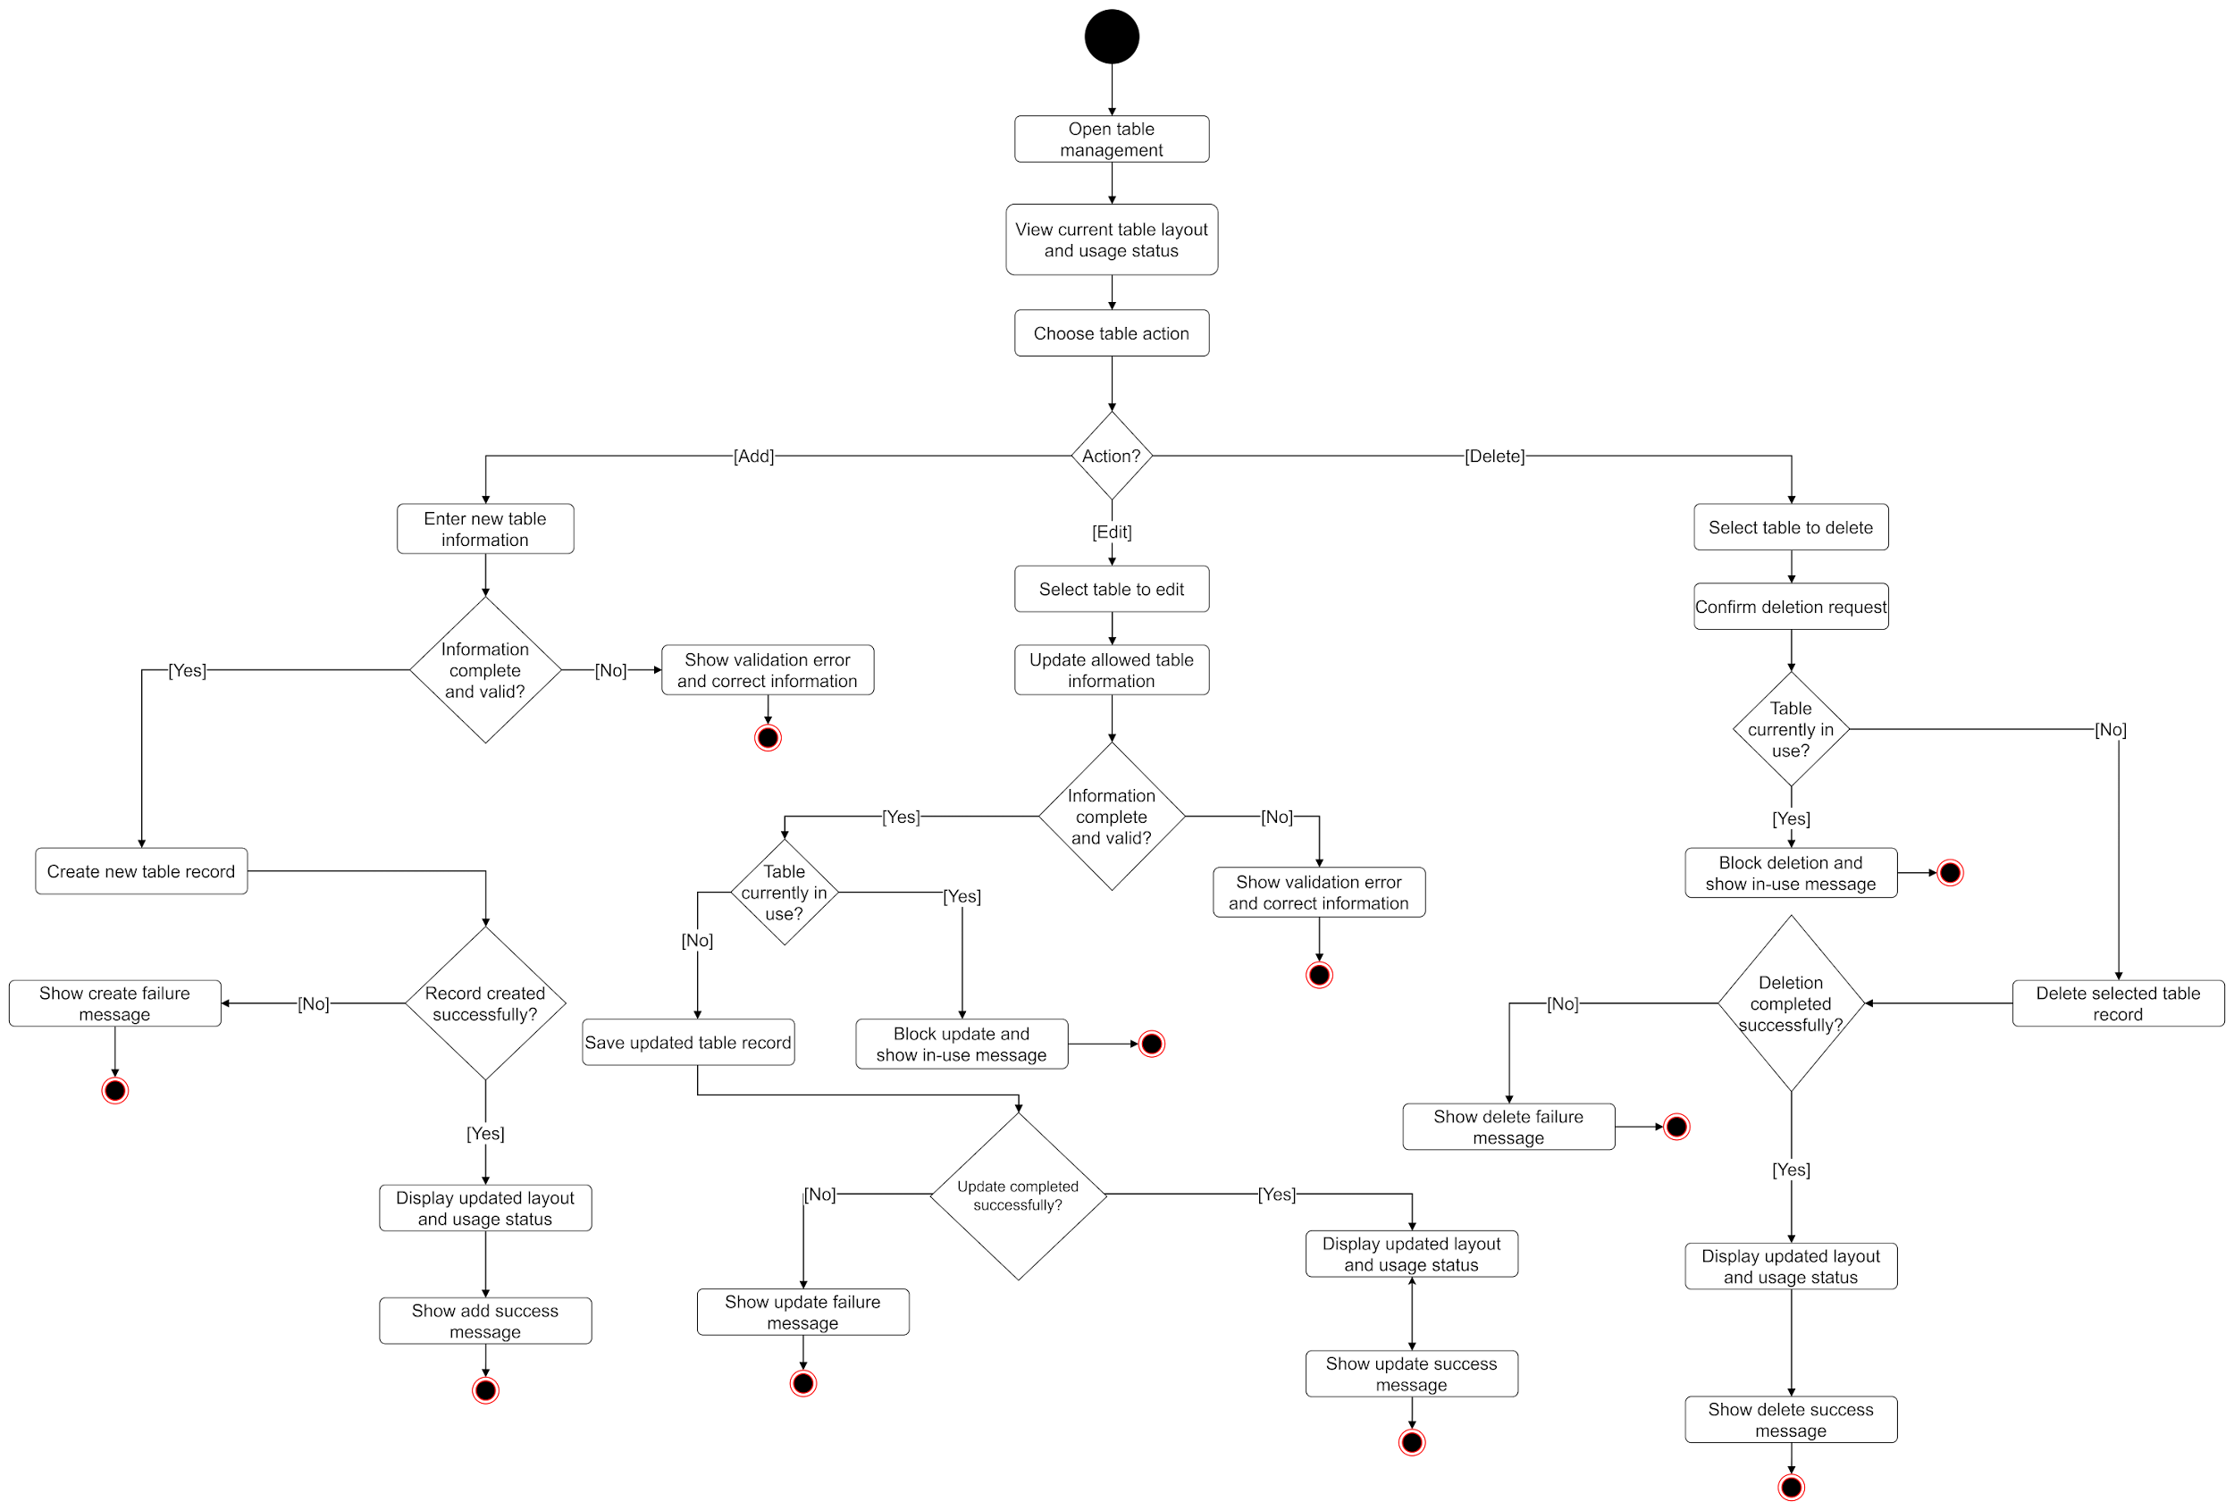
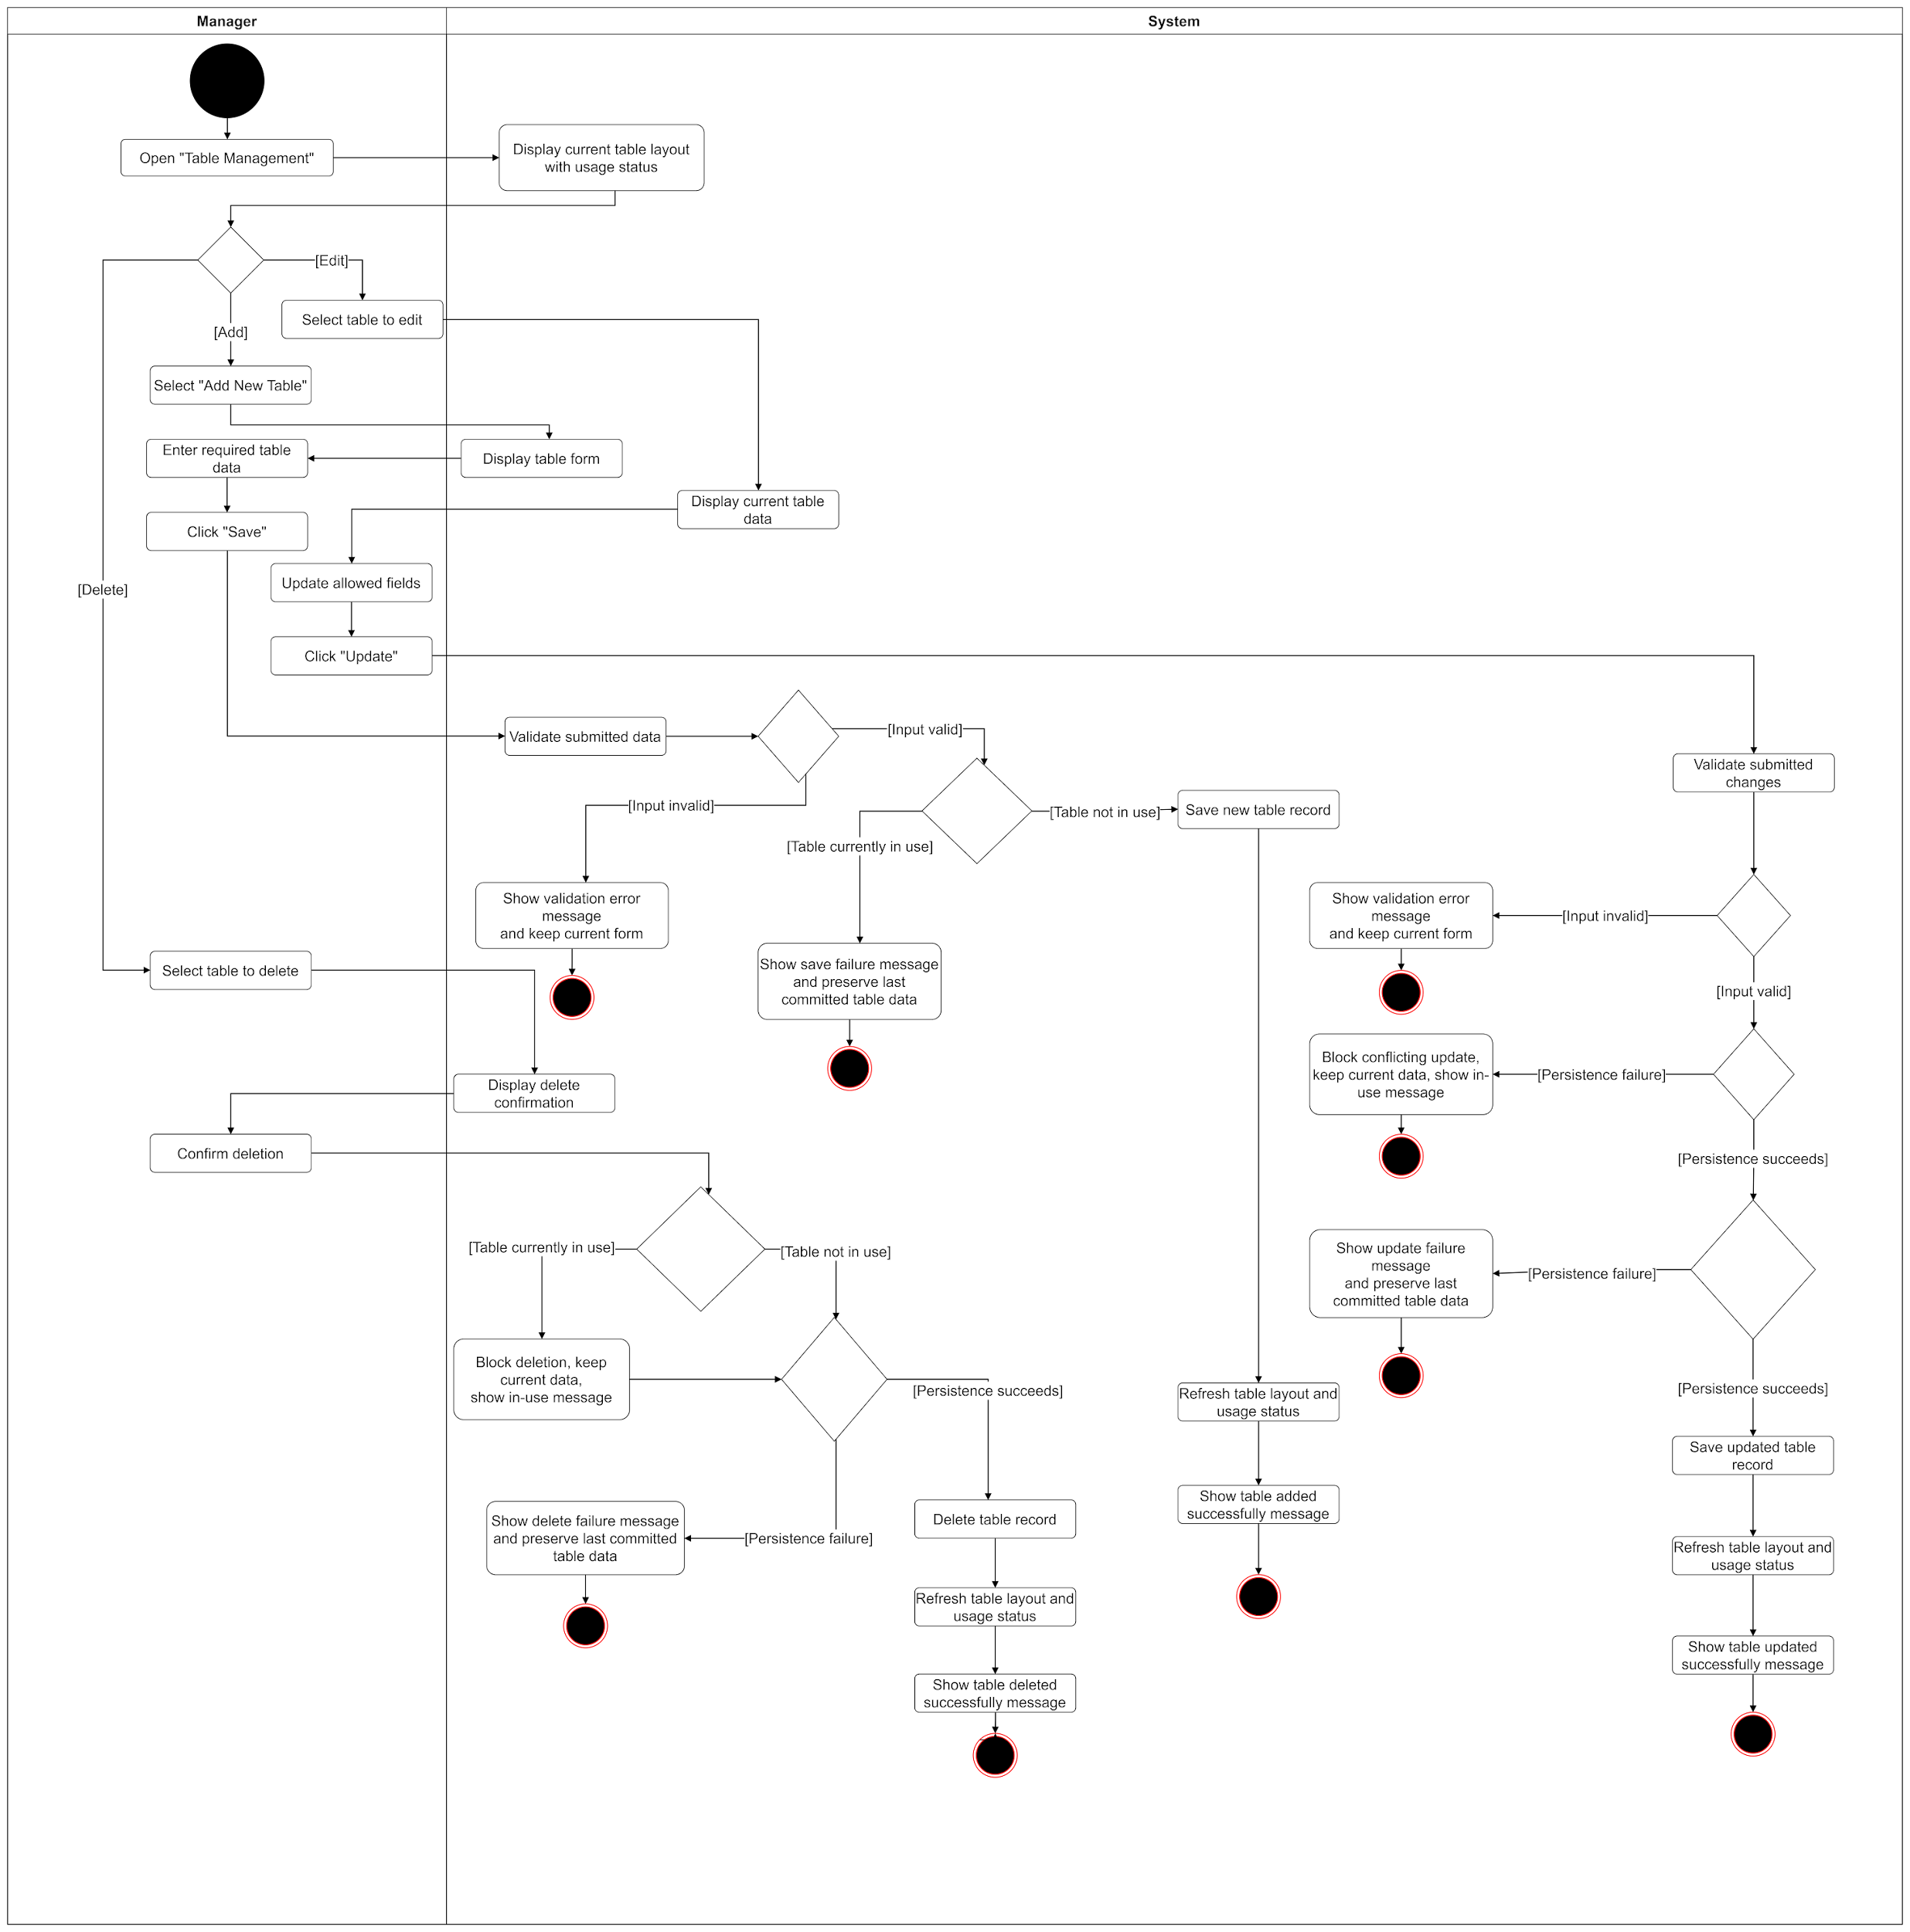

Use Case 09
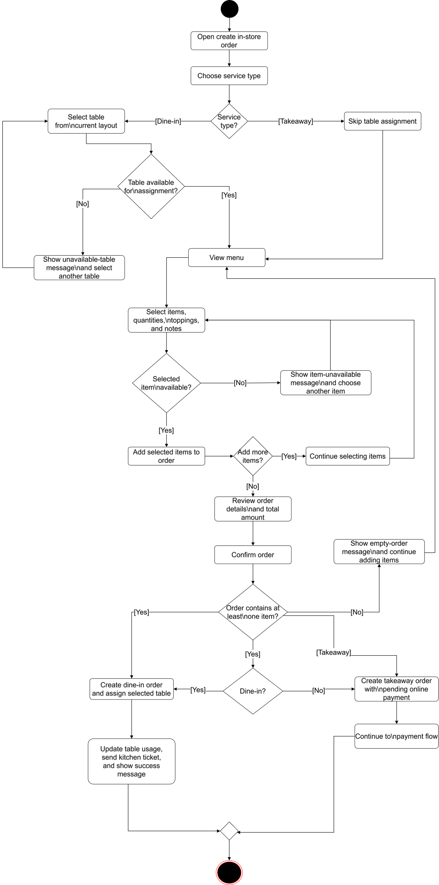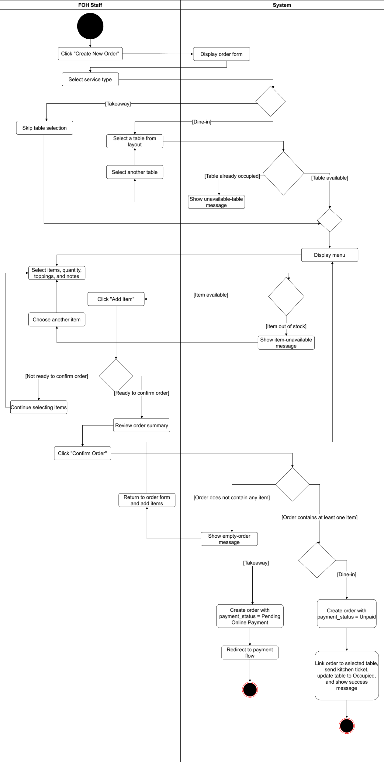
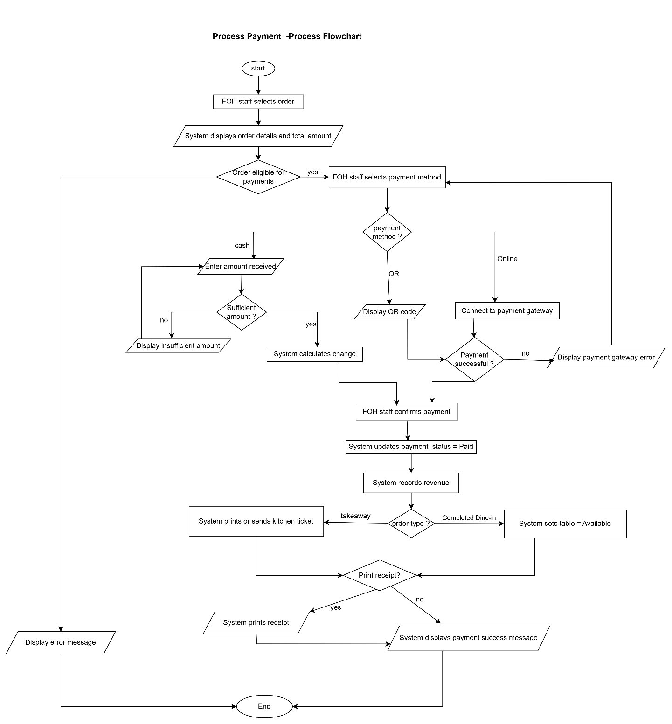
Use Case 10

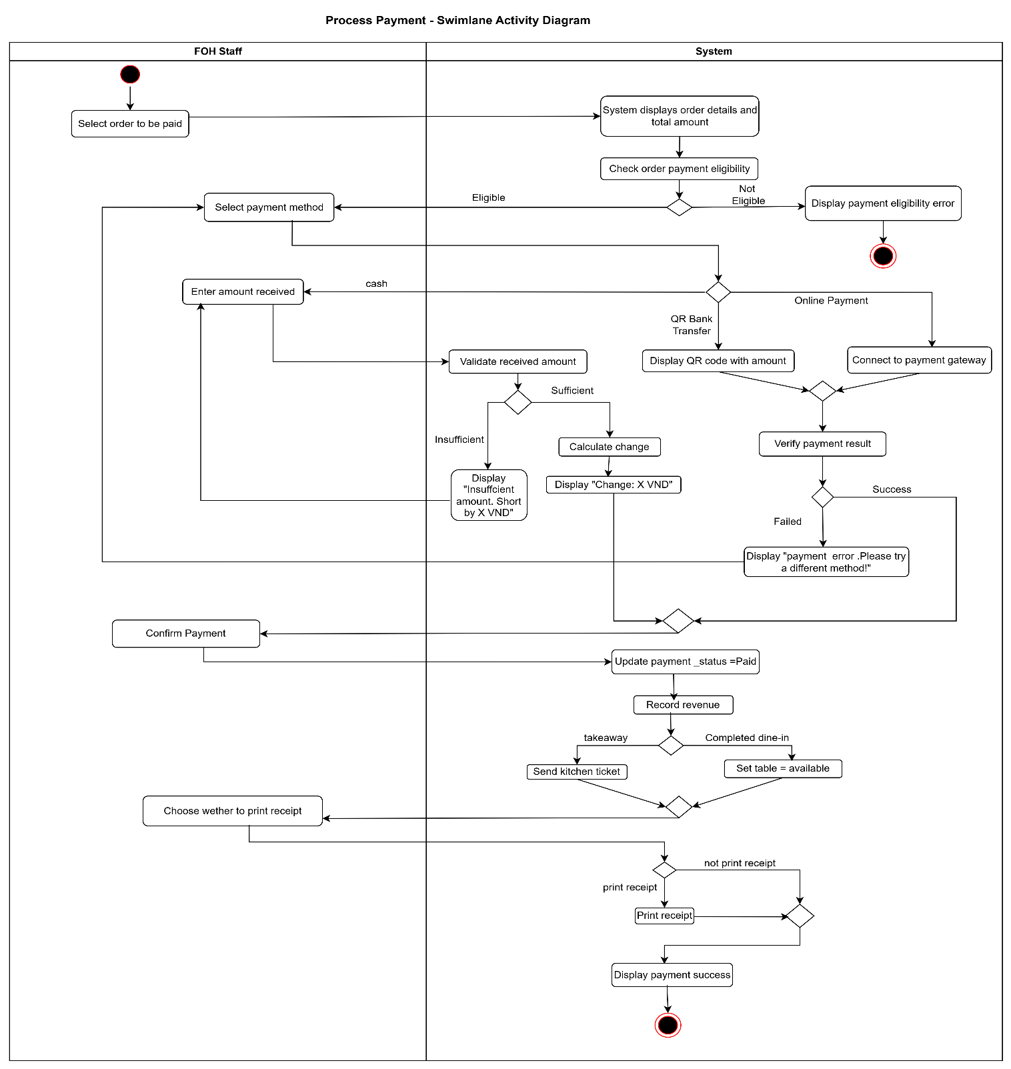
Use Case 11
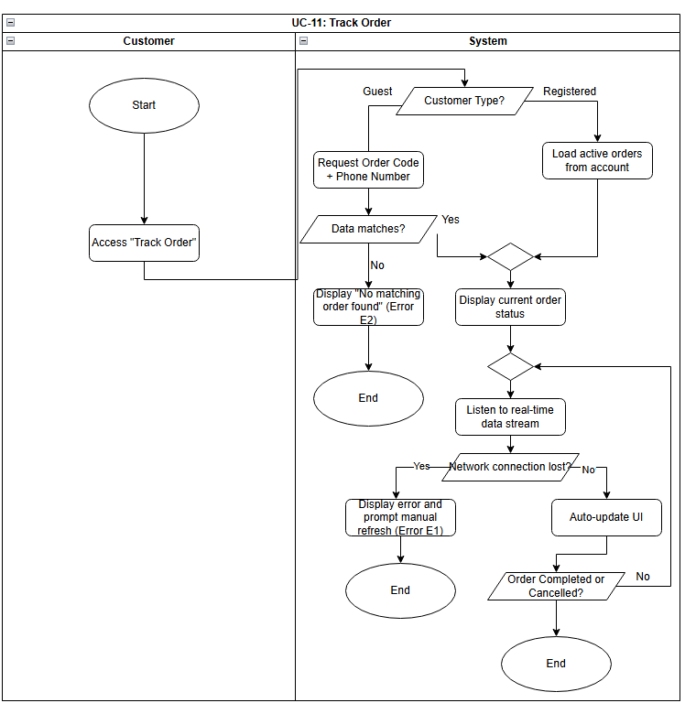
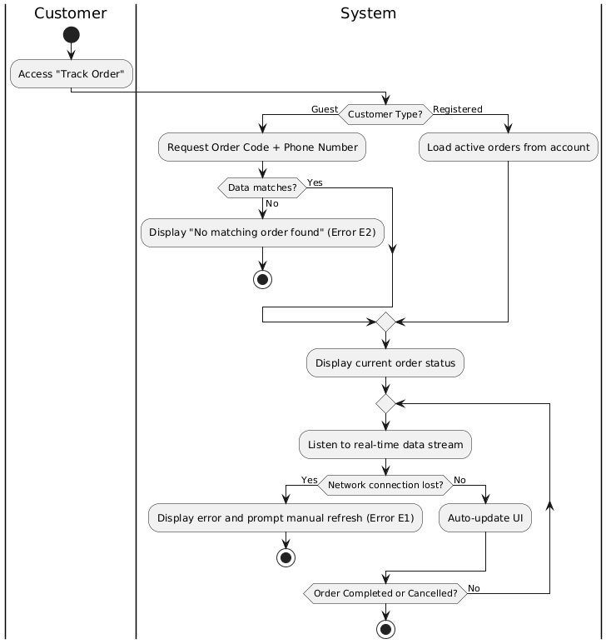
Use Case 12
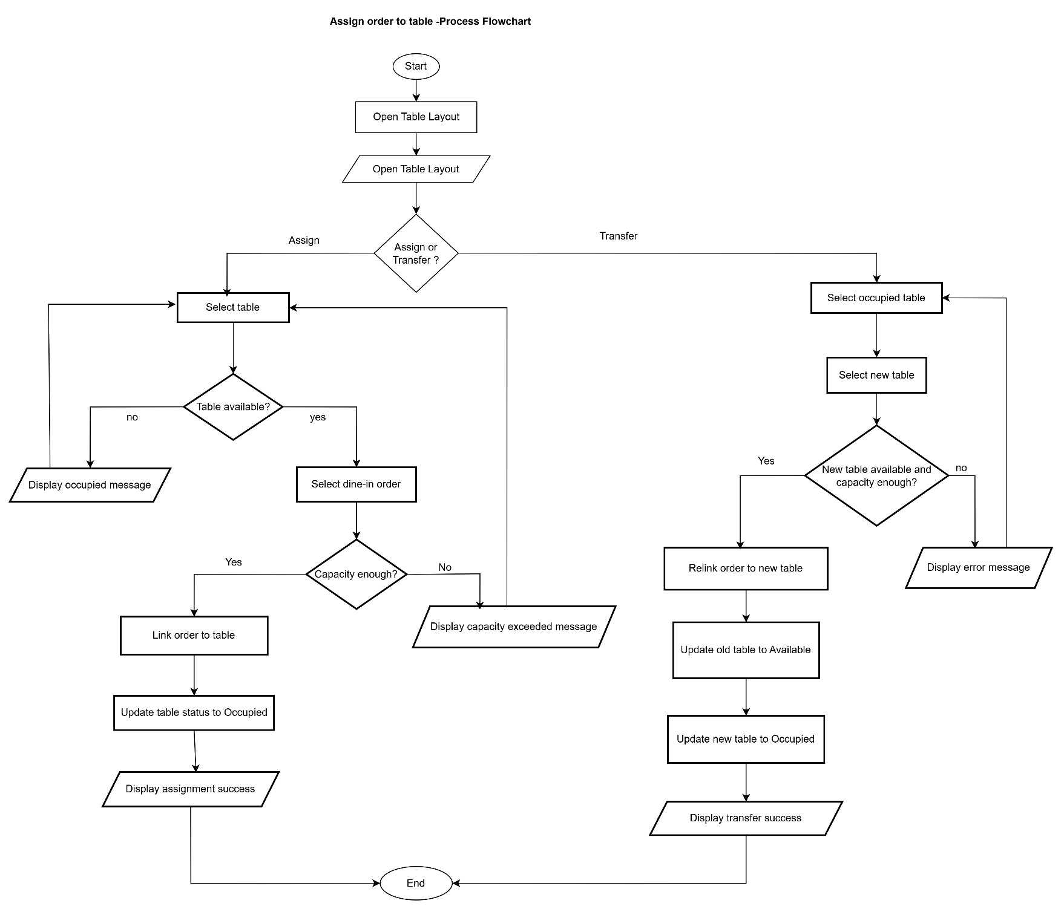
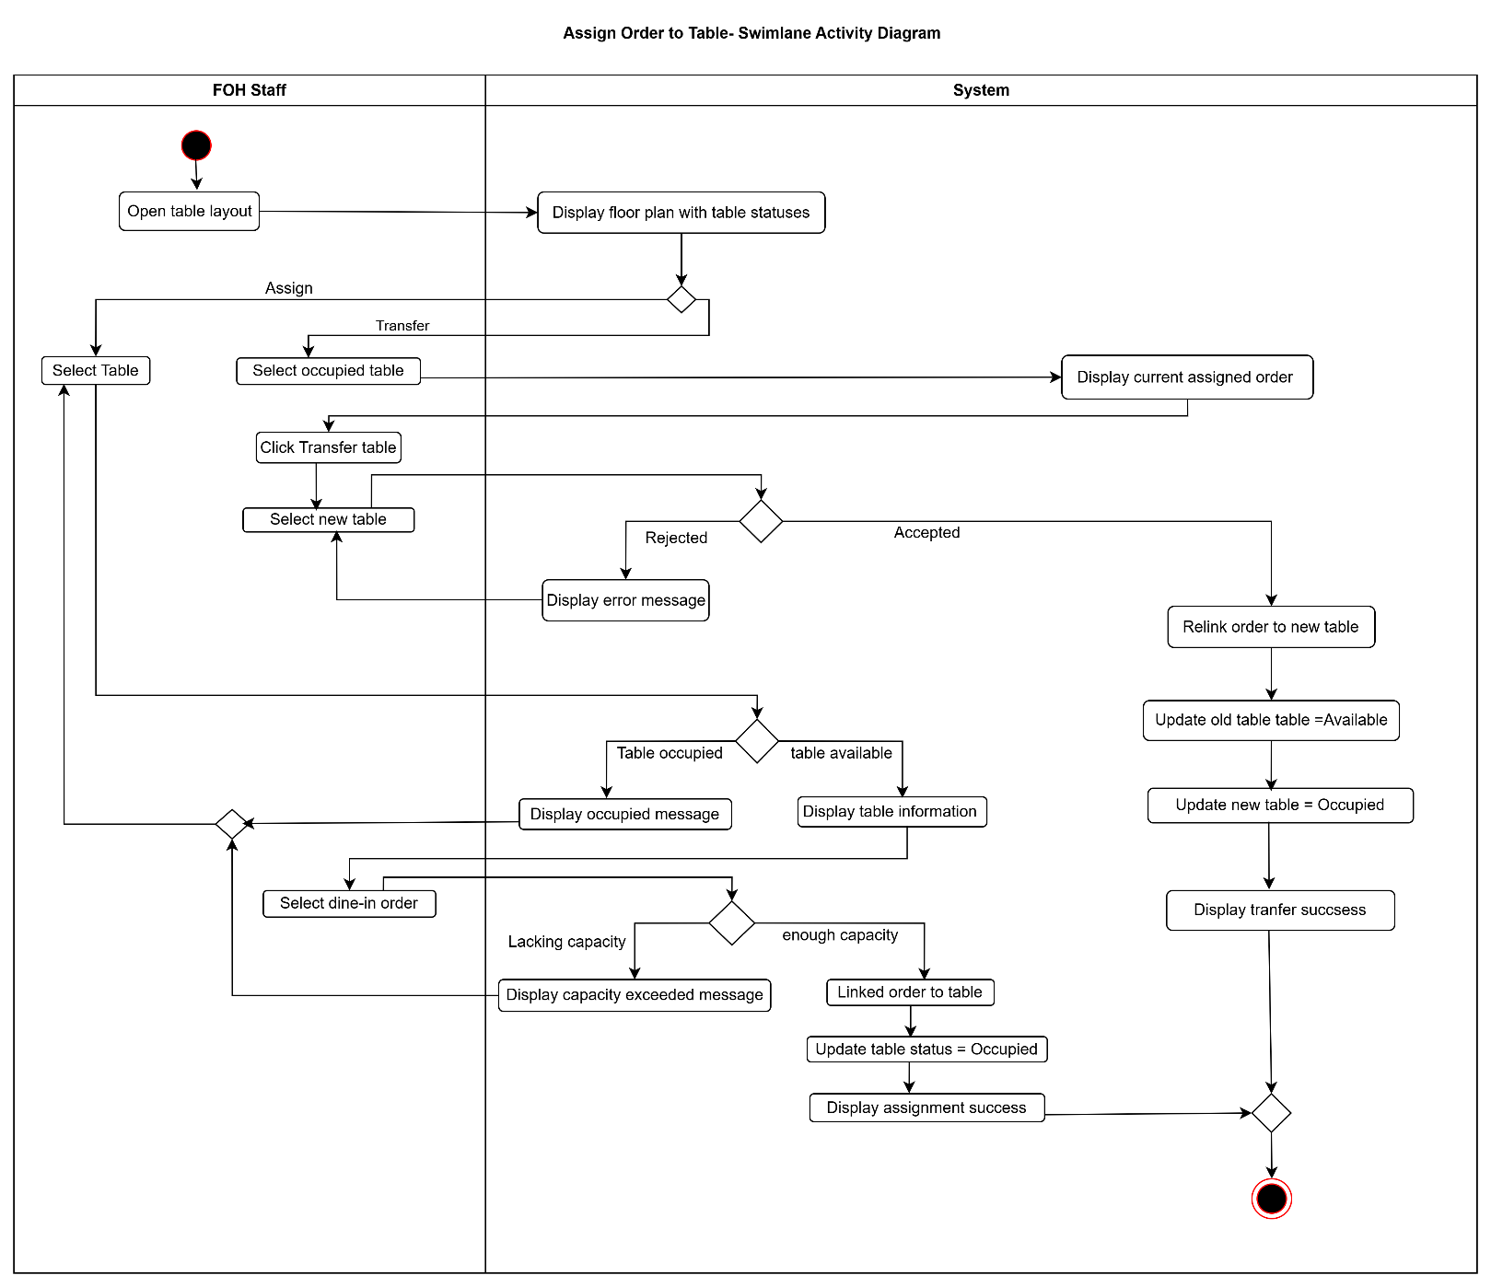

Use Case 13
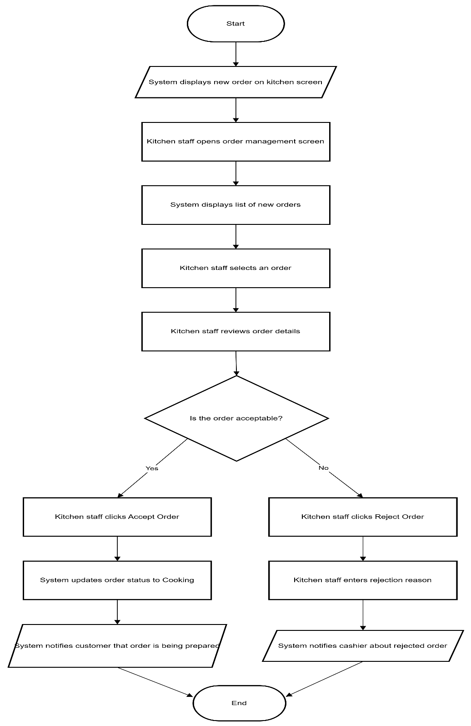
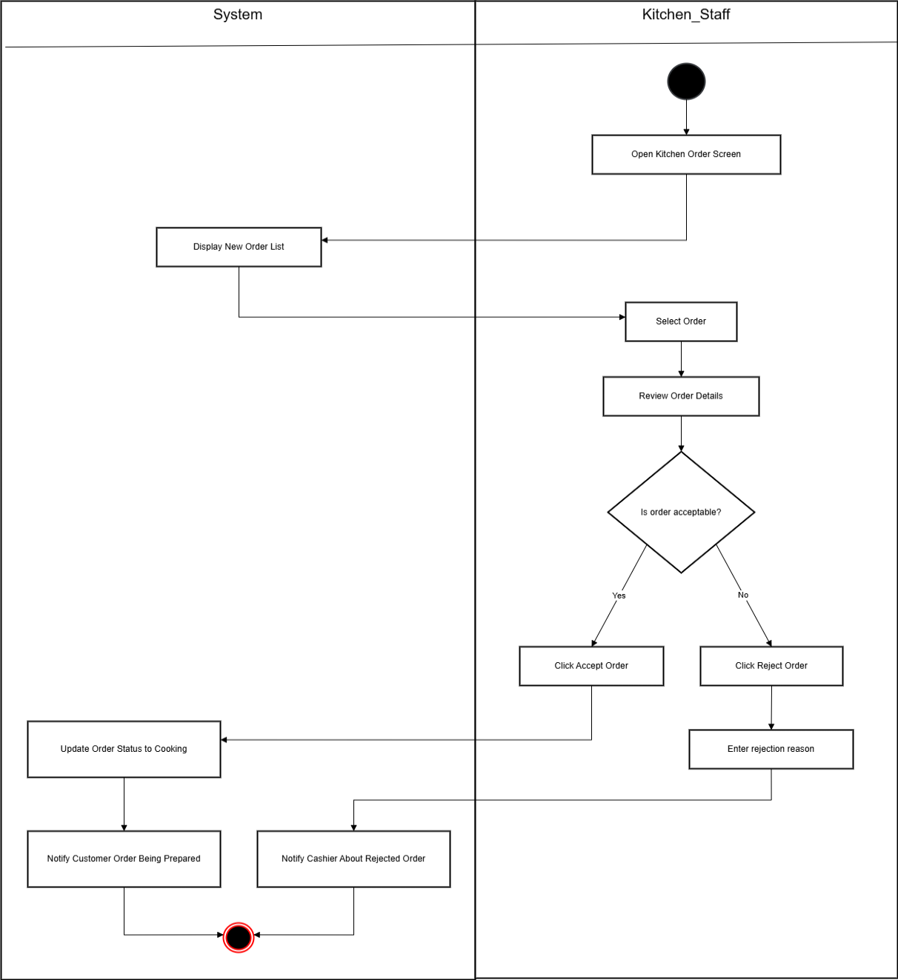
Use Case 14

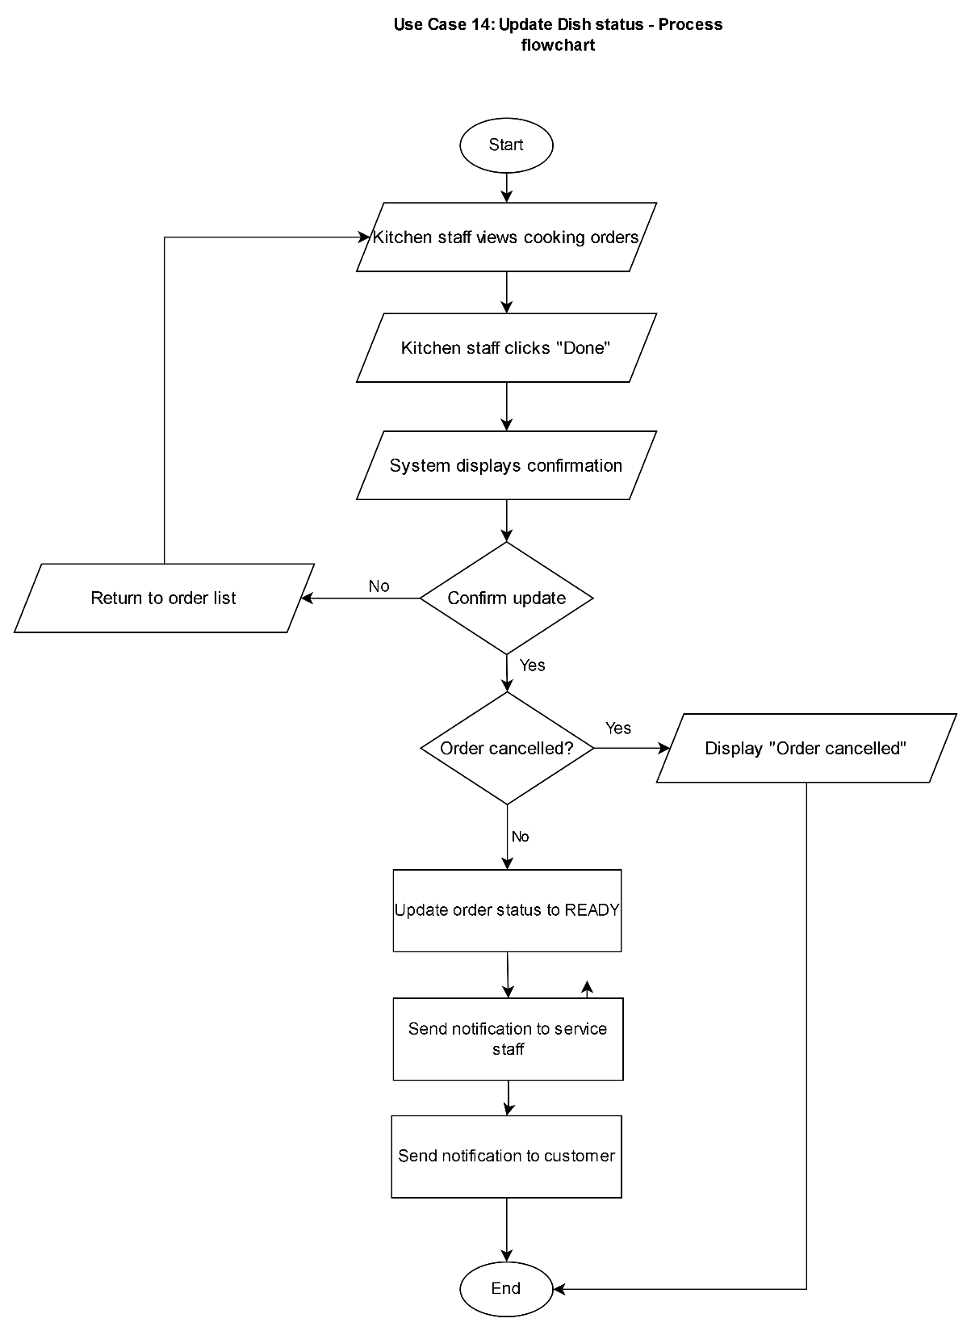
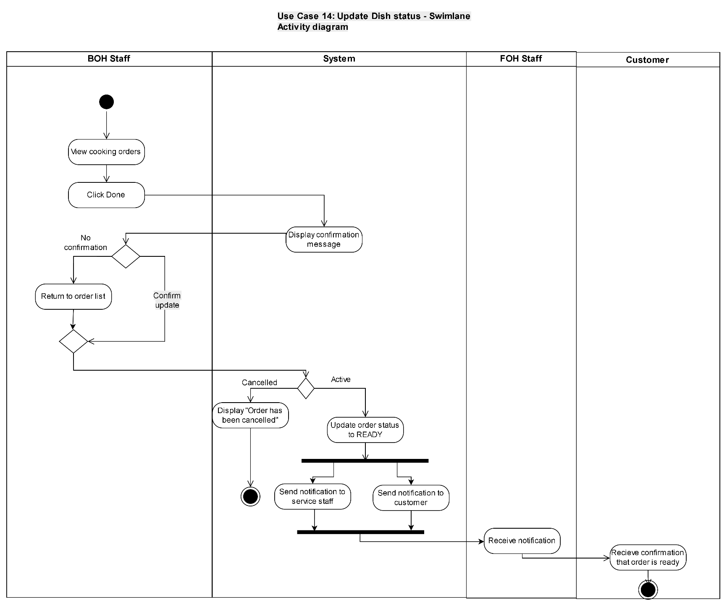
Use Case 15
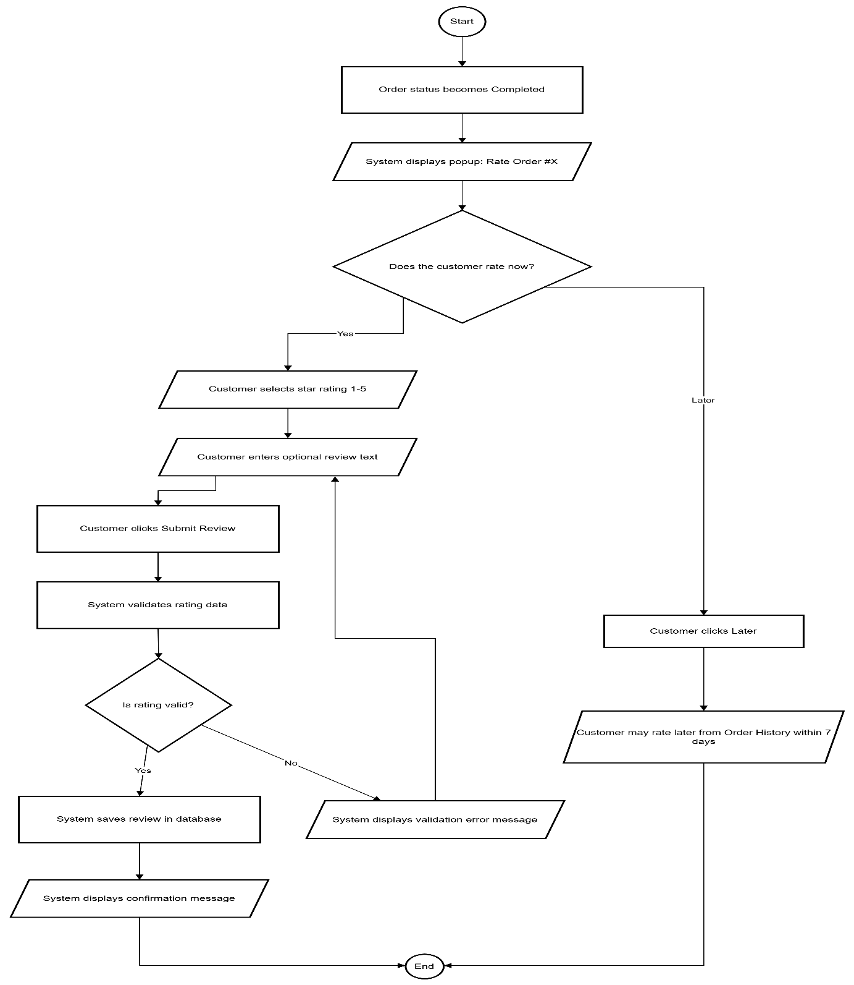
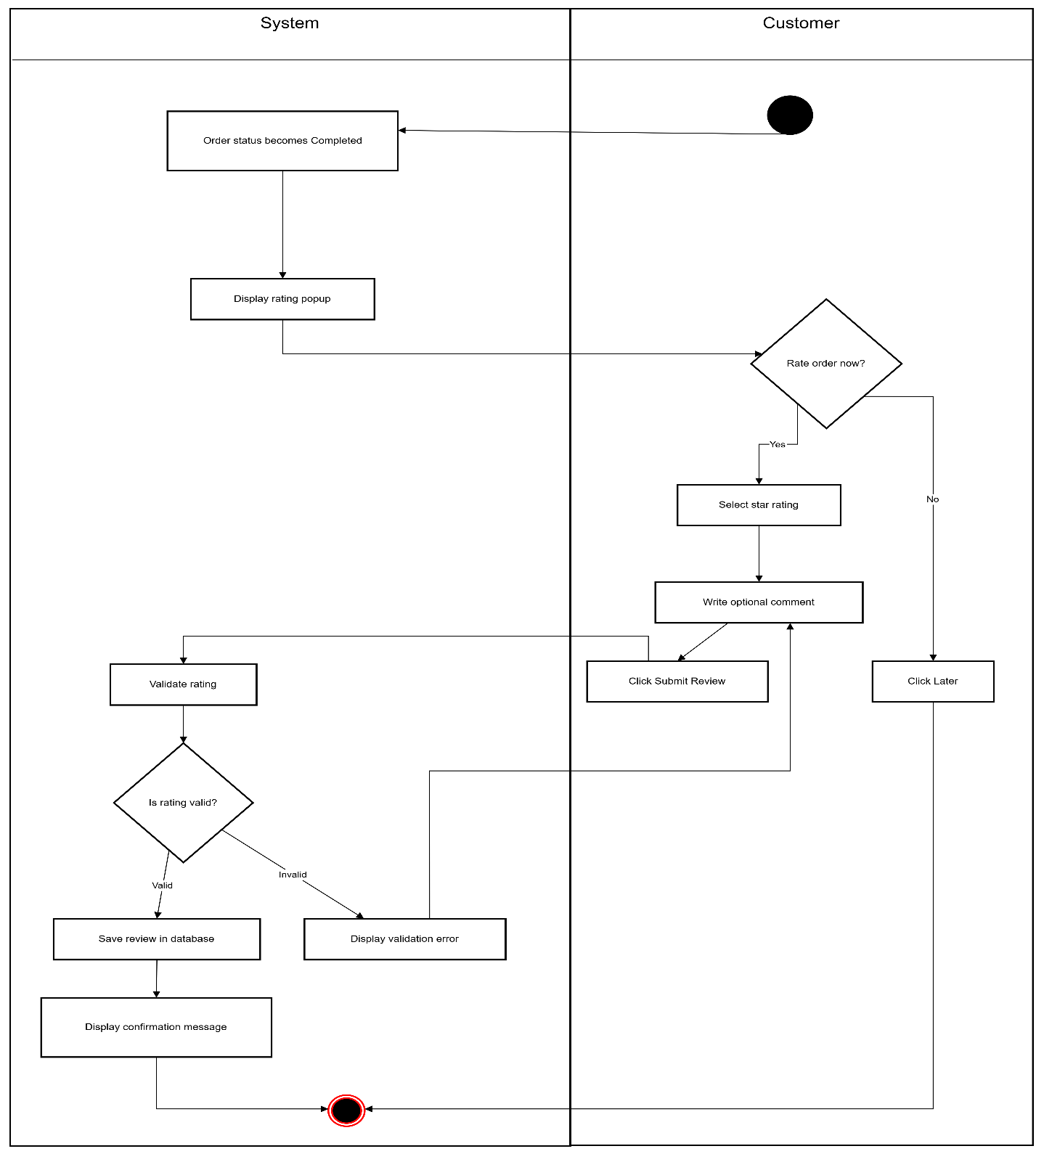

Use Case 16
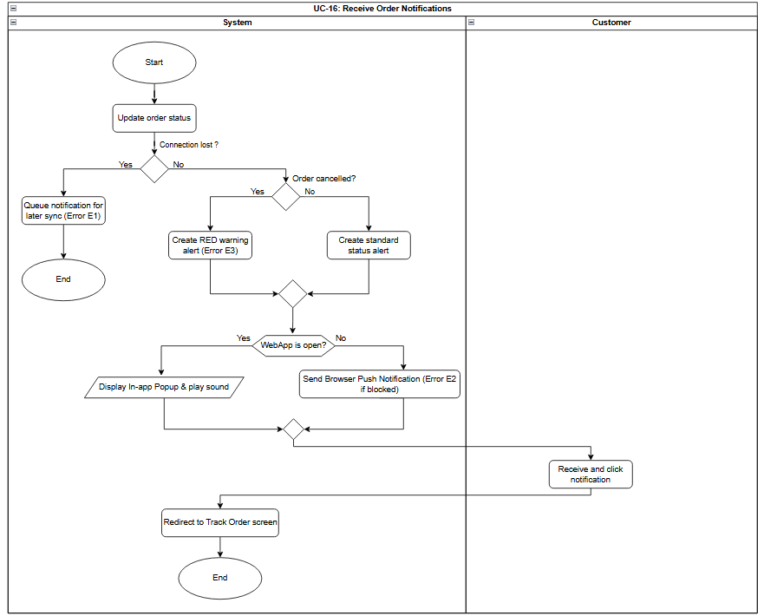

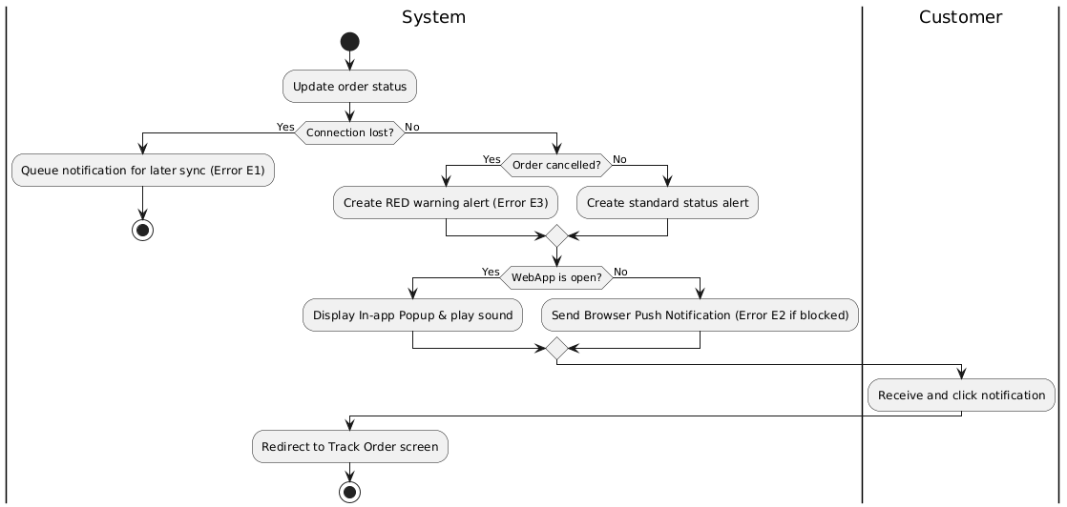

Use Case 17
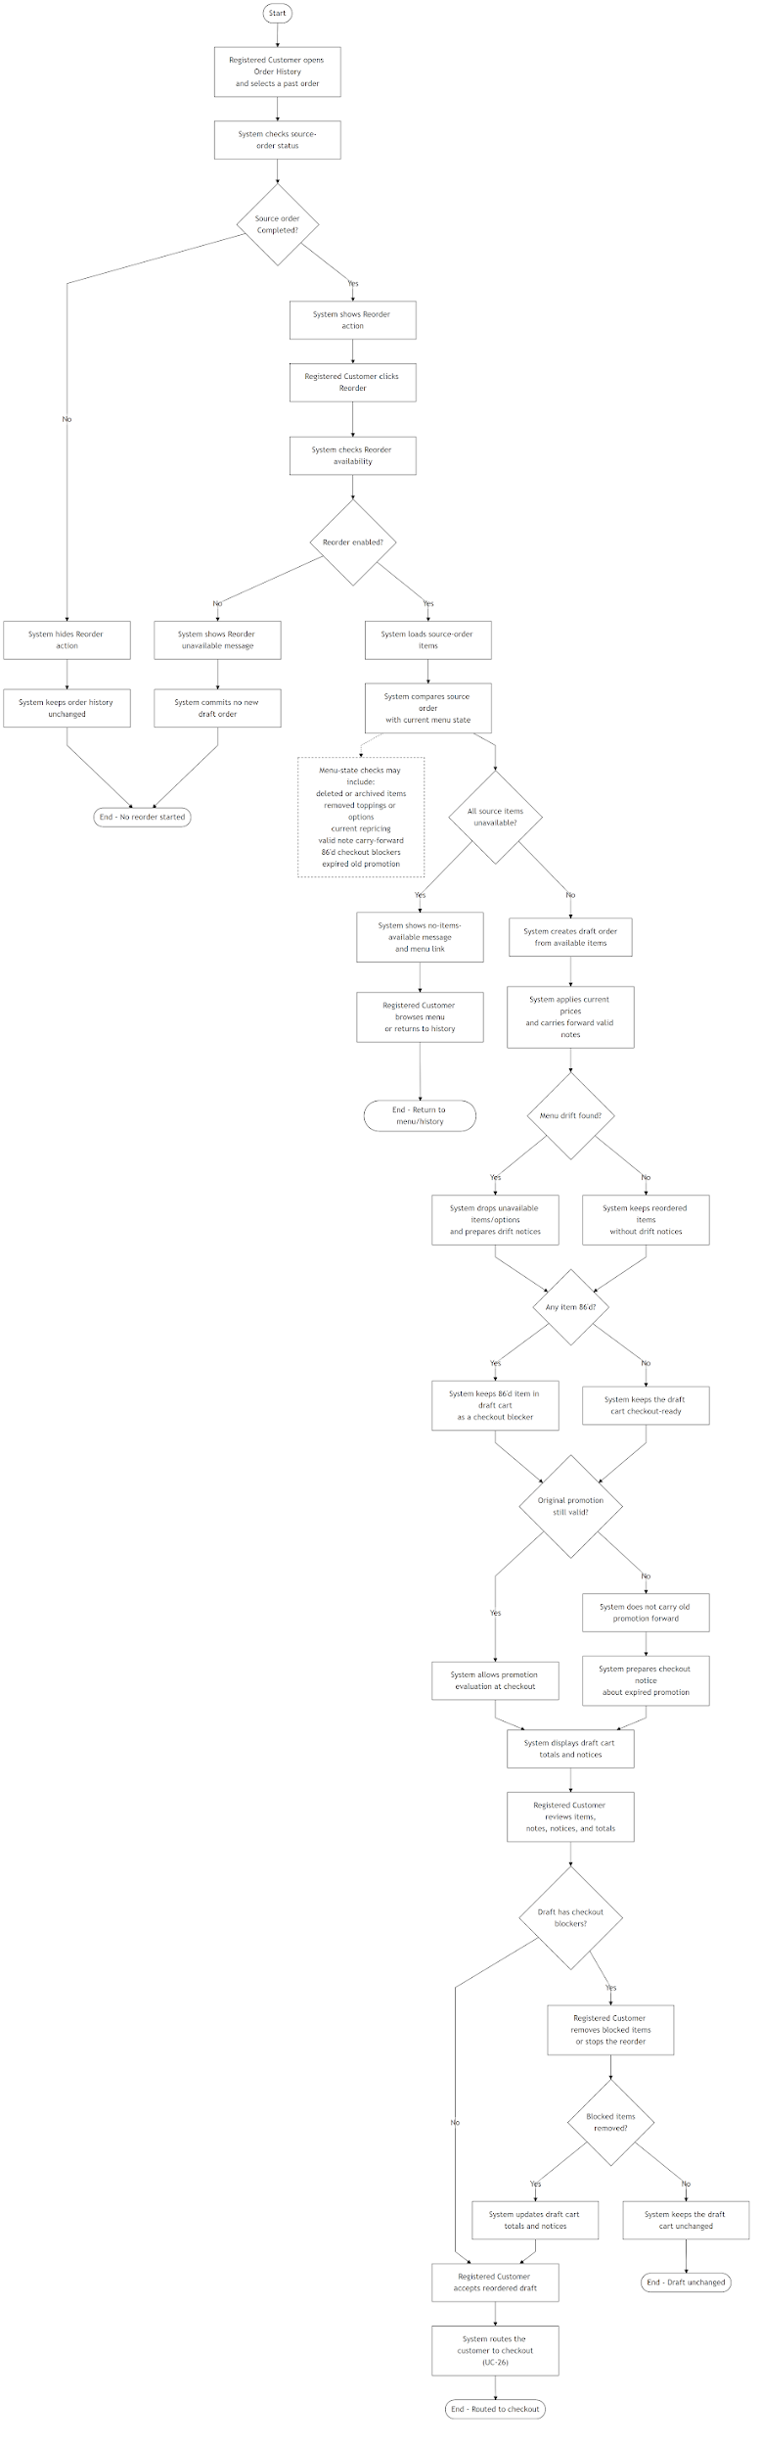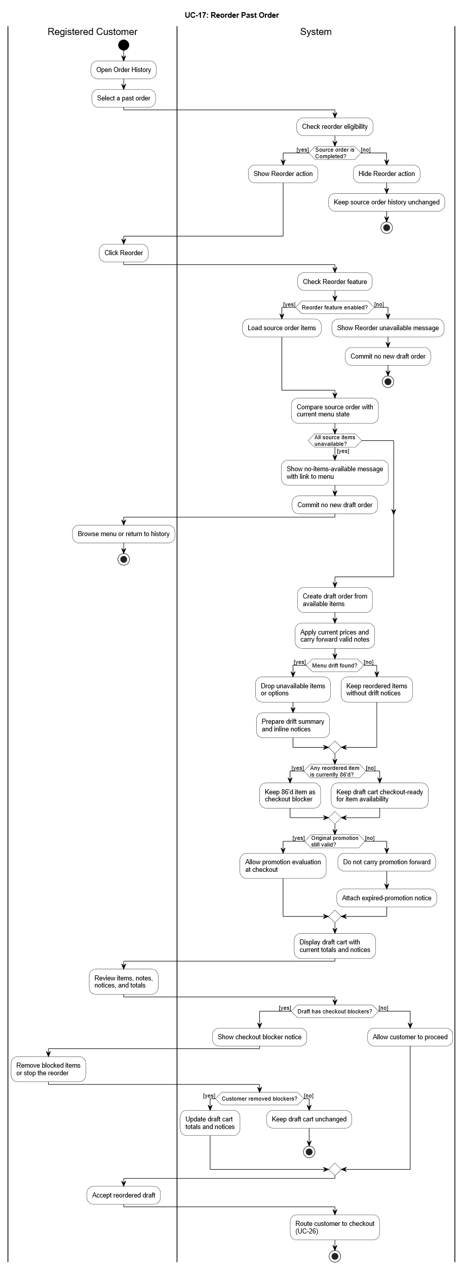
Use Case 18
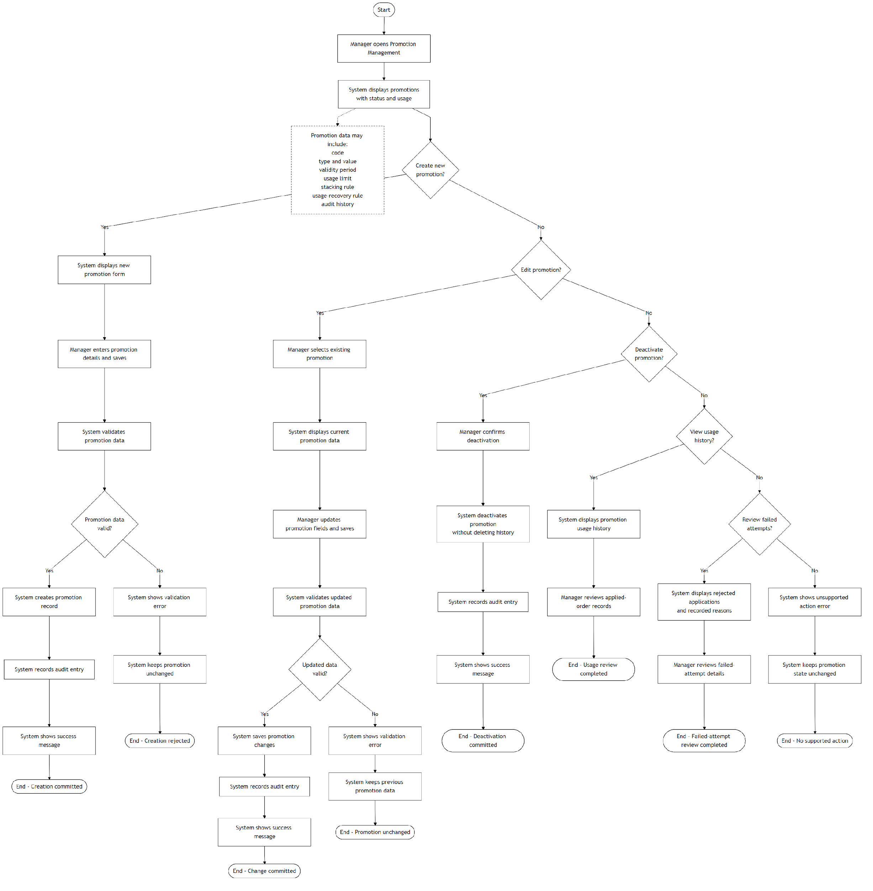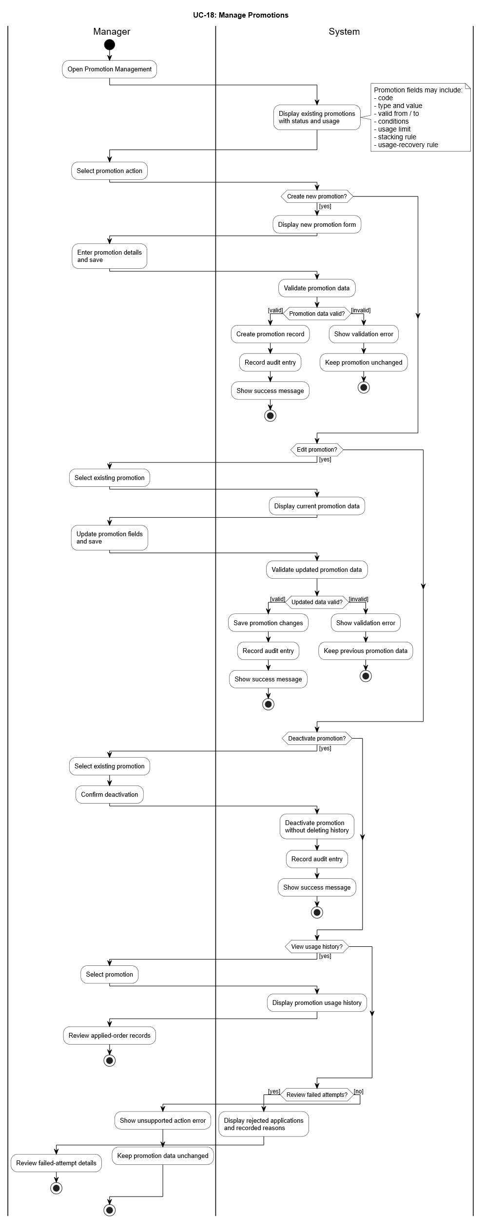
Use Case 19
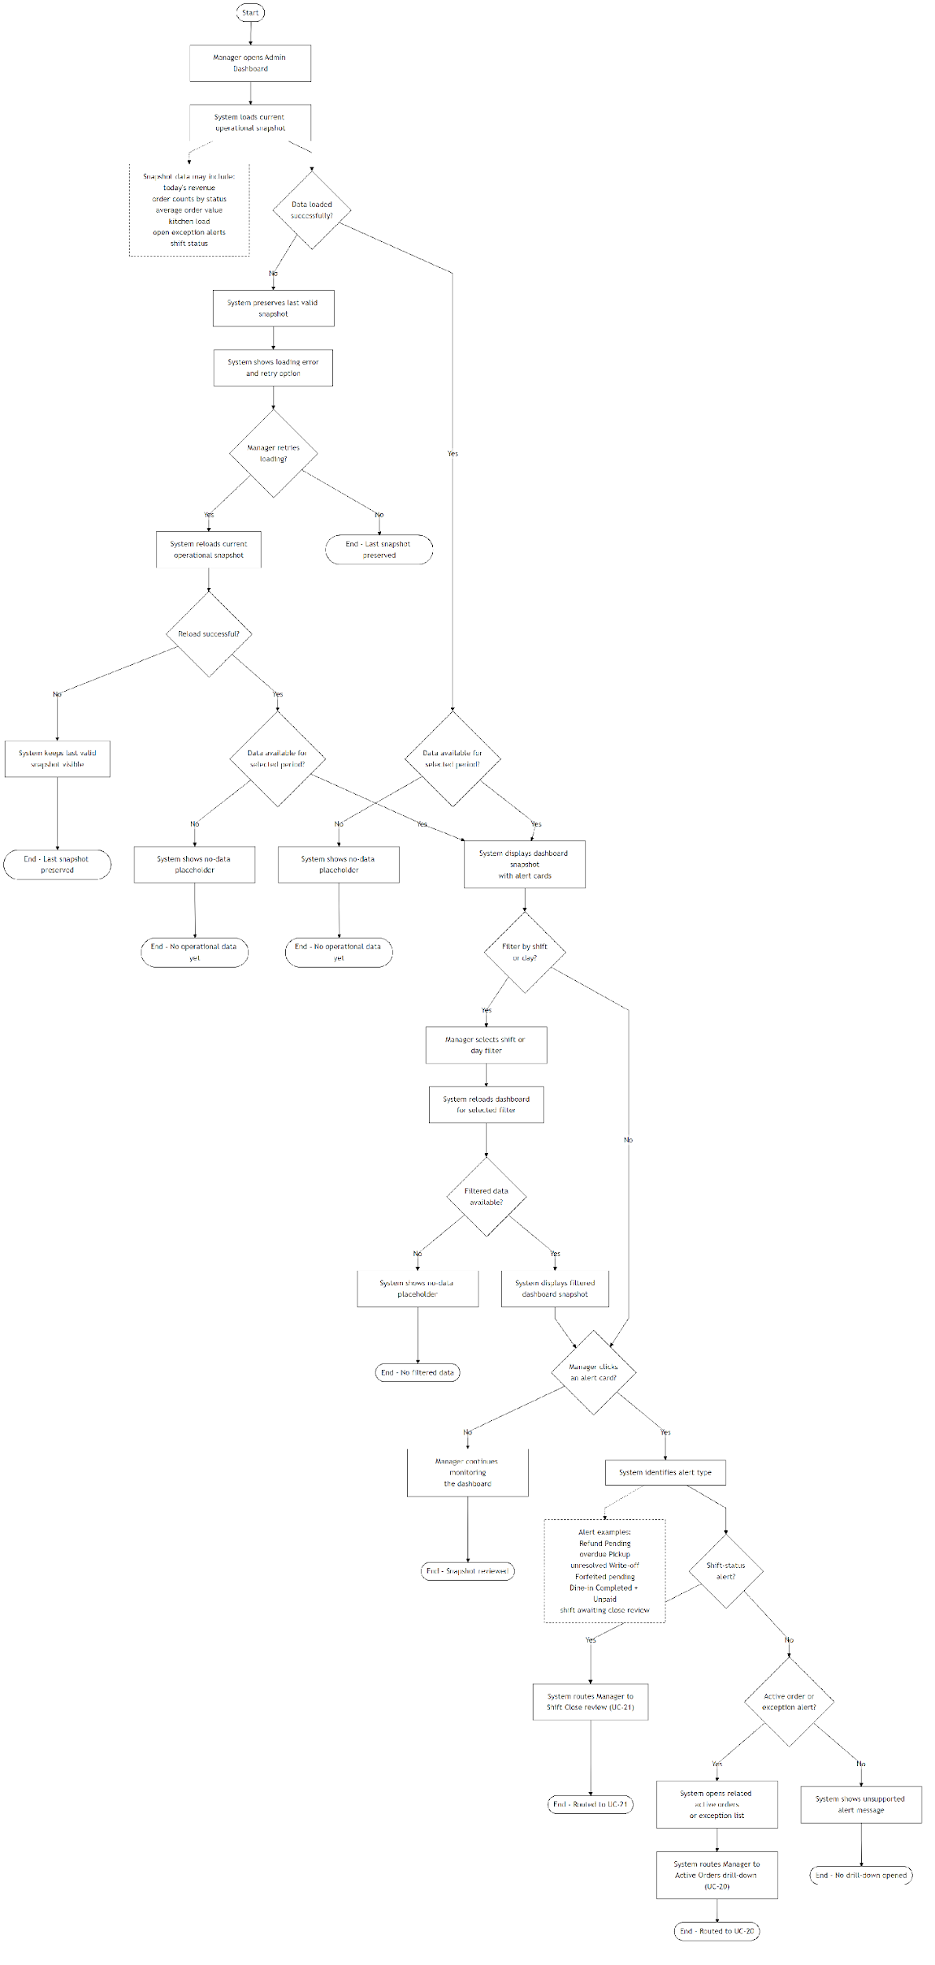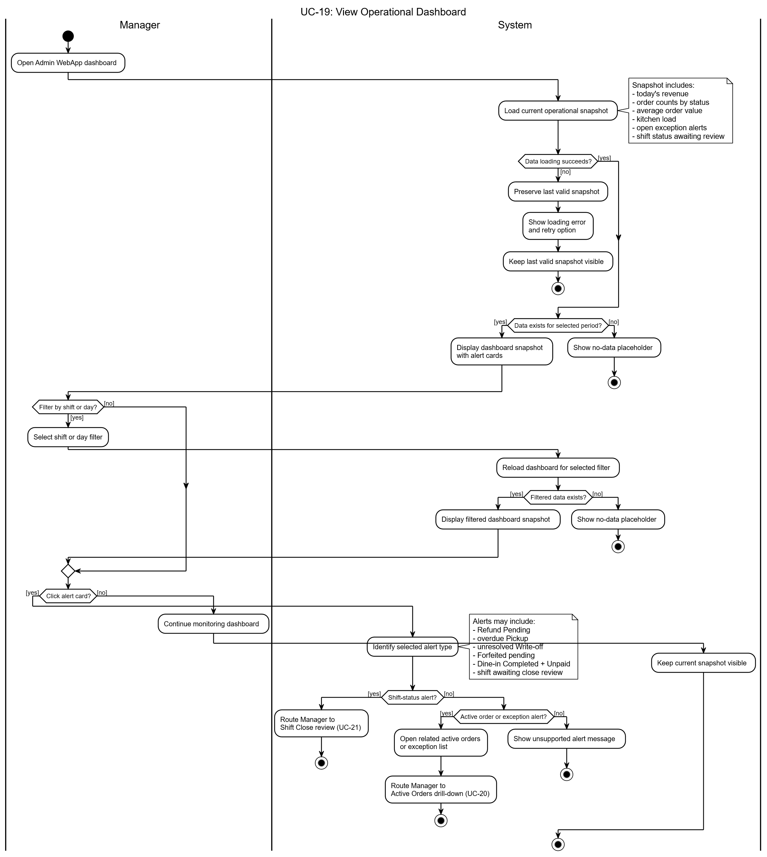
Use Case 20
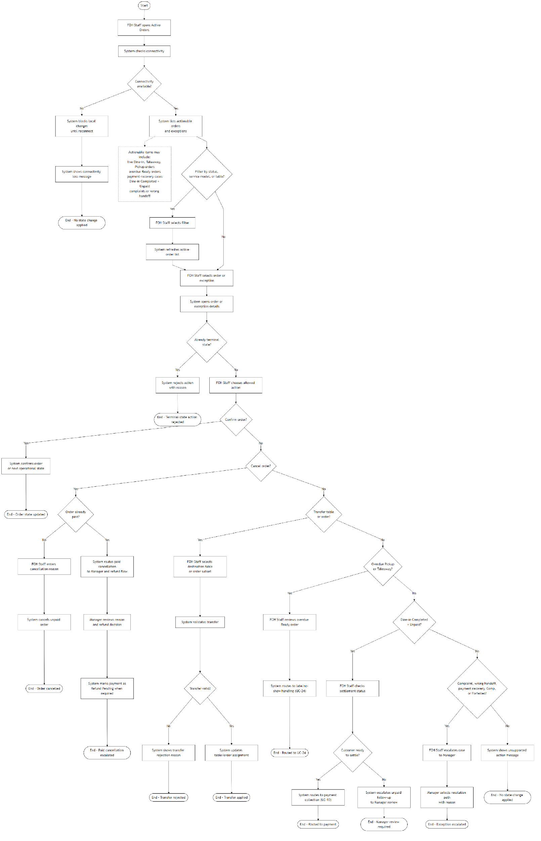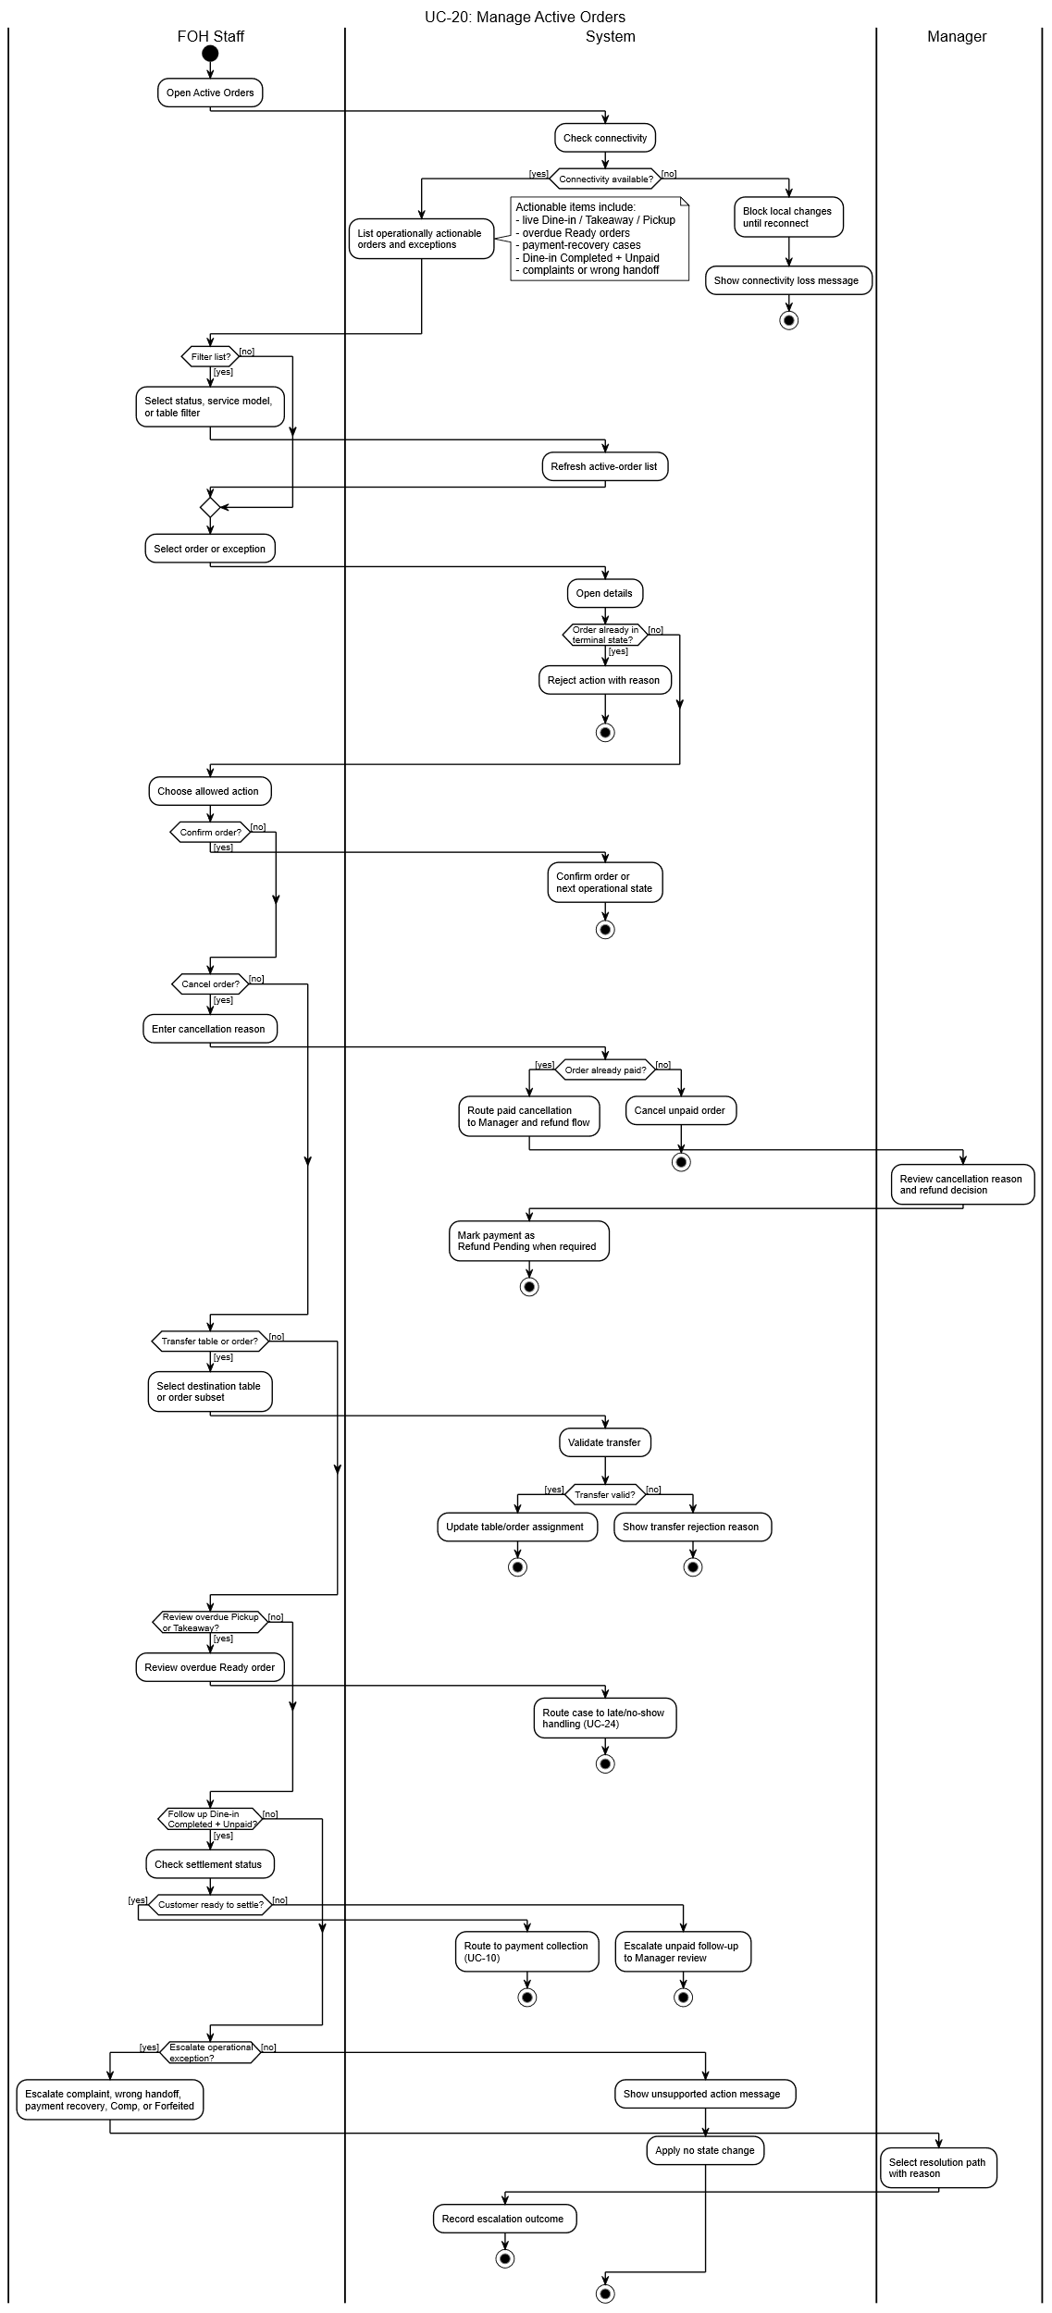
Use Case 21
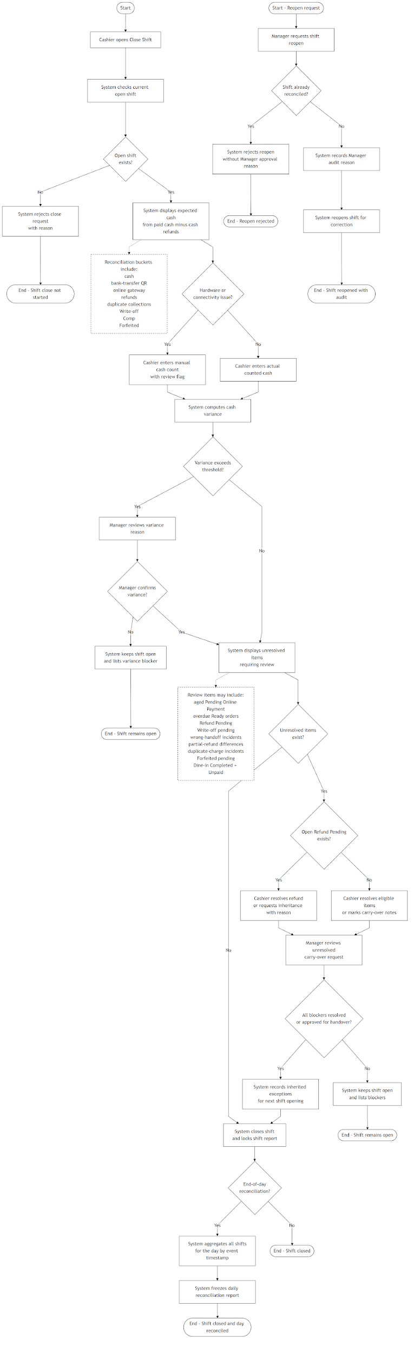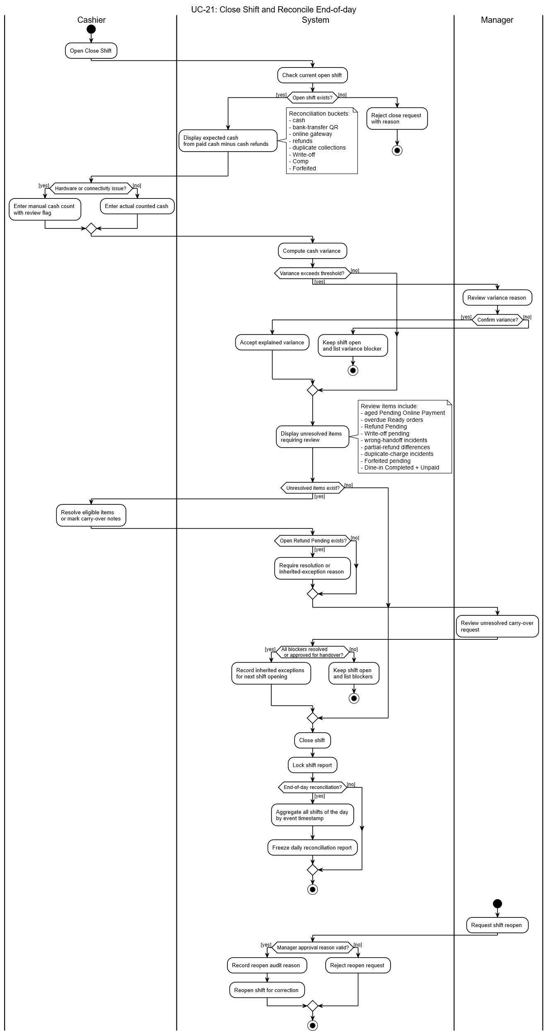
Use Case 22
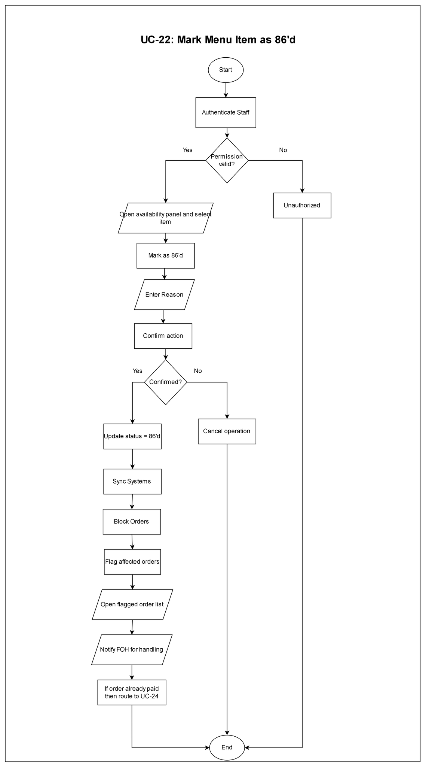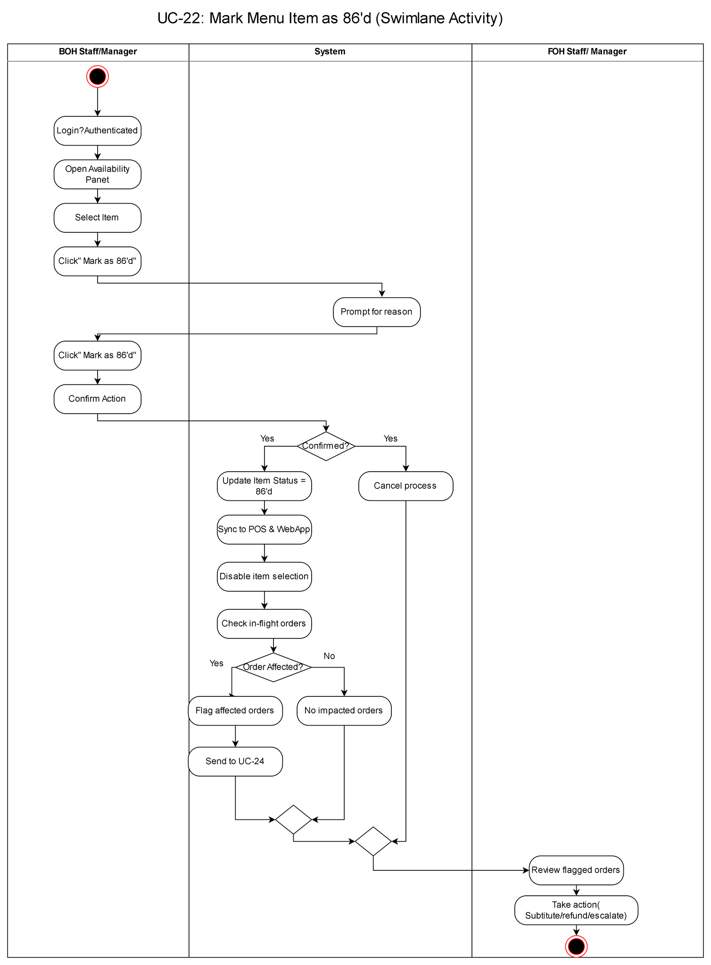
Use Case 23
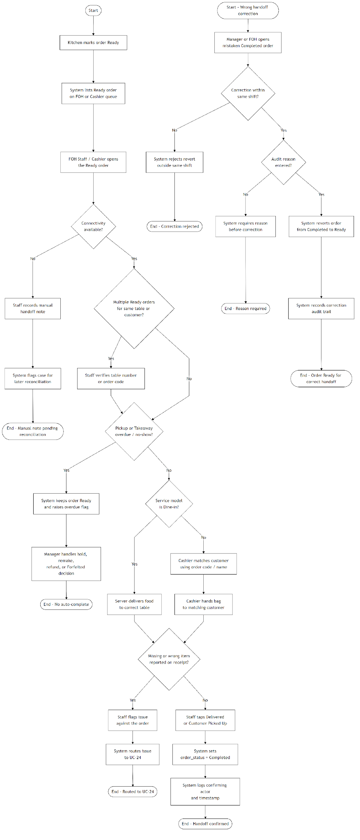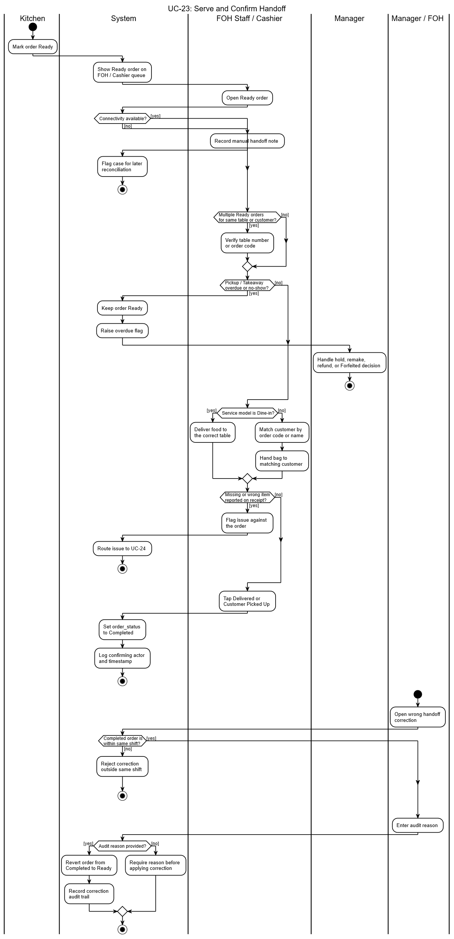
Use Case 24
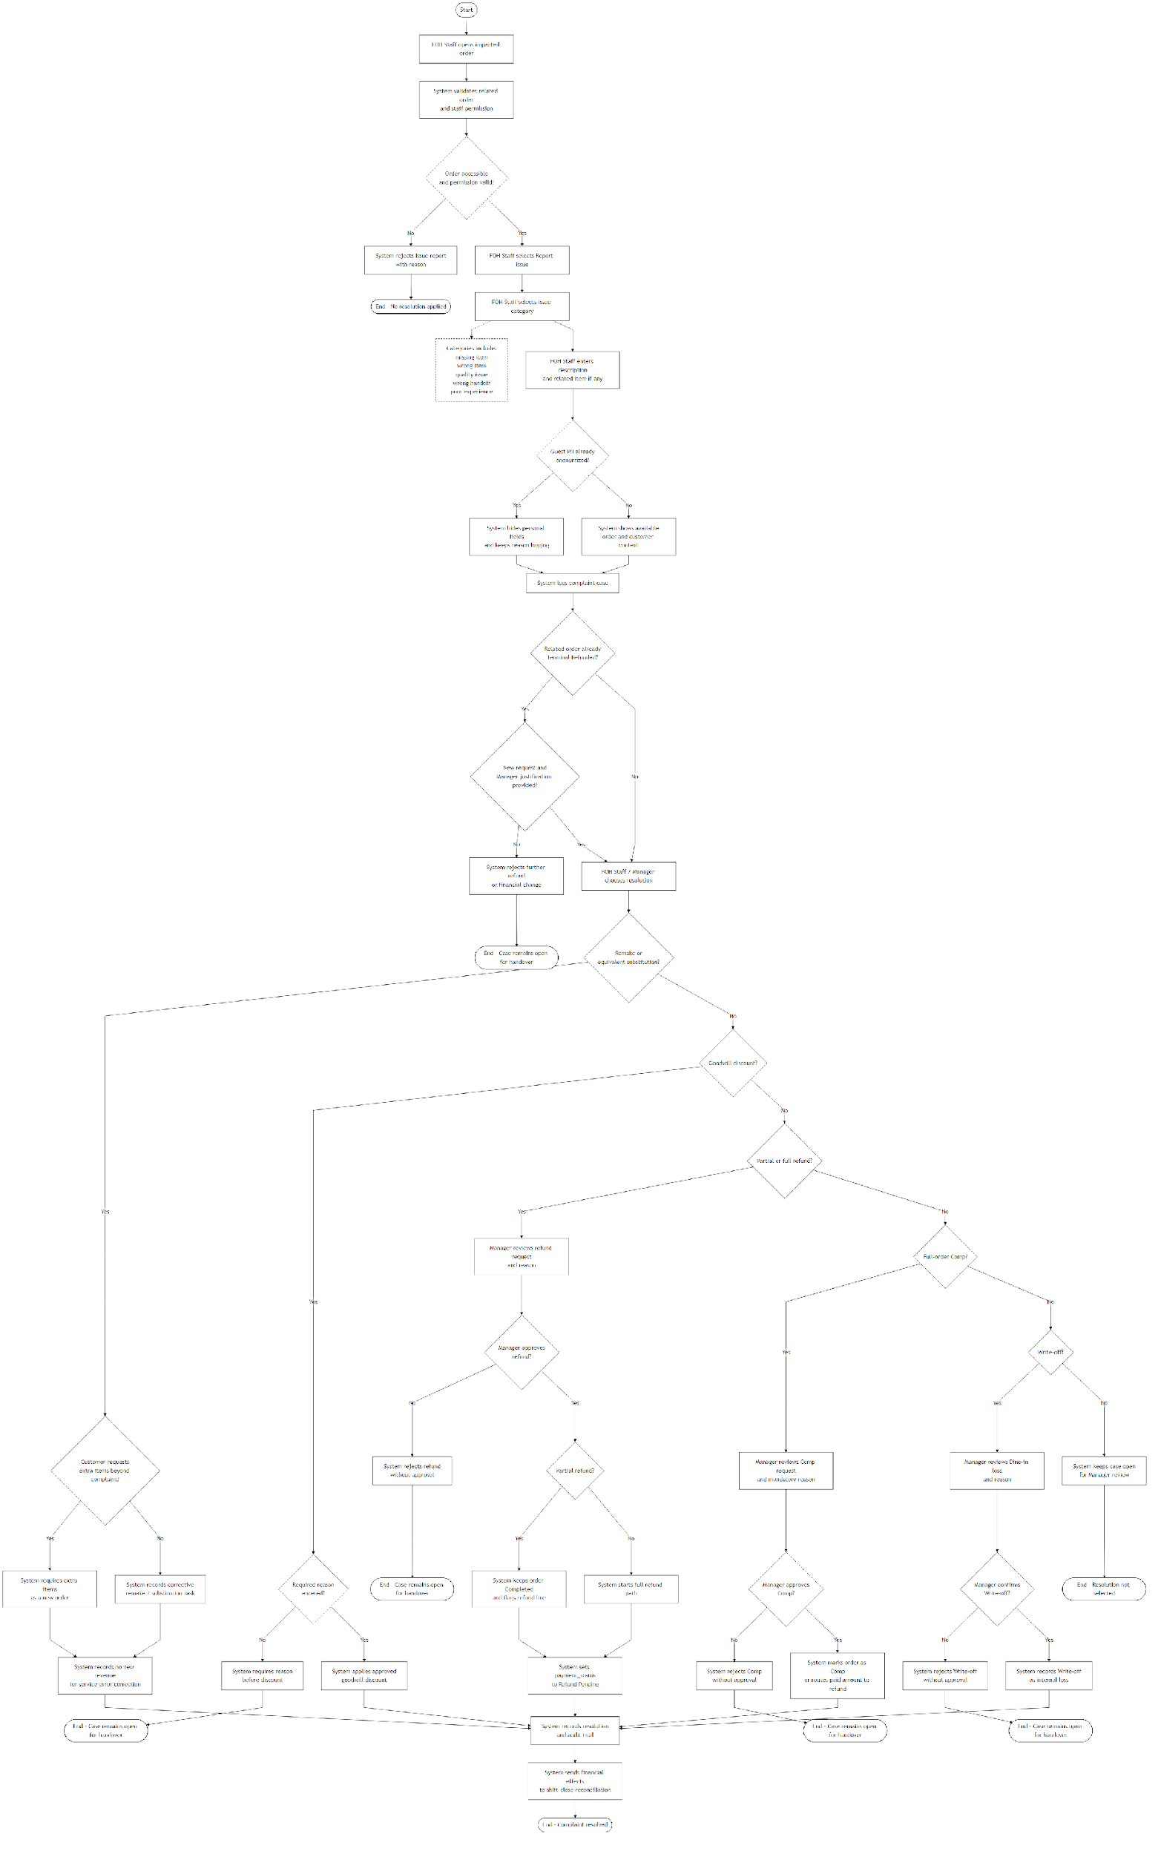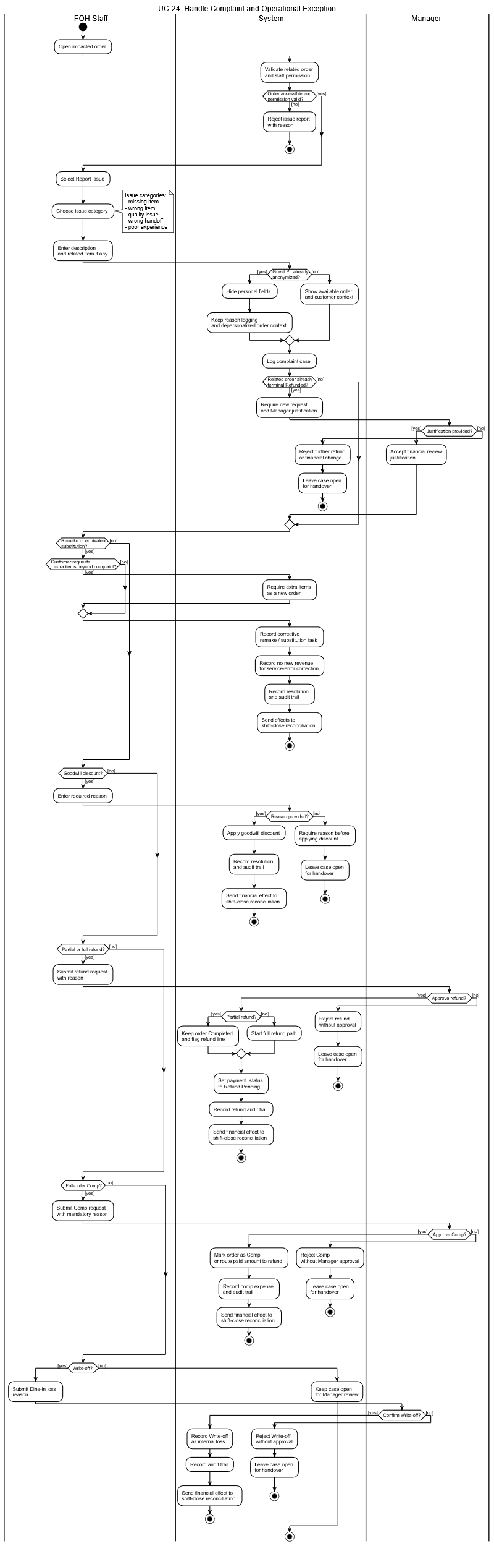
Use Case 25
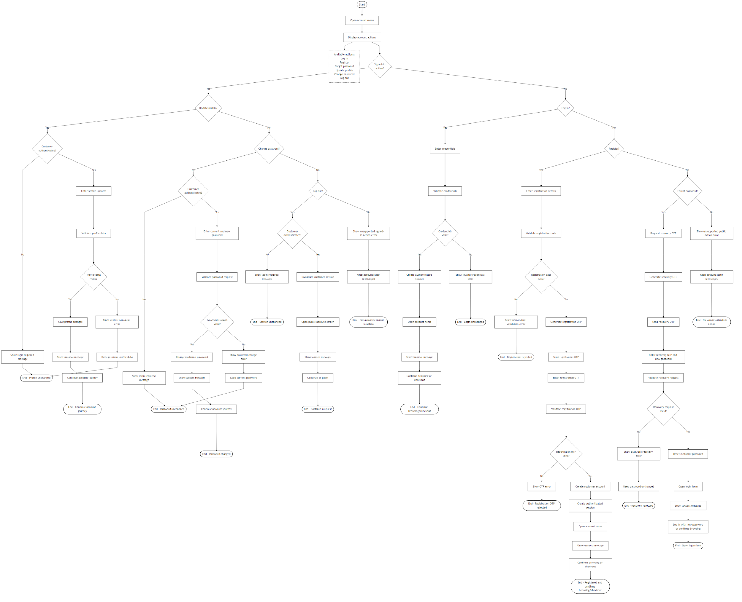
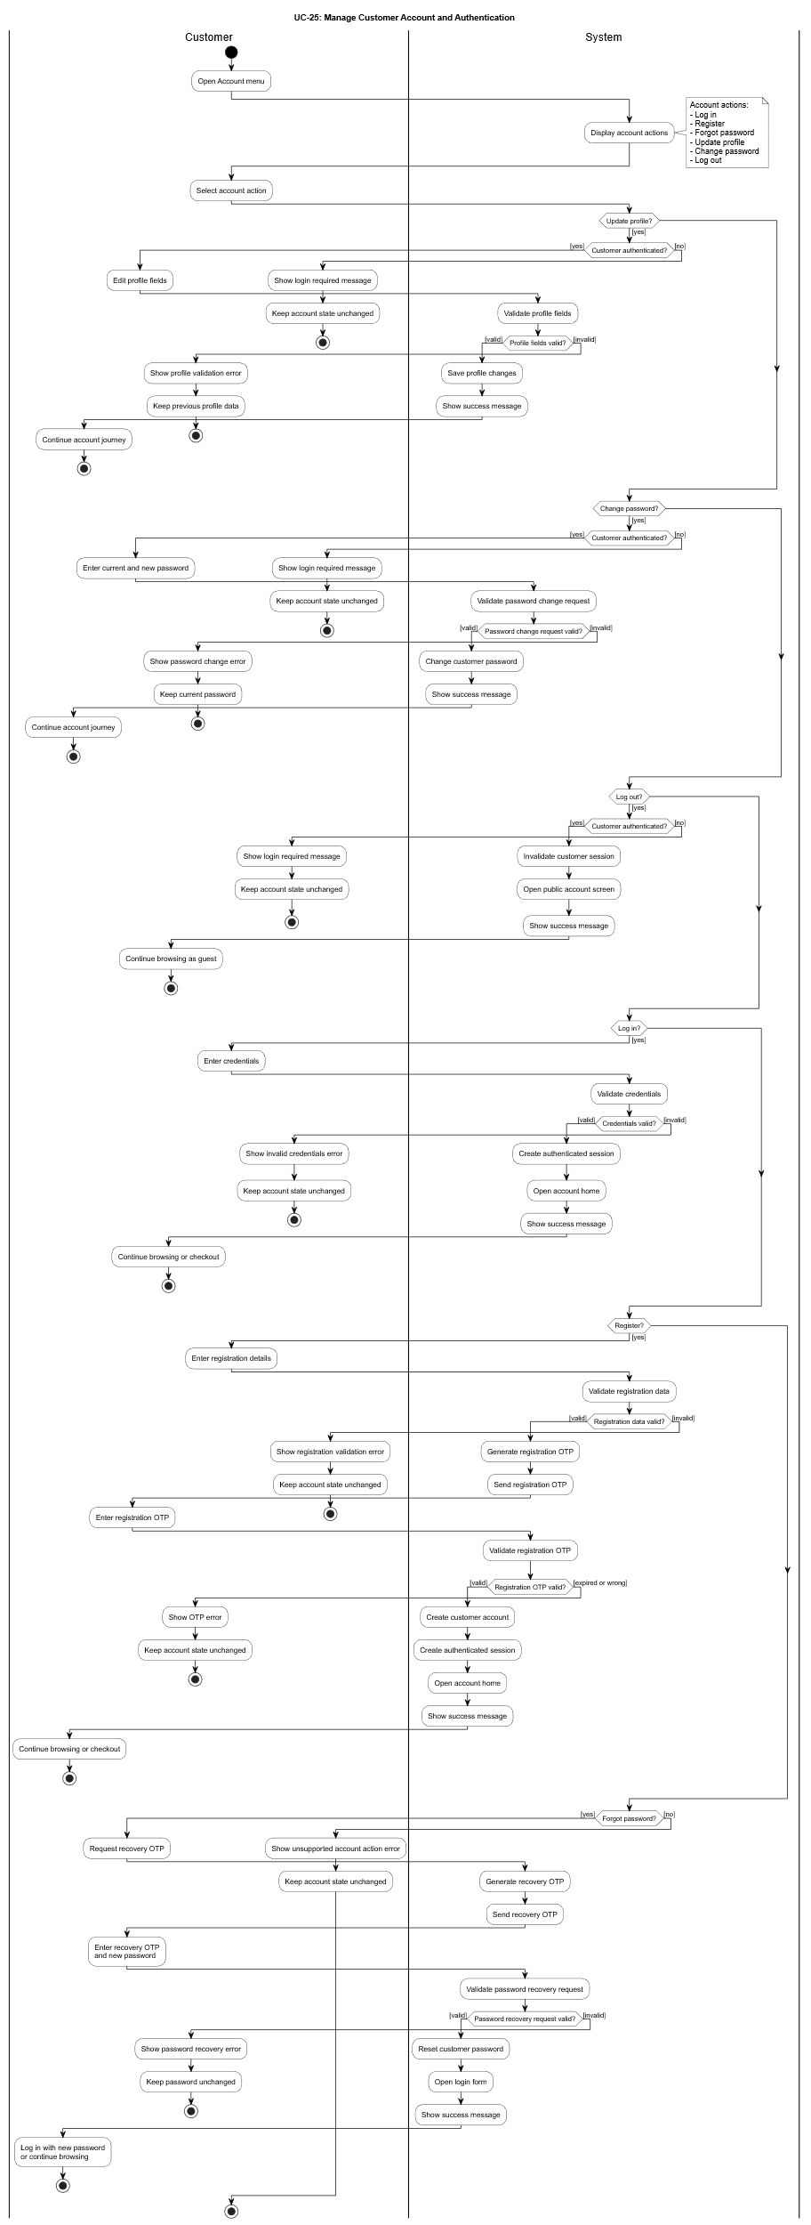
Use Case 26

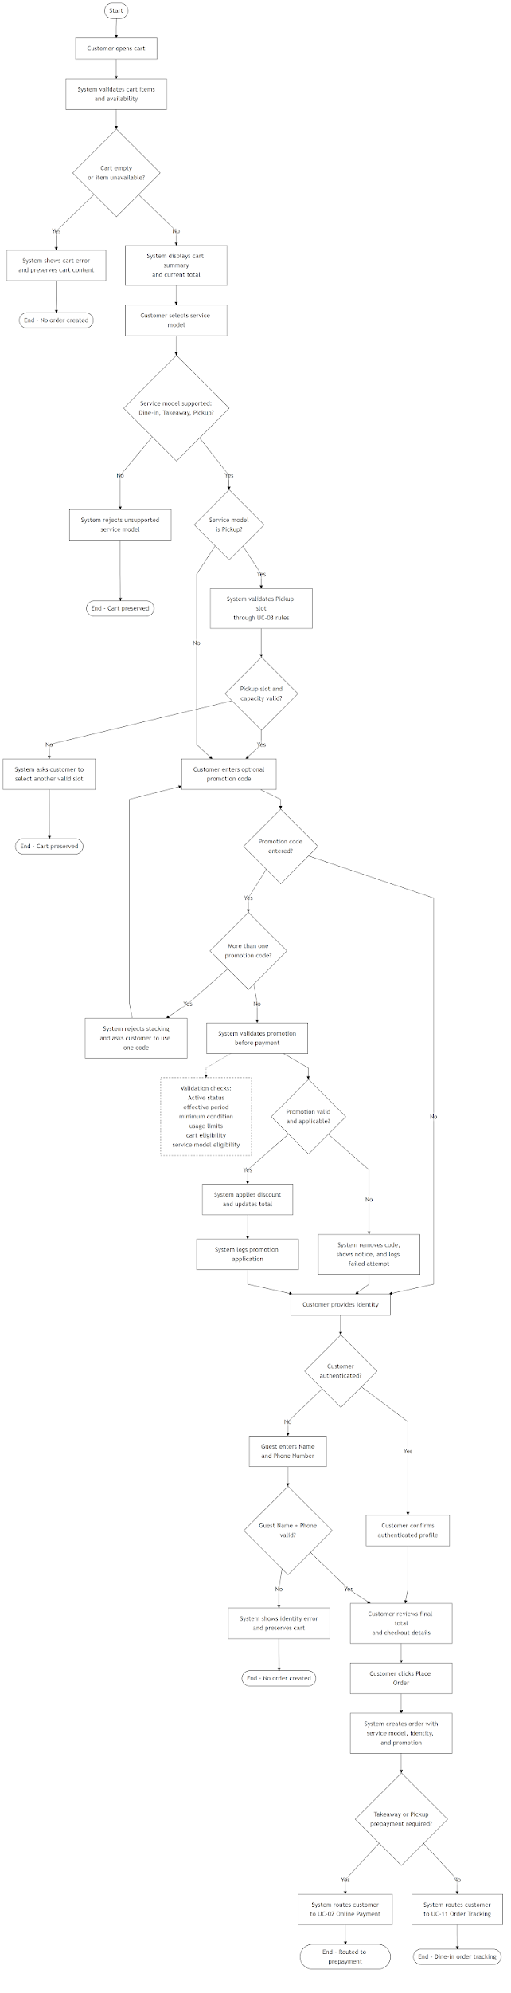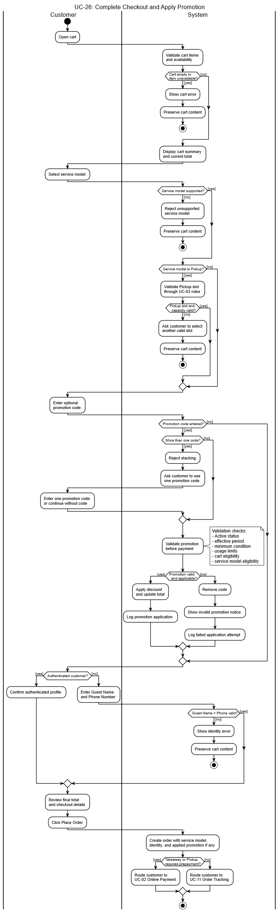

Appendix B – Business Rules Catalog

Business case
Name: | Nguyen Thi Hai My | Date: | 03/04/2026

- – EXECUTIVE SUMMARY
The WonTon POS project is a strategic initiative to digitize the operational model of a traditional wonton noodle shop. By replacing fragmented manual processes with an integrated cloud-based solution, the system will manage the entire service lifecycle, from menu management and tablet-based ordering to a real-time Kitchen Display System (KDS) and revenue analytics. The primary objectives are to eliminate most manual ordering errors, improve peak-hour service speed, and provide management with actionable, real-time business insights. A custom-built solution is recommended to ensure a close fit with the made-to-order kitchen workflow and to provide a scalable foundation for future expansion.

- - CORE BUSINESS PROBLEM
The business lacks an integrated internal order and operations management system, so manual record-keeping and verbal coordination are still used for order handling, kitchen communication, payment control, and daily monitoring.
This single problem creates the following business impacts:
Operational inefficiency and service delay: Manual order entry and repeated handoffs consume staff time, slow kitchen routing, and reduce peak-hour productivity.
Order inaccuracy and revenue-control risk: Handwritten or verbal instructions increase the chance of incorrect fulfilment, recooks, billing mistakes, and unreliable end-of-day reconciliation.
Limited accountability and auditability: Without a digital trail, the business cannot consistently verify voided bills, staff discounts, cash handling, or stock-related exceptions.
Insufficient real-time management visibility: The absence of timely reporting hides sales patterns, demand peaks, and operational issues, which weakens scheduling, control, and planning decisions.

- – ANALYSIS
What: The system will automate the end-to-end service lifecycle: from QR-code/Tablet ordering at the table to automated routing to the kitchen KDS, and finally, integrated digital payment processing.
Why: Internal observations indicate that manual reconciliation takes the manager 2 hours daily. Automating this process releases 60 hours per month for high-value activities such as marketing, quality control, and staff training.
Impact of Inaction: Failure to modernize will lead to a continued decline in competitive advantage against tech-enabled fast-casual chains. Projected losses from order errors and inventory leakage are estimated at 12-15% of monthly gross revenue.
Resources Needed:
Budget: $2,000 (Covers custom development, hardware procurement, and cloud infrastructure).
Timeline: 3 months (MVP), 6 months (full rollout).
Team: 8 internal members (covering BA, UI/UX, and Dev roles) + external vendors for hardware and API integrations.

- – SOLUTION OPTIONS
Option | Pros | Cons
1. Custom WonTon POS | Tailored to noodle shop flow, scalable, full control | Higher upfront cost, longer development time
2. Off-the-Shelf SaaS | Faster deployment, lower initial cost | Limited customization for kitchen-specific flows, recurring monthly fees
3. Do Nothing | No initial cost or disruption | Operational risks, financial leakage, and competitive decay persist

- – COST-BENEFIT ANALYSIS
Option | Cost | Benefits | ROI Timeline
Custom WonTon POS | $2,000 upfront + $200/year (Maintenance & Cloud hosting) | Eliminates 99% of order overlaps; saves ~$3,000/year in operational inefficiencies; increases peak-hour throughput by 20%. | ~8 to 10 Months
SaaS Solution | $400/year + 2-3% transaction fee on every digital order | Quick setup; standard POS features; limited customization for kitchen flow | Ongoing subscription costs (Lower short-term, higher long-term)
Do Nothing | $0 | None. Continued $1,500 losses (Errors, leaks and waste) | N/A
Key Benefits:
Order Accuracy: Digitizing the workflow eliminates 95% of errors caused by illegible handwriting. This completely removes losses from "wrong dishes," saving an estimated $50 - $100/month in wasted ingredients.
Time Savings: Reduces average order-to-kitchen transmission time by 40%. By speeding up table turnover (saving ~5 mins/table), the shop can serve 15-20 more customers during peak hours.
Compliance & Integrity: Automated audit logs and cloud storage reduce the risk of financial discrepancies. Real-time auditing prevents "forgotten items" and unauthorized discounts, recovering an estimated 5% of daily gross revenue.

- – RECOMMENDATION
Recommended Solution: Develop a custom WonTon POS with phased implementation:
Phase 1 (3 months): Launch MVP focusing on core Tabletop Ordering, KDS routing, and basic Billing modules to stabilize daily operations.
Phase 2 (6 months): Implement Advanced Analytics, Inventory Management, and multi-wallet Digital Payment integration.
Methodology: Agile development with bi-weekly sprints to ensure feedback alignment..
Justification:Long-term strategic value and operational cost savings far outweigh the initial $2,000 investment. The flexibility to adapt the system as the business grows is essential for digital transformation.
Next Steps: Secure stakeholder sign-off, finalize hardware vendor contracts (Tablets/Printers), and initiate the UI/UX prototyping phase..

Appendix C- Models

Data flow diagram

Level-0

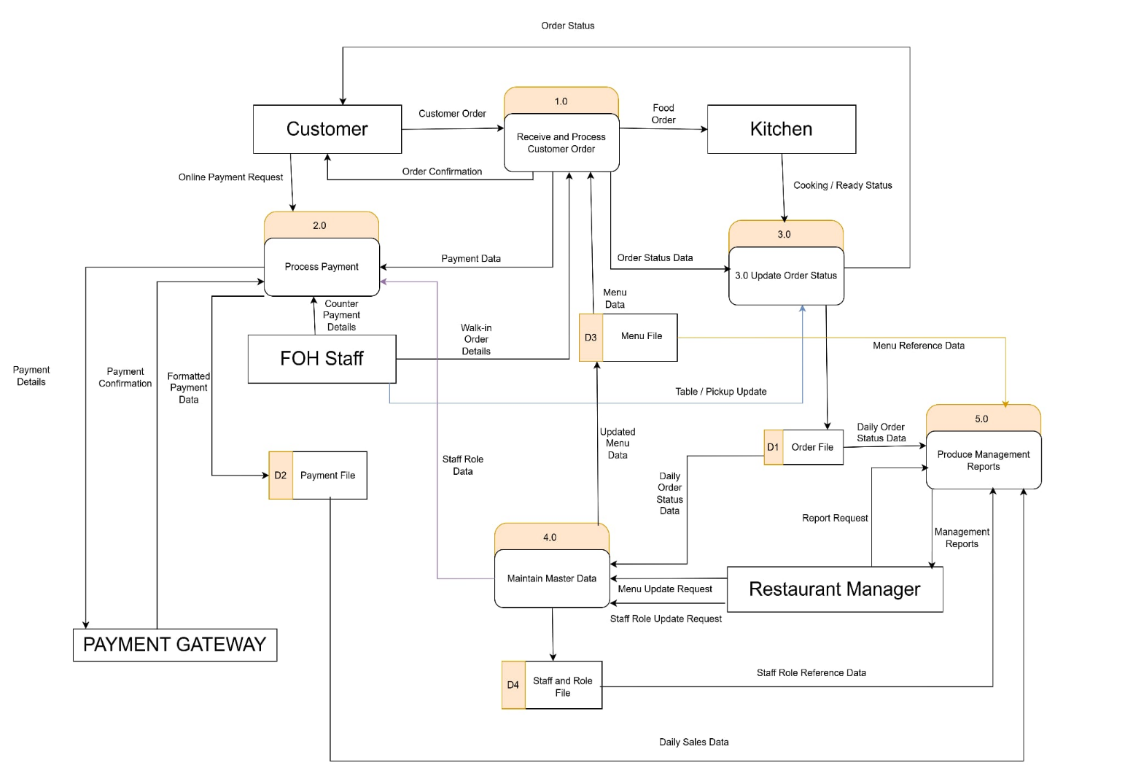

Level-1 DFD for 2.0 Process Payment
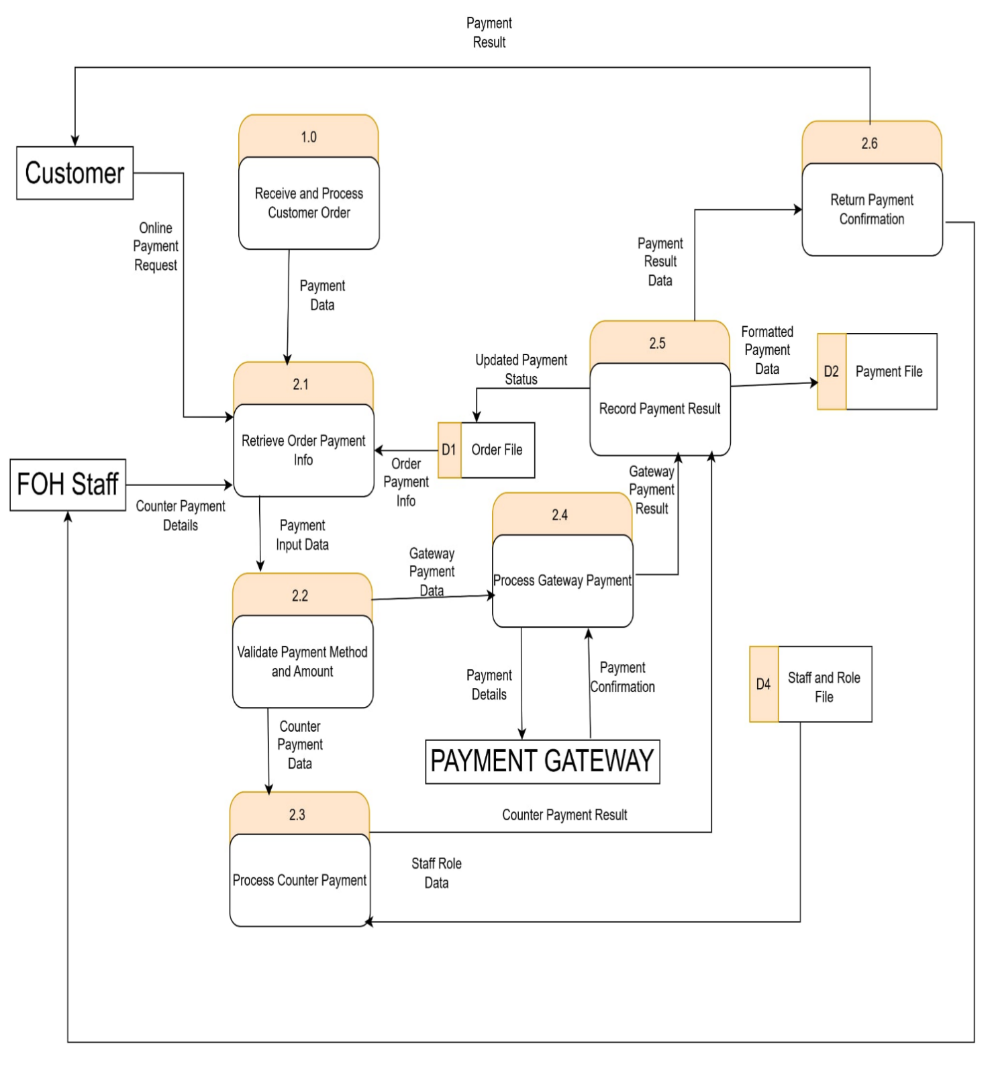

Level-2 của 2.3 Process Counter Payment

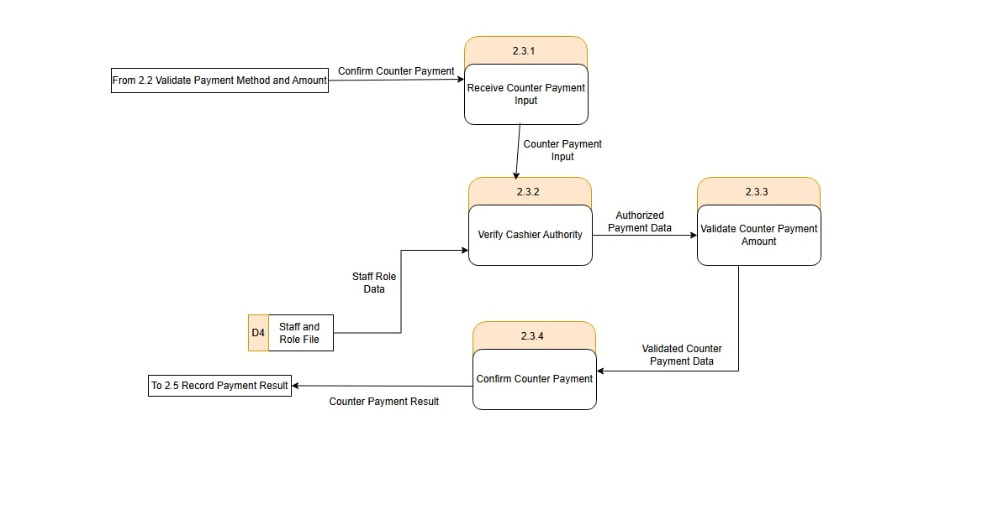
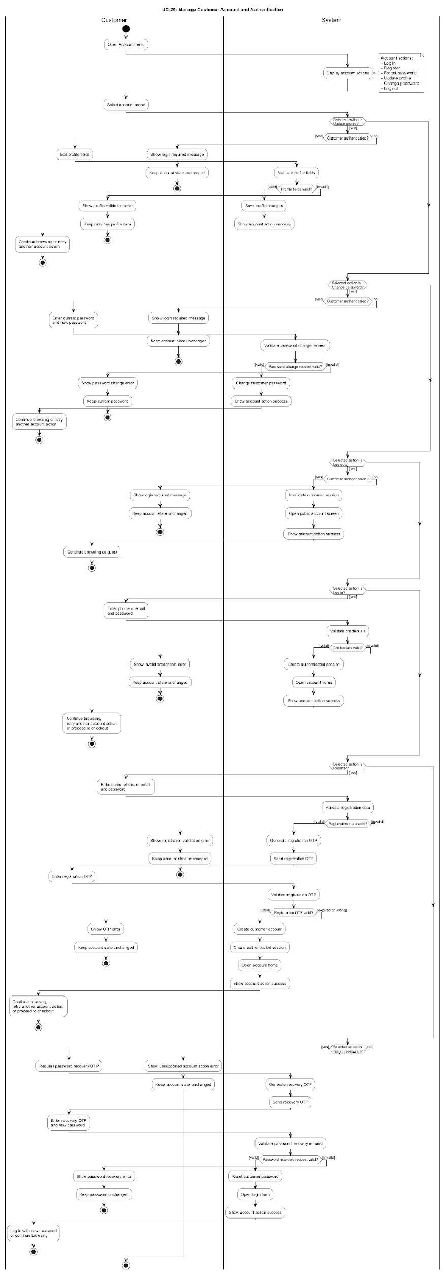

Balancing for DFD — 2.0 Process Payment

Parent Flow at 2.0 | Where It Appears in Level-1 | Status
Payment Data from 1.0 Receive and Process Customer Order | 1.0 Order Processing → 2.1 Retrieve Order Payment Info | Balanced
Online Payment Request from Customer | Customer → 2.1 Retrieve Order Payment Info | Balanced
Counter Payment Details from FOH Staff | FOH Staff → 2.1 Retrieve Order Payment Info | Balanced
Staff Role Data from D4 Staff and Role File | D4 Staff and Role File → 2.3 Process Counter Payment | Balanced
Payment Details to Payment Gateway | 2.4 Process Gateway Payment → Payment Gateway | Balanced
Payment Confirmation from Payment Gateway | Payment Gateway → 2.4 Process Gateway Payment | Balanced
Formatted Payment Data to D2 Payment File | 2.5 Record Payment Result → D2 Payment File | Balanced
Updated Payment Status to D1 Order File | 2.5 Record Payment Result → D1 Order File | Balanced
Payment Result to Customer | 2.6 Return Payment Confirmation → Customer | Balanced
Payment Confirmation to FOH Staff | 2.6 Return Payment Confirmation → FOH Staff | Balanced

ERD

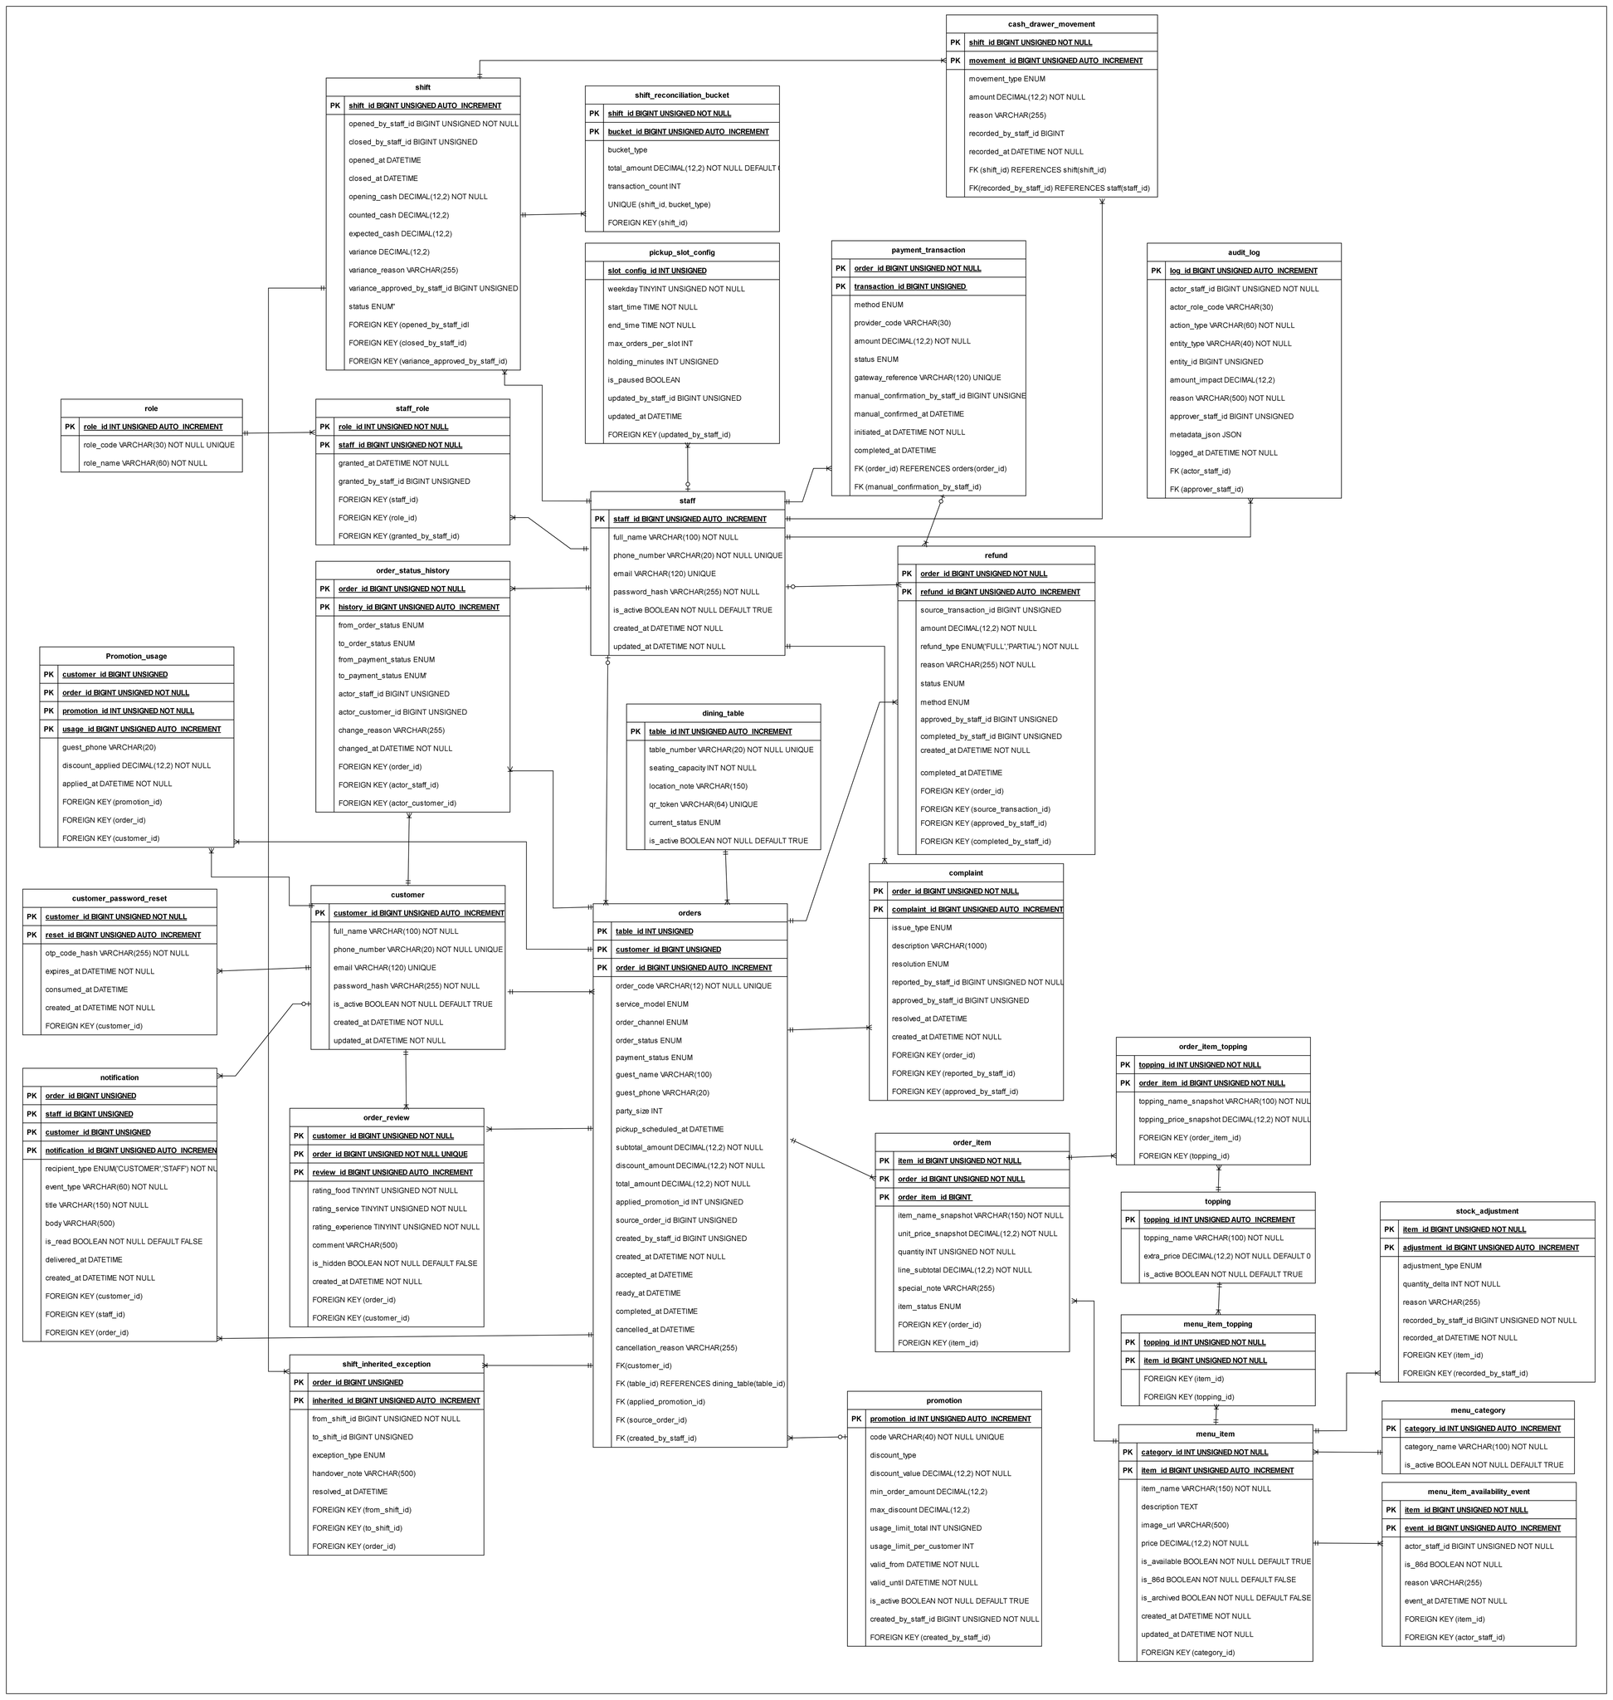

Class Diagram
