sHANOI UNIVERSITY
FACULTY OF INFORMATION TECHNOLOGY
----✧•༺📖༻•✧----

Wonton POS System
SRS Report
COURSE NAME: Software Requirements Analysis (61FIT3REQ)
Spring - 2026
1. Nguyễn Thị Hải My | 2301040126
2. Nguyễn Đạt Vinh | 2301040198
3. Vương Gia Ly | 2301040113
4. Nguyễn Minh Đức | 2301040048
5. Đặng Khánh Huyền | 2301040088
6. Lê Thành Đạt | 2301040036
7. Nguyễn Đình Chiến | 2301040025
8. Nguyễn Thiện Hiếu | 2301040071

Team Guide: Hoang Ngoc Duy

Wonton POS System
1. INTRODUCTION
Restaurants that still depend on handwritten notes, verbal coordination, and disconnected payment handling often face slow service, order mistakes, delayed kitchen communication, and weak operational visibility. These issues become more serious during rush hours, when staff must handle multiple dine-in tables, takeaway requests, and pickup orders at the same time.
Wonton POS System is proposed as a web-based point-of-sale and restaurant operations platform for a wonton noodle restaurant. The system integrates customer ordering, payment processing, kitchen coordination, table operations, promotion handling, shift control, and management reporting into one consistent workflow instead of many separate manual steps.
The system is designed around three service models: Dine-in, Takeaway, and Pickup. It supports both guest and registered customers, while also providing dedicated capabilities for Front-of-House staff, Kitchen staff, and Managers. As a result, Wonton POS is expected to improve order accuracy, speed of service, financial control, and the overall customer experience.
1.1 PURPOSE
The purpose of this Software Requirements Specification is to define the functional scope, non-functional requirements, business rules, user roles, and structural models of Wonton POS System in a clear and verifiable form. This document serves as the main reference for analysts, designers, developers, testers, instructors, and stakeholders when discussing what the system must do and what constraints it must respect.
In addition, this SRS aims to translate the final project business baseline into a structured technical document. It captures how customers place orders, how staff operate the restaurant, how managers monitor business performance, and how the system preserves data consistency, payment correctness, auditability, and operational reliability.
1.2 SCOPE
Wonton POS System covers the whole-system final-project baseline of a restaurant POS environment. The scope includes customer account management, guest checkout, online ordering, counter ordering, menu browsing, checkout, online and counter payment, order tracking, pickup scheduling, notifications, ratings, reorder from order history, kitchen status management, dine-in table assignment, service completion, promotions, reporting, complaint handling, refund handling, shift closing, reconciliation, receipt support, and inventory-lite controls such as 86'd item management.
The system explicitly supports three service models. Dine-in allows customers to consume meals at the restaurant and settle payment at the counter after service. Takeaway allows customers to place and collect food for off-site consumption, with full payment required before the order is released to the kitchen. Pickup allows customers to pre-order food online, choose a collection time slot, and collect the food later at the restaurant.
The current scope does not include third-party delivery integration, loyalty points, native mobile applications, full accounting ledger features, payroll, or complete supplier procurement management. These items may be considered future extensions but are intentionally excluded from the present final baseline.
1.3 Definitions, Acronyms, and Abbreviations:
● POS -> Point of Sale system used to create, manage, and settle restaurant orders.
● KDS -> Kitchen Display System used by kitchen staff to receive and update food preparation status.
● FOH -> Front of House staff such as cashier and service staff who interact with customers and tables.
● BOH -> Back of House staff such as kitchen personnel responsible for food preparation.
● SRS -> Software Requirements Specification.
● BRD -> Business Requirements Document.
● UC -> Use Case.
● UCD -> Use Case Diagram.
● UML -> Unified Modeling Language used for modelling use cases, classes, and system behavior.
● FR -> Functional Requirement.
● NFR -> Non-Functional Requirement.
● ERD -> Entity Relationship Diagram.
● UI -> User Interface.
● UX -> User Experience.
● API -> Application Programming Interface.
● QR -> Quick Response code used for table access or payment.
● VAT -> Value Added Tax information used for invoice support.
● OTP -> One-Time Password used for identity confirmation where applicable.
● HTML5 -> HyperText Markup Language version 5, used as a frontend implementation technology in the prototype.
● CSS3 -> Cascading Style Sheets version 3, used for styling the web prototype.
● RAM -> Random Access Memory required by the runtime environment.
● Client WebApp -> Customer-facing web application used by guests and registered customers to browse, order, pay, track, and manage customer-side actions.
● Admin WebApp -> Staff-facing web application used by the Manager, Cashier, Service Staff, and Kitchen Staff to operate the restaurant.
● Guest Customer -> Customer who places or tracks an order without logging into a registered account.
● Registered Customer -> Customer who has an account and can use account-based functions such as order history, reorder, profile update, and password management.
● Dine-in -> Service model where the customer consumes food at a restaurant table.
● Takeaway -> Service model where the customer orders food for collection without table service.
● Pickup -> Scheduled service model where the customer orders online and collects the order at a selected pickup time.
● Delivery -> Service model where an order is delivered to an external address; Delivery is out of scope for the current Wonton POS baseline.
● Checkout -> The step where the customer confirms the cart, service model, contact information, promotion, and payment requirement before order submission.
● Order Code -> Unique code used to identify an order, especially for guest order tracking and takeaway or pickup handoff.
● Order Status -> Operational progress of an order, such as Pending Confirmation, Cooking, Ready, Completed, or Cancelled.
● Payment Status -> Financial progress of an order, such as Unpaid, Pending Online Payment, Paid, Refund Pending, Refunded, Write-off, Comp, or Forfeited.
● Payment Gateway -> External payment service that processes online payment transactions and returns payment results or callbacks.
● Refund Pending -> Payment status showing that a refund has been requested but has not been completed yet.
● Write-off -> Manager-approved status for an unpaid or loss order that should not be counted as normal revenue.
● Comp -> Manager-approved free-of-charge resolution for an order or complaint case.
● Forfeited -> Manager-approved status for a paid no-show Takeaway or Pickup case where the restaurant retains the payment according to policy.
● 86'd -> Restaurant operation term meaning a menu item is temporarily unavailable and cannot be sold to new orders.
● FIFO -> First In, First Out queue order, used by the kitchen to prioritize eligible orders by arrival time.
● Handoff -> The process of giving a completed order to the correct table, customer, or pickup or takeaway recipient.
● Promotion -> Discount or offer configured by the Manager and applied during checkout when valid.
● Reconciliation -> End-of-shift or end-of-day process of comparing expected revenue, cash, payment records, refunds, and exceptions.
● Operational Exception -> Non-standard situation such as complaint, wrong handoff, unavailable item, refund, remake, or unresolved payment issue.
2. OVERALL DESCRIPTION
2.1 PRODUCT PERSPECTIVE
Wonton POS System is a restaurant operations system composed of two major interaction layers. The first layer is the Client WebApp used by guests and registered customers to browse menu items, place orders, pay, track order status, reorder, and rate completed orders. The second layer is the Admin WebApp used by restaurant staff and managers to create in-store orders, manage tables, process payments, monitor kitchen activity, apply corrections, manage menu and promotion data, and review business reports.
From a business perspective, the system acts as the central source of truth for the restaurant. It connects customer demand, front-of-house execution, back-of-house preparation, and management oversight. Once an order is created, the same order record is used for payment tracking, kitchen preparation, serving or handoff confirmation, complaint handling, and end-of-day reporting. This reduces the need for duplicate records and manual reconciliation.
The system also depends on a small set of external services or supporting infrastructure, such as payment gateway services, browser-based push or real-time notification channels, receipt printing facilities, and stable network connectivity inside the restaurant. However, the core workflow logic remains under the control of the Wonton POS System.
2.2 SOFTWARE REQUIREMENT
● Front end: Responsive web interface implemented with HTML5, CSS3, and JavaScript for both customer-facing and admin-facing pages.
● Back end: A web application server capable of handling authentication, order processing, payment status management, reporting, audit logging, and integration with external services.
● Database: A relational database management system such as MySQL or PostgreSQL to store menu data, accounts, orders, payments, tables, shifts, notifications, complaints, and audit logs.
● Real-time communication: WebSocket or Server-Sent Events support for timely order status updates, kitchen alerts, and operator notifications.
● Payment integration: Support for payment gateway QR flows and manually confirmed bank-transfer QR flows where callback behavior differs.
● Browser support: Current versions of Google Chrome, Microsoft Edge, Mozilla Firefox, and Safari for normal operation.
● Development and maintenance tools: Version control, code editor, test browser, database administration tool, and deployment environment for staging or demonstration.
2.3 HARDWARE REQUIREMENT
● Customer access device: Smartphone, tablet, or personal computer with an internet connection and a modern browser.
● Cashier / FOH terminal: Desktop or laptop computer with at least Intel Core i3 equivalent processor, 4 GB RAM, and a stable browser environment.
● Kitchen display terminal: Tablet or screen device capable of displaying active kitchen orders throughout the operating day.
● Peripheral devices: Receipt printer, optional kitchen printer, QR code print materials for tables, and optional barcode or order-code scanner if the restaurant chooses to use one.
● Network infrastructure: Stable local Wi-Fi or wired internet access that can support simultaneous client, cashier, manager, and kitchen sessions.
2.4 REQUIREMENTS
2.4.1 FUNCTIONAL REQUIREMENTS
• R.1: Place Online Order (UC-01)
Description: The system shall allow guest and registered customers to browse the menu, customize items, manage cart content, choose a supported service model, and create an online order through the Client WebApp.
Input: Selected menu items, quantities, toppings or options, item notes, customer identity or contact details, and service model.
Output: Created order, updated cart or order summary, validation message, and initial order status.
Processing: The system validates item availability, cart content, required customer information, and service model rules; calculates totals; attaches the order to either a guest identity or registered account; and routes the order to checkout, payment, or operations according to the selected service model.
• R.2: Complete Online Payment (UC-02)
Description: The system shall support online payment for customer-created Takeaway and Pickup orders that require prepayment before kitchen intake.
Input: Order identifier, payable amount, selected payment method, gateway response, callback data, retry request, or manual bank-transfer confirmation event.
Output: Payment result, updated payment status, payment record, customer notification, and eligibility decision for kitchen release.
Processing: The system creates a payment request, verifies the payment result, supports retry where allowed, handles duplicate or late callbacks idempotently, keeps failed or expired payments from entering the kitchen, and updates payment status separately from order status.
• R.3: Schedule Pickup Order (UC-03)
Description: The system shall allow customers to schedule a Pickup order by selecting an available pickup time slot before final confirmation and payment.
Input: Pickup date, pickup time slot, customer contact information, cart content, and current slot capacity data.
Output: Confirmed pickup schedule, rejected slot notice, or suggested alternative pickup slot.
Processing: The system checks opening hours, Pickup availability, slot capacity, service pause settings, and order readiness rules before confirming the slot and allowing the order to continue.
• R.4: View Order History (UC-04)
Description: The system shall allow registered customers to view their previous orders and order details from their account history.
Input: Authenticated customer account, history filter, selected order, or date range.
Output: Order history list, selected order detail, item list, payment summary, and order status information.
Processing: The system retrieves only orders belonging to the authenticated customer, protects other customers' data, and displays historical details without allowing unauthorized modification of completed records.
• R.5: Manage Menu (UC-05)
Description: The system shall allow managers to create, update, deactivate, and organize menu categories, menu items, toppings, prices, and availability information.
Input: Menu item data, category data, topping definitions, pricing, images where applicable, status values, and manager action.
Output: Updated menu catalogue, confirmation message, validation error, or availability update visible to customer and staff interfaces.
Processing: The system validates menu records, preserves historical order integrity when items are changed or deactivated, updates customer-visible availability, and prevents unavailable items from being selected in new orders.
• R.6: Manage Staff (UC-06)
Description: The system shall allow managers to create, update, disable, and assign roles or permissions to staff accounts used by the Admin WebApp.
Input: Staff profile data, login identifier, role assignment, permission set, account status, and manager identity.
Output: Created or updated staff account, disabled account, role assignment result, or validation error.
Processing: The system validates staff information, prevents duplicate active accounts, stores role-based permissions, disables access when needed, and exposes staff functions only according to authorized roles.
• R.7: View Revenue Statistics (UC-07)
Description: The system shall allow managers to view revenue statistics and business reports for selected dates, payment methods, and operational dimensions.
Input: Date range, report type, payment method filter, service model filter, and export request where applicable.
Output: Revenue report, summarized statistics, filtered report view, chart-ready data, or export-ready file.
Processing: The system aggregates paid orders, refunds, write-offs, comp actions, forfeited payments, and shift records so revenue, losses, and exceptions are not mixed together.
• R.8: Manage Tables (UC-08)
Description: The system shall allow managers to maintain table records and table status for dine-in operations.
Input: Table identifier, table name or number, capacity, location, status, and floor-layout information.
Output: Updated table list, floor status view, validation message, or table availability result.
Processing: The system validates table data, maintains current occupancy status, supports multiple active orders for the same dine-in party, and prevents invalid table references in dine-in order handling.
• R.9: Create In-Store Order (UC-09)
Description: The system shall allow FOH staff or cashiers to create dine-in or counter Takeaway orders for walk-in customers through the Admin WebApp.
Input: Selected menu items, quantities, options, notes, service model, table information where needed, and cashier or FOH staff identity.
Output: Created in-store order, order summary, payment requirement, or validation error.
Processing: The system records the order under the correct service model, calculates totals, links dine-in orders to tables when applicable, and routes Takeaway orders to counter payment before kitchen intake.
• R.10: Process Payment (UC-10)
Description: The system shall allow cashiers to process supported counter payment methods and generate payment confirmation or receipt records.
Input: Order identifier, payable amount, payment method, paid amount, invoice or VAT information where applicable, and cashier identity.
Output: Paid order, payment record, receipt output, refund or discrepancy warning, or validation error.
Processing: The system validates payable amount, records the financial event, updates payment status, supports cash and QR confirmation rules, prevents unpaid Takeaway orders from entering the kitchen, and preserves receipt data for review.
• R.11: Track Order (UC-11)
Description: The system shall allow customers to track order progress through an account or through Order Code and Phone Number for guest orders.
Input: Authenticated customer account, Order Code, Phone Number, or selected order tracking request.
Output: Current order status, payment visibility where appropriate, timeline events, or lookup validation message.
Processing: The system verifies order ownership or guest lookup data, limits abusive lookup attempts, retrieves current status events, and displays only information permitted for the requesting customer.
• R.12: Assign Order to Table (UC-12)
Description: The system shall allow FOH staff to assign, correct, or transfer dine-in orders to restaurant tables.
Input: Order identifier, source table, target table, table correction request, active order set, and FOH staff identity.
Output: Updated table-order linkage, changed table status, correction confirmation, or validation error.
Processing: The system validates table availability, keeps related active dine-in orders together where required, updates occupancy information, and logs table corrections for traceability.
• R.13: Receive Kitchen Orders (UC-13)
Description: The system shall allow BOH staff to receive valid kitchen orders that are eligible for preparation.
Input: Eligible order, kitchen queue request, service model, payment status, and BOH staff action.
Output: Kitchen queue entry, accepted kitchen order, rejected ineligible order warning, or printed/displayed kitchen ticket.
Processing: The system sends only valid and financially eligible orders to the kitchen, prevents duplicate ticket generation, orders the kitchen queue using operational priority such as FIFO, and keeps kitchen intake synchronized with FOH and customer views.
• R.14: Update Dish Status (UC-14)
Description: The system shall allow BOH staff to update item-level or order-level preparation progress until food is ready for service or handoff.
Input: Kitchen order, dish or item selection, cooking status update, grouped update action, and BOH staff identity.
Output: Updated dish status, updated order status, ready notification trigger, or validation error.
Processing: The system records preparation progress, supports grouped updates where appropriate, prevents invalid status transitions, and synchronizes Cooking and Ready events with FOH and customer tracking.
• R.15: Rate Order (UC-15)
Description: The system shall allow customers to rate or review an eligible completed order after service completion.
Input: Completed order identifier, customer account or permitted feedback identity, rating score, comment, and submission time.
Output: Saved rating, updated feedback record, confirmation message, or eligibility warning.
Processing: The system checks order completion and rating eligibility, prevents duplicate ratings where policy requires one rating per order, stores feedback, and links the rating to the correct order without changing financial data.
• R.16: Receive Order Notifications (UC-16)
Description: The system shall send role-appropriate notifications when important order, payment, preparation, ready, completion, cancellation, or exception events occur.
Input: Order event, payment event, kitchen status event, exception escalation, recipient role, and notification channel.
Output: Customer notification, staff alert, manager alert, notification history entry, or retry state.
Processing: The system detects relevant events, selects the correct recipient group, sends or stores the notification, avoids duplicate alerts, and restores missed notifications after reconnection where applicable.
• R.17: Reorder Past Order (UC-17)
Description: The system shall allow registered customers to reorder from eligible completed orders while handling current menu changes safely.
Input: Authenticated customer account, selected completed order, reorder request, current menu availability, and current price data.
Output: New cart populated from reorderable items, item-change notice, unavailable-item warning, or checkout block until issues are resolved.
Processing: The system verifies that the source order belongs to the customer and is completed, copies eligible items into a new cart, applies current prices and availability, flags changed or 86'd items, and prevents checkout until unavailable items are removed or resolved.
• R.18: Manage Promotions (UC-18)
Description: The system shall allow managers to create, update, deactivate, and monitor promotions or discount codes with clear validity and usage rules.
Input: Promotion code, discount type, discount value, effective period, usage limit, applicability rule, stacking setting, and manager identity.
Output: Saved promotion, activated or deactivated promotion, usage history, validation message, or audit record.
Processing: The system validates promotion configuration, enforces validity and non-stacking rules, records each successful or failed application where required, and preserves promotion change history for audit.
• R.19: View Operational Dashboard (UC-19)
Description: The system shall allow managers to view an operational dashboard showing current restaurant status and important alerts.
Input: Manager session, selected operating date, dashboard filter, alert type, and refresh request.
Output: Dashboard snapshot, active order count, kitchen status, payment or exception alerts, pickup pressure indicators, and operational summary.
Processing: The system aggregates live order, table, kitchen, payment, pickup, complaint, and shift data into a manager-facing view without changing source transaction records.
• R.20: Manage Active Orders (UC-20)
Description: The system shall allow FOH staff and managers to monitor active orders, confirm permitted actions, perform manual corrections, and escalate issues when needed.
Input: Selected active order, requested action, order status, payment status, reason note, and operator identity.
Output: Updated order state, correction result, cancellation result, escalation case, or permission warning.
Processing: The system checks role permissions, validates status transitions, keeps order status separate from payment status, requires manager approval for sensitive changes, and records audit reasons for manual corrections.
• R.21: Close Shift and Reconcile End-of-day (UC-21)
Description: The system shall allow cashiers and managers to close shifts, count cash, reconcile payments, and review unresolved exceptions before final confirmation.
Input: Shift identifier, cashier identity, counted cash, expected payment summaries, variance reason, refund status, and outstanding exception list.
Output: Closed shift, reconciliation summary, variance warning, inherited exception record, or blocked close confirmation.
Processing: The system compares expected and actual values, separates revenue from refunds, write-offs, comp, forfeited payments, and operational losses, requires reasons for discrepancies, and carries unresolved exceptions into the next shift where appropriate.
• R.22: Mark Menu Item as 86'd (UC-22)
Description: The system shall allow authorized staff or managers to mark a menu item as temporarily unavailable and later restore it when available again.
Input: Menu item identifier, availability action, reason note, operator identity, and optional expected restoration information.
Output: Updated 86'd status, customer-facing availability update, staff warning, or audit entry.
Processing: The system applies 86'd status to new ordering attempts, prevents customers from checking out with unavailable items, keeps historical order records unchanged, and records who changed availability and why.
• R.23: Serve and Confirm Handoff (UC-23)
Description: The system shall allow FOH staff or cashiers to confirm that a ready order has been served to the correct table or handed to the correct customer.
Input: Ready order, table or customer confirmation, Order Code where applicable, service model, staff identity, and correction note if needed.
Output: Completed order, confirmed handoff record, wrong-handoff flag, or manager correction request.
Processing: The system allows completion only after actual service or customer pickup, verifies the correct table or customer according to the service model, and supports manager-supervised correction when completion or handoff was wrong.
• R.24: Handle Complaint and Operational Exception (UC-24)
Description: The system shall allow managers and authorized staff to resolve complaints and operational exceptions such as wrong handoff, fulfilment failure, refund, remake, substitution, write-off, comp, or forfeited cases.
Input: Order identifier, complaint or exception type, affected items, customer contact where applicable, resolution choice, financial decision, reason note, and approving manager identity.
Output: Resolved exception case, updated operational or payment state, refund or remake record, audit trail, and customer or staff notification.
Processing: The system validates the selected resolution, applies only allowed financial outcomes, prevents fake revenue, records approval and reason, updates related order/payment states, and exposes unresolved exceptions to dashboard and shift reconciliation.
• R.25: Manage Customer Account and Authentication (UC-25)
Description: The system shall allow customers to register, log in, log out, recover password access, change password, and maintain customer account information.
Input: Customer name, phone number, email, password, OTP or recovery token where applicable, profile updates, and authentication credentials.
Output: Registered account, login session, logout result, password recovery result, profile update confirmation, or validation error.
Processing: The system validates identity and credential data, prevents duplicate customer accounts where required, protects authentication flows, preserves customer order history, and applies profile changes without modifying historical order records.
• R.26: Complete Checkout and Apply Promotion (UC-26)
Description: The system shall allow customers to finalize cart review, choose service model, provide required information, apply valid promotions, and proceed to order creation or payment according to business rules.
Input: Cart content, selected service model, contact details, table or pickup information where applicable, promotion code, and customer account or guest information.
Output: Validated checkout summary, applied discount, rejected promotion message, created order, payment requirement, or checkout validation warning.
Processing: The system validates cart availability, required checkout data, service model rules, pickup slot rules, promotion applicability and usage limits, calculates final totals, logs failed promotion attempts where required, and routes Dine-in, Takeaway, and Pickup orders according to their payment and kitchen-intake rules.
2.4.2 NON-FUNCTIONAL REQUIREMENTS
● Usability Requirement: The system shall provide a responsive and understandable interface for both customers and restaurant staff. Common tasks such as placing an order, processing payment, or updating kitchen status should be achievable with a small number of clear steps and without specialist training.
● Availability Requirement: The system should be available during restaurant operating hours and support continuous daily use with minimal downtime. Planned maintenance should be scheduled outside normal service periods whenever possible.
● Performance Requirement: Common user actions such as opening the menu, updating the cart, checking out, or changing an order status should normally respond within 1 to 3 seconds under ordinary usage conditions. More complex operations such as report generation may take longer but should remain acceptable for staff use.
● Reliability Requirement: The system shall preserve order integrity so that one logical order is not duplicated, lost, or sent to the kitchen multiple times because of refresh, reconnect, or repeated payment callbacks.
● Security Requirement: The system shall enforce role-based access control, protect authentication credentials, restrict sensitive actions to authorized staff, and maintain traceable operator identity for critical financial or operational actions.
● Privacy Requirement: Guest and registered customer data shall be stored only for legitimate business purposes. Guest personal identifiers should be anonymized according to defined retention policy after their business use period ends.
● Auditability Requirement: Sensitive actions such as refund approval, write-off confirmation, comp decision, completed-status correction, shift discrepancy confirmation, and manual bank-transfer confirmation must be logged with actor, timestamp, reason, and affected order value.
● Maintainability Requirement: The system should separate customer logic, cashier logic, kitchen logic, and management logic clearly enough to support future maintenance, testing, and controlled enhancement.
● Compatibility Requirement: The solution shall operate on common modern browsers and support the hardware environment typically available in a small or medium restaurant.
● Recovery Requirement: After temporary network or device failure, the system should allow operators to review abnormal states and continue from a recoverable position rather than forcing silent data loss.
2.5 USER CHARACTERISTICS
Guest Customer: A guest customer uses the Client WebApp without creating a full account. This user can browse the menu, add items to cart, choose service model, place takeaway or pickup orders, and track the resulting order using the order code and phone number.
Registered Customer: A registered customer has persistent account access and can log in, maintain profile information, view order history, reorder completed orders, and submit ratings within the allowed review period. This role benefits from stronger continuity and post-purchase visibility than guest checkout.
FOH Staff: Front-of-house staff members such as cashiers and servers use the Admin WebApp to create in-store orders, assign tables, collect payment, serve ready orders, and communicate with customers. They require fast, clear screens and strong operational feedback during busy periods.
BOH Staff: Back-of-house or kitchen staff use the system primarily through a kitchen-oriented view. They need to see incoming valid orders quickly, group preparation tasks efficiently, and update item or order status without unnecessary friction.
Manager: The manager has the broadest role. This user manages menu data, promotions, staff accounts, operational corrections, complaints, refunds, dashboard analysis, reporting, and end-of-day reconciliation. Manager actions often carry financial impact and therefore require audit logging.
2.6 CONSTRAINTS
● Delivery service model is out of scope for the current baseline and must not be silently reintroduced.
● Takeaway and Pickup orders created online must be fully paid before they are released to the kitchen.
● Dine-in orders may remain unpaid until the service is completed and the customer settles at the counter.
● Pickup time slots must respect the restaurant's configured capacity and operating hours.
● Orders already sent to the kitchen cannot be freely self-edited by customers; financial-impact changes require controlled exception handling.
● Sensitive financial actions such as refund, write-off, comp, and manual correction must record the reason and operator.
● Inventory-lite control is limited to availability management, 86'd items, low-stock warnings, and manual adjustments rather than full procurement workflows.
● The document uses three modelling types in the final SRS package: detailed Client/Admin Use Case Diagram views, one overall ERD, and one Class Diagram.
2.7 USE CASE DIAGRAM

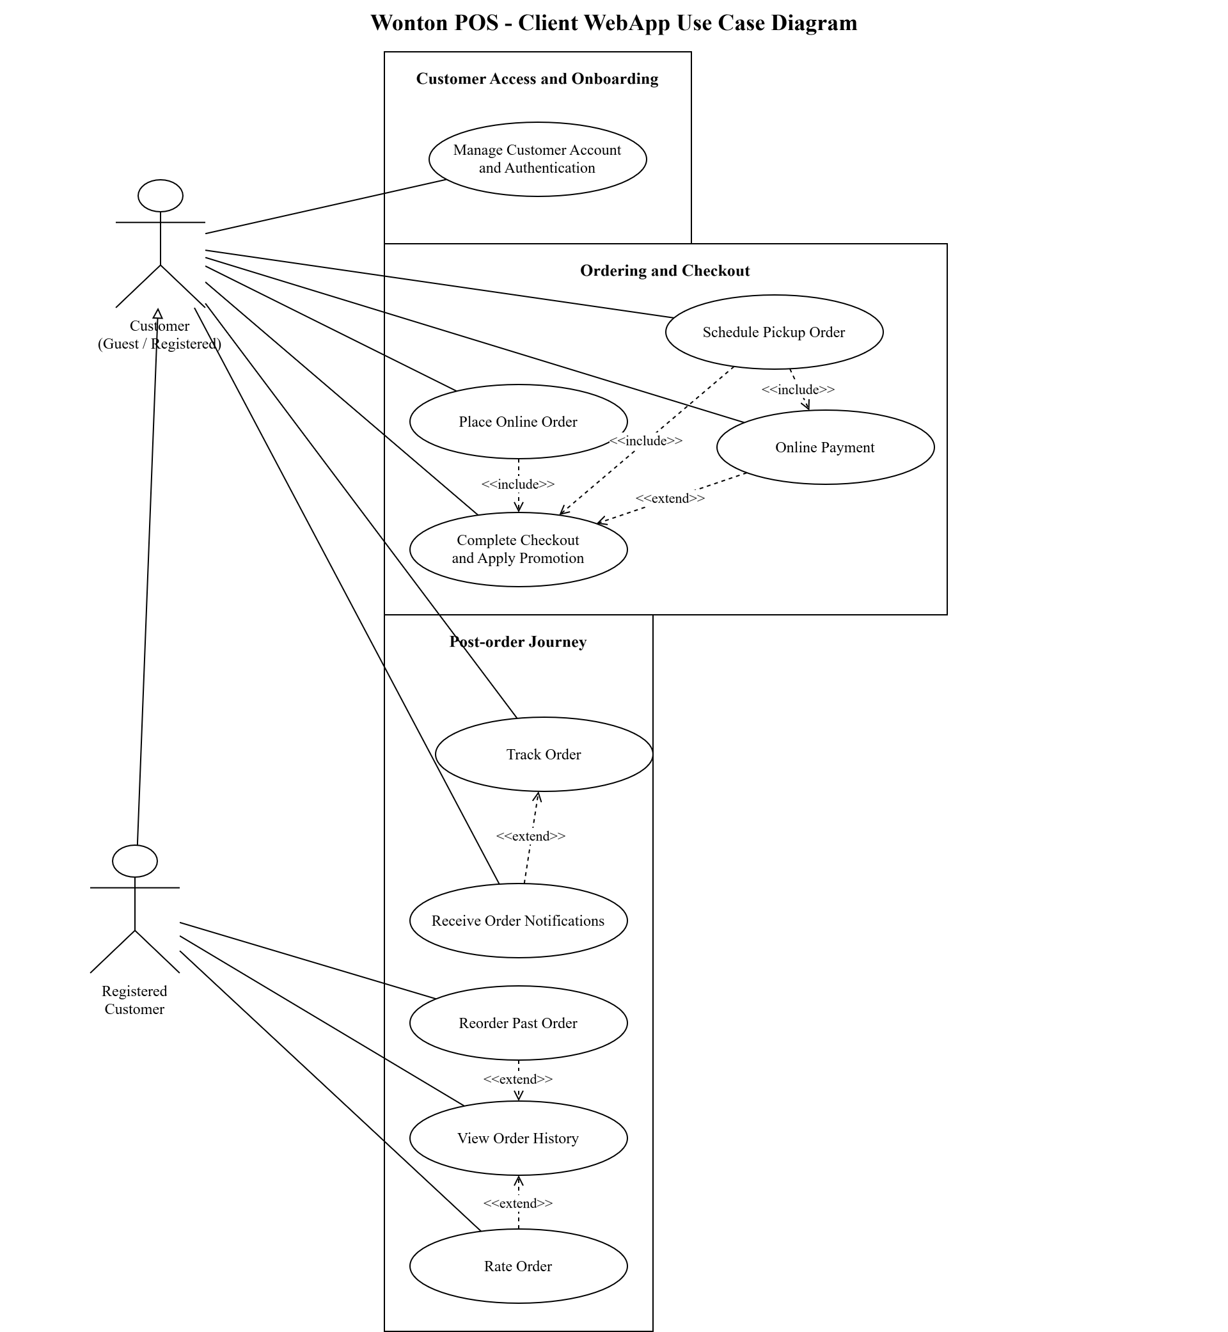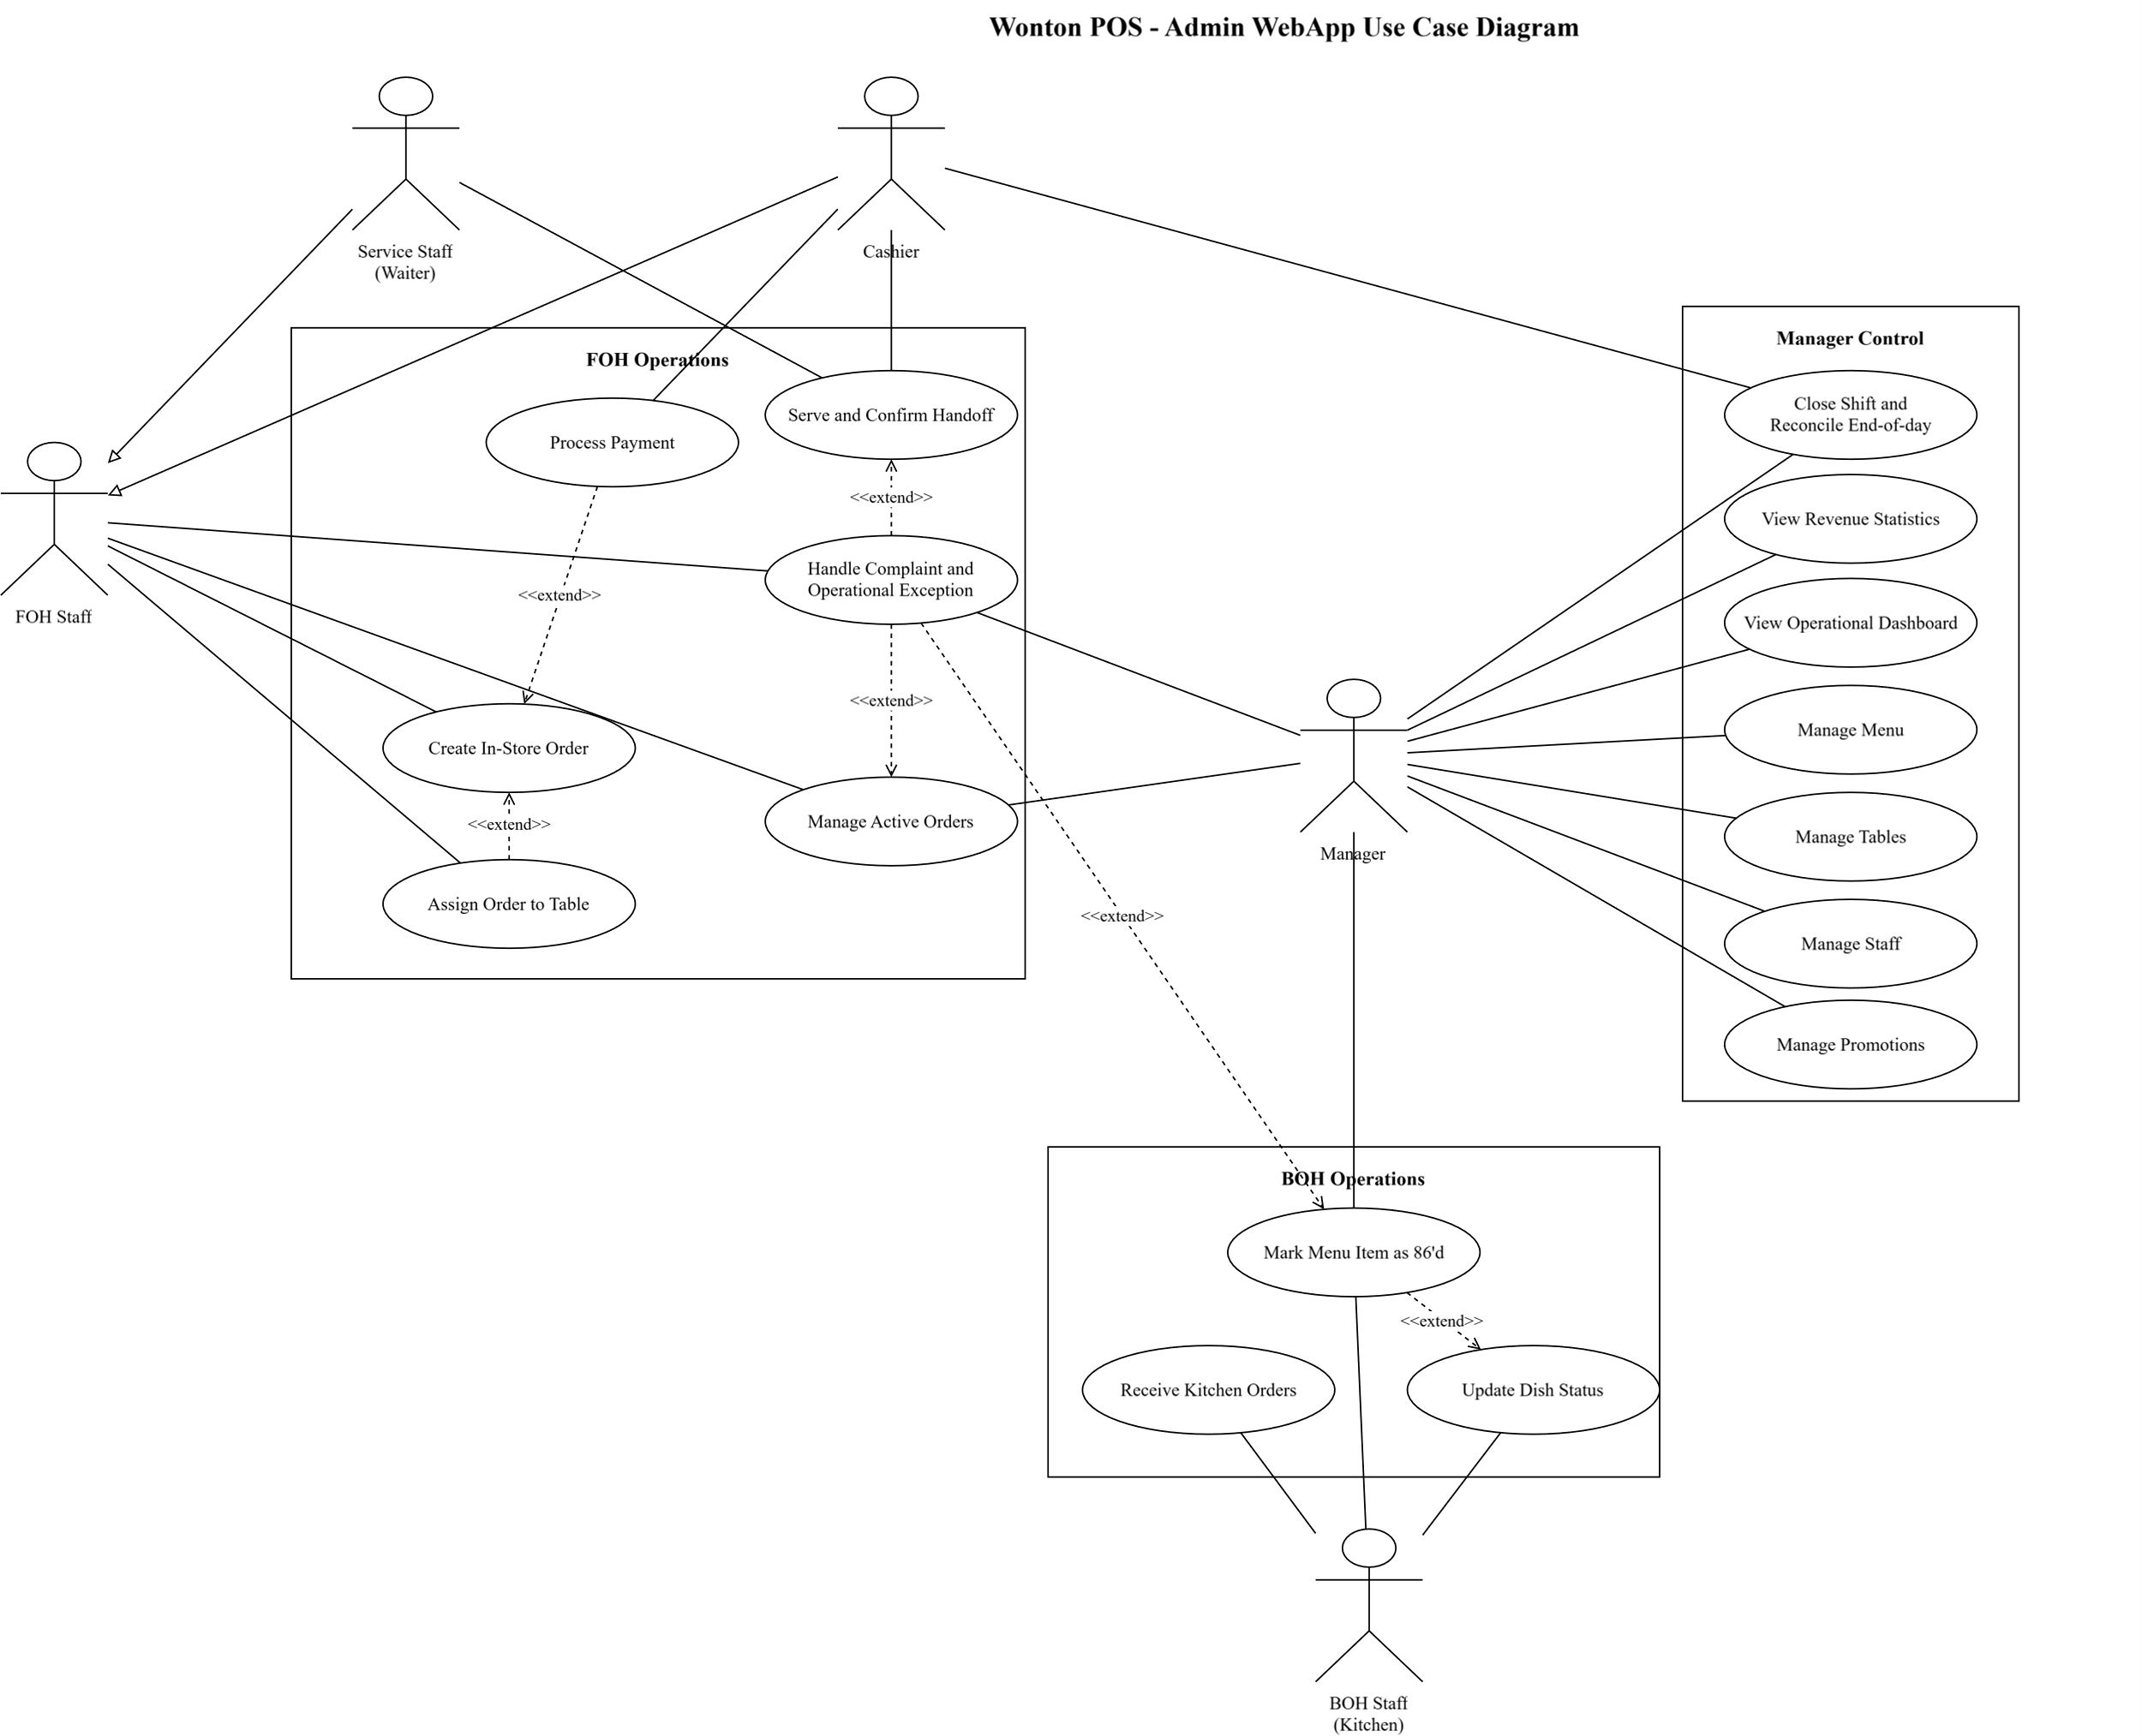
Fig 1. Client WebApp Use Case Diagram and Fig 2. Admin WebApp Use Case Diagram
The Client WebApp use case diagram focuses on the customer-facing boundary of Wonton POS. It uses Customer (Guest / Registered) as the general actor and Registered Customer as a specialized actor, which means registered users inherit the common customer ordering behavior while also gaining account-continuity functions. The diagram groups the customer functions into three logical areas: Customer Access and Onboarding, Ordering and Checkout, and Post-order Journey. Customer Access and Onboarding is represented by Manage Customer Account and Authentication, which covers registration, login, logout, password recovery, password change, and profile maintenance as one coherent account capability. Ordering and Checkout is centered on Place Online Order, Complete Checkout and Apply Promotion, Schedule Pickup Order, and Online Payment. The include relationships show that placing an online order and scheduling a pickup order both depend on checkout validation, while pickup scheduling also requires payment before the order can proceed under the prepaid Pickup rule. Online Payment is modeled as an extend relationship from checkout because payment becomes mandatory for Takeaway and Pickup but may vary according to the selected service model and payment method. The Post-order Journey group contains View Order History, Reorder Past Order, Track Order, Rate Order, and Receive Order Notifications. Reorder Past Order and Rate Order extend View Order History because they are conditional actions available only from eligible historical or completed orders. Receive Order Notifications extends Track Order because notifications support the tracking experience by informing the customer when payment, cooking, ready, completion, cancellation, or exception events occur. Overall, the Client WebApp diagram demonstrates that the customer module covers the complete lifecycle from account access and order creation to checkout, payment, pickup scheduling, tracking, reorder, rating, and notification, while still allowing guest checkout and guest order tracking by order information.
The Admin WebApp use case diagram describes the internal operation boundary used by restaurant staff and managers. The actor model separates Manager, FOH Staff, Cashier, Service Staff (Waiter), and BOH Staff (Kitchen), with Cashier and Service Staff modeled as specialized forms of FOH Staff. This structure reflects the real restaurant workflow because front-of-house work may be performed by different staff members while still sharing the same operational responsibility group. The use cases are organized into FOH Operations, Manager Control, and BOH Operations. FOH Operations covers Create In-Store Order, Assign Order to Table, Process Payment, Manage Active Orders, Serve and Confirm Handoff, and Handle Complaint and Operational Exception. Assign Order to Table and Process Payment extend Create In-Store Order because table allocation and payment handling depend on the service model and the order state rather than occurring identically for every order. Manage Active Orders is the day-to-day control point for monitoring current orders, while Serve and Confirm Handoff closes the service loop only after a ready order is delivered to the correct table or customer. Handle Complaint and Operational Exception extends Manage Active Orders, Serve and Confirm Handoff, and Mark Menu Item as 86'd because complaints, wrong handoff, fulfilment failure, refunds, remakes, and manager corrections are conditional exception flows that arise from active service or availability problems. Manager Control covers View Operational Dashboard, View Revenue Statistics, Manage Menu, Manage Tables, Manage Staff, Manage Promotions, and Close Shift and Reconcile End-of-day. These use cases show that the manager role is responsible not only for configuration data but also for business visibility, promotion governance, financial reconciliation, and controlled end-of-day review. BOH Operations covers Receive Kitchen Orders, Update Dish Status, and Mark Menu Item as 86'd. This group captures the kitchen-facing flow in which only valid orders enter the kitchen queue, preparation status is updated for staff and customers, and unavailable items are marked so new orders cannot silently select them. Overall, the Admin WebApp diagram shows how Wonton POS connects cashier workflow, table service, kitchen execution, menu and promotion administration, shift reconciliation, and operational exception handling in one controlled staff-facing system.
2.8 USE CASE MODEL DESCRIPTION
The following use case specifications describe the complete 26-use-case visible lane used by the final SRS package. Together, they cover customer access, ordering, checkout, payment, pickup scheduling, post-order visibility, menu and promotion control, table and counter operations, kitchen execution, service handoff, complaints, 86'd item handling, dashboard reporting, and shift reconciliation. No extra use case graphics are inserted in this section because the detailed Client WebApp and Admin WebApp use case diagram views are already presented in Section 2.7.
UC-01: Place Online Orde
ID & Name: | UC-01: Place Online Order
Primary Actor: | Guest Customer / Registered Customer
Description: | The customer browses the menu, customizes items, adds them to the cart, and submits an online order for Takeaway or Pickup, or prepares a Dine-in order from the customer side where applicable.
Trigger: | The customer decides to purchase menu items through the Client WebApp.
Pre-conditions: | The menu is available, the customer has access to the Client WebApp, and at least one orderable item exists.
Post-conditions: | A new order record is created in the system with the correct service model, items, and initial status.
Normal Flow: | 1. Customer opens the menu. 2. Customer searches or browses categories. 3. Customer selects items and options. 4. Customer updates quantities and notes in the cart. 5. Customer chooses service model. 6. Customer provides required contact details. 7. System validates cart content and required fields. 8. System creates the order and moves the customer to checkout or payment.
Alternative Flows: | A1. Customer removes one or more items before submission. A2. Customer changes the service model before final confirmation. A3. Customer is a guest and proceeds without creating an account.
Exceptions: | E1. One or more selected items become unavailable before submission. E2. The customer provides incomplete required information. E3. The system fails to create the order due to temporary service error.
Priority: | High

UC-02: Complete Online Payment
ID & Name: | UC-02: Complete Online Payment
Primary Actor: | Guest Customer / Registered Customer
Description: | The customer pays for an eligible Takeaway or Pickup order using an online method supported by the system.
Trigger: | The customer confirms checkout for an order that requires prepayment.
Pre-conditions: | The order already exists, the order is in an unpaid but payable state, and a supported payment channel is available.
Post-conditions: | The payment status is updated to Paid if successful, or remains pending/fails according to the result.
Normal Flow: | 1. Customer reviews order total. 2. Customer selects a payment method. 3. System creates a payment request. 4. Customer completes payment interaction. 5. Payment service returns a result or callback. 6. System verifies the payment outcome. 7. System updates payment status. 8. If payment is valid, the order becomes eligible for kitchen intake.
Alternative Flows: | A1. Customer retries payment on the same order. A2. Customer changes to another supported payment method. A3. Bank-transfer QR is used and staff later performs manual confirmation if required by the configured flow.
Exceptions: | E1. The payment gateway returns a failure. E2. A callback arrives after the order has expired. E3. Duplicate callback is received for the same successful transaction.
Priority: | High

UC-03: Schedule Pickup Order
ID & Name: | UC-03: Schedule Pickup Order
Primary Actor: | Guest Customer / Registered Customer
Description: | The customer selects Pickup service, chooses a pickup time slot, and lets the system validate operating hours, pickup availability, and slot capacity before the order continues to payment and kitchen processing.
Trigger: | The customer chooses Pickup during checkout or from the ordering flow.
Pre-conditions: | The cart contains at least one orderable item, Pickup service is enabled, pickup slot configuration exists, and the customer has provided required contact information.
Post-conditions: | A valid pickup slot is attached to the order. If payment is later completed, the order becomes eligible for kitchen intake; if validation fails, the order is not released to kitchen processing.
Normal Flow: | 1. Customer selects Pickup as the service model. 2. System displays available pickup dates and time slots. 3. Customer selects a preferred slot. 4. System checks operating hours, pause status, and capacity. 5. Customer confirms the slot. 6. System stores the pickup schedule and returns the customer to checkout or payment.
Alternative Flows: | A1. Customer selects a suggested nearby slot when the preferred slot is nearly full or unavailable. A2. Registered customer reuses saved contact information before confirming the pickup schedule.
Exceptions: | E1. Selected slot is full or outside operating hours. E2. Pickup is temporarily paused. E3. One or more cart items become unavailable before slot confirmation.
Priority: | High

UC-04: View Order History
ID & Name: | UC-04: View Order History
Primary Actor: | Registered Customer
Description: | The registered customer reviews previous orders, order details, payment status, and post-order actions such as reorder or rating where eligible.
Trigger: | The customer opens Order History from the account area.
Pre-conditions: | The customer is logged in with a valid account session.
Post-conditions: | The order history list or selected order detail is displayed without changing historical order data.
Normal Flow: | 1. Customer opens the account area. 2. Customer selects Order History. 3. System retrieves orders linked to the account. 4. System displays summary rows with status and payment information. 5. Customer selects one order. 6. System displays order details and eligible follow-up actions.
Alternative Flows: | A1. Customer filters history by status or date range. A2. Customer opens an eligible completed order for reorder. A3. Customer opens an eligible completed order for rating.
Exceptions: | E1. No historical orders exist. E2. Order history cannot be loaded temporarily. E3. The customer attempts to access an order outside the account context.
Priority: | Medium

UC-05: Manage Menu
ID & Name: | UC-05: Manage Menu
Primary Actor: | Manager
Description: | The manager manages menu categories, menu items, toppings, prices, images, and normal catalogue status while preserving historical order integrity.
Trigger: | The manager opens Menu Management in the Admin WebApp.
Pre-conditions: | The manager is authenticated and has permission to manage menu data.
Post-conditions: | Menu catalogue changes are saved and reflected in customer, staff, and kitchen views according to the item status.
Normal Flow: | 1. Manager opens Menu Management. 2. System displays categories and menu items. 3. Manager chooses to add or edit a record. 4. Manager enters item, category, topping, price, image, or status data. 5. System validates the submitted values. 6. System saves the change and refreshes the menu catalogue.
Alternative Flows: | A1. Manager archives or deactivates an item that has historical order data. A2. Manager updates category or topping information. A3. Manager edits price while old order snapshots remain unchanged.
Exceptions: | E1. Required menu data is missing or invalid. E2. A duplicate name conflicts with an existing item or category. E3. Manager attempts to hard-delete a record that must be preserved for history.
Priority: | High

UC-06: Manage Staff
ID & Name: | UC-06: Manage Staff
Primary Actor: | Manager
Description: | The manager creates, updates, disables, and assigns roles to staff accounts used by cashier, service, kitchen, and management users.
Trigger: | The manager opens Staff Management in the Admin WebApp.
Pre-conditions: | The manager is authenticated with staff-management permission.
Post-conditions: | The staff account and role assignments are saved, disabled, or updated according to the manager action.
Normal Flow: | 1. Manager opens Staff Management. 2. System displays staff accounts and roles. 3. Manager selects Add Staff or edits an existing staff member. 4. Manager enters profile and role data. 5. System validates required fields and role rules. 6. System saves the staff record and updates access permissions.
Alternative Flows: | A1. Manager disables a staff account instead of deleting it. A2. Manager changes role assignments. A3. Manager triggers a password reset or account recovery process for a staff member.
Exceptions: | E1. Phone number or email is already used. E2. Selected role is invalid for the account. E3. Manager attempts to disable the last active manager account.
Priority: | High

UC-07: View Revenue Statistics
ID & Name: | UC-07: View Revenue Statistics
Primary Actor: | Manager
Description: | The manager reviews revenue statistics, top-selling items, peak hours, payment-method summaries, refunds, losses, and exportable reporting data.
Trigger: | The manager opens Statistics and Reports in the Admin WebApp.
Pre-conditions: | The manager is authenticated with reporting permission and completed transaction data exists or can be queried.
Post-conditions: | The requested statistics are displayed or exported; no transactional data is changed.
Normal Flow: | 1. Manager opens Statistics and Reports. 2. Manager selects a date range. 3. System aggregates order and payment data. 4. System displays revenue, refund, payment-method, top-item, and peak-hour metrics. 5. Manager reviews the report. 6. Manager exports the report if needed.
Alternative Flows: | A1. Manager filters by payment method or service model. A2. Manager switches between summary view and detailed table view. A3. Manager exports the result for offline review.
Exceptions: | E1. No data matches the selected filters. E2. Report generation fails temporarily. E3. The user does not have permission to view revenue data.
Priority: | High

UC-08: Manage Tables
ID & Name: | UC-08: Manage Tables
Primary Actor: | Manager
Description: | The manager maintains dine-in table records and floor-layout information used by front-of-house staff during table assignment and service.
Trigger: | The manager opens Table Management in the Admin WebApp.
Pre-conditions: | The manager is authenticated and has permission to manage table master data.
Post-conditions: | The table record or layout data is created, updated, deactivated, or displayed according to the manager action.
Normal Flow: | 1. Manager opens Table Management. 2. System displays the current table list and layout. 3. Manager adds or edits a table. 4. Manager enters table number, capacity, location, and status information. 5. System validates the table data. 6. System saves the change and refreshes the layout.
Alternative Flows: | A1. Manager marks a table temporarily unavailable. A2. Manager views table status without changing configuration. A3. Manager deactivates a table that is no longer used.
Exceptions: | E1. Table number is duplicated. E2. Capacity or layout data is invalid. E3. Manager attempts to deactivate or remove a table that still has active orders.
Priority: | High

UC-09: Create In-store Order at Counter
ID & Name: | UC-09: Create In-store Order at Counter
Primary Actor: | FOH Staff / Cashier
Description: | The cashier or server creates a dine-in or takeaway order directly for a walk-in customer at the restaurant.
Trigger: | A walk-in customer requests service at the counter or staff station.
Pre-conditions: | The staff member is logged in and has permission to create an order.
Post-conditions: | A valid in-store order is created and becomes available for payment handling or later dine-in settlement.
Normal Flow: | 1. Staff opens the create-order screen. 2. Staff selects the service model. 3. Staff adds menu items, options, and notes. 4. Staff assigns the table if the order is dine-in. 5. System calculates totals. 6. Staff confirms order creation. 7. System stores the order and shows the created order summary.
Alternative Flows: | A1. Staff creates a new additional order for an already occupied dine-in table. A2. Staff changes the selected service model before final confirmation.
Exceptions: | E1. A selected item is currently unavailable. E2. Required dine-in table information is missing. E3. The order cannot be saved due to temporary system failure.
Priority: | High

UC-10: Process Counter Payment
ID & Name: | UC-10: Process Counter Payment
Primary Actor: | Cashier
Description: | The cashier accepts and records payment for an eligible order at the restaurant counter.
Trigger: | The customer is ready to pay for a dine-in or counter-created takeaway order.
Pre-conditions: | The cashier is logged in, the order exists, and the order is in a payable state.
Post-conditions: | The payment status is updated and a receipt or confirmation can be produced.
Normal Flow: | 1. Cashier locates the order. 2. System shows the payable balance. 3. Cashier selects the payment method. 4. Cashier records the received payment. 5. System validates the amount and method. 6. System updates payment status to Paid if successful. 7. System prints or prepares receipt data.
Alternative Flows: | A1. Cashier selects cash payment. A2. Cashier selects QR or another supported electronic method. A3. Cashier settles multiple open dine-in orders for one table in a combined payment scenario if supported by the configured flow.
Exceptions: | E1. The paid amount is insufficient. E2. The payment confirmation fails. E3. The order is no longer in a valid payable state.
Priority: | High

UC-11: Track Order Status
ID & Name: | UC-11: Track Order Status
Primary Actor: | Guest Customer / Registered Customer
Description: | The customer views the current status and timeline of a placed order.
Trigger: | The customer wants to know whether an order is waiting, cooking, ready, completed, cancelled, or under exception handling.
Pre-conditions: | A valid order exists. Guest customers must provide Order Code and Phone Number. Registered customers must be logged in or access an order belonging to their account.
Post-conditions: | The customer sees the current order state and the visible status history available to that role.
Normal Flow: | 1. Customer opens the order tracking function. 2. Customer enters tracking credentials or selects an order from account history. 3. System validates access permission. 4. System retrieves current order and payment states. 5. System displays tracking information and relevant notifications.
Alternative Flows: | A1. Registered customer opens the order directly from order history. A2. Guest customer retries lookup after correcting the phone number or order code.
Exceptions: | E1. The provided lookup information is invalid. E2. The customer exceeds lookup retry limits. E3. The order exists but is outside the visible access context of the requester.
Priority: | High

UC-12: Assign Order to Table
ID & Name: | UC-12: Assign Order to Table
Primary Actor: | FOH Staff / Cashier
Description: | FOH staff assign a dine-in order to a table, attach an additional order to an active table for the same party, or transfer active table orders when required.
Trigger: | A dine-in order needs a table assignment, an existing party adds another order, or customers move to another table.
Pre-conditions: | The staff member is logged in, a dine-in order exists, and table layout data is available.
Post-conditions: | The order-to-table relationship is updated and table occupancy reflects the active dine-in situation.
Normal Flow: | 1. Staff opens the table layout. 2. Staff selects the dine-in order. 3. Staff selects an available table. 4. System checks table availability. 5. Staff confirms the assignment. 6. System links the order to the table and updates table status.
Alternative Flows: | A1. Staff attaches an additional order to an already occupied table for the same party. A2. Staff transfers the party to another table; by default all active orders for that party move together. A3. Staff requests manager correction for a sensitive table-assignment mistake.
Exceptions: | E1. Selected table is occupied by a different party. E2. Table information is missing or outdated. E3. Transfer cannot be completed because the target table becomes unavailable.
Priority: | High

UC-13: Receive Kitchen Orders
ID & Name: | UC-13: Receive Kitchen Orders
Primary Actor: | BOH Staff
Description: | Kitchen staff receive valid kitchen tickets, review order details, and move eligible orders into the preparation queue.
Trigger: | A dine-in order is submitted or a prepayment-required Takeaway/Pickup order becomes paid and eligible for kitchen intake.
Pre-conditions: | The BOH staff member has kitchen access and the order is valid for kitchen processing under the service-model payment rule.
Post-conditions: | The kitchen order is visible in the preparation queue, or an issue is escalated without creating duplicate kitchen work.
Normal Flow: | 1. Kitchen staff opens the kitchen queue. 2. System displays newly eligible orders in FIFO order. 3. Staff selects an order to inspect. 4. System displays items, toppings, notes, and service model. 5. Staff accepts the work into preparation. 6. System records kitchen intake and makes the order ready for status updates.
Alternative Flows: | A1. Kitchen staff groups similar items for batch preparation. A2. Kitchen staff flags an item-level issue for FOH or manager handling. A3. The system highlights pickup time windows for Pickup orders.
Exceptions: | E1. Duplicate ticket is detected for the same order. E2. An unpaid Takeaway/Pickup order is incorrectly presented for kitchen intake. E3. A paid order contains a newly unavailable item and must be escalated for substitution, refund, or cancellation handling.
Priority: | High

UC-14: Update Preparation Status
ID & Name: | UC-14: Update Preparation Status
Primary Actor: | BOH Staff
Description: | Kitchen staff updates item-level or order-level preparation progress for active orders.
Trigger: | The kitchen starts, continues, or finishes preparing one or more order items.
Pre-conditions: | A valid order has been accepted into the kitchen queue and the staff member has kitchen access.
Post-conditions: | The current preparation status is updated and visible to relevant actors.
Normal Flow: | 1. Kitchen staff opens the kitchen queue. 2. Staff selects an order or group of items. 3. Staff marks the order as being prepared or updates grouped item status. 4. System records the update. 5. When preparation is complete, staff marks the order or items as Ready. 6. The system notifies FOH or customers as appropriate.
Alternative Flows: | A1. Kitchen staff updates several similar items in a grouped batch. A2. Kitchen staff flags an issue such as an unavailable ingredient for escalation.
Exceptions: | E1. A duplicated kitchen ticket is detected. E2. A paid order contains an 86'd item and cannot continue normally. E3. The status update fails because of temporary network disruption.
Priority: | High

UC-15: Rate Completed Order
ID & Name: | UC-15: Rate Completed Order
Primary Actor: | Guest Customer / Registered Customer
Description: | The customer submits a rating and optional comment after an order has been completed, allowing the restaurant to collect post-service feedback.
Trigger: | The customer opens the rating function from order history, tracking completion, or a post-order notification.
Pre-conditions: | The order is completed, the customer can prove access to the order, and the rating window is still valid.
Post-conditions: | The rating and comment are stored and linked to the completed order, or no feedback is saved if validation fails.
Normal Flow: | 1. Customer opens an eligible completed order. 2. Customer selects a rating score. 3. Customer optionally enters a comment. 4. System validates eligibility and content. 5. Customer submits feedback. 6. System stores the rating and shows confirmation.
Alternative Flows: | A1. Customer submits only a score without comment. A2. Registered customer opens the rating action from order history. A3. Guest customer accesses the completed order using Order Code and Phone Number.
Exceptions: | E1. Order is not completed yet. E2. Rating window has expired. E3. The order has already been rated. E4. Comment violates basic content rules.
Priority: | Medium

UC-16: Receive Order Notifications
ID & Name: | UC-16: Receive Order Notifications
Primary Actor: | Guest Customer / Registered Customer
Description: | The customer receives order-related notifications such as payment result, cooking progress, ready status, completion, cancellation, or exception updates.
Trigger: | A relevant order event occurs after the order is created.
Pre-conditions: | A valid order exists and notification delivery is available through the Client WebApp or fallback notification view.
Post-conditions: | The customer sees the relevant notification and the notification event is recorded for later visibility where applicable.
Normal Flow: | 1. An order event occurs. 2. System identifies affected customer and order. 3. System creates a notification message. 4. System delivers the notification through the active channel. 5. Customer opens or views the notification. 6. System shows the related order context.
Alternative Flows: | A1. Customer reconnects after being offline and views missed notifications. A2. Registered customer opens notification history. A3. Guest customer follows the notification to the order-tracking screen.
Exceptions: | E1. Browser notification permission is unavailable. E2. Real-time channel is disconnected. E3. Notification is delivered but the linked order is no longer accessible to the requester.
Priority: | Medium

UC-17: Reorder Past Order
ID & Name: | UC-17: Reorder Past Order
Primary Actor: | Registered Customer
Description: | The customer uses a completed past order as a starting point for a new cart while the system revalidates current menu availability, prices, toppings, and service-model rules.
Trigger: | The customer selects Reorder from an eligible completed order.
Pre-conditions: | The customer is logged in, at least one completed order exists, and current menu data can be checked.
Post-conditions: | A new cart is populated with currently valid items and clear notices for changed or unavailable content.
Normal Flow: | 1. Customer opens Order History. 2. Customer selects a completed order. 3. Customer clicks Reorder. 4. System compares the past order with current menu, price, topping, and availability data. 5. System shows changed or unavailable items. 6. Customer reviews the adjusted cart. 7. System sends the customer to checkout.
Alternative Flows: | A1. Customer accepts updated prices or topping changes. A2. Customer removes unavailable items. A3. Customer edits notes or customization before checkout instead of blindly copying the past order.
Exceptions: | E1. The selected order is not completed. E2. All items in the past order are unavailable or archived. E3. Current service-model rules prevent the reordered cart from proceeding.
Priority: | Medium

UC-18: Manage Promotions
ID & Name: | UC-18: Manage Promotions
Primary Actor: | Manager
Description: | The manager creates, edits, deactivates, and reviews promotion codes or discount rules with validity, usage-limit, stacking, cancellation, and audit behavior.
Trigger: | The manager opens Promotion Management in the Admin WebApp.
Pre-conditions: | The manager is authenticated with promotion-management permission.
Post-conditions: | The promotion rule is saved, updated, deactivated, or reviewed, and sensitive changes are recorded for audit.
Normal Flow: | 1. Manager opens Promotion Management. 2. System displays promotion list and usage status. 3. Manager selects Create Promotion. 4. Manager enters code, discount value, validity period, usage limit, and stacking rules. 5. System validates the promotion. 6. System saves the promotion and records the change.
Alternative Flows: | A1. Manager edits an existing promotion. A2. Manager deactivates a promotion without deleting historical usage. A3. Manager views promotion usage history and failed application attempts.
Exceptions: | E1. Promotion code is duplicated. E2. Validity period or discount rule is invalid. E3. Stacking configuration conflicts with current promotion policy. E4. Promotion has historical usage and cannot be hard-deleted.
Priority: | High

UC-19: View Operational Dashboard
ID & Name: | UC-19: View Operational Dashboard
Primary Actor: | Manager
Description: | The manager views a high-level operational dashboard showing active orders, revenue snapshot, alerts, exception counts, kitchen/service pressure, and inventory-lite warnings.
Trigger: | The manager opens the Admin dashboard or refreshes the dashboard view.
Pre-conditions: | The manager is authenticated and dashboard source data can be retrieved.
Post-conditions: | The dashboard displays the latest available operational snapshot without modifying business data.
Normal Flow: | 1. Manager opens the dashboard. 2. System retrieves order, payment, kitchen, table, complaint, shift, and availability data. 3. System aggregates key indicators. 4. System displays the operational snapshot. 5. Manager opens a related detail page if further action is needed.
Alternative Flows: | A1. Manager refreshes the dashboard manually. A2. Manager filters the view by service model or time period. A3. Manager follows an alert to active orders, complaints, or 86?d items.
Exceptions: | E1. Some dashboard data cannot be loaded. E2. User lacks permission for financial indicators. E3. A stale data warning is shown after temporary connectivity problems.
Priority: | High

UC-20: Manage Active Orders
ID & Name: | UC-20: Manage Active Orders
Primary Actor: | FOH Staff / Manager
Description: | FOH staff and managers monitor current orders, confirm operational actions, cancel or correct eligible orders, and escalate sensitive cases when business rules require approval.
Trigger: | Staff opens the active-order view during restaurant operations.
Pre-conditions: | The staff member is authenticated and at least one active order may exist in the system.
Post-conditions: | The selected active order is updated, cancelled, monitored, or escalated according to allowed state and role rules.
Normal Flow: | 1. Staff opens Active Orders. 2. System displays orders by status, service model, and priority. 3. Staff selects an order. 4. System displays order, payment, table, pickup, and kitchen context. 5. Staff selects an allowed action. 6. System validates role and state. 7. System applies the update and records the action.
Alternative Flows: | A1. Staff cancels an order before kitchen acceptance where allowed. A2. Staff edits a minor note before kitchen acceptance. A3. Staff escalates a complaint, failed fulfilment, or wrong-handoff issue to UC-24.
Exceptions: | E1. Requested action is not valid for the current order state. E2. Sensitive action lacks a required reason or manager approval. E3. Payment-related correction requires refund or reconciliation handling instead of a simple order update.
Priority: | High

UC-21: Close Shift and Reconcile End of Day
ID & Name: | UC-21: Close Shift and Reconcile End of Day
Primary Actor: | Cashier / Manager
Description: | The cashier and manager review transactional totals, cash drawer values, unresolved exceptions, and close the current shift responsibly.
Trigger: | The operating shift reaches its end or the restaurant is preparing to hand over to another shift.
Pre-conditions: | A shift is open, transactional records exist, and the responsible operator has closing permission.
Post-conditions: | The shift is closed with recorded reconciliation results, unresolved issues are inherited if necessary, and financial summaries are preserved.
Normal Flow: | 1. Cashier opens the shift-close function. 2. System shows expected totals by payment method. 3. Cashier counts actual cash and enters the result. 4. System compares expected and actual values. 5. System lists unresolved exceptions. 6. Cashier adds variance reason if needed. 7. Manager reviews and confirms the close when required. 8. System closes the shift and stores the summary.
Alternative Flows: | A1. A discrepancy exists but is within a tolerated range and is still recorded. A2. Unresolved cases are handed over as inherited exceptions to the next shift.
Exceptions: | E1. Required manager confirmation is missing. E2. A critical unresolved exception blocks the shift close. E3. The cash drawer count cannot be reconciled with current recorded events.
Priority: | High

UC-22: Mark Menu Item as 86'd
ID & Name: | UC-22: Mark Menu Item as 86'd
Primary Actor: | Manager / BOH Staff
Description: | Authorized staff mark a menu item temporarily unavailable, restore it when available again, and ensure new orders cannot select 86'd items while active impacted orders are handled explicitly.
Trigger: | Kitchen or manager discovers that an item is out of stock or temporarily unavailable.
Pre-conditions: | The staff member has availability-management permission and the target menu item exists.
Post-conditions: | The item availability status is updated, new orders are blocked from selecting the item, and the availability event is recorded independently from full inventory procurement.
Normal Flow: | 1. Staff opens menu availability control. 2. Staff selects the affected item. 3. Staff chooses Mark Unavailable. 4. Staff enters reason or expected recovery note. 5. System validates permission. 6. System updates availability and records the event. 7. System hides or disables the item for new orders.
Alternative Flows: | A1. Staff restores the item to Available. A2. Staff records a low-stock warning without marking the item fully unavailable. A3. System highlights active paid orders affected by the availability change for manual handling.
Exceptions: | E1. Staff lacks permission to change availability. E2. The item is already inactive or archived. E3. A paid active order contains the affected item and must be resolved through substitution, refund, cancellation, or complaint handling instead of silent removal.
Priority: | High

UC-23: Serve Order and Confirm Correct Handoff
ID & Name: | UC-23: Serve Order and Confirm Correct Handoff
Primary Actor: | FOH Staff / Cashier
Description: | Staff confirms that a ready order has been delivered to the correct table or collected by the correct customer.
Trigger: | An order reaches Ready status and is awaiting service or pickup handoff.
Pre-conditions: | The order is marked Ready and staff has access to the active-order view.
Post-conditions: | The order changes to Completed after actual successful handoff, or an exception case is raised.
Normal Flow: | 1. Staff views ready orders. 2. Staff identifies the correct table or customer. 3. Staff serves the dish or hands over the order. 4. Staff confirms successful handoff in the system. 5. System updates the order to Completed. 6. The completion event is recorded for reporting and post-service flows.
Alternative Flows: | A1. Staff discovers the order has been taken by the wrong person and raises a wrong-handoff issue. A2. Staff serves one dine-in order while the table still has other active orders.
Exceptions: | E1. Staff confirms completion by mistake before the correct handoff occurs. E2. The customer cannot be identified at collection time. E3. A completed order requires manager-supervised correction back to a serviceable state.
Priority: | High

UC-24: Handle Complaint and Operational Exceptions
ID & Name: | UC-24: Handle Complaint and Operational Exceptions
Primary Actor: | Manager
Description: | The manager resolves operational problems such as wrong handoff, failed item fulfilment, complaint, remake request, refund request, write-off, or comp decision.
Trigger: | A complaint or exception is reported by staff or customer, or the system flags an abnormal case.
Pre-conditions: | A related order exists and the manager is logged in with appropriate privileges.
Post-conditions: | The case is resolved through an approved operational or financial action and recorded for audit and reporting.
Normal Flow: | 1. Manager opens the affected order or exception case. 2. System displays order, payment, and item details. 3. Manager reviews the issue and supporting notes. 4. Manager selects an appropriate resolution. 5. Manager enters the required reason. 6. System applies the approved action. 7. System records audit details and updates related statuses.
Alternative Flows: | A1. Manager approves a partial refund for one affected item. A2. Manager approves remake without creating new revenue. A3. Manager records a write-off or comp decision depending on the business context.
Exceptions: | E1. Refund processing is delayed or remains pending. E2. The requested resolution is not allowed for the current order state. E3. Supporting order data is incomplete due to prior outage and requires manual review.
Priority: | High

UC-25: Manage Customer Account and Authentication
ID & Name: | UC-25: Manage Customer Account and Authentication
Primary Actor: | Guest Customer / Registered Customer
Description: | The customer registers, logs in, logs out, recovers access, changes password, and updates profile information used for customer-side continuity.
Trigger: | The customer chooses an account or authentication action in the Client WebApp.
Pre-conditions: | The Client WebApp is available. For profile, password, and logout actions, the customer must already be logged in.
Post-conditions: | The account, session, password, or profile data is updated according to the selected action, or no account data is changed if validation fails.
Normal Flow: | 1. Customer opens Account or Sign In. 2. Customer selects register, login, profile update, password change, password recovery, or logout. 3. System displays the required form. 4. Customer enters required data. 5. System validates identity, credentials, and field rules. 6. System completes the selected account action and shows confirmation.
Alternative Flows: | A1. Guest customer continues checkout without registering. A2. Registered customer uses password recovery before login. A3. Logged-in customer updates profile information or changes password from the account page.
Exceptions: | E1. Phone number or email is already registered. E2. Credentials are incorrect. E3. Recovery token or OTP is invalid or expired. E4. New password fails validation.
Priority: | High

UC-26: Complete Checkout and Apply Promotion
ID & Name: | UC-26: Complete Checkout and Apply Promotion
Primary Actor: | Guest Customer / Registered Customer
Description: | The customer reviews the cart, selects service model, enters required details, applies eligible promotion codes, and confirms checkout before order creation or payment.
Trigger: | The customer proceeds from the cart to checkout.
Pre-conditions: | The cart contains at least one valid item and current menu, promotion, and service-model rules can be checked.
Post-conditions: | Checkout is confirmed with validated details and totals. Dine-in may proceed under counter-settlement rules, while Takeaway and Pickup continue to mandatory prepayment before kitchen intake.
Normal Flow: | 1. Customer opens checkout. 2. System displays cart, totals, and service-model choices. 3. Customer selects Dine-in, Takeaway, or Pickup. 4. Customer enters required contact, table, or pickup information. 5. Customer enters a promotion code if available. 6. System validates promotion and checkout data. 7. Customer confirms checkout. 8. System routes the order to payment or valid next step.
Alternative Flows: | A1. Customer checks out as guest. A2. Customer removes an invalid promotion and continues. A3. Customer changes service model before confirmation. A4. Customer proceeds without a promotion code.
Exceptions: | E1. Promotion is invalid, expired, over usage limit, or not stackable. E2. Required checkout information is missing. E3. Cart content changes before confirmation. E4. Takeaway or Pickup cannot continue to kitchen flow until payment is completed.
Priority: | High

2.9 DATA AND CLASS MODELS
2.9.1 ENTITY RELATIONSHIP DIAGRAM (ERD)
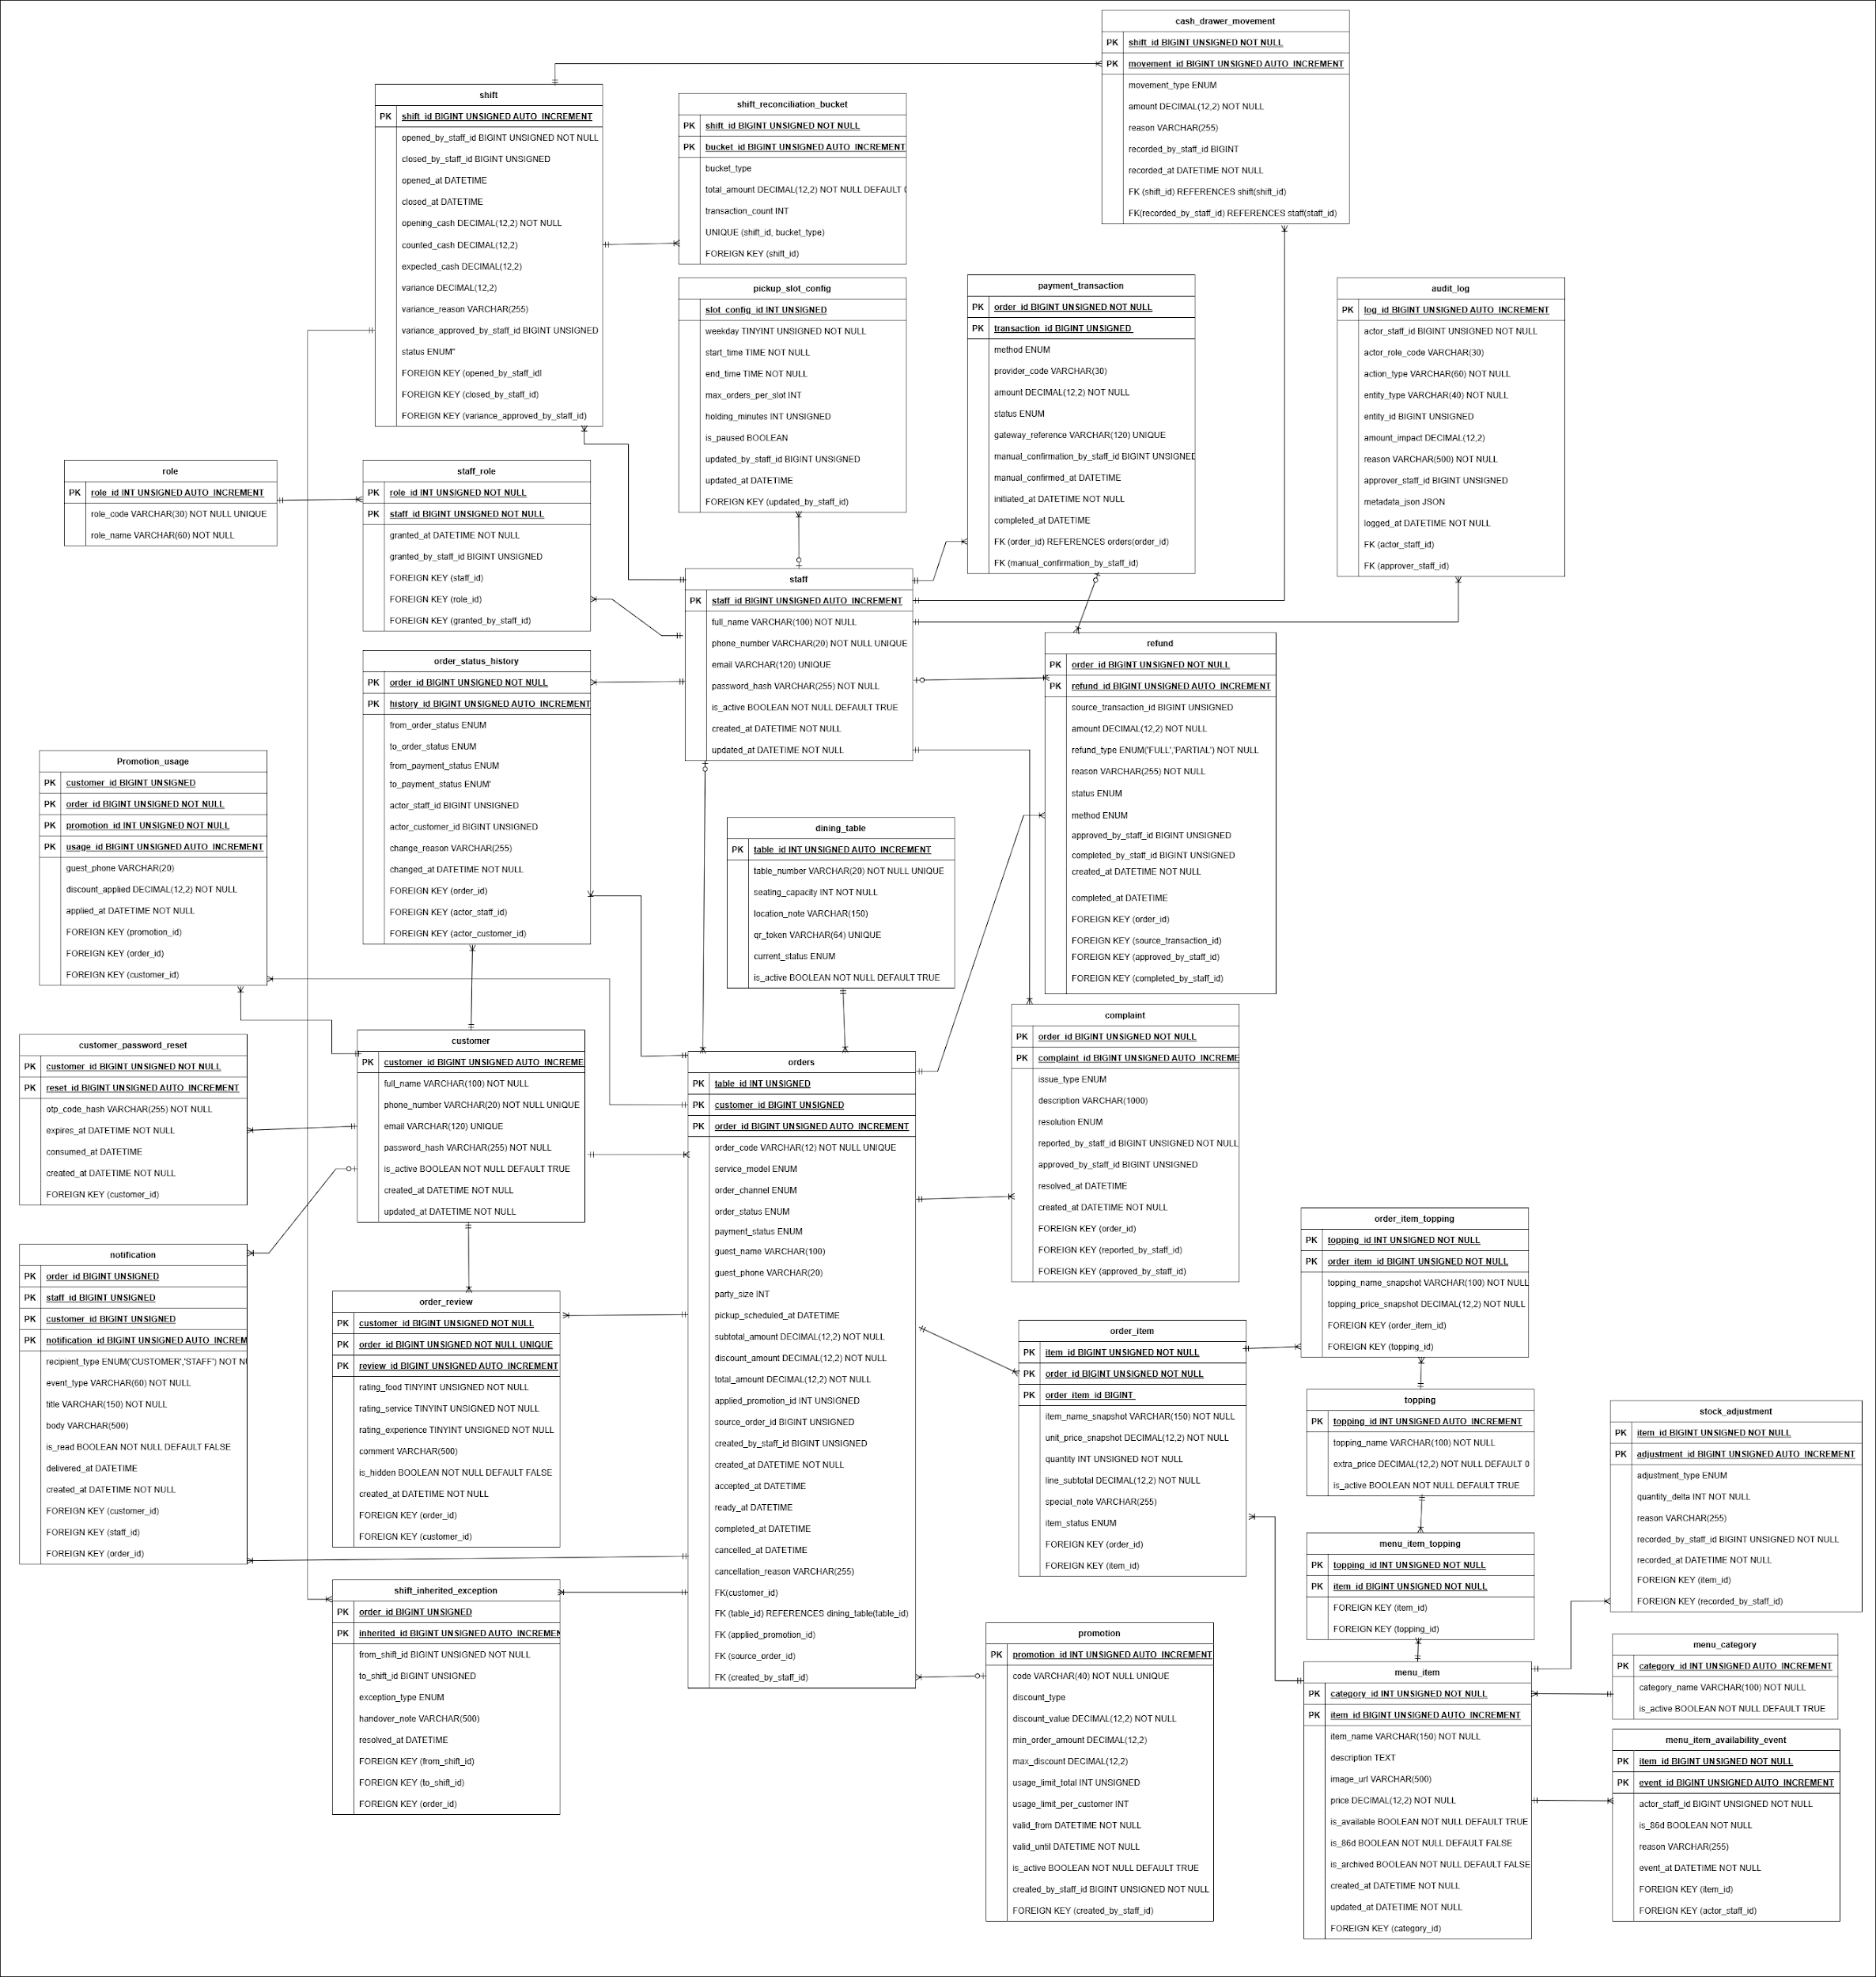

Fig 3. Overall Entity Relationship Diagram
The ERD presents the full logical data structure of the Wonton POS system and explains how the final project scope is supported at the database level through connected operational, financial, menu, customer, and audit entities. At the center of the model is the orders table because the order is the main transactional object that links nearly all business processes in the system. Each order stores essential information such as service type, order status, payment status, total amount, source, and customer linkage, allowing the system to manage Dine-in, Takeaway, and Pickup using one unified structure. This is an important design decision because the repository rules require the system to support different service models while still preserving one consistent order lifecycle. The ERD also reflects a key business principle from the repo: order_status and payment_status are stored separately, because operational progress and financial progress are not always the same. For example, a dine-in order may move through preparation and serving while still unpaid, whereas takeaway and pickup orders must be paid before they are released to kitchen processing. Around the orders table, the order_item and order_item_topping tables represent the detailed contents of the order, allowing one order to contain multiple items and each item to contain multiple topping selections. This supports the restaurant's real ordering behavior and preserves granular transaction detail for kitchen preparation, receipt generation, and later review. The customer and identity side is modeled through customer, customer_password_reset, and notification-related structures, showing that the system supports both account management and order-linked communication. Internal user management is represented by staff, role, and staff_role, which allows one staff member to hold system permissions according to their operational role, such as cashier, manager, or kitchen staff. On the menu side, menu_category, menu_item, topping, and menu_item_topping organize the sellable menu structure, while menu_item_availability_event records 86'd or availability changes over time. This is especially important because the final repository rules explicitly require support for temporary out-of-stock behavior, 86'd propagation, and operational tracking rather than only a static availability flag. The financial part of the system is modeled through payment_transaction, refund, promotion, promotion_usage, and cash_drawer_movement, which together support online payment, cashier payment, partial and full refund handling, promotion application, and reconciliation of cash-related activity. This design is necessary because the project scope includes duplicate payment callback handling, refund pending states, promotion usage limits, and end-of-day balancing. The service-operation context is represented by dining_table and pickup_slot_config, showing that dine-in orders need table-based coordination while pickup orders depend on slot configuration, capacity, and time-window control. The complaint and quality-feedback side is covered by complaint and order_review, which means the database is designed not only for successful flows but also for post-service issues and customer evaluation. For traceability and governance, the ERD includes audit_log, order_status_history, shift, shift_reconciliation_bucket, and shift_inherited_exception, which together ensure that every sensitive action, lifecycle change, reconciliation event, and unresolved operational issue can be reviewed later. This matches the repository's emphasis on manager approval, exception carryover, auditability, and shift closing. Overall, the ERD shows that Wonton POS is designed as a complete operational data model for restaurant service, where customer identity, order composition, payment control, menu management, table coordination, pickup scheduling, promotion usage, complaints, reviews, and audit history are all integrated into one coherent and traceable database structure.
2.9.2 CLASS DIAGRAM
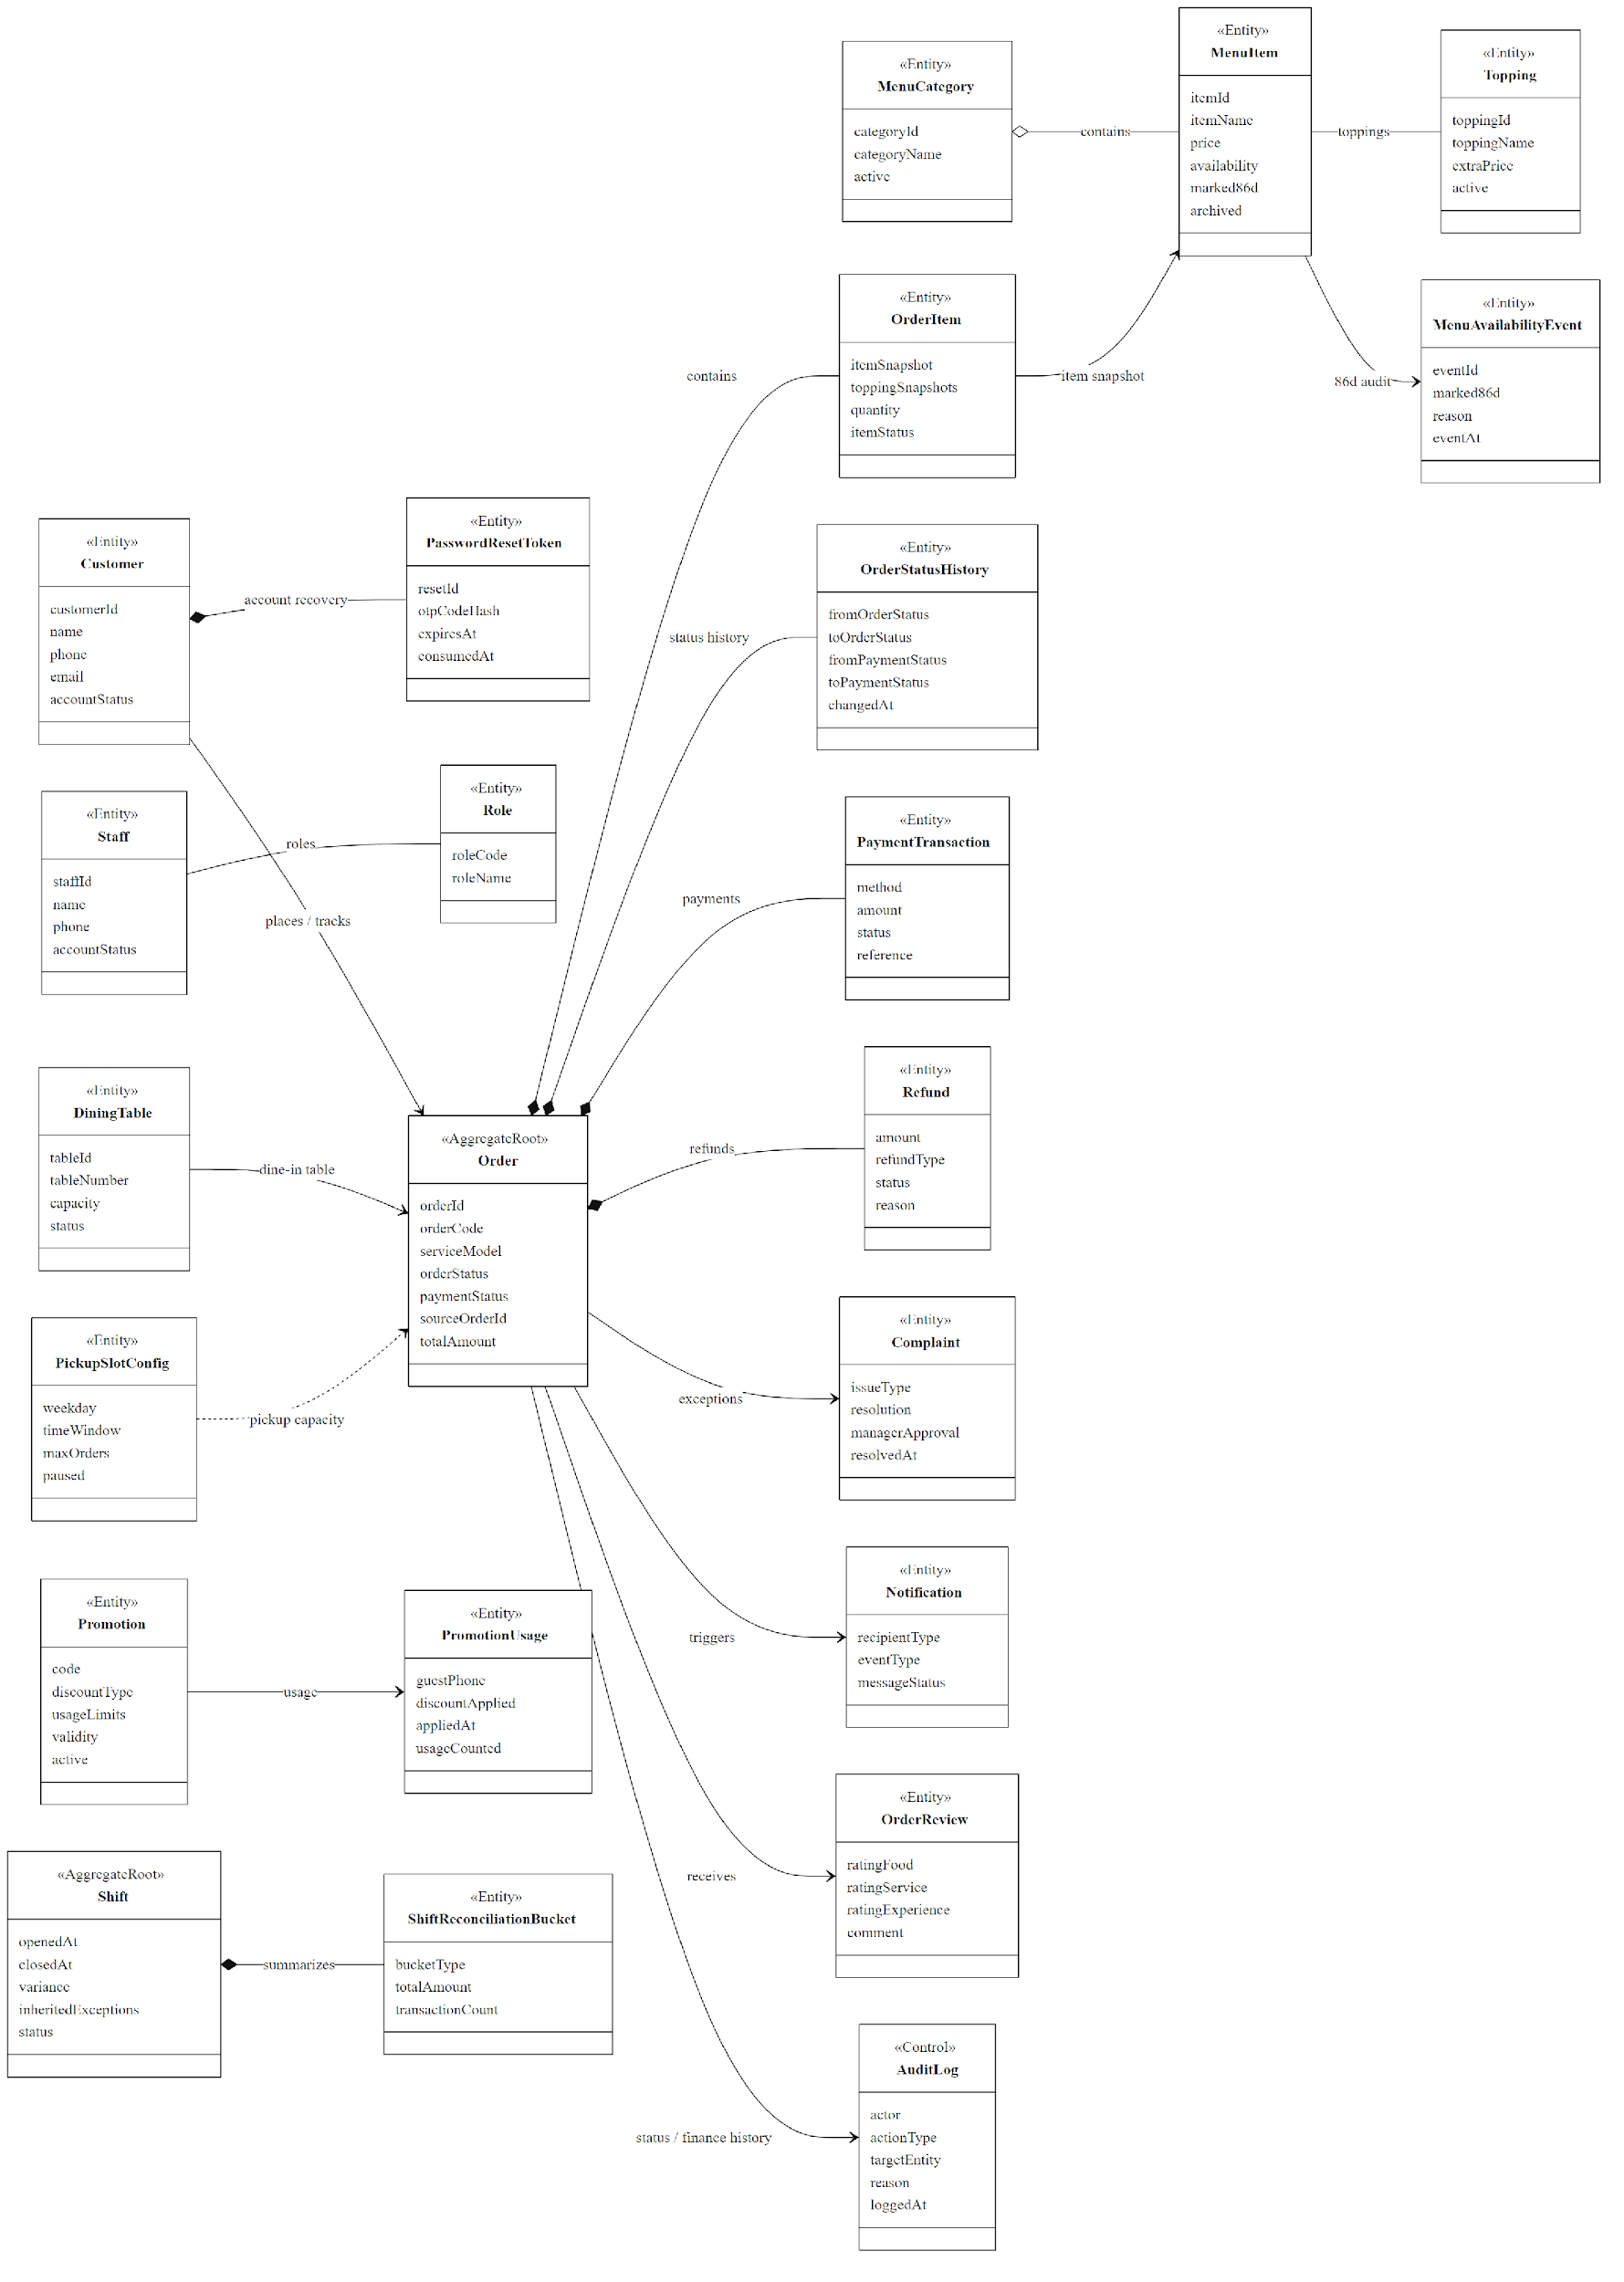
Fig 4. Class Diagram
The class diagram illustrates the core domain model of the Wonton POS system, in which Order is designed as the central aggregate root because almost all major business processes in the final project scope revolve around the order lifecycle. On the identity and access side, Customer stores customer information for registered and trackable guest-related flows, PasswordResetToken supports secure account recovery, Staff represents internal operators, and Role defines authorization for cashier, service, kitchen, manager, and administrative actions. On the menu side, MenuCategory groups multiple MenuItem objects, each MenuItem may have several Topping options, and MenuAvailabilityEvent records 86'd or out-of-stock changes so that item availability is not treated as a simple flag only but as an auditable operational event. Each Order contains multiple OrderItem objects, and these items keep itemSnapshot and toppingSnapshots so the system preserves the exact ordered content even if the menu is edited later; in parallel, OrderStatusHistory records every transition of order and payment state, which is essential because the repository rules explicitly separate orderStatus from paymentStatus to support cases such as unpaid dine-in orders, prepaid takeaway and pickup orders, payment timeout auto-cancellation, duplicate payment callbacks, and refund-pending situations. The service-specific context is modeled through DiningTable for dine-in operations and PickupSlotConfig for pickup capacity and time-window validation, reflecting the business rules that one table may have multiple active orders and that pickup must respect configured slot limits. The financial layer is represented by PaymentTransaction, Refund, Promotion, and PromotionUsage, where payment, refund, and discount application are modeled as different but related business objects so the system can handle partial refund, full refund, promotion validity, usage limits, and financial traceability correctly. Post-order and exception handling are covered by Complaint, Notification, OrderReview, and AuditLog, showing that customer issues, order-event messages, review eligibility, and all sensitive actions such as refund approval, receipt reprint, write-off, or manual override are recorded explicitly instead of being processed invisibly. Finally, Shift and ShiftReconciliationBucket model shift opening, closing, variance control, transaction grouping, and unresolved-exception carryover, which aligns with the final scope requirement for cashier shift closing and end-of-day reconciliation. Overall, this class diagram shows that Wonton POS is modeled as a traceable restaurant operations system rather than a simple ordering app, because it integrates menu management, customer and staff identity, table handling, pickup scheduling, payment control, exception management, feedback capture, and auditability into one coherent domain structure.
2.10 ASSUMPTIONS AND DEPENDENCIES
● The restaurant will provide stable internet connectivity for cashier, manager, and kitchen terminals during normal operation.
● Customers are assumed to access the Client WebApp through a modern browser and possess basic smartphone literacy.
● Restaurant staff are assumed to receive short operational training before daily use of the Admin WebApp.
● External payment providers or QR-based methods are assumed to be available when online prepayment is required.
● If manual bank-transfer confirmation is used, staff are assumed to check the evidence carefully before confirming payment.
● The restaurant is assumed to maintain its own menu, table, promotion, and staff master data in the system.
● The final document now includes detailed Client/Admin Use Case Diagram views, the overall ERD, and the overall Class Diagram, and each figure is accompanied by detailed explanatory text for academic review.
● This SRS assumes that the business baseline remains locked to Dine-in, Takeaway, and Pickup service models throughout the final project documentation phase.

