HANOI UNIVERSITY
FACULTY OF INFORMATION TECHNOLOGY
----🙥∙🙧🕮🙥∙🙧----



Organic Foods E-commerce Website System
SRS Report

COURSE NAME: Software Requirements Analysis (61FIT3REQ)
Spring - 2025

- Nguyen Quang Anh | 2301040007
- Nguyen Kim Ngan | 2201040125
- Nguyen Thanh Dat | 2201040040
- Le Van Duong | 2201040035
- Bui Thai Bao | 2201040016
- DAICHI ISHIKAWA | 22LIF04001

Team Guide: Hoang Ngoc Duy

E-commerce Website System

INTRODUCTION
With the growing awareness of healthy living, better access to organic products is becoming essential. The Organic Foods E-Commerce Website is designed to improve the way people shop for organic goods in their city or town.
What if you could order fresh organic vegetables and fruits directly from your phone? What if instead of going to different stores, you could find all your favorite organic products in one place? Or what if you could get personalized health recommendations while shopping for your weekly groceries?
The Organic Foods E-Commerce Website makes this possible. From browsing a wide variety of certified organic products to placing an order and tracking delivery, everything can be done from your home. The platform focuses on providing a simple, convenient, and reliable shopping experience for people who care about health and sustainability..

PURPOSE
The purpose of this project is to provide a simple and effective platform for users to purchase organic products online. This website aims to create a smooth connection between local organic food suppliers and customers in a city or town. Users can search for products, view availability, place orders, and track their deliveries using a computer or mobile phone. It also helps in maintaining user details such as delivery address, contact number, and order history. Moreover, users can review products and give feedback to improve the service.

SCOPE
This project focuses on transforming the traditional way of buying organic products into a fully online system. The Organic Foods E-Commerce Website allows users to explore various organic food items, check for availability, and buy them directly through the website. Customers can check product categories, view health-related details, and apply filters according to their dietary needs.
Sellers can manage their stock, view customer feedback, and handle orders efficiently. The website also ensures secure payment methods and real-time delivery tracking. It aims to offer a healthy and sustainable lifestyle choice to users without requiring them to visit physical stores.

Definition, Acronyms, Abbreviation:
    - HTML -> HyperText Markup Language
    - CSS -> Cascading Style Sheets
    - JS -> JavaScript
    - SQL -> Structured Query Language
    - UI -> User Interface
    - UX -> User Experience
    - API -> Application Programming Interface
    - ERP -> Enterprise Resource Planning
    - CMS means Content Management System
    - SSL -> Secure Sockets Layer
    - SRS -> Software Requirement Specification

OVERALL DESCRIPTION

PRODUCT PERSPECTIVE
The proposed Organic Foods E-Commerce Website is an independent web-based platform designed to provide users with real-time information about available organic products. The system will automatically update product details such as stock availability, pricing, and order status. When a customer places or cancels an order, the product list will be updated instantly, ensuring accurate and current information is always available to users. This helps both customers and sellers manage their organic food needs efficiently.

SOFTWARE REQUIREMENT
    - Front end:
HTML
CSS
JavaScript
React (optional for dynamic components)
    - Back end:
PHP or Node.js
MySQL database
    - Additional tools:
Visual Studio Code or any preferred code editor
XAMPP or relevant local server for testing
Browser support (Chrome, Firefox, etc.)

HARDWARE REQUIREMENT
    - Minimum system requirements for developers and users:
    - 2 GB RAM
    - 1.2 GHz dual-core processor
    - Intel i3 or higher for development
    - Windows 7, 8, 10, or 11 operating system
    - Stable internet connection
    - Modern smartphone or PC for customers accessing the website

FUNCTIONAL REQUIREMENT

R.1:Register
Description: Users must register an account before using the website. Two types of users can register: regular users (customers) and warehouse managers.

R.1.1: Sign up
        - Input: Full name, email, phone number, address, password, and role (customer/warehouse manager).
        - Output: Confirmation message with login credentials sent to user’s email.
        - Processing: The system checks for duplicate emails or errors. If valid, registration is successful and credentials are generated.

R.1.2 : Login
- Input: Email and password.
- Output: Access to user dashboard.
- Processing: Credentials are verified. If incorrect, an error message is shown. Otherwise, the user is logged in.

R.2 :Update Profile
- Description: Users can edit personal details such as name, email, phone number, and address.
- Input: Updated profile information.
- Output: Profile updated confirmation.
- Processing: Input is validated and saved to the user database.

R.3 Add Product
- Description: Allows admin or warehouse managers to add new products to the system.
- Input: Product name, description, image, category, price, quantity, organic certifications.
- Output: Product successfully added.
- Processing: System checks data integrity and saves it to the product catalog.

R.4: Delete Product
- Description: Admin/warehouse manager removes a product
- Input: Product ID or name.
- Output: Product removed confirmation.
- Processing: Product is deleted from the system if it exists.

R.5: Edit Product
- Description: Admin or warehouse manager can update product information.
- Input: Product ID, updated fields (e.g., price, quantity).
- Output: Product update confirmation.
- Processing: Updates are saved to the product catalog.

R.6:Manage Shopping Cart
- Description: Users can add, remove, or update quantity of items in the shopping cart.
- Input: Product selections and quantity.
- Output: Updated shopping cart.
- Processing: System adjusts the cart according to user actions.

R.7: Checkout Process
- Description: Handles secure checkout and payment process.
- Input: Shipping address, payment option (card, e-wallet), discount code (if any).
- Output: Order confirmation and payment receipt.
- Processing: Validates payment, calculates total, and saves the order.

R.8: Filter Products
- Description: Users can filter products by category, price, and organic certification.
- Input: Selected filters.
- Output: Filtered product list.
- Processing: The system fetches products that match the criteria.

R.9: Revenue Statistics
- Description: Shows income over time for management purposes.
- Input: Date range or category filters.
- Output: Revenue chart or report.
- Processing: Retrieves and summarizes transaction data.

R.10: Redeem Points
- Description: Customers can use loyalty points for discounts.
- Input: Available points during checkout.
- Output: Updated order total.
- Processing: Points are deducted, and discount is applied.

R.11: Update Accounts of Warehouse Manager
- Description: Admin can edit the information of warehouse managers.
- Input: Manager ID and updated info.
- Output: Confirmation message.
- Processing: The updated information is saved to the system.

R.12: Review Product
- Description: Users can leave reviews for purchased products.
- Input: Review text and rating.
- Output: Review posted confirmation.
- Processing: Review is linked to the user and product, then stored.

R.13: Track Order
- Description: Users can track the delivery status of their orders.
- Input: Order ID.
- Output: Order status (e.g., preparing, shipped, delivered).
- Processing: System retrieves and shows the order status.

R.14: Create Blog
- Description: Admin can write and publish blogs to share organic food knowledge or news.
- Input: Blog title, content, image.
- Output: Blog post published.
- Processing: Blog is saved and made visible on the site.

R.15: Subscribe Promotions
- Description: Users can sign up for promotional emails or SMS.
- Input: User email/phone number.
- Output: Subscription confirmation.
- Processing: Adds user to the notification list.

R.16: Request a Refund
- Description: Users can request a refund for their orders.
- Input: Order ID, reason for refund.
- Output: Refund request confirmation.
- Processing: Refund request is sent to the admin for review.

R.17: Create Warehouse Manager Accounts
- Description: Admin can create accounts for new warehouse managers.
- Input: Manager’s name, email, phone number, password.
- Output: Login credentials for the new manager.
- Processing: System creates a new manager account and sends credentials.

Non Functional Requirements
      - Usability Requirement
The system shall allow users to access the platform through both desktop and mobile browsers. The website provides a responsive interface that adjusts automatically to different screen sizes. Since users are familiar with basic online shopping platforms, no special training is required. The system is user friendly and intuitive for all types of users.
      - Availability Requirement
The system shall be available at all times for users and is designed to operate 24 hours a day and 365 days a year. The system must remain accessible to customers and vendors without interruption throughout the year.
      - Efficiency Requirement
Mean Time to Repair (MTTR) — If the system experiences a failure, it shall be restored within one hour or less to ensure minimal disruption to users.
      - Accuracy
The system shall accurately provide real-time information on product availability, pricing, and order status while handling concurrent user requests. It shall ensure 100% reliability in presenting up-to-date and correct information.
      - Performance Requirement
The system shall respond to user requests such as product search or order submission within one seconds. In case of heavy processing tasks like order confirmation or payment processing, the response time may extend up to five seconds. The system shall only refresh data when updates are necessary to maintain performance efficiency.
      - Reliability Requirement
The system shall maintain high reliability to avoid any loss of customer orders or incorrect transaction details. It will run continuously 24 hours a day and 7 days a week to support uninterrupted shopping and selling experiences.

USER CHARACTERISTICS
The Organic Foods E-Commerce Website operates with three levels of users, based on their roles and responsibilities within the system:
Customer Module
This module is intended for end-users who browse and shop for organic food products on the website. Customers have access to the following features:
- View and search available organic products
- Add items to the shopping cart and place online orders
- Track the status of current and past orders
- Request returns or cancel orders if needed
- Access account details, delivery address, payment history, and invoice records
Staff Module
This module is designed for the internal team responsible for managing products and order fulfillment. Staff members can:
- Add new products to the online catalog
- Remove unavailable or expired products
- Update product information including prices, descriptions, and images
- Manage order packaging and shipping process
- View and update order status for better tracking and customer communication
Administrator Module
The administrator oversees the entire website operation and has access to advanced management tools. The administrator can:
- Register and manage staff user accounts
- Monitor and control product listings
- Access and manage customer accounts
- Review and resolve order or payment-related issues
- Generate reports and maintain system integrity

CONSTRAINTS
All updates related to product availability, pricing, or details must be accurately recorded to ensure up-to-date and correct information on the website. Any additional charges or fees (such as delivery or penalties) must be promptly notified to the customer and correctly calculated.

FLOW DIAGRAM
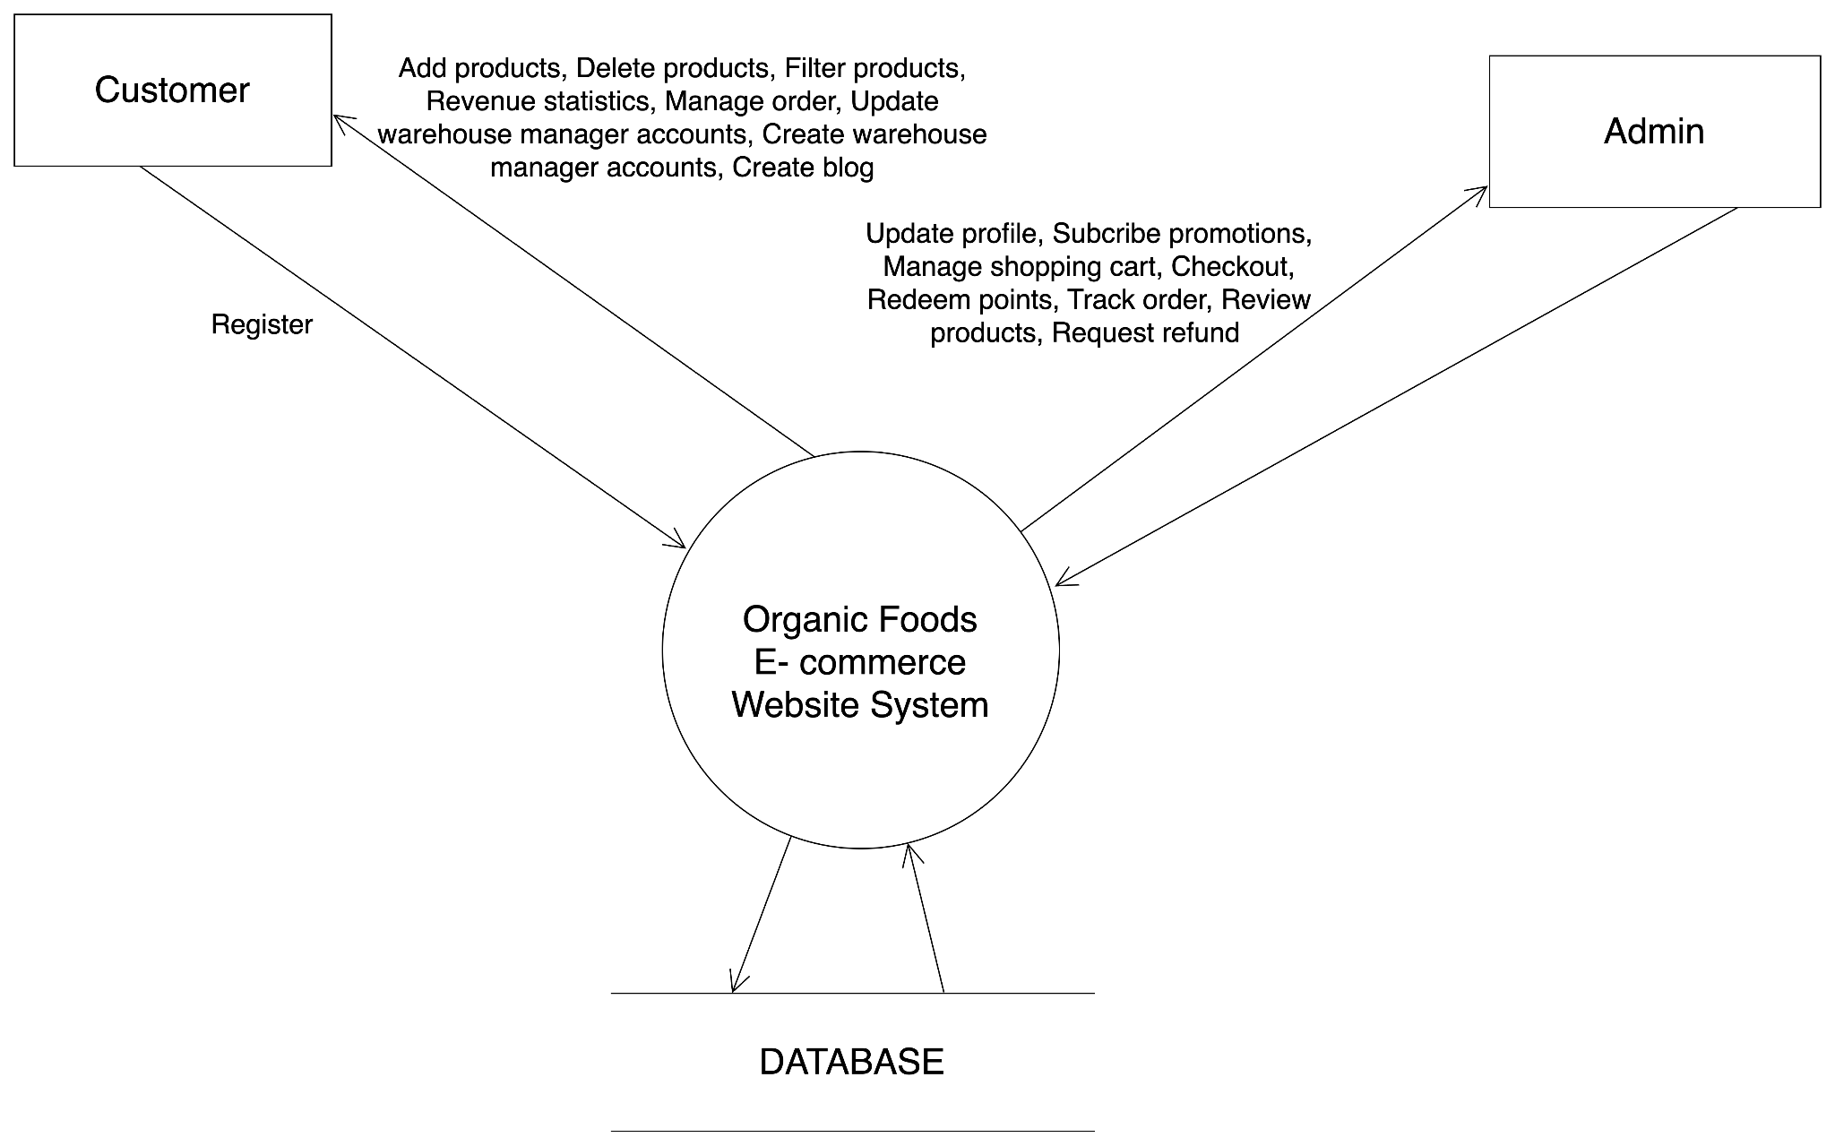
Fig 1. Flow diagram
This flow diagram represents the interaction between the main actors—Customer and Admin—with the Organic Foods E-commerce Website System and the underlying Database.
- Customer: The customer can perform activities such as registration, profile updates, subscribing to promotions, managing their shopping cart, proceeding to checkout, redeeming points, tracking orders, reviewing products, and requesting refunds.
- Admin: The admin is responsible for backend operations including adding/deleting/filtering products, managing orders, viewing revenue statistics, managing warehouse manager accounts, and creating blog posts.
- System Interaction: Both actors interact directly with the system, which processes their requests and updates the Database accordingly. The database acts as the backend repository supporting all data-related operations.
This architecture provides a clear division of functionality between frontend users and administrative users, enhancing both user experience and system management efficiency.

USE CASE MODEL DESCRIPTION:

ID & Name: | UC: Add Product
Primary Actor: | Admin
Description: | The admin adds a new product to the system by entering product details. The system validates the data, stores it in the database, and confirms the addition.
Trigger: | The admin wants to add a new product to the catalog.
Pre-conditions: | - The admin must be logged into the system.  - The "Add Product" page must be available.
Post-conditions: | - The new product is successfully stored in the database.  - The admin receives a confirmation message.
Normal Flow: | 1.1. Navigate to the "Add Product" page.  1.2. Enter product details (name, price, category, stock, image, description).  1.3. Click the "Submit" button.  1.4. System validates the input (checks required fields, format, and stock availability).  1.5. System checks for duplicate products.  If no duplicates exist:  1.6. System stores the product in the database.  1.7. The system displays a “success” message.  1.8. Admin verifies the product in the product list.
Alternative Flows: | 2.1: Admin uploads multiple product images  The system allows the admin to select and upload multiple images instead of a single image.  2..2: Admin imports products using a CSV file  The system supports bulk product import from a CSV file.
Exceptions: | Exception #1: Missing Required Fields  1.1. Admin clicks "Submit".  1.2. System detects missing required fields and displays "Error: Required fields are missing!".  1.3. Admin must fill in the missing fields before resubmitting.  Exception #2: Duplicate Product Name  2.1. Admin clicks "Submit".  2.2. The system detects a duplicate product name and displays "Error: Product name already exists!".  2.3. Admin must change the product name or confirm overwriting of the existing product.  Exception #3: Database Error  1.1. System encounters a database failure while storing the product.  1.2. System displays "Error: Unable to save product, please try again later!".  1.3. Admin is prompted to retry later.
Priority: | high
Use Case Graphic (if any)

ID & Name: | UC: Shopping Cart Management
Primary Actor: | Customer
Description: | Customer can manage cart
Trigger: | Customer selects an item to add to the cart.
Pre-conditions: | Customer is logged in and browsing products.
Post-conditions: | Shopping cart is updated with the selected item, and the customer receives a confirmation or out-of-stock message.
Normal Flow: | 1. Customers browse products.  2. Customer selects an item.  3. Customer adds the item to the cart.  4. System checks stock availability.  5. If the item is in stock, the system updates the shopping cart and shows a confirmation message.
Alternative Flows: | If the item is out of stock, the system shows an out-of-stock message and does not update the cart.
Exceptions: | - System fails to check stock availability.  - System fails to update the cart.
Priority: | High
Use Case Graphic (if any)

ID & Name: | UC: Checkout Process
Primary Actor: | Customer
Description: | The customer completes the purchase by reviewing the shopping cart, entering shipping information, and providing payment details. The system validates the payment and processes the order.
Trigger: | Customer initiates the checkout process.
Pre-conditions: | Customer has items in the shopping cart.
Post-conditions: | Order is processed, inventory is updated, and the customer receives an order confirmation.
Normal Flow: | 1. Customer reviews the shopping cart.  2. Customer enters shipping information.  3. Customer enters payment details.  4. System validates payment information.  5. If payment is valid, the system processes the order, updates inventory, and sends an order confirmation.
Alternative Flows: | If payment information is invalid, the system displays an error message and prompts the customer to re-enter payment details.
Exceptions: | - System fails to validate payment information.  - System fails to process the order or update inventory.
Priority: | Medium
Use Case Graphic (if any)

ID & Name: | UC: Manage Order (Admin)
Primary Actor: | Admin
Description: | The admin manages customer orders from placement to delivery, including verifying stock, updating order status, and coordinating logistics.
Trigger: | Customer places an order.
Pre-conditions: | Admin is logged into the system.  Customer order is in the system (pending confirmation).
Post-conditions: | Order status is updated (e.g., confirmed, shipped, delivered).  Customers receive order confirmation and tracking details.
Normal Flow: | - System receives order  - System sends notification to the admin when a new order is placed.  - Admin views order details  Admin accesses the "Pending Orders" dashboard.  - Admin confirms order  Admin clicks the "Confirm Order" button.  - System updates order status to "Confirmed"  - Admin assigns logistics partner  Admin selects a shipping provider.  - System generates shipping label and tracking number  - Admin updates order status to "Shipped"  - System sends shipping confirmation email to customer  - Admin monitors delivery status  - System updates status to "Delivered" once logistics partner confirms.
Alternative Flows: | 2.1 Customer Requests Cancellation  2.2 Customer click on “Cancel Order” button  2.3 System receive Cancel order request  2.4 System send request to admin  2.4 Admin clicks on the "Confirm Cancel Order" button.  2.5 System updates status to "Cancelled" and notifies customers.
Exceptions: | Exception #1: Logistics delay  1.10 Admin monitors delivery status  1.11 System receive delivery is delayed  1.12 Admin manually updates status to "Delayed" and notifies customers.
Priority: | High
Use Case Graphic (if any)

i
At the center of the diagram is the ec_products table, which contains detailed information about each product such as name, description, price, stock, SEO metadata, and status. Each product can have multiple stock entries recorded in ec_stock_ins and ec_stock_outs , which track the quantity and price of inventory movements.
Products are also connected to flash sales through the ec_flash_sale_products table, linking them to ec_flash_sales, which includes promotional content and timing. Additionally, products can be assigned labels via the ec_products_labels join table, connecting to the ec_product_labels entity.
Order and Transaction Management
Orders are stored in the ec_orders table, which references the Users table (indicating who placed the order) and the payment_methods table. Each order includes fields such as order amount, shipping, tax, discount, and recipient details. Transactions related to products and orders are stored in ec_transactions, capturing product snapshots at the time of purchase.
User and Address Management
User information is maintained in the Users table, including email, name, OTP for password reset, avatar, and user type. Each user can have multiple addresses stored in the Users_address table, which contains fields for phone, city, district, and street.
Slider and UI Elements
There are tables like Simple_sliders and Simple_slider_items which manage visual content such as banners or promotional sliders. Each slider can have multiple items with image, description, and link.

Sequential diagram

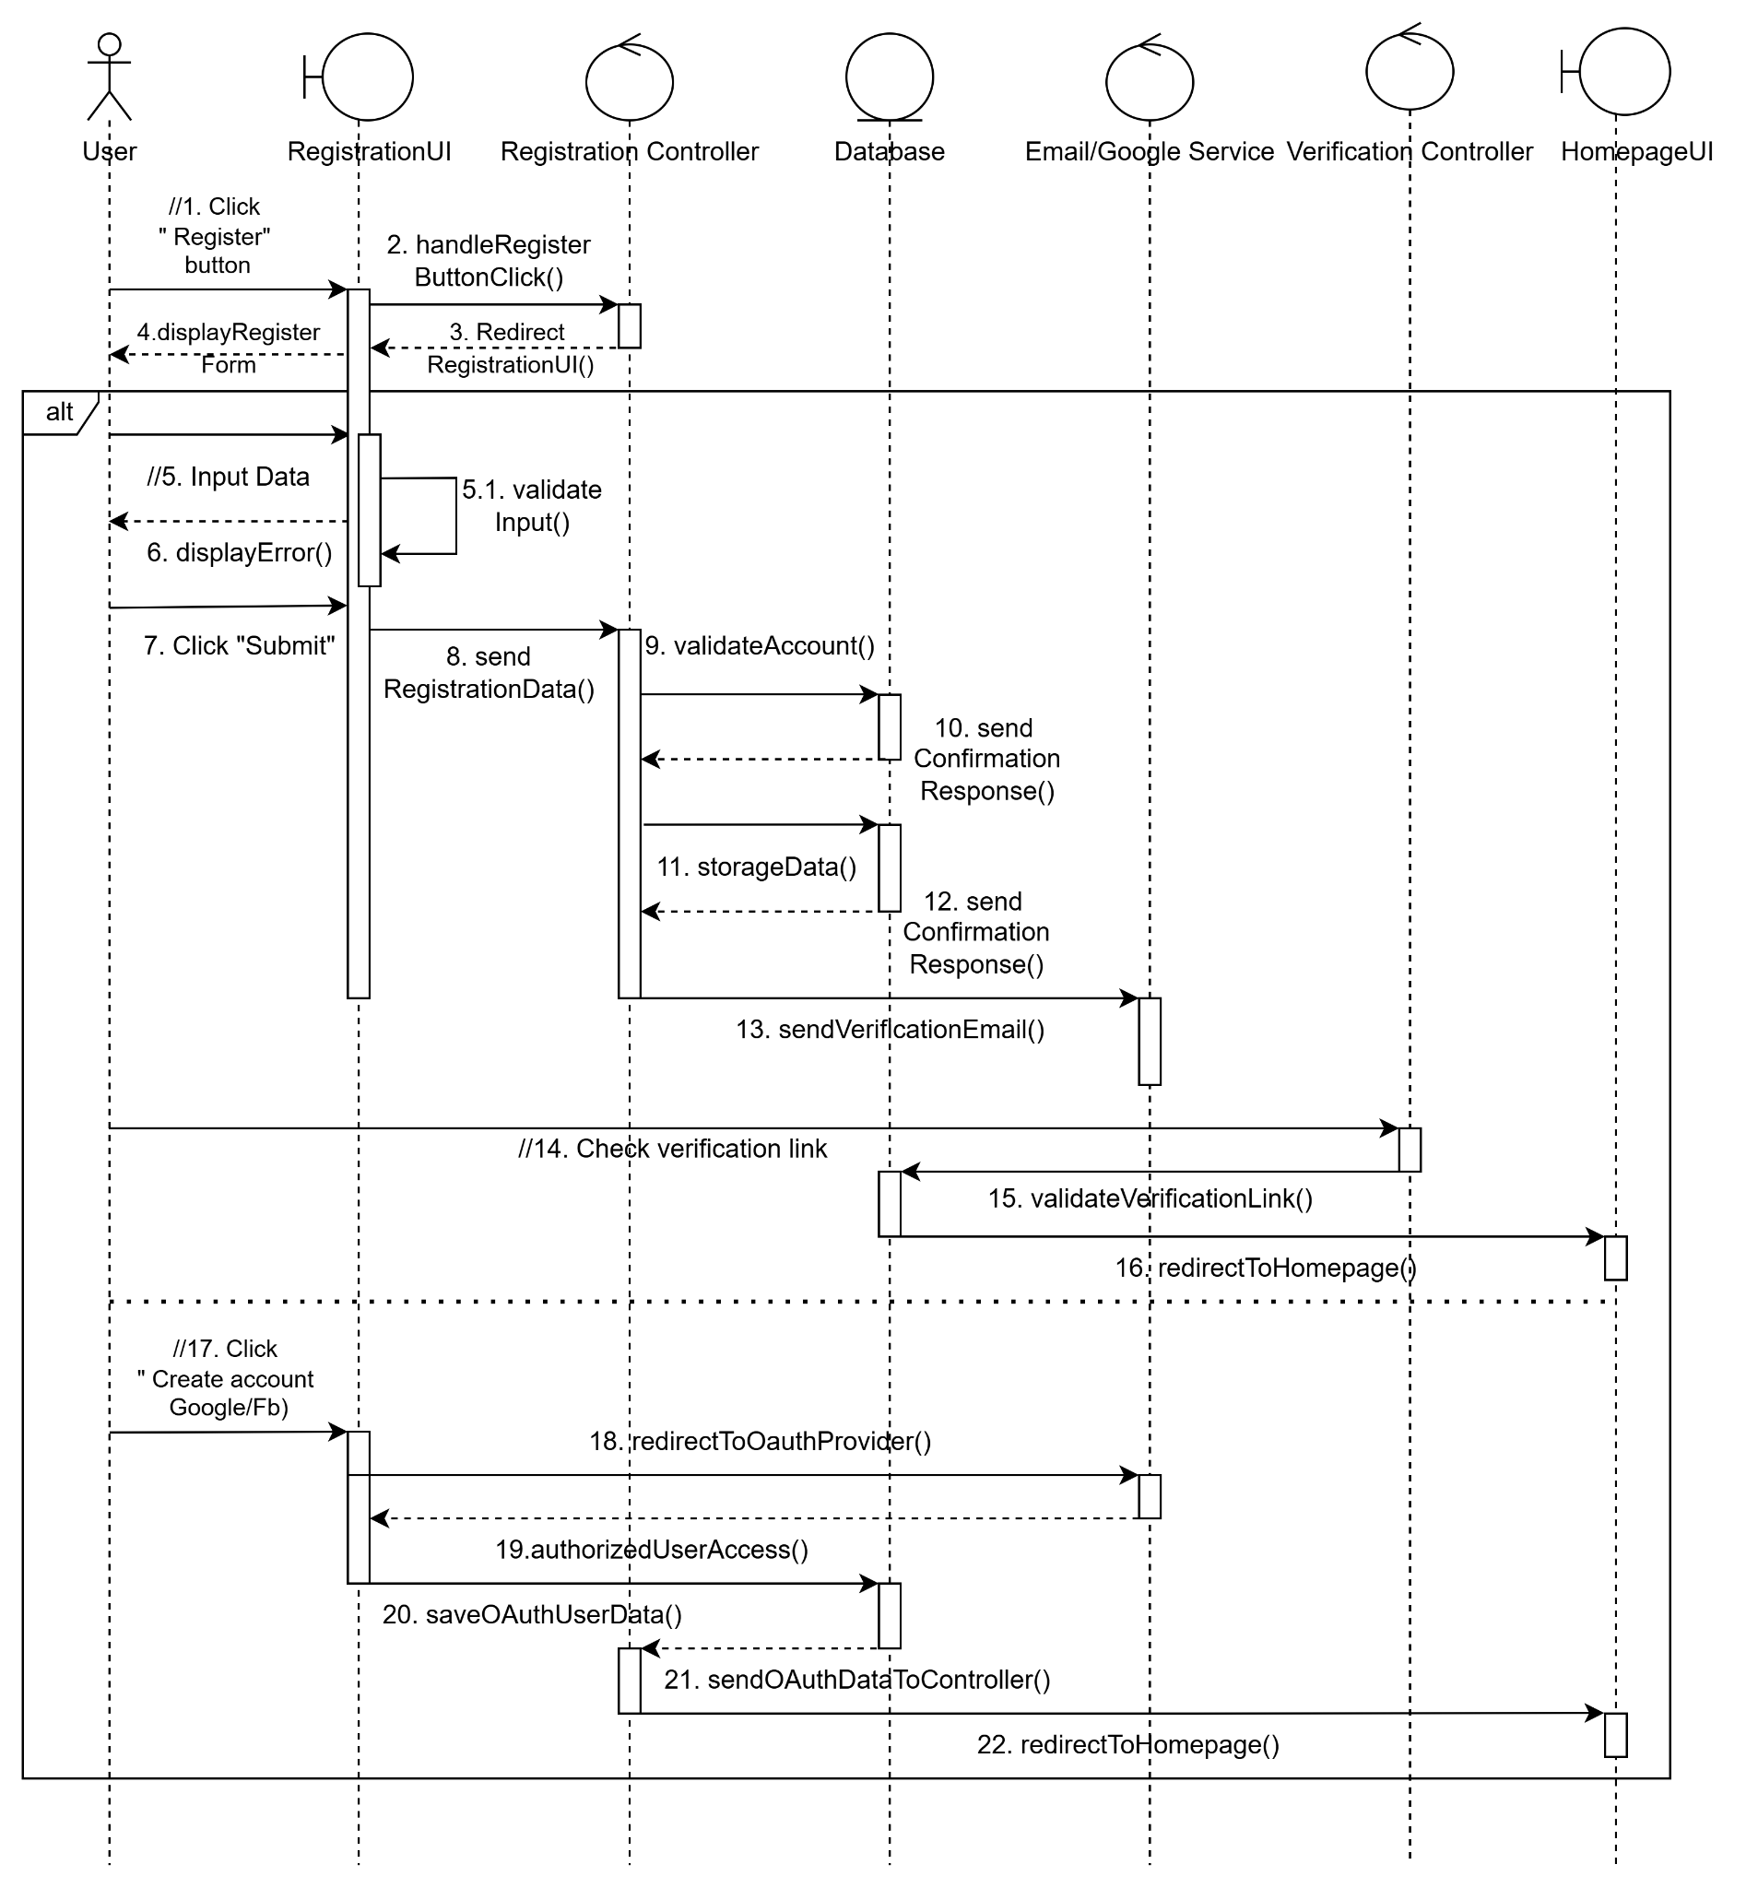

Fig 4(a). Register sequence diagram

The sequence diagram in Figure 4(a) details the registration process for new users, including both traditional form-based registration and OAuth-based registration. The flow begins when the User clicks the “Register” button, prompting the RegistrationUI to render the registration form via displayRegisterForm(). After inputting personal data, the system performs input validation (validateInput()), and in case of invalid data, an error is returned to the user (displayError()). If validation passes, the user proceeds to submit the registration, triggering the sendRegistrationData() method in the Controller, which then calls validateAccount() to ensure the data’s uniqueness and correctness. Upon successful validation, the data is stored via storageData() into the Database, and confirmation responses are generated (sendConfirmationResponse()). The Email/Google Service Verification component then sends out a verification email (sendVerificationEmail()), prompting the user to click a link. Once the user accesses the verification link, the system calls validateVerificationLink() to confirm authenticity. If verified, the user is redirected to the HomepageUI via redirectToHomepage(). An alternative OAuth registration flow is also included: if the user clicks “Create account with Google/Facebook”, the system redirects to the OAuth provider using redirectToOauthProvider() for authentication. After authorization (authorizedUserAccess()), user data is captured (saveOauthUserData()), passed to the controller (sendOauthDataToController()), and the user is redirected to the homepage. This sequence ensures that both standard and social login registration paths are validated, secure, and provide immediate system access upon success.

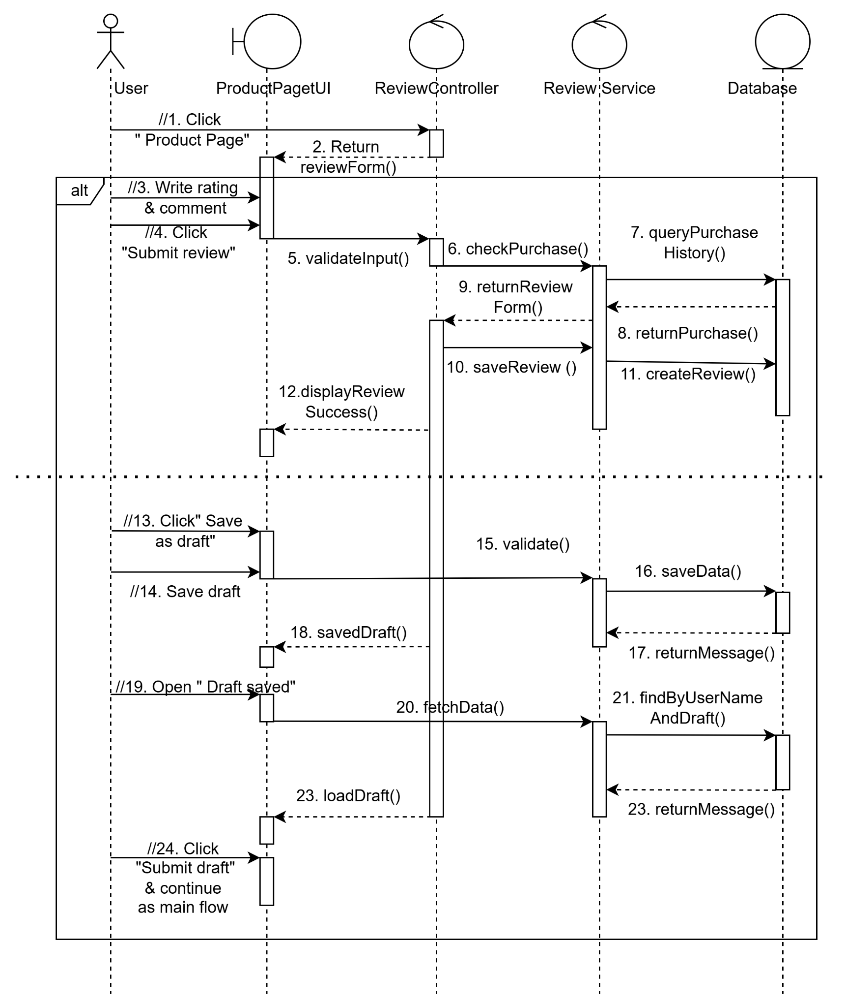
Fig 4(b). Review product sequence diagram

The sequence diagram in Figure 4(b) illustrates the complete process through which a user submits a product review. The interaction starts when the User clicks on the “Product Page”, prompting the ProductPageUI to return the review submission form via the reviewForm() method. The user then writes a rating and comment and clicks the “Submit review” button, which initiates input validation through the validateInput() function. The ReviewController calls checkPurchase() in the ReviewService to verify whether the user has purchased the product by querying the purchase history from the Database. If the purchase is validated, the system proceeds with rendering the form (returnReviewForm()), and the review is saved using saveReview() and createReview(), followed by a success message displayed through displayReviewSuccess(). An alternative flow is included for saving a review as a draft. In this case, the user clicks “Save as draft,” prompting the system to validate and store the draft using saveData(), and confirm with savedDraft() and returnMessage(). Later, the user can access the draft by clicking “Draft saved,” which triggers a fetchData() call. The system finds the draft using the findByUserNameAndDraft() method from the database and loads it via loadDraft() for editing or final submission. If the user proceeds to submit the draft, the process continues as in the main flow, starting from validation. This diagram captures both the primary and alternative paths for product review submission, ensuring purchase verification, optional draft management, and proper interaction between UI, controller, service, and data layers.

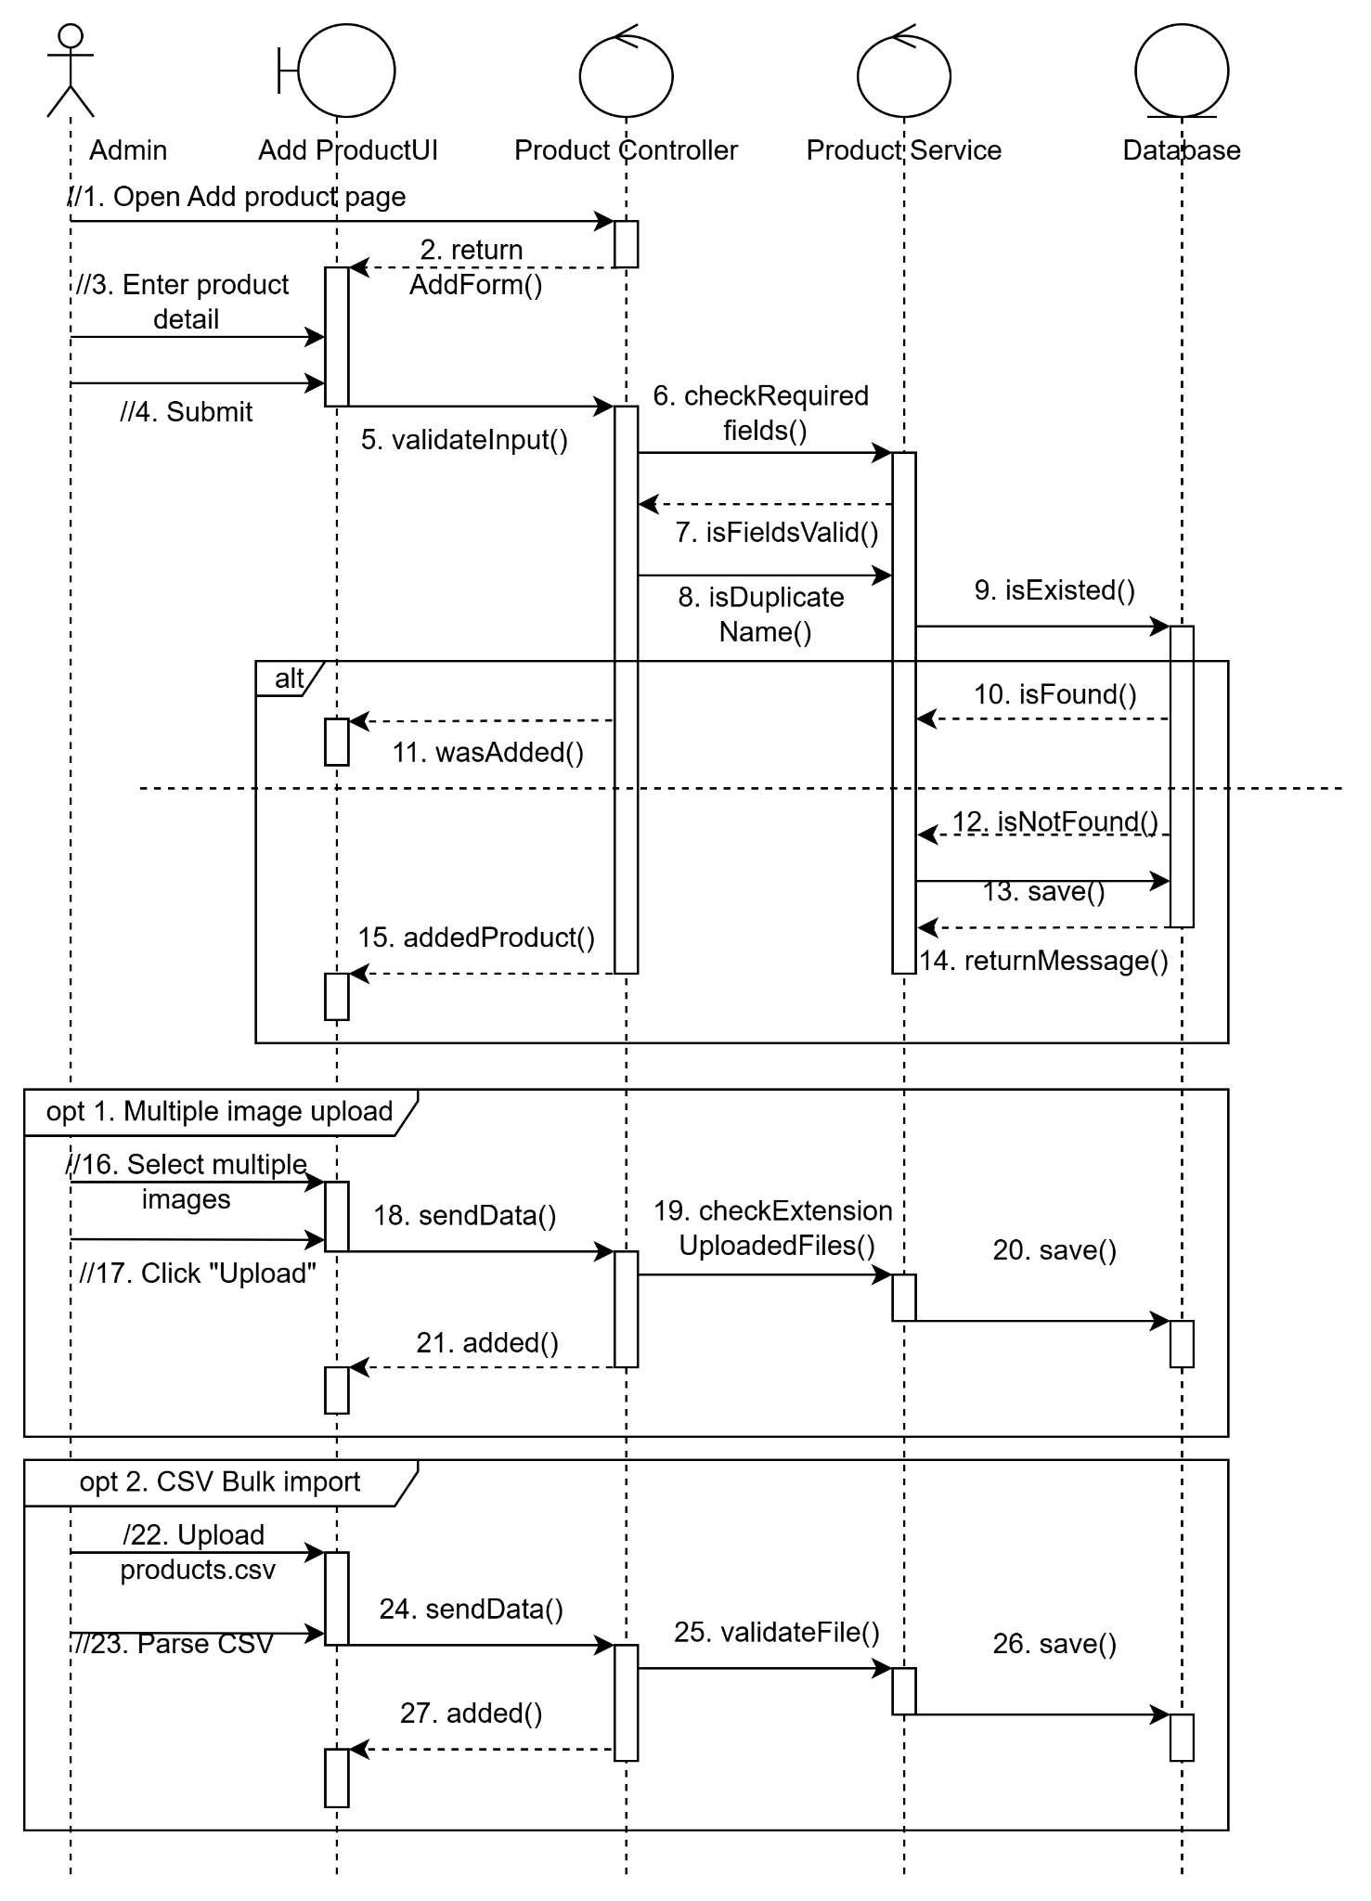

Fig 4(c). Add product sequence diagram
The extended sequence in Figure 4(c) continues by illustrating two optional flows for adding product-related assets: multiple image upload and CSV bulk import. In the first optional path (opt 1), the Admin selects multiple product images and clicks the "Upload" button. This action triggers the sendData() method from the UI to the ProductController, which then verifies the uploaded files through the checkExtensionUploadedFiles() method to ensure valid image formats. Upon successful validation, the images are stored using the save() method, and a confirmation (added()) is returned to notify the Admin that the upload was successful. In the second optional path (opt 2), the Admin uploads a products.csv file to import multiple products in bulk. The file is sent using sendData() to the controller, which invokes parseCSV() to extract product information. Each record is validated using validateFile(), and if valid, the products are persisted via the save() method. The system then confirms the successful operation by returning an added() message. These two extension flows enhance the system’s flexibility by supporting both manual and batch product entry, streamlining administrative tasks while maintaining data validation and integrity throughout the process.
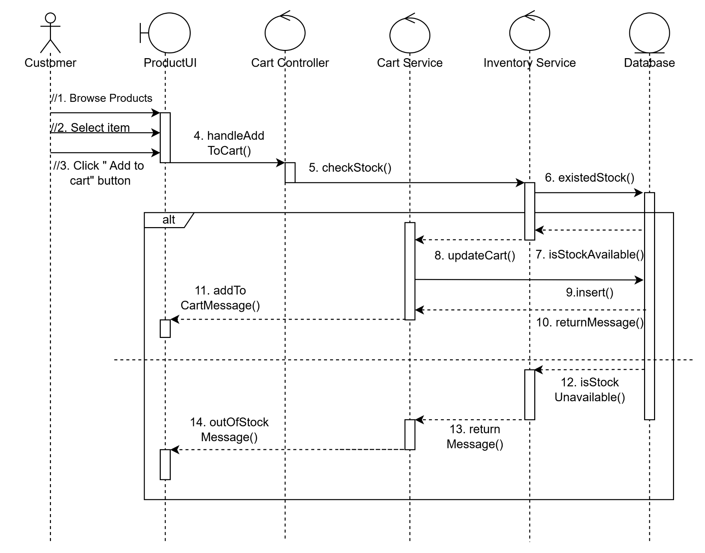
Fig 4(d). Manage Shopping Cart Sequence Diagram

The sequence diagram Fig 4(d) illustrates the interaction process for the “Add to Cart” functionality in an e-commerce system. The process begins when the Customer browses products, selects an item, and clicks the “Add to cart” button on the ProductUI. This triggers the handleAddToCart() method in the CartController, which then calls the checkStock() method in the CartService. To verify inventory status, the CartService invokes the existedStock() function in the InventoryService. An alternative flow is defined at this point: if the item is available, the InventoryService confirms it via isStockAvailable(), allowing the CartService to proceed with updateCart(). It then interacts with the Database using the insert() method to save the updated cart data and returns a returnMessage() through the service and controller layers. The ProductUI receives the final response and displays an addToCartMessage() confirming the item has been added. Conversely, if the item is out of stock, the InventoryService signals isStockUnavailable(), prompting the system to return an outOfStockMessage() to inform the user. This structured flow ensures that user actions are validated and responded to in a consistent manner across UI, controller, service, and data layers, supporting modularity and reliable cart operations.

CLASS DIAGRAM
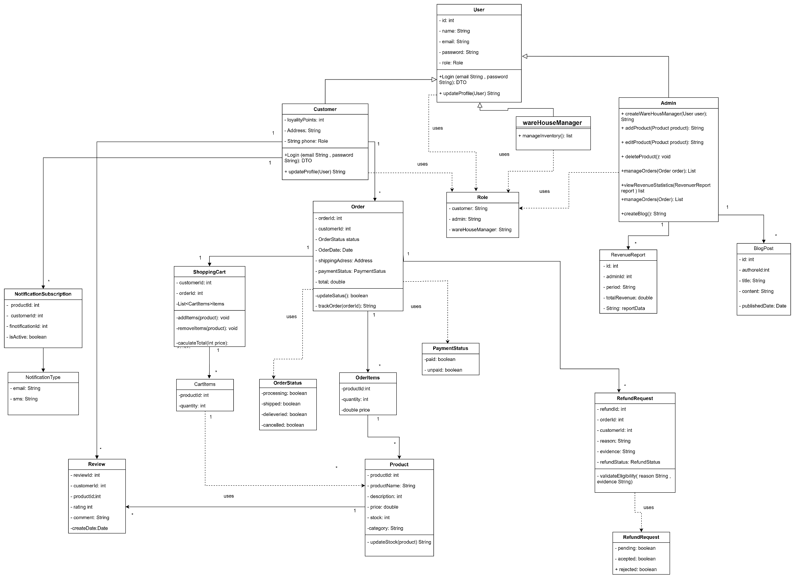
Fig 5. Class diagram
The class diagram illustrates the structural design of an e-commerce system, encompassing functionalities for customer interaction, product management, order processing, and administrative oversight. At the core of the system is the abstract User class, which encapsulates common user attributes such as userId, name, email, and password, along with methods for user authentication and profile updates. This class is extended by three specific user roles: Customer, Admin, and WarehouseManager, each with additional attributes and methods tailored to their responsibilities. The Customer class includes personal details such as loyaltyPoints, address, and phone, and can manage shopping carts, place orders, write product reviews, and submit refund requests.
The Admin class has elevated permissions allowing it to manage products, create warehouse manager accounts, generate revenue reports, and oversee order processing. The WarehouseManager, on the other hand, is responsible for managing a list of products in the inventory.
The Product class stores details such as productId, name, price, category, and stock, and is linked to both the
Review and NotificationSubscription classes. Customers can subscribe to notifications (email or SMS) for product updates and submit reviews, which include a rating and comment. The ShoppingCart class is tightly coupled with CartItems, allowing customers to add or remove products and calculate the total price dynamically. Orders placed by customers are represented by the Order class, which includes details such as orderId, customerId, orderDate, paymentStatus, and the total amount. The status of an order is tracked using the OrderStatus and PaymentStatus classes, providing insight into whether an order has been paid, shipped, delivered, or canceled.

Administrative reporting is facilitated through the RevenueReport class, which records the total revenue over a defined period and is associated with an admin user. Additionally, the platform includes a blogging feature managed via the BlogPost class, allowing administrators or warehouse managers to publish content. The RefundRequest class enables customers to submit claims with supporting evidence for order-related issues, with its status maintained through the RefundStatus class. Role management across the platform is handled by the Role class, which assigns user permissions based on their functional category. Altogether, the diagram provides a comprehensive view of the data structure and interrelations within the system, ensuring modularity, reusability, and maintainability of the application.
Administrative reporting is facilitated through the RevenueReport class, which records the total revenue over a defined period and is associated with an admin user. Additionally, the platform includes a blogging feature managed via the BlogPost class, allowing administrators or warehouse managers to publish

Assumptions and Dependencies
The development of the system assumes the use of the following core technologies and tools:
- HTML, CSS, and JS for front-end development.
- SQL for database management and data retrieval.
- API integrations for communication between system components and external services.
- ERP or CMS platforms may be integrated to manage business operations and website content, respectively.
- SSL is assumed to be implemented to ensure secure data transmission.
It is assumed that developers have a good understanding of UI and UX principles to create a user-friendly experience.
The system depends on reliable hosting and domain services that support the required technologies.
Any third-party libraries or plugins used must be compatible with the selected tech stack and regularly maintained.
The project development follows the guidelines outlined in the SRS (Software Requirement Specification) document

